

Crime: Is Crime created by Nature or Nurture?
A critical study into the contributary factors on the likelihood of a person committing crime in the United Kingdom. How can we prevent the cycle of re-offending? How do ACEs play a part in the likelihood of offending?

Benjamin Doyle
1920592

Bsc(Hons) Professional Policing Practice

Declaration

This work has not previously been accepted in substance for any degree and is not being concurrently submitted in candidature for any degree.
Signed: 1920592 Date: 28.12.22

Statement 1

This dissertation is being submitted in partial fulfilment of the requirements for the degree of Bsc Professional Policing Practice.
Signed: 1920592 Date: 28.12.22

Statement 2

This dissertation is the result of my own independent work and investigation, expect where otherwise stated. Other sources are acknowledged throughout this dissertation and is identified within the attached bibliography.
Signed: 1920592 Date: 28.12.22

Statement 3

I hereby give consent for my dissertation, if accepted, to be available for photocopying and for interlibrary loan and for the title and summary to be made available to outside organisations where required.
Signed: 1920592 Date: 28.12.22

Statement 4
I hereby give consent for my dissertation, if accepted, to be available on the university’s IT system to those who have consent to use the system.
Signed: 1920592 Date: 28.12.22

Table of Contents

Declaration…………………………………………………………………………………………………………………………2
Acknowledgements……………………………………………………………………………………………………………5
Glossary of Abbreviations………………………………………………………………………………………………….6
- Chapter One: Introduction………………………………………………………………………………………………..7
  - Introduction – Research Background………………………………………………………………………….7
  - Aim of Study………………………………………………………………………………………………………………8
  - Objective of Study……………………………………………………………………………………………………..9
- Chapter Two: Literature Review……………………………………………………………………………………….10
2.1 Introduction – Background………………………………………………………………………………………….10
2.2 Aims of Research…………………………………………………………………………………………………………10
2.3 What are the Biological contributory factors of crime?..................................................11
2.4 What are the Psychological contributory factors of crime?............................................12
2.5 What are ACE’s and how do they influence crime?.........................................................13
2.6 What are individuals knowledge and perceptions of ACE’s and how these affect
Crime………………………………………………………………………………………………………………………….15
2.7 What is currently being done to reduce crime and educate about ACEs?......................16
2.8 Is the reduction of Police effecting the number of crimes being committed?................17
2.9 Is the reduction in Local Authority funding affecting the number of crimes being
committed?......................................................................................................................17
2.10 Conclusion………………………………………………………………………………………………………………..18
3. Chapter Three: Methodology……………………………………………………………………………………………19
3.1 Introduction……………………………………………………………………………………………………………….19
3.2 Research Onion………………………………………………………………………………………………………….19
3.3 Research Approach…………………………………………………………………………………………………….21
3.4 Time Horizon………………………………………………………………………………………………………………22
3.5 Data Collection and Analysis………………………………………………………………………………………22
3.6 Ethical Considerations………………………………………………………………………………………………..23
3.7 Conclusion………………………………………………………………………………………………………………….24
4. Chapter Four: Analysis of Research…………………………………………………………………………………..25
4.1 Introduction……………………………………………………………………………………………………………….25
4.2 Data Analysis……………………………………………………………………………………………………………..25
4.3 Survey Findings………………………………………………………………………………………………………….25
4.3.1 What are individuals perceptions of the causes of crime?....................................25
4.3.2 How aware are the public of ACE’s?......................................................................26
4.3.3 Is there a link between ACE’s and offending?........................................................27
4.3.4 Are the public aware of what support is available?...............................................28
4.3.5 How should ACE’s be taught?................................................................................28
4.4 Conclusion…………………………………………………………………………………………………………………28
5. Chapter Five: Conclusions and Recommendations…………………………………………………………..29
5.1 Introduction………………………………………………………………………………………………………………29
5.2 Main Findings……………………………………………………………………………………………………………29
5.3 Recommendation for reducing crime influences created by Nurture and ACEs………..29
5.4 Limitations……………………………………………………………………………………………………………….30
5.5 Further Research……………………………………………………………………………………………………..30
5.6 Achievement of Objectives………………………………………………………………………………………30
5.7 Self Reflection and Conclusion…………………………………………………………………………………31
6. Chapter Six: Bibliography………………………………………………………………………………………….……32
7. Chapter Seven: Appendices……………………………………………………………………………………………37
7.1 Appendix One: Questionnaire………………………………………………………………………………….37
7.2 Appendix Two: Questionnaire Results……………………………………………………………………..42
7.3 Dissertation Proposal……………………………………………………………………………………………….46
7.4 Ethics Form………………………………………………………………………………………………………………54

Acknowledgements

I would like to take this opportunity to thank all of my friends, family and colleagues who have been a constant pillar of support to me throughout my undertaking of this dissertation.
I would like to give particular thanks to my wife, Jasmine, who has showed immense patience and understanding throughout this lengthy degree process.
I would also like to thank the University staff for guiding me in the right direction throughout this study, all of which has helped me to complete this piece of work.

Glossary of Abbreviations

A&E Accident and Emergency
ACE’s Adverse Childhood Experiences
CSEW Crime Survey for England and Wales
TCSEW Telephone-Operated Crime Survey for England and Wales
GP General Practitioner
HOCR Home Office Counting Rules
HOPIF Home Office Police Innovation Fund
NICL National Incident Category List
ONS Office for National Statistics
REACh Routine Enquiry into Adversity in Childhood
UK United Kingdom

- Chapter one: Introduction

  - Introduction – Research Background

There are several theories underpinning the social root causes and what motivates individuals to commit a crime. There are notably two main schools of thought, those who view criminals as being bad people with biological pre-disposition to want to commit crime and those who believe that criminals are a projection of the way that they have been brought up and the environment that they are brought up in.

Stevens (2002) whom is a Metropolitan Commissioner highlights that there has been a sharp increase in crime within the UK and that every 5 seconds a crime is committed. Additionally, Stevens (2002) outlines that the criminal justice system is “creaking” under its workload and that police officers spend nearly 22,000 hours a day processing arrests.

This study is to investigate and review the contributing factors leading to crimes being committed in the UK. According to the Crime Survey for England and Wales (CSEW 2022), in the year ending June 2022, the public in England and Wales experienced approximately 9.4 million offences. These figures do not include crimes that have occurred and have not been reported to the Police.

The increase in crime has influenced the UK economy. In April 2021. The Times newspaper (2021) reported that Crime in the UK is costing approximately £100billion per year. (Times 2021)

Crime figures began to increase as funding for the Police hit a low of £16.35 billion in 2013/14, with funding not increasing until 2017/18. One of the main consequences of these spending cuts was a reduction in the number of police officers after 2010.Clark (2022) found that Police numbers between 2010 and 2017 in the UK dropped by 22,000 due to austerity cuts and other economic pressures on UK Police forces.
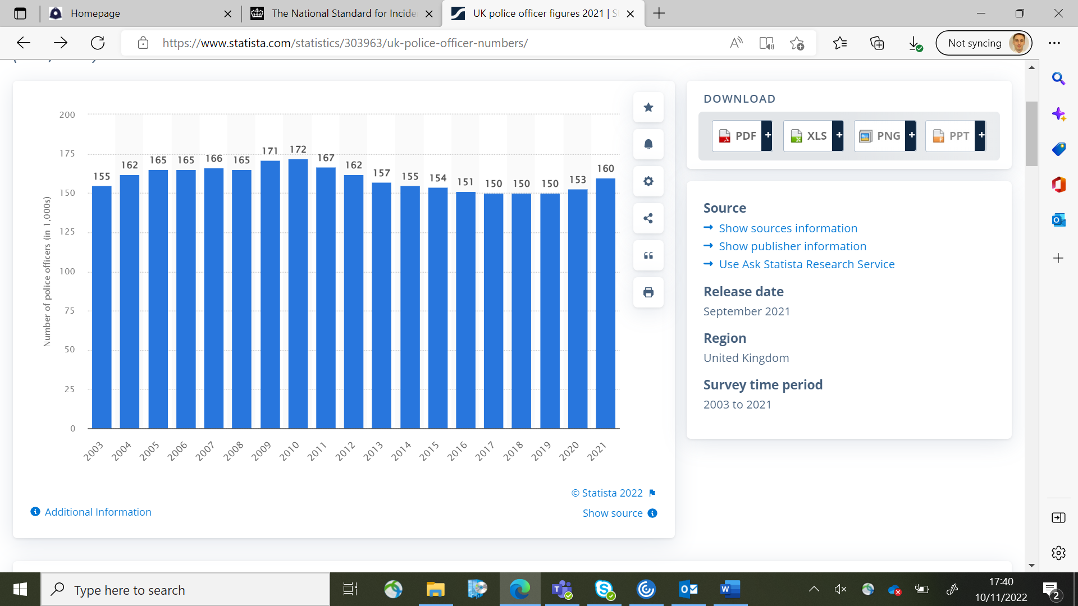

Figure 1: Police Officer Numbers in the UK between 2003-2021(Clark 2022)

The Office of National Statistic (ONS) (2002), outlines another factor driving the overall increase in crime figures relates to increased reporting of sexual offences, which rose after 2012/13. This is due to successful investigations into historic offences giving victims confidence to report, in 2021, 71.2% of rape-flagged cases resulted in prosecutions (CPS 2021. According to TCSEW (2022), adults aged 18 years and over experienced 12.8 million offences in 2021. This was an 18% increase compared to 2019.

Crime affects every person in the UK. Whether they are a victim, a witness or are the perpetrator. It is essential to understand crime and its causes in order to reduce it within our communities.

This study will aim to identify statistical figures and scientific studies into the contributory factors affecting the likelihood of a person committing crime within the UK. Also, will look at both biological and environmental influences with the aim of providing recommendations to reduce offending for the future.

1.2 Aim of the Study

A critical study into the contributory factors on the likelihood of a person committing crime in the United Kingdom. How can we prevent the cycle of re-offending?”

1.3 Objective of the Study

- Investigate the contributory factors of Crime.

- Analyse data obtained via a survey to identify contributory factors relating to a person’s biology and environment and how these affect the likelihood of offending.

- Analyse data and research collected regarding the impact of ACE’s on a person’s likelihood of offending.

- Provide recommendations to reduce the number of ACES experienced and therefore reduce the likelihood of a person offending and re-offending.

- Chapter Two: Literature Review

2.1 Introduction: Background

Stevens (2002) outlines that every 5 seconds a crime is committed within the United Kingdom. The research in this study will seek to compare and identify the causes of crime and produce recommendations to prevent and reduce crime and re-offending. It is imperative to note that there are a wide variety of reasons and explanations as to why individuals commit crimes (Conklin, 2007) .

The number of crimes in the UK are recorded using the Home Office Counting Rules (HOCR). This is the national standard of recording a counting of ‘notifiable’ offences by Police forces in England and Wales (Gov.uk, 2022).

The UK spends millions of pounds each year funding a range of community projects and rehabilitation projects and facilities to prevent offenders from committing further crime. In December 2021, the Government announced an additional £550 million in funding to prevent re-offending. (Gov.uk 2021)

Rehabilitation to prevent re-offending is becoming increasingly important as Clark (2014) found that in 2019/20, the average cost of a prison place in England and Wales was £44,600a year, compared with £43,200 pounds in 2018/19, an increase of £1,400.
It is important to ensure that the money is being spent on the correct rehabilitation courses.

2.2 Aims of Research

A review into existing studies and literature will provide information regarding what factors influence the likelihood of a person committing crime. This information will be the basis for this study and will outline the problem and recommendations will be made. Blumle et al (2018) highlights that a sound research base of existing literature is essential in formulating a well-framed research question. This allows for a narrowed down search result and reduces the amount of irrelevant hits. By carrying out this work, Blumle (2018) states that any shortcomings or gaps in research can be identified.
Following these steps, a thorough review of the literature will achieve the aims of exploring the following points:

1. What are the biological factors that influence crime?
2. What environmental factors contribute to individuals committing crime?
3. Does exposure to Adverse Childhood Experiences contribute to an individual’s likelihood of committing crime?
4. What support is available to reduce the likelihood of an individual committing a crime?

2.3 What are the Biological contributory factors of crime?

Raine et al (1997), hypothesised that there was a difference in brain structure between criminals and other members of society. Raine et al (1997) conducted a study on the brains of 41 murderers. Raine observed abnormalities in the prefrontal cortex of the murderer’s brains. This part of the brain is responsible for executive function, personality expression, decision making and moderating social behaviour.
Falconer (1965) conducted a study of both DZ (Fraternal twins) and MZ (Identical twins) Falconer looked at the statistics of offending between the two groups of twins. His findings were that there was a significant increase in likelihood of deviant behaviour between MZ twins.
Falconer found that 13 other studies around the world had found a stronger concordance between MZ twins as with DZ twins. An example of this is Raine (1993), who found a concordance rate of 51.5 for MZ twins, compared to 20.6 for DZ twins in their likelihood to display violent behaviour.
Further studies in 1993 have further supported Raine and Falconer’s findings. Slutske et al (1997) and Ely, Lichenstein and Stevenson (1999) also found an increased likelihood of offending from MZ twins.
Falconer conceded there were, Methodological limitations to these studies. One being that MZ twins may share a more common environment than DZ twins, due to being treated alike as they are identical, this is particularly the case in same sex MZ twins. Also, Mednick et al (1984) carried out an adoption study on twin children that were separated at birth, and therefore grew up in differing environments.
Mednik et al (1984) found a genetic correlation between the delinquency rates of adopted children and their biological parents. Below is a table of their findings.

Results of Cross-Fostering Analysis (Percentages refer to the proportion of adoptees who had court convictions)

Are Biological parents criminal?
Yes No
Are Adoptive parents criminal? Yes 25.5% 14.7%
No 20% 13.5%

Source: Mednik, Gabrielli and Hutchings (1984)

2.4 What are Psychological contributory factors of crime?

Violent behaviour is usually a learned behavioural response to real-life experiences. According to Sutherland (1947), criminal behaviour is learned within intimate personal groups through interaction with family and society. This involves internalising motives, antisocial attitude and techniques of committing a crime. These motives are classified as favourable and unfavourable. Unfavourable behaviours are mostly associated with the environment in which the individual is raised. Criminal behaviour is found to be the expression of the deprived needs and values of the individual.
An example of where a theory of Psychological and environmental factors has contributed to an offence is the murder of James Bulger, where Jon Venables and Robert Thompson, who were both only aged 10 at the time of the offence, brutally murdered the two year old.

Whilst growing up Thompson was abused by his father along with his mother and siblings. The abuse continued after his father left the family home, where his brothers regularly fought and his mother became an alcoholic. It is clear from this that Thompson experienced several ACEs over a prolonged period. ACEs stands for Adverse Childhood Experiences, which are events that can trigger a stress response.
Venables, appeared to not have experienced any abuse at home. His parents were estranged. Therefore, even Venables has experienced an ACE and he may have been heavily influenced by Thompson.
Judge Mr Justice Morland stated post trial ‘The home background, upbringing, family circumstances, parental behaviour and relationships were needed so that a worthwhile debate can take place for the public good in the case of grave crimes by young children’.
West and Farrington (1973) conducted a longitudinal study of 411 schoolboys in London aged between 8 and 18. During the study, 20% of the children went on to become delinquents and offended. When researchers looked more closely at the results, they found that half of the convicted children belonged to just 6% of the families. This was extended to 66% of the children convicted belonging to 10% of the families.
These findings have since been supported by the Justice Departments Bureau of Statistics in America, who looked at the current prison population. They found that roughly 800,000 parents behind bars had a close relative who had previously been incarcerated.
During an article by Fox Butterfield in 2018, they spoke to an inmate named Tracy Bogle, who was one of over 60 members of the family who were in prison in America. On asking why so many of her family were in prison she replied “What you are raised with is what you become. There is no escape from our criminal contagion”.
This thought from Bogle shows the practical application of the Social Learning Theory, proposed by Albert Bandura (1977). Bandura proposes that all learning was a result of direct experience with the environment through the process of association and reinforcement. Bandura (1977) adds to this theory by saying that a person can learn new behaviours and new information by observing others which Bandura (1977) refers to as observational learning.
In other research, Kirk (2005) studied offenders following release from prison in the USA. Kirk (2005) research shortly followed the aftermath of Hurricane Katrina in New Orleans. Kirk (2005) identified that individuals released from incarceration were unable to return to their homes due to extensive hurricane damage. Kirk (2005) identified a trend that the re-located individuals had lower rates of re-offending than those who remained in New Orleans. Kirk (2005) theorised that the cause of re-offending referred to the individuals breaking their social networks of which influenced illicit and criminal behaviours. Inevitably, Kirk (2005) found that a biproduct of this rehabilitation was that the cost per persons for this type of rehabilitation was far cheaper than re-incarceration.

2.5 What are Adverse Childhood Experiences (ACEs) and how do they influence crime?

Adverse Childhood Experiences (ACE’s) have the potential to significantly impact a child’s future in terms of perpetration, violence and victimisation (Centre for disease Control 2022) Young Minds (2018) stipulate that ACE’s are notably traumatic, stressful prolonged or single events and/or incidents that occur throughout childhood.
Bellis et al (2014) found that ACE’s are in fact, common with 47% of individuals in the UK being exposed to at least one ACE and 9% of the population having 4 or more ACEs. Manchester University NHS Trust (2021), supported by NHS Scotland, outline ACEs that a child can potentially be exposed to:
- Domestic violence
- Parental abandonment through separation or divorce
- A parent with a mental health condition
- Being the victim of abuse (physical, sexual and/or emotional)
- Being the victim of neglect (physical and emotional)
- A member of the household being in prison
- Growing up in a household in which there are adults experiencing alcohol and drug use problems.

Felitti et al (1998) found that these potentially traumatic events can have a negative and long-lasting effect on both the health and the well-being of the child. Felitii’s study also found that the occurrence of an ACE is common and that the occurrence of one ACE in a child’s life increases the probability of experiencing another. Anda et al (1999) found that often ACE’s co-occur, such as abuse in the household from a divorced parent suffering mental illness.
Until recently, little research has been conducted into ACE’s and their long-term effects on a person. Vink Van der Pal et al (2016) conducted a study on a cross section of children aged between 11-12 who lived in the Netherlands. Children were asked to rate how happy they were in themselves, along with individual medical examinations. The results showed the children who had experienced an ACE were less happy and healthy than children who had not experienced an ACE in their lives to this age.
There have been more studies in recent years which looked at the mental health effects of ACE’s. Anda et al (2006) found that experiencing ACE’s have a greater chance of being diagnosed with mental health problems such as Depression, Anxiety and PTSD. Anda’s finding were echoed in earlier studies conducted by Chapman et al (2004) and DeBellis & Thomas 2003).
Mersky et al (2013) found whilst studying the effects of ACE’s can result in social or behavioural problems, such as increased use of illicit drugs, tobacco and alcohol. Lui et al 2013 found a direct correlation between the experience of ACE’s and the chances of being unemployed.

These factors can increase a person's likelihood of committing crime. Therefore, vitally important that we try and help children to cope with their traumatic experiences and even try and reduce the number of events experienced to prevent them entering the Criminal Justice System.

In July 2018, Bangor University found children who have adverse childhood experiences were more than twice as likely to use accident and emergency departments and to be frequent GP surgery users. This creates a new dynamic on how ACE’s experiences as children can increase the demand on public resources in adulthood. The study also found from a national study across Wales that adults who had suffered four or more types of ACE were almost 10 times more likely to have felt suicidal or self-harmed than those who had experienced none.

2.6 What are individuals’ knowledge and perceptions of ACE’s and how these affect crime?

The Children’s Parliament, in Edinburgh, outline those one of their three strategic aims is to grow public awareness of ACEs and drive cultural and behavioural change to deliver a nation that values children and their rights. This demonstrates the current lack of knowledge and awareness of ACEs amongst the general population.
Blackburn & Darwin Council (2012) conducted a study into ACEs in England and found almost 50% of participants reported experiencing at least one ACE and 9% reported experiencing four or more ACEs. In a Welsh sample, the prevalence was almost 50% of people reporting experiencing at least one ACE and 14% reported experiencing four or more. This demonstrates how prevalent ACEs are in children’s lives. Based on these results, researchers calculated that following;

o Two times more likely to binge drink and have a poor diet;
o Three times more likely to be a current smoker;
o Five times more likely to have had sex while under 16 years old;
o Six times more likely to have had or caused an unplanned teenage pregnancy;
o Seven times more likely to have been involved in violence in the last year; or
o Eleven times more likely to have used heroin/crack or have been incarcerated.

These figures show that there is a strong connection between the experiencing of ACEs and the likelihood of committing crime.
During a report by Couper (2016) named ‘Polishing the Diamonds – Addressing ACEs in Scotland’, Lancashire Care found many of patients who made disclosures of experiencing ACEs following the commencement of a new procedure by staff had never made this disclosure previously. This suggests that ACEs are often supressed memories or feelings and that they do not carry the burden in the forefront of their minds. (Couper 2016)
The public’s lack of knowledge and understanding of ACEs may be due to lack of media coverage. Reiner (2007) points out that media coverage of crime and deviance is filtered through journalists’ sense of ‘what makes a story newsworthy’. This means that journalists themselves decide what parts of a story to include and leave out and it is entirely plausible that they often ignore the existence of ACE’s in an offenders’ history.

2.7 What is currently being done to reduce crime and educate about ACE’s?

The Welsh Government are making changes within the Education sector in order to tackle the harmful effects of ACE’s on young people. The Welsh Government, in partnership with the Police and Crime Commissioner Alun Michael (South Wales Police 2022) have set aside £200,000 in a grant scheme to help tackle ACEs. The scheme aims to bolster initiatives that support individuals growing up, or living in homes, where there is domestic abuse or substance misuse. Its aims are to tackle family finance, parenting and improve resilience. (South Wales Police 2022).
During a report named ‘Polishing the Diamonds – Addressing ACEs in Scotland’ (Couper 2016), Lancashire Care have developed a process known as Routine Enquiry into Adversity in Childhood, or ‘REACh’ for short. This process is carried out by Practitioners who ask adults about traumatic/adverse experiences in their childhood so that interventions can be planned accordingly.
During year one of the implementation of this process, staff from primary care, local authorities and the voluntary sector were provided with awareness training of ACEs. Following a period of implementation of this process, staff found that most participants were not aware of the impact of adversity in later life outcomes before receiving the training. They also found that if participants gave a disclosure, the person would have often already used other services in the past and they were either never previously asked regarding their childhood or had not self-disclosed off their own backs. Staff that were trained also found that they were able to create more appropriate intervention plans to deal with the root causes of presenting issues rather than dealing with a ‘symptom’. Participants and Managers also felt that the assessments they were conducting were more enhanced by having this knowledge of adverse experiences (Couper and Mackie 2016).

2.8 Is the reduction of Police effecting the number of crimes being committed?

HMICRS (2020) Setback funding to Police forces in England and Wales totalling £120 million since 2013. This is a fall of 34%. This, alongside a fall in Police numbers of approximately 22,000, means that the public’s perception of the Police has changed as the Police are now not able to be pro-active. This has resulted in fewer criminals being apprehended. This has led to a culture of belief that criminal will not be caught. There is therefore less of a deterrent to offenders.
This has been reflected in the number of crimes committed every year in the UK. In 2013, approximately 3.5 million crimes were recorded in the UK. This has increased to 5.8 million in 2021 in the most recent crime figures released by the Office for National Statistics (ONS).

2.9 Is the reduction in Local Authority funding affecting the number of crimes being committed?

Local Authorities are responsible for delivering social care for children and adults within their area. This includes waste collection, maintenance of facilities such as libraries and this also covers housing, education and care for young and vulnerable people.
The Cabinet Office (2019) states that local authorities receive a large portion of their funding from government in the form of grants. This makes up approximately 23% of funding in England in 2019. Local authorities have other sources of income, such as Council tax and business rates. All of which is generated within their area.(Gov.uk 2019)
Unlike the government, local authorities cannot borrow money to finance day-to-day spending and must run budgets strictly.
The Institute for Government (IFG 2022) reports that over the last decade, local authorities would have faced a reduction to core funding from the government of nearly £16billion over the last 10 years. There is a reduction in public funding for the community such as youth clubs and other rehabilitation and diversionary projects.
Sampson and Groves (1989) created the Social Disorganisation Theory (STD). This theory is when a community’s structure cannot realize the common values of the residents and maintain social control, crimes occur. In modern times this would relate to financial hardships where people are often resorting to crime.

2.10 Conclusion

The review of extensive existing literature and statistics has provided an insight into the biological and psychological causes of crime. Statistics have allowed for other factors to be considered into the causes of crime. It has shown that ACEs play a role in crime and has showed how they influence the likelihood of a person offending in adulthood. It has also outlined the current lack of knowledge and training in order to deal with ACEs and create appropriate treatment plans for patients who have experienced ACEs.

- Chapter Three: Methodology

3.1 Introduction

The Oxford Dictionary defines research as ‘The systematic investigation into and study of materials and sources in order to establish facts and reach new conclusions.
There are two types of research that are carried out, Primary and Secondary. Primary is where data is collected first-hand and is carried out with the goal of producing new knowledge. This is often done in order to answer a question that has not been asked before. (Gartton & Jones 2010)
Driscoll (2010) states that Primary Research can be done through various methods, but the main scientific method is to create research questions and a research hypothesis, before collecting data and drawing evidence-based conclusions. Driscoll states that primary data can be obtained through the dissemination of surveys, conducting interviews, focus groups and by observing individuals.
Primary research has its pitfalls. Driscoll (2010) states that due to its nature, primary research requires more time, effort compared to secondary research. However, technology has helped to ease this burden.
Secondary involves the summary and analysis of data that has already been published by others. A common type of secondary research is a systematic review. This involves a researcher reviewing a topic and views all existing literature and studies to formulate their findings. (Fitchburg State University, 2020).
The literature review states there is a lack of research into the causes of crime and the influence that ACE’s has on the likelihood of a person offending. This study will seek to help to bridge to gap in knowledge and understanding of this topic by obtaining primary research utilising an online questionnaire.

3.2 Research Onion

Saunders et al (2009) created the ‘Research Onion’ which allows researchers to take a systematic approach to conducting research and this provides guidance to how the research they are undertaking should be conducted.

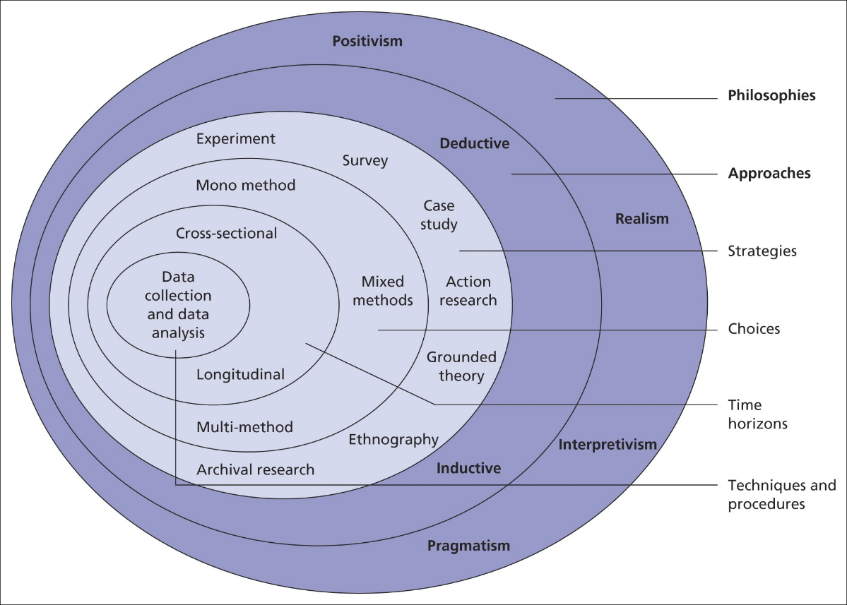

Figure 1: Saunders Research Onion (Saunders et al, 2009)

Saunders’ research onion can be dissected into the following categories:

- The outer layers contain the philosophy, which is the stance from which the research is conducted.
- The middle layers refer to the strategy of a study and how the research and information is going to be obtained. It also covers the time horizon for the research.
- The centre refers to the data collection and analysis, in order to ascertain the findings of the research (Saunders et al 2009).

There are other theories for research study methodology. Deci and Ryan (2000) created the Self-Determination Theory. This states that our motivation stems from satisfaction of three psychological views, Competence, Autonomy and Relatedness. Competence in this theory refers to the capability to complete a task. Autonomy being the feeling of choice and control over the research topic. Relatedness refers to the perception that the researcher has meaningful social relationships. (Deci and Ryan 2000).
Deci and Ryan believe that intrinsic motivation is key to a successful research study. They define intrinsic motivation as having a sense of pleasure, interest in and enjoyment of the activity and topic.
Bandura (1977) posited that we are much more likely to imitate behaviour when we observe others who are perceived as having elevated power or status modelling the behaviour. This theory is pertinent to this research study as this study wishes to assess the influence of a person’s environment on a person’s behaviour.

3.3 Research Approach

According to Saunders et al (2016), there are two main research processes which are commonly used in academic writing. These are Deductive and Inductive methods.
Deductive theory creates a theory and using observations to confirm or reject the theory. Inductive theory works by making an observation, before they review and analyse findings from research in order to understand why a theory has been realised.

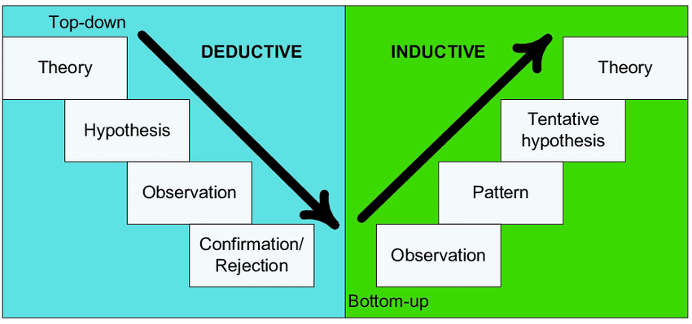
Figure 2: Distinction between Deductive and Inductive approach (Burney 2008)

Within this dissertation, a Deductive approach will be adopted. This will enable statistics and information to be collected, before being critically analysed in order to answer the dissertation question.

Survey research is ‘the collection of information from a sample of individuals through their responses to questions’ (Check & Schutt 2012). Ponto (2015) states that surveys may be distributed in a paper or an electronic form, giving participants an option to choose which method is preferred.
For this dissertation, a survey via Microsoft Forms has been created. This has been shared on social media and email to obtain a variety of responses. The survey audience includes members of South Wales Police.
Singleton and Straits (2009) believe that surveys use quantitative and qualitative strategies as they are used to describe human behaviour. This benefits this study as it provides an insight into how well Police and other agencies are trained regarding recognising ACE’s. Singleton and Straits (2009).
A disadvantage of using a survey is that sending and receiving these can be a time-consuming process. However, a free method has been utilised by Microsoft Forms (2022) and a link can be sent out participants. An advantage of surveys is that Self-administered or Internet-based questionnaires are relatively low cost and practical for a large sample (Check & Schutt, 2012). This can gather many responses quickly.

3.4 Time Horizon

The Time Horizon is the time frame for the research to be conducted. This can be split into Longitudinal and Cross-Sectional study. Longitudinal Studies follow the concept of interviewing and studying the same sample of people over a period repeatedly due to its longitudinal nature. This allows a researcher to identify trends and patterns that form over time however they are costly and time consuming.
Cross-Sectional study gathers information from a variety of participants in a single encounter. This means that the study is never repeated to the same sample. This enables a researched to obtain a snapshot of a wide variety of a sample audience quickly as this can be more cost-effective. It has been decided that Cross-Sectional study will be utilised within this piece of work.

3.5 Data Collection and Analysis

Data will be collected from the dissemination of an online survey. Survey research is ‘the collection of information from a sample of individuals through their responses to questions’ (Check and Schutt 2012). This type of research allows for a variety of methods of collecting data.
For this piece of work, the survey has been completed using Microsoft Forms tool which is simple to construct and is very user friendly, with a single link providing access to the survey.
The survey disseminated is expected to receive between 50-80 responses. This data will consist of both Qualitive and Quantitative data displayed in graphs and broken down into percentages to identify any correlations and patterns.
The survey consisted of a mixture of open and closed questions and was compiled in this format to ensure it was simple to complete. Akinci and Saunders (2015) believe that surveys are a dependable means of acquiring data as they collect a lot of information capturing the participants opinions. (Akinci and Saunders, 2015)
Faber et al (2014) believes that a sample should not either be too big or too small, as these both have their own limitations. A small sample may prevent findings being extracted, whilst too large of a sample may amplify the detection of statistical differences. The suggested sample size for this study is sufficient and will provide the researcher with primary data for analysis. (Faber et al 2014)

3.6 Ethical Considerations and Methodological Limitations

This project has been limited word count, therefore it is reasonable to deduce that the study would be constrained. It is important that the research findings are relevant to the study objectives.
Self Projection Theory (1972) will also be considered, where people develop attitudes and behaviours by observing their own behaviour and drawing conclusions. Whilst completing the survey, they will reflect on their own behaviour and experiences and their conclusions may be biased or skewed for self-preservation. (Bem DJ 1972)
A further limitation for this study is Bruggen’s theory of Determinants of Participation. Bruggen believes participants need curiosity, cognition and agreeableness in order to participate in a survey. These traits directly predict survey participation. Bruggen conducted a study of 327 participants and found response effort was affected the greatest by these traits. (Bruggen et al, 2010)
The main ethical considerations are Anonymity, Confidentiality and Potential of Harm. Participant’s anonymity and confidentiality is a main consideration, therefore there are no ethical concerns. No data will be collected that could help to identify the participant.
The main ethical consideration for the online survey is ensuring that participants are giving informed consent. The University of Oxford (2021) state that informed consent is one of the founding principles of research ethics. (University of Oxford 2021). This consent will be obtained prior to the commencement of my research questionnaire. Informed consent is vital as it gives participants an informed choice of whether to participate in the research study or not.
There are, however, alternative approaches other than a questionnaire that can be utilised during research. It is also possible to conduct face to face interviews of willing participants. These would allow for controlled interactions with the participants and would also allow for complex questions to be asked. These interviews would also last longer than other forms of interactions and so more data can be obtained.
A disadvantage of face to face interviews are that they are very time consuming and heavily resource intensive if this was done on a large scale. It would therefore take a long time in order to obtain a large enough sample size to review.

3.7 Conclusion
This methodology chapter has described and explained all aspects of this chapter for this dissertation. It has considered limitations that may be a factor whilst undertaking this study and has identified the methods which will be used to answer the research question.

- Chapter Four: Analysis of Results

4.1 Introduction

The previous chapter has outlined the researchers’ methods and methodology. This chapter will analyse the data that has been collected. This data was obtained through an online survey. The survey received 81 responses. This provides the researcher with sufficient data to understand the public perception of crime and whether crime is caused by Nature or Nurture. It will also seek to understand what the impact of ACEs have on the likelihood of a individual offending.
A greater understanding of the public’s experiences will enable to researcher to provide suitable recommendations to reduce offending and the offending cycle within family structures.
This chapter will explore how the survey was conducted and will refer to questions asked within the survey. The findings will be presented using statistics.

  - Data Analysis

Data Analysis is the process of gathering, sorting and organising data and examining it to identify any patterns or themes. Johnson (2022) defines Data analysis as a process of cleaning, transforming and modelling data to discover useful information. The purpose of which is to use the information to make supported decision and conclusions.
The data analysis within this chapter will seek to answer the research question. The data was obtained using Microsoft Office Tools survey tool

  - Survey Findings

This survey was completed by a total of 81 anonymous respondents, who ranged in age from 18-61+. 22% (18) were currently working in the Police.

    - What are individuals’ perceptions of the causes of crime?

It was found that, 58 out of 81(81%) participants answered that the main influence on the likelihood of offending is the Parents and close family of a person. The other 19% believed it was a person’s friend/s. It could therefore be argued that this supports Mednik et al (1984) who found that adopted children that had both adopted parents and biological parents with convictions were more likely to go on to offend themselves. However, it is important to note that not every person who’s parents have convictions will go on to have contact with Police or go on to offend.

    - How aware are the Public of ACE’s?

The first question posed to the participants was “Are you familiar with the term ACE’s (Adverse Childhood Experiences?“. To this question, 19% (15 participants) answered that they were aware of ACE’s. This is not only alarming statistic and disappointing from a safeguarding point of view, but 18 of the participants were currently working for the Police. Within the Police, ACEs is a mandatory piece of training that all staff should be receiving. Police are the front line in tackling crime and directing vulnerable people to support agencies. It is important that all Police are aware of ACEs and their causes.
The participants were then asked how they were made aware of ACE’s. Only 1 participant was made aware during a medical appointment, and the others were made aware during occupational training or had prior knowledge of the subject.


The participants were then asked how many ACE’s they had experienced, if any. Of the 81 participants, 53 stated that they had not experienced a single ACE in their lifetime, whilst 17% (14) participants had experienced 2 or more ACEs.

Figure 2: Number of ACEs experienced by participants

    - Is there a link between ACE’s and offending?

The results of the survey conducted show that 13 participants (16%) stated that they had been convicted of a criminal offence in the UK. However, a larger number of the participants, 28 in total stated that they had experienced 1 or more ACEs within their lifetime, this is 34% of the participants. It can therefore be argued that there is a link between ACES and crime. However, these findings have made it clear that not every person that experiences an ACE will go on to offend, or have any contact with the Police.
This sample size is relatively small for conducting research on such a complex subject. Therefore, although results suggest that there is a link between ACEs and crime, further research is needed with a larger study size. It would also be beneficial to conduct a national survey, so that socio-economic factors can be investigated.

Figure 3: Number of participants that had a criminal record

    - Are the public aware of what support is available?

85% of participants (68) were not aware of the services available. This highlights the lack of knowledge and education around ACE’s and supports the answers earlier in the survey where 81% of the participants were not aware of ACEs.
Another alarming statistic is that 95% of the participants had not been offered any support for any ACE’s they may or may not have experienced. From this study we have discovered that many people repress traumatic experiences, and many are not even aware of the effects that these experiences can have. Only 2 respondents admitted to being offered support and a further two respondents preferred not to answer.

4.3.5 How should ACE’s be taught?

The participants voted strongly in favour of ACEs training being accessible and visible in as many avenues as possible in order to inform and educate the wider public regarding ACEs and their effects, with 76% (71) of the participants selecting this option.

4.4 Conclusion

From this study, it could be argued that there is a link between ACEs and crime. This is due to the correlation between the number of participants who admitted to being convicted of a crime and the number of participants who had experienced ACEs.
The study also highlighted that there is a lack of understanding and awareness amongst the general population regarding ACEs and this is concerning in the battle to reduce crime and the cycle of offending within families.
The analysis of the results obtained from the survey supports secondary research that was carried out within the literature review chapter. The final chapter within this piece of work will further analyse the results and will produce recommendations for reducing the amount of crime.
It is clear from these results that further research with a large sample size would be beneficial in order to gain a clearer understanding of the links between ACEs and crime.

- Chapter Five: Conclusions and Recommendations

5.1 Introduction

The previous chapters have guided the research through the Introduction, Existing Research, Planning and Analysis phases of the research process and has analysed primary data obtained via the research survey quantitative research. The following chapter will achieve the study’s final objective and will now examine the findings and will produce recommendations to achieve the objectives stated earlier in this project.

  - Main Findings

Throughout this study and the subsequent survey dissemination, there have been several key findings identified. It has been discovered that there is an intrinsic link between ACE’s and the a person offending.

  - Recommendations for reducing Crime influences created by Nurture and ACE’s

It is important that recommendations are put forward during this study to attempt to reduce the effects of nature and nurture on the likelihood of a person offending.
The first recommendation is to give consideration for targeted support to families where there are already members that have been incarcerated or have offended. It should be identified early that there is a link between the environment that a child is brought up in and the ACE’s experienced and the likelihood of offending. The targeted support should be aimed at couples who are expecting children, where midwives and anti-natal classes should be tailored to educating participants about ACEs and their harmful effects. It is suggested that making parents more aware of ACE and their harmful effects prior to a child being born will reduce the amount of ACEs being experienced.
The second recommendation is that during these tailored antenatal and midwife classes, questionnaires are distributed to the participants to identify those expectant parents that have themselves experienced the most ACEs within their own childhood. This will help to be able to target the most in need with the most support. The theory behind this is to act in a pre-emptive manner is better that to react retrospectively after an ACE has been experienced to prevent the recurring cycle.
The third recommendation is to make questionnaires regarding ACE’s mandatory at every health unit within the UK. This would help to identify previously unidentified ACEs and would ensure better and more informed decisions in relation to a persons treatment for any mental health conditions that they may be suffering from. It is suggested that more effective treatment in the first instance would reduce re-attendance and recurring utilisation of key services. A biproduct of this would be a drop in demand for currently overstretched medical services.
A fourth recommendation would be for safe spaces to be created within primary and secondary schools where counsellors are present during the school day to allow children to disclose and express their feeling towards any ACEs that they may be experiencing at home. This would mean that children would have almost instant access to support services in order to process and overcome any traumatic experiences they experience. A biproduct of this recommendation is hoped that this would encourage children from attending school even when they are experiencing adverse experiences at home. This would also give them time and space away from any issues and give them a place that they could feel safe.

5.4 Limitations

Whilst completing a study of this type, it is important to note limitations encountered by the researcher. Ioannidis (200) believe that presenting limitations supports proper interpretation and validity of the findings.
Within this study, the data obtained was done solely via internet surveys. On review, this could have been supplemented by interviews with volunteers so that more in depth questions could have been asked to gather for data, instead of closed questions. These volunteers could have been both persons convicted of an offence and employees of support agencies. This may have assisted in achieving the aims of the study. This was not carried out due to the word count limit and time-limits.

5.5 Further Research

It is felt by the researcher that this study can be revisited with a larger sample size in order to confirm findings and to better understand that causes of crime and any links there may be to ACEs experienced during childhood. This could take place following the implementation of the Welsh governments plans to tackle ACE’s to measure it’s effectiveness.

5.6 Achievement of Objectives

It is important to ensure that the objectives outlined at the start of this study have been met in order to ensure the dissertation question has been answered:

- Investigate the contributory factors of Crime.
This has been completed during a comprehensive Literature Review chapter, which has explored several influences on crime using both statistical research and theoretical research.

- Analyse data collected via a survey to identify contributory factors relating to a person’s biology and environment and how these affect the likelihood of offending.

- Analyse data collected regarding the impact of ACE’s on a persons likelihood of offending.

This objective was completed during the dissemination of a Microsoft Forms survey, which received 81 responses in a timely and efficient manner. The analysis of the responses received shows the influence that ACEs have on the likelihood of offending and the publics perception that this is the case.

- Provide recommendations to reduce the amount of ACES experienced and therefore reduce the likelihood of a person offending and re-offending

This objective was completed by providing recommendations within this chapter. The recommendations put forward focused mainly on trying to stop the cycle of re-offending by informing and educating the public about ACEs and their effects in later life. The aim is the change peoples attitudes towards ACEs in order to instigate change within society.

5.7 Self Reflection & Conclusion

Whilst conducting this study, the researcher has gained a greater understanding of the contributary factors of the causes of crime. The researcher has discovered how much of an influence ACEs experienced at a young age can have on the likelihood of a person offending in later life.
The researcher has found that there are causes for concern in relation to the impact of ACEs and the publics lack of awareness and lack of support services to identify people that are at risk of adverse effects of their traumatic experiences. This has led to a series of recommendations within this chapter.
This survey has informed and raised awareness of ACEs to the public and has highlighted how essential this is going forward.

6. Bibliography

Anda, R. F., Croft, J. B., Felitti, V. J., Nordenberg, D., Giles, W. H., Williamson, D. F., & Giovino, G. A. (1999). Adverse childhood experiences and smoking during adolescence and adulthood. Journal of the American Medical Association, 282, 1652-1658.

Anda, R. F., Felitti, V. J., Bremner, J. D., Walker, J. D., Whitfield, C. H., Perry, B. D., Dube, S. R., & Giles, W. H. (2006). The enduring effects of abuse and related adverse experiences in childhood. European archives of psychiatry and clinical neuroscience, 256, 174-186

Bangor University. (n.d.). Childhood and Youth Studies. [online] Available at: https://www.bangor.ac.uk/study/undergraduate/childhood-and-youth-studies

Bem DJ (1972) Self-perception theory. Adv Exp Soc Psychol 6:1–62

Bellis MA, Hughes K, Leckenby N, Perkins C, Lowey H. National household survey of adverse childhood experiences and their relationship with resilience to health-harming behaviors in England. BMC Med. 2014 May 2;12:72. doi: 10.1186/1741-7015-12-72. PMID: 24886026; PMCID: PMC4234527.

Bhandari, P. (2021) Ethical Considerations in Research / Types & Examples. (Online) Scribbr. Available at http://www.scribbr.com/methodology/research-ethics

Blümle A, Lagrèze WA, Motschall E. Systematische Literaturrecherche in PubMed : Eine Kurzanleitung [Systematic literature search in PubMed : A short introduction]. Radiologe. 2018 Sep;58(9):855-872. German. doi: 10.1007/s00117-018-0425-1. PMID: 29974137.

Bramble et al (2008) "Examining barriers to health information technology adoption"

Brüggen E, Dholakia UM (2010) Determinants of participation and response effort in Web panel surveys. J Interact Mark 24:239–250

Bryman, A (2016), Social Research Methods, Oxford University Press, Oxford, England.

Bryman, A and Hardy, M (2009), Handbook of Data Analysis, Sage Publications, London, England.

Checj J. Scutt R. K. Survey research, In: J.Check, R. K. Schutt, editors. Research methods in education. Thousand Oaks, CA: Sage Publications, 2012. Pp 159-185

Children’s Parliament. (n.d) About us (Online) Available at: https://www.childrensparliament.org.uk/about-us.

Childhood Trauma, Blackburn with Darwin Council (2012). Available at: https://www.blackburn.gov.uk/health/childhood-trauma. Accessed January 30, 2023

Coid, B, Lewis, S. W. and Reveley, A. M. (1993) “A Twin Study of Pyschosis and Criminality”, British Journal of Psychiatry. Cambridge University Press, 162(1), pp. 87-91

Coid, B, Lewis, S. W. and Reveley, A. M. (1993) “A Twin Study of Pyschosis and Criminality”, British Journal of Psychiatry. Cambridge University Press, 162(1), pp. 87-92

Commissioner.south-wales.police.uk. Grant scheme opens to support those impacted by Adverse Childhood Experiences (ACEs). [online] Available at: https://commissioner.south-wales.police.uk/en/news/grant-scheme-opens-to-support-those-impacted-by-adverse-childhood-experiences-aces.(2021)

Conklin HM, Luciana M, Hooper CJ, Yarger RS. Working memory performance in typically developing children and adolescents: behavioural evidence of protracted frontal lobe development. Dev Neuropsychology. 2007;31(1):103-28. doi: 10.1207/s15326942dn3101_6. PMID: 17305440

Couper, S. and Mackie, P. (2016). Scottish Public Health Network (ScotPHN) ‘Polishing the Diamonds’ Addressing Adverse Childhood Experiences in Scotland. [online] Available at: https://www.scotphn.net/wp-content/uploads/2016/05/2016_05_26-ACE-Report-Final2.pdf.

CPS (2021) CPS Quarterly Data Summaries, The Crown Prosecution Service. Available at: https://www.cps.gov.uk/publication/cps-data-summary-quarter-4-2020-2021 (Accessed: January 29, 2023).

Deci, E. L., & Ryan, R. M. (2008). Self-determination theory: A macrotheory of human motivation, development, and health. Canadian Psychology, 49(3), 182-185.

Elkin, M. (2022) Crime in England and Wales – Office for National Statistics. (Online) www.ons.gov.uk, Available at: https://www.ons.gov.uk/peoplepopulationandcommunity/crimeandjustice/bulletins/crimeinenglandandwales/yearendingdecember2021.

Faber J, Fonseca LM. How sample size influences research outcomes. Dental Press J Orthod. 2014 Jul-Aug;19(4):27-9.

Greer (2005) Extremes of Otherness. Media images and Social exclusion. Social Justice 32 (2005), P 20-31.

GOV.UK. (n.d.). Government grants statistics 2019 to 2020. [online] Available at: https://www.gov.uk/government/statistics/government-grants-statistics-2019-to-2020/government-grants-statistics-2019-to-2020.

Herrnstein, R.J. and Wilson, J.Q. (1985). ARE CRIMINALS MADE OR BORN? The New York Times. [online] 4 Aug. Available at: https://www.nytimes.com/1985/08/04/magazine/are-criminals-made-or-born

In-mind.org. (2019). Adverse Childhood Experiences and its lifelong consequences | Other | the InMind blog | In-Mind. [online] Available at: https://www.in-mind.org/blog/post/adverse-childhood-experiences-and-its-lifelong-consequences.

Institute for Government. (n.d.). Local government funding in England. [online] Available at: https://www.instituteforgovernment.org.uk/explainer/local-government-funding-england.

Ioannidis JPA. Limitations are not properly acknowledged in the scientific literature. J Clinc Epid. 2007;60:324–329

Jewkes (2004) The Oxford Handbook of Criminology, Oxford University Press, Oxford Press, UK, p 67-79

Justice Analytical Services (2015). rep. Available at: https://www.gov.scot/binaries/content/documents/govscot/publications/research-and-analysis/2018/05/understanding-childhood-adversity-resilience-crime/documents/00535550-pdf/00535550-pdf/govscot%3Adocument/00535550.pdf (Accessed: January 29, 2023).

Kaiser, B., & Rasminsky, J. (2010, October 25). Biological Risk Factors for Challenging Behavior. Retrieved November 3, 2013, from Education.com: http://www.education.com/reference/article/biolgical-risk-factors-challenging/

Liu, Y., Croft, J. B., Chapman, D. P., Perry, G. S., Greenlund, K. J., Zhao, G., & Edwards, V. J. (2013). Relationship between adverse childhood experiences and unemployment among adults from five US states. Social psychiatry and psychiatric epidemiology, 48, 357-369.

Ministry of Justice (2021. New Prison strategy to rehabilitate offenders and cut crime. GOV.UK. Available at: https://www.gov.uk/government/news/new-prison-strategy-to-rehabilitate-offenders-and-cut-crime.

Mixed Methods of Research, Published by R. Burke Johnson, Anthony J. Onwuegbuzie 2014. University of South Alabama, College of Education. Volume: 33 issue 7 Pages: 14-26

Office for National Statistics, www.ons.gov.uk, Crime in England and Wales - Office for National Statistics. Crime and Justice bulletins. London, UK

Ponto Julie Ann, Ellington Lee, Mellon Suzanne, Beck Susan L. Predictors of adjustment and growth in women with recrurrent ovarian cancer. Oncology nursing forum. 2010;37;357-364

Ponto, J. (2015). Understanding and Evaluating Survey Research. Journal of the advanced practitioner in oncology, (Online) 6(2), pp.168-71

Raine, A. (2002). Biosocial studies of antisocial and violent behavior in children and adults A review. Journal of Abnormal Child Psychology, 30, 311-326. References - Scientific Research Publishing. [online] Available at: https://www.scirp.org/reference/ReferencesPapers.aspx?ReferenceID=846289

Reiner (2007) The Oxford Handbook of Criminology, Oxford University Press, Oxford, UK, pp 302-337.

Schilling, E. A., Aseltine, R. H., & Gore, S. (2007). Adverse childhood experiences and mental health in young adults: a longitudinal survey. BMC public health, 7, 30.

Schools trained to help children facing trauma at home. (2018). BBC News. (Online) 12 Mar. Availablle at: https://wwww.bbc.co.uk/news/uk-wales-43345927

Vink, R.M, van Dommelen, P, van der Pal, S.M, Eekhout, I. Pannebakker, F.D, Klein Velderman, M, Haagman, M. Mulder, T and Dekker, M (2019). Self-reported adverse childhood experiences and quality of life among children in the two last grades of Dutch elementary education. Child Abuse & Neglect, 95, P104051

- Appendices

  - Appendix One: Questionnaire























7.2 Appendix Two: Questionnaire Results



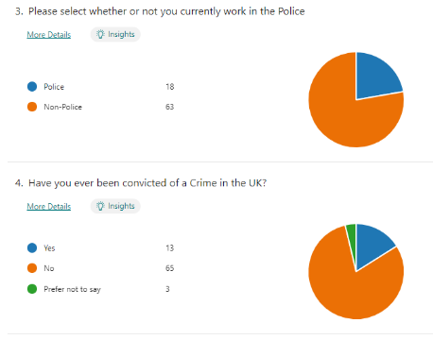















7.3 Dissertation Proposal



UNDERGRADUATE DISSERTATION
RESEARCH PROPOSAL FORM

Please complete the following research proposal and submit it to Turnitin.
Please get rid of the red writing for your final submission.

NAME: Ben Doyle | STUDENT ID No.: 1920592

DRAFT RESEARCH TITLE QUESTION:
Crime – Is it Nature or Nurture? Why do people commit crime?

INTRODUCTION:

Over recent years that has been a sharp increase in crime in the UK. This has been fuelled by a number of different causes, such as economic hardship, increased unemployment, reduction in the number of Police Officers and increased demand of the Court and Judicial System.

The increase in Crime has had an adverse affect of the UK economy. In April 2021, The Times newspaper reported that Crime in the UK is costing close to £100billion pounds per year.

There are many theories regarding what causes a person to commit a crime and the reasons for it. There is a clear divide between those who view criminals as being bad people, who have a pre-disposition to want to commit crime, to those who believe that criminals are a projection of the nurturing and the background that they have been brought up in.

Crime figures began to increase just as funding for the police hit a low of 16.35 billion pounds in 2013/14, with funding not increasing by any significant amount until 2017/18. One of the main consequences of these spending cuts was a reduction in the number of police officers after 2010.

According to TCSEW estimates, adults aged 18 years and over experienced 12.8 million offences in the year ending December 2021. This was an 18% increase in estimated levels of crime compared with the year ending December 2019.

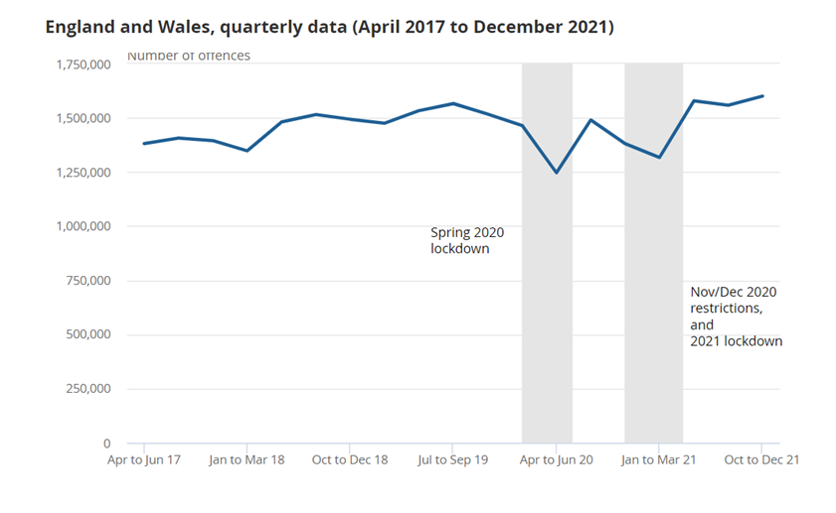

Crime figures now appear to be on the rise. This topic is relevant as crime reaches every person in the UK, whether directly or indirectly.
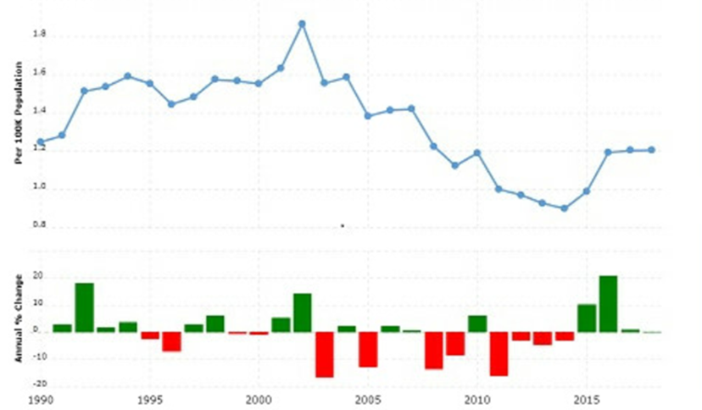

The UK spends millions of pounds each year funding a range of community projects and rehabilitation projects and facilities in an attempt to divert offenders away from committing further crime.

Rehabilitation to prevent re-offending is becoming increasingly important as Clark (2014) found that in 2019/20, the average cost of a prison place in England and Wales was £44,600 pounds a year, compared with £43,200 pounds in 2018/19, an increase of £1,400.

This is a huge part of the Governments annual budget and it is important to ensure that the money is being spent correctly on the correct rehabilitation courses.

It is vital that the route causes of crime are understood so that education and diversionary projects can be created in order to prevent the cycle of re-offending.

SUMMARY OF RESEARCH OBJECTIVES:

- Identify recent crime figures for the UK and ascertain whether there is a trend, whether this is an increase or decrease.
- Understand why crime figures are trending in this way. What impact factors are present to cause the fluctuation.
- Identify what impact factors are present around offender’s family and history, which could impact their likelihood to offend.
- Identify what impact factors relate to the Nurturing environment around offender’s which could impact their likelihood to offend.
- Understand whether Nature or Nurture has the biggest impact to a person’s likelihood to offend.
- Look at what rehabilitation courses and projects are being funded by the Government and assessing if these are an effective way to prevent re-offending, i.e is this value for money for the general public.

LITERATURE REVIEW:
Stevens (2002) outlines that every 5 seconds a crime is committed within the United Kingdom. The research in this study will seek to compare and identify the causes of crime and produce recommendations to prevent and reduce crime and re-offending. The figures of crimes committed, and the number of ACE’s (Adverse Childhood Experiences) experienced by individuals is alarming and therefore a review is essential.
The number of crimes in the UK are recorded using the Home Office Counting Rules (HOCR). This is the national standard of recording a counting of ‘notifiable’ offences by Police forces in England and Wales (Gov.uk).

The UK spends millions of pounds each year funding a range of community projects and rehabilitation projects and facilities to prevent offenders from committing further crime.

Rehabilitation to prevent re-offending is becoming increasingly important as Clark (2014) found that in 2019/20, the average cost of a prison place in England and Wales was £44,600a year, compared with £43,200 pounds in 2018/19, an increase of £1,400.
It is important to ensure that the money is being spent on the correct rehabilitation courses.

SUMMARY OF RESEARCH –SURVEY METHOD:

A variety of research methods will be used to provide a balanced and unbiased view across the study.
Johnson and Onwuegbuzie 2014 state that a mix of qualitative and quantitative research as the traditional method for conducting research. I intend to use this mix as I believe that this will give me the fairest and most independent results.
Quantitative research deals with numbers and statistics, while qualitative research deals with words and meanings. Quantitative methods allow you to systematically measure variables and test hypotheses. Qualitative methods allow you to explore concepts and experiences in more detail.
Quantitative data will provide me with crime figures and also the number of persons who have taken part in the research that has been conducted around my objective. The qualitative data will assist me in understanding the results and placing this in perspective in relation to my dissertation objective of understanding whether nature or nurture is the biggest influence on the likelihood of a person offending.

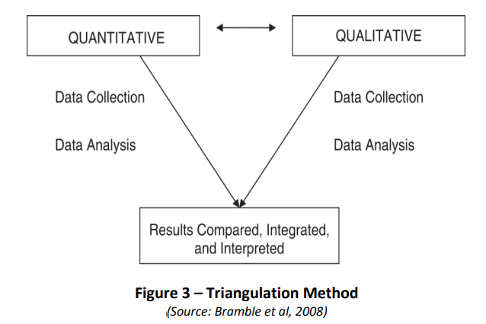

Once the data has been obtained, the quantitative and qualitative data will be analysed to identify any patterns or trends. This will allow the researcher to interpret the results and create findings, from which recommendations can be put forward.

SUMMARY OF SAMPLING FRAMEWORK:

I will be reviewing existing literature on the topic of crime and it’s causes. This will cover both Biological and psychological influences of crime.

I will be utilising Microsoft Forms in order to disseminate a questionnaire to the public for them to complete.

ETHICAL ISSUES:

The main ethical considerations are Anonymity, Confidentiality and Potential of Harm. The topic of this dissertation covers crime and Adverse Childhood Experience’s, with a possibility of triggering repressed memories and traumatic experiences. Participant’s anonymity and confidentiality is a main consideration, therefore there are no ethical concerns. No data will be collected that could help to identify their identity.

This project has been limited to 10,000 words, therefore it is reasonable to deduce that the study would be constrained. Therefore, it is important that the research conducted is significant and the findings are relevant to the study objectives.

TIME SCALE:

During this academic year, I have many demands on my time both inside and outside of work. I am working full time as well and balancing family commitments. It is vital that I utilise my time effectively to achieve the aims of this piece of work.

I have therefore created the below table to illustrate how I will allocate my time to this dissertation.

No | Project Name | 2022-2023
No | Project Name | May | Jun | Jul | Aug | Sept | Oct | Nov | Dec | Jan
1. | Proposal
 | - Define Research Aims, Objectives & Methodology
2. | Literature Review
 | - Carry out research
 | - Compile research and review results
3. | Findings & Analysis
 | - Collate and Analyse feedback
 | - Consider alternative research methods for any gaps in results
 | - Conclusion
4. | Submission Preparation
 | - Consultations with Supervisor
 | - Proof-read and editing
 | - Submission

REFERENCE LIST:

Blackstone’s Student Handbook 2020. Backstones, Oxford, Oxford Press.

Bramble et al (2008) "Examining barriers to health information technology adoption"

Kaiser, B., & Rasminsky, J. (2010, October 25). Biological Risk Factors for Challenging Behavior. Retrieved November 3, 2013, from Education.com: http://www.education.com/reference/article/biolgical-risk-factors-challenging/

Mixed Methods of Research, Published by R. Burke Johnson, Anthony J. Onwuegbuzie 2014. University of South Alabama, College of Education. Volume: 33 issue 7 Pages: 14-26

Office for National Statistics, www.ons.gov.uk, Crime in England and Wales - Office for National Statistics. Crime and Justice bulletins. London, UK

Statista - Cost per prisoner England and Wales 2020. (Clark 2014)

Warr, M. (2002). Companions in Crime. Cambridge, United Kingdom: Cambridge University Press

Word Count 1097.

7.4 Appendix Four: Ethics Form

APPLICATION FOR ETHICAL APPROVAL

SECTION A: About You (Principal Researcher)
Full Name: |  | Benjamin Doyle
Tick all boxes which apply: |  | Member of staff: | ☐ | Honorary research fellow: | ☐
Undergraduate Student | ☒ | Taught Postgraduate Student | ☐ | Postgraduate Research Student | ☐

Institute/Academic Discipline/Centre: | IMH
Campus: | Swansea
E-mail address: | 1920592@student-uwtsd.ac.uk
Contact Telephone Number: | 07870918010
For students:
Student Number: | 1920592
Programme of Study: | BSc (Hons) Professional Policing Practice
Director of Studies/Supervisor: | Michelle HILL

SECTION B: Approval for Research Activity
Has the research activity received approval in principle?  (please check the Guidance Notes as to the appropriate approval process for different levels of research by different categories of individual) |  | YES | ☒ | NO | ☐
 |  |  |  | Date
If Yes, please indicate source of approval (and date where known): Approval in principle must be obtained from the relevant source prior to seeking ethical approval | Research Degrees Committee |  | ☐
 | Institute Research Committee |  | ☐
 | Other (write in) |  | ☐

SECTION C: Internal and External Ethical Guidance Materials
Please list the core ethical guidance documents that have been referred to during the completion of this form (including any discipline-specific codes of research ethics, and also any specific ethical guidance relating to the proposed methodology). Please tick to confirm that your research proposal adheres to these codes and guidelines.
UWTSD Research Ethics & Integrity Code of Practice | ☒
UWTSD Research Data Management Policy | ☒
 | ☐

SECTION D: External Collaborative Research Activity
Does the research activity involve collaborators outside of the University? |  | YES | ☐ | NO | ☒
If Yes, please provide the name of the external organisation and name and contact details for the main contact person and confirmation this person has consented to their personal data being shared.as part of this collaboration.
Institution
Contact person name
Contact person e-mail address

Has this individual consented to sharing their details on this form? |  | YES | ☐ | NO |  |  | ☒
Are you in receipt of a KESS scholarship? |  | YES | ☐ | NO |  |  | ☒
Is your research externally funded |  | YES | ☐ | NO |  |  | ☒
Are you specifically employed to undertake this research in either a paid or voluntary capacity? | Voluntary | YES | ☐ | NO |  | ☒
 | Employed | YES | ☐ | NO |  | ☒
Is the research being undertaken within an existing UWTSD Athrofa Professional Learning Partnership (APLP) | If YES then the permission question below does not need to be answered. | YES | ☐ | NO |  |  | ☒
Permission to undertake the research has been provided by the partner organisation | (If YES attach copy)  If NO the application cannot continue | YES | ☐ | NO |  |  | ☒

Where research activity is carried out in collaboration with an external organisation
Does this organisation have its own ethics approval system? | YES | ☐ | NO | ☒
If Yes, please attach a copy of any final approval (or interim approval) from the organisation

SECTION E: Details of Research Activity
Indicative title: | Crime – Is it Nature or Nurture?
Proposed start date: | 23/03/2022 | Proposed end date: | 02/01/23
Introduction to the Research (maximum 300 words)
Ensure that you write for a Non-Specialist Audience when outlining your response to the three points below:
- Purpose of Research Activity
- Proposed Research Question
- Aims of Research Activity
- Objectives of Research Activity
Demonstrate, briefly, how Existing Research has informed the proposed activity and explain
- What the research activity will add to the body of knowledge
- How it addresses an area of importance.
Purpose of Research Activity

The purpose of my research activity if the create a balanced argument of whether Nature or Nurture is the biggest influence on whether a person commits a crime or not. It will also allow me to understand what is the biggest determining factor to the likelihood of a person offending and re-offending.

(this box should expand as you type)
Research Question

Crime – Is it Nature or Nurture?

(this box should expand as you type)
Aims of Research Activity

- Investigate the contributory factors of Crime.

- Analyse data collected to identify contributory factors relating to a person’s biology and environment and how these affect the likelihood of offending.

- Analyse data collected on the public perception and experiences of why crimes are committed.

- Analyse data and research collected regarding the impact of ACE’s on a person’s likelihood of offending.

- Analyse the data collected and identify the most suitable research method to successfully gather and analyse information to best understand people perceptions of crime.

- Provide recommendations to reduce the number of ACES experienced and therefore reduce the likelihood of a person offending and re-offending.

(this box should expand as you type)
Objectives of Research Activity

The Objectives are to ascertain which factor in persons life or personality is a determining factor is their future and their future behaviours. It is also to see what types of diversionary tactics are being utilised in the UK and the evaluate whether these are value for money for the UK Public.

(this box should expand as you type)
Proposed methods (maximum 600 words)
Provide a brief summary of all the methods that may be used in the research activity, making it clear what specific techniques may be used. If methods other than those listed in this section are deemed appropriate later, additional ethical approval for those methods will be needed.
A variety of research methods will be used to provide a balanced and unbiased view across the study.

The Oxford Dictionary defines Research as “The systematic investigation into and study of materials and sources in order to establish facts and reach new conclusions”.

Johnson and Onwuegbuzie 2014 state that a mix of qualitative and quantitative research as the traditional method for conducting research. I intend to use this mix as I believe that this will give me the fairest and most independent results.

Quantitative research deals with numbers and statistics, while qualitative research deals with words and meanings. Quantitative methods allow you to systematically measure variables and test hypotheses. Qualitative methods allow you to explore concepts and experiences in more detail.

Quantitative data will provide me with crime figures and also the number of persons who have taken part in the research that has been conducted around my objective. The qualitative data will assist me in understanding the results and placing this in perspective in relation to my dissertation objective of understanding whether nature or nurture is the biggest influence on the likelihood of a person offending.

(this box should expand as you type)

Location of research activity
Identify all locations where research activity will take place.
Research will be conducted by utilising a Microsoft Forms survey online.

(this box should expand as you type)
Research activity outside of the UK
If research activity will take place overseas, you are responsible for ensuring that local ethical considerations are complied with and that the relevant permissions are sought. Specify any local guidelines (e.g. from local professional associations/learned societies/universities) that exist and whether these involve any ethical stipulations beyond those usual in the UK (provide details of any licenses or permissions required). Also specify whether there are any specific ethical issues raised by the local context in which the research activity is taking place, for example, particular cultural and/or legal sensitivities or vulnerabilities of participants.
N/A

(this box should expand as you type)
Use of documentation not in the public domain: Are any documents NOT publicly available? | NO | ☒
 | YES | ☐
If Yes, please provide details here of how you will gain access to specific documentation that is not in the public domain and that this is in accordance with prevailing data protection law of the country in question and England and Wales.

(this box should expand as you type)

SECTION F: Scope of Research Activity
Will the research activity include: | YES | NO
Use of a questionnaire or similar research instrument? | ☒ | ☐
Use of interviews? | ☐ | ☒
Use of diaries? | ☐ | ☒
Participant observation with their knowledge? | ☐ | ☒
Participant observation without their knowledge? | ☐ | ☒
Use of video or audio recording? | ☐ | ☒
Access to personal or confidential information without the participants’ specific consent? | ☐ | ☒
Administration of any questions, test stimuli, presentation that may be experienced as physically, mentally or emotionally harmful / offensive? | ☐ | ☒
Performance of any acts which may cause embarrassment or affect self-esteem? | ☐ | ☒
Investigation of participants involved in illegal activities? | ☐ | ☒
Use of procedures that involve deception? | ☐ | ☒
Administration of any substance, agent or placebo? | ☐ | ☒
Working with live vertebrate animals? | ☐ | ☒
Other primary data collection methods, please explain in this box  For example, ‘focus groups’. Please indicate the type of data collection method(s) in this box and tick the accompany box. | ☐ | ☒
Details of any other primary data collection method:  (this box should expand as you type) | ☐ | ☒

SECTION G: Intended Participants
Who are the intended participants: | YES | NO
Students or staff at the University? | ☒ | ☐
Adults (over the age of 18 and competent to give consent)? | ☒ | ☐
Vulnerable adults? | ☐ | ☒
Children and Young People under the age of 18? (Consent from Parent, Carer or Guardian will be required) | ☐ | ☒
Prisoners? | ☐ | ☒
Young offenders? | ☐ | ☒
Those who could be considered to have a particularly dependent relationship with the investigator or a gatekeeper? | ☐ | ☒
People engaged in illegal activities? | ☐ | ☒
Others (please identify specifically any group who may be unable to give consent) please indicate here and tick the appropriate box. | ☐ | ☒
Other – please indicate here:  (this box should expand as you type) | ☐ | ☒

Participant numbers and source
Provide an estimate of the expected number of participants. How will you identify participants and how will they be recruited?
How many participants are expected? | Between 50-80  (this box should expand as you type)
Who will the participants be? | The general public and Police employees.  (this box should expand as you type)
How will you identify the participants? | All participants will be anonymous. However, there will be questions relating to their gender, age and employment.  (this box should expand as you type)

Information for participants: | YES | NO | N/A
Will you describe the main research procedures to participants in advance, so that they are informed about what to expect? | ☒ | ☐ | ☐
Will you tell participants that their participation is voluntary? | ☒ | ☐ | ☐
Will you obtain written consent for participation? | ☐ | ☐ | ☒
Will you explain to participants that refusal to participate in the research will not affect their treatment or education (if relevant)? | ☒ | ☐ | ☐
If the research is observational, will you ask participants for their consent to being observed? | ☐ | ☐ | ☒
Will you tell participants that they may withdraw from the research at any time and for any reason? | ☒ | ☐ | ☐
With questionnaires, will you give participants the option of omitting questions they do not want to answer? | ☒ | ☐ | ☐
Will you tell participants that their data will be treated with full confidentiality and that, if published, it will not be identifiable as theirs? | ☒ | ☐ | ☐
Will you debrief participants at the end of their participation, in a way appropriate to the type of research undertaken? | ☒ | ☐ | ☐
If NO to any of above questions, please give an explanation
(this box should expand as you type)

Information for participants: | YES | NO | N/A
Will participants be paid? | ☐ | ☐ | ☒
Is specialist electrical or other equipment to be used with participants? | ☐ | ☐ | ☒
Are there any financial or other interests to the investigator or University arising from this study? | ☐ | ☐ | ☒
Will the research activity involve deliberately misleading participants in any way, or the partial or full concealment of the specific study aims? | ☐ | ☐ | ☒
If YES to any question, please provide full details
(this box should expand as you type)

SECTION H: Anticipated Risks

Outline any anticipated risks that may adversely affect any of the participants, the researchers and/or the University, and the steps that will be taken to address them.

If you have completed a full risk assessment (for example as required by a laboratory, or external research collaborator) you may append that to this form.
Full risk assessment completed and appended? |  | Yes | ☐
 |  | No | ☒
Risks to participants
For example: emotional distress, financial disclosure, physical harm, transfer of personal data, sensitive organisational information
Risk to Participant:  None  (this box should expand as you type) | How will you mitigate the Risk to Participant  (this box should expand as you type)
If research activity may include sensitive, embarrassing or upsetting topics (e.g. sexual activity, drug use) or issues likely to disclose information requiring further action (e.g. criminal activity), give details of the procedures to deal with these issues, including any support/advice (e.g. helpline numbers) to be offered to participants. Note that where applicable, consent procedures should make it clear that if something potentially or actually illegal is discovered in the course of a project, it may need to be disclosed to the proper authorities
N/A

(this box should expand as you type)
Risks to investigator
For example: personal safety, physical harm, emotional distress, risk of accusation of harm/impropriety, conflict of interest
Risk to Investigator:  None  (this box should expand as you type) | How will you mitigate the Risk to Investigator:  (this box should expand as you type)
University/institutional risks
For example: adverse publicity, financial loss, data protection
Risk to University:  None  (this box should expand as you type) | How will you mitigate the Risk to University:  (this box should expand as you type)

Disclosure and Barring Service
If the research activity involves children or vulnerable adults, a Disclosure and Barring Service (DBS) certificate must be obtained before any contact with such participants. | YES | NO | N/A
Does your research require you to hold a current DBS Certificate? | ☐ | ☐ | ☒

SECTION I: Feedback, Consent and Confidentiality
Feedback
What de-briefing and feedback will be provided to participants, how will this be done and when?
Participants will be briefed that there will be no feed back given to them in relation to this survey.

(this box should expand as you type)
Informed consent
Describe the arrangements to inform potential participants, before providing consent, of what is involved in participating. Describe the arrangements for participants to provide full consent before data collection begins. If gaining consent in this way is inappropriate, explain how consent will be obtained and recorded in accordance with prevailing data protection legislation.
A summary will be produced at the beginning of the survey to explain to participants what the survey is about and the reasons for the survey being conducted.

(this box should expand as you type)
Confidentiality / Anonymity
Set out how anonymity of participants and confidentiality will be ensured in any outputs. If anonymity is not being offered, explain why this is the case.
I will outline within the summary at the beginning of my survey that all participation is completely anonymous.

(this box should expand as you type)

SECTION J: Data Protection and Storage
In completing this section refer to the University’s Research Data Management Policy and the extensive resources on the University’s Research Data Management web pages (http://uwtsd.ac.uk/library/research-data-management/).
Does the research activity involve personal data (as defined by the General Data Protection Regulation 2016 “GDPR” and the Data Protection Act 2018 “DPA”)? | YES | NO
“Personal data” means any information relating to an identified or identifiable natural person (‘data subject’). An identifiable natural person is one who can be identified, directly or indirectly, in particular by reference to an identifier such as a name, an identification number, location data, an online identifier or to one or more factors specific to the physical, physiological, genetic, mental, economic, cultural or social identity of that natural person. | ☐ | X☐
If YES, provide a description of the data and explain why this data needs to be collected:
(this box should expand as you type)
Does it involve special category data (as defined by the GDPR)? | YES | NO
“Special category data” means sensitive personal data consisting of information as to the data subjects’ –  (a) racial or ethnic origin,  (b) political opinions,  (c ) religious beliefs or other beliefs of a similar nature,  (d) membership of a trade union (within the meaning of the Trade Union and Labour Relations (Consolidation) Act 1992),  (e) physical or mental health or condition,  (f) sexual life,  (g) genetics,  (h) biometric data (as used for ID purposes), | ☐ | X☐
If YES, provide a description of the special category data and explain why this data needs to be collected:
(this box should expand as you type)
Will the research activity involve storing personal data and/or special category data on one of the following: | YES | NO
Manual files (i.e. in paper form)? | ☐ | ☒
University computers? | ☐ | ☒
Private company computers? | ☐ | ☒
Home or other personal computers? | ☐ | ☒
Laptop computers/ CDs/ Portable disk-drives/ memory sticks? | ☒ | ☐
“Cloud” storage or websites? | ☐ | ☒
Other – specify: | ☐ | ☒
For all stored data, explain the measures in place to ensure the security of the data collected, data confidentiality, including details of password protection, encryption, anonymisation and pseudonymisation:
(this box should expand as you type)
All Data Storage
Will the research activity involve any of the following activities: | YES | NO
Electronic transfer of data in any form? | ☐ | ☒
Sharing of data with others at the University? | ☐ | ☒
Sharing of data with other organisations? | ☐ | ☒
Export of data outside the European Union or importing of data from outside the UK? | ☐ | ☒
Use of personal addresses, postcodes, faxes, emails or telephone numbers? | ☐ | ☒
Publication of data that might allow identification of individuals? | ☐ | ☒
Use of data management system? | ☐ | ☒
Data archiving? | ☐ | ☒
If YES to any question, please provide full details, explaining how this will be conducted in accordance with the GDPR and DPA (and/or any international equivalent):
(this box should expand as you type)
List all who will have access to the data generated by the research activity:
(this box should expand as you type)
List who will have control of, and act as custodian(s) for, data generated by the research activity:
(this box should expand as you type)
Give details of data storage arrangements, including security measures in place to protect the data, where data will be stored, how long for, and in what form. Will data be archived – if so how and if not why not.
(this box should expand as you type)
Please indicate if your data will be stored in the UWTSD Research Data Repository (see https://researchdata.uwtsd.ac.uk/ ). If so please explain. (Most relevant to academic staff)
(this box should expand as you type)
Confirm that you have read the UWTSD guidance on data management (see https://www.uwtsd.ac.uk/library/research-data-management/) | YES | ☒
 | NO | ☐
Confirm that you are aware that you need to keep all data until after your research has completed or the end of your funding | YES | ☒
 | NO | ☐

SECTION K: Declaration
The information which I have provided is correct and complete to the best of my knowledge. I have attempted to identify any risks and issues related to the research activity and acknowledge my obligations and the rights of the participants.

In submitting this application I hereby confirm that I undertake to ensure that the above named research activity will meet the University’s Research Ethics and Integrity Code of Practice which is published on the website: https://www.uwtsd.ac.uk/research/research-ethics/
Signature of applicant: | B. Doyle | Date: 15/05/2022

For STUDENT Submissions:
Director of Studies/Supervisor: |  | Date:
Signature: |  | Date:

For STAFF Submissions:
Academic Director/ Assistant Dean: |  | Date:
Signature: |  | Date:

Checklist: Please complete the checklist below to ensure that you have completed the form according to the guidelines and attached any required documentation:
☒ | I have read the guidance notes supplied before completing the form.
☒ | I have completed ALL RELEVANT sections of the form in full.
☒ | I confirm that the research activity has received approval in principle
☐ | I have attached a copy of final/interim approval from external organisation (where appropriate)
☐ | I have attached a full risk assessment (and have NOT completed Section H of this form) (where appropriate) ONLY TICK IF YOU HAVE ATTACHED A FULL RISK ASSESSMENT
☒ | I understand that it is my responsibility to ensure that the above named research activity will meet the University’s Research Ethics and Integrity Code of Practice.
☒ | I understand that before commencing data collection all documents aimed at respondents (including information sheets, consent forms, questionnaires, interview schedules etc.) must be confirmed by the DoS/Supervisor, module tutor or Academic Director.
☒ | I have deleted the guidance notes before submitting the PG2 for consideration

