LCCB4005
The Global Business Environment
(Environmental Analysis of Automobile Industry)

Student name: Raul Trif
Student number: 2030167

Table of Contents
Introduction 3
Overview of Rolls-Royce 4
Analysis of the challenges of Rolls-Royce’s internal and external business environments. 4
External environmental analysis of Rolls-Royce 4
Internal environmental analysis of Rolls-Royce 8
Evaluation 11
Conclusion 12
References 13

Introduction
The global business environment refers to the influence of macroeconomic and microeconomic factors over the business performance and competitive sustainability of the international organisation (Ahmed and Alam, 2021). The report will consider Rolls-Royce as a suitable example of the Automobile industry to reflect and evaluate the influences of the external and internal environment for business organisations. For this purpose, the report will incorporate the pestle model for analysing external influences whereas porter's five forces and value chain model in explaining internal influences to appraise the competitive sustainability of the company.

Overview of Rolls-Royce
Rolls-Royce is a globally well-recognised brand for luxury cars. The British company has started its journey in 1998 and provided wonderful cars to rich and aristocratic people of the society (Christodoulou and Cullinane, 2019). The remarkable contribution of the company is bringing quality and luxury car models such as phantom, Cullinan, ghost, etc. Through the company has been headquartered in Goodwood, United Kingdom, the organisation has spread out its fame and business around the globe.

Analysis of the challenges of Rolls-Royce’s internal and external business environments.
The business environment refers to the surrounding elements of the organisation. The elements are categorised into two classes depending on their impact and controllability (Guenole and Feinzig, 2019). They are called external environment and internal environment. The elements of the external environment have great influence over the activities of business through they are remained out of control. On the other hand, the elements of the external environment indicate characteristics of influences over the business though they remain within the control of the business. For the Automobile industry, the business environment has an influential role in deciding the growth and opportunity as well as the challenges of the business. The following section will present the external and internal environmental analysis using appropriate business models:

External environmental analysis of Rolls-Royce
The external environment is formed with outside factors which impact the operational process of the business. For analysing the impact of the external environment, the pestle model is the most useful in this approach. The pestle framework consists of major macroeconomic elements of the environment such as political, economic, technological, socio-cultural, environmental, and legal forces which have a direct contribution to the operations and management of the company. The subsequent section of the report will analyse the external environment of Rolls-Royce using the Pestle framework:
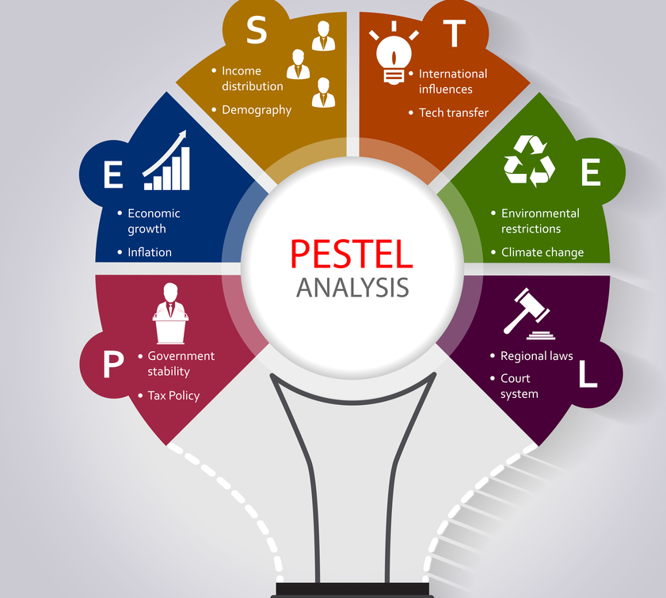
Figure 1: Pestle framework Analysis (Hamilton and Webster, 2018)
Political forces: The political forces of the business environment have consisted of political stability, trade restrictions, tariffs, labour law, and tax policy imposed by the government. The United Kingdom has a long tradition of maintaining a stable political environment (Kumar and Rajeev, 2016). The country has one of the most influential and powerful administrative systems powered by the constitutional monarchy and democratic parliament. The political parties of the country have maintained good relations with business organisations and support their activities. Through recently the exit of the United Kingdom from the European Union has impacted the political arena of the country and led to debate among different political parties. Further, as a permanent member of the United Nations, the country holds and maintains good political relations with other nations of the world fostering the growth of the business community.
Economic forces: Economic forces of the country include GDP, monetary policy and fiscal policy, interest rate, inflation rate, and others (Lillah and Struwig, 2016). By keeping those forces under favourable conditions, the business has to maintain profitability and sustainability. Here, the United Kingdom has the 6th most powerful and large economy in the world. According to recent information, the GDP of the country has touched the heights of 1.96 trillion GBR. The country provides a great opportunity for growth for business organisations and holds large markets of diverse communities. Moreover, the tax and inflation rate of the country has always been stable and diminished which has been a great motivation for business communities. Along with this, the country has great reserves of foreign currency as well as foreign direct investments.
Technological forces: The automobile industry is one of the most competitive industries and focuses on attracting customers through developing the most useful and innovative technologies. The automobile industry of the country has made huge investments in the Research and development of projects which have supported companies such as Rolls-Royce to bring revolution in automobile design and development (Mathooko and Ogutu, 2015). For example, the industry has shown a great opportunity for electric car manufacturing companies which has increased the drive of Rolls-Royce to enter into the race of electric cars.
Socio-cultural forces: the United Kingdom has the collection of one of the wealthiest persons in the world and the country features a class system in their social order. Rolls-Royce is a brand of luxury and demonstration of superior social status. For this reason, having a Rolls-Royce indicates that people feel higher and respectable status in society as well as social order (Matovic, 2020). The luxury brand attracts customers who belong to the high-income group people and distinguished its position in the marketplace.
Environmental forces: Environment has a crucial impact on the life of the people in a community which influence the economic activities of business organisation. For this reason, most business organisations around the globe take great consideration of the environment while performing their business activities. In most of their approach, the effort to reduce the negative impacts of waste and design their manufacturing process by which they can improve the natural environment of their community. Rolls-Royce has adopted green technology for manufacturing their countries. Further, the company has incorporated many initiatives in creating environmental awareness and protection campaigns that help in restoring the environment.
Legal forces: The United Kingdom has a tough legal system and procedures which govern the business of the country. The act which has promoted the legal environment of the country includes employment act 1996, Companies act 2006, Equality act 2010, Trade Union and Labour relations act 1992, etc (Motohashi, 2015). Through legislative rules and regulations, the governing body of the country controls the activities of the business in safeguarding employees' rights and managing business-related problems.

Internal environmental analysis of Rolls-Royce
Porter’s five forces:
The threat of new entrants
The industry in which Rolls-Royce is operating is required a large amount of capital. Besides, creative product design and little product differentiation don't allow new entrepreneurs (Ricciotti, 2020). The large extent fixed and operating cost deters the new entrance into this industry. Further, investing a large quantity in research and development flourishes the existing firm's efficiency level. Thus there are not enough rooms for any new business to enter into and grow properly.
Competition among existing players
In that industry, the prevailing competitors are not very. Besides, almost all of them are large in terms of capital and economies of scale. So they can't leave the industry without any prior notice. Besides, the market is led by a few companies and occupied the market share. So, Rolls-Royce could be engaged aggressively to gain a market position. Further, the market size and that industry are growing gradually at the national and international level. This creates an opportunity for the firm to grab new market opportunities.
Bargaining power of customers
It indicates that the buyers of this industry are a role-playing factor influencing greatly on the firms' functionality. The first and foremost thing is the availability of the car company in the market with different merits and facilities. Besides the brand switching cost is very low that also weakens Rolls-Royce. Further, competitors' aggressive price-cutting strategy and intense competition level strengthen customers’ bargaining power (Ahmed and Alam, 2021).
Bargaining power of suppliers
This indicates that the suppliers in this industry are slightly in the dominant position. As the raw materials are the most contributing factors to the profit margin so the suppliers impact the profitability of the firms by modifying their pricing strategies and qualities. Besides, the higher switching cost of suppliers, previous trade relationship, trustworthiness, and greater forward integration impede often buyers’ interest and enable them to hold powers.
The threat of substitute products
There are very substitute products in the industry in which Rolls-Royce is operating now. The indirect competitors produce the substitute products and are demotivated now due to the lower profit margin (Christodoulou and Cullinane, 2019). So there is no maximum limit to gaining profit in that industry. So, the new one is not being interested. Because of higher economies scale and associated cost, maintaining compulsory the standard quality the small players could not gather courage.
Competitive Factors | Low | Medium | High
The threat of new entrants

Competition among existing players

Bargaining power of customers

Bargaining power of suppliers

The threat of substitute products

From the above table, it is keenly observed that the profitability and competition level of this industry are moderately attractive.

Porter’s Value chain analysis:
Primary activities
Inbound Logistics: This is very important as it maintains the connectivity of the firm with the suppliers and supports their activities. Rolls-Royce’s activities fall under this are receiving raw materials and products parts, storing those in the warehouse, retrieving materials, and internal distributing to the product station, etc (Guenole and Feinzig, 2019).
Operation: This stage accomplishes the final products from raw materials. It is crucial for maximizing efficiency, improving productivity, and maintaining economic growth. The activities are assembling, machining and packaging, testing, etc.
Outbound Logistics: This is essential for ensuring the proper distribution of the products to the dealers. The activities that fall under this are handling, warehousing, order processing, and scheduling, transporting and delivering, etc (Lillah and Struwig, 2016). These are also improved organisational productivity and acceptance overall performing with minimal cost and without product defect.
Marketing and sales: This is one of the influential stages which directly impact the firm's profitability. While marketing, Rolls-Royce mainly highlights the product features and differentiation to make conscious the potential customers. To do so, the performing functions are advertising and promotional activities, selecting channels and pricing strategy, quoting and building relations with relevant parties, etc.
Services: To build up higher customer loyalty and brand value, after-sales service is also very important as pre-sale service because they affect the customers' satisfaction and enhances brand retention rate (Hamilton and Webster, 2018). Rolls-Royce weights these as marketing and promotional activities due to their respective contribution.
Secondary activities: These activities support the primary value chain of the company through coordinating and facilitating.
Firm Infrastructure: by doing these tasks effectively, the firm can optimize its value. Activities done in this manner are strategic management, managing legal matters, quality management, financing, and planning.
Human Resource Management: This encompasses: advertising for vacancies, recruiting and selecting, training and development, performance appraising and rewarding, personal management-related activities (Mathooko and Ogutu, 2015).
Technology Development: Tasks done in this manner are launching new technology in the production and operation process, performing HRM functions, distribution, and marketing, etc.
Procurement: To optimize the inbound, operation, and outbound value chain, Rolls-Royce should consider those carefully. The functions are placing high-quality raw materials and replacement parts, producing perfect products, supplying them to the retailers, etc.
The above value chain analysis demonstrates the process of how the key competitive and differential factors of Rolls-Royce added a firm's value in terms of operations.

Evaluation
From the pestle analysis, the economic, technology, and social environment has shown a great business opportunity for the company. The branding position of the company has increased its sustainability and competitive position of the company (Matovic, 2020). On the other hand, the organisation must carefully understand and take strategic action to utilise the political’s advantage, focus on environmental sustainability and maintain legal regulations imposed by the government.
Based on the prior discussion, it can be stated finally that the overall firm’s profitability and attractiveness are moderately high found on five competitive forces analysis. The key force that weakens the firm’s competition scope is customers’ bargaining power due to the business concentration (Motohashi, 2015). Besides, the substitute products are produced and supplied in the market by the firms with lower profit margin also erodes the given company by misleading customers setting a lower pricing strategy.
Knowledge gained from Rolls-Royce’s value chain analysis helps to state that its operating process and marketing activities are strongly adding value to the customers. It also induces prospective customers to be permanent clients. In addition, the segmented customers are pleased with their brand and after-sale valuable service.

Conclusion
Through understanding the business environment, the organisation can improve its stands which will upraise its chances of survival and profitability (Kumar and Rajeev, 2016). Rolls-Royce is a symbol of superiority and social status which has positioned the company higher than most of its competitors. For the evaluation of the external environment, the majority of the elements have shown extreme support for the sustainability of the company. Here, the organisation must demonstrate compliance with the government's regulation which will improve its reputation in general. From the perspective of the internal environment, the company must strengthen its value chain to increase customers' satisfaction and win over their hearts to support the continuous growth of the company.

References
Ahmed, F. and Alam, M.A., 2021. Business Environment: Indian and Global Perspective. PHI Learning Pvt. Ltd.
Christodoulou, A. and Cullinane, K., 2019. Identifying the main opportunities and challenges from the implementation of a port energy management system: A SWOT/PESTLE analysis. Sustainability, 11(21), p.6046.
Guenole, N. and Feinzig, S., 2019. Strategic workforce planning in dynamic business environments. People & Strategy, 2019(Fall), pp.9-12.
Hamilton, L. and Webster, P., 2018. The international business environment. Oxford University Press.
Kumar, D. and Rajeev, P.V., 2016. Value chain: a conceptual framework. International journal of engineering and management sciences, 7(1), pp.74-77.
Lillah, R. and Struwig, M., 2016. Factors influencing business implementation of environmental management systems. Journal of Economics, Business and Management, 4(4), pp.272-279.
Mathooko, F.M. and Ogutu, M., 2015. Porter’s five competitive forces framework and other factors that influence the choice of response strategies adopted by public universities in Kenya. International Journal of Educational Management.
Matovic, I.M., 2020. PESTEL Analysis of External Environment as a Success Factor of Startup Business. ConScienS, p.96.
Motohashi, K., 2015. Global business strategy: Multinational corporations venturing into emerging markets (p. 259). Springer Nature.
Ricciotti, F., 2020. From value chain to value network: a systematic literature review. Management Review Quarterly, 70(2), pp.191-212.

