Liam Salter
Student Number: 1702256
Course: Web Development
3rd Year Major Project Proposal
Strategies for maximising PC performance.

Table of Contents
1. Introduction. 2
1.1. Title. 2
1.2. Background. 2
1.2.1. What is a computer? 2
1.2.2. Computer Hardware Examples. 2
1.2.3. What is PC performance and Benchmarking? 5
1.2.4. Critical Literature Review. 6
1.2.5. Study Justification. 6
2. Aims and Objectives. 6
2.1. Aims. 6
2.2. Objectives. 6
3. Research and Development Methods. 7
3.1. Research Methods. 7
3.1.1. Research Philosophy and Approach. 7
3.1.2. Research Strategy. 8
3.1.3. Generalisability, Reliability and Validity. 8
3.2. Data Collection Methods. 8
3.3. Risks. 8
3.4. Data Analysis. 9
4. Resources and Planning. 9
4.1. Required Resources. 9
4.2. Gantt Chart. 10
5. Conclusion. 10
6. Appendices. 11
6.1. Appendix 1. 11
6.2. Appendix 2. 11
References 12

Introduction.

Title.
After receiving the available 3rd year major project options, the next step was to carefully read through all available options to see which options are most relevant to the area of study and take into consideration what interests the author the most. As the author is within the area of Web Development, naturally web related were considered, however there is strong interest in computer hardware. After thoughtful consideration, the final title that was chosen was “Strategies for maximising PC performance”. This was decided as the web related topics can be incorporated into the project, for example displaying data through a web-based application. Therefore, the two areas which interest the author the most can both be incorporated into the project.

Background.

What is a computer?
A computer is a machine which is operated by a set of instructions which is located within its own memory. The computer can accept input data, process this data according to specified rules, produce information as output data and finally, can store this information for further use in the future. A computer has many functionalities, according to a paper released by the university of Jordan, the primary functionalities being that a computer can take data as input, a computer stores data in its memory and will use this data when necessary, a computer can process this data and turn it into information that is readable to an end user, a computer can generate output and finally a computer can control all previous functionalities [1]. Under this definition, a computer can take multiple forms, for example not just computer towers and laptops, this encompasses smartphones, tablets etc.

Computer Hardware Examples.
A computer is the sum of its parts, and computers have many components which make it up the final machine. The primary components which make up a computer is a motherboard, CPU (Central Processing Unit) and required CPU cooler to keep the CPU from overheating, GPU (Graphics Processing Unit), RAM (Random Access Memory), PSU (Power Supply), Storage Drive, either an SSD (Solid State Drive) or HDD (Hard Disk Drive) and finally for simplicity, a case. Computers can be fitted with optional hardware such as Optical Drives and Card Readers, however these components have become next to obsolete as time and computer technology has progressed [2].
Firstly, the motherboard. The motherboard is one of the most crucial components of a computer as all other computer components route back to the motherboard. The motherboard also house most of the other components of a computer, such as the CPU, GPU, RAM etc. The base of the motherboard is made up of strong, stiff and firm piece of non-conductive piece of plastic. Extremely thin layers of copper and aluminium foil are printed onto the board, these are referred to as traces, these make the circuits which connects the rest of the components of the motherboard together. The primary components of the motherboard are the CPU socket, this is where the CPU is housed. Power Connectors, this is where power is distributed to all the other components on the motherboard. RAM slots, this where RAM is housed. 2 chips, the northbridge chip is main interface between the CPU and primary memory components, and the southbridge chip controls the input/output (I/0) functions. Several connectors which allow the interface between input/output devices and the motherboard, these can take the form of USB connectors or rarely PS/2 connecters etc. Connectors for long term storage, commonly SATA (Serial Advanced Technology Attachment) ports. A ROM (Read Only Memory) chip which contains the firmware for the system, also known as the BIOS (Basic Input/Output System). Expansion slots for used for expansion cards such as graphics cards, sound cards, network cards etc, these are commonly PCIe (Peripheral Component Interconnect Express) slots and PCI (Peripheral Component Interconnect) slots [3].
Next is the CPU. The CPU, like the motherboard, is one of the most important components of a computer. According to paper written by the Portland State University, The CPU is commonly known as the brain of the computer, the CPU handles all the primary computations of the computer. Some computation can be offloaded to other parts of the PC, such ad the GPU, however, the CPU remains as the central area of computation. The CPU is made of 2 primary parts, the ALU (Arithmetic Logic Unit), which performs all arithmetic and logical operations. The CU (Control Unit), which coordinates and controls various computer parts. All CPU’s are made up of billions of individual switches, known as transistors which can only be in one of two states, on or off [4]. Newer high end processors from Intel and AMD include other components such as Cache, which is high speed volatile memory which helps the processor reduce memory operations, and also include integrated graphics, which are micro, less powerful graphics chips integrated onto the dye of the processor, which allows video output of standard resolutions such as 1080p and 4k without a dedicated graphics processing unit [5]. Along with the CPU, the CPU cooler is essential as CPU overheating can cause thermal throttling, which will be detailed later in this proposal, and can also cause detrimental damage to the chip and motherboard such as warping and even component failure, essentially breaking the system [6].
Next is GPU. The GPU, mostly unlike other components of a computer, isn’t essential for a computer to work, however more and more computers have dedicated graphics cards installed as more and more jobs and programs require GPU acceleration. Such as gaming, creative design used in programs by Adobe [7], 3D modelling and animation used in programs by Autodesk [8], AI (Artificial Intelligence) [9] etc. The primary role of the GPU is to assist with the heavy lifting of 3D scene, object and visual effects rendering so the CPU doesn’t have to. As written by the New Jersey Institute of Technology, the GPU contains essentially the same components as a CPU, a CU, ALU, DRAM etc, however, the structure and number of components on the chip is vastly different to a CPU. The GPU contains a significantly larger amount of ALU’s as the GPU is tailored to highly parallel operations [see Appendix 1 for diagram]. As the GPU deals with a significantly large amount of data at a time, they are equipped with much faster and more advanced memory interfaces compared to CPU’s. This is also the reason why the GPU takes up the PCIe slot on the motherboard, as the slot can handle the most data throughput [10].
Next is the RAM. As detailed by the Maharishi Markandeshwar Private University (deemed to be), RAM is part of the primary memory type group. This memory is located on the motherboard which is directly connected to the CPU. RAM is also volatile memory, this means that any data that is stored in RAM is only maintained while the computer is powered on, if the computer is shut off by any means, all the data is lost. RAM is very important to a computer as a computer needs somewhere to store information [11]. While programs and Operating Systems are installed onto non-volatile memory, the programs and systems themselves are loaded into memory. However, when a system does not have enough RAM, and a program is writing more data into than the amount of currently available RAM, that data is then written to other available areas of memory, typically into non-volatile memory such as hard disks. This is referred to as buffer overflow [12]. Consequently, the higher the amount of RAM available to the system, the more data the computer can handle at a given time. There are 2 primary components to a RAM module, the board, which like most computer hardware boards, is a circuit board which has silicon-based semiconductor circuitry between the memory components and allow the RAM module to interface with the rest of the system, namely the motherboard. Secondly, the other part(s) being the memory components or memory banks, these are the physical components where the data is stored [13].
Next is the Power Supply Unit. Simply, the power supply unit provides power to a computer. The power supply is rather important to a computer as no components will work without power. The power supply will pull the necessary amount of power from the power source, usually a wall socket, then will convert AC to DC current. The power supply also has another important task, it regulates the voltage passing through it, eliminating any irregularities, spikes and surges, which can cause harm to the system [14].
Finally, of the important required computer components, there are the storage drives. Storage drives are part of the secondary memory type group. This type of memory is not located on the motherboard and can be situated anywhere within the case; however, the drive must be connected to one of the available SATA port on the motherboard. Storage drives are not volatile memory, this means that when data is written to the drive, even after the system is shut down by any means, the data is retained on the drive. This is incredibly important to save important data such as university work, job information, applications, operating systems etc [15]. There are two different types of storage drive, HDD’s and SSD’s. Hard Disk Drives work by storing data on series of rotating magnetic disks, also known as platters. An arm, known as the actuator arm with a head on the end, which is capable of read/write capabilities over the correct and appropriate areas when need be to read or write data to the platter. SSD’s are different as SSD’s do not include any moving parts whatsoever, instead data is saved to area of NAND flash, it is similar technology to the memory used in RAM, however, NAND is designed to retain a charged state even without power, this makes the memory non-volatile [16].

What is PC performance and Benchmarking?
PC performance is dictated by many factors which come from many components of the computer. One computer component that can heavily affect performance is the CPU. Performance can be dictated by CPU clock speeds, which is how many CPU cycles the can execute per second [4], temperature, which is when if the temperature reaches a certain value, the CPU will downclock its speeds in an attempt to keep itself cool [5], the amount of cores and the technology process the CPU was created with, Intel is currently still working with a 14nm process, whereas rival company AMD is currently developing its 7nm process [17]. Another example of a computer component that can affect overall performance is the GPU. As the GPU is designed with rendering graphics fast, considering the resolution of the graphic, the amount of detail and how much is happening visually. As GPU cores tend to have slower clock speeds, but is made up via large core counts, this is one aspect which can affect performance. A GPU with a higher number of cores, better technology process and higher clock speeds can dramatically affect how fast scenes are rendered and how many scenes per second a GPU can output (commonly known as framerate or FPS).
Benchmarking is the process of testing certain hardware, software or an entire system. These results can then be taken and compared to other benchmarks to see how well or worse the results compare to other benchmarks [18]. Benchmarks are undertaken for many reasons, such as comparing the same product to see how they stack up on the silicon lottery, which is when imperfections on the fabrication process of some computer components affects the quality and performance of the component [19]. Benchmarking is also done to compare different components within the same family, such Intel Core CPU’s or Nvidia GeForce GPU’s. Programs such as Cinebench offer CPU and GPU benchmarks within the same program [20].

Critical Literature Review.
Due to he nature of the subject area, locating journals and books that are relevant to the subject and are also up to date can be very difficult, as computer technology and hardware is always evolving, an example of this would be Moore’s Law, where transistor counts double every 18 to 24 months, which is detailed by the New Jersey Institute of Technology [21]. This area is not well explored in Academia. Also, many articles and testing results are web based and/or located on online forums, which are not viable sources. However, corporations such as Intel and Nvidia have official documentation located on their official web sites. Also, general information can be located through journals and reports conducted by academic organizations such as universities and technological institutions. However, when specific information is needed, some web sources are used from websites that focus on computer and technological subjects.

Study Justification.
Based on the research that has been conducted on the subject area, literature review and amount of exploration that has not been conducted for this subject area in Academia, this project aims to bring a new approach of research to the subject area by bringing up to date, relevant, important and formal new information to the subject area. In the hopes that the new information will help provide reliable information to future studies and inspire new further research into the subject area.

Aims and Objectives.

Aims.
After the background research that was conducted, three primary aims have been devised. The first aim being to bring new, up to date, relevant and formal information to the subject area. The second aim is to integrate web-based aspects into the project. The third and final aim is to design a computer with the most optimal hardware specifications within a certain price range.

Objectives.
With the aims of project decided, the objectives must be completed to ensure the aims are met. For the first aim, one objective that will be followed to ensure relevant information is to ensure that no superfluous or irrelevant information pertaining to the subject area is used, this can be done by evaluating all information gathered and only using the relevant information going forth. Another objective ensuring up to date information is by testing and comparing benchmarks of the authors current hardware with newer hardware benchmarks sourced from verified or trustworthy sources, comparing them against each other to validate the tests.
For the second aim, one objective to integrate web-based aspects into the project would be to create and/or use open source code to create web application with the capabilities of testing and monitoring hardware. However, this objective could be costly on time. Another objective to integrate web-based technology into the project would be to create a web page to display the results of the projects tests. This would not be as taxing on time as the previous objective.
For the final aim, one objective to ensure that the computer designed is in the most optimal state will be to compare benchmark tested on the system to other system of the same specification or very near the same specification. Another objective to ensure maximum performance is to check if modifications, such as frequency tuning and cooling have not altered throughout testing, this would create non-reliable results and may jeopardise the project.

Research and Development Methods.

Research Methods.

Research Philosophy and Approach.
Before in depth research can commence, an appropriate research philosophy must be decided upon.
“A research philosophy is a belief about the way in which data about a phenomenon should be gathered, analysed and used” [22].
In Appendix 2, a breakdown of the “Research Onion” can be seen. This diagram shows how different strategies, approaches, techniques and philosophies are linked together. It shows that depending on the type of research, there are certain accompanying philosophies and strategies.
After some research, there are two types of philosophies which would best suit the project. These being Positivism and Interpretivism. The Positivism philosophy is a highly structured philosophy which is suited for large data sample sizes. This ensures that the data is credible, and the outcomes are driven by facts.
Next is the Interpretivism philosophy. This philosophy is very investigative and is optimised for small sample sizes, however it encourages in depth analysis of the data. Like Positivism, this ensures that the data is credible through thorough analysis [23]. After careful consideration, the Positivism philosophy will be used for the project as large quantities of data will be tested.
Now, an approach must be chosen. There are two types of approaches, Inductive and Deductive. The inductive approach is the more theoretical of the two. The research is ‘fluid’ and evolves slowly as the research is carried out. The deductive approach utilises are more analytical approach, which heavily links to the positivism philosophy. This approach is highly structured and because of this, can be replicated, which can ensure high data reliability if the tests can be carried out more than once [24]. Due to this approach being heavily complimentary to the chosen philosophy, the deductive approach will be chosen for the project.

Research Strategy.
There are numerous amounts of research strategies available such as Attitudinal Research and Case Studies, however, the strategy that has been chosen is altered form of Case Study developed by SciVal, which is detailed in report provided by said company. The strategy is split into three sections, Strategy, Execution, Results. This form of Case Study is heavily data driven and has a strong emphasis on evidence-based decision making [25]. As this project will have multiple forms of data collection methods, this compliments the case study strategy as well, this means that the data gathered would be highly valid.

Generalisability, Reliability and Validity.
Consistent data results are a results of reliable data collection during a given project, however, consistency and reliability can be impaired by a numerous number of factors. Reliability refers to how consistent results are, reliability of results can be affected by factors like observer bias and observer error. Validity is the measure of if the test or study is measuring what is claimed to by studied and/or tested. Validity can be affected by factors such as history, testing, maturation, instrumentation, statistical regression, selection of subjects, experimental mortality, selection-maturation interaction and the john henry effect [26].

Data Collection Methods.
There are two types of data collection methods. Primary Data Collection Methods and Secondary Data Collection Methods. Primary Data Collection methods involves gathering and collecting data through first-hand experience and creating information out of that data. Secondary Data Collection methods involve searching through literature of the subject area, such as books, articles and web sources which relate to the subject. The primary data collection method that will be used during the project will be a ‘primary data collection’ method [25]. This method being observation and documentation. As the author will be carrying out the tests, the results can be observed first-hand and documented. These results will then be compared with previous results and secondary data collected from reliable sources such as approved benchmark sites and corporations such as Intel and Nvidia.

Risks.
Considering the scope of a project of this magnitude, there are many risks than can befall the project. One of these risks being time constraints, as the scope of the project is quite large, goals would have to be completed on time regularly, as completing work late could cause a spiralling effect which may cause large portions of work to not be completed. Another risks which is associated with time, is Gold plating, this could be large problem as by adding extra requirements to the project mid development could be costly on time, and there is also the risk of the features not working as intended or are seen of a waste of time, which affects other parts of the project. Another possible risk is budget, as this project requires testing of computer hardware, there may be a need to acquire extra hardware for testing, there is a possibility the university may be able to help to an extent with monetary issues, however it isn’t a guarantee. Another possible risk would be lack of necessary skills, the project requires both writing code and physical hardware manipulation which may be out of the authors skill range, however, if the Gantt chart is followed, there is time dedicated to skill acquisition. The final risk could be possible legal trouble with copyright holders of specific hardware, if information is discovered about the hardware that the manufacturer didn’t intend for public visibility, it could bring legal trouble, however fair use policy is law which is enforced by the EU, as detailed by Stanford University [28].

Data Analysis.
The data gathered from testing will be primarily compared user tests conducted by the author and benchmarks which will be gathered from reliable and valid secondary sources, as previously mentioned. Testing will be conducted multiple times to ensure reliable results, these results will then be compared with other results to see to see if they match or are around the same area of similar systems. This would ensure there is valid and correct data. This data will then be documented and graphed. Throughout all stages of testing, the data will be compared to see any trends if variables are changed or consistency if variables are not changed.

Resources and Planning.

Required Resources.
As the project involves the use of software creation and hardware testing, there are several required resources which will be of need to complete the project. One of these resources being access to a personal computer than can be used for testing and potentially modified for further testing. This resource is provided by the author. Another resource that is required would be access to premium software such as the Microsoft Office Suite and Microsoft Visual Studio. This resource has been provided by the university. Another required resource would be access to the internet and the 24-hour area of the university. There are resources that could be useful to the project such as extra hardware, monetary assistance, access to lecturer help over the summer period, however these are not necessary to the project.

Gantt Chart.

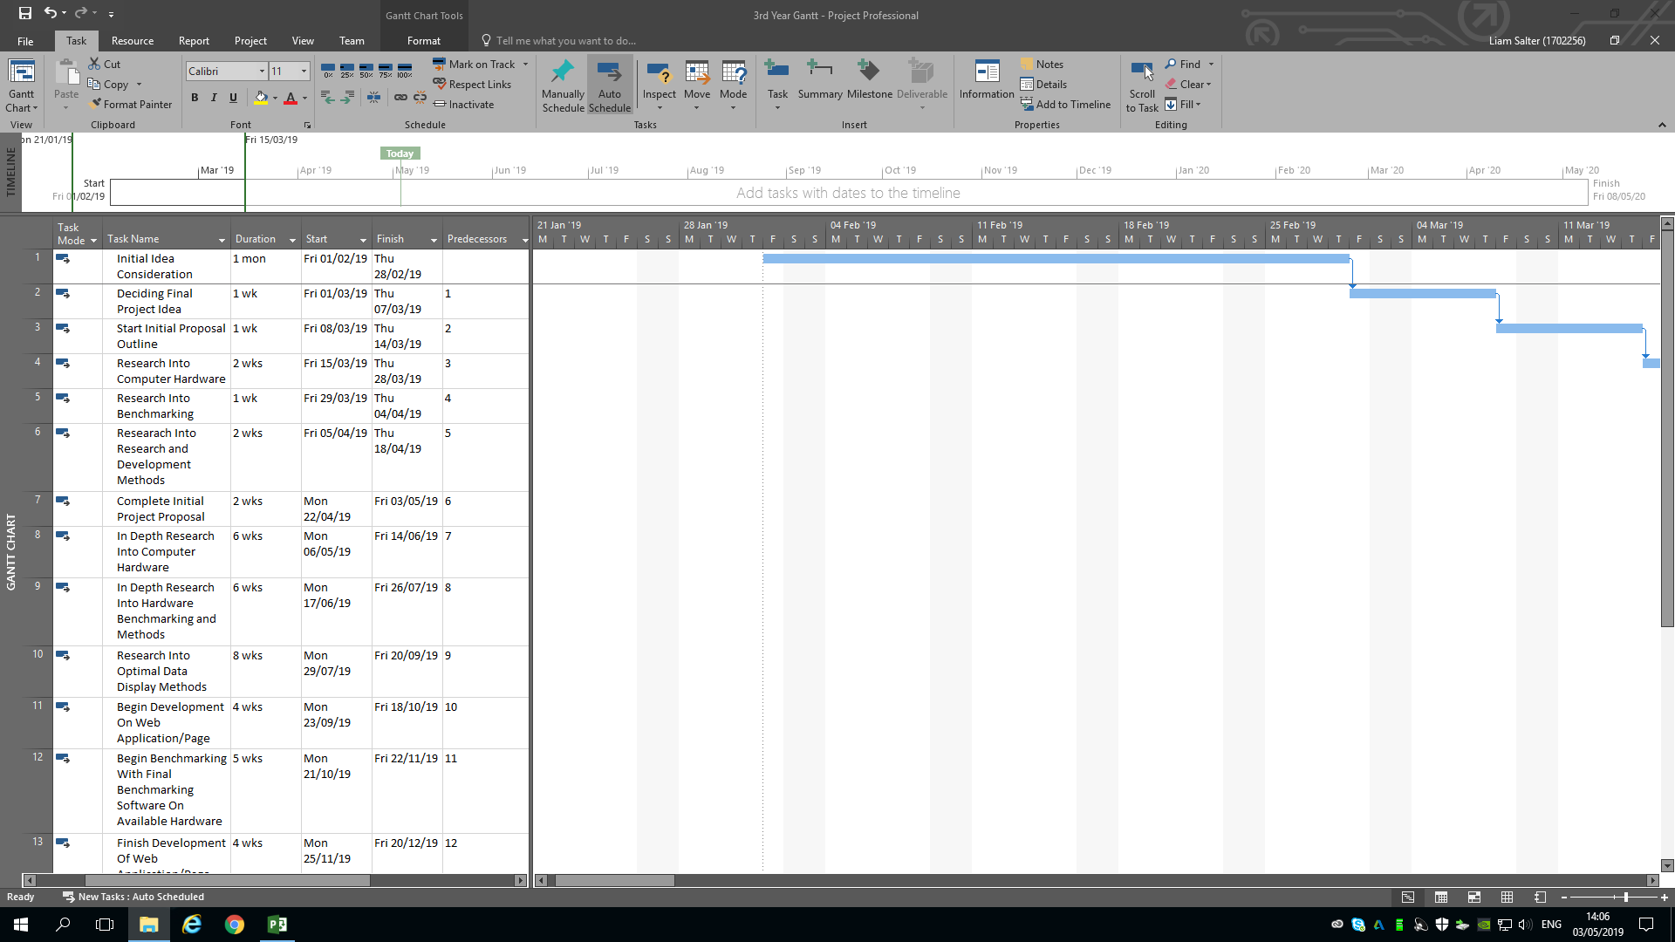
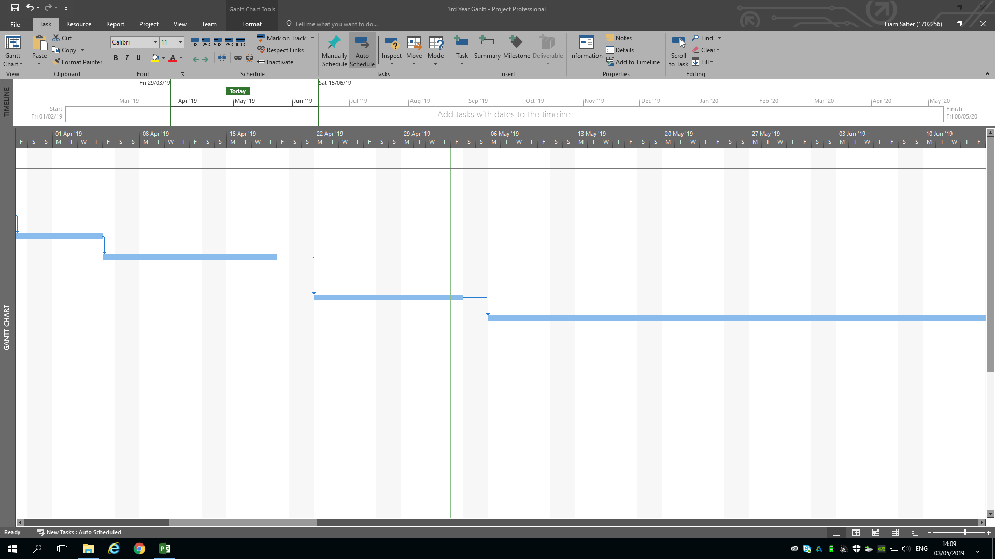
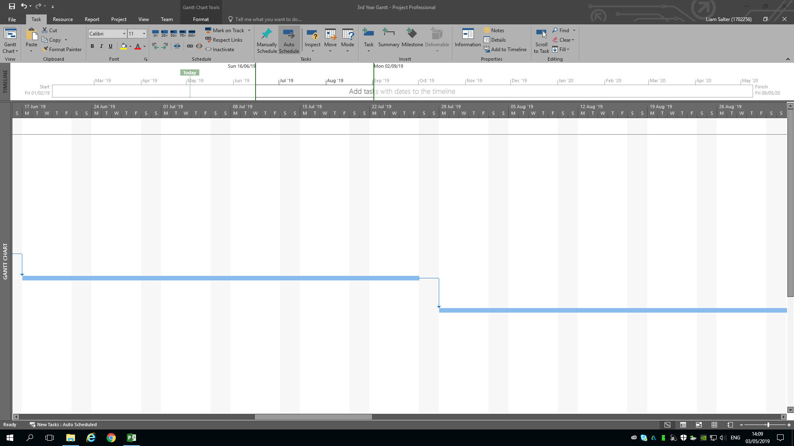
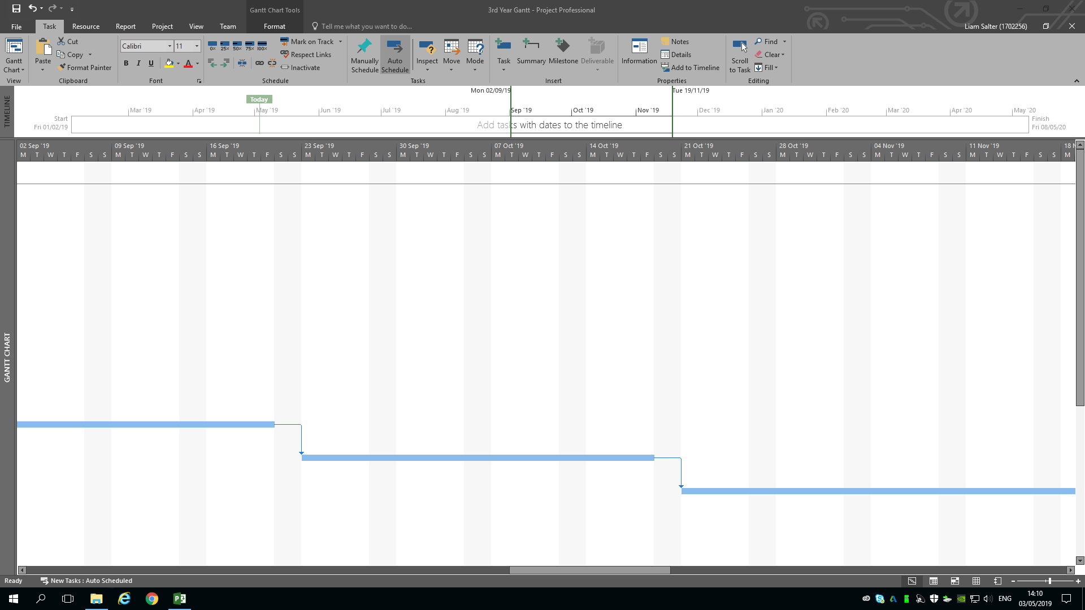
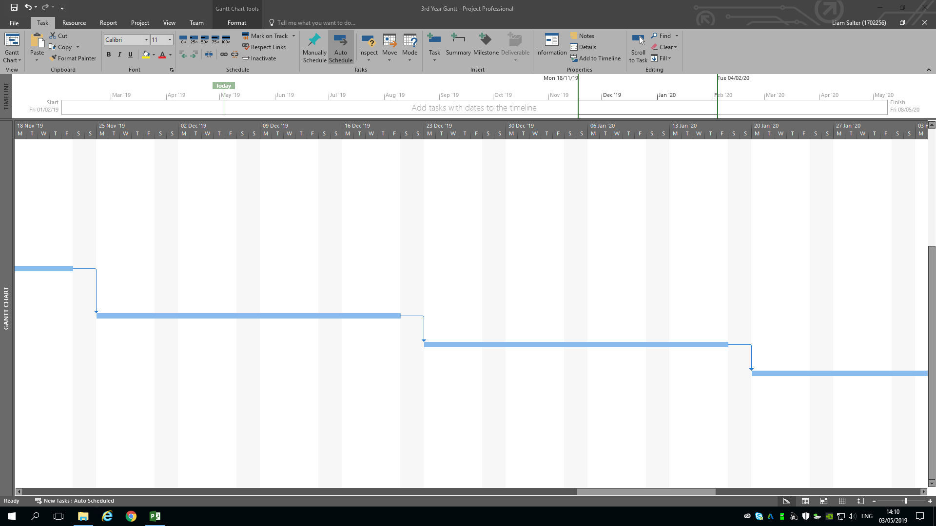
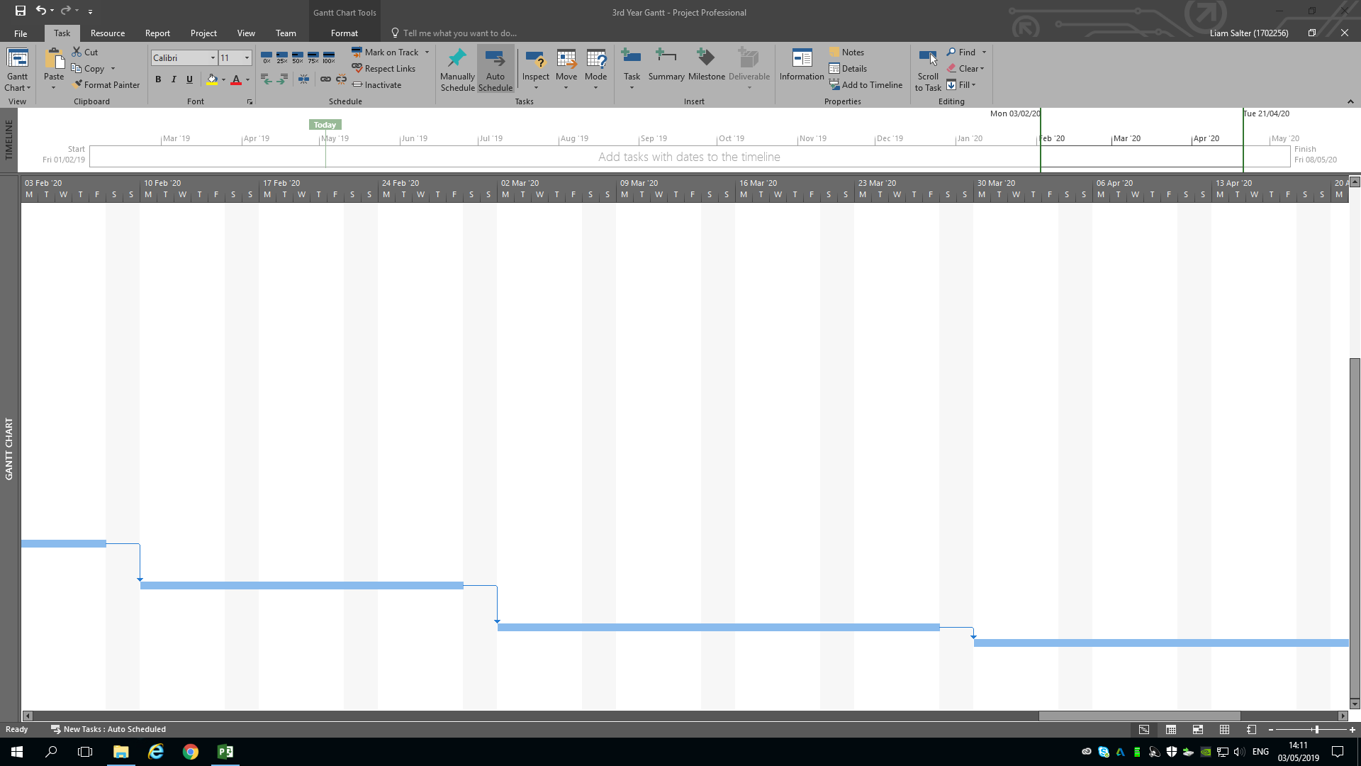
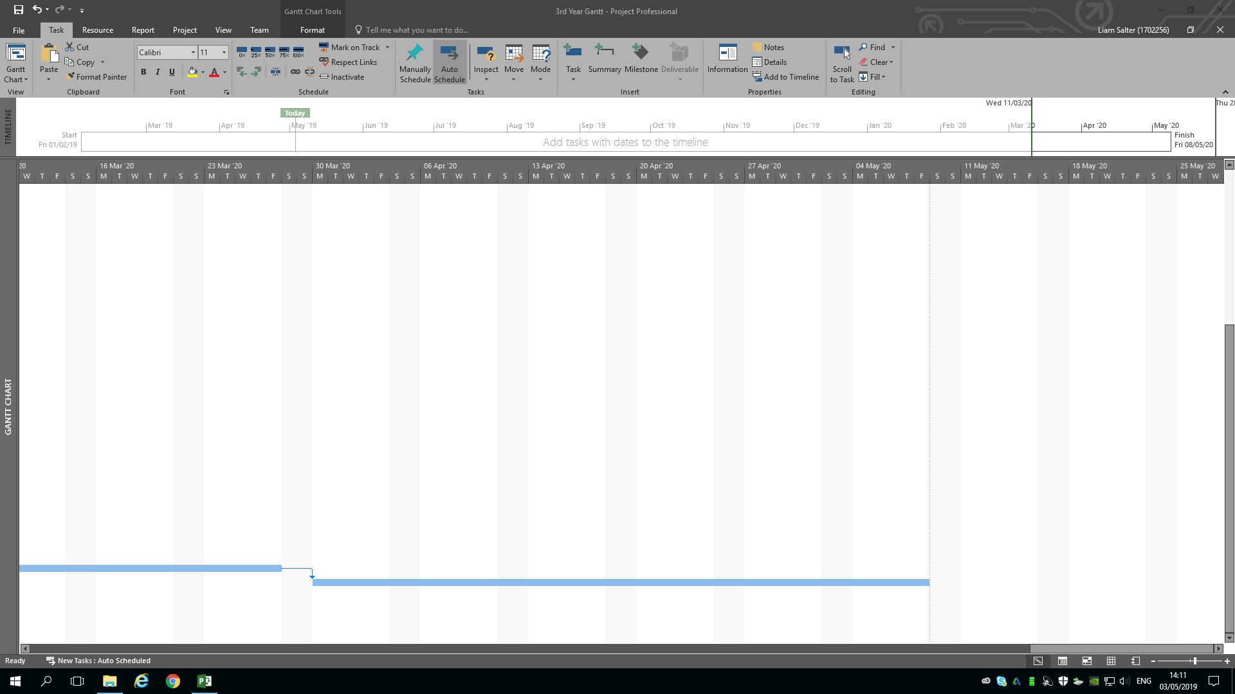
Above is a version of the Gantt Chart that will be followed during the duration of the project.

Conclusion.
In conclusion, the author introduced the working title and explained the reasoning behind said title, a background to the subject area has been described through answering what a computer is, an introduction to computer hardware through brief description of certain types of hardware has been detailed, pc performance and benchmarking have been detailed, a mini critical literature review has taken place to describe the type of literature was used for the background research, the author has justified why the project should take place. The aims and objectives have been detailed. Research methods have been discussed by detailing the research philosophy and approach that will be used, the research strategy that will be used and detailing what may affect the validity and reliability of the results, the data collection methods that will be used and what types of data collection methods they are have been detailed, possible risks that may befall the project have been detailed, how the data gathered from the project will be analysed has been detailed. Required resources that are needed by the project have been detailed and finally a Gantt Chart that the author will follow during the duration of the project has been provided.

Appendices.

Appendix 1.
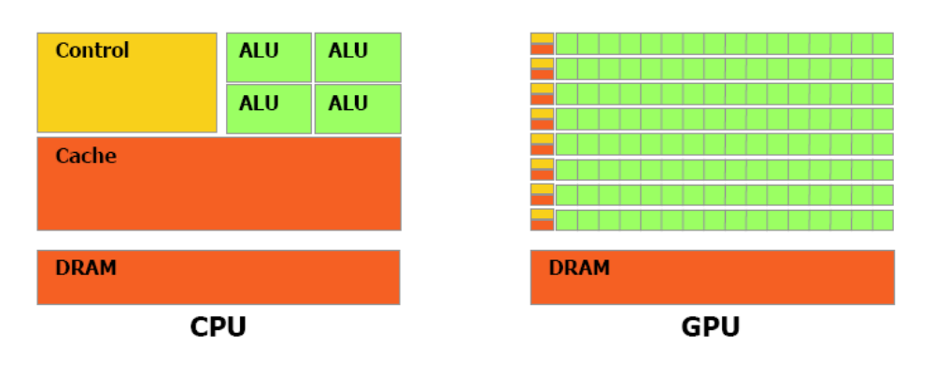

Appendix 2.
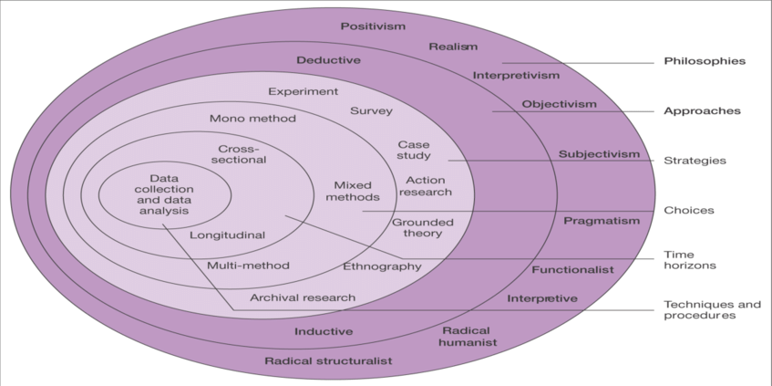

References

[1] | University of Jordan, “Introduction To Computers,” University Of Jordan, Jordan, 2014.
[2] | C. Morgan, “Death of the Optical Disk,” StorageCraft, [Online]. Available: https://blog.storagecraft.com/death-of-the-optical-disk/. [Accessed 30 April 2019].
[3] | Study.com, “What is a Motherboard? - Definition, Function & Diagram,” 2014 January 2014. [Online]. Available: https://study.com/academy/lesson/what-is-a-motherboard-definition-function-diagram.html. [Accessed 30 April 2019].
[4] | D. W. Gerbing, “Computer Components,” School of Business Administration Portland State University, Portland, 2018.
[5] | Intel Corporation, Intel® Core™ i7-9700K Processor, Santa Clara: Intel Corporation, 2018.
[6] | B. Moore, “Will overheating my CPU cause any real damage?,” PCGamer, 28 September 2016. [Online]. Available: https://www.pcgamer.com/uk/cpu-temperature-overheat/. [Accessed 30 April 2019].
[7] | Adobe Inc., “Photoshop graphics processor (GPU) card FAQ,” Adobe Inc., 7 September 2018. [Online]. Available: https://helpx.adobe.com/uk/photoshop/kb/photoshop-cc-gpu-card-faq.html. [Accessed 30 April 2019].
[8] | Autodesk Inc., “Hardware Acceleration,” Autodesk Inc., [Online]. Available: https://knowledge.autodesk.com/support/revit-products/learn-explore/caas/CloudHelp/cloudhelp/2019/ENU/Revit-Customize/files/GUID-0162E4FA-AC42-419F-B11A-7DFC99DFE1CD-htm.html. [Accessed 30 April 2019].
[9] | NVidia Corporation, “WELCOME TO THE ERA OF AI.,” [Online]. Available: https://www.nvidia.com/en-gb/data-center/tesla-v100/. [Accessed 30 April 2019].
[10] | New Jersey Institute of Technology, “Graphics Processing Unit,” New Jersey Institute of Technology, New Jersey, 2018.
[11] | Maharashi Markandeshwar Private University (Deemed To Be), “Computer Memory,” Maharashi Markandeshwar Private University (Deemed To Be), Haryana.
[12] | M. Rouse, “buffer overflow,” TechTarget | Search Security, 21 September 2016. [Online]. Available: https://searchsecurity.techtarget.com/definition/buffer-overflow. [Accessed 30 April 2019].
[13] | Techwalla, “What Are the Parts of RAM?,” Techwalla, [Online]. Available: https://www.techwalla.com/articles/what-are-the-parts-of-ram. [Accessed 30 April 2019].
[14] | Webopedia, “Power Supply,” Webopedia, [Online]. Available: https://www.webopedia.com/TERM/P/power_supply.html. [Accessed 30 April 2019].
[15] | Computer Hope, “Hard Drive,” Computer Hope, 12 September 2018. [Online]. Available: https://www.computerhope.com/jargon/h/harddriv.htm. [Accessed 30 April 2019].
[16] | J. Hruska, “How Do SSD's Work,” ExtremeTech, 6 February 2019. [Online]. Available: https://www.extremetech.com/extreme/210492-extremetech-explains-how-do-ssds-work. [Accessed 30 April 2019].
[17] | Intel Corporation, “Intel® 14 nm Technology,” [Online]. Available: https://www.intel.com/content/www/us/en/silicon-innovations/intel-14nm-technology.html. [Accessed 30 April 2019].
[18] | ComputerHope, “Benchmark,” 13 November 2017. [Online]. Available: https://www.computerhope.com/jargon/b/benchmar.htm. [Accessed 30 April 2019].
[19] | SiliconLottery.com, “Silicon Lottery,” SiliconLottery.com, [Online]. Available: https://siliconlottery.com/. [Accessed 30 April 2019].
[20] | Cinebench, “Cinebench,” Cinebench, [Online]. Available: https://www.maxon.net/en/products/cinebench-r20-overview/. [Accessed 30 April 2019].
[21] | New Jersey Institute of Technology, “Moore's Law,” New Jersey Institute of Technology, New Jersey.
[22] | Education University of Hong Kong, “Chapter Three: Research Methodology,” Education University of Hong Kong, Hong Kong.
[23] | Research Methodology, “Research Philosophy,” Research Methodology, [Online]. Available: https://research-methodology.net/research-philosophy/. [Accessed 2 May 2019].
[24] | L. K. Soiferman, “Compare and Contrast Inductive and Deductive,” University of Manitoba, Manitoba, 2010.
[25] | SciVal, “Data Driven Research Strategy | Insights from US research development professionals,” Elsevier, 2011.
[26] | J. C. S. Donald T. Campbell, Experimental and Quasi-experimental Designs for Research, HOUGHTON MIFFLIN COMPANY BOSTON , 1963.
[27] | Research Methodology, “Data Collection Methods,” Research Methodology, [Online]. Available: https://research-methodology.net/research-methods/data-collection/. [Accessed 2 May 2019].
[28] | R. Stim, “What Is Fair Use?,” Stanford University, Stanford, 2017.

