


Mandatory Cyber Security Awareness Training For All Organisation Staff to enhance security surface

by
Aida Luca Lamer
1706552

Research Proposal as part of the requirements for the award of MSc (Hons) Computer Networks

March 2022
Abstract/Synopsis
A research proposal on the impact of mandatory cybersecurity training for all organisation staff to enhance the overall security surface. The impact of the global pandemic and other contributing factors reshaped the way several organisations operate and moved to homeworking or to hybrid model. Although large changes have been made cyber security awareness and education for staff remains often overseen. The proposed research if successful would encourage employers to make cybersecurity training a mandatory module.
Table of Contents
Table of Figures 5
Chapter 1-Introduction 6
1.1 The purpose of the study 6
1.2 Importance of research 6
1.3 Rationale of study 7
1.4 Research problems 7
1.5 Independent and dependent variables 8
1.6 Hypothesis and theory 8
1.7 Boundaries 9
1.8 Key concepts 10
Chapter 2-Literature Review 11
2.1 Introduction 11
2.2 Research 1-Cyber security awareness training 11
2.3 Research 2- Contributing security risks and threats in organisations 13
2.4 Conclusion 15
Chapter 3-Methodology 16
3.1 Introduction 16
3.2 Research overview 16
3.2.1 Research process 17
3.2.2 Philosophies 17
3.2.3 Approach 18
3.2.4 Strategies 18
3.2.5 Choice 18
3.2.6 Time horizons 19
3.2.7 Techniques and Procedures 19
3.3 Conclusion 19
Chapter 4-Results 22
4.1 Introduction 22
4.2 Collection of primary data 22
4.3 Demonstration of results 23
4.5 Conclusion 27
Chapter 5-Evaluation 28
5.1 Introduction 28
5.2 Summary 28
5.3 Limitations and weaknesses 28
5.4 Conclusion 29
Chapter 6-References 30
Appendices 32
Appendices 1-Gantt chart 32
Appendices 2-Ethics Form 35

Table of Figures
Figure 1-Research DV and IV 8
Figure 2-Research onion diagram [19] 16
Figure 3-Research Process 17
Figure 4-Research method process 20
Figure 5-Mock design of testbed 21
Figure 6-Primary data collection process 22
Figure 7-Total percentage of results pre-test 23
Figure 8-Total percentage of results post-test 23
Figure 9-Pre-test and post-test results based on job type 24
Figure 10-Pre-test results based on gender 25
Figure 11- Post-test results based on gender 25
Figure 12-Pre-test based results based on age 26
Figure 13-Post-test results based on age 26
Figure 14-Pre-test and post-test line with markers chart 27
Figure 15-Gantt Chart 32
Figure 16-Closer view of Gantt Chart 33
Figure 17-Closer view of Gantt Chart timeline 34

Chapter 1-Introduction

1.1 The purpose of the study
In modern days, organisations are facing greater risks of cyber threats and incidents occurring. Due to this, organisations take all measures to strengthen their endpoint security thus including end user computing (EUC), users, servers, networks, web applications and the list continues. Recently human errors became an increasingly high factor that resulted in security breaches and these human errors result in confidential data and cyber data breaches. [1] With this outlined, one of the factors that is responsible for cyber incidents is often forgotten about; staff training and awareness. Cyber security awareness training is currently not a mandatory course in most UK based organisations. Cyber security is also not embedded into everyone’s culture and the majority of UK school children are exposed to cyber security through national extra-curricular competitions, rather than through mandatory teaching methods. [2] Due to this, staff are often responsible for cyber security breaches and incidents due to lack of knowledge, training and irresponsible use of equipment. Employees that are unaware are more vulnerable to social engineering cyber-attacks. [1] The purpose of the research is to establish if mandatory cyber security training strengthens the overall security surface of an organisation.

1.2 Importance of research
In 2020 with the start of the COVID-19 pandemic organisations adapted to a new approach of working; home office working. Although in 2022 the public health guidelines and safety measures eased, another new approach became popular to use by organisations. The hybrid approach is used by organisations that allows staff to carry out their work in an even ratio both working from home and in the office. [3] Many organisations decided to keep the home office approach for staff where office attendance is not required of them. Home working came unforeseen and organisations were unprepared for the increase of cyber-threats that followed with it. [4] Staff working from home connecting to the organisation’s private network using the organisation's equipment comes with many cyber security risks and emphasises the need for mandatory cyber security training for all staff. In 2022 due to the ongoing unfortunate threat tensions in Eastern Europe, organisations are required to be on guard in an event of cyber threats. Historically, tensions from Russia often affect surrounding geographical locations with cyber incidents occurring. The National Cyber Security Centre (NCSC) advises organisations to act following Russia’s attack on Ukraine and take action to improve their resilience with heightened cyber threat. [5] This also emphasises the requirement for cyber security training for all staff. With the ongoing security risks and threats outlined, the purpose of the research is to establish if mandatory cyber security training strengthens the overall security surface of an organisation.

1.3 Rationale of study
The study is worth doing as it shows the effects cyber security awareness training courses have on organisation’s security. Organisations mainly rely on technical solutions, however as a matter of fact, a significant number of information security incidents are due to exploitation of human elements that result in the most security incidents. [6] It is difficult to establish the effect of cyber security training that organisations arrange for staff due to various factors. As cyber security awareness training is not mandatory in most organisations, majority of staff do not view the area with importance and priority. By providing employees with security awareness as part of the company protection process rather than all focus being on implementing technology to reduce cyber risks, human awareness of security will significantly reduce the risks and encourage changes in staff cyber awareness. [1] Such study on how mandatory cyber security training would affect the overall security surface of an organisation has not been carried out by fellow researchers. The successful research would benefit organisations and potentially influence their cyber security policy by making cyber security awareness a mandatory training course for all staff.

1.4 Research problems
The research is to address the critical problem organisations face with cyber threats in modern days. A significant number of security incidents that organisations report are due to exploitation of human elements. [6] Most incidents recorded are in result of reckless users, lack of training for staff and lack of technical knowledge staff acquire. In result of staff not receiving cyber security awareness training, it makes it easier for bad actors to target these users and trick them to fall for malicious activity. Malicious incidents include receiving phishing email, downloading or installing unauthorised content onto company network devices, installing malware onto devices connected to the organisation’s network. Research found that 77% of company’s data breaches are due to exploitation of human weakness. [7]

1.5 Independent and dependent variables
The independent variable (IV) is the variable that is changed and the dependent variable (DV) is the variable affected by the change implied. The research IV change is cyber security awareness content provided to participants and the DV is measured using the knowledge of the participants affected by the change implied.

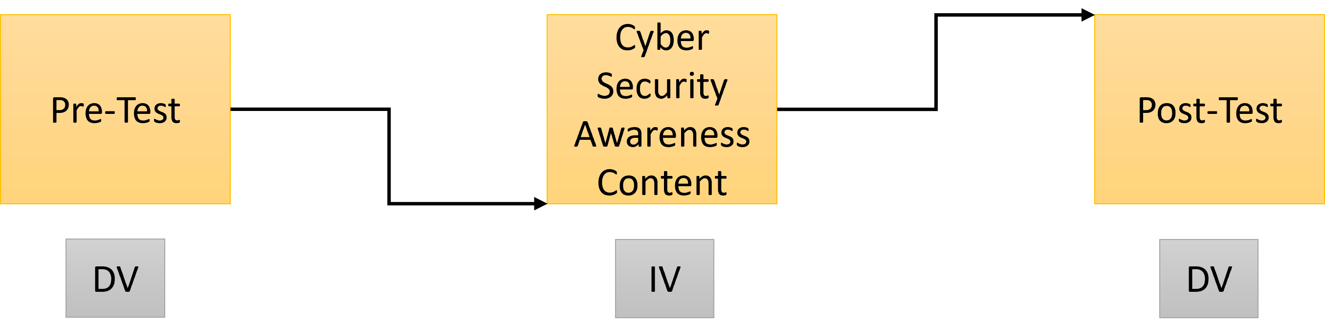
Figure 1-Research DV and IV

Example of experiment:
The aim of the research is to determine the impact of mandatory cyber security training on organisation staff.
To see the changes in the awareness knowledge, the tests are divided into two parts. The pre-test does not provide any cyber security awareness content to participants prior to taking the test. The post-test provides cyber security awareness content to participants prior to taking the test.
The participants during pre-test and post-test remain the same, and both tests include the same cyber security related questions. Figure 1 demonstrates the DV and IV of the research. The DV is the test score in the pre-test and post-test, and the IV is the exposure of cyber security training of participants.

1.6 Hypothesis and theory
The hypothesis is the assumption of the research outcome based on information researched and is made prior to conducting the experiment. The research hypothesis is that mandatory cyber security training for all staff enhances the overall security surface of organisations. This is supported by research found that the biggest threat factor for cyber security incidents is lack of user knowledge and training. Careless and uninformed users are the second most likely contributing factor to a serious security breach, with the most likely contributing factor being viruses, malware and trojans. This is a risk that organisations are searching to mitigate. [8]

The theory is the assumption made to explain the research facts and phenomenon. The theory of the research is supported by data collected by other researchers to explain how or why the results have been achieved. The theory is made following the collection of evidence from the tests carried out in the research. The theory of the following research is that cyber security can be strengthened in organisations by delivering mandatory cyber security awareness training for all staff.

1.7 Boundaries
In the first stage of the study, research carried out on related work conducted by other researchers on cyber security awareness is to be used to aid design pre-test, post-test and develop an educational awareness training video. In the following stage, a website is developed to act as a testbed where all participants participate in the pre-test, watch the educational awareness video and complete the post-test. In the final stage of the study, the findings are collected, compared and evaluated to conclude why mandatory cyber security training for all organisation employees would benefit the overall security based on the impact on how the cyber security awareness content delivered effected pre-test and post-test results.

The project is set to include 50 participants whom remain anonymous, and are to be grouped using job sector genres. The goal of the project is set to demonstrate the impact of cyber security awareness training for employees. This is to be evaluated based on the pre-test and post-test result’s comparisons. All participants are responsible for completing the testbed from start to finish. This role of the participants is vital to the project’s success to collect primary data.

1.8 Key concepts
The key concept of the research is to establish if mandatory cybersecurity training would strengthen the overall security surface. This to be achieved by observing the impact of cyber security awareness training.

Aim:
The aim of the research is to gather primary data through pre-test and post-test on selected participants and demonstrate an educational awareness video in between tests. This is to determine the if mandatory cyber security awareness training for all employees would benefit the overall security surface of organisations.

Objectives:
- Carry out literature review on security threats that organisations face, cyber security awareness and training delivery methods, and physical device security.
- Design pre-test and post-test content to include set of cyber security related questions. Develop educational awareness video to show selected participants in between the tests.
- Develop a website to be used as a testbed where participants are required to perform pre-test, watch video and perform post-test.
- Collect and compare the findings of re-test and post-test. Evaluate data collected on how the cyber security awareness video delivered in between tests impact the selected participants and their cyber security awareness and skills.
- Make conclusion on how mandatory cyber security training would benefit the overall security surface of organisations.

Chapter 2-Literature Review

2.1 Introduction
The following chapter reviews the impact of cyber security awareness training for employees and similar studies that have been carried out to understand the best method and the benefits of conducting the research. Further research conducts research on security threats that organisations face to outline the types of risks and threats that users need to be aware of in their surroundings. This also includes the largest contributing threats towards organisations that employees and the organisation would potentially fall victims to.

2.2 Research 1-Cyber security awareness training
A critical review of Wu He and Zuopeng Zhang, 2019, Enterprise cybersecurity training and awareness programs: Recommendations for success, Journal of Organisational Computing and Electronic Commerce. [9] The found article is part of the Journal of Organisational Computing and Electronic Commerce. The paper is aimed to highlight the importance of successful cyber security training awareness courses in organisations by identifying the best practices to help organisations develop effective cyber security training and awareness programs. [9]

A critical review of Moti Zwilling, Galit Klien, Dusan Lesjak, Lukasz Wiechetek, Faith Cetin and Hamdullah Nejat, 2020, Cyber Security Awareness, Knowledge, and Behaviour: A Comparative Study, Journal of Computer Information Systems. [10] The found article is part of the Journal of Computer Information Systems and the paper is aimed to highlight the potential threats to information security that the increase of data usage and internet consumption contribute. [10] The article found that the increase of data usage and internet consumption contribute to the requirement of further cyber security training. The results found that internet users possess cyber security threat knowledge, however they only apply the minimal threat protection which are usually the simplest ones. [10] the study also found connectivity between the level of cybersecurity awareness and the gender of the individual. [10]

A critical review of Hussain Aldawood and Geoffrey Skinner, 2018, Educating and Raising Awareness of Cyber Security Social Engineering: A Literature Review, IEEE International Conference on Teaching, Assessment, and Learning for Engineering. [11] The found article is part of the IEEE International Conference on Teaching, Assessment, and Learning for Engineering and the aim of the article is to identify various social engineering cyber security threats that are as result of human errors and detail how security education programs can increase the user’s awareness and educe the risk of cyber security incidents. [11] The research found that social engineering is the best practice of taking advantage of human weakness by manipulating the users into malicious goals. [11] The research also found that one of the best solutions to combat human weakness is through effective training and education. [11] The research is beneficial to the proposed project as it details how innovative information security education programs can effectively increase the employee awareness and reduce the number of cyber security incidents.

A critical review of Alex Koohang, Alojzy Nowal, Joanna Paliszkiewicz and Jeretta Horn Nord, 2019, Information Security Policy Compliance: Leadership, Trust, Role Values, and Awareness, Journal of Computer Information Systems. [12] The found article is part of A Journal of Computer Information Systems and is aimed to identify which of the effective variables (leadership, trusting beliefs, role values or awareness) is the most influential in order to predict the employee’s intentions to comply with the organisational security policies. [12] The research methodically examined the data and found that infact all four variables influenced the employee’s intentions to comply with organisational security policies and requirements. [12] This research is beneficial to the project as it shows that awareness is a contributing variable to employees complying with security policies.

A critical review on Inho Hwang, Robin Wakefield, Sanghyun Kim and Taeha Kim, 2019, Security Awareness: The First Step in Information Security Compliance Behaviour, Journal of Computer Information Systems. [13] The article is part of Journal of Computer Information Systems and the aim of the study is to outline the connection between attentional phase of social engineering method and work-based security experiences by observing the employee’s security awareness. [13] The research found that users gain security awareness through both explicit and subjective security experiences through employment. [13] The research found that knowledge on physical systems does not contribute towards security awareness, however security education, policies, visibility and security participation from managers are beneficial for enhancing security awareness. [13] The research found that managerial participation strengthens the internal organisation links between physical security efforts and security awareness. [13] This is beneficial to the proposed research as it shows the direct link between cyber security awareness and the increase of overall security surface of the organisation.

2.3 Research 2- Contributing security risks and threats in organisations
A critical review on Sudakshina Mandal and Danish Ali Khan, 2020, A Study of Security Threats in Cloud: Passive Impact of COVID-19 Pandemic, International Conference on Smart Electronics and Communication. [14] The article is part of International Conference on Smart Electronics and Communication, and the aim of the research is to discover the security changes due to the use of cloud platforms and highlight areas causing security breaches, providing preventive solutions. [14] The article is useful as it was written to research the impact of the COVID-19 pandemic on organisations and the unprecedented growth of cloud, data breaches and cyber security as a result of adapting the use of cloud infrastructure. [14] This contributes to the proposed research as it closely related to the research topic and question. The article shows the necessity of cyber security awareness training following the increase of cyber risk factors which provides further reason as of how mandatory cyber security awareness training would benefit the overall security of organisations. [14]

A critical review on Roaa Al Nafea an Mohammed Amin Almaiah, 2021, Cyber Security Threats in Cloud: Literature Review, International Conference on Information Technology. [15] The article is part of the International Conference on Information Technology and the aim of the article is to outline the most popular threats in cloud system environment and the mitigation techniques to combat these threats. [15] The article was written as many organisations use cloud systems to facilitate large data, not knowing the security and privacy threats that the use of these systems cause and actively avoid the important techniques and procedure solutions that should be implemented on cloud systems. [15] The article found that several organisations and small enterprises have moved to cloud systems, the cause of death security issues are required to be addressed van migrating to the cloud. [15] The article also found that the responsibility is between the client and the service provider to mitigate the threats at all stages as much as possible. [15] This article is useful for the proposed research as it outlines security issues that organisations face, which both the client and service provider are responsible for mitigating. Users being aware of threats which mandatory cybersecurity awareness training would contributes towards would achieve this from both client and service provided perspective.

A critical review on Cyril Onwubiko, 2017, Security operations centre: Situational awareness, threat intelligence and cybercrime, International Conference on Cyber Security And Protection Of Digital Services. [16] The Found article is part of the International Conference on Cyber Security And Protection Of Digital Services, and the aim of the research is to provide improved situational cyber security awareness to help detect common and frequent exploits. [16] The research found a gap between cybersecurity and cyber threats, due to changes and advancements that are present in current days. [16] The study also found that this gap provides wider opportunities for cyber threat actors to carry out malicious activities successfully. [16] This research found is useful for the proposed project as the gap between cyber security and cyber threats demonstrate that organisations are challenged by keeping up to date with new changes and advancements of information technology and users are required to have more responsibility over the decisions and actions to stay cyber protected. This is also informative to the proposed study Contributes evidence of the need for cyber security awareness training for staff working in organisations in order to spread the responsibility between clients and service providers.

A critical review on Hamad Al-Mohannadi, Irfan Awan, Jassim A Hamar, Yousef Al Hamar, Mahammad Shah and Ahmad Mussa, 2018, Understanding Awareness of Cyber Security Threat among IT Employees, 6th International Conference on Future Internet of Things and Cloud Workshops. [17] The article is part of the 6th International Conference on Future Internet of Things and Cloud Workshops, and the aim of this research is to examine the awareness of cyber security amongst IT employees. [17] The research was carried out as cyber-attacks are an increasing threat on people and organisations with a large impact. [17] The research states that all employees are required to handle cyber-attacks through intrusion detection systems and intrusion prevention systems as well as required the possess enough knowledge and competency to operate and handle incidents. [17] This research is useful for the proposed project as it demonstrates the level of cyber security awareness amongst employees and demonstrates the requirement of all employees having some level of cyber security knowledge and competency.

A critical review on Kamil Halouzka, Ladislav Burita and Pavel Kozak, 2021, Overview of Cyber Threats in Central European Countries, Communicational and Informational Technology. [18] The article is part of the Communicational and Informational Technologies and the aim of the article is to provide overview of the most recent cyber threats and types of attacks and evaluate the objectives of cyber-attacks through the viewpoint of the organisation. [18] The article found that the most common types of attacks are malware, ransomware, phishing, and spear phishing which are currently on the rise and are likely to be encountered by not just ordinary users but also by employees of organisations.[18] This article is useful for the proposed research as its highlights that the most common types of threats can be encountered through human error and in order to increase security of an organisation, the employees are required to be aware of the threats that they are facing. This research also relates to the NCSC advice discussed earlier in the proposal that instructs organisations to act following Russia’s attack on Ukraine and take action to improve their resilience with heightened cyber threat. [5] Although the research is based on Central European countries, the security threats outlined in the article impact organisations globally and the NCSC is actively monitoring cyber related threats globally.

2.4 Conclusion
In conclusion the impact of cyber security training for employees has been studied using the research literature carried out by other researchers. The articles discuss the contributing factors and variables that enhance security risks that organisations face and proves the need for further cyber security awareness training. Further research has also been critically reviewed to overview emerging contributing security risks and threats that organisations face in modern days. The research found further evidence for the need of further cyber security awareness training as organisations are required to harden their security surface in current days more so than ever. The research also found that most threats are global and although some have been around for long years, they are still impacting the security of organisations, some more than ever.

Chapter 3-Methodology

3.1 Introduction
The following chapter provides an overview of the methodology used for the project research. The chapter provides reasoning behind the selected methods and the advantages of those chosen methods contributing towards a successful project. Furthermore, advice on how to tackle disadvantages if the methods array any is provided. The methodology follows the research onion diagram by Saunders Et Al that is used to select the best methods specific to the project. [19]
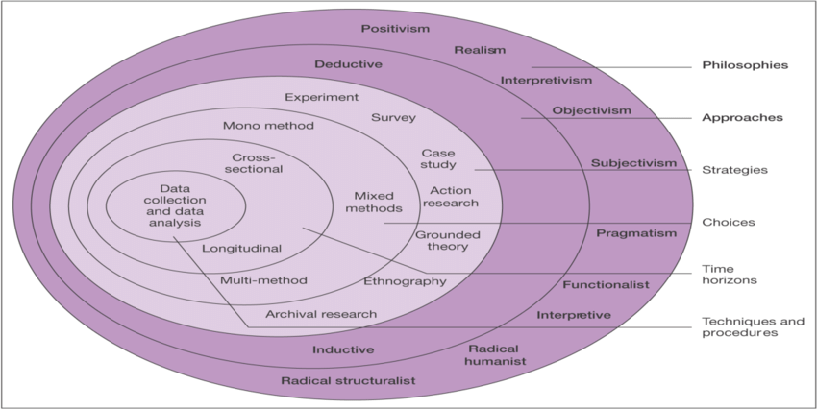
Figure 2-Research onion diagram [19]
Figure 2 demonstrates the research onion diagram that outline the different stages required and methods used to conduct a successful project.

3.2 Research overview
The nature of the project is to establish the impact that cyber security awareness training provides for employees working in organisations. The hardware used to perform the project include a PC to set up the testbed for the participants. The required features for the project include a website for testbed, pre-test questions, post-test questions and awareness video. The tool used to gather the primary data and analyse it by putting it into graphs is Excel.

3.2.1 Research process
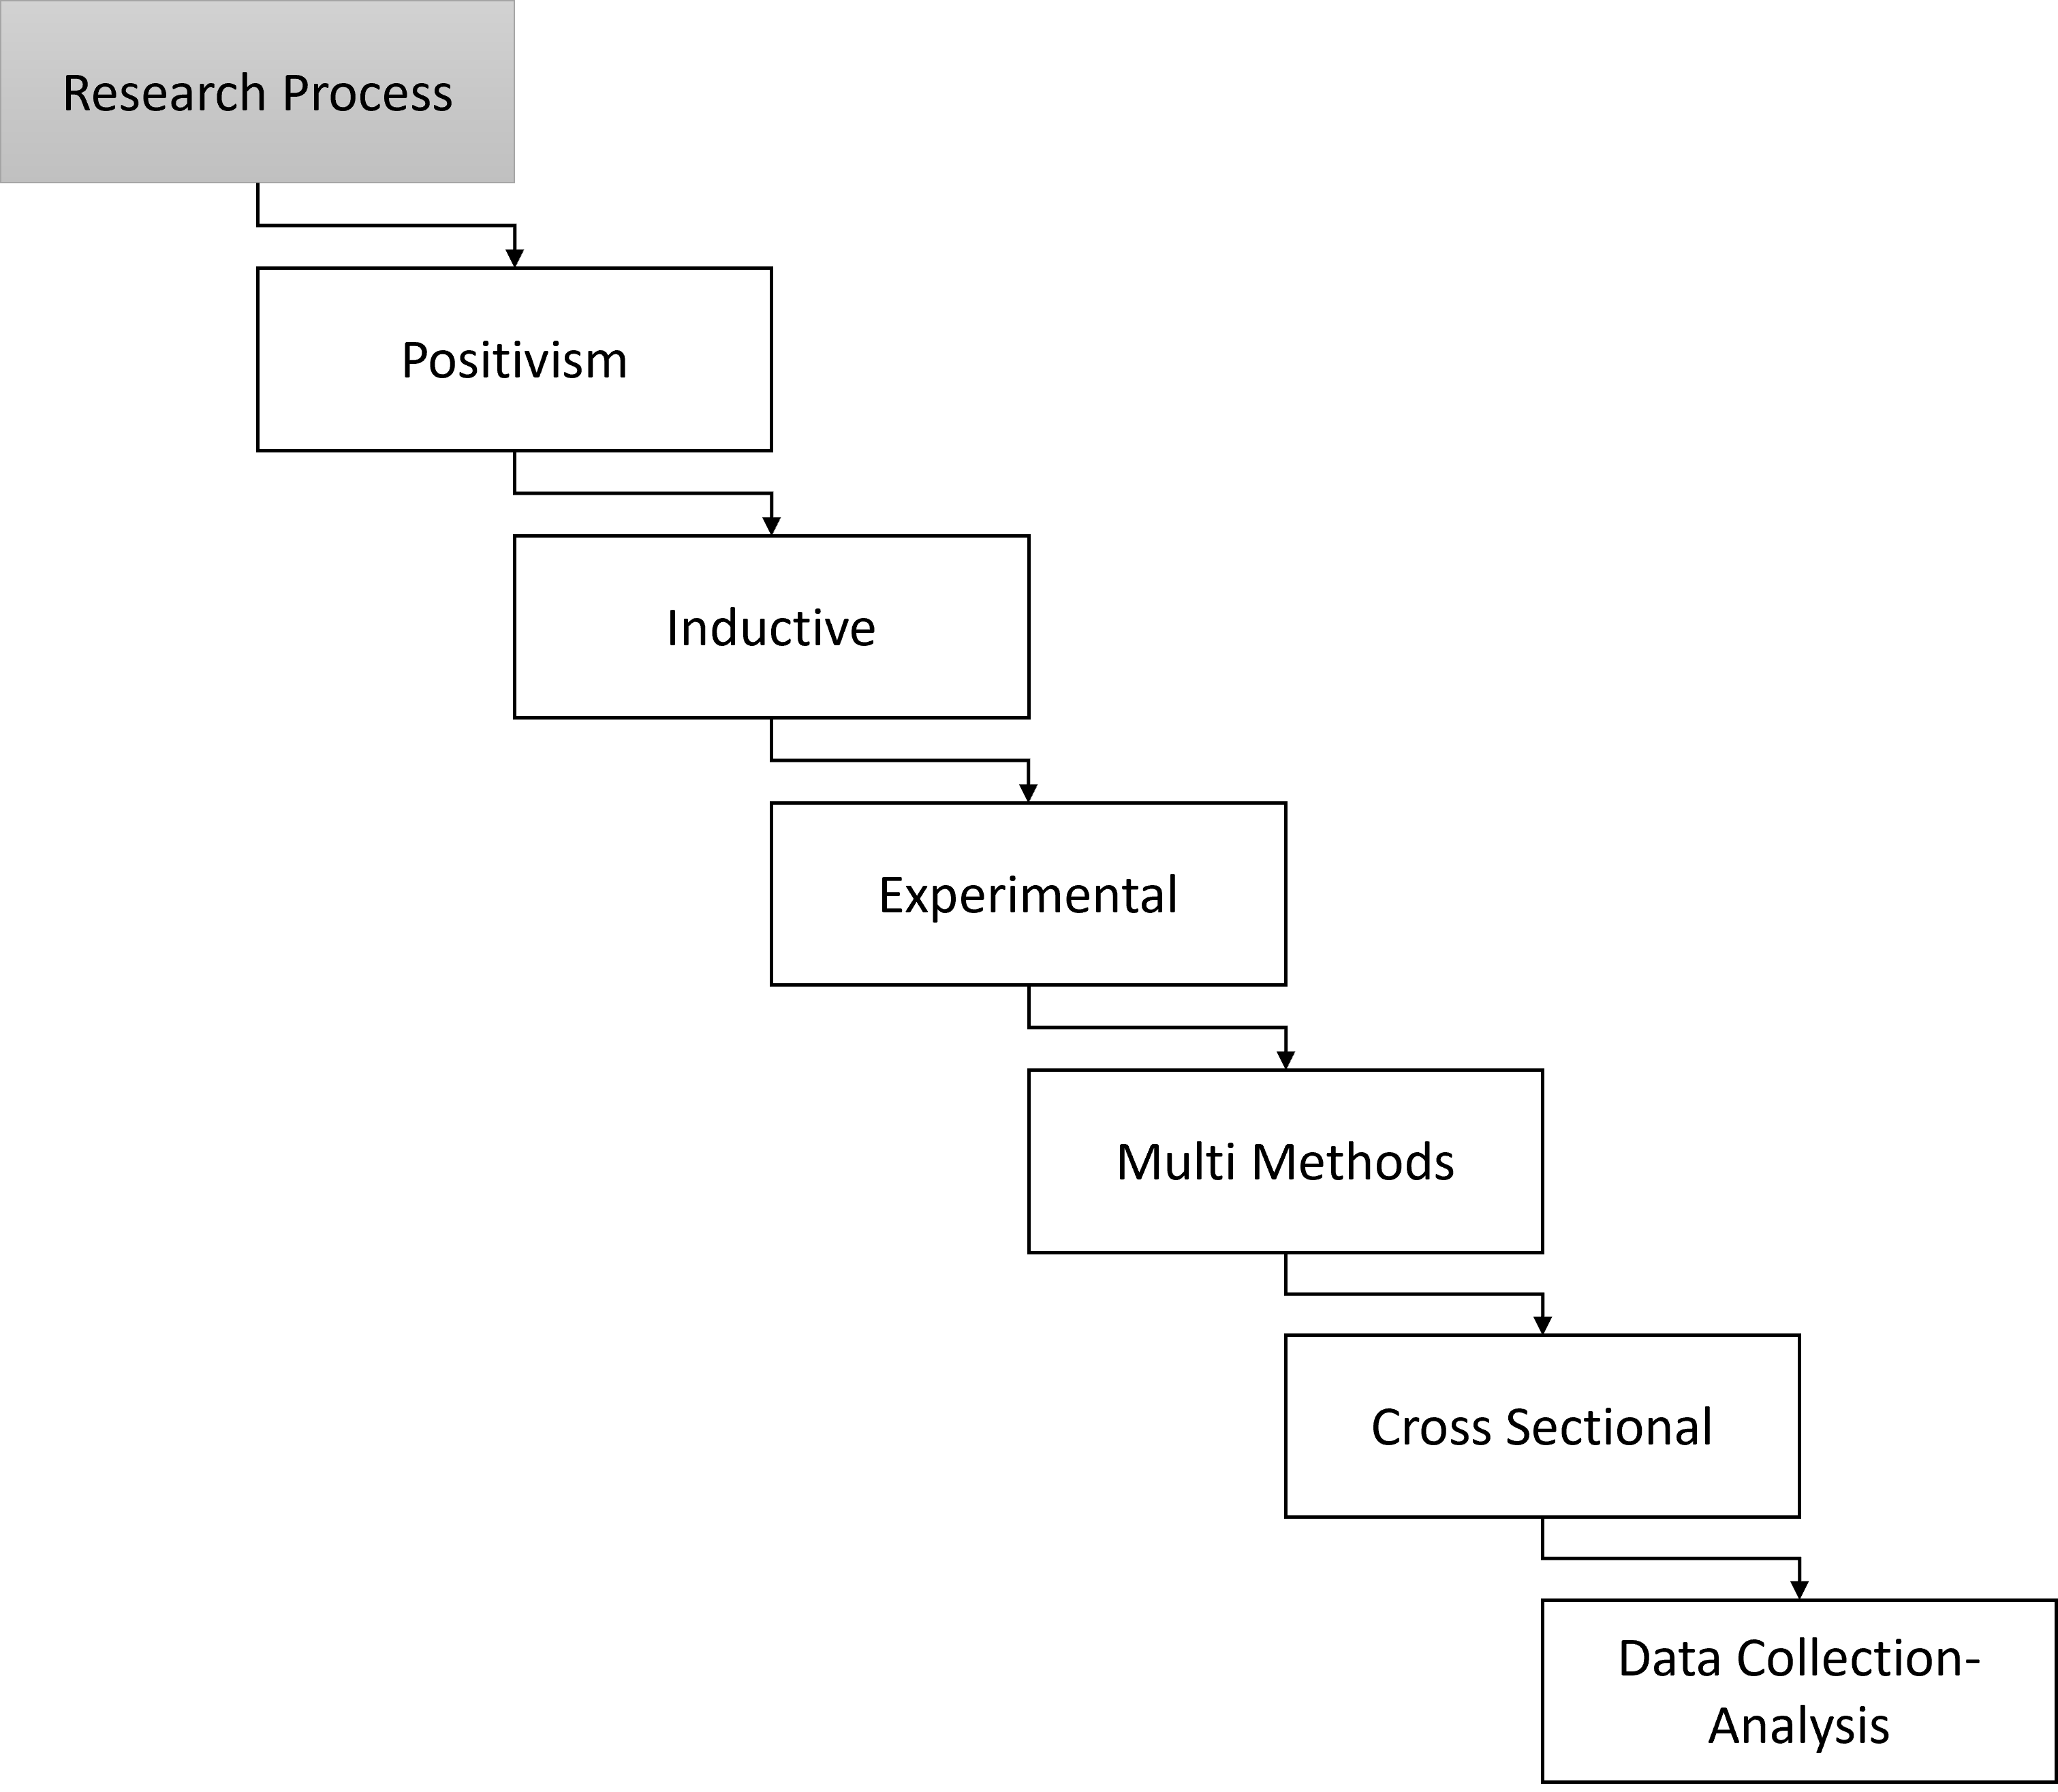
Figure 3-Research Process
Figure 3 demonstrates the process of the research based on the onion diagram.

3.2.2 Philosophies
The philosophy used is positivism as the approach to the study relies on scientific evidence that include experiments and statistics to conclude the research. The experiment is observable and the data is observed over the period of the experiment. The data outcomes collected are comparable. During the experiment, two tests are required to be carried out by the participants. In between these tests, an educational awareness video is demonstrated.

3.2.3 Approach
Inductive approach is used in the methodology as the project is to test a new theory or hypothesis. The experiment hypothesis is that mandatory cyber security awareness training can enhance the overall security surface of organisations. The alternative hypothesis is that mandatory cyber security awareness training content to employees will benefit the overall security surface of the organisation. The null hypothesis is that mandatory cyber security awareness training content to employees does not provide a beneficial impact on organisations security.

3.2.4 Strategies
The strategy used in the methodology is experimental as the process of successfully meeting the project aim requires experiments to be carried out. The experiment requires two tests (DV) to be carried out, and in between the tests an awareness video (IV) presented to all participants. The tests require all participants to answer cyber security related questions. The awareness video displayed to all participants contains the answer to the tests, delivered in an educational manner. The experiment process for all participants to follow is pre-test (Test 1), watch awareness video and take post-test (Test 2). The aim of the project is met once the hypothesis is proven. The testbed is set up with the aid of a website that meets minimal security standard requirements. All participants are prompted to enter criteria of job role upon entering the website. Using the website, both tests and awareness video is displayed to all participants. Data from pre-test and post-test is collected and grouped using the employment criteria of participants. Data is only stored successfully upon total completion of experiment.

3.2.5 Choice
The choices used in the project are multi methods as two experiments (pre-test and post-test) are to be conducted, compared and evaluated to meet the hypothesis. This method is based on the use of multiple methods of research with the use of qualitative methodology. The qualitative methods used in the experiment are the pre-test and post-test. The first method is the pre-test where the participants are not provided with awareness content on the test topic. The second method is the post-test where participants are required to answer the same questions following them being exposed to cyber security awareness content (video). The data from both tests is collected on the website and displayed into suitable graphs and charts to be evaluated.

3.2.6 Time horizons
The time horizon is the timeframe of the research. The timeframe of the following research is cross sectional as data is collected and observed over a short period of time, rather than over years. This approach is suitable for the selected project with the run time of the project being less than a year to make a strong conclusion. Throughout this process of the project, primary data is to be documented, captured and valuated to demonstrate the timeline of the experiment. The data gathered during the experiment can be collected and observed over a short period of time to conclude the project hypothesis.

3.2.7 Techniques and Procedures
The techniques and procedures used in the research is data collection-analysis. The project uses primary data and qualitative data which are placed into appropriate graphs, charts and tables to view the results and make a conclusion.

3.3 Conclusion
In conclusion, the chapter provides an overview of the design and process of the experiment. The project is taking a scientific approach and is using positivism philosophy. The approach is inductive as a new hypothesis is being tested with the research. The project strategies used are experimental as through the process of the project, multiple experiments are to be carried out by participants to reach a conclusion. Multi methods are used as qualitative data are being compared to reach the results and meet the aim. As the data is collected and observed over a short period of time, the time horizon used is cross sectional. The data collected during the research is raw primary data, and the techniques used to sort these data and visually view them include graphs, charts and tables.

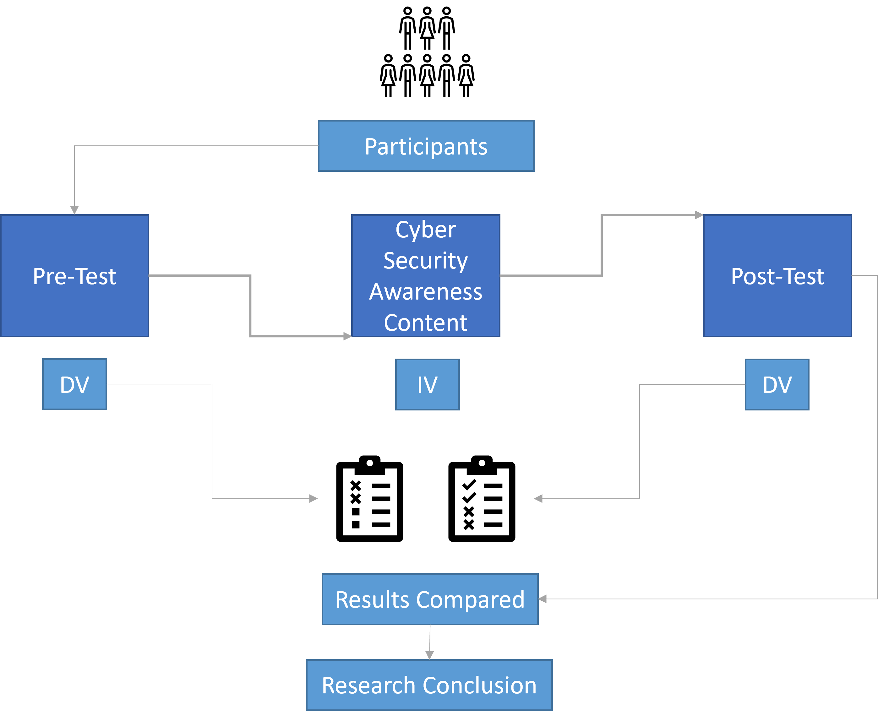
Figure 4-Research method process

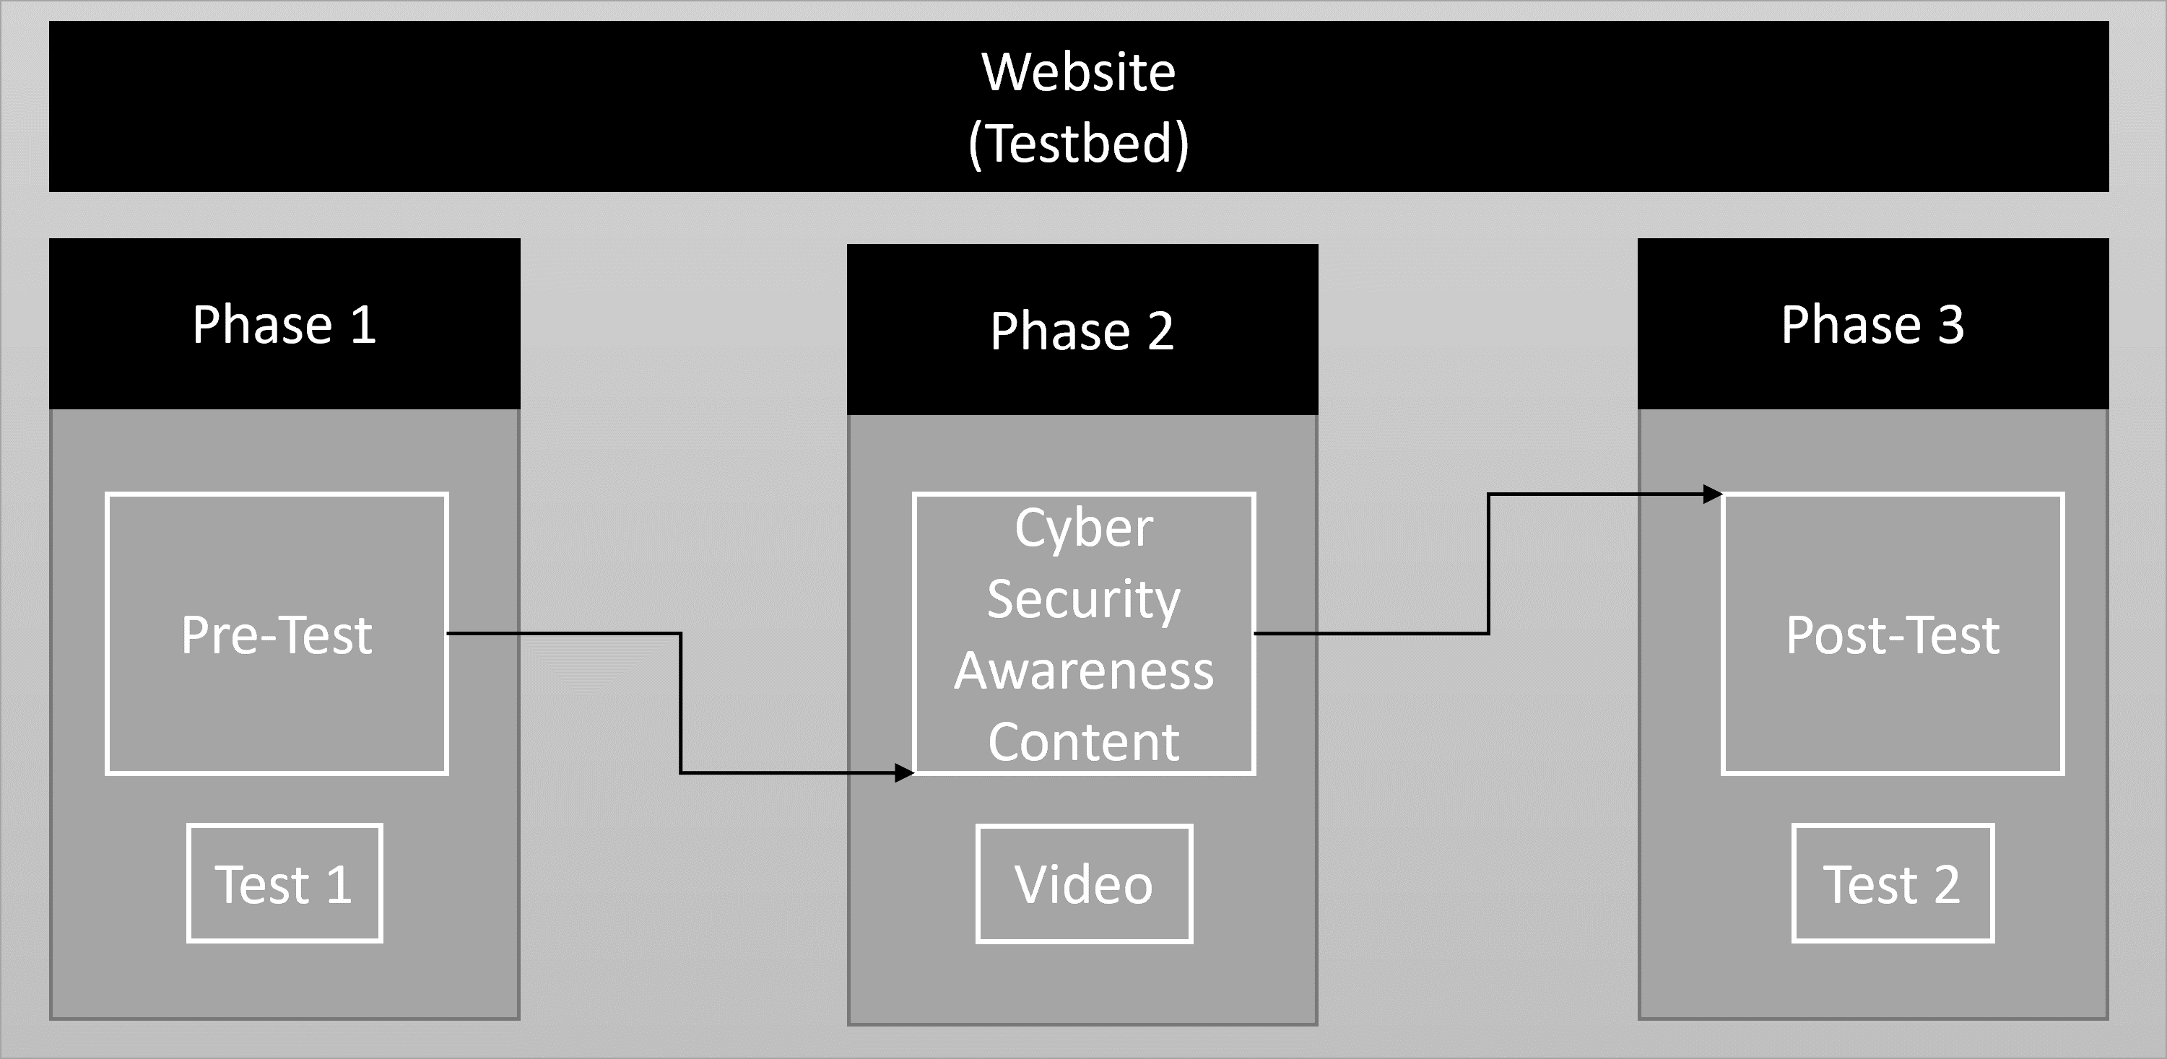
Figure 5-Mock design of testbed
Figures 4 and 5 provide an overview of the process of the design for the research methods and test bed. Users are to complete test 1, watch the cyber security educational video, take test 2, and show results. All results gathered from the data is to be logged in graphs to show before and after of completion of the tests. Although the designs are not the final design, they provide insight into the project’s operations.

Chapter 4-Results

4.1 Introduction
The following chapter discusses the results and statistical figures to be used in order to answer the research question. Although the results at the proposal stage are not present, the chapter highlights the type of data to be collected and statistical procedures to be taken during the research.

4.2 Collection of primary data
Primary data is collected during pre-test and post-test phase of the experiment. This data is later inserted into appropriate charts to visualise the impact of the educational awareness video demonstrated in between the two tests.

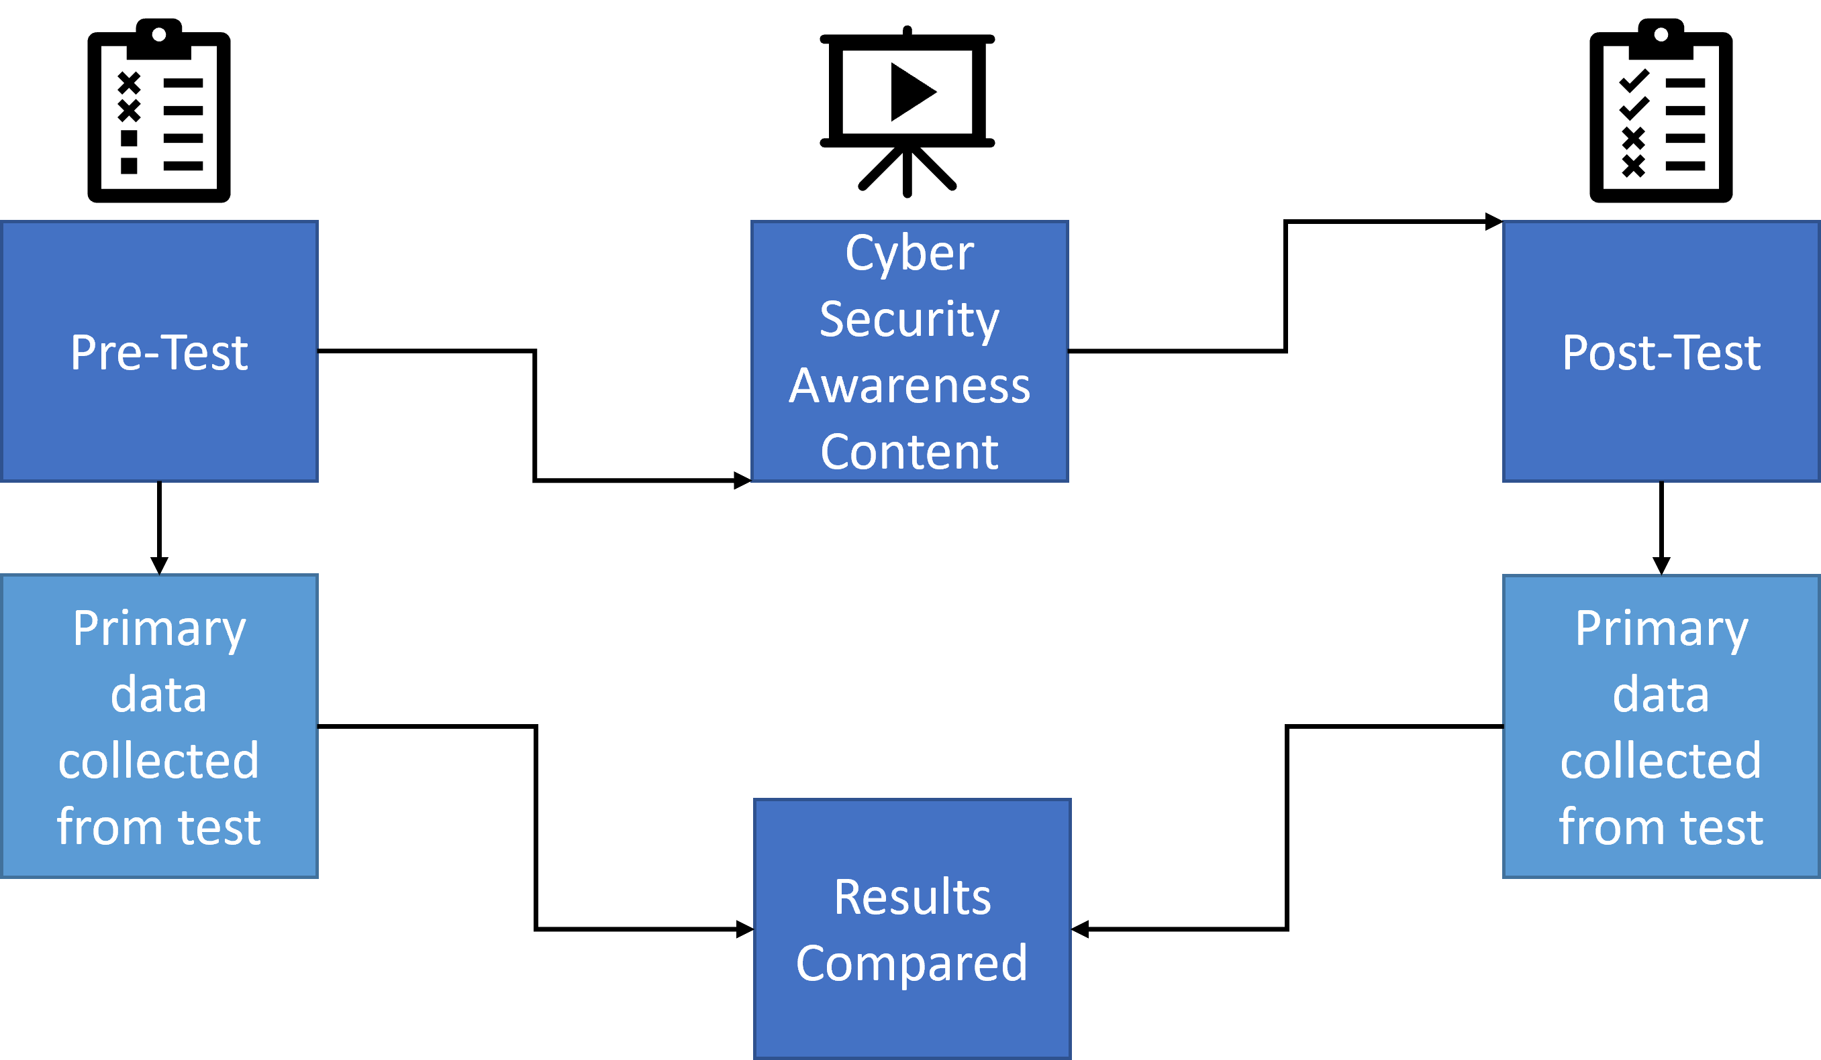
Figure 6-Primary data collection process
Figure 6 demonstrates the process of primary data collection from pre-test and post-test. All participants are required to take part in pre-test and post-test, where primary data is collected from both tests and the results are comparable.

4.3 Demonstration of results
The primary data collected during the experiment is to be placed into appropriate charts as a statistical procedure to visually understand the impact of the cyber security awareness video that the participants are required to watch. Although at this stage there is no data to place into charts, the proposal is demonstrating the assumed results of the experiment.

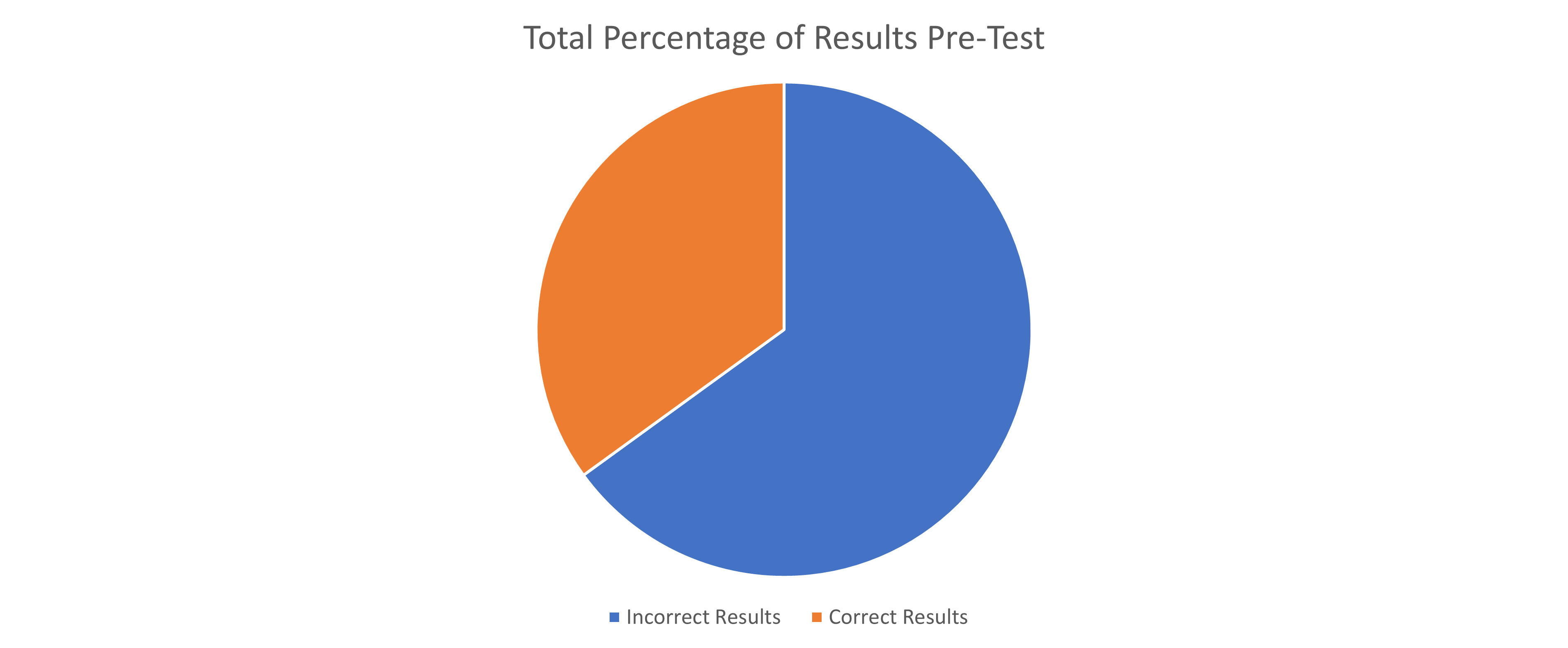
Figure 7-Total percentage of results pre-test
Figure 7 illustrates the proposed method of collecting and sorting the total primary data from pre-test. This data is placed into a pie chart.

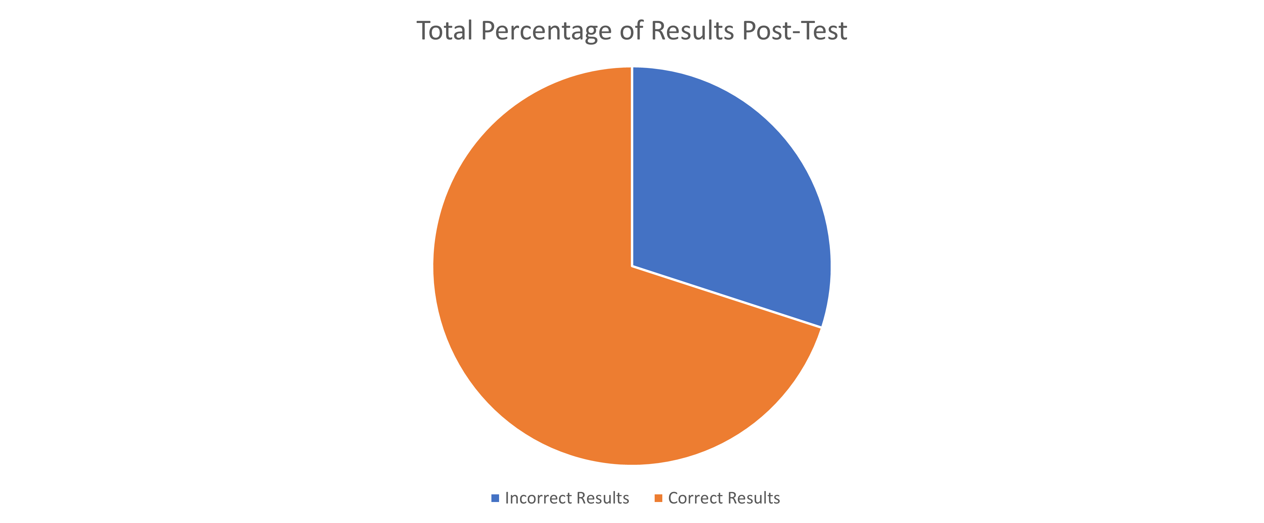
Figure 8-Total percentage of results post-test
Figure 8 illustrates the proposed method for the collection of the expected primary data from post-test. This predicted data is also placed into a pie chart to compare the two results.

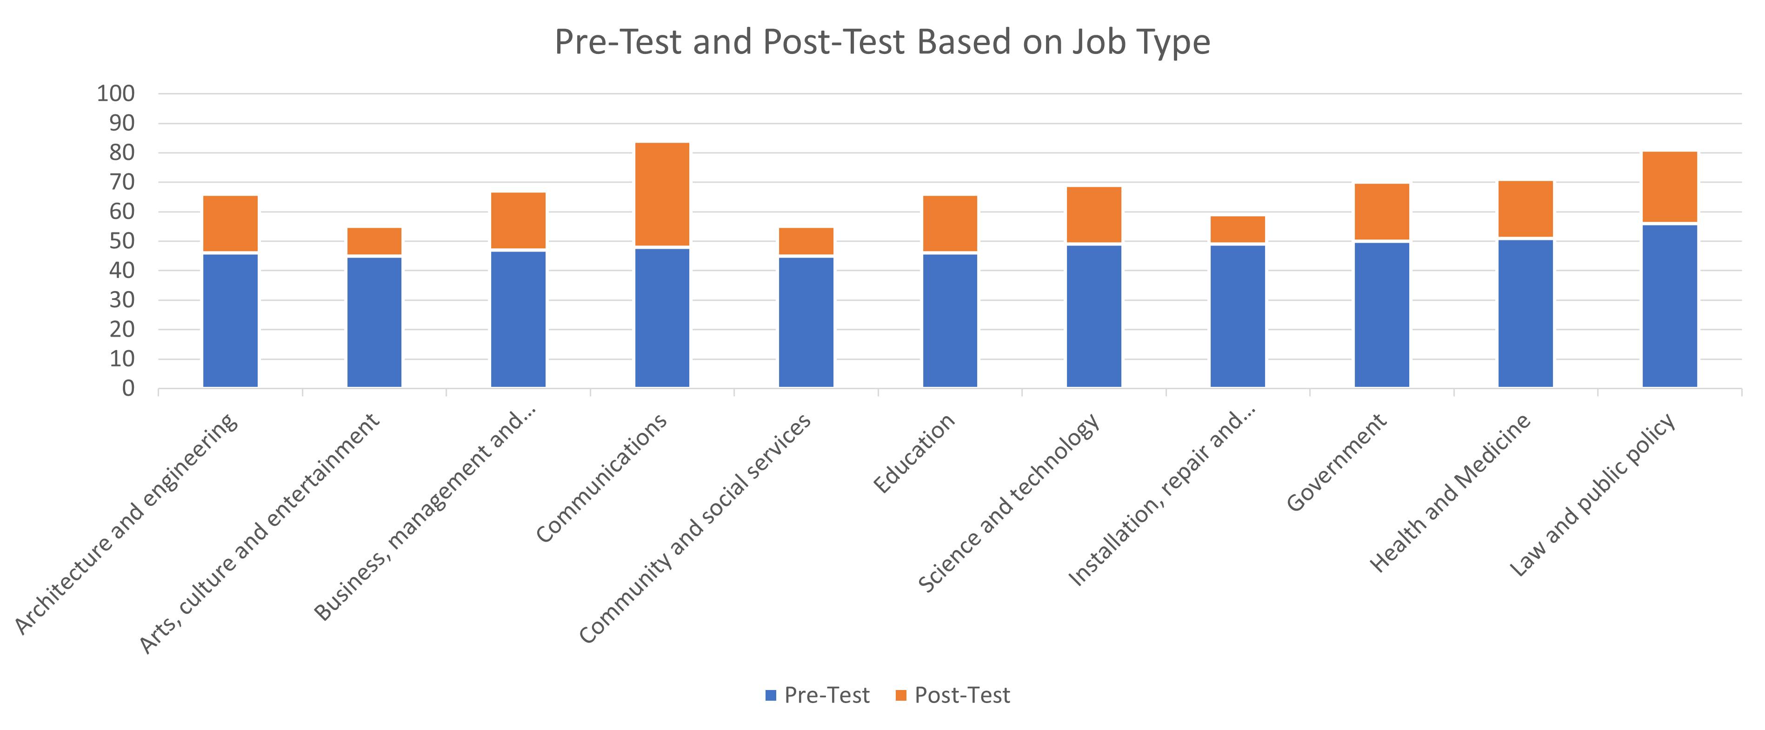
Figure 9-Pre-test and post-test results based on job type
Figure 9 illustrates the pre-test and post-test results based on the participant’s job type. The data from both tests is illustrated using a stacked column chart. This particular chart is chosen as it clearly highlights the change in results following the educational awareness video played between the tests.

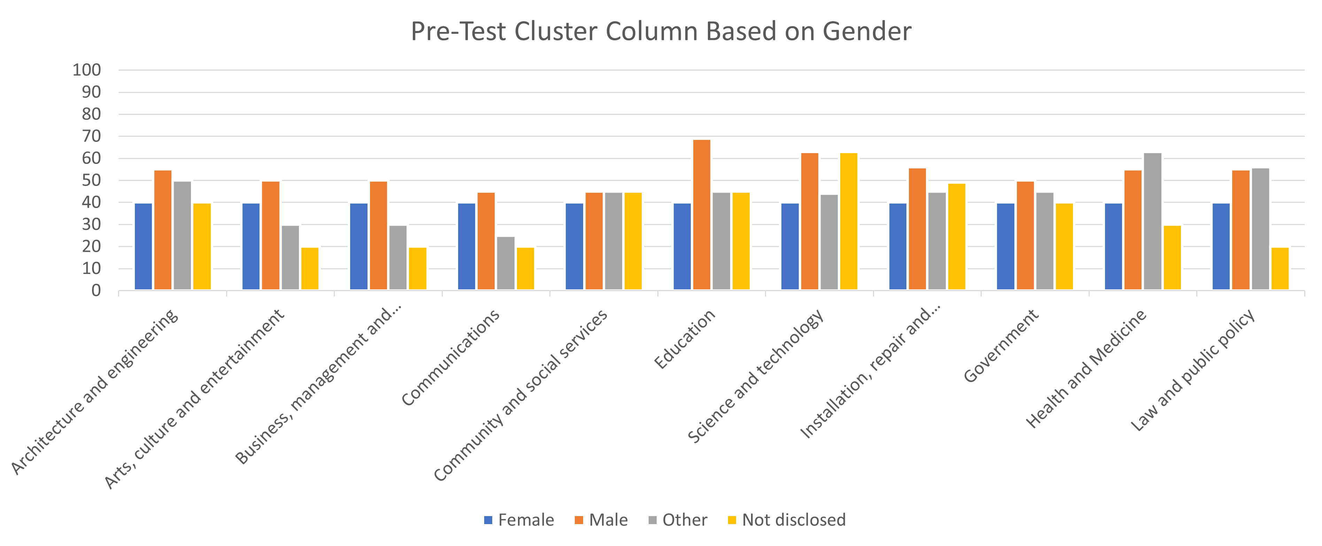
Figure 10-Pre-test results based on gender

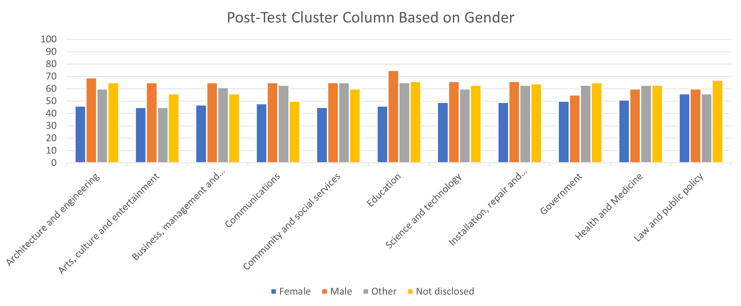
Figure 11- Post-test results based on gender
Figure 10 and 11 illustrates the pre-test and post-test results based on gender. This method is selected as earlier research carried out on Cyber Security Awareness, Knowledge, and Behaviour: A Comparative Study, Journal of Computer Information Systems found a direct connectivity between cyber security awareness and the gender of the participant. [10] Both primary data collected are illustrated in cluster columns based on job types and the gender of the participant. This is to monitor if the participant’s gender contributes any impact on their cyber security awareness.

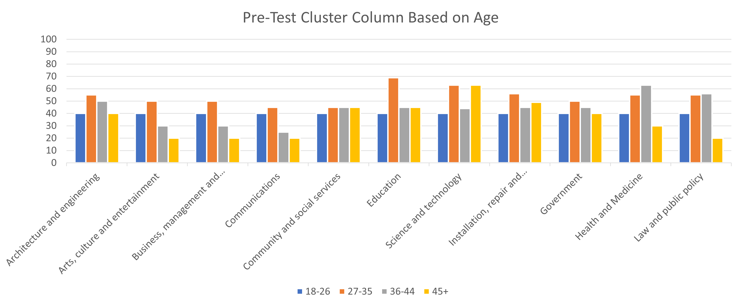
Figure 12-Pre-test based results based on age

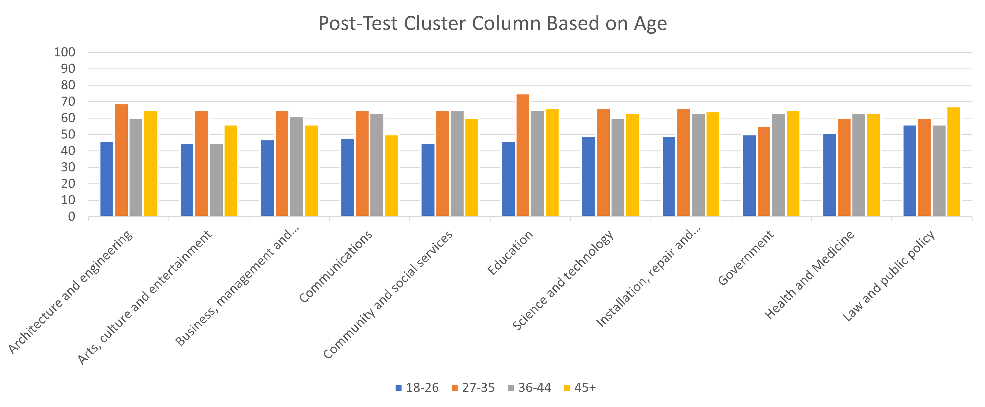
Figure 13-Post-test results based on age
Figure 12 and 13 illustrates the pre-test ad post-test results based on age. The primary data collected is placed into cluster columns similarly to the method used in gender. This helps demonstrate if there is a connectivity between the individual’s age and their cyber security awareness.

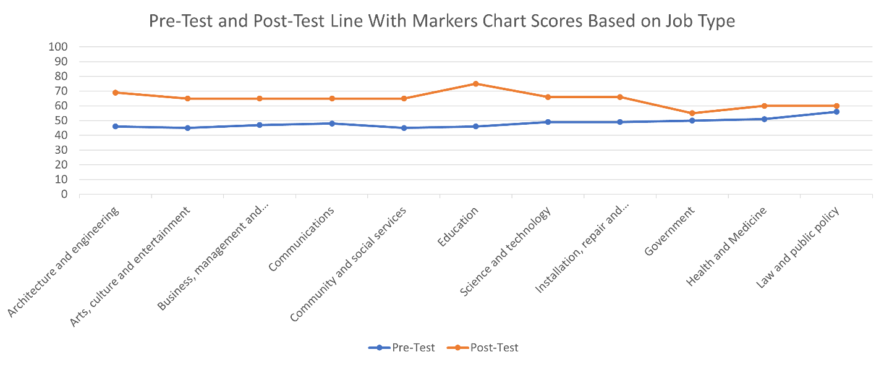
Figure 14-Pre-test and post-test line with markers chart
Figure 14 illustrate the pre-test and post-test results of the experiment. Both data is placed into a line with markers chart. The selection of this chart is so the data can be clearly allocated, and the changes can be easily visually noticed with the help of the markers.

4.5 Conclusion
In conclusion various types of charts are selected to be used during the experiment. These include stacked columns, pie charts, clustered columns and line with markers charts. All primary data results received from participants is placed into these charts to help answer the research question. The results gathered are to be evaluated and criticised against the critical literature review conducted earlier on in the research.

Chapter 5-Evaluation

5.1 Introduction
The following section elaborates the potential impact of the proposed research to be carried out including the limitations and weaknesses of the proposed research. The literature review carried out in Chapter 2 is used to provide the potential impact of the proposed research.

5.2 Summary
Based on this finding there is confidence that the research is achievable, beneficial and can answer the proposed research question. Based on these findings it is evident that there is further need for research into the impact of mandatory cybersecurity awareness training and the proposed research is worth doing. The study is beneficial as it demonstrates to organisational leaders the impact of mandatory cybersecurity training for all staff and the benefits that can bring to the organisation.

5.3 Limitations and weaknesses
All research is accompanied by limitations and weaknesses that can arise during any part of the project. The identified limitations and weaknesses of the proposed research include:
- Difficulty allocating correct number of participants to take part in the experiment to collect enough data to be analysed.
- Participants failing to focus on the experiment and inputs false data.
- Participants inputting falls inaccurate data. An example of this is guessing the answers to the questions.
- Selected participants failing to complete experiment.
- Time constraint of research. Excellent time management is necessary to complete successful research in short space of time.
- Financial constrains impact the use of tools and require for more free open source tools to be used during the experiment and the se up of testbed.

5.4 Conclusion
In conclusion the proposed project comes with several factors that encourage for the research to be carried out. This includes several ways of demonstrating how cybersecurity awareness can enhance the overall security surface of organisations. The research is worth conducting as although other similar research has been carried out by other researchers, the question of would mandatory cyber security awareness for all staff enhance the overall security surface has not been researched. This factor would feed back to employers further valid reasons of why mandatory cyber security training for all staff is necessary. Furthermore, the limitations and weaknesses of the proposed research are discussed to outline the foreseeable obstacles that the project could potentially face.

Chapter 6-References
[1] A. Alkhaiwani and G. Almalki, "Saudi Human Awareness Needs. A Survey in How Human Causes Errors and Mistakes Leads to Leak Confidential Data with Proposed Solutions in Saudi Arabia", 2021 National Computing Colleges Conference (NCCC), 2021. Available: 10.1109/nccc49330.2021.9428790 [Accessed 1 February 2022].
[2] T. Crick, J. Davenport, A. Irons and T. Prickett, "A UK Case Study on Cybersecurity Education and Accreditation", 2019 IEEE Frontiers in Education Conference (FIE), 2019. Available: 10.1109/fie43999.2019.9028407 [Accessed 1 February 2022].
[3] 2022. [Online]. Available: https://www.acas.org.uk/working-from-home-and-hybrid-working. [Accessed: 01- Feb- 2022].
[4] S. Furnell and J. Shah, "Home working and cyber security – an outbreak of unpreparedness?", Computer Fraud & Security, vol. 2020, no. 8, pp. 6-12, 2020. Available: 10.1016/s1361-3723(20)30084-1 [Accessed 1 February 2022].
[5] 2022. [Online]. Available: https://www.ncsc.gov.uk/news/organisations-urged-to-bolster-defences. [Accessed: 24- Feb- 2022].
[6] K. Khando, S. Gao, S. Islam and A. Salman, "Enhancing employees information security awareness in private and public organisations: A systematic literature review", Computers & Security, vol. 106, p. 102267, 2021. Available: 10.1016/j.cose.2021.102267 [Accessed 24 February 2022].
[7] "ENISA threat landscape report 2018: 15 Top Cyber-Threats and Trends", Heraklion: european Network and Information Security Agency (ENISA), 2022. Available: 10.2824/622757 [Accessed 24 February 2022].
[8] "The Human Factor in IT Security: How Employees are Making Businesses Vulnerable from Within", Kaspersky.com, 2022. [Online]. Available: https://www.kaspersky.com/blog/the-human-factor-in-it-security/. [Accessed: 25- Feb- 2022].
[9] W. He and Z. Zhang, "Enterprise cybersecurity training and awareness programs: Recommendations for success", Journal of Organizational Computing and Electronic Commerce, vol. 29, no. 4, pp. 249-257, 2019. Available: 10.1080/10919392.2019.1611528 [Accessed 25 February 2022].
[10] M. Zwilling, G. Klien, D. Lesjak, Ł. Wiechetek, F. Cetin and H. Basim, "Cyber Security Awareness, Knowledge and Behavior: A Comparative Study", Journal of Computer Information Systems, vol. 62, no. 1, pp. 82-97, 2020. Available: 10.1080/08874417.2020.1712269 [Accessed 25 February 2022].
[11] H. Aldawood and G. Skinner, "Educating and Raising Awareness on Cyber Security Social Engineering: A Literature Review", 2018 IEEE International Conference on Teaching, Assessment, and Learning for Engineering (TALE), 2018. Available: 10.1109/tale.2018.8615162 [Accessed 25 February 2022].
[12] A. Koohang, A. Nowak, J. Paliszkiewicz and J. Nord, "Information Security Policy Compliance: Leadership, Trust, Role Values, and Awareness", Journal of Computer Information Systems, vol. 60, no. 1, pp. 1-8, 2019. Available: 10.1080/08874417.2019.1668738 [Accessed 25 February 2022].
[13] I. Hwang, R. Wakefield, S. Kim and T. Kim, "Security Awareness: The First Step in Information Security Compliance Behavior", Journal of Computer Information Systems, vol. 61, no. 4, pp. 345-356, 2019. Available: 10.1080/08874417.2019.1650676 [Accessed 25 February 2022].
[14] S. Mandal and D. Khan, "A Study of Security Threats in Cloud: Passive Impact of COVID-19 Pandemic", 2020 International Conference on Smart Electronics and Communication (ICOSEC), 2020. Available: 10.1109/icosec49089.2020.9215374 [Accessed 26 February 2022].
[15] R. Nafea and M. Amin Almaiah, "Cyber Security Threats in Cloud: Literature Review", 2021 International Conference on Information Technology (ICIT), 2021. Available: 10.1109/icit52682.2021.9491638 [Accessed 26 February 2022].
[16] C. Onwubiko, "Security operations centre: Situation awareness, threat intelligence and cybercrime", 2017 International Conference on Cyber Security And Protection Of Digital Services (Cyber Security), 2017. Available: 10.1109/cybersecpods.2017.8074844 [Accessed 27 February 2022].
[17] H. Al-Mohannadi, I. Awan, J. Al Hamar, Y. Al Hamar, M. Shah and A. Musa, "Understanding Awareness of Cyber Security Threat among IT Employees", 2018 6th International Conference on Future Internet of Things and Cloud Workshops (FiCloudW), 2018. Available: 10.1109/w-ficloud.2018.00036 [Accessed 28 February 2022].
[18] K. Halouzka, L. Burita and P. Kozak, "Overview of Cyber Threats in Central European Countries", 2021 Communication and Information Technologies (KIT), 2021. Available: 10.1109/kit52904.2021.9583621 [Accessed 28 February 2022].
[19] C. Malalgoda, D. Amaratunga and R. Haigh, "Empowering Local Governments in Making Cities Resilient To Disasters: Case Study as a Research Strategy.", Conference: International Post Graduate Research Conference: IPGRC 2013, 2013. Available: https://www.researchgate.net/publication/303674706_Empowering_Local_Governments_in_Making_Cities_Resilient_To_Disasters_Case_Study_as_a_Research_Strategy. [Accessed 28 February 2022].

Appendices

Appendices 1-Gantt chart

Figure 15-Gantt Chart
Figure 15 demonstrates the Gantt Chart of the process of the project including the timeline and list of tasks to complete.

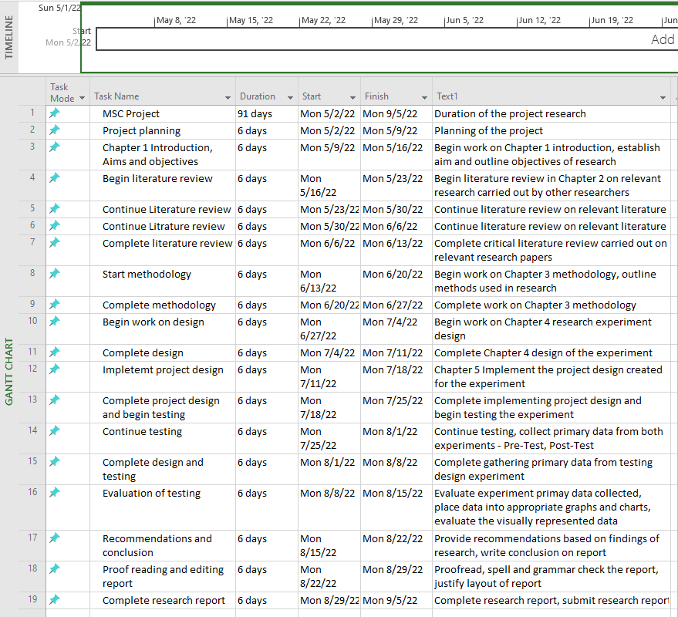
Figure 16-Closer view of Gantt Chart
Figure 16 demonstrates a closer view of the Gantt Chart including the tasks, duration of tasks, start and finish dates of tasks and brief description of tasks.


Figure 17-Closer view of Gantt Chart timeline
Figure 17 demonstrates a closer view of the timeline of the project tasks. The duration of the project is to start from May and research is carried out until September.

Appendices 2-Ethics Form
Appropriate ethics form to suit the research is submitted separately via Moodle.

