

BA leadership and management
Skills in the workplace.
Module Assignment Submission
Student Name: | Shanice Hodgson
Student Number: | 2238725
Module No: | BMSK4012
Module Title: | Engaging and understanding customer experience.

Statement of Confirmation of Authenticity
By the act of making this submission, the student declares that this is the work of the student named above. The work has not, in whole or in part, been knowingly presented elsewhere for assessment, or where assessment has been built on a previous assessment, this has been identified. Where materials have been used from other sources it has been properly acknowledged. If this statement is untrue, the student acknowledges that an assessment offence has been committed.
Attention is drawn to the plagiarism and unfair practice policies of both the University and of ILM.

- Table of Contents
1. Introduction 2
2. Customer value (cv) 2
2.1 Definition of customer value (cv) 2
- 2.2 Customer engagement value (CEV) 2
- 2.3 Customer values within my own organisation 2
3. Maximising customer value 3
3.1 Factors that impact maximising customer value 3
4. Customer centrality 3
5. Managing expectations 3
5.1 Customer satisfaction v customer loyalty 3
5.2Customer relationship management (CRM) 3
5.3 The Kano models 4
6. Quality process 4
6.1 Quality process models 4
7. Quality process within my own organisation 4
8. Conclusion 5
9. References 5
10 Appendices 5

Introduction

In this assignment we will investigate how important customer values are to a company and how customer values relate to our own workplace. Touching upon a few different models such as: The Kano Model and the 8 dimensions of quality and how they fit into the workplace.

Customer value (cv)

2.1 Definition of customer value (cv)

A simple definition of customer value in the workplace is how much a product or the service is worth to the customer. In simple terms customer value= benefit-cost (cv=b-c) Mahajan (2020). Some examples of these would be the quality of products that have been used, the price of the products they are paying for, and what the products or service can do for that customer.
Gallarza et al (2011) found that there were many problems associated with defining Value, with Holbrook & Corfman (1985) stating “Our difficulties in defining quality have indicated a need to consider this concept within the broader context of the general theory of value” whereas Al-Sabbahy et al (2004) found that “despite its strategic importance for marketing, perceived value has not received sufficient attention in the literature”.
One of the difficulties associated with customer value is that it is “inextricably linked to major marketing related constructs such as perceived price, service quality, or customer satisfaction” Gallarza, (2011). However, constructs such as service quality and customer satisfaction are personal, and this makes it harder to determine value because value is different for every individual customer.
Kumar & Reinartz (2016) stated that “in various definitions of value there is reasonable variety in the spirit of describing the trade-off between give elements and get elements” or as Gutman (1982) concluded customer value is “the aggregation of benefits that the customer is seeking, expecting, or experiencing, and the undesired consequences that come with them.”
Therefore, we can determine that customer value is whether a customer perceives the benefits of buying the products outweighing the costs.

Customer engagement value (CEV)

A brief description of customer engagement value would be the ongoing cultivation of a relationship between the customer and the consumer that goes way beyond the transaction. It is an intentional, consistent approach by the company that provides value for every customer's interaction.
Kumar & Pansari (2016) stated that customer engagement has a considerable positive effect on firms performance” therefore “firms need to provide some incentives to stimulate customer transactional and non-transactional interactions with the firm to create customer engagement value (CEV)” Tourchian et al (2022).
Various definitions of customer engagement exist including one that suggests it is a psychological process that models customer loyalty (Bowden, 2009) a customers behaviour towards a brand (Van Doorn et al, 2010), a customers motivational state of mind (Hollebeek, 2011), a customer’s intensity of participation and connection to the firm (Viveck et al, 2012), a customer’s voluntary contributions stemming from motivational drivers (Jarrkkola & Alexander, 2014), and finally as the level of connectedness (Kumar and Pansari 2016).
El Hamd et al (2022) found CEV links to Kumar and Pansaris definition of customer value, stating that “CEV is a comprehensive term that measures the total value of the customer through capturing his transactional and non-transactional behaviours”, however it is clear from the definitions above that customer engagement involves a range of elements which, once again, are different for each customer, therefore to cultivate a long term relationship requires understanding of what the customer values, what stimulates their buying decisions and whether they desire connectedness or not.
In conclusion it is possible to determine that CEV is measured by customers total value. As stated above businesses tend to put their customers into individual brackets of how much they bring to them and the value they get from them. Having comprehensive value for each customer to describe their total engagement allows a firm to treat their customers accordingly to their engagement level.

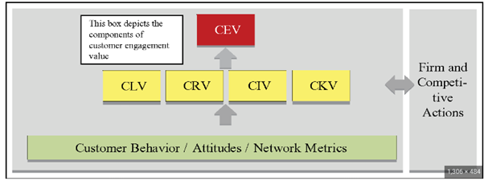
Source- Semanticscholar.org
There are four core dimensions that feed into customer engagement and these are:
Customer Lifetime Value (CLV)
CLV is a metric that calculates the total worth of a customer to a business over the entire duration of their relationship. It represents the predicted revenue a business can expect to generate from a single customer.
Harvard Business School (2007) defines CLV as being based on purchase transaction in large part because the performance metrics associated with successful initiatives tend to be of the stimulus-response variety.
Customer Referral Value (CRV)
CRV refers to the monetary value that a customer brings to a business through referrals. It is a measure of potential revenue that can be generated by a particular customer.
Kumar, Peterson, Leone (2007) explains that a company that wants to know a customer's full value would include a measure of that person's ability to bring in profitable new customers.
Customer Influencer Value (CIV)
CIV refers to the impact and influence that customers have on the purchasing decisions of others. It measures the value of importance of customers that actively promote a brand or product to their social media pages, for example; Instagram, Facebook, Twitter.
Katz and Shapiro (1985) stated that many product categories, information sharing, word of mouth (WOM), interaction, and assistance from customers post-acquisition can significantly affect others’ behaviours.
Customer Knowledge Value (CKV)
CKV refers to the importance and worth of the information and insights a company has about their customers. Having a deep understanding of customers allows businesses to personalise their marketing, products, and services, leading to improved customer satisfaction, loyalty, and retention.
Stevens and Burley (2003) explain that networks such as brand communities have been proposed as a valuable resource for innovation ideas for companies.

Value Pyramid
The Value Pyramid categorises the elements of customer value into the levels of a pyramid, with those providing more objective value at the base and those that offer more subjective value higher up (Cleghorn, 2018).
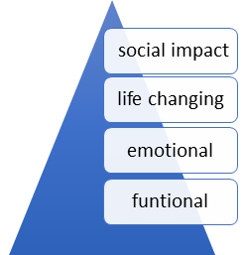

Social Impact: Aligns brands with purposes other than profits e.g. championing sustainability.
Life Changing: Spark the drive for self-improvement and fuel ambition.
Emotional: The purpose is to reduce stress, enhance confidence and cultivate a sense of belonging.
Functional: these elements offer practical advantages that increase convenience, reduce pain, and provide appealing variety.
If a business can meet the four needs of values, then it is possible that loyalty will increase, and a business’s revenue will have a greater chance of steady growth. (Almquist et al., 2016)

Customer values within my own organisation

My business is a nail technician; therefore, I am offering a service that provides customers with an experience. Whilst it is believed that the four levels of the “values pyramid” can be met but this does depend on the customer’s perception of value.
Social impact is important for my business as I'm selling a certain product (nail enhancements- acrylics, builder gel, and gels) . I am championing sustainability, how long they last, what amazing quality my product is. Getting the clients money's worth, making sure they are happy with the product.
Life changing is an area that I could possibly improve in, since becoming a mother of two my drive for work isn't as much as it was before I only had my daughter. which means I tend to put my business last, this needs to change as I could lose a lot of business this way, and my business could end in permanent closure.
The emotional part of my job is where I personally think I excel in, I can show a huge amount of empathy to every client as they come to me for not only their nails, but for a counselling session, they come to me with the most amazing news, but they also come to me with the worst possible news and we share tears together, which is amazing as these people grow to become not only clients, but very good friends.
The functional aspect of the customer value would be that I always make myself pretty accessible to clients, I work evenings for clients that work in offices and I work weekends which also makes it easier for clients that work in nurseries/schools to book in.

Maximising customer value

3.1 Factors that impact maximising customer value

As an independent nail technician running the business it is extremely important that the customers values are cherished. When running the business, it is important that the product provided is affordable to the clients, with the current cost of living crisis it has been very noticeable that clients can no longer afford the luxuries such as beauty treatments, even with the cost of products that keep rising I still like to keep my prices as affordable as I possibly can.
It is important to me that clients that have come to me from the very start know that I will always try my best to give them the best experience, even if that means a small discount for their sets. CLV is extremely important, there are clients that have stuck with me from building my small business with very few clients, to now seeing them every 3-4 weeks throughout the year. If they need to change an appointment in an emergency at any time, they know that they can ask, and I will do as much as I can to fit them back in.
As an independent business CRV makes a stark difference, clients referring their friends, family members means so much to the business, it means that they enjoy their time at their appointments, and to then recommend them to me for their treatments helps me grow my clientele. The power of recommendations/referrals and reviews cannot be underestimated as statistics show that 92% of consumers trust recommendations from friends and family over all forms of advertising (Reed-Enver, 2024), therefore it is key for me to ensure that I continue to offer a quality service to my friends and family and encourage the referrals to increase business.
CIV goes a long way, when a client uploads their nails onto their social media tagging my business page this helps grow my business page, the activity then grows on the business page, which will in turn show my business page more frequently on customers pages.
CKV also plays a key role in my business, understanding what my clients like, such as certain nail trends, if clients like to have acrylics or builder gel to grow their nails. I would not offer a certain enhancement to a client that I know would not be able to grow their nails. Even down to stocking cuticle oils for clients to purchase, the perfect bag accessory for holidays, and to just use as self-care it is important to know what customers want. Clients love certain scents, and it is always important I have them stocked up in the salon ready to be purchased as this knowledge generates sales and shows my clients that I know what they like. Research indicates that there are 131% more chances customers will buy from the brands they are familiar with (Radica, 2024) and those brands that use knowledge of the customer to ensure their needs are met will generate CLV and CEV which will increase the profits.
When thinking of how to improve my business, I need to put CLV ahead of newer clients, when taking on new clients they do not have the same respect for you as older clients do. They tend to not prioritise their appointments as they feel no loyalty to the nail technician as they might not have had an appointment yet. The new clients tend to not show up to appointments that have been offered, but I had turned away a regular client for that week as my diary would be full, turning them away to find someone else.

Customer centric

Customer-centric is defined by placing the customer at the centre of the business strategy and decision-making processes. The customer-centric approach focuses on delivering exceptional customer service, building long-term relationships, and providing value to customers throughout their journey with the brand.
According to Jayachandran et al (2005) a customer-centric management system has been found to be positively related to organisational routines that are crucial for CRM.
When relating customer centrality to my organisation it is extremely important that the current needs are put first for the existing clients, they come to get their nails done every 3-4 weeks, they expect the same products that have been used previously. clients also come in hoping to have the same conversations that are had at previous appointments, whether that means venting if things aren't going right at home, sharing their exciting news, or sometimes the very sad news. These appointments more often or not turn into a counselling session for them and for myself.
the future needs of the client is important as a lot of the clientele get used to certain routines, some clients travel down to swansea from other areas, they have a routine that they are used to for example; one client travels down from Merthyr, she has her nails done for 2 hours then does her food shop in Tesco Llansamlet which is around the corner from the salon because she likes that tesco. if i decided to move salons to be situated closer to town this would be more of an inconvenience for her as she would have to travel further and her routine would change. This is why it is important I keep the clients future needs as a priority, and what they would be comfortable with.
desired needs would be what the client wants from their appointment, what trends i would need to learn for the clients next appointment. Keeping up to date with nail trends is very important as it keeps me relatable and my clients know they will not be turned away for something they want.
clients informational needs are important for the business, keeping client information cards is a good way to store clients information, such as: contact information, any allergies the clients may have, any contraindications that the client may have at other appointments, or any reasons i have had to turn the clients away for their appointments.
When it comes to product needs it is extremely important that I keep customers up to date with products that I am using. I always keep my eyes out for new trends which will mean new nail products, but I will only buy the best to make sure they are having the best product on their nails. I also will not just change to a different brand without telling my clients, and making sure they get the very best products. unless absolutely necessary, such as an allergy has become apparent on clients which has given me no choice to change suppliers.

Managing expectations

5.1 Customer satisfaction v customer loyalty

It is commonly known that there is a positive relationship between customer loyalty and profitability (Bowen & Chen, 2001) therefore it is important to know what creates customer loyalty, and why people keep coming back.
Loyal customers are less likely to switch because of price and they make more purchases than similar non-loyal customers (Reichheld and Sasser, 1990). A Loyal customer “will provide strong word-of-mouth, create business referrals, provide references, and serve on advisory boards” (Bowen & Chen, 2001) therefore it is vital that loyal customers are kept satisfied as they reduce the cost of marketing the business and are more likely to be believed by potential customers. Where businesses need to be careful is to not mistake repeat purchase for commitment and loyalty as this may not be the case.
Ningsih and Segoro (2014) defined satisfaction as an attitude, assessment and emotional response shown by the consumer post purchase and is linked to whether a customer is pleased with a product or a service, whilst Yap, et al (2012) suggested satisfaction was an overall customer attitude towards a service provider.
It has been suggested that customer satisfaction does not equal customer loyalty (Bowen & Chen, 2001), Chandrashekaran et al (2006) argue that whilst research suggests satisfaction is intimately linked to loyalty, evidence shows that many customers who state that they are very satisfied with a service provider nevertheless subsequently defect. However, Leninkumar (2017) argues that customer loyalty is calculated as a straight outcome to customer satisfaction. What Hyken (2019) found was that “satisfaction is a rating, but loyalty is an emotion”. Whilst you can explain satisfaction with statistics you cannot explain loyalty this way because there are emotions involved which come from employees understanding customer’s wants and needs and the empathy they display for those customers.
Leninkumar (2017) introduced the concept of trust into the loyalty and satisfaction debate and felt that to build loyalty there had to be satisfaction and trust. Within my business this is the case as I have satisfied customers, who are happy with their nails and post on social media, but I may not see them again. I have not been able to build trust with them on one visit. My regulars have built that trust relationship, and they tell me very personal things which I never repeat, this has helped build up trust and created loyal customers.
There are loyalty schemes that make customers want to shop there, such as the Tesco Clubcard, it offers customers with a Clubcard cheaper prices on foods, they also get a certain number of points for an amount spent on their shopping, those points can be turned into vouchers for another shop, or the points can be turned into a voucher scheme for virgin flights, or experience days. These loyalty schemes make it exciting for the person to shop there as some might rely on those points for cheaper days out with the family.
When relating a loyalty scheme to my business a loyalty card scheme could be put in place, clients could be given a card and every 6th nail appointment they could have 15% off their next appointment, or be given a cuticle oil free every 6th nail appointment. This will show clients how much they are appreciated.

5.2 Customer relationship management (CRM)

Customer Relationship Management (CRM) refers to the strategies, technologies, and practices that companies use to manage and analyse customer interactions and data throughout the customers lifecycle. CRM plays a crucial role in enhancing customer satisfaction, increasing customer loyalty, and driving business growth. It helps businesses grow stronger relationships with their customers and improve their overall sales and marketing effectiveness.
Parvatiyar and Sheth (2001) define CRM as a comprehensive strategy and process of acquiring, retaining, and partnering with selective customers, to create superior value for the company and the customer.
Payne and Frow (2005) state that an effort to provide customers with the “perfect customer experience,” customer relationship management (CRM) has become a sine qua non for many organisations as a means of enhancing performance.
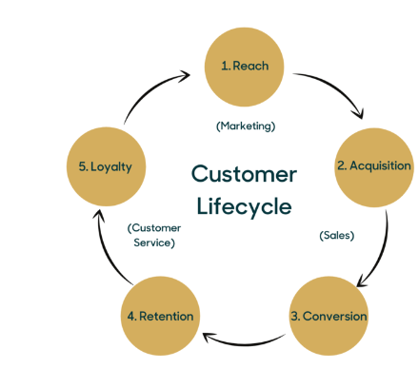
Source - Zendesk.co.uk
There are 5 steps of the customer lifecycle:
- Reach: This is the stage where a customer becomes aware of a company and its product/service that it provides.
- Acquisition: In the first stage, the customer makes their first purchase or signs up to the service. The goal is to now convert awareness into a paying customer.
- Conversion: Once a customer has made a purchase, this stage is about focusing on a smooth and positive experience for the customer.
- Retention: During this stage, the company focuses on maintaining long-term relationships with the customers. The goal is to prevent customer loss by providing ongoing value, addressing any issues promptly, and building customer loyalty.
- Loyalty: The final step of the customer lifecycle is turning satisfied customers into brand advocates. When a client becomes a brand advocate, they promote the business through word of mouth, social media, and will recommend your services to their friends.

5.3 The Kano models

The Kano Model is a theory of customer satisfaction and product development. It was developed by Noriaki Kano in the 1980s and is widely used for quality management.
According to Goffin, Varnes, Hoven, & Koners,(2012) “the growing emphasis on customers’ requirements as the basic prerequisite of customer satisfaction is one of the current trends in modern management, not only in industry but also in services.”
Grauzel & Hrnciar (2003) thinks that “increasing customer satisfaction, the areas improved are often identified by questionnaires. The organisation uses the results obtained from these questionnaires to set the areas which will get attention in order to increase the overall degree of customer satisfaction.”
However, Berry, Zeithaml, & Parasuraman, (1990) highlights that “several empirical studies have shown that this approach usually goes wrong. Customers tend to assess the quality of a product/service based on a small number of important attributes.”
As a small business owner using the Kano Model would not be of any use to me on building my business, I rely more on word of mouth, social media, and my regular clients to help grow my business.

Quality process

6.1 Quality process models

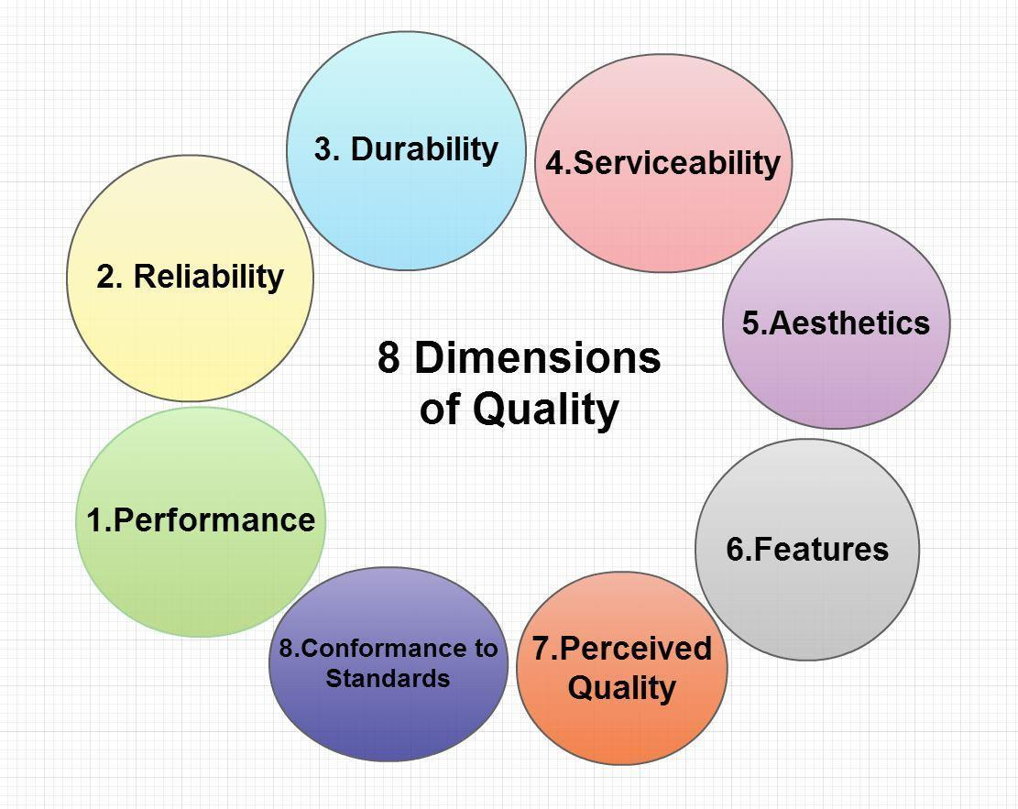
(Source- Bing)

The 8 dimensions of quality are:
- Performance: It is the ability of a product or service to fulfil its intended function and meet customers expectations.
- Features: this is the additional characteristics or capabilities that enhance the performance of a product or service.
- Reliability: This is the consistency and dependability of a product or service to perform as expected over time.
- Conformance: is the extent to which a product or service meets established standards or specifications.
- Durability: The ability of a product or service to withstand wear, tear or damage over an extended period of time.
- Serviceability: The ease and speed with which a product or service can be repaired or maintained.
- Aesthetics: The visual appeal and attractiveness of a product or service.
- Perceived Quality: This is the customer's overall perception of the quality of a product or service, which can be influenced by factors of brands used, reputation, and marketing efforts.
Steven A Fasko (2023) writes that “by considering dimensions such as performance, features, reliability, conformance, durability, serviceability, aesthetics, and perceived quality, the DoD can ensure that its acquisition processes meet the highest standards and effectively improve mission support.”

Quality process within my own organisation

Quality control is a systematic approach that is used to ensure that products or services meet specified quality standards. The goal of quality control is to try to prevent or minimise issues that could impact customers satisfaction and maintain consistency in the quality of products or services.
When using quality control in my business it is important to make sure that all products used are up to great standards, using the best quality products, making sure that products open past their use by dates are thrown away and replaced with new. This will reduce the risk of clients getting possible allergies to products.

Conclusion

To conclude this assignment, keeping customer values at the heart of a business is extremely important, it gives the service providers a chance to build up strong relationships with their customers, keeping them loyal customers which is extremely important when growing a company. It also helps us to acknowledge where we need to progress to help make our companies better.

References
Almquist, E., Senior, J., & Bloch, N. (2016). The Elements of Value. Harvard Business Review, 1.
Al-Sabbahy H, Ekinci Y, Riley M. (2004) An investigation of perceived value dimensions: implications for hospitality research. Journal of travel research 42: 226-234.
Berry, Zeithaml, & Parasuraman (1990) “Increasing accuracy of the Kano Model- a case study”
Bowden J.L.H (2009) “The process of customer engagement: a conceptual framework”, Journal of marketing theory and practice, vol. 17 no.1, pp. 63-74
Bowen, J T & Chen S, 2001, The relationship between customer loyalty and customer satisfaction, International Journal of Contemporary Hospitality Management, 13 (5)
Chandrashekaran M, Rotte K, Tax S S, & Grewal R, 2006, Satisfaction Strength and Customer Loyalty, Journal of Marketing Research
Cleghorn J, 2018, The Elements of Value, The Marketing Journal, April 11
Goffin, Varnes, Hoven & Koners (2012) “Increasing accuracy of the Kano Model - a case study.”
Grauzel & Hrneiar (2003) “Increasing accuracy of the Kano Model - a case study”
Gupta S & Ramachandran D (2021), Emerging Market Retail: Transitioning from a Product-Centric to a Customer-Centric Approach, Journal of Retailing, 97 (4)
Gutman, Jonathan (1982), “A Means-End Chain Model Based on Consumer Categorization Process,” Journal of Marketing, 46 (April), 60-72.
Hollebeek. L. (2011) “Exploring customer brand engagement: definition and themes” Journal of Strategic Marketing, Vol. 19, No. 7, pp. 555-573.
Holbrook MB, Corfman KP. (1985). Quality and value in the consumption experience: Phaedrus rides again. In Perceived Quality: How Consumers View Stores and Merchandise, Jacoby J, Olson J C. D.C. Health and Company: Lexington, MA: 31-57.
Hoyer, Wayne, Rajesh Chandy, Matilda Dorotic, Manfred Krafft, and Siddharth Singh (2010), “Customer Participation in Value Creation,” Journal of Service Research, 13 (3), 283-296.
Hyken S, 2019, How To Turn Satisfied Customers Into Loyal Customers, https://www.forbes.com/sites/shephyken/2019/04/21/how-to-turn-satisfied-customers-into-loyal-customers/, accessed 1/7/2024
Jaakkola, E. and Alexander, M. (2014) “The role of customer engagement behaviour in value co-creation: a service system perspective”, Journal of Service Research, Vol. 17, No. 3, pp. 247-261
Jayachandran, S, Sharma, S, Kaufman, P. and Raman, P. (2005), “The role of relational information process and technology use in customer relationship management”, Journal of Marketing, Vol. 69, October, pp. 177-92.
Joshi, Ashwin W, and Sanjay Sharma (2004), “Customer Knowledge Development: Antecedents and Impact on New Product Performance,” Journal of Marketing, 68 (October), 47-59
Kumar, V. and Pansari, A. (2016) “Competitive advantage through engagement”. Journal of Marketing Research, Vol. 53, No. 4, pp. 497-514.
Lengnick-Hall, Cynthia A. (1996), “Customer Contributions to Quality: A Different View of the Customer-Oriented Firm,” Academy of Management Review, 21 (3), 791-824.
Leninkumar The Relationship between Customer Satisfaction and Customer Trust on Customer Loyalty, 2016, The Relationship between Customer Satisfaction and Customer Trust on Customer Loyalty, International Journal of Academic Research in Business and Social Sciences, 7(4)
Mahajan, G. (2020). What Is Customer Value and How Can You Create It? Journal of Creating Value, 6(1), 119-121. 10.1177/2394964320903557
Ningsih, M. S. & Segoro, W. (2014). “The influence of customer satisfaction, switching cost and trusts in a brand on customer loyalty - the survey on student as im3 users in Depok, Indonesia”, Procedia-Social and Behavioral Sciences, 143
Parvatiyar, A. & Sheth, N. J. (2001). Customer relationship management: Emerging practice, process, and discipline. Journal of Economic and Social Research, 1-34.
Payne, A. and Frow, P. (2006), “Customer relationship management: from strategy to implementation”, Journal of Marketing Management, Vol. 22, pp. 135-68.
Reed-Enver L, 2024, The Power of Recommendations and Reviews in Business and Marketing, https://www.enevergroup.com.au/the-power-of-recommendations-and-reviews-in-business-and-marketing/, accessed 1/7/2024
Reichheld, F., and Sasser, W.E. (1990), ``Zero defections: quality comes to services'', Harvard Business Review, Vol. 68 September/ October, pp. 105-11.
Steven A. Fasko, D.H.A (2023) “Garvin’s Eight Dimensions of Quality and DOD Acquisition.”
Stevens, Greg A. and James Burley (2003) “Piloting the Rocket of Radical Innovation,” Research Technology Management, 46 (March-April), 16-25.
Van Doorn, J. Lemon, K.N, Mittal, V. Nass, S. Pick, D. Pirner, P. and Verhoef, P.C. (2010), “Customer engagement behaviour: theoretical foundations and research directions”, Journal of Service Research, Vol. 13, No. 3, pp. 253-266.
Vavra, Terry G. (2002) “ISO 9001: 2000 and Customer Satisfaction,” Quality Progress, 35 (May), 69-75.
Vivek, S.D, Beatty, S.E, and Morgan, R.M, (2012), “Customer engagement: exploring customer relationships beyond purchase”, Journal of Marketing Theory and Practice, Vol. 20, No. 2, pp. 122-146.
Yap, B.W., Ramayah, T., and Shahidan, W.N.W. (2012). Satisfaction and trust on customer loyalty: a PLS approach. Business Strategy Series, 13(4), 154 – 167

Appendices

Image 1. Source- Semanticscholar.org
Image 2. Value Pyramid.
Image 3. Source - Zendesk.co.uk
Image 4. Source- Bing

