A written assignment critically evaluating how Assessment for Learning can be utilised in a series of learning opportunities to aid progression across chosen areas of learning and experience.

Introduction.
This assignment will examine how Assessment For Learning (AFL) can be utilised in a series of learning opportunities to aid progression across the Areas of learning and Experience (AOLES). The subject of AFL is particularly relevant as Wales begins with the Curriculum for Wales 2022 which has been developed ‘to ensure that our children and young the people in Wales have the best opportunity and support in life to ensure that they are all able to thrive for the future of Wales’ (Welsh Government, 2021). To support all learners to thrive as suggested, a series of teaching approaches and strategies are required. This is where AFL enters teaching practice. According to Black & Wiliam, (1998) ‘Assessment for Learning helps low achievers more than other students and so reduces the range of achievement while raising achievement overall’. This would suggest that if teachers are using AFL strategies to understand the learning needs of all learners this could close the attainment gap meaning success and development for all but in particular lower ability learners. Throughout this assignment I will be critically evaluating how AFL strategies can be used in teaching and learning to underpin and scaffold pupil progression.
The learning opportunities planned and discussed in this assignment were prepared for a year 6 class of thirty-three 10–11-year-old pupils. The class consists of mixed ability groups of More Able and Talented (MAT) learners, middle ability, and lower ability learners. Within the lower ability group there are a group of pupils with additional learning needs (ALN) who are supported through differentiated tasks, support staff and individual learning plans as detailed in my lesson plans.
The focus theme this term was conflict with particular emphasis on World War 2. These learning opportunities were delivered at the beginning of this topic and the pupils used the information and knowledge gathered to write a recount diary entry from the point of view of a World War 2 evacuee at the end of term. The three learning opportunities discussed covered three AOLES: humanities, expressive arts and Literacy, languages, and communication. The humanities AOLE inspired the theme for this term. In accordance with the statement of what matters 1: enquiry, exploration and investigation inspires curiosity about the world, its past, present, and future, it was decided given that Remembrance Day would be celebrated this term it was an appropriate time to cover the theme of conflict through WW2. The aim of the learning opportunities was to give learners information and stimuli to encourage learners to explore this area of history and channel the ethically informed citizen through enquiry about the past.
From here it was decided that through the AOLE Literacy, languages and communication the learners could use their new knowledge to progress in the area of recount diary writing. To underpin the learners creative writing the expressive art learning opportunity was planned. This aimed to encourage learners to read over the stimulus text, study the illustrations and discuss the way this part of history was portrayed. The aim of this was to give learners the opportunity to collaboratively come up with descriptive language that could be recalled to write their diary entries.
There was a particular focus on gathering information and new vocabulary to create learners own bank of knowledge to use in their own work. There was also a focus on taking an empathetic approach to the topic to allow learners to reflect in their diary entries the new knowledge and information they have gained. This also progressed learners through the new four purposes in the curriculum for Wales 2022 to become ethically informed citizens by learning about the past and showing respect to others.

Literature review.

It is widely accepted that there are four key elements to Assessment for Learning; sharing criteria with learners, quality of questions/quality of talk, use and quality of feedback and peer and self-assessment (Black & William, 1998). These four elements to AFL give teachers a clear guide on the types of feedback that make good teaching and learning but also the types of feedback that could be used to aid pupil progression. Research into AFL strategies provides both strengths and challenges to the use of these strategies, both of which will be explored in this section. Vygotsky’s sociocultural theory suggests that learning has a social aspect and that children will engage in problem solving and challenging conversations regarding their learning when scaffolded to do so. A key component to this theory is thought to be the idea of this conversation being with more knowledgeable others. This could reference a teacher or another child such as a MAT learner. (Saul Mcleod, 2022).
This theory could be taken to imply that learning is a social activity which could suggest that an effective learning environment would be a dialogue rich environment where learners are encouraged to discuss their ideas, theories and findings which feeds into the quality of questions/quality of talk element to AFL.
Practical examples of this AFL strategy could include but are not limited to; see, think, wonder discussions where learners are given a stimulus and the three statements to build opinions and ideas around, ‘speed dating’ or reflection alley style activities where learners are lined up and have a set amount of time to give opinions to the person opposite in the hopes of coming to a shared conclusion, Debono’s thinking hats (to be discussed further on) where learners are assigned roles in the conversation, consensorgrams where by learners all take turns to write their ideas or opinions onto large pieces of paper to see were the majority opinion lies and think, pair, share where learners are posed a question, given time to think about it then ‘pair’ up with another learner and share ideas.
A possible weakness to this element of AFL as suggested in research gathered by (Cambridge Assessment, 2022) could be that teachers fear they could lose control in the classroom by using this AFL strategy. It is noted that as this is a social form of AFL it will require discussion that could allow learners to get off track with their learning. This research goes on to explain that this is usually a concern that is overcome when these discussions are structured appropriately.
Similarly, it is suggested in research by (Welsh Assembly Government , 2010) that teachers are apprehensive about small group work as it could cause pupils to lose focus although it is also stated this type of group work leads to dialogue that checks and reinforces understanding.
However new research by (Voice 21, 2022) suggests that ‘on average pupils who take part in spoken language interventions make approximately 5 months of additional progress over a year, with some studies showing the progress of up to six months for pupils from economically disadvantaged backgrounds. This research became the foundation of the Voice 21 Oracy scheme. This scheme scaffolds pupils’ verbal discussions to underpin learning and aid pupil progression. This scheme formed part of my learning opportunities to be discussed later in this assignment.
Both Osborn (1953) & DeBono (1971) theorised about creative aspects of AFL. DeBono suggested the thinking hats tool in which pupils would take on individual roles in a discussion to broaden their thinking and challenge their learning. This strategy could allow a teacher to assess pupil learning of a subject so far and could aid in pupil progression by allowing the teacher to see where the learning needs to go next. Osborn (1953) emphasised the tool of brainstorming to encourage learners to collaboratively tackle a learning challenge. This can be seen in modern AFL strategies such as the snowball questioning strategy where a teacher asks a question about the learning topic and pupils need to give answers that build upon each other’s statements. This strategy could allow a teacher to see the flexibility in the pupil’s knowledge and could help to identify gaps in knowledge that could form the next steps in learning. Suggested weaknesses to these strategies reflect the ones discussed above where a teacher may be hesitant due to a fear of lack of control or pupils getting off task. Klenowski, (2009) suggests that there could be a flaw to teachers focussing on where the learning needs to go next. Klenowski suggests that deciding on where pupils are in their learning and where to go next can be misconstrued and lead to teachers assessing pupils learning level and solely focussing on getting that pupil onto the next learning level possibly, without ensuring that the learning that has taken place was real, sustained and flexible knowledge. These strategies could be linked to the use and quality of feedback element of AFL.

In regard to the peer and self-assessment element to AFL, Donaldson, (2015) suggested that in order for pupils to have sustained learning that will stay with them for life they must be able to reflect and assess on their own learning and progression. This also feeds into the new four purposes of leading pupils to become ambitious capable learners who set themselves challenges and seek out high standards. Equally, Donaldson suggests that peer assessment demonstrates a pupil’s knowledge and understanding as they must have a flexible understanding of the learning to be able to study and give feedback on another learner’s work. It is theorised that peer assessment can lead to discussions that help learners understand the knowledge on a deeper level.
Practical examples of this element of AFL could include but are not limited to; traffic lights to show confidence level in learners work, self-assessing how a learner is fining the work by colouring in a square into the margins of their workbooks and having good success criteria and potentially what a good one looks like (WAGOLL) to successfully self or peer assess work using a guide. The success criteria element to AFL ties into peer and self-assessment element in many ways as there could be many possible overlaps, potentially, in order for a pupil to successfully peer or self-assess they need clear guidelines and a point of reference to assess against.
Contradictory to this, Webb & Jones , (2009) research suggests that honesty and trust are some of the foundations to a classroom that underpins the ethos of achievement however these are difficult to achieve. They theorised that this could be down to a lack of time or training in this area of AFL and possibly the teacher found it difficult to teach trust and honesty as traits when peer and self-assessing learning as many learners see getting an answer wrong as failing instead of taking it as a learning opportunity.
Lastly, Florez & Sammons, (2013) suggest that AFL strategies underpins pupils to become active participants in their own learning and the classroom. They also suggest that with a variety of AFL strategies a learner will develop a strong self-image and relationship with learning specifically with having the resilience to have another attempt at learning if they have not been successful originally. This is a required trait across all four elements of AFL as this confidence and resilience is needed to ensure that learners are fully participating in the assessment for learning and there for providing their teacher with the necessary information to assess a pupil’s learning needs and how to support their own progression. Research conducted by Cambridge Assessment, (2022) argues that AFL strategies may not provide learners with a strong self-image and relationship with learning as MAT learners could find it challenging to critique their work and may be reluctant to critically analyse their work in effort to avoid showing failure or uncertainty to their peers.

Discussion of lesson planning decisions.
Whilst on my professional teaching experience 2 (PTE2) I planned a series of lessons within our term topic of conflict. The aim of this term was to monitor pupils’ progression in regard to recount diary writing, at the start of term learners completed a ‘cold task’ where they wrote a diary entry without any teaching input, practice, or stimuli. This was in the hopes of gaining a clear idea of where the pupils learning was at the start of term. At the end of term pupils will complete the ‘hot task’ where pupils will use all the knowledge and new learning they have gained. This should show steady pupil progression in the chosen areas. It was then decided that in order to aid pupil progression and to extend their writing a series of lessons would be planned to encourage learners to think creatively using a broad scope of language and imagery. These aims are where the learning opportunities were planned from. I chose to plan a humanities lesson for this topic as I felt it was important to give learners a base line of knowledge surrounding the theme conflict. The lesson was planned around the statement of what matters 1(WM1) for humanities – inquiry, exploration and investigation inspire curiosity about the world its past, present, and future. (Welsh Government 2020). This WM statement underpins learners’ natural curiosity about the unknown, so I decided to plan a discussion and writing lesson around a number of stimulus images, videos, and diary entries in the hopes of sparking creativity in the learners. I was able to find local sources for these stimuli which made the learning more real for many pupils and through discussion we found out that one pupil was aware that their family had taken in an evacuee during WW2. The aim of this lesson was to spark learners’ interest and begin that rich discussion that would lead to their creative writing later on.
From here, the second lesson was planned. I decided that the next step in the pupil’s progression was to give them a structured opportunity to discuss their knew knowledge and implement what they have already learnt. As highlighted in the literature review, research has been conducted regarding the role discussion and oracy has on learners written work. I planned an Oracy focus lesson around the WM3 language, literacy and communication statement – expressing ourselves through language is key to communication. (Welsh Government 2020). The aim of this lesson was to give the learners our model text ‘Rose Blanche’ and encourage learners to discuss the model text in detail. This model text was chosen as it gave context to why there were local evacuees during WW2 and what the world conflict was at that point in history. This was to underpin one of the four purposes to be an ethically informed citizen who knows about the past and the different viewpoints that make up our opinions. This lesson aimed to give learners a scaffold to a vocabulary rich discussion surrounding the topic of conflict. Finally, the third lesson plan was planned around the WM1 statement for expressive arts - Exploring the expressive arts is essential to develop artistic skills and knowledge and it enables learners to become curious and creative individuals. (Welsh Government 2020). The aim of this lesson was for pupils to further discuss the model text and break down the illustrations in the story to not only cement their understanding of the text but also to understand how imagery can be used within creative writing and to encourage them to think of an image for their writing to generate descriptive and creative ideas.
(Douglas, 2023) suggests that using a stimulus as a ‘hook’ to start a topic can be hugely affective as it engages pupils, motivates them to solve or to inquire about a topic and pupils gain fulfilment from this type of learning. Contradictory to this, Young & Ferguson, (2021) disagree and imply that research suggests that teachers usually set tasks with a stimulus that is typically tailored within the needs of teacher assessment thus limiting the range of creativity that learners could display. After conducting this own research I decided that I would still provide a stimulus to the learners as I felt it would give them context and content knowledge however, I ensured that during discussion and writing learners could be responsible for their on creativity so as not to limit them but provided a success criteria which detailed steps to success to ensure they had covered what I expected them to learn within their own creativity.

In this section I will discuss some AFL strategies that I incorporated into my lesson planning. I will be discussing one strategy for each of the four elements to AFL; sharing success criteria, quality of questions/quality of talk, use and quality of feedback and peer and self-assessment.
In regard to sharing success criteria, I decided to make a skill slip with steps to success on it (appendix 1). Prior to starting the humanities lesson (appendix 2) I discussed this success criteria with learners to ensure they understood the aim of the task but also how to lay their work out. I also ensured that the learners understood which pieces of information we needed to acquire. Hattie, (2012) suggests that success criteria needs to show children not only what success looks like as in the end product but also the steps that will allow pupils to reach success. However, I was cautious of limiting learners’ creativity as discussed by Young & Ferguson above. To overcome this, I included a mind map section to this lesson where learners could document any additional thoughts/feelings/ideas surrounding being an evacuee. (Appendix 3). At the end of this lesson, we discussed the success criteria again and students checked over their work to check they had covered all ‘steps to success’.
In regard to quality of questions and quality of talk I chose to use the research discussed in the literature review conducted for Voice 21. Voice 21 created a series of ‘talk tactics’ (appendix 4) that could help to structure a group discussion. I then turned these into lanyards for each pupil to wear to use as scaffolds for the discussion in the Literacy, languages, and communication lesson (appendix 5). These talk tactic lanyards gave each pupil a role in the discussion and some sentence starters to help them fulfil this role. This allows the students to have a comprehensive and thorough conversation regarding the model text. It also allowed me to assess what the pupils had learnt so far and possible ideas I could introduce using my teacher talk tactics to move their learning on (appendix 4). I was very cautious of the discussion getting off topic as discussed by Cambridge Assessment (2022) in the literature review. I was also cautious of the fact that these lanyards were a new tool in the classroom which could also cause the learning to get off track. To overcome this, I had a series of questions prepared to refocus the discussion however I found the pupils to be deeply engaged and following their roles as outlined on their cards. I also found that these talk lanyards gave confidence to some lower ability learners and proved to be the scaffold required to encourage them to be adventurous with their talking points and by the end of this lesson all pupils in this activity were contributing to the conversation and having topical debates surrounding each other’s ideas. To extend some of the MAT learners during this activity I chose to delegate the role of summarising what had been discussed so far to these learners and they then chose where the discussion was heading next. I feel that this challenged the MAT learners but also allowed them to act as that more knowledgeable other (Vygotsky) as discussed in the literature review.
In regard to use and quality of feedback and peer and self-assessment I used a think, pair, share strategy and success criteria in for assessment for learning during my expressive arts lesson (appendix 6). I firstly covered some success criteria that I expected to see in the learner’s art to give a clear goal and steps to success. I then asked the pupils to ‘think, pair, share’ over the model text to find examples of the illustrator showing moods and feelings specifically. This not only related directly to the success criteria, but it also contributed to the bigger picture which would be the end goal of pupils writing a diary entry using creative and adventurous vocabulary and imagery. From here the learners set off on their artwork. During my mini plenary I encouraged learners to peer assess each others work against the success criteria and to then give feedback to each other on how to improve their work to reach the success criteria. It was then a personal choice of each pupil whether to take this feedback on board or to discard it. The bigger picture aim of this activity was to improve learners creative writing through imagery so as long as this feedback was creating a language rich conversation regarding the imagery pupils were still progressing irrespective of their individual art skill level. I found that all pupils were engaging in this type of discussion and witnessed many children suggesting ways to achieve the mood or feeling of the story better. At the end of the lesson, I encouraged learners to review the success criteria and the feedback they were given from their peers to determine if they had achieved the steps to success. I was cautious about these two elements of assessment for learning and making the feedback and assessments fair and work relevant as outlined by Webb & Jones (2009) in the literature review. This is why I made the decision to combine them in this lesson so I could give learners the steps to success which would underpin their peer assessment finally leading to their own structured and relevant self-assessment. I found that because I had added success criteria to begin with, students had a clear idea of the expectations and also the steps to success so when it came to giving feedback through assessment the pupils knew what success looked like so limited their feedback based on this.

Conclusion.
To conclude, assessment for learning strategies as outlined above and, in my lesson planning has consistently provided me with opportunities to understand where pupils are in their learning. Through research outlined in my literature review I have considered possible limitations to assessment for learning however I have found that for the majority of scenarios the benefits outweigh the limitations. I found that not only planning to use assessment for learning strategies but also planning when in the lesson I would use them allowed me more control over the outcome of the learning. It allowed me to ensure I had questions to extend and challenge pupils learning but also to assess individually to identify any learners who needed extra support. I also found that my opening phases were far more engaging for pupils when adding in AFL strategies, I also found that in most scenarios’ pupil progression was aided by these strategies as they usually involved some aspect of shared thinking or feedback which many students used as a scaffold for their own learning. To begin with peer and self-assessment was the most challenging element to afl with the class I worked with. They found it difficult to move away from generic comments complimenting each other’s work. This is why I moved to combine giving success criteria and peer and self-assessment in many instances as it gave learners starting points to assess work. I found that many pupils were able to use the success criteria to form their feedback and from here could suggest other improvements relevant to the task. A possible weakness to planning assessment for learning strategies into lesson plans could be that commonly ideas and the flow of a lesson can change depending on the knowledge and skills of the pupils. This could mean that if something has been explicitly planned it may need to be changed according to the pupils needs in the moment. This is why it is detrimental to not only good teaching and learning but also to pupil progression that a teacher has a broad range of assessment for learning strategies that they are confident to implement in the moment while teaching. It is my experience thus far that in order to underpin pupil progression It is paramount that assessment for learning has its place in all areas of teaching, learning and experience.

Appendices.

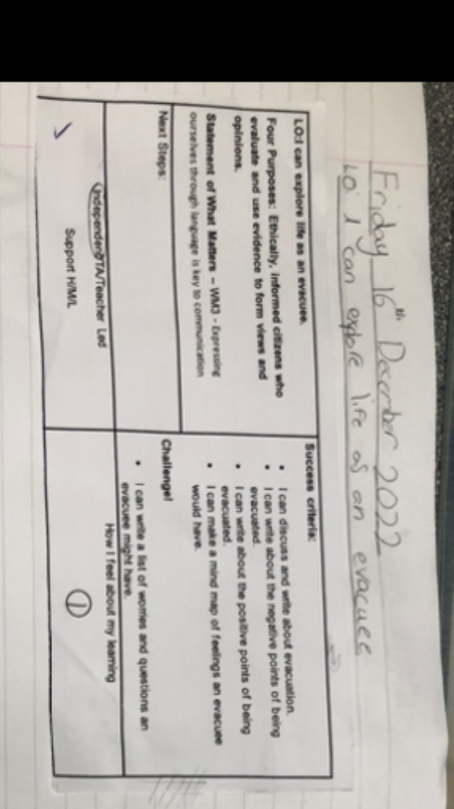
Appendix 1 – skill slip.

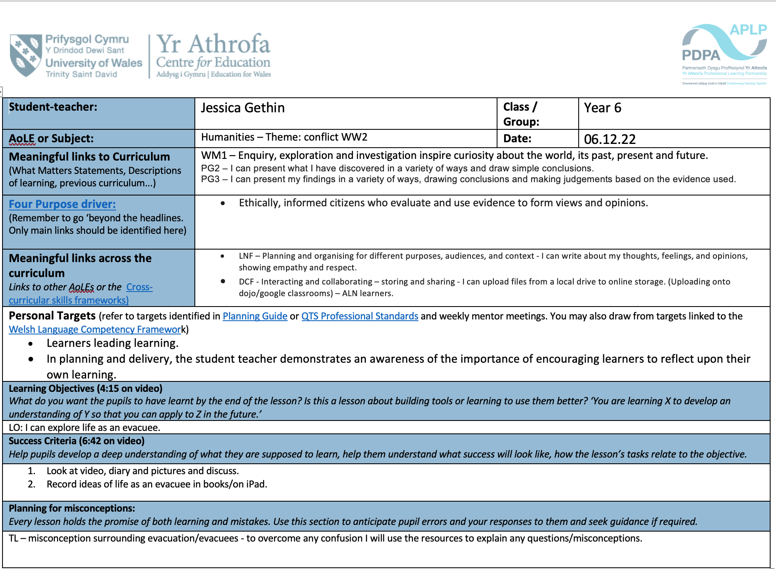
Appendix 2 – humanities lesson plan

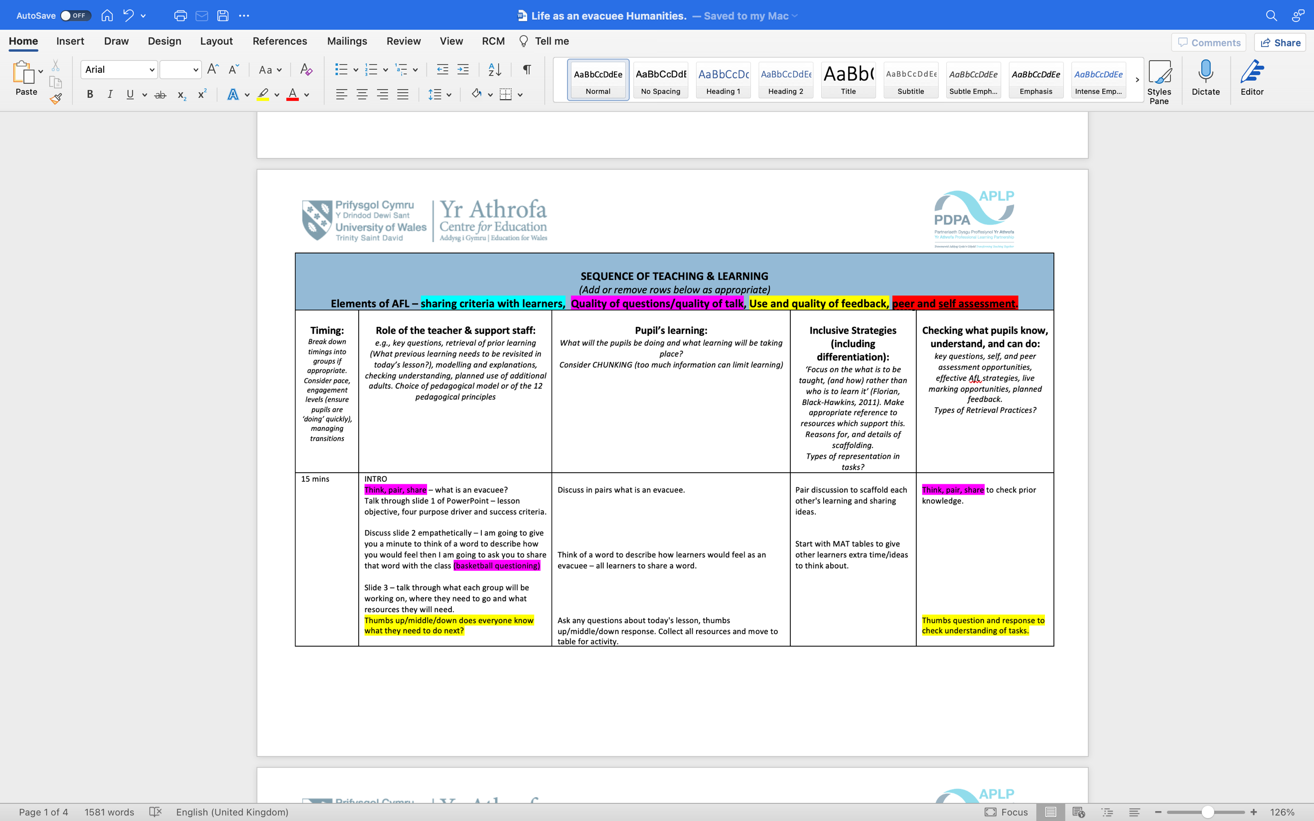

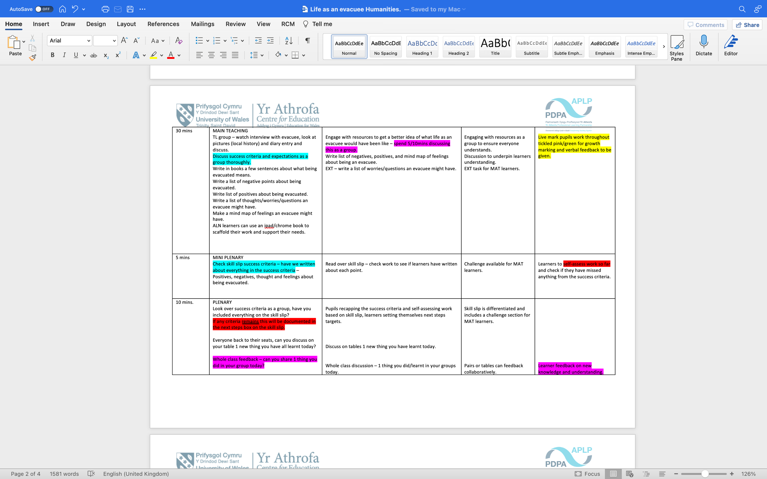

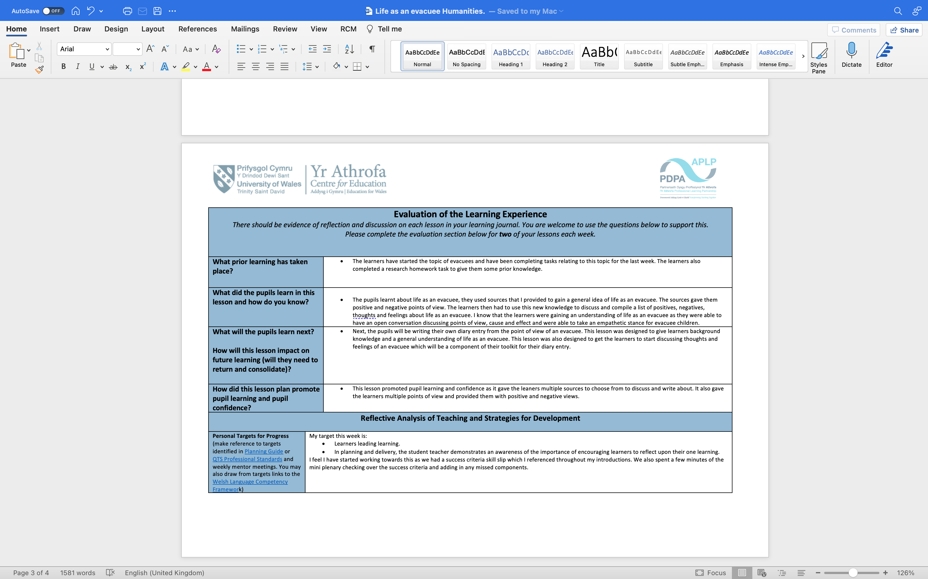

Appendix 3 – mindmap.
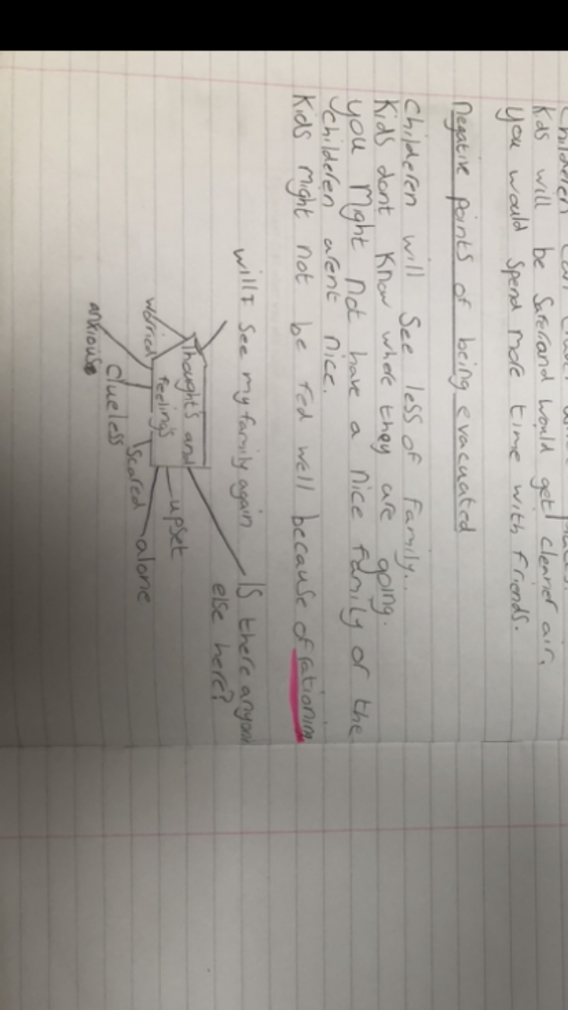

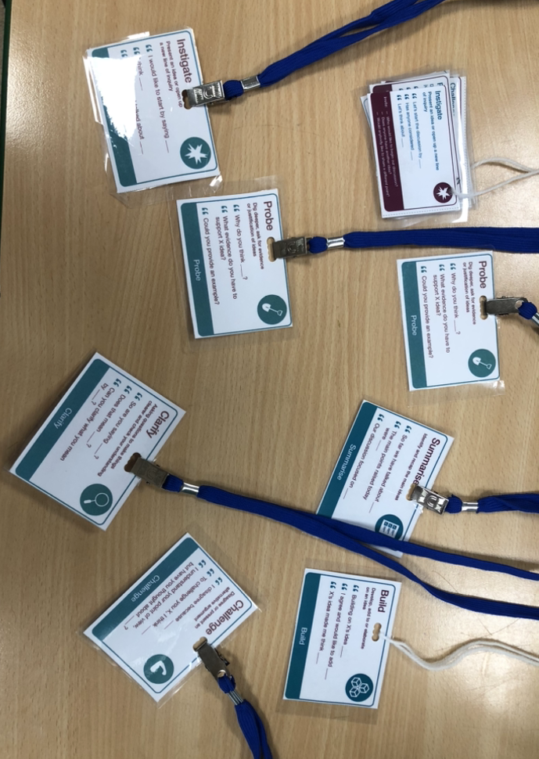
Appendix 4 – student 7 teacher talk tactic lanyards.

Appendix 5 – Language, literacy and communication lesson plan.
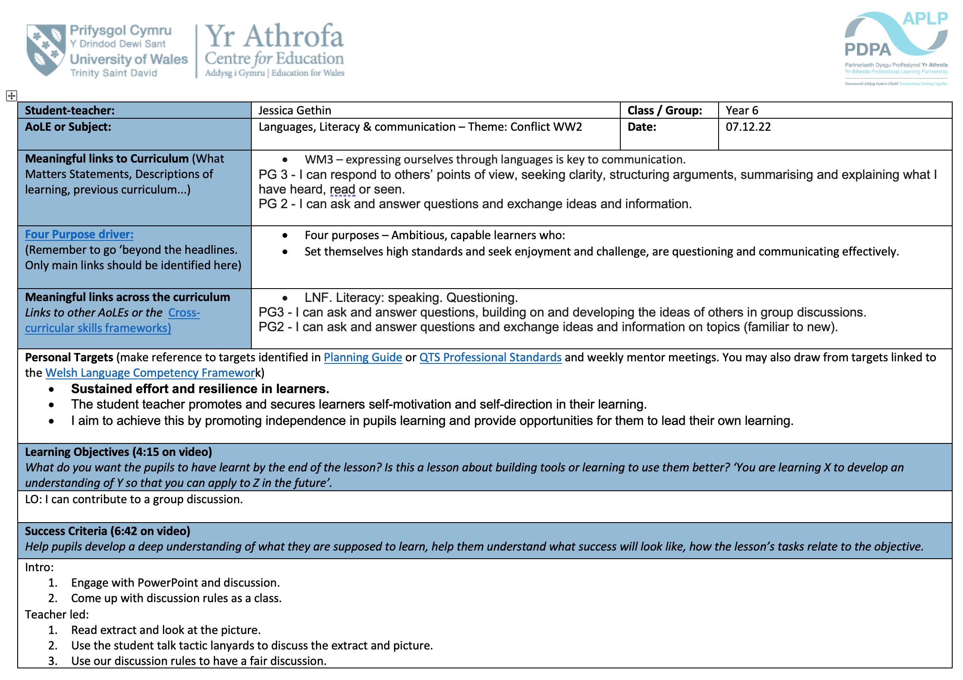
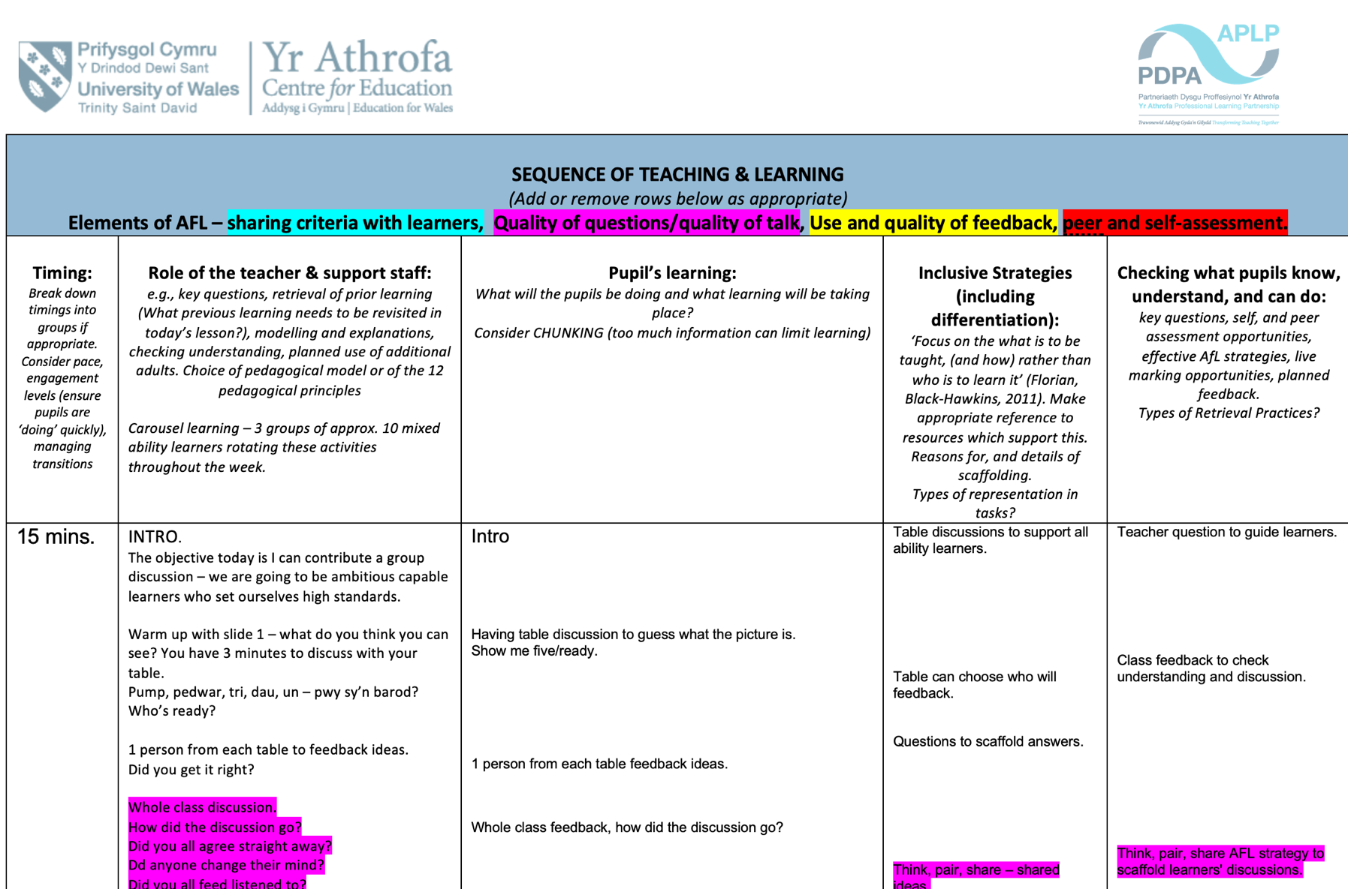
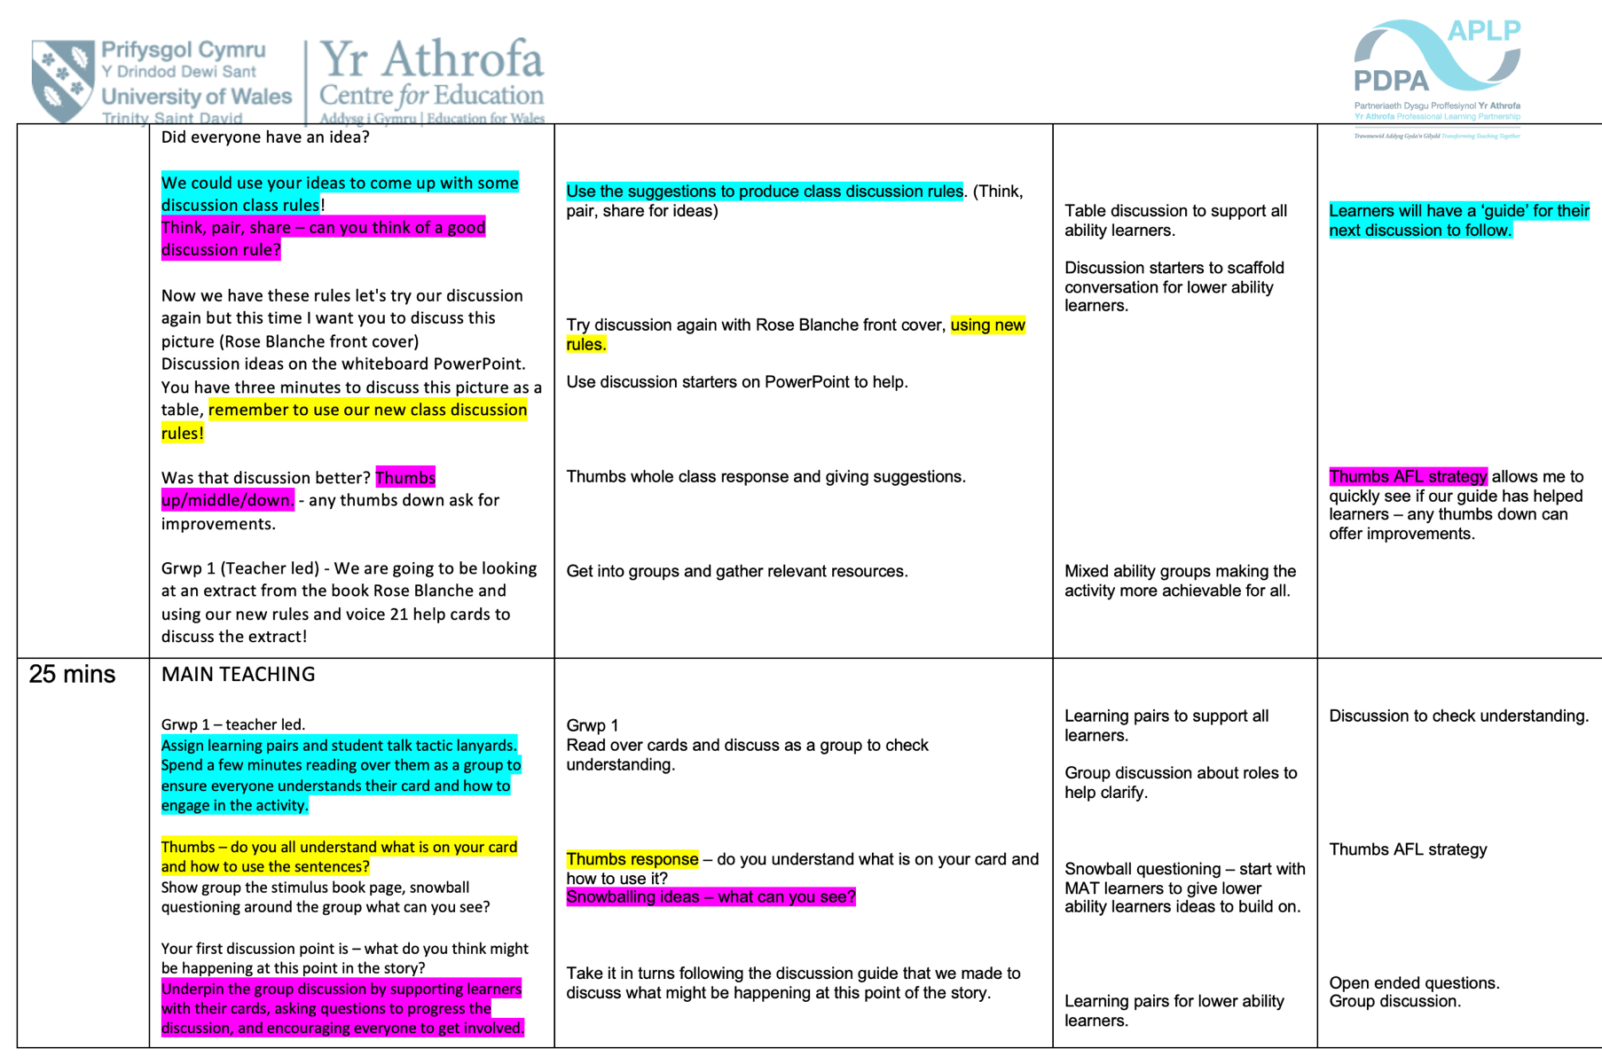

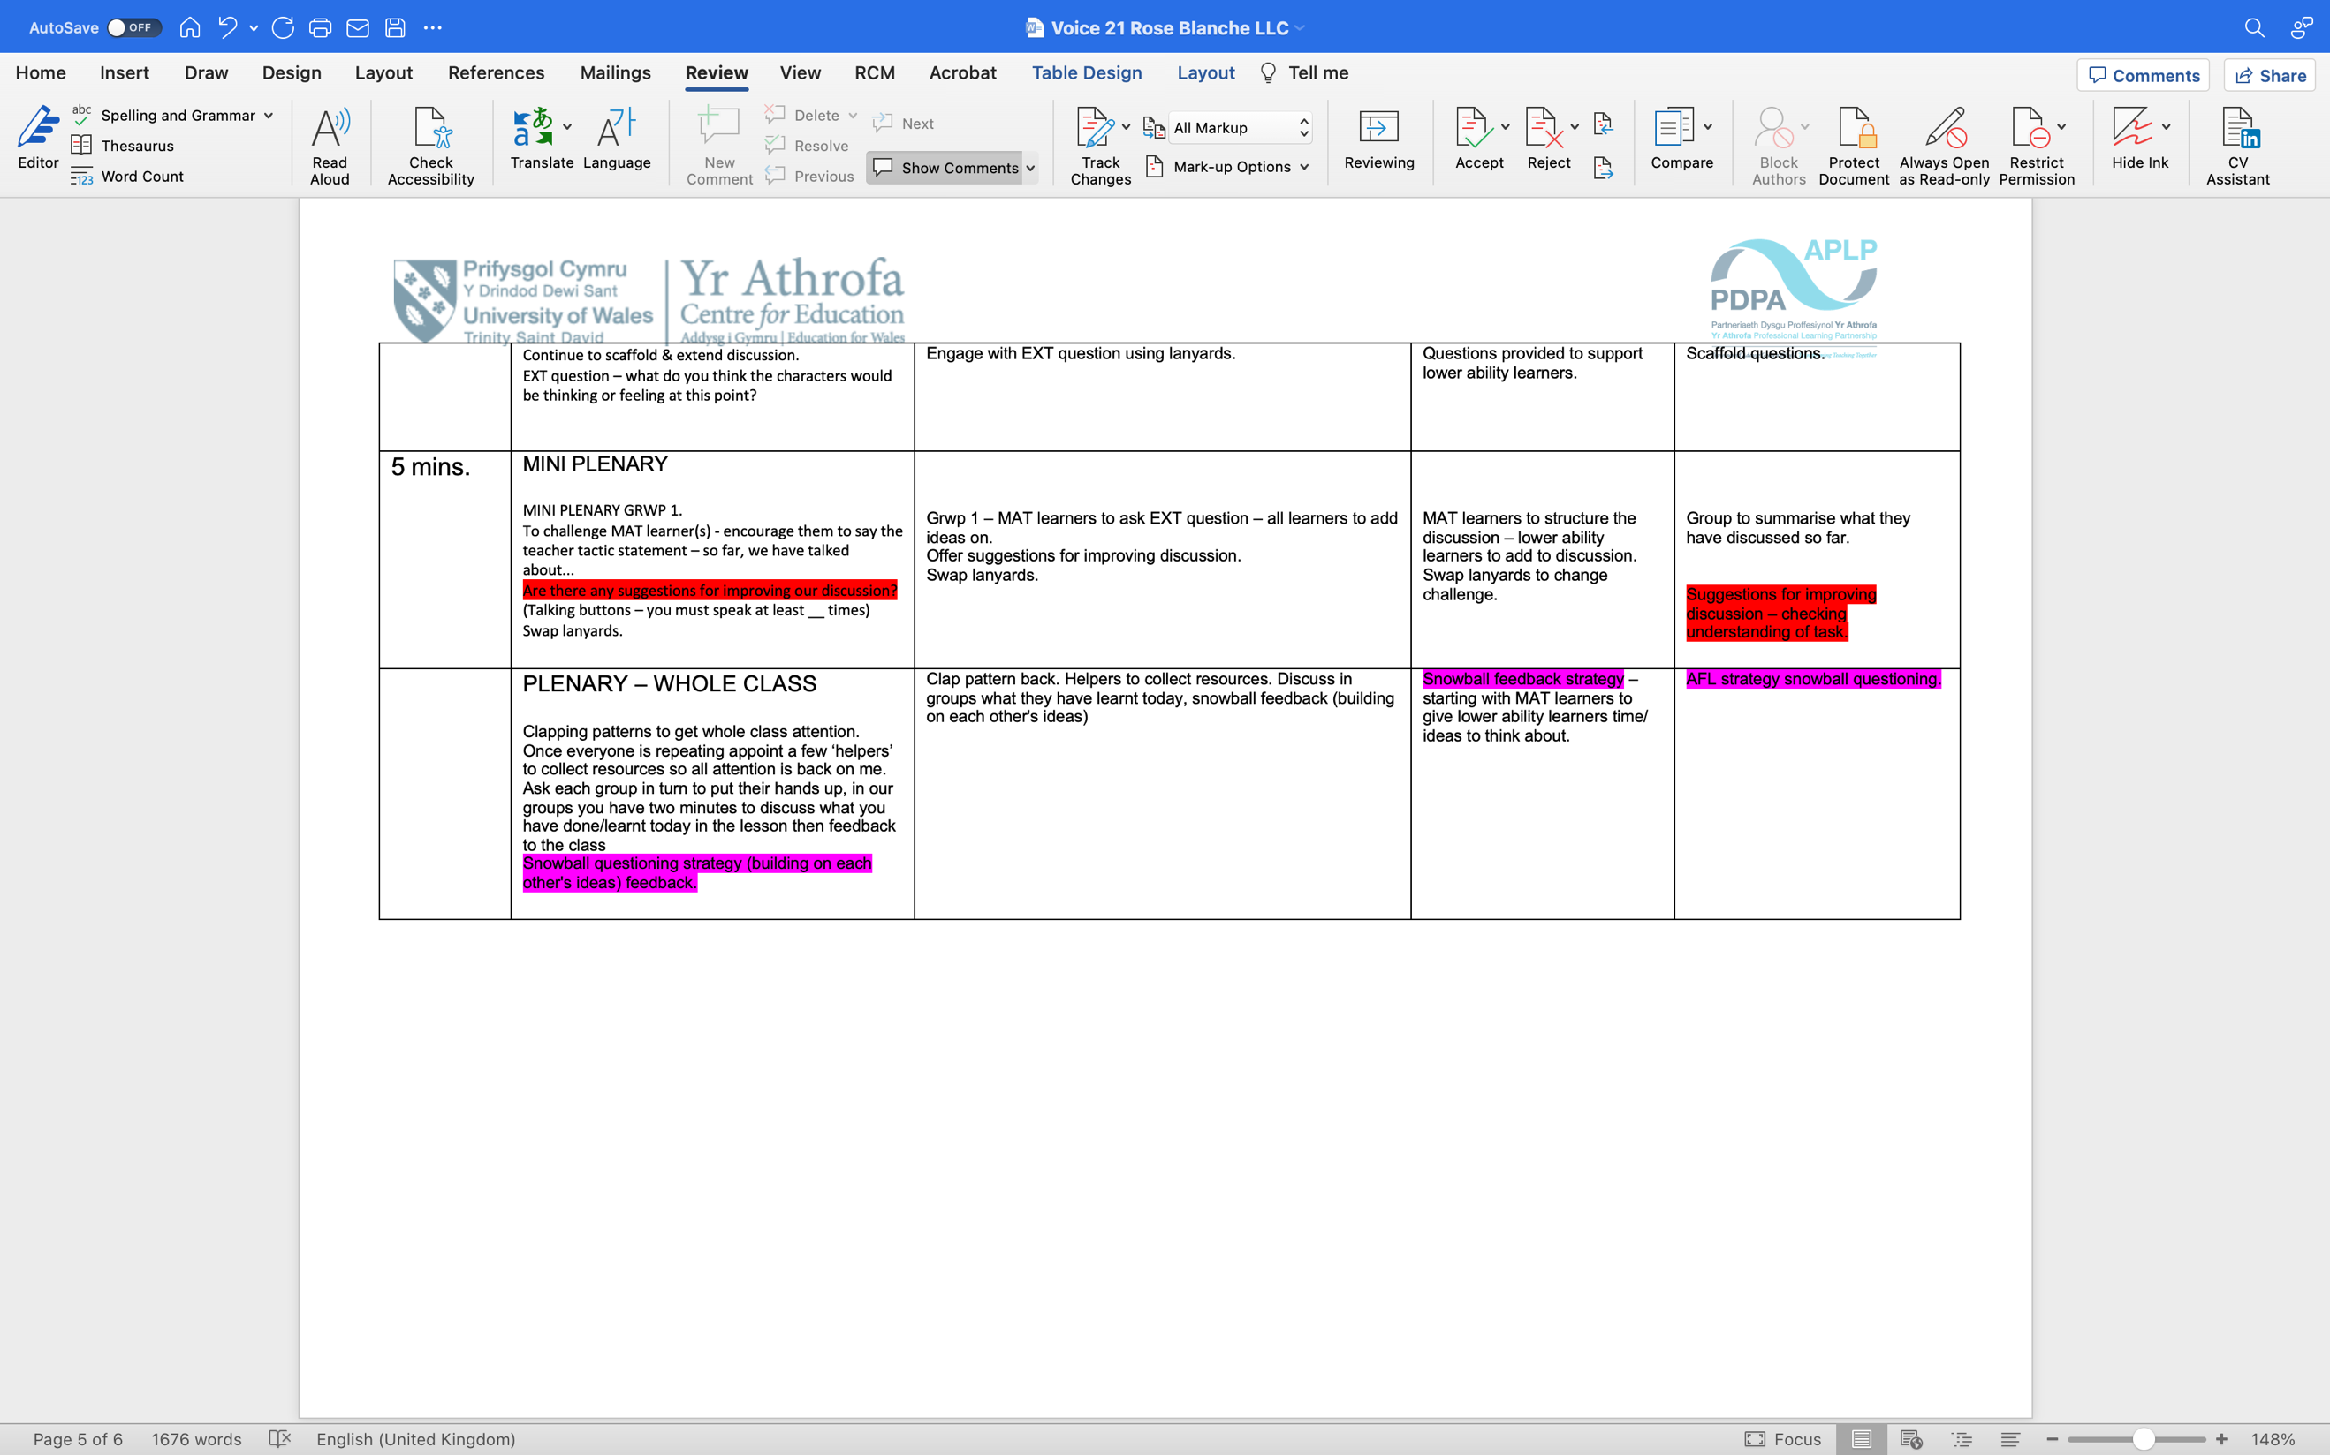

Appendix 6 – Expressive arts lesson plan.
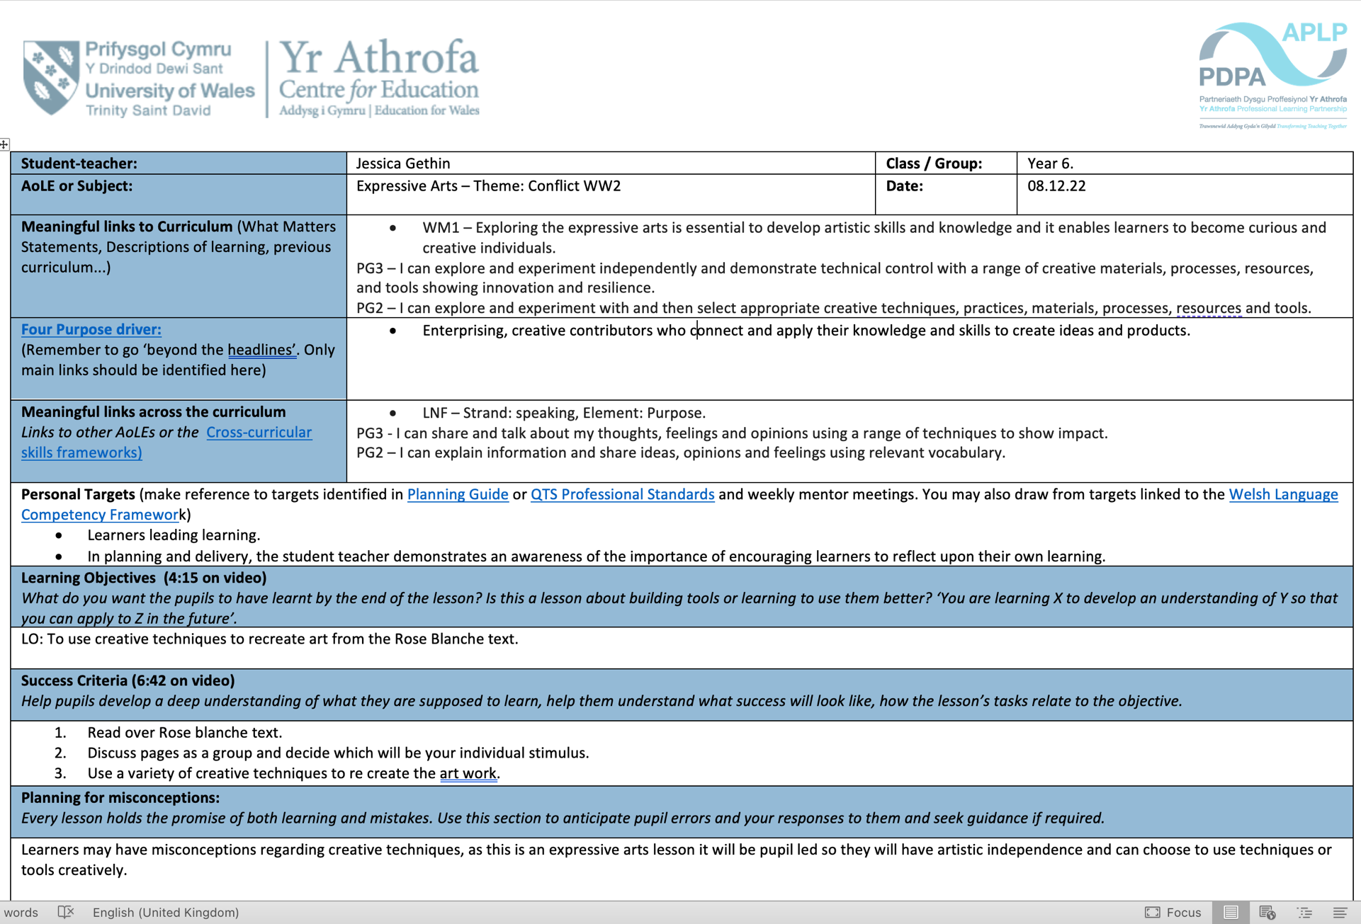

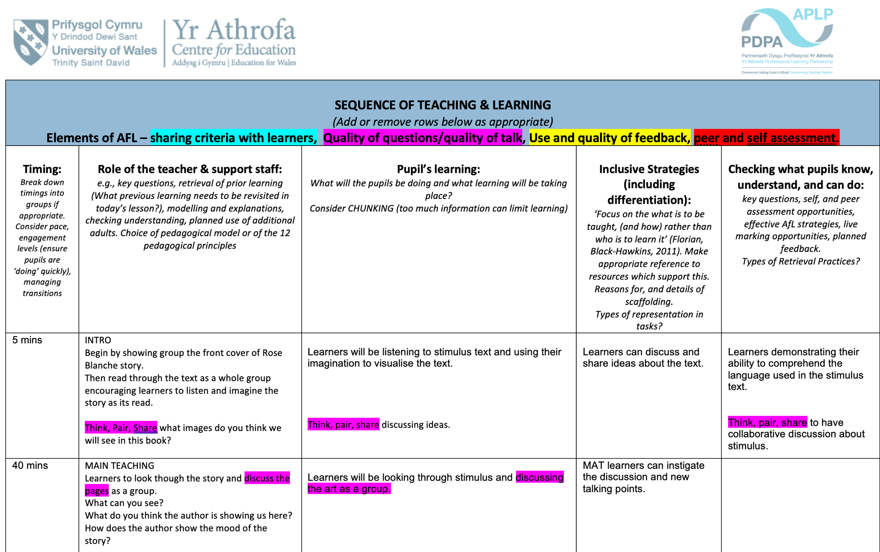

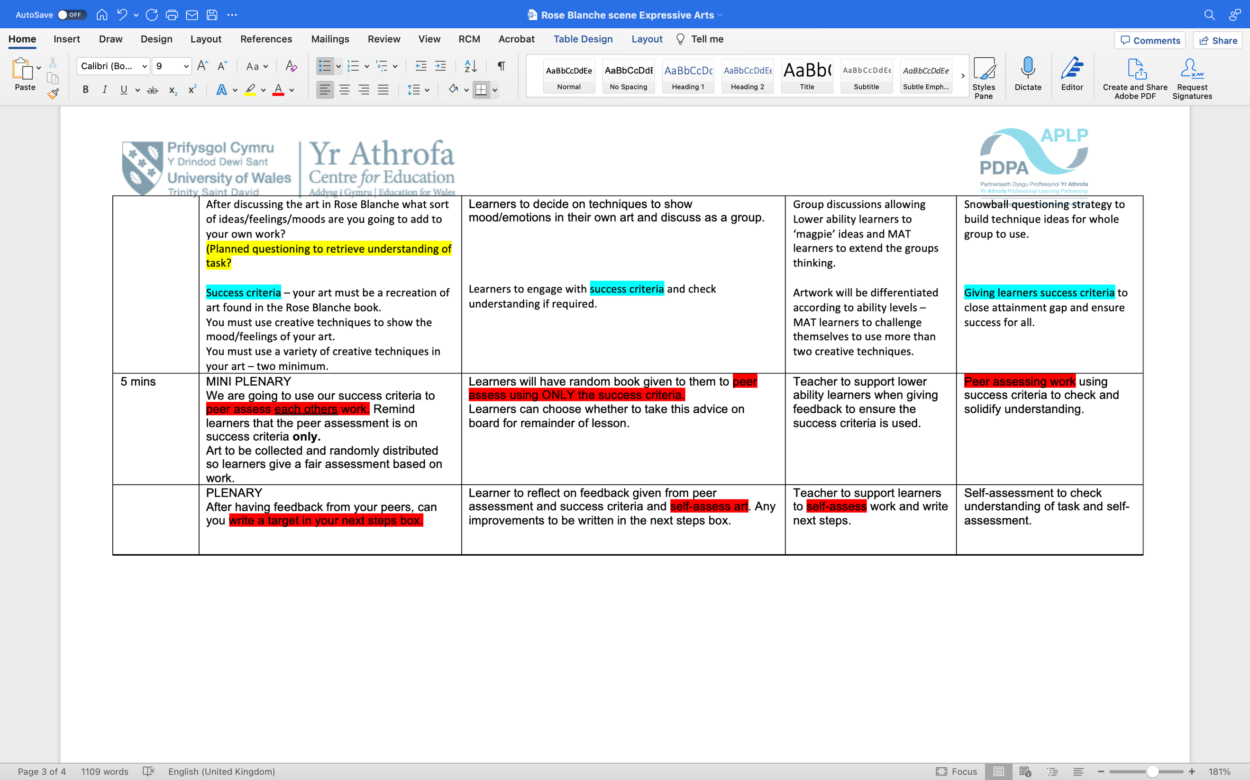
Reference list.

Black, P. & Wiliam, D., 1998. Inside the black box: raising standards through classroom assessment. Phi Delta Kappan, pp. 5-6.

Cambridge Assessment, 2022. Getting started with Assessment for learning. [Online]
Available at: https://cambridge-community.org.uk/professional-development/gswafl/index.html
[Accessed 17 December 2022].

Donaldson, P. G., 2015. Successful Futures. [Online]
Available at: https://www.gov.wales/sites/default/files/publications/2018-03/successful-futures.pdf
[Accessed 17 December 2022].

Douglas, H., 2023. creative writing in a classroom: start with a stimulus. [Online]
Available at: https://prowritingaid.com/art/1057/using-a-writing-stimulus-in-the-classroom.aspx
[Accessed 1 January 2023].

Florez, M. T. & Sammons, P., 2013. Assessment for learning: effects and impact. [Online]
Available at: https://files.eric.ed.gov/fulltext/ED546817.pdf
[Accessed 17 December 2022].

Hattie, D. J., 2012. Learning intentions and success criteria [Interview] (2 November 2012).

Klenowski, V., 2009. Assessment for learning revisited. Assessment in Education Principles Policy and practice , Volume 16, pp. 263-268.

Saul Mcleod, p., 2022. Vygotsky's Sociocultural theory of cognitive development. [Online]
Available at: https://www.simplypsychology.org/vygotsky.html
[Accessed 17 December 2022].

Voice 21, 2022. Why Oracy matters. [Online]
Available at: https://voice21.org/why-oracy-matters/
[Accessed 17 December 2022].

Webb, M. & Jones , J., 2009. Exploring tensions in developing assessment for learning. Assessment in Education: Principles, Policy & Practice , 16(2).

Welsh Assembly Government , 2010. How to develop thinking and assessment for learning in the classroom. [Online]
Available at: https://hwb.gov.wales/api/storage/663d00fd-9c3b-4003-9a1f-0012bad39fad/how-to-develop-thinking-and-assessment-for-learning-in-the-classroom.pdf
[Accessed 17 December 2022].

Welsh Government, 2021. Wales's new curriculum. [Online]
Available at: https://www.gov.wales/5-things-you-may-not-know-about-waless-new-curriculum
[Accessed 17 December 2022].

Young , R. & Ferguson, F., 2021. Writing for pleasure. 1st ed. New York : Routledge.

