Programme – HNC/D Mechanical Engineering

Module – HNC Design

Module Code – PSDM5010

Lecturer – Morgan Lewis

Student – Gruff Williams

Contents Page

Introduction – page 6

Images – pages 7 – 10

Reference page – 11

Introduction

Images of the calculated and designed gears for the flap actuator. Images made on the computer software fusion 360.

Images of the designed gear configuration for the flap actuator. These images were created on the computer software fusion 360.

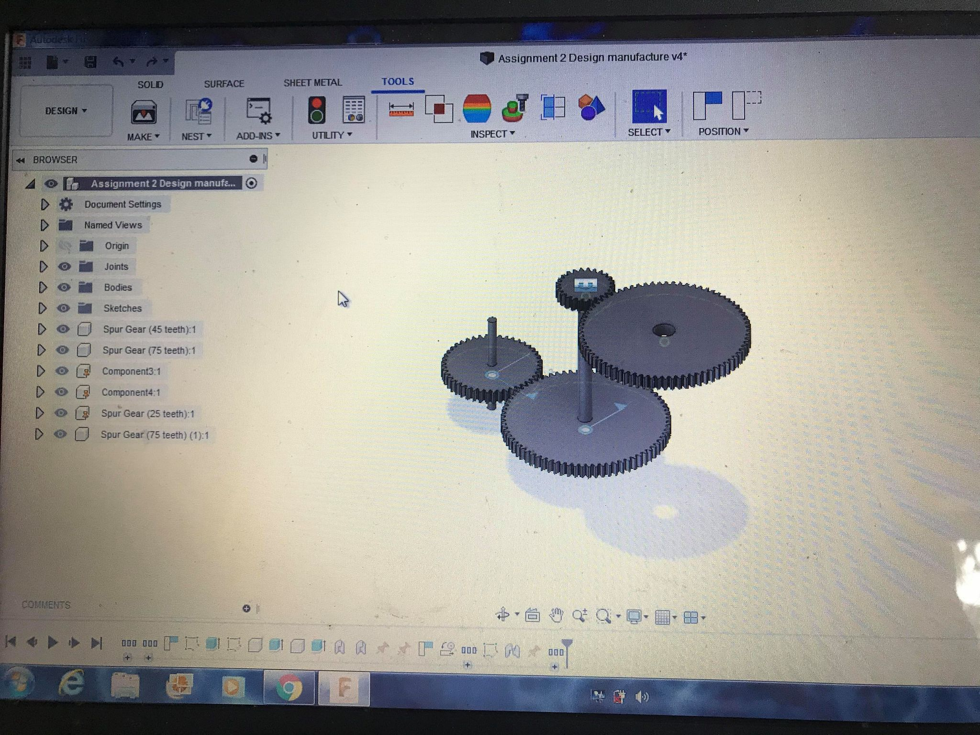

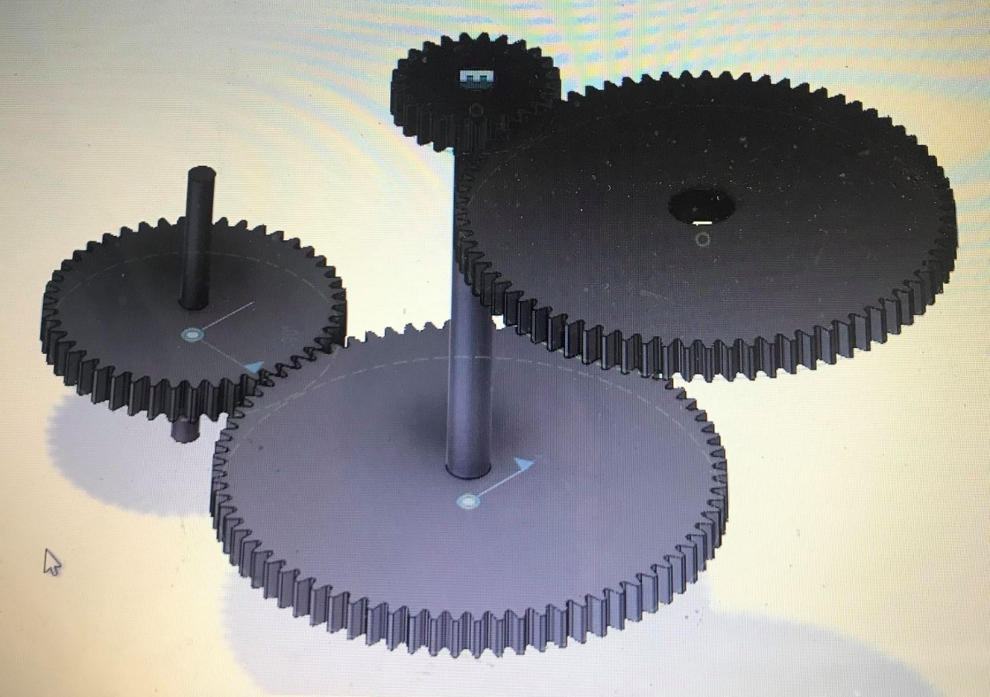

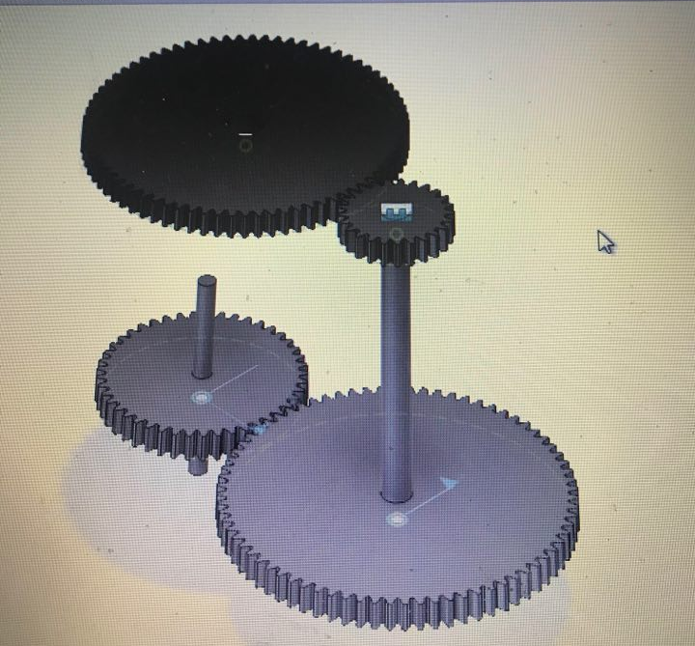

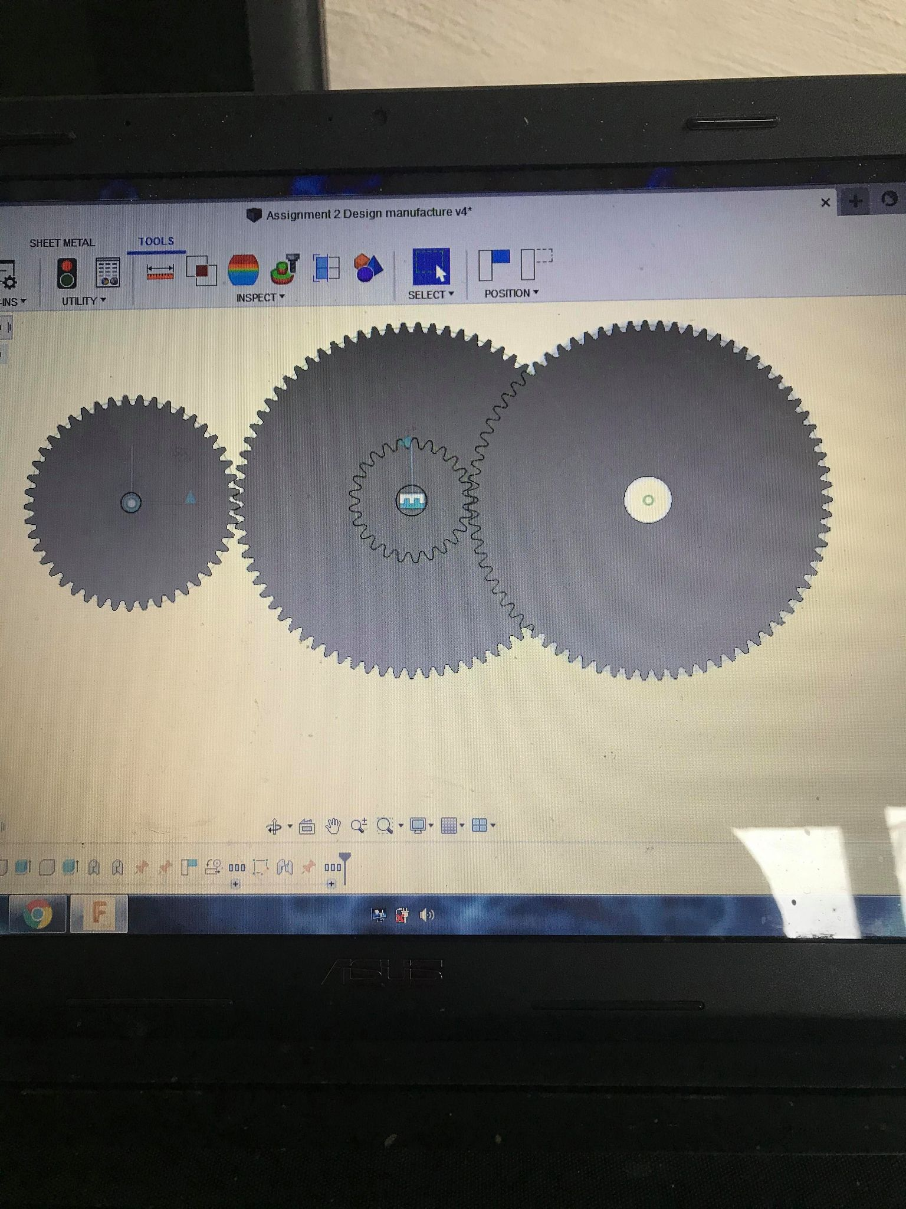

Reference page

Society of Automotive Engineers (1990). Gear Design: Manufacturing and Inspection Manual (Advances in Engineering). .: Society of Automotive Engineers.

Tutorial Books (2019). Autodesk Fusion 360 For Beginners. .: Independently published

