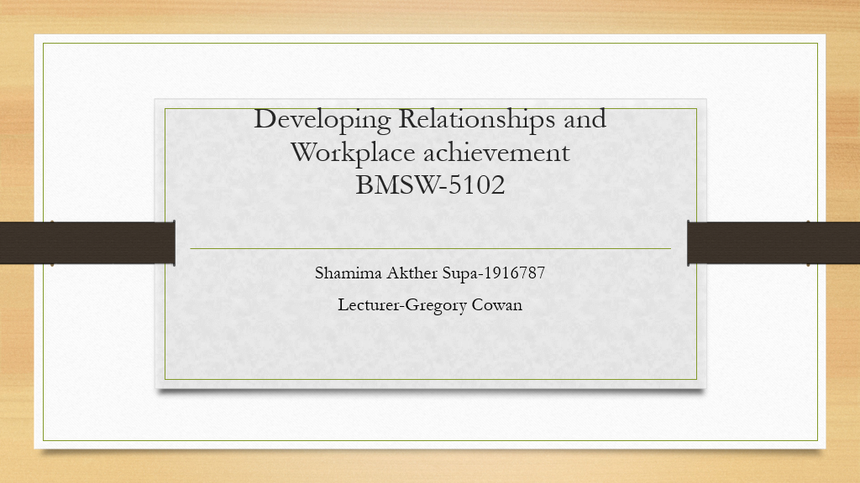

Developing Relationships and Workplace Achievement BMSW-5102 T2G1
Shamima Akther Supa-1916787
Lecturer-Gregory Cowan

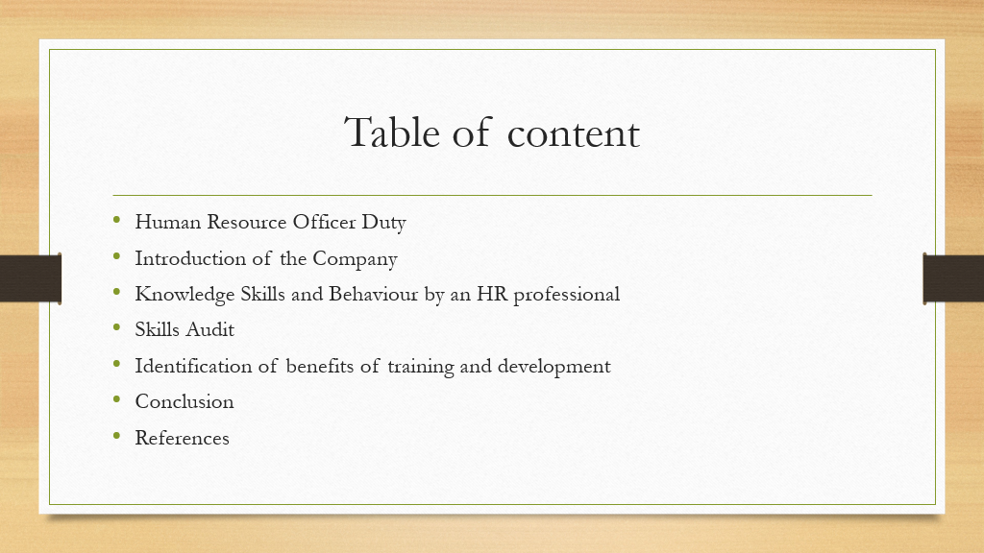
Table of Content
Human Resource officer duty
Introduction of the Company
Knowledge Skills and Behaviour by an HR professional
Skills Audit
Identification of Benefits of training and development
Conclusion
References

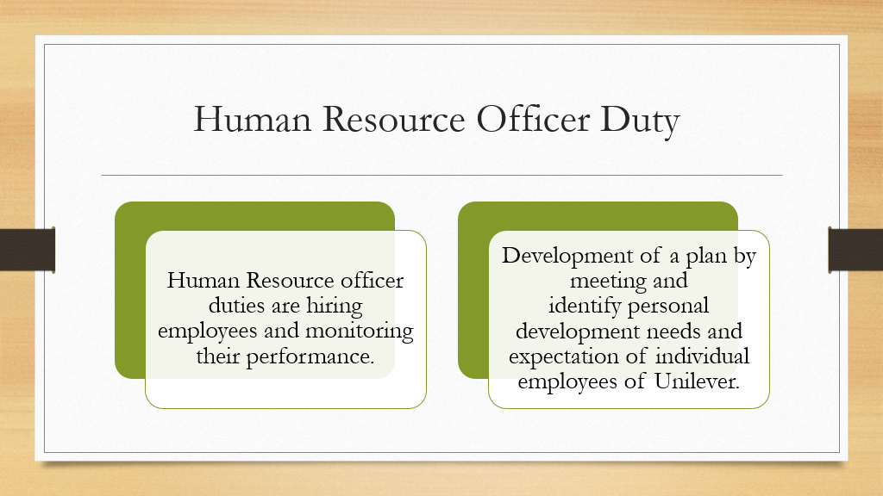
Human Resource Officer Duty
- Human Resource officer duties are hiring employees and monitoring their performance.
- Development of a plan by meeting and identify personal development needs and expectation of individual employees of Unilever.

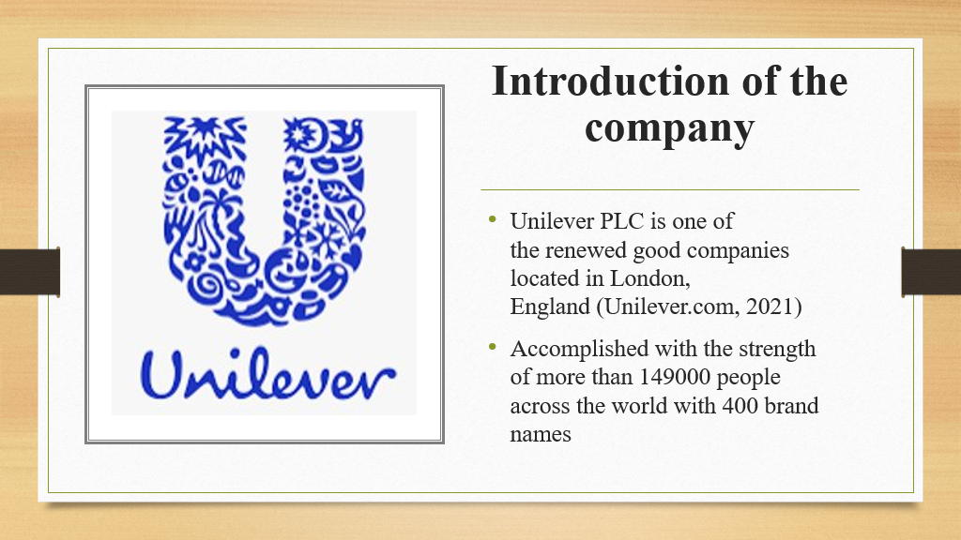
Introduction of the Company

- Unilever PLC is one of the renewed good companies located in London, England (Unilever.com, 2021)
- Accomplished with the strength of more than 149000 people across the world with 400 brand names
Unilever isn't one of the renowned organisations located in the UK that initiates in ringing up the customers with the best personal care products. It includes products like food, beverages, cleaning agents and personal care products.

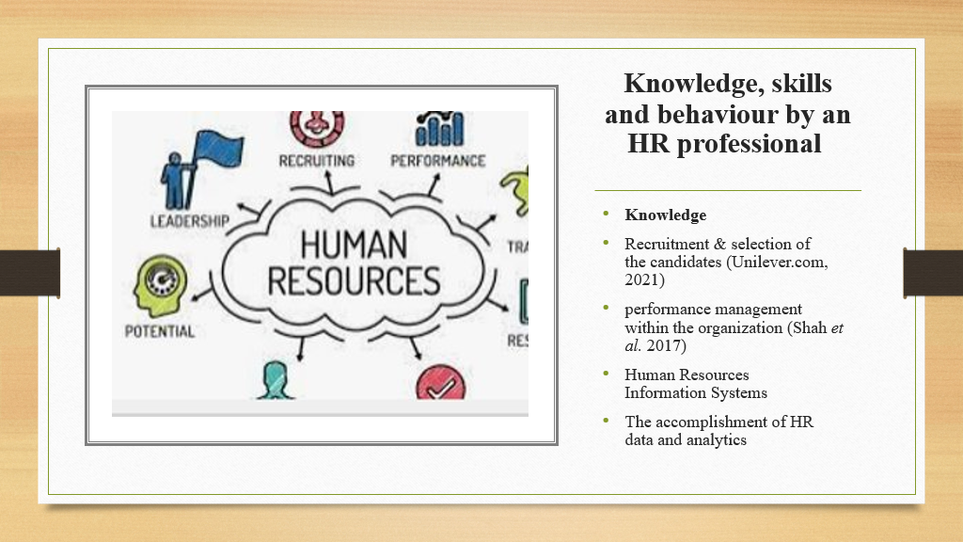
Knowledge, Skills and behaviour by an HR professional
Knowledge
- Recruitment & selection of the candidates (Unilever.com, 2021)
- performance management within the organisation (Shah et al. 2017)
- Human Resources Information Systems
- The accomplishment of HR data and analytics
It can be said that bits of knowledge are required by HR professionals in accomplishing various other words that are required to be done. Igniting betterment within the type of knowledge required needs to be affirmative and needs to be inspiring for others.

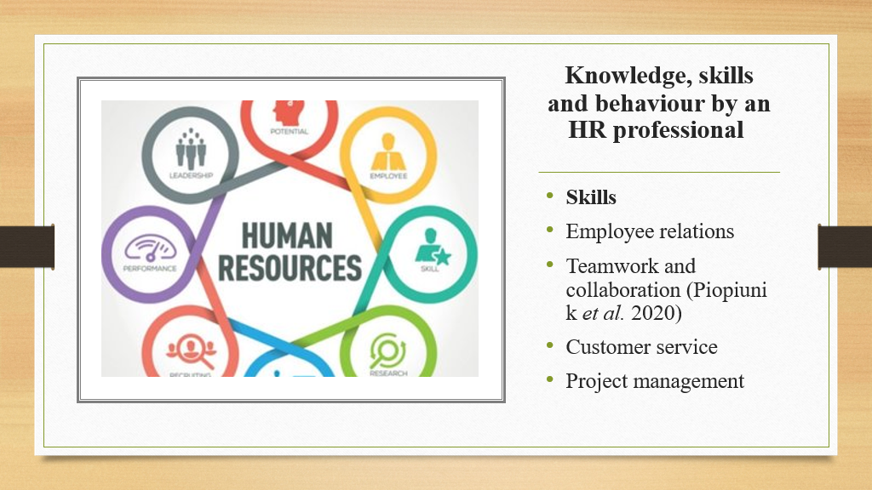
Skills
- Employee relations
- Teamwork and collaboration (Piopiunik et al. 2020)
- Customer service
- Project management
It can be said that by initiation to bringing betterment within the organisation, certain skills are important. It is essential to evaluate the associative in collaboration with the team members with validation state proper project management. In addition, profiling within teamwork, customer services that are required to be focused shall be maintained.

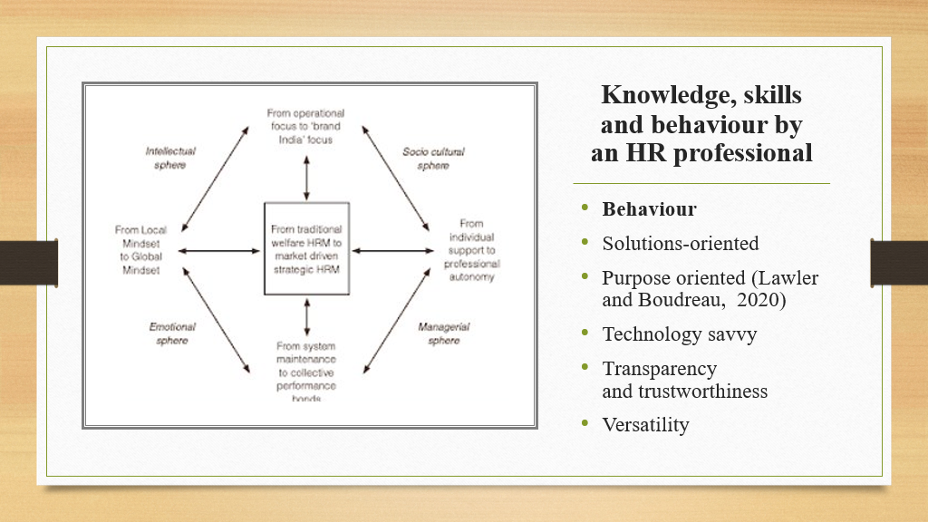
Behaviour
- Solutions-oriented
- Purpose oriented (Lawler and Boudreau, 2020)
- Technology savvy
- Transparency and trustworthiness
- Versatility
Behaviour is an important aspect that plays an essential part in the life of an HR. It is important to evaluate certain types of behaviour within organisations to associate themselves in order to have a better environment for work with the organisation for better results and development.

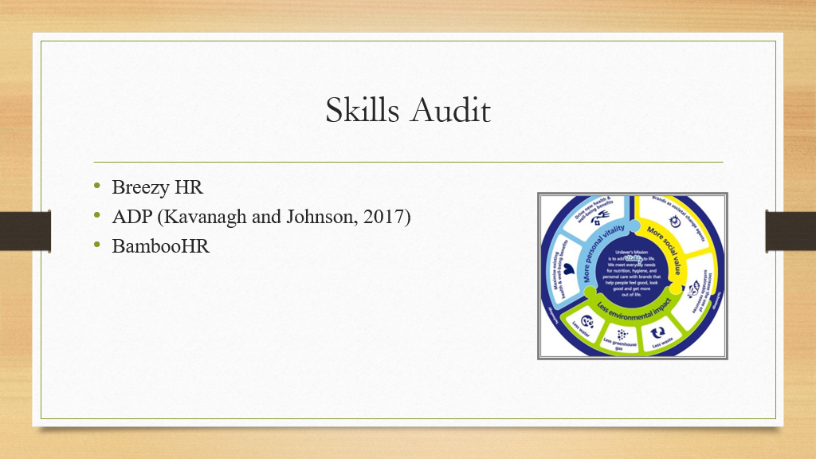
Skills Audit
- Breezy HR
- ADP (Kavanagh and Johnson, 2017)
- BambooHR
The initiation to the betterment of the skills needs to be better HR is affirmative and needs to be focused more on the type of software that is best for HR. The above is noted in bringing up the best software for HR.

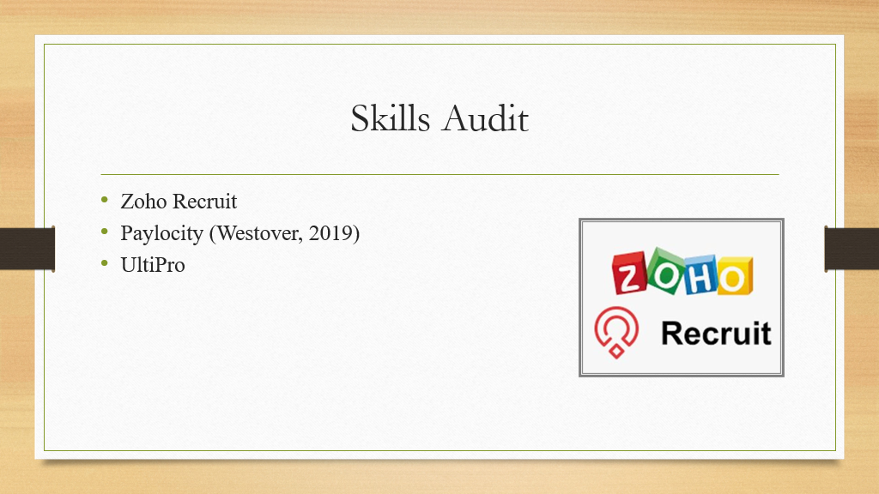
Skills Audit
- Zoho Recruit
- Paylocity (Westover, 2019)
- UltiPro
The proclamation to best software needs to be focused on bringing up with best positions in exclamatory provision to providing the best development criteria to HR as per the organisation Unilever.

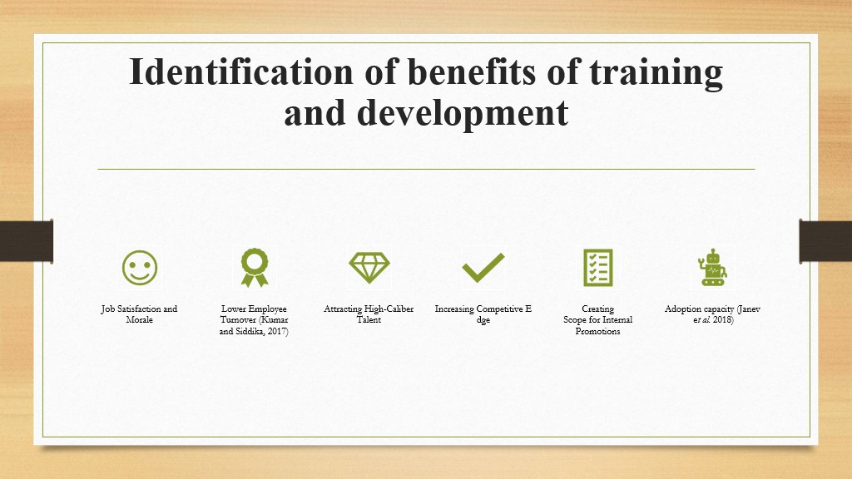
Identification of benefits of training and development
- Job Satisfaction and Morale
- Lower Employee Turnover (Kumar and Siddika, 2017)
- Attracting High-Caliber Talent
- Increasing Competitive Edge
- Creating Scope for Internal Promotions
- Adoption capacity (Janev et al. 2018)
There are variants of benefits that being an HR; it would be accessible within an organisation in providing training and development. It can be said that providing training and development, sets up the initiative for betterment.’
The initiative taken as an HR needs to be imperial as it takes a lot of assertive mode in creating a better place for candidates within the organisation to evaluate better.

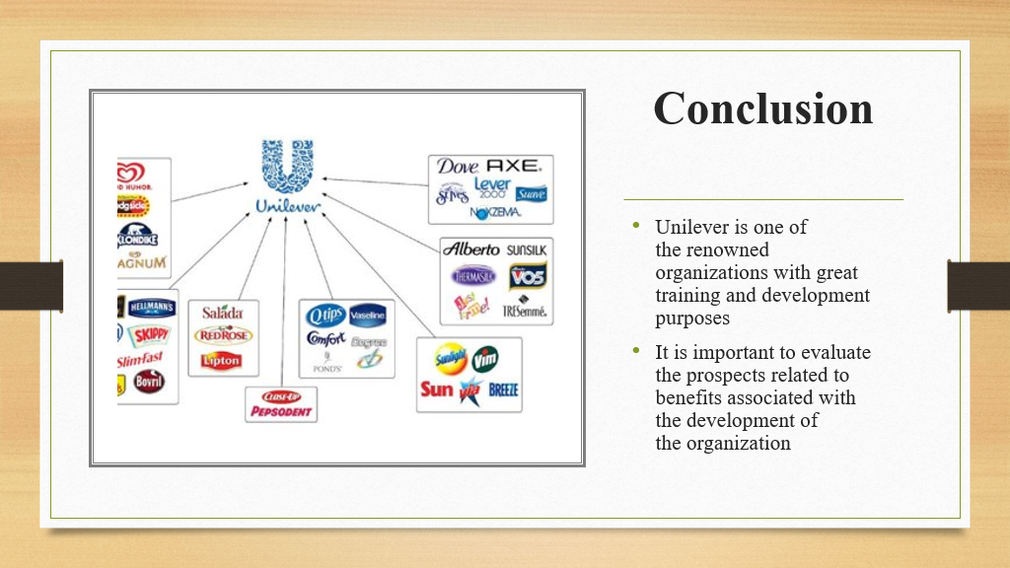
Conclusion
- Unilever is one of the renowned organisations with great training and development purposes
- It is important to evaluate the prospects related to benefits associated with the development of the organisation
From the above, it can be concluded that training and development are important within an organisation. The associative importance that HR plays within an organisation is imperial and needs to be focused more on as per the essentiality.

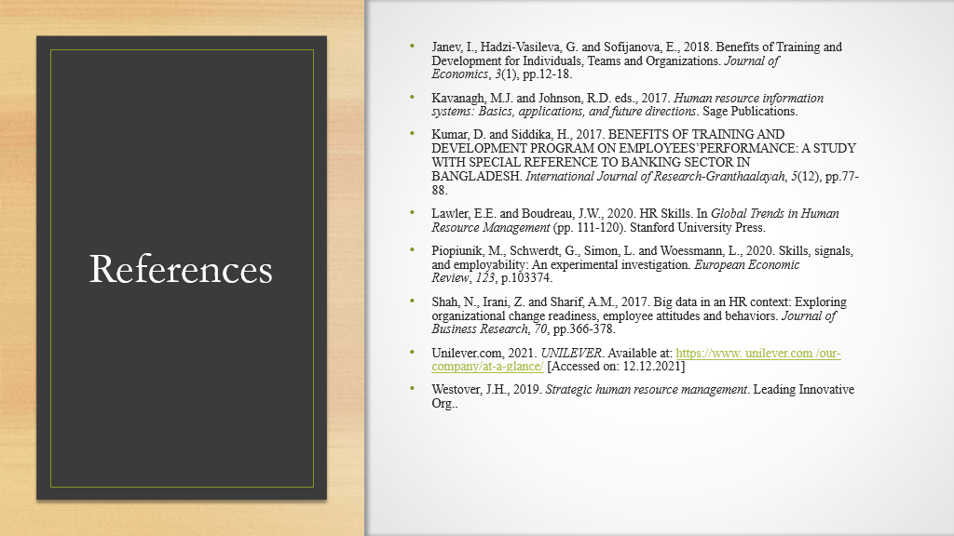
References
- Janev, I., Hadzi-Vasileva, G. and Sofijanova, E., 2018. Benefits of Training and Development for Individuals, Teams and Organizations. Journal of Economics, 3(1), pp.12-18.
- Kavanagh, M.J. and Johnson, R.D. eds., 2017. Human resource information systems: Basics, applications, and future directions. Sage Publications.
- Kumar, D. and Siddika, H., 2017. BENEFITS OF TRAINING AND DEVELOPMENT PROGRAM ON EMPLOYEES’PERFORMANCE: A STUDY WITH SPECIAL REFERENCE TO BANKING SECTOR IN BANGLADESH. International Journal of Research-Granthaalayah, 5(12), pp.77-88.
- Lawler, E.E. and Boudreau, J.W., 2020. HR Skills. In Global Trends in Human Resource Management (pp. 111-120). Stanford University Press.
- Piopiunik, M., Schwerdt, G., Simon, L. and Woessmann, L., 2020. Skills, signals, and employability: An experimental investigation. European Economic Review, 123, p.103374.
- Shah, N., Irani, Z. and Sharif, A.M., 2017. Big data in an HR context: Exploring organizational change readiness, employee attitudes and behaviors. Journal of Business Research, 70, pp.366-378.
- Unilever.com, 2021. UNILEVER. Available at: https://www. unilever.com /our-company/at-a-glance/ [Accessed on: 12.12.2021]
- Westover, J.H., 2019. Strategic human resource management. Leading Innovative Org..

