Report for Strategic Management Assignment 1 2018 – Application Analysis of Hybrid Strategy in Adidas



NOVEMBER 2018

MODULE NAME: m3x9111 strategic management
Name:Tong jin
Student Number:1800166

TABLE OF CONTENTS
1. EXECUTIVE SUMMARY 3
2. INTRODCTION 4
2.1 REPORT REMIT 4
2.2 BACKGROUND OF THE ORGANIZATION 4
2.3 DEFINITIONS OF MAJOR CONCEPTS 6
3. MAIN BODY 8
3.1 ANALYSIS OF COMPETITIVE STRATEGIES 8
3.1.1 LOCALIZATION STRATEGY TREND 8
3.1.2 NIKE BY “MELROSE” 8
3.1.3 ADIDAS BY "SPEEDFACTORIES" 9
3.2 STRATEGIC ASSESSMENT 11
3.2.1 ADVANTAGES 11
3.2.2 DISADVANTAGES 11
4. CONCLUSION 13
5. RECOMMENDATIONS 14
6. REFERENCES 15
LIST OF FIGURES
Figure 1: The Revenue and Earnings of Nike 6
Figure 2: The Revenue and Earnings of Adidas 7
Figure 3: Bowman and Faulkner’s strategy clock 8

EXECUTIVE SUMMARY
The formulation of a company's competitive strategy is the key to become bigger and stronger. The focus of this report is how Adidas and the competitor have utilized their strategy to compete with other competitors in their current competitive position, and analysis the background of the industry in which Adidas is located, and combines the situation of current green economy and consumer demand orientation; Based on the study of Bowman's competitive strategy model.
Adidas use hybrid strategy in the current competitive environment, achieve differentiation and low price relative to competitors, Adidas take localization marketing strategy and use speed factories to product and its competitor Nike develop Melrose, then the report evaluate the strengths and weaknesses of Adidas' competitive strategy critically, on the one hand, it can personalize consumers’ experience and saving manpower、material resources and produce sustainable products, on the other hand, customers can enjoy personalized products, but its service still need improvement.
At last make appropriate recommendations for Adidas based on the analysis, such as improve Humanized service, create good customer engagement and loyalty and utilize the celebrity effect of athletes to expand sports brand influence.

INTRODCTION

REPORT REMIT
The company's targeted competitive strategy can guide staffs to provide products and services that satisfy customer satisfaction and achieve brand growth. This article plans to start from the background of the industry in which Adidas is located, and combines the current large-scale production and service orientation; Based on Bowman's competitive strategy model, the strategic measures taken by Adidas in the current environment are positioned. relative to the reaction of competitors, critically evaluate the advantages and disadvantages of Adidas' competitive strategy. Finally, put forward constructive suggestions and draw conclusions.

BACKGROUND OF THE ORGANIZATION
Adidas is a German sports product manufacturer and one of the world's leading sports brands. Among the existing sporting goods manufacturers, Nike is its strongest rival， and the sports brand Under Armour surpassed Adidas in 2014 to become the second largest sports sales brand in the United States (Davies,2015). As emerging companies emerging in an endless stream, Adidas, a world-renowned sports brand, expanding its market share and establishing consumer loyalty become necessary. As Porter（1989） mentioned in " How Competitive Forces Shape Strategy ", researching competitors' marketing strategies and market positioning has an inspiring effect on the development of their own company. Thompson and Martin (2010) claimed that competitive business environment is permanently fluid and unpredictable, competition has an incentive effect on enterprises. Nike and Adidas are two of the most popular sports apparel manufacturing companies in the world and their competition is intense, their income is shown in Figure 1 and Figure 2 below in recent years. Both of their popularity has become so gigantic that they are literally household names. The main customers in the market are sport lovers, their sponsorship on athletes is very prevalent and they pretty much have the same goal: To be the best sports company in the world.
Adidas specialize in soccer and tennis, because of their historical soccer connection and good quality, it was labeled as the world's sports brand. The companies under Adidas-GROUP such as Reebok and TaylorMade Adidas Golf company, Rockport, which also expend Adidas' sports equipment markets over the years. Adidas achieve a significant income in 2017 (Darren,2017), and in the third quarter of 2018, Adidas' revenue increased by 10%, and the operating profit increased to a level of € 901 million (Adidas-Group,2018). The growth rate of the company's strategic growth areas in North America and Greater China reached Two-digit growth in 2017.
Nike's key markets are people in the following sports: basketball and running, On March 22, Nike Group announced its third quarter results for the 2018 fiscal year. As of February 28, 2018, Nike's global revenue increased 7% year-on-year to US$8.984 billion, still ranked first, but its gross profit margin in the third quarter fell 70 basis points to 43.8%. In the previous eight quarters, the indicator has been declining, with sales and administrative expenses increasing by 11% year-on-year to US$2.8 billion, and pre-tax profit for the period fell 12% to US$1.2 billion (Nike,2018).
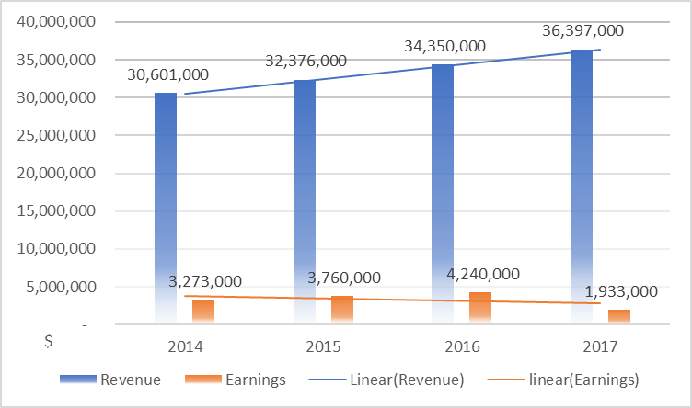
Figure 1: The Revenue and Earnings of Nike
(Source: yahoo finance,2018)
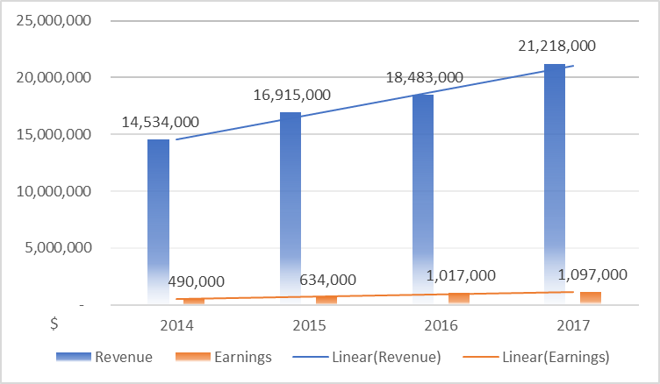
Figure 2: The Revenue and Earnings of Adidas
(Source: yahoo finance,2018)

DEFINITIONS OF MAJOR CONCEPTS
- Strategy: Strategies often involve setting goals, identifying actions to achieve them, and using resources to implement actions (Simandan,2018), which describing that achieve goals by means of resources.
- competitive strategy: Under the constraints of the overall strategy, the company guides and manages the plans and actions of specific strategic business units (Porter,1980).
- “Hybrid” strategy: Achieve differentiation and low price relative to competitors, which including both cost leadership and differentiation strategy (Baroto,2012).
- Bowman and Faulkner’s strategy clock.
Bowman's strategy clock represents eight possible strategies in the four quadrants defined by the price axis and the perceived added value, it identified the relationship of cost of production to the perceived value to the customer by applying different business strategy which helps managers make the choices about positioning and competitive advantage (Johnson,2011).
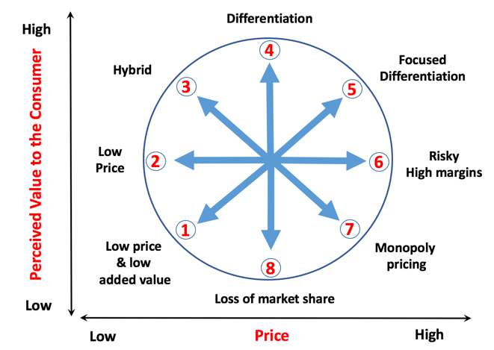
Figure 3: Bowman and Faulkner’s strategy clock
(Source: Bowman and Johnson,1992)

MAIN BODY

ANALYSIS OF COMPETITIVE STRATEGIES

LOCALIZATION STRATEGY TREND
According to a new research from Accenture and the Retail Industry Leaders Association (2017), retailers need to become more trusted advisors to their customers, as the shopping becomes more pervasive through online, mobile and brick-and-mortar channels. They should take measures to provide them with personalized, immersive shopping experiences. For example, Amazon recently opened a new Amazon four-star store in Manhattan, where it sells high-priced (4 stars or more) Amazon merchandise on the site, while preparing New York customers for some of the "New York market trends." In addition, according to a recent study, 63% of consumers are interested in retailers' personalized selections, as for sports equipment factories, it reminds them to focus on the needs of the current community, put the most suitable products (Huffman,2001). Nike adopts a differentiation strategy, it delivers benefits beyond the customers’ core and actual benefits, while Adidas adopts a low-cost leadership competition strategy.

NIKE BY “MELROSE”
Nike's localization strategy is demonstrated through its on-site concept store “Nike by Melrose”, created based on the unique interests of local consumers who provide customized products and services in local stores through data and technology. Nike's data sources include Nike's official website, local consumer purchase data, and online shopping data for local customers in the system. Nike can learn about local consumers' preferences to determine the in-store selection.
At the same time, Nike has added an inventory-based inventory system that adjusts inventory based on local characteristics to allow in-store merchandise to be highly relevant to local consumer demand. In addition, the community will conduct research and communicate with local customers, organizations, and community leaders to understand what they need most, not just other products of Nike's season, and their marketing strategies become customer oriented.
What's more, services are localized outside of goods and inventory. For example, for the car culture of Los Angeles, Nike by Melrose provides roadside pick-up services to serve consumers who don't have time to park or walk into the store. In addition, the Nike by Melrose store will also research the habits and preferences of its NikePlus members through the APP, so that they can reserve special items for individual consumers and recognize them when they come to a specific area around the store (Sultan,2005). By this way, consumers can feel the affinity of the brand, Nike's customized urban style and customized personalized seasonal policies, which provide consumers a sense of unique superiority.

ADIDAS BY "SPEEDFACTORIES"
Adidas is one step ahead on a personalized path. Last year, Adidas announced the launch of the Speedfactories line to customize clothing and shoes, and according to the Quartz report, Adidas' goal is to achieve 50% sales of this fast-moving product by 2020. Adidas uses this localization strategy to meet the needs of local consumers, and Adidas announced in 2017 that it will produce localized, urban-inspired shoes at the new Speedfactory. Klaus Moser (2016) said that Adidas has transformed mass customization from a marketing instrument to a sustainable business model. This fast factory is Adidas' own development of a new manufacturing facility that can hit the entire production process of a pair of shoes under the same roof. Previously, Adidas usually made in Asia. The whole process usually took several months and worked together across different factories. Speedfactories will subvert this and complete production in a factory in a few days. Because it utilizes a variety of digital facilities, such as 3D printing, robotic arms and automated knitting, it reduces production time and greatly reduces the labor requirements of workers. They can adapt to the preferences of consumers and carry out targeted production (Thompson,2010). The implementation of Speedfactories allows Adidas to customize products based on consumer preferences, and it is highly commended by consumers.
Currently, Adidas is using a fast factory to implement its localization strategy, piloting several international metropolises around the world, such as London, Paris, Shanghai, Los Angeles, and launching its customized shoes in Tokyo. In 2015, Adidas acquired Runtastic, an application for motion data analysis, and launched Adidas' new service system，Mi Coach series, which provide customized sports shoes for global athletes, using near field communication chip in the production process, so that buyers can pass Adidas App to sync their shoes, get original content and information related to the shoes and their own sports data, and everyone can scientifically develop their own exercise plan through mobile APP, on the other hand, Adidas will use this technology to obtain customer usage data and related feedback, personalized in the future Improvements are made; AM4NYC, is designed by Adidas for various sharp bends in New York City. It uses local athlete feedback and sports science data during the design process to reduce the degree of danger, In April 2017, adidas' new running shoe product, adidas Future craft 4D, was launched, with digital optical synthesis technology. They can break through existing constraints and link athlete data to the shoemaking process to accurately address the unique needs of each athlete. In addition, last month adidas announces a new membership program, the “Creators Club”, providing loyal customers with early access to products, exclusive offers, and invitations to special events, aiming to connect consumers with the best products, experiences and services from adidas, which is used in American now. The program is scheduled to launch in additional markets in the future.

STRATEGIC ASSESSMENT

ADVANTAGES
- Personalizing consumer’s experience
As for Adidas, technological superiority of its products is the principal factor of market penetration. Constantly updated technological innovation and spirit of excellence are the strong competitive advantages of Adidas. Adidas (2018) endeavors to create and sell the best sports and fitness products in the world, and come to work to offer the best service and improve consumer experience. Adidas adheres to the concept of designing perfect shoes, constantly connects and engages with our consumers. After repeated testing and evaluation by the R&D center, Adidas has developed a series of new ergonomic products which contributes to improving various athletes’ performance and meeting the demands of the normal consumers for a high-quality sports experience. Through the Speedfactory production chain, adidas produces localized, urban-inspired shoes to meet the needs of local consumers.
- Saving manpower and material resources
In the past, Adidas usually produced shoes in Asia. The production process took several months and spanned multiple factories, Speedfactories will subvert this and complete production in a factory in a few days. Because it utilizes a variety of digital facilities, such as 3D printing, robotic arms and automated knitting, it reduces production time and greatly reduces the labor requirements of workers, it refers to the Cost leadership of Porter’s Generic Strategies (1980), which do helpful to reduce product costs and achieve small profits but quick turnover.

DISADVANTAGES
- Neglecting the changing tastes of middle-class consumers
Adidas has different marketing strategies for low-tier cities. In the products of small and medium-sized consumers, the layout will be based on the consumption level and consumer preferences of small and medium-sized cities, and the sales of some high-end products will be concentrated in the first-tier metropolis. However, we found that with the development of the information age of science and technology, some people in small and medium-sized cities are becoming more and more knowledgeable and their purchasing power is greatly improved，they hope to buy the top sports shoes on the market. Therefore, Adidas should launch new top and better-selling products in retail stores both in small and medium-sized and metropolis.
- The Service is not enough
Adidas focuses on product development and does not concentrate on the user's buying experience. For the car culture of Los Angeles, Nike by Melrose provides roadside pick-up services to serve consumers who don't have time to park or walk into the store. In addition, the Nike by Melrose store will also research the habits and preferences of its NikePlus members through the APP, so that they can reserve special items for individual consumers and recognize them when they come to a specific area around the store (Gerry,2008), in this way, Consumers can feel the affinity of the brand.

CONCLUSION
This paper mainly analyzes the Adidas Group's Cost Leadership competitive strategy and Adidas realized that it is no longer suitable for the original retail measures in the sports equipment manufacturers' consumer-oriented economy, and began to take a series of measures to provide products and services that consumers need. Adopt community business and localization strategies to enable consumers to obtain personalized customized products (Graham,2016). By the comparison with Nike, Adidas has advantage and disadvantage. In order to improve its disadvantage, Adidas should concentrate more on the user's buying experience to make the consumers feel the affinity of the brand and get regular customer feedback may be the best strategy to stay ahead of competitors and develop and maintain long-term profitable customer relationships at the lowest cost.

RECOMMENDATIONS
- Improve Humanized service
Providing meticulous service, fully considering the consumption habits of local customers and the inconveniences that may arise when entering the store, adopting humanized improvement measures, not only can brand consumers feel caring and not be interfered.
- Create a high level of customer engagement and loyalty.
Getting regular customer feedback may be the best strategy to stay ahead of competitors and develop and maintain long-term profitable customer relationships at the lowest cost (McLean,2006).
- utilize the celebrity effect of athletes to expand sports brand influence
Adidas' projects and promotional activities should be more connected with the idols of the sports world, which will help them spread the spirit of Adidas, gain consumer recognition, and obtain stable sales and income.

REFERENCES
Accenture,2017, the changing consumer and the new definition of retail, DELIVERING FOR THE NEW CONSUMER, The Move to Ubiquitous & Ultra-Personal Shopping
Adidas-Group,2018, Media, news archiver, Available at:https://www.adidas-group.com/en/media/news-archive/press-releases/2018/adidas-delivers-strong-third-quarter-results/
Adidas, Speedfactory, Available at:< https://www.adidas.com/us/speedfactory>
Baroto M B, Abdullah M B, Wan H L, 2012, Hybrid strategy: A new strategy for competitive advantage[J]. International Journal of Business and Management. 7.20 (2012): 120.
Bowman C and Johnson G,1992, strategy clock, Surfacing Competitive Strategies, European Management Journal, Vol.102, pp210-263.
Darren H, 2017, Adidas Q3 2017 Results Reveal 31% Growth In North America, Available at :< https://www.forbes.com/sites/bensin/2018/11/16/meet-the-man-behind-oppos-and-oneplus-super-fast-charging-speeds/#5c5396382cfd>
Davies M J.& Burakowski K A, 2015, A qualitative analysis of athletic apparel and equipment sponsorship related to student-athlete recruitment, The Qualitative Report, 20(3),pp271-285.
Gerry J and Kevan Scholes, Richard Whittington, 2008, Challenges for managing strategy development, Exploring corporate strategy, 8th Edition, pp419-429
Graham J. Hooley, Nigel F. Piercy, Brigitte Nicoulaud, John Rudd,2016, Competitive market analysis, Marketing strategy and competitive positioning, pp106-130
Huffman B ,2001, strategy innovation, What makes a strategy brilliant? Business Horizons, 44 (4), pp24-32.
Johnson G, Whittington R, Scholes K, 2011, Exploring Strategy, 9th Edition, pp34-52
Thompson J L, Martin F, 2010, Strategy Creation, Strategic Management: Awareness and Change, Cengage Learning Business Press, pp385-439
Thompson J L, Martin F,2010, competition: an introduction, Strategic Management: Awareness and Change, Cengage Learning Business Press, pp306-315
Klaus M, Melanie M, Frank T. P, 2016, Transforming mass customization from a marketing instrument to a sustainable business model at Adidas International Journal of Mass Customization
McLean C, Penni ,2006, Listen and Respond to the Voice of the Customer, Customer service: utility style: proven strategies for improving customer service and reducing customer care costs, pp65-78
Nike, 2018, investors, Available at:< https://investors.nike.com/Home/default.aspx>
Porter M E, 1980, Competitive Strategy: The Core Concepts, competitive advantage creating and sustaining superior performance
Porter M E, 1989, How Competitive Forces Shape Strategy, Readings in Strategic Management. Palgrave, London, pp133-143
Simandan D, 2018. Iterative lagged asymmetric responses in strategic management and long-range planning. Time & Society, Available at:https://doi.org/10.1177/0961463X17752652
Sultan F, Rohm A, 2005, The Coming Era of "Brand in the Hand" Marketing, MIT Sloan Management Review
The Revenue and Earnings of Nike, Income Statement, Financials, Available at :< https://finance.yahoo.com/ >
The Revenue and Earnings of Adidas, Income Statement, Financials, Available at :< https://finance.yahoo.com/ >

