
Module: Analysing & Solving Problems

Module Code: ACCA4019
Student Name: Saeen Bux Patujo
Student ID: 2506990
Lecturer Name: Nouh Elmitwally
Submission Date: 23/03/2026

List of Contents
Introduction 3
1. Problem Deconstruction 3
1.1 Understanding the Nature of the Problem 3
1.2 Identification of Key Variables 4
1.3 Requirements and Constraints Using MoSCoW 4
2. Proposed Solution and Explanation 6
2.1 Rationale for the Approach 6
2.2 Step-by-Step Allocation Model 6
2.3 Alignment with Objectives 7
2.4 Flowchart Representation 8
3. Reflection and Justification 8
4. Conclusion 10

Introduction
Effective classroom allocation is central to the smooth operation of any educational institution. When space is poorly assigned, the consequences are immediate and visible: some rooms are overcrowded while others remain half empty, lecturers arrive late because of distant back-to-back sessions, and timetable clashes disrupt teaching continuity [1]. In the present scenario, the local college is experiencing precisely these operational weaknesses. The issue is not simply administrative inconvenience; it reflects an underlying resource allocation problem that requires structured analysis and disciplined problem solving.
Within operations management, allocation and scheduling problems arise when limited resources must be distributed among competing activities under defined constraints. In this case, classrooms and time slots are finite resources, while classes represent competing demands [2].
The aim of this report is to examine the classroom allocation problem using recognised analytical techniques and to design a clear, logical solution. The discussion first deconstructs the problem using abstraction and prioritisation tools such as the MoSCoW framework. A step-by-step allocation model is then proposed and explained with reference to relevant theory. The report concludes with critical reflection on the chosen approach, including its strengths, assumptions and limitations.

Problem Deconstruction

Understanding the Nature of the Problem
The classroom allocation challenge can be defined as a constrained scheduling and optimisation problem. According to Hillier and Lieberman, optimisation problems involve assigning limited resources in a manner that satisfies constraints while improving performance outcomes. Here, the college must allocate a fixed number of rooms across a fixed timetable while meeting capacity, availability and quality requirements. The issue contains three interrelated weaknesses [3]:
- Capacity imbalance, where class sizes do not align with room capacities.
- Scheduling conflicts, where rooms or lecturers are double-booked.
- Excessive movement between sessions, leading to lost instructional time.
These elements are interconnected rather than independent. System thinking emphasises that organisational inefficiencies often arise from structural interactions between components rather than isolated errors. For example, assigning a class to a distant room may solve a capacity issue but create movement inefficiency. Therefore, the problem must be examined as an integrated system involving space, time and human movement.
Educational timetabling has been widely studied in operational research and is recognised as computationally complex because multiple constraints must be satisfied simultaneously. While the college context may not require advanced algorithmic software, the underlying logic remains consistent with established scheduling theory.

Identification of Key Variables
To manage complexity, abstraction is applied. Abstraction involves focusing on essential variables while removing irrelevant detail. The following variables are central [4]:
- Class size
- Room capacity
- Time slot allocation
- Lecturer availability
- Physical location of classrooms
From these variables, performance indicators can be derived:
- Room utilisation rate
- Number of timetable clashes
- Average movement distance between consecutive sessions
Room utilisation can be expressed as:
- Utilisation Rate = Class Size ÷ Room Capacity
- A value close to 1 indicates efficient use of space without overcrowding.
- By reducing the problem to measurable elements, a structured solution becomes possible.

Requirements and Constraints Using MoSCoW
The MoSCoW technique provides a systematic method of prioritising requirements. It distinguishes essential conditions from desirable improvements [5].

Must Have Requirements
- Each class must be assigned to a room with sufficient capacity.
- No classroom may be double-booked in the same time slot.
- Lecturers must not be scheduled for simultaneous sessions.
- Every scheduled class must receive a room allocation.
These represent non-negotiable conditions, often described in timetabling literature as hard constraints.
Should Have Requirements
- Movement between consecutive classes should be minimised.
- Overall room utilisation should be balanced across the campus.
These are soft constraints. While not mandatory, they significantly influence timetable quality.
Could Have Requirements
- Allocation of specialised rooms according to subject needs.
- Consideration of departmental preferences.
Won’t Have (Out of Scope)
- Real-time adaptive scheduling during the semester.
- Predictive modelling of attendance fluctuations.
The primary constraints include a limited number of rooms, fixed time slots, and physical capacity limits. These structural limitations shape all subsequent decision-making.


Proposed Solution and Explanation

Rationale for the Approach
Given the institutional context, a structured heuristic model is appropriate. Heuristic methods are frequently employed in educational timetabling because exact optimisation techniques can be computationally demanding. A rule-based model offers clarity, transparency and practical applicability [6].
The proposed solution is built upon five principles:
- Prioritisation of constrained tasks
- Capacity alignment
- Conflict prevention
- Spatial efficiency
- System validation

Step-by-Step Allocation Model
Step 1: Data Preparation
Accurate data are compiled regarding class enrolments, room capacities, lecturer timetables and building layout. Reliable input data are essential, as flawed inputs undermine optimisation outcomes.
Step 2: Prioritisation of Larger Classes
Classes are arranged in descending order of size. Larger classes are allocated first because they have fewer suitable room options. This reflects a greedy allocation strategy, which assigns the most restrictive tasks before less constrained ones.
Step 3: Capacity Filtering
For each class, rooms with inadequate capacity are immediately excluded. This reduces the search space and prevents infeasible assignments.
Selecting the smallest adequate room improves utilisation and avoids wasted seating capacity.
Step 4: Availability Verification
Each potential room is checked against:
- Time slot availability
- Lecturer schedule
If either condition fails, the next feasible room is evaluated. This ensures that hard constraints are satisfied before proceeding.
Step 5: Spatial Consideration
Where lecturers or cohorts have consecutive sessions, room proximity is considered. Research on timetabling highlights the importance of incorporating soft constraints such as convenience and movement efficiency to improve timetable quality.
Although precise optimisation of movement would require complex modelling, a simplified distance-based preference provides meaningful improvement.
Step 6: Iterative Allocation
The process repeats until all classes are assigned. Decision points include:
- Is room capacity sufficient?
- Is the room free?
- Is the lecturer available?
- Is the distance acceptable?
These decision nodes form the basis of the flowchart representation.
Step 7: Final Validation
After allocation, the timetable is reviewed to ensure:
- No remaining clashes
- Balanced utilisation across rooms
- All classes successfully assigned
If inconsistencies are detected, adjustments are made before final confirmation.

Alignment with Objectives
The solution directly addresses the college’s aims.
Efficient allocation is achieved through capacity filtering and smallest-fit selection.
Movement time is reduced through spatial awareness during allocation.
Scheduling conflicts are prevented through systematic availability checks [7].
The method therefore balances operational practicality with theoretical grounding.

Flowchart Representation
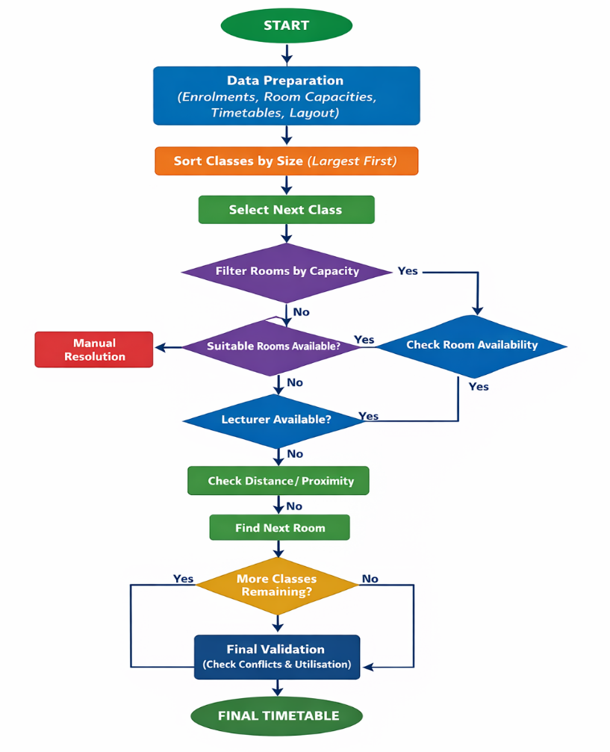

Reflection and Justification
The solution was developed through three core problem-solving techniques: decomposition, abstraction and structured sequencing. Each technique contributed directly to the clarity and feasibility of the final model. Decomposition allowed the broad institutional inefficiency to be separated into distinct but interconnected components: capacity management, scheduling integrity and spatial organisation [8]. Without this analytical breakdown, the issue could easily have been addressed at a superficial level, for example by simply increasing room usage without resolving timetable clashes. By isolating each dimension, it became possible to identify causal relationships and understand how one decision could affect other parts of the system. This approach reflects structured analytical thinking and aligns with systems-based perspectives in operations management.
Abstraction ensured that attention remained focused on measurable operational variables such as class size, room capacity and time allocation. While qualitative factors, including staff preference or departmental politics, may influence satisfaction, their inclusion would have reduced clarity and complicated implementation. The deliberate exclusion of non-essential variables strengthened logical consistency and ensured that the model remained transparent and reproducible [9].
Algorithmic sequencing further reinforced the reliability of the solution. Each allocation decision follows from explicit conditions: capacity suitability, room availability and lecturer availability. This step-by-step logic ensures that the process can be replicated consistently and audited if necessary. The structured flow also reduces the likelihood of arbitrary decision-making, thereby improving accountability [10].
A critical comparison with alternative approaches is essential. Research indicates that advanced optimisation methods, including genetic algorithms and multi-criteria optimisation models, can achieve highly refined timetabling outcomes. Such models can balance multiple objectives simultaneously and adapt to complex constraint structures. However, these techniques demand specialist expertise, computational resources and dedicated software systems. In the context of a local college, the marginal efficiency gains may not justify the financial and organisational investment required.
The chosen heuristic model therefore represents a pragmatic compromise. It does not guarantee mathematical optimality, yet it delivers practical efficiency within realistic constraints. Nonetheless, limitations remain. The model assumes stable enrolment figures and fixed timetables. It does not account for uncertainty, late enrolments or unexpected room unavailability. Movement calculations are simplified and do not consider peak congestion or accessibility needs. Future enhancement could involve integrating digital scheduling platforms capable of real-time adjustment and multi-objective balancing.
Overall, the methodology demonstrates structured reasoning, theoretical awareness and practical applicability, which are appropriate for the institutional context in which it is intended to operate.

Conclusion
The classroom allocation problem at the local college represents a structured scheduling and resource distribution challenge. Through systematic deconstruction, prioritisation and logical sequencing, a practical solution has been developed. The proposed model aligns room capacity with class size, eliminates scheduling conflicts and reduces unnecessary movement.
While simplified, the approach provides a disciplined framework capable of improving operational efficiency. With further refinement and technological enhancement, the model could evolve into a more advanced optimisation system. At its current stage, it offers a realistic and theoretically informed solution suitable for institutional implementation.

References (IEEE Style)
[1]R. Ross, “4 classroom organisation tips for the upcoming school year,” Maths – No Problem! Maths Mastery for Primary School Education, Jan. 05, 2021. Available: https://mathsnoproblem.com/blog/teaching-tips/classroom-organization
[2]“Allocation Problems | Overview & Research Examples,” Perlego.com, 2016. Available: https://www.perlego.com/index/mathematics/allocation-problems.
[3]X. Zhang, P. Parikh, and L. Xiao, “Course Scheduling Problem with Cohort Group and Room Considerations,” International Journal of Industrial and Systems Engineering, vol. 1, no. 1, p. 1, 2022, doi: https://doi.org/10.1504/ijise.2022.10047812. Available: https://corescholar.libraries.wright.edu/cgi/viewcontent.cgi?article=3615&context=etd_all
[4]L. Team, “Examples of Abstraction in Everyday Life | Learning.com,” Learning, Oct. 18, 2022. Available: https://www.learning.com/blog/examples-of-abstraction-in-everyday-life/
[5]TheKnowledgeAcademy, “MosCow Analysis: A Guide To The Project Priorisation Method,” Theknowledgeacademy.com, 2024. Available: https://www.theknowledgeacademy.com/blog/moscow-analysis/
[6]P. Singh, “Heuristic Method of Teaching: Principles, Benefits, Steps,” Extramarks Blogs: Weaving stories for schools, students, and parents, Jan. 17, 2025. Available: https://www.extramarks.com/blogs/teachers/heuristic-method-of-teaching/
[7]“Capacity Planning Strategies: Optimize Resource Allocation,” Celoxis.com, 2024. Available: https://www.celoxis.com/article/capacity-planning-strategies
[8]“Computational thinking, what it is, phases and characteristics,” smowl.net, Oct. 04, 2023. Available: https://smowl.net/en/blog/computational-thinking/
[9]“prefeitura.aracaju.se.gov.br - Examples Of Abstraction In Computer Science,” Se.gov.br, 2026. Available: https://prefeitura.aracaju.se.gov.br/libweb/pByEkl/3AD125/ExamplesOfAbstractionInComputerScience.pdf.
[10]A. Z. Azhar, A. Segal, and K. Gal, “Optimizing Representations and Policies for Question Sequencing Using Reinforcement Learning.,” International Educational Data Mining Society, 2022. Available: https://eric.ed.gov/?id=ED624101.

