4/30/2026
Network and Cyber Security Essentials


Lecturer’s Name: Dr Kwame Assa-Agyei
Student Name: Milana Hemalova
Student Number: 2439874

Table of Contents
1. Introduction 1
2. Identification of Modern Threats 1
2.1 Internal Threats 1
2.2 External Threats 2
2.3 Impact Analysis (CIA Triad) 3
3. Modern Security Policies 3
3.1 Access Control Policy 4
3.2 Data Protection and GDPR Compliance Policy 4
3.3 Acceptable Use Policy 4
3.4 Network Security Policy 4
3.5 Incident Response Policy 4
4. Technical Mitigation Measures 4
4.1 Preventive Controls 4
4.2 Detective Controls 5
4.3 Corrective Controls 5
4.4 Cloud Security Measures 5
5. Proactive Monitoring and Incident Response 5
5.1 Monitoring Strategy 5
5.2 Incident Response Plan 6
5.3 Incident Response Flow (Diagram) 6
6. Continuous Training and Awareness 7
6.1 Employee Training Program 7
6.2 Workshops and Simulations 7
6.3 Policy Compliance Training 7
6.4 Building a Security Culture 8
7. Conclusion 8
References 9
Appendix A: Screenshot of the Board of Directors PowerPoint presentation 11

Cybersecurity Policy Development for HealthPlus Analytics

Abstract
Healthcare organisations are concerned about cybersecurity as the number of sensitive data and the progression of cyber threats are on the rise. The threats to HealthPlus Analytics (HPA) include ransomware, phishing, insider threats, and cloud vulnerability that may affect data confidentiality, integrity, and availability. In this report, a detailed cybersecurity framework is created, which includes the identification of major threats and the development of effective security policies that are compliant with such standards as ISO 27001, NIST, and UK GDPR. It also describes realistic technical mitigation controls, such as preventive, detective and corrective controls and a formal monitoring and response plan. Also, the report highlights the significance of training and awareness of employees in mitigating the human-related risks.
Keywords: Cybersecurity, Healthcare Data Security, Ransomware, Phishing, GDPR Compliance, Incident Response, Risk Management, Cloud Security

1. Introduction
The issue of cybersecurity is now a significant challenge facing contemporary organisations because of the rapid growth of the digital transformation, cloud computing, and remote working trends [1]. Cyber threats are highly susceptible to healthcare organisations, especially due to the handling of high amounts of sensitive patient information. HealthPlus Analytics (HPA) is a data-driven technology company in the healthcare field, which is at risk of major threats such as ransomware attacks, unauthorised access, and data breach. The threats do not only threaten the confidentiality, integrity and availability of data, but they also have severe legal and reputational impacts, particularly in the context of regulations like the UK GDPR [2].
The purpose of this report is to design an effective cybersecurity policy framework of HPA by defining the most critical internal and external threats, suggesting the corresponding security policy, and providing recommendations on technical mitigation strategies. The report also provides the recommendations on how the proactive monitoring, incident response, and employee training can be used to improve the overall security posture of the organisation and maintain compliance with the regulations.

2. Identification of Modern Threats

2.1 Internal Threats
Internal threats exist and are caused by people in the organisation and can be both deliberate and unintentional. Sensitive data may be misused by employees, contractors or third-party vendors who have an authorised system access and may be motivated by personal gain or negligence [3]. As an example, poor passwords, credential sharing, or sharing of login information may open up systems to unwarranted attacks.Moreover, phishing messages or other malicious attachments can fall into the hands of the workers as well accidentally, and the system will be compromised. Weak access control measures also contribute to the insider threats since the users are able to access the information that they do not need in their line of duty [4]. The threats are very high with regard to HealthPlus Analytics (HPA) owing to the sensitivity of patient data and the stringent regulatory requirements.
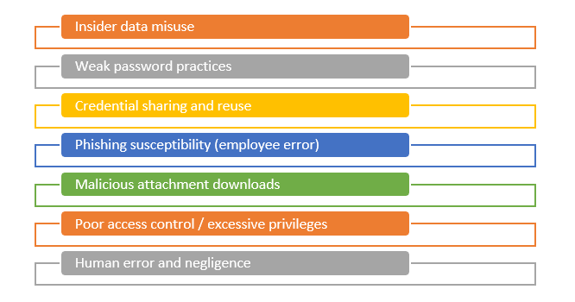
Figure 1: Internal threats for HPA
(Source: Self-made)

2.2 External Threats
Cybercriminals conduct external threats with the intention of taking advantage of vulnerabilities within the organisational systems [5]. Ransomware is one of the most significant threats, whereby the attackers encrypt organisational data and demand money to release it. HPA has already seen cases of this nature, which indicates the gravity of this threat. Phishing and social engineering are also similar practices so that they strive to gain access to confidential data which takes the form of log-in credentials. Furthermore, the cloud vulnerabilities, including the misconfigured databases or unprotected APIs, can lead to the unauthorised access to the patient records. DDoS attacks can affect the network systems and lead to the disruption and downtime of healthcare services [6]. Such threats not only affect the operations but also causes financial and reputational risks.

Figure 2: External threats for HPA
(Source: Self-made)

2.3 Impact Analysis (CIA Triad)
The CIA Triad model can be used to measure the impact of these threats, and it comprises of Confidentiality, Integrity and Availability [24]. Privacy breaches and failure to comply with the UK GDPR regulations are caused by unauthorised access to sensitive data about patients by individuals who are not supposed to have such access. Integrity is compromised when data is changed or distorted by malicious actors or insider activities and can lead to wrong medical records and even harmful decisions [7]. Availability is at risk when the systems are unavailable because of the ransomware attacks or DDoS events that affect the provision of healthcare services and postpones essential processes.
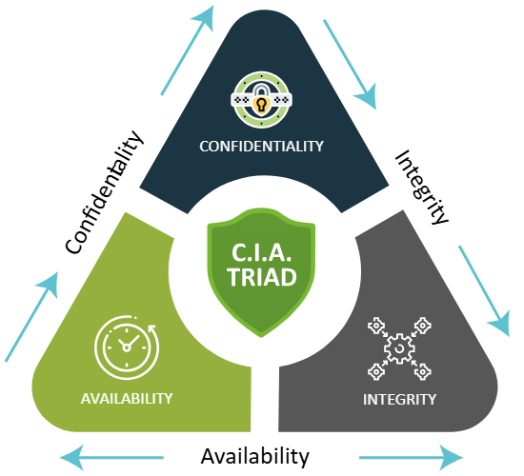
Figure 3: CIA triad
(Source: [24])

3. Modern Security Policies

3.1 Access Control Policy
An effective access control policy is necessary to make sure that sensitive data and systems at HealthPlus Analytics (HPA) are accessed by the authorised individuals. The organisation must use Role-Based Access Control (RBAC) in which access controls are granted according to the job roles and responsibilities. This reduces the chances of unauthorised access and insider abuse. Moreover, Multi-Factor Authentication (MFA) is recommended to be imposed on everyone, particularly the users who have access to critical systems or cloud platforms [8].

3.2 Data Protection and GDPR Compliance Policy
Due to the sensitivity of healthcare data, HPA should develop a strong data protection policy in line with the UK GDPR requirements. This will involve the use of encryption of data at rest and during transit, the data of patients should be securely stored and transmitted [9]. In addition, frequent data backups and safe data storage methods are to be implemented to exclude the loss of data. The reporting of data breach should also have clear procedures to achieve timely response and regulation compliance [10].

3.3 Acceptable Use Policy
The acceptable use policy is a policy that defines how the employees are supposed to use the organisational systems, devices, and networks. It needs to contain the policies regarding the use of personal devices (BYOD), internet connection, email correspondence, and software installation. It should not allow the employees to enter unauthorised websites or download unverified applications that are likely to bring about malware [11]. This policy also focuses on proper management of sensitive information and the disciplinary measures of violations.

3.4 Network Security Policy
An effective network security policy will be important to ensure that the infrastructure of HPA is not attacked by outsiders. This involves application of firewalls, intrusion detection and prevention systems (IDS/IPS) and usage of secure Virtual Private Networks (VPNs) to access the resources remotely [12]. The network segmentation should also be applied to restrict the propagation of possible attacks within the system. Vulnerability checks and penetration testing should be done on a regular basis to ensure that weaknesses that can be exploited are identified and dealt with before they become weaknesses.

3.5 Incident Response Policy
Incident response policy is a solution that helps the organisation to efficiently detect, respond to and recover security incidents. It must establish clear roles and duties, reporting processes and agendas. Identification, containment, eradication and recovery are the structured approach that should be followed in order to minimise damage and restore normal operations within the shortest time [13].

4. Technical Mitigation Measures

4.1 Preventive Controls
Preventive controls are supposed to prevent cyber threats in advance. HealthPlus Analytics (HPA) is supposed to introduce firewalls to block the incoming and outgoing network traffic so that unauthorized access may be avoided. Antivirus and anti-malware should also be updated on a regular basis to identify and prevent malicious software. Multi-Factor Authentication (MFA) is recommended in order to enhance user verification in all systems. Moreover, the systems should be securely configured and ensure patch management on a regular basis to address the vulnerabilities and minimize the chances of being exploited by attackers [14].

4.2 Detective Controls
Detective controls assist in the detection and reaction to security incidents in real time. To prevent suspicious activities, HPA should install Intrusion Detection and Prevention Systems (IDS/IPS) to track the traffic in the network. Log monitoring systems must also be put in place to monitor the user activities as well as system events. Logs can be analysed using Security Information and Event Management (SIEM) tools and alerts about possible threats can be created [15].

4.3 Corrective Controls
Corrective controls are aimed at ensuring that the damage is minimised and the restoration of the systems following a security incident. Data backups are to be taken regularly and stored in a safe place so that data can be restored in case of ransomware attacks or system malfunctions [16]. There should be disaster recovery plans that are put in place to restore operations within a short time. Moreover, systems are to be updated and patched consistently to deal with the vulnerabilities detected after attacks.

4.4 Cloud Security Measures
Since HPA is based on cloud-based systems, cloud security measures are required. Both stored and transmitted data should be encrypted with data to secure sensitive information [17].Cloud storage must be properly configured, and secure API must be enforced to prevent unauthorised access. The access to cloud resources should be limited to identity and access management (IAM).

5. Proactive Monitoring and Incident Response

5.1 Monitoring Strategy
HealthPlus Analytics (HPA) ought to use constant network scanning on the basis of sophisticated applications like Security Information and Event Management (SIEM) systems. These tools collect and analyze logs of different sources, including servers, networks, and applications, to find out unusual patterns or suspicious behavior [18]. In addition, Intrusion Detection Systems (IDS) will be installed which would not only monitor the network traffic but also raise warnings about any possible attacks. Real-time alert systems also allow the IT security team to react to security breaches promptly, minimizing the amount of damage [19].

5.2 Incident Response Plan
The process of response must be organized, and the threat identification must be engaged which can be achieved by the use of monitoring tools, and user reports [20]. After being contained, the eradication stage consists of the destruction of malicious files, account lockout, and the eradication of vulnerabilities that enabled the attack.
The recovery phase involves recovery of the affected information and systems with the help of the secure backup and the assurance of full testing of systems before returning to normal operations. There should also be communication guidelines with which to update the stakeholders including the management and regulatory bodies. Lastly, post-incident analysis should be done to examine the root cause of the incident, analyse how well the incident was handled, and make amendments to prevent further incidences [21].
Table 1: Incident Response Plan
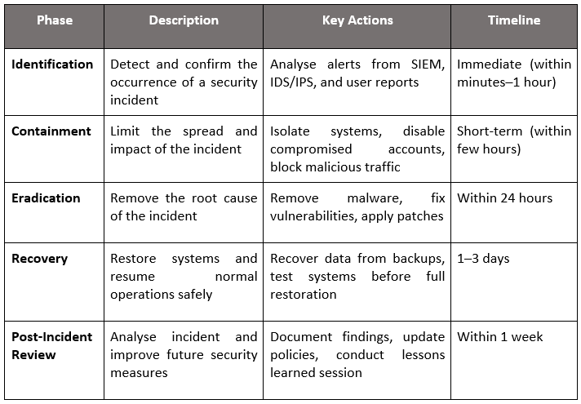

5.3 Incident Response Flow (Diagram)
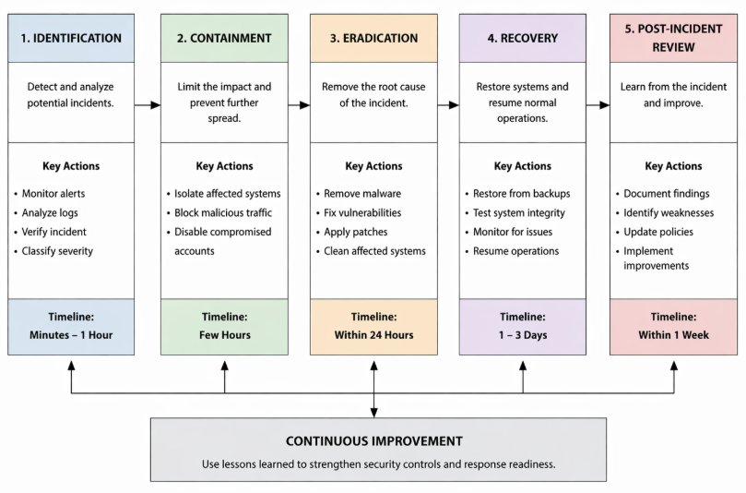
Figure 4: Incident Response Flow
(Source: Self-created)

6. Continuous Training and Awareness

6.1 Employee Training Program
The workers of HealthPlus Analytics (HPA) need a proper training program to be sensitised about the dangers of cybersecurity and the compliance with organisational regulations. The staff should also be educated via regular training sessions about the way to identify phishing email and effective passwords and how to work with patient information safely [22]. Induction security training should be offered to new employees and security refresher training should be conducted to the already existing employees periodically so that they can be kept informed of the changing cyber threats.

6.2 Workshops and Simulations
Workshops and cyberattack simulation exercises are also feasible methods of learning that can assist in attaining a substantial level of employee awareness. As an illustration, simulation campaigns on phishing can be used to test the capacity of employees in detecting suspicious emails and reacting accordingly to phishing. The drills will help to solidify the theoretical knowledge and train the staff to work in a manner that would be responsive in a real-life situation [22]. Exercises are also regular exercises that help the organisation to test its preparedness and what it can do better.

6.3 Policy Compliance Training
The workforce will be sensitised on the organisational policies such as data protection, acceptable use and incident reporting policies. Regulatory provisions, such as UK GDPR, need to be understood in order tobe in compliance and prevent legal sanctions [23]. The protocols of reporting security incidents in a responsible manner and in a timely manner should be clarified.

6.4 Building a Security Culture
The establishment of a strong security culture within HPA is crucial towards long term protection. Employees will be encouraged to be accountable, as far as cybersecurity is concerned, and report suspicious activities without being afraid of accusations. The management will create awareness by communicating a lot, reminding and rewarding to make security a part of daily operations [23].

7. Conclusion
This report has highlighted the most common internal and external threats such as insider risks, ransomware, phishing and vulnerabilities in cloud, which may severely affect operations of the organisation. In order to overcome these, a detailed list of security policies in line with industry standards has been suggested and effective technical mitigation measures to overcome the threats have been proposed and addressed.
Moreover, the significance of proactive monitoring and a properly designed incident response plan has been pointed out so as to prevent security incidents timely and successfully. Constant training and awareness campaigns should also be carried out to reinforce employee knowledge and ensure that there is a culture of security. In general, the suggested control measures will improve the security position of HPA, guarantee compliance with the regulations, and safeguard vulnerable data against emerging cyber threats.

References
[1] K. L. Offner, E. Sitnikova, K. Joiner and C. R. MacIntyre, “Towards understanding cybersecurity capability in Australian healthcare organisations: A systematic review of recent trends, threats and mitigation,” Health Security Intelligence, pp. 92–121, 2021.
[2] L. Coventry and D. Branley, “Cybersecurity in healthcare: A narrative review of trends, threats and ways forward,” Maturitas, vol. 113, pp. 48–52, 2018.
[3] S. Nifakos et al., “Influence of human factors on cyber security within healthcare organisations: A systematic review,” Sensors, vol. 21, no. 15, p. 5119, 2021.
[4] S. A. E. Hoffman, “Cybersecurity threats in healthcare organizations: Exposing vulnerabilities in the healthcare information infrastructure,” World Libraries, vol. 24, no. 1, 2020.
[5] J. A. Chua, “Cybersecurity in the healthcare industry,” Physician Leadership Journal, vol. 8, no. 1, pp. 69–72, 2021.
[6] K. Anastasopoulou et al., “Public and private healthcare organisations: A socio-technical model for identifying cybersecurity aspects,” in Proc. 13th Int. Conf. Theory and Practice of Electronic Governance, 2020, pp. 168–175.
[7] P. H. Chen and C. Wald, “A review of cybersecurity and privacy standards in medical imaging: Consensus, frameworks, and best practices,” Journal of the American College of Radiology, 2025.
[8] H. Lawson, “AI-driven multi-factor authentication: Enhancing IAM security in healthcare systems,” 2020.
[9] W. Shah, “Enhancing cybersecurity resilience: Strategies for patient data protection in healthcare systems,” 2024.
[10] C. Botrugno, “Cybersecurity, privacy, and health data protection in the digital strategy of the European Union,” RECHTD, vol. 14, no. 3, pp. 300–312, 2022.
[11] K. Y. Yigzawet al., “Health data security and privacy: Challenges and solutions for the future,” in Roadmap to Successful Digital Health Ecosystems, 2022, pp. 335–362.
[12] S. M. Pedapudi and N. Vadlamani, “A comprehensive network security management in virtual private network environment,” in Proc. Int. Conf. Applied Artificial Intelligence and Computing (ICAAIC), 2022, pp. 1362–1367.
[13] A. Ahmad et al., “How integration of cyber security management and incident response enables organizational learning,” J. Assoc. Inf. Sci. Technol., vol. 71, no. 8, pp. 939–953, 2020.
[14] L. Zhu et al., “Research on cybersecurity risk prevention and control of new infrastructure,” in Journal of Physics: Conf. Series, vol. 1856, no. 1, 2021, p. 012034.
[15] D. Tykholazet al., “Incident response with AWS detective controls,” Cybersecurity Providing in Information and Telecommunication Systems II, vol. 3826, pp. 190–197, 2024.
[16] A. Desai and M. Desai, “A review of the state of cybersecurity in the healthcare industry and propose security controls,” Mesopotamian Journal of Artificial Intelligence in Healthcare, pp. 82–84, 2023.
[17] S. K. Pendyala, “Strengthening healthcare cybersecurity: Leveraging multi-cloud and AI solutions,” J. Comput. Sci. Appl. Inf. Technol., vol. 10, no. 1, pp. 1–8, 2025.
[18] C. Iwendiet al., “Security of things intrusion detection system for smart healthcare,” Electronics, vol. 10, no. 12, p. 1375, 2021.
[19] A. A. Hady et al., “Intrusion detection system for healthcare systems using medical and network data: A comparison study,” IEEE Access, vol. 8, pp. 106576–106584, 2020.
[20] Y. He et al., “Healthcare security incident response strategy: A proactive incident response procedure,” Security and Communication Networks, 2022, p. 2775249.
[21] O. Okusiet al., “Designing resilient data risk management protocols for regulatory compliance and cyber incident response,” Int. J. Adv. Res. Publ. Rev., vol. 2, no. 7, pp. 45–70, 2025.
[22] T. O. Abrahams et al., “Cybersecurity awareness and education programs: A review of employee engagement and accountability,” Computer Science & IT Research Journal, vol. 5, no. 1, pp. 100–119, 2024.
[23] D. Ussher-Eke, “From awareness to action: Designing effective cybersecurity training programs,” Int. J. Sci. Res. Archive, vol. 16, pp. 494–504, 2023.
[24] C. Team, “What is The CIA TRIAD & its Importance for Cybersecurity,” Website Security Store, Aug. 18, 2021. https://websitesecuritystore.com/blog/what-is-the-cia-triad/

Appendix A: Screenshot of the Board of Directors PowerPoint presentation

Title Slide:
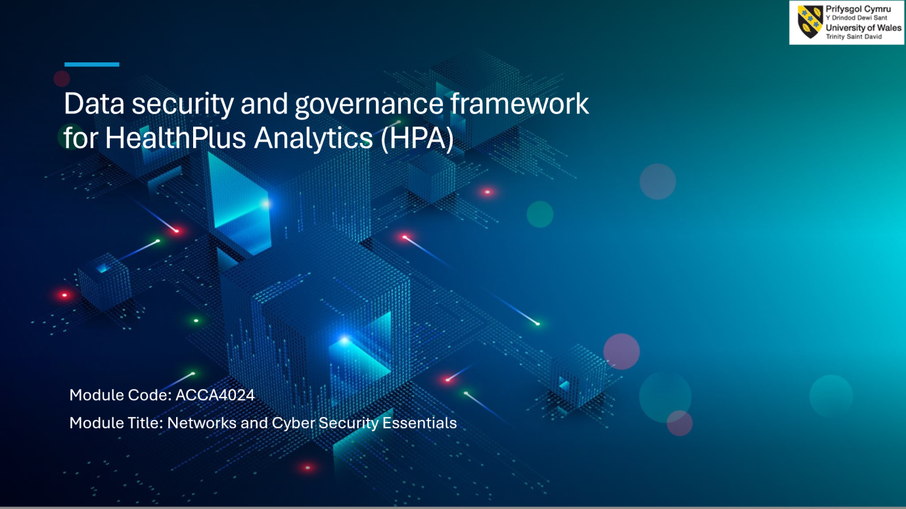
Slide 1:
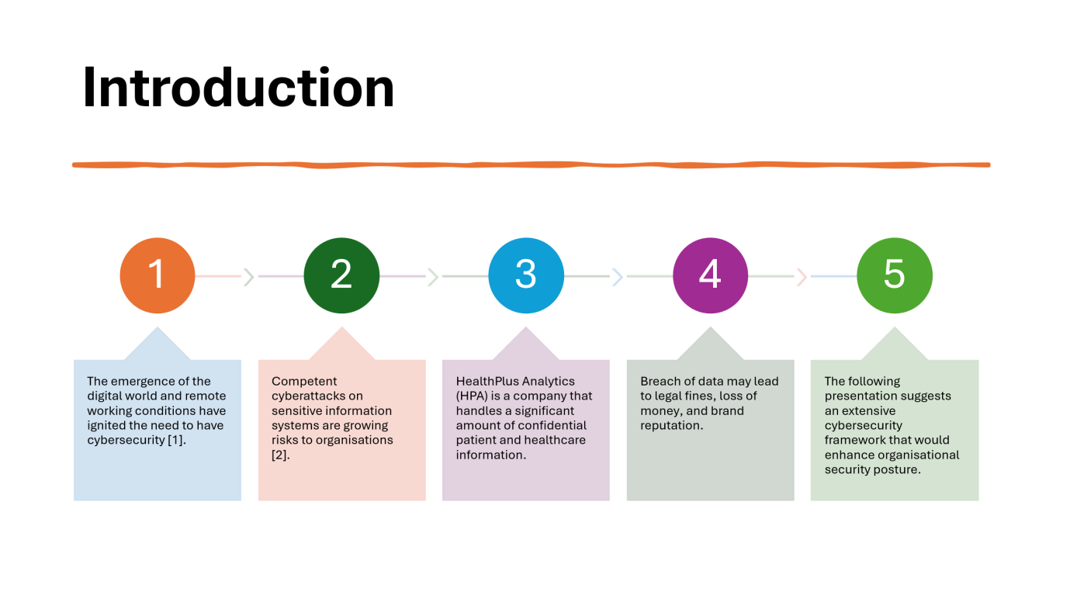
There is a growing concern about cybersecurity because of rising levels of digitalisation and telecommuting. In the present day, organisations are under continuous cybersecurity risks of sensitive information. HealthPlus Analytics deals with sensitive health information, which is extremely sensitive. The purpose of this presentation is to propose an effective and comprehensive cybersecurity framework to secure data, guarantee compliance, and enhance the overall security framework of the organisation.
Slide 2:
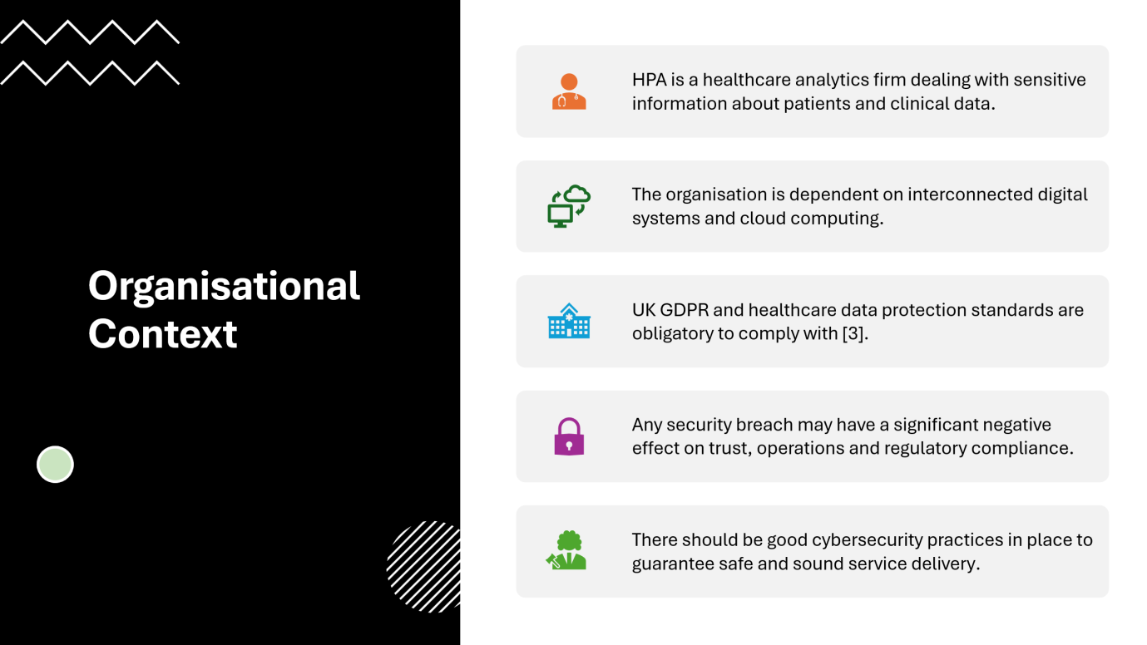
HealthPlus Analytics is an organisation that handles and stores sensitive patient data and is a healthcare analytics organisation. It is extremely dependent on cloud solutions and online services, exposing it to cyber threats. The UK GDPR must be adhered to in this process. Trust and operations may be affected by any violation. As such, effective cybersecurity solutions are required to make the delivery of the services safe, reliable, and compliant.
Slide 3:
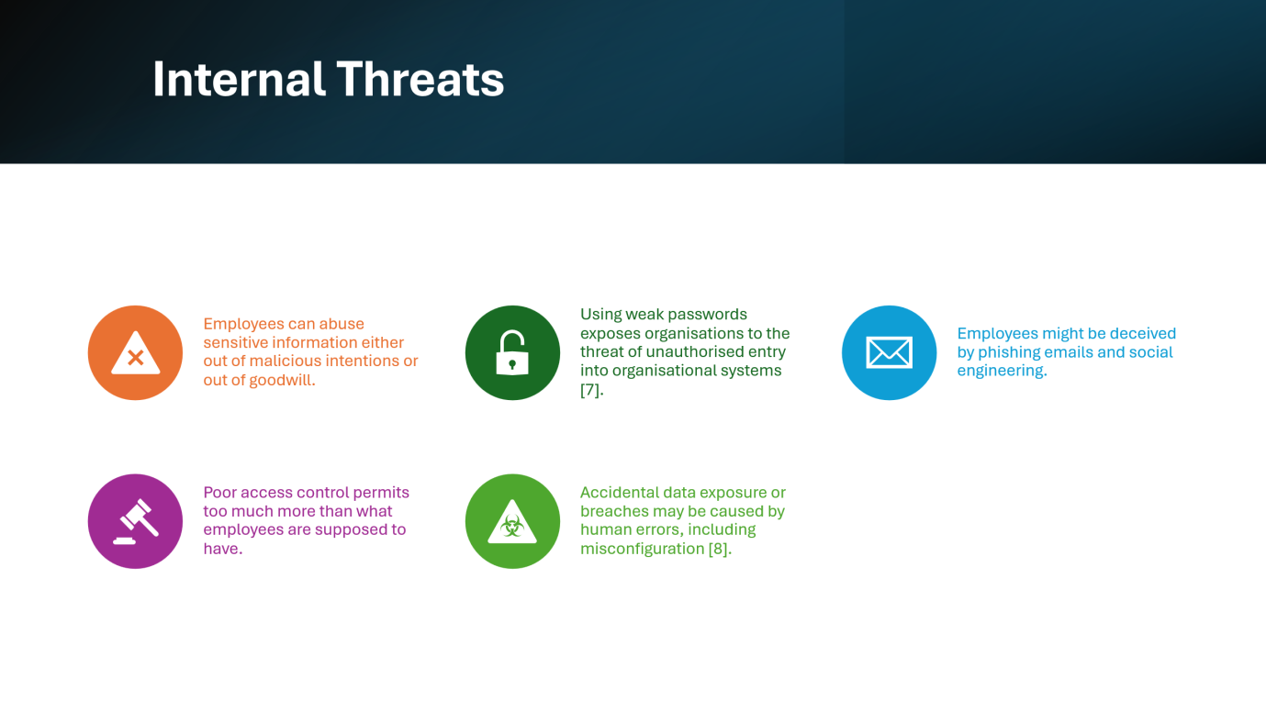
Internal threats come about as a result of employees or insiders who might either deliberately or accidentally breach security. Common causes are weak passwords, low awareness and phishing attacks. There is also abuse of access privileges by employees. Misconfiguration and human mistakes may cause data breaches. Thus, strict access controls and training should be applied by organisations to contain insider-related risks.
Slide 4:
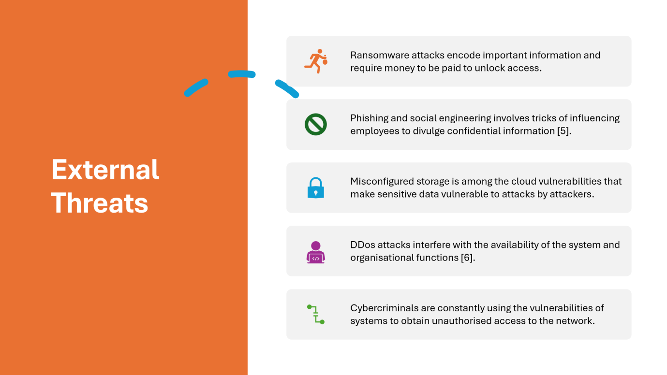
Cybercriminals attack organisational systems with the aim of causing external threats. Ransomware attacks are able to encrypt information and request funds. Phishing schemes deceive employees and make them provide confidential information. Services may be disrupted by cloud vulnerabilities and DDoS attacks. The threats keep on getting updated, and organisations should therefore adopt advanced security measures to ensure that systems and data are secure.
Slide 5:
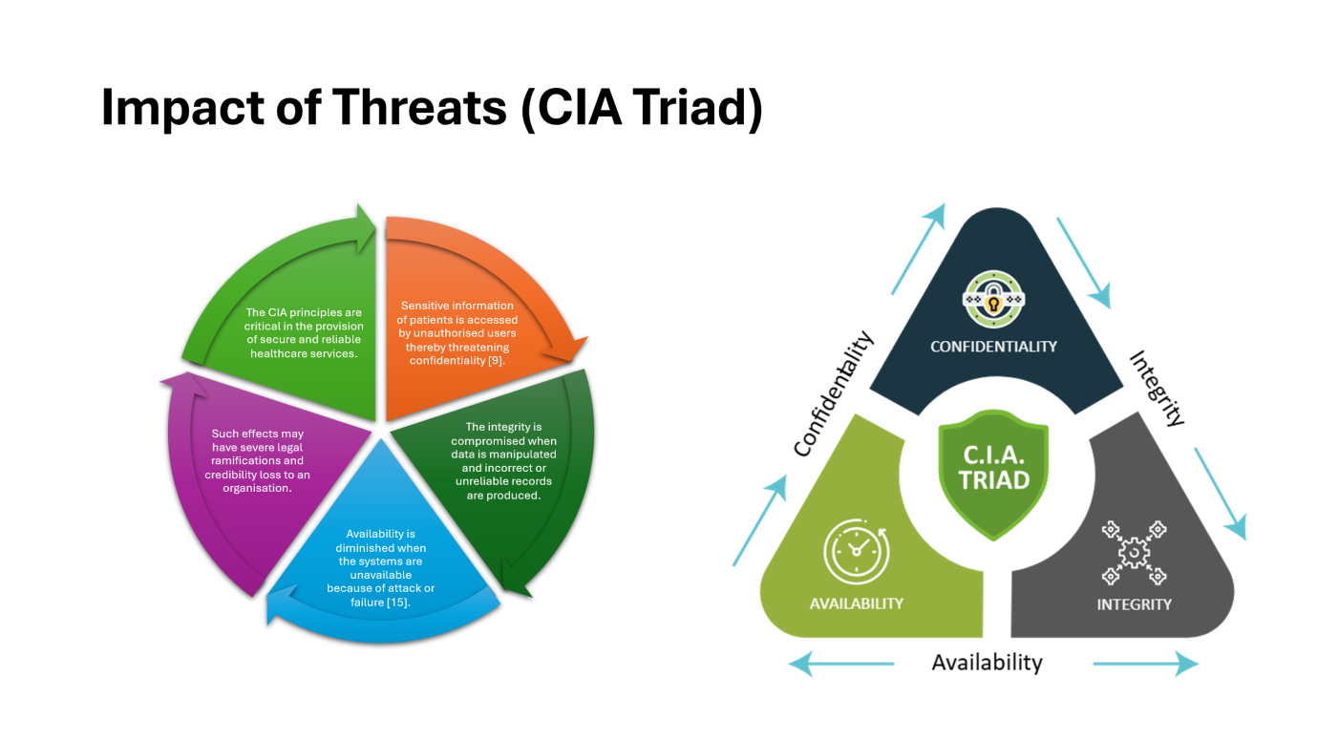
The CIA Triad can be used to measure the effect of cyber threats. This issue of confidentiality is compromised when confidential information is revealed. When data is corrupted or modified, it is compromised. Availability decreases in cases where the systems are inaccessible. These effects may result in legal action, loss of normal business operation and trust. To ensure organisational security, it is necessary to maintain CIA principles.
Slide 6:
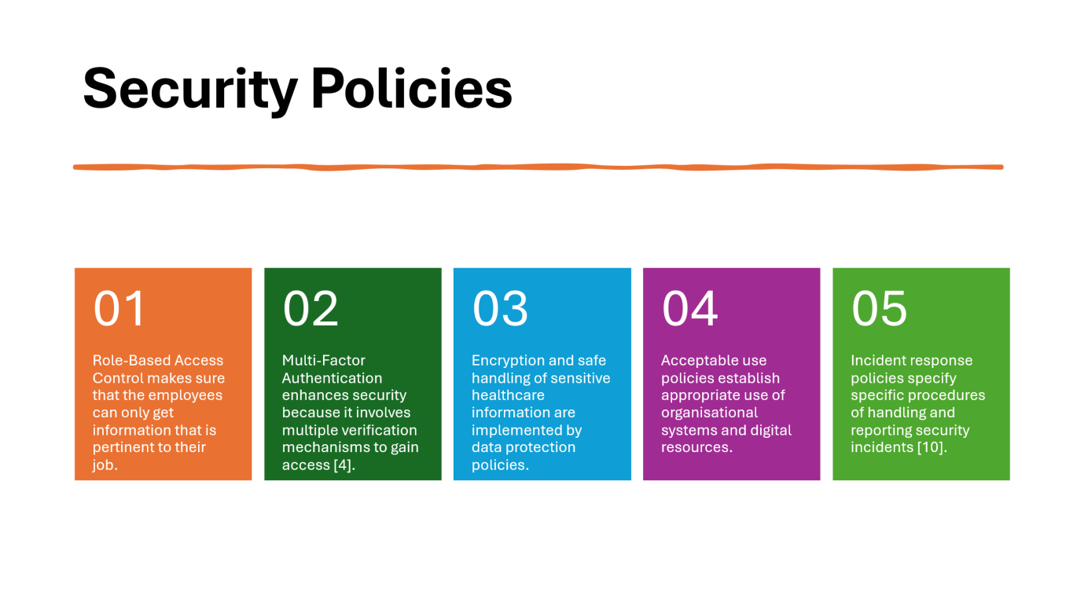
Security policies are policies that give guidelines to safeguard the organisational systems and data. Role-Based Access Control is a way of granting limited access to roles. Multi-Factor Authentication provides an additional security level. Data protection policies guarantee adherence to GDPR. Employee behaviour is guided by acceptable use policies. Incident response policies are used to control security breaches and reduce possible damage.
Slide 7:
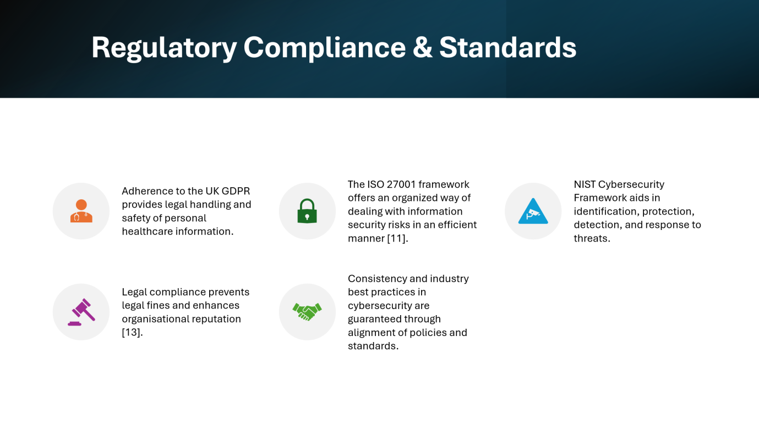
Healthcare organisations need to comply with regulations in cybersecurity. To safeguard patient information and prevent legal consequences, HealthPlus Analytics would have to adhere to UK GDPR. Such frameworks as ISO 27001 and NIST offer guided principles of risk management. The alignment of security policies with these standards would provide consistency, better security practices, and increase the credibility and trustworthiness of the organisation.
Slide 8:
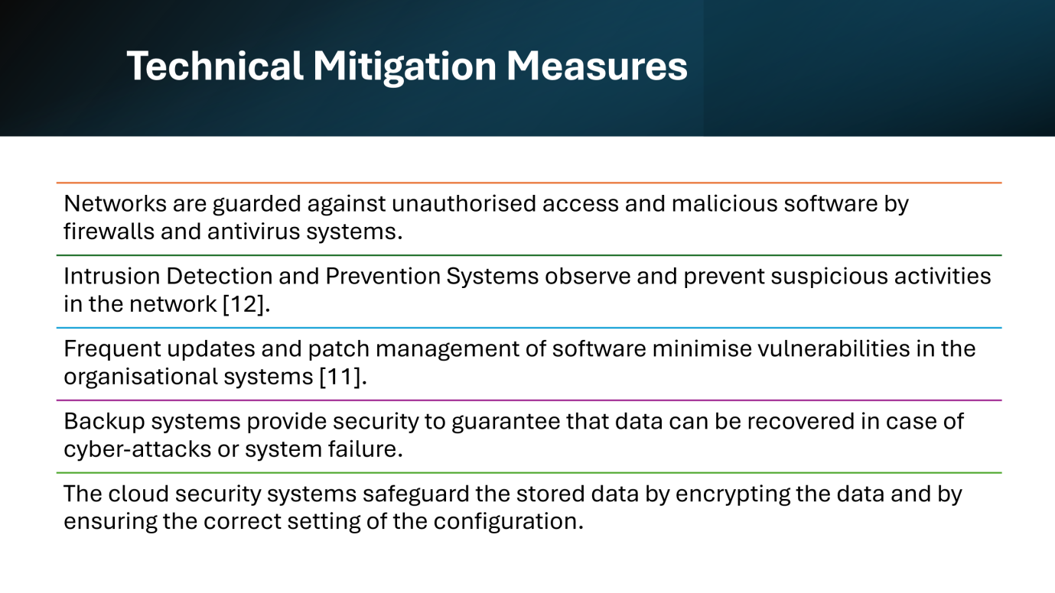
Technical controls should be applied to prevent and manage cyber threats. Antivirus systems and firewalls are used to guard against malicious activities. Threats are monitored and detected by IDS and IPS systems. Vulnerabilities are minimized through regular updates and patching. Backup systems ensure that there is recovery of the data after attacks. Cloud security controls are also important in safeguarding sensitive data over the Internet.
Slide 9:
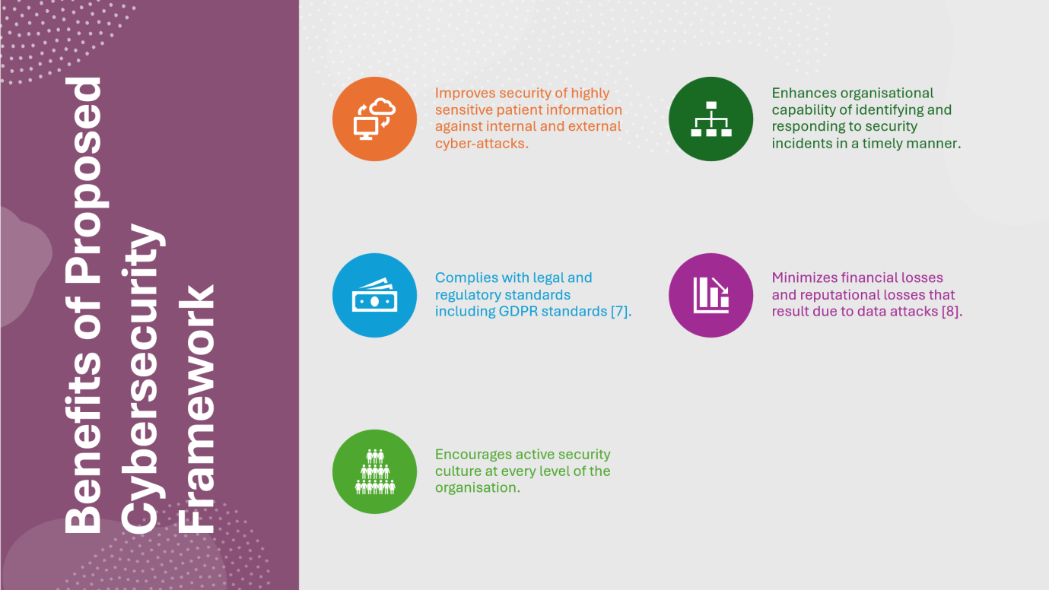
The suggested cybersecurity model has a number of valuable advantages to HealthPlus Analytics. It enhances the protection of data, threat detecting and responding, and regulatory compliance. It also eliminates the chance of financial losses and bad reputation. Above all, it encourages the active security culture in which employees play an active role in ensuring the security of the organisation.
Slide 10:
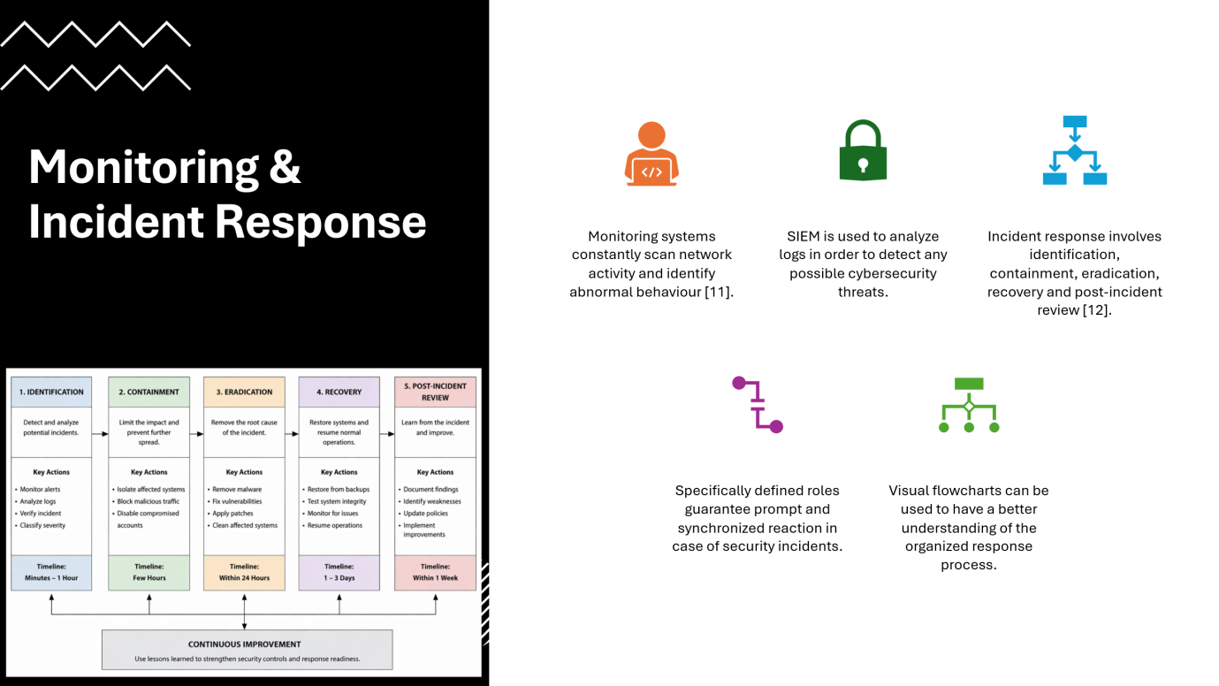
Real-time monitoring is used to identify threats using tools such as SIEM systems. These tools examine logs and send warnings of suspicious behaviour. The incident response process involves identification, containment, eradication, recovery and review. Specific defined roles assist in reducing the harm and in accelerating recovering procedures in case of cyber-attacks.
Slide 11:
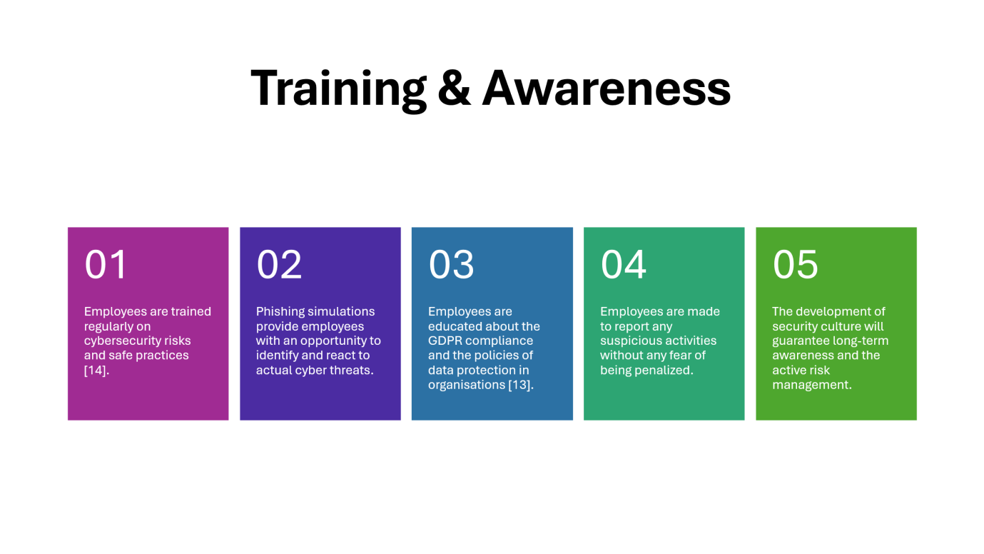
One of the important elements of cybersecurity is employee awareness. Training also enables the staff to be aware of the risks and use safe practices. Phishing exercises enhance the effectiveness of real-life responses. The employees should know the GDPR requirements and organisational policies. The culture of reporting suspicious activities would ensure that threats are detected early and that the overall security framework of the organisation is improved.
Slide 12:
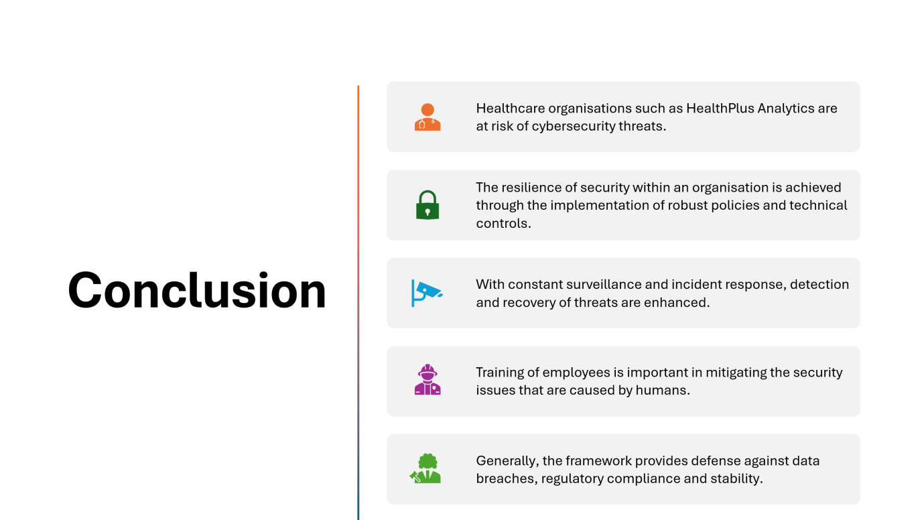
In conclusion, cybersecurity is crucial in the safety of confidential healthcare information. HealthPlus Analytics will need to deal with its internal and external threats using robust policies and technical controls. Good response initiative and constant monitoring enhance strong ties. Training of employees minimizes risks that are caused by humans. Comprehensively, the suggested framework will improve security, compliance, as well as safe and trustworthy organisational operations.
Reference Slide


