Contents
Introduction 2
Requirements 2
Purpose and subject matter 2
Target Audience 2
Implementation 4
Home page 4
About page 4
Skills Page 5
Education page 5
Contact page 6
6
HTML 6
Index.HTML 6
About.HTML 7
Skills.HTML 8
Education.HTML 8
Contact.HTML 9
CSS 9
Style.CSS 9
Evaluation 10
References 10

Introduction

I wanted my website to be something I can easily talk about and code about, I also wanted it to be something I have knowledge and interest for, so for my website I decided to make a portfolio. My report will examine the elements of my website and go over the requirements and implementation.
I will show and talk about the website purpose and all the content is has and explain the content of it.
I made this website as it is, because I have a lot of interest in coding websites, using excel to make graphs and make calculation on profit if it is either personal or a company that I am doing it for. I use excel a lot to spread my University student loan into monthly so I have a better idea of how much money I should be using monthly, by me doing this on a daily and constantly checking I have improved my knowledge and understanding of excel and made me enjoy it a lot more.
I also love to use access as before I had to make a access database for a small company in college and I got so into it that I made the best access database in my class and because I enjoyed it I kept learning more and more about it.

Requirements

Purpose and subject matter

The purpose of my website is to talk about myself and share more information about me, both a bit or my personal life on the about me page and also my interests and hobbies and what I’m currently doing in terms of education and what I want to do after I graduate University.
On my website I talk about how old I am and where I was born and where I came from as also my history from when I was born to where I am today. I also talk about my skills that I’ve learned both in college and school, these skills are IT related such as: Microsoft Access, Excel and word; these skills I have learned in college and school, these skills allow me to demonstrate that I have learned how to write good structed reports and also my ability to make good excel sheets which are good when it comes to business and statistics which are often used in real life business and companies.

Target Audience

My target audience is anyone who is interested in me and my skills, this can be anything from future jobs I apply to and they want to know more about me, where I came from, studied and my skills involving IT.
Also if anyone is interested in any of my skills and want to learn more about excel and how to make macros or make a big working excel sheet to help a business work out income and future profits, they can see on my website that I acquire those skills and can get in contact with me and I can help them with any enquiries.

Implementation

Home page
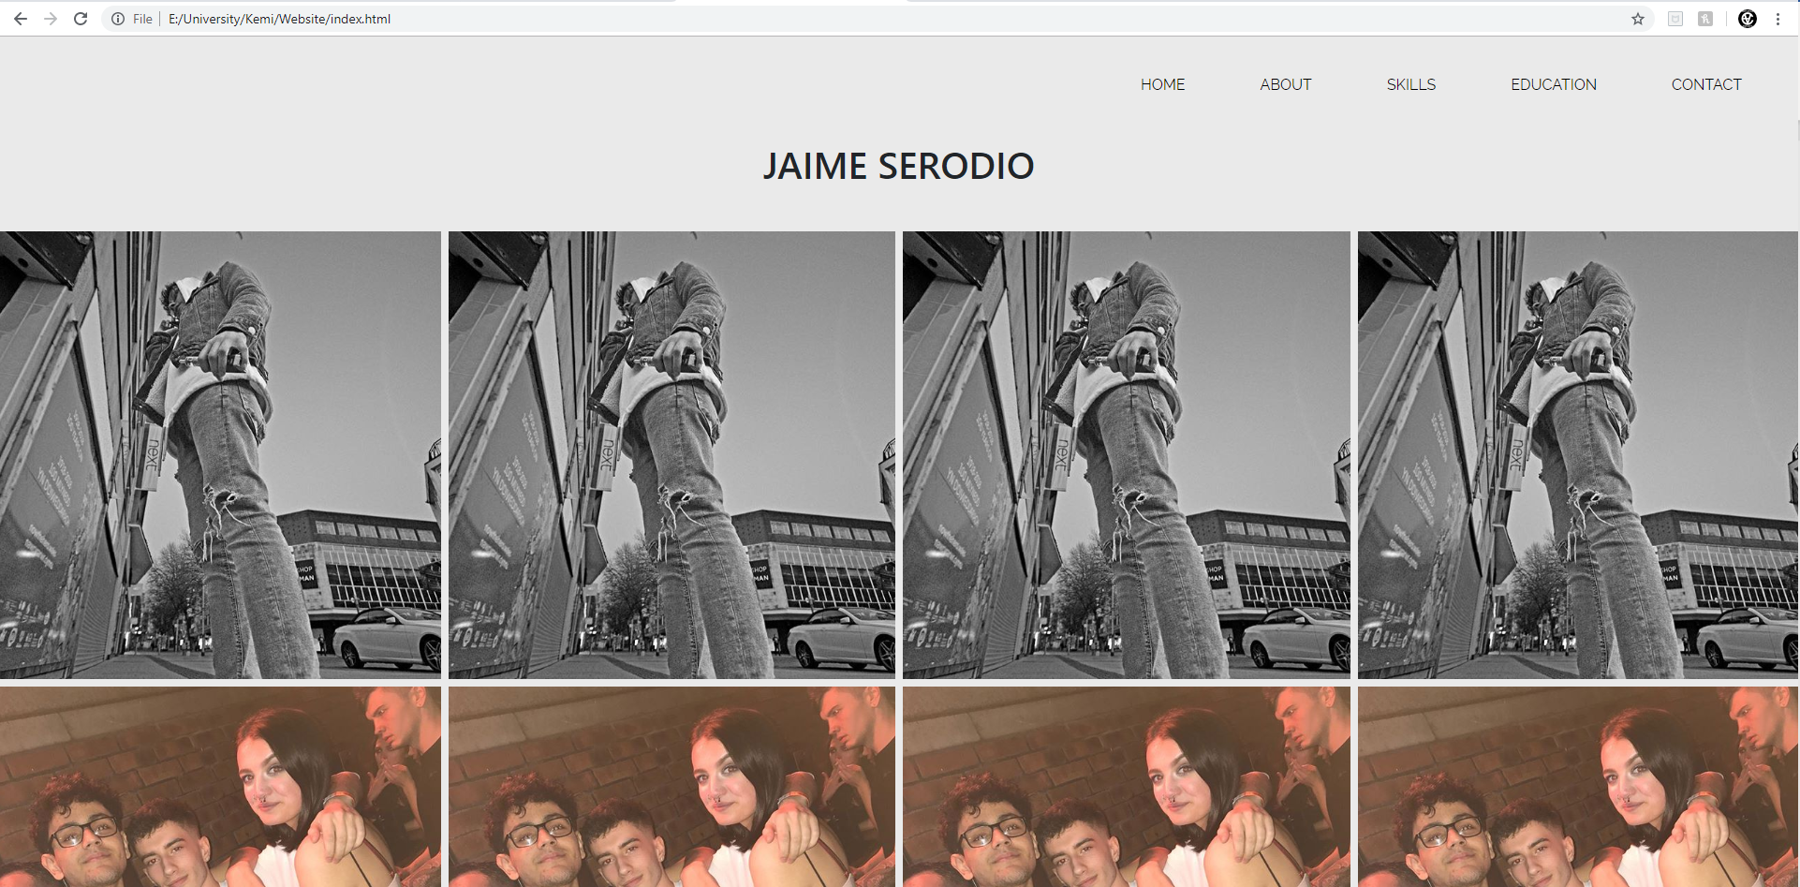
On my home page I didn’t want to write anything as about me will describe everything important about me, so for this I just wanted to display an art show with pictures of me and show my skills to apply a gallery on a website.

About page
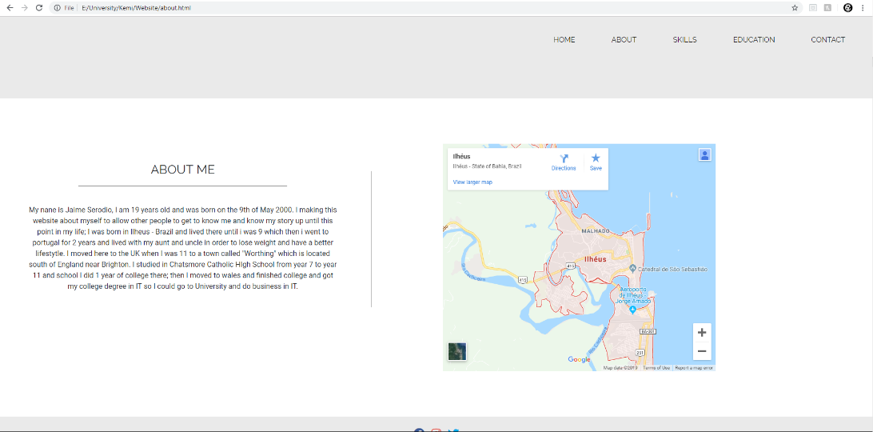

For the about page I just wanted to give everyone a brief summary of my life, from where I was born and where I grew up and how I got to where I am today.
On this page I just talk about where I was born and where I moved to over the years, I don’t talk about my current education because I have a designated page for that.

Skills Page

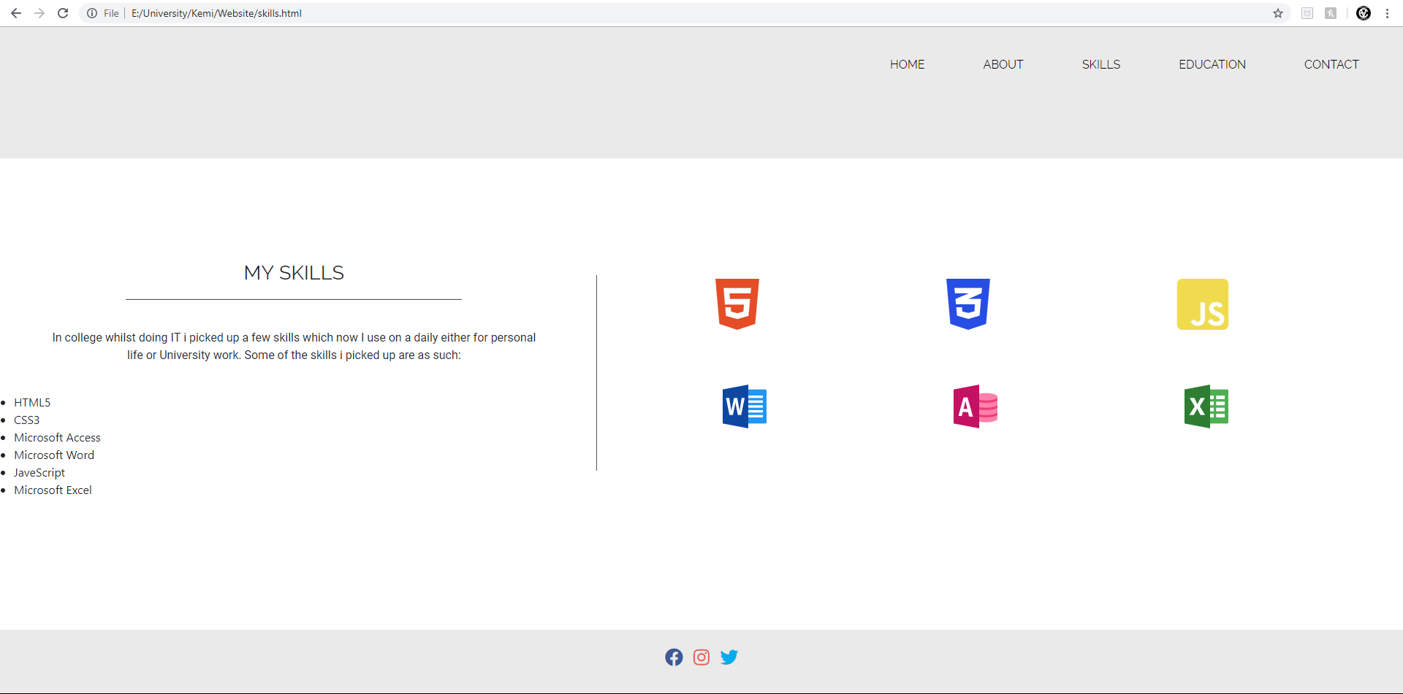

On my skills page I just describe my current skills that I have that are IT related and where I acquired them.

Education page

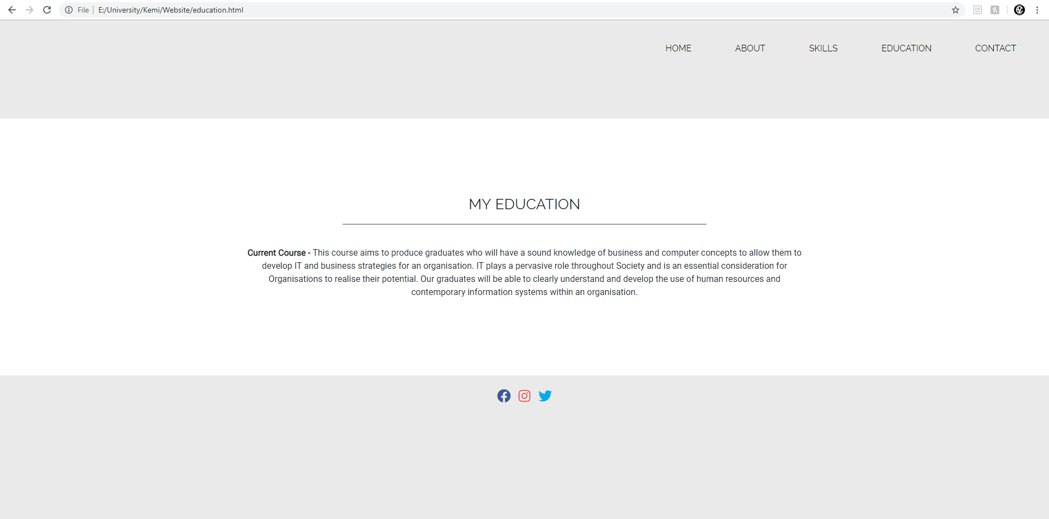
On this page I just describe what the course that I am currently doing will provide in the future, that being my knowledge in IT and business so when I graduate I will have a good knowledge on those topics and be able to get a good job or even open up my own business when I am older.

Contact page

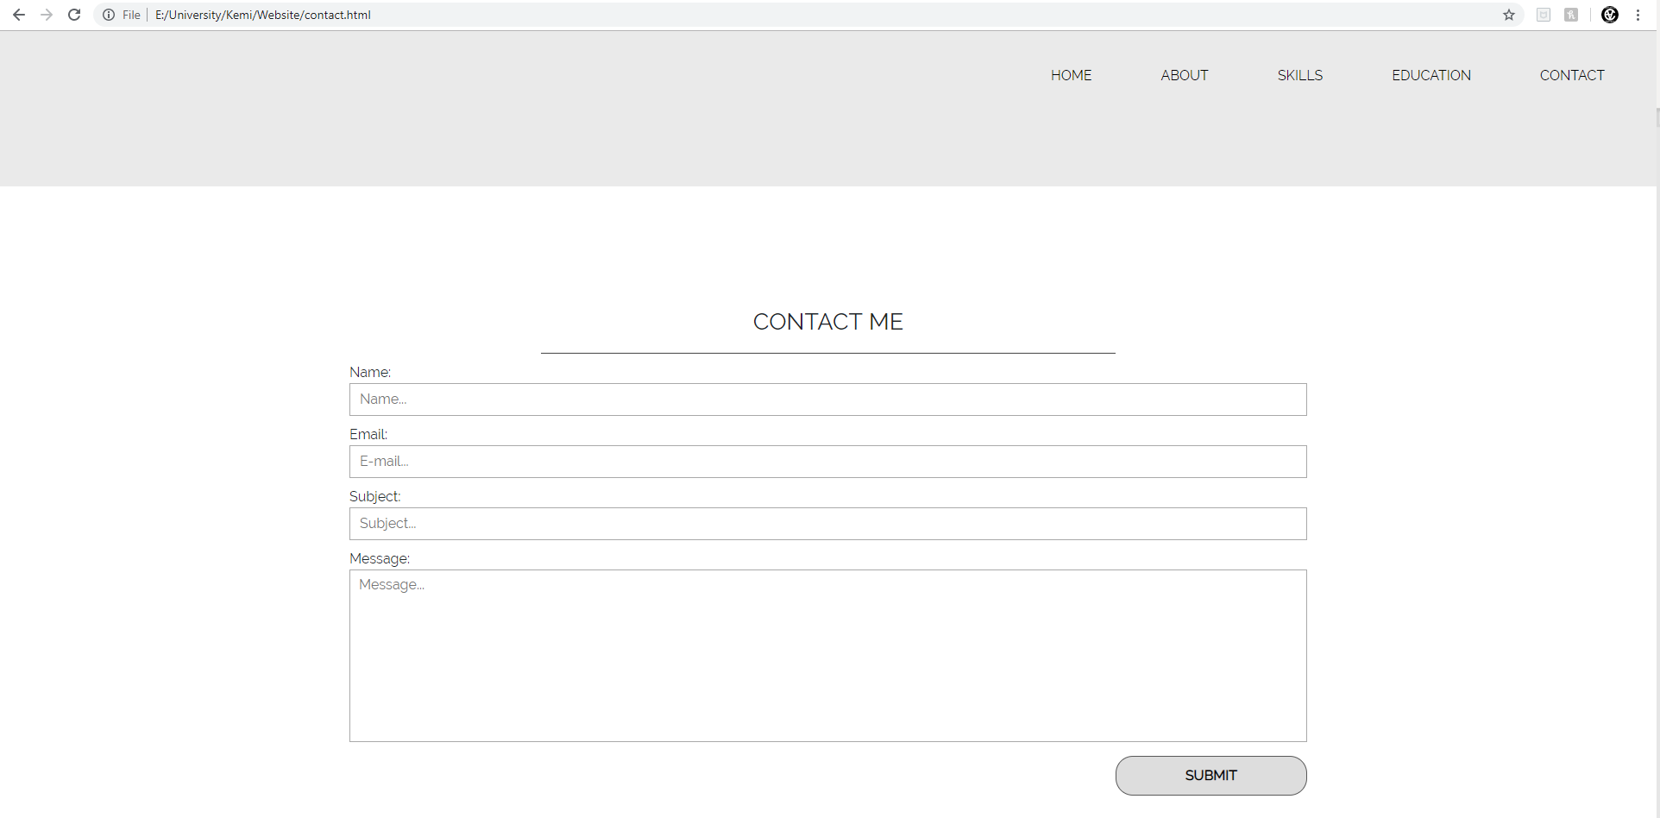
This page is just for anyone who needs to contact me with any questions about me or if they need any help, they are able to contact me.

HTML

Index.HTML

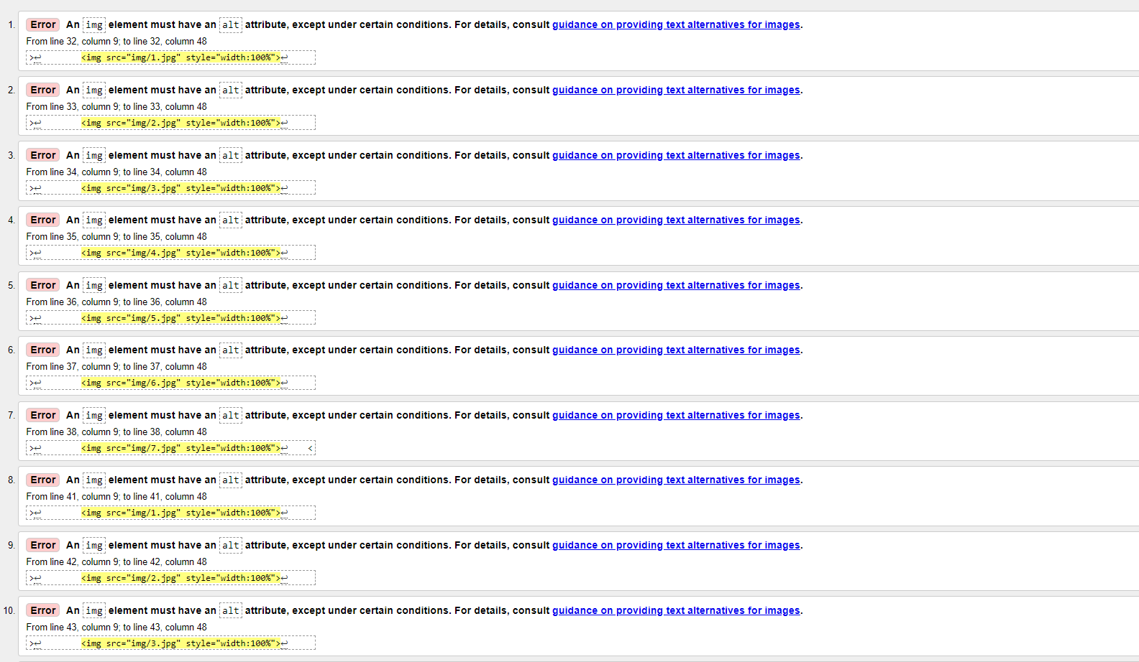
Errors:
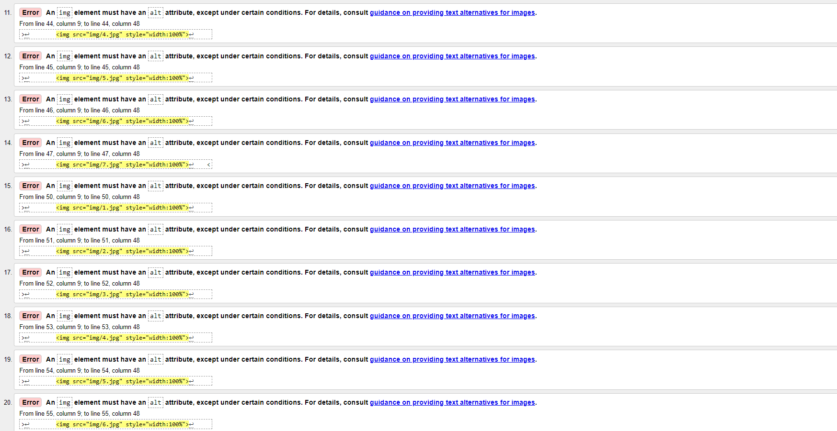
I didn’t use the ‘alt’ tag, which basically is when you hover over an imagine it will display a text telling the user what the imagine is.
Fix:
To fix this all I would need to do is add the ‘alt’ tag to each imagine in my code.

About.HTML

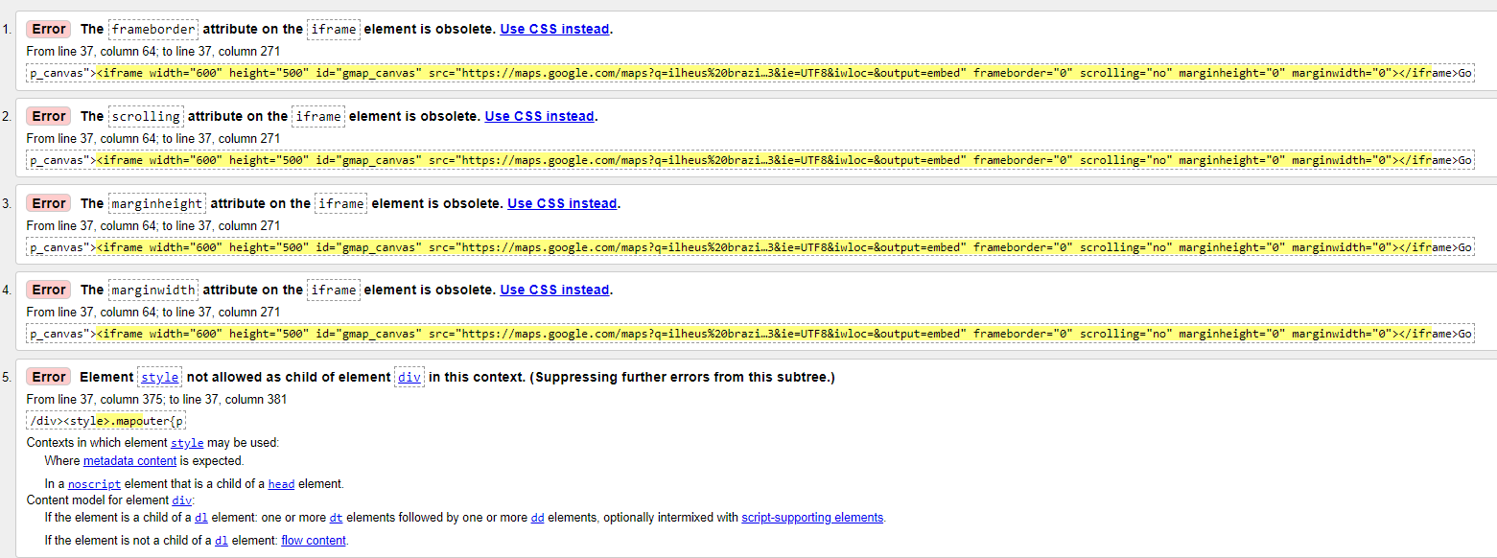
Error:
This error is saying that there is a new method/way to do adjust the boarder on my iframe.
Fix:
To fix this I would use CSS instead which would be a lot easier as the CSS can be applied for every iframe tag.

Skills.HTML

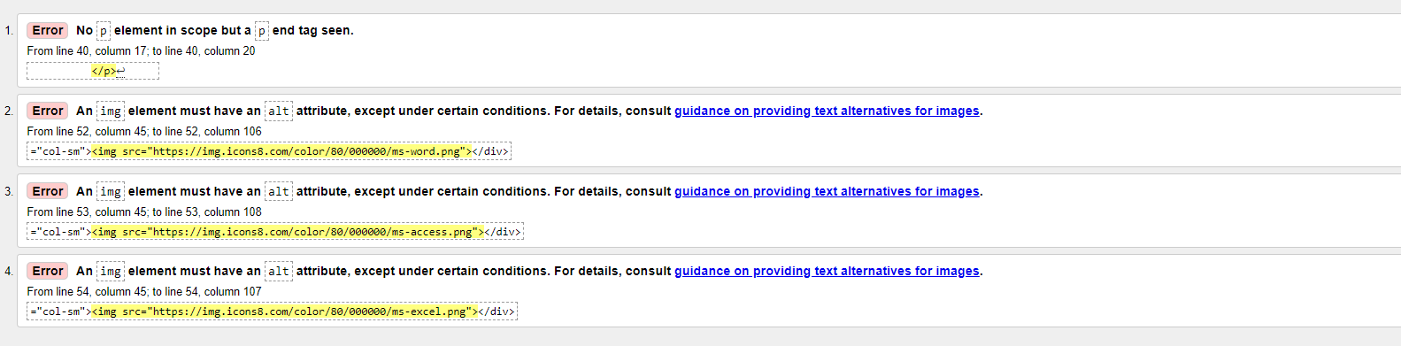
Errors:
In this page I got an ending paragraph tag with out an opening one, also the other errors are all the ‘alt’ tag errors.
Fix:
Add the ‘alt’ tags to each line of code where the image is stored, I didn’t change this because I don’t want a text popping out of the imagine when the mouse curser is hovering over it.

Education.HTML

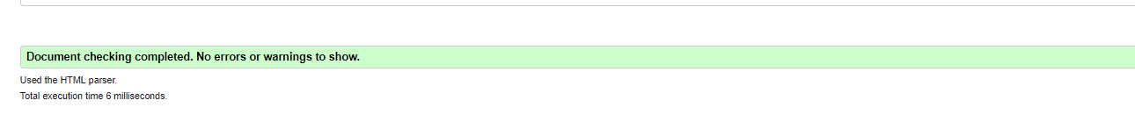

On this page there was no errors or warning messages.

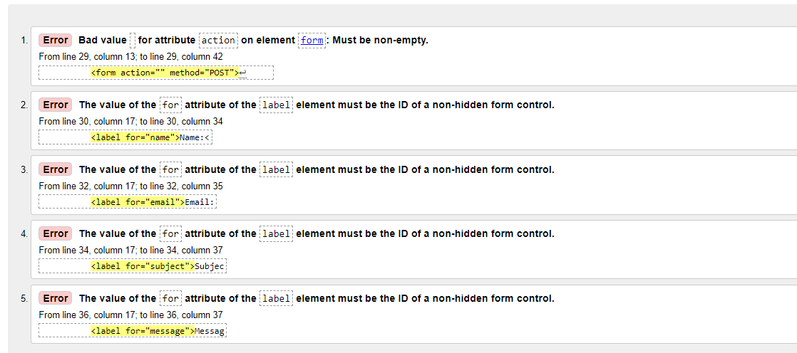
Contact.HTML

Errors:
The first error is saying that the form doesn’t have a value, so I need to give it a value.

CSS

Style.CSS

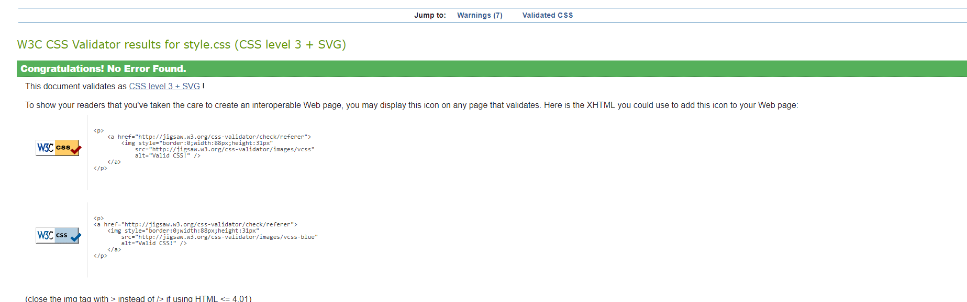

Evaluation

My website is pretty user friendly as it is as simplistic as I could possibly make it, the menu bar is simple and very visible. I believe in terms of colour use my website is very comforting as it is mostly black and white and colour-blind users won’t have any troubles reading or any troubles trying to make out the colours of my website.
On my skills page I describe my skills in certain software, Next to it I also put up the logos of each software to give the website a bit more of life.

References

http://validator.w3.org/
http://jigsaw.w3.org/css-validator/

marking criteria and Student FEEDBACK

This section details the extent to which the assessment criteria are demonstrated by you, which in turn determines your mark. The marks available for each category of skill are shown. Lecturers will use the space provided to comment on the achievement of the task(s), including those areas in which you have performed well and areas that would benefit from development/improvement.

Common Assessment Criteria Applied (Assignment 1) | Marks available | Marks  awarded
1. Engagement with Literature Skills

A limited list of references has been provided. It is expected that you would consult a wider range of reference sources. Expand the scope of references consulted to further improve your work. (Grade mark: 20.00%) | 5 | 1
2. Knowledge and Understanding Skills

Demonstrates a good understanding of the standards used to design and implement a website. See further comments below under practical application and development. (Grade mark: 60.00%) | 20 | 12
3. Cognitive and Intellectual Skills

A fair evaluation of the website has been provided. Generally, this section could be improved as your evaluation is too brief and does not consider all of the elements you have been asked to evaluate. (Grade mark: 43.33%) | 30 | 13
4. Practical Application Skills

A very good attempt featuring a simple website with well-thought-out content. Overall, demonstrates some good use of HTML and CSS but there is some room for improvement. For example, note that the alt attribute is required for all images for accessibility and add your CSS styles to your style sheet instead of adding the style attribute to HTML elements as this is a better practice. (Grade mark: 65.00%) | 40 | 26
5. Transferable Skills for Life and Professional Practice

The report is of a good standard. See your report for comments of how to improve your reports. (Grade mark: 60.00%) | 5 | 3

Assignment Mark (Assessment marks are subject to ratification at the Exam Board. These comments and marks are to give feedback on module work and are for guidance only until they are confirmed. ) | Late Submission Penalties (tick if appropriate) |  | 55%
 | Up to 1 week late (40% Max) |  | 55%
 | Over 1 week late (0%) |  | 55%

Note that as this is a RESIT attempt, the mark is capped at 40%.

