Data Handling and Business Intelligence
By Denis Nedzhmiev
Student ID: 2029363

Instructor: Gasso Wilson Mwaluseke
LCBB5000

Introduction
Business and technology often go hand in hand; modern businesses have adopted numerous technology as a strategy to improve overall efficiency and performance. This adoption has resulted in data analysis becoming a key part of business operations and analysis. Evidence from various organizations shows that businesses are increasingly leveraging to collect data relating to markets, key transactions, and other processes (Laursen & Thorlund, 2016). Analysis shows that businesses are using more and more information artificial intelligence as the key approach to unlocking the value in the data. Such changes have seen business focus on data-driven operations and informed decision-making (Laursen & Thorlund, 2016). Given these observations, it is critical to examine key approaches to data handling within the business environment. In this case, the analysis adopts data from Superstore and Ice cream sales to perform different forms of analysis and

Part 1: Superstore and Data Handling Analysis
Today, businesses adopt data-driven mechanism for effective decision-making and improve overall business efficiency. This has seen businesses (small and medium-sized as well as large-scale enterprises) have focused on leveraging various technologies for effective data collection. An example of such a dataset has been provided by the Superstore Sales data. This section, therefore, aims to analyze and obtain key insights into the bonuses based on the record provided.
Data analysis
The analysis shows that the data is highly comprehensive, containing a total of 8,400 records with approximately 21 variables. The data contains a time series element with the focus aimed at showing variation in sales between 1st January 2009 and 31st December 2012. The data contains insights into the geographical distribution of stores; each record, therefore, contains key information relating to sales profits, geographical distribution, and customers. This creates the need to fully examine the variations within the data for better understudying of the business.
An analysis of the sales shows significant variations between 2009 and 2012. The variation is highlighted by a significant decline between the set periods. While the general trend shows a decline in sales, it is critical to acknowledge that the observation does not account for the internal characteristics of the dataset. A future examination of the data shows a declining trend between 2009 and 2011. This decline was accompanied by a significant increase in sales during the 2012 period. Despite the observed increase, sales in 2012 were notably lower than sales in 2009 (see figure 1 below).

Figure 1: Variation in sales between 2009 and 2012
The changes in sales across the years show a general trend in the datasets. The insights, while critical, they do not account for the internal variabilities within the datasets. This creates the need to examine the regional variability within the dataset. This examination was possible through the use of pivot charts and tables for a detailed overview and analysis. The analysis shows that the Superstore businesses were able to fully operate acorss8 regions. These differences in the region were key to the variation in sales, with some region recording higher sales than others. In this case, the stores operating in the Ontario region recorded the highest number of sales, while those in the Northwest Territories recorded the lowest amount of sales. Similar observations were made when profits were considered key characteristics within the dataset. Specifically, Ontario recorded the highest profit margin, with the Northwest Territories recording the lowest profits. Based on such observations, one may conclude that a positive correlation exists between business salsas and profits across different regions. However, it is critical to acknowledge other sources of variation that may modify such relationships.

Figure 2: Sales, Discount, and Profits across different regions
The observations and conclusion from figure 2 indicate the need to examine more variables to fully understand busyness performance. This calls for an examination of the variabilities as a strategy to improve business practices and enhance sales. Therefore, future exploration of the datasets using pivot charts, LOOKUP, and SUMIFS functions shows that goods provided by the superstore business can be categorized into 5 major categories: Critical, High, Low, and Not specified. This level of categorization highlights customer needs and the number of purchases made due to such approaches to classification. In this case, high-priority orders had the highest contribution to total sales across the years; they also accounted for the highlighted profits within the business environment. Nonetheless, a high number of customers preferred not to specify their type of order, while a significant portion of them categorized their orders as critical. Where profitability of the business is concerned, the highest profit margins were recorded by orders that were categorized as a high priority. This observation further highlights the positive correlation between sales volume and profits.

Figure 3: Sales and profits with a priority of orders
In summary, the Superstore sales data provided shows the importance of data-driven approaches informing business performance and operations. For instance, the provided datasets show the essence of geographic location and prioritization of orders in shaping the volume of sales. At the same time, it allows one to understand the importance of sales in shaping the direction of business profits. While providing such insights, it is essential to recognize the role of Microsoft Excel in data handling. An examination of the datasets shows that they are highly varied and voluminous. Such variations imply that they accounted for daily transactions and volume sales across each location and store. At the same time, they accounted for customers acquiring such goods and services. This level of accountability indicates the ability of Microsoft excel to shape the data consolidation and preprocessing process. Therefore, it is vital to examine the software as a data-handling tool.
Microsoft Excel is a critical data-handling tool/software
According to Carlberg (2014), modern businesses are primarily oriented toward ensuring their growth, attaining a competitive advantage, and overall expansion. These needs are usually reflected in their business models, which are usually oriented towards leveraging key market characteristics in relation to the underlying business operations (Nisbet et al., 2018). This aspect explains the regional variation in superstore sales and type of orders. Such elements of the business mode, while crucial to enhancing profitability, they present significant weaknesses to the organization or businesses. The most notable weakness has been the volume of data generated; in the case of superstore sale data, a total of 8400 records with at least 21 variables were collected and stored. This high volume tends to present numerous difficulties in terms of data handling and processing to obtain business-related insights. In the process, numerous questions emerge; some of these questions include (1) is the software able to accommodate such a large dataset? (2) What are the key functions used to handle and analyze such data? (3) Are the approaches effective?
An examination of superstore data shows that the data was obtained from a wide range of sources. The diversity of such sources tends to create several shortcomings in consolidation and data structuring. While such shortcoming exists, the presence of Microsoft excel was critical in creating a foundation structure for data analysis. As a preprocessing tool, Microsoft excel was able to consulate datasets from different sources, identify the key variables, creating a semi-structured dataset for more efficient analysis. Such capabilities highlight its overall efficacy as a data preprocessing tool.
While preprocessing is key, it is critical to acknowledge that Microsoft excel is predominantly used as a tool for data consolidation, storage, and management. However, such applications are not a true reflection of their overall capabilities. An analysis of Microsoft excel functionalities shows that the software has been widely used as a data analytic tool. This is due to the numerous mathematical, logical, and scientific functions that allow one to perform different calculations or manipulations on the datasets. In this case, some key functions used include LOOKUP, SUMIFS, PIVOT TABLES, and CHARTS, and in some cases, the IF functions.
SUMIFS: the provided dataset can best be described as semi-structured. This implies that it could not be fully understood without further predefined classification. Amidst these needs, it was critical to recognize that the datasets were highly specific, especially where the variable was concerned. Such specificity limited the capacity to analyze annual variation in the datasets fully. This challenge was addressed by the adoption of a SUMIFS function. The function is primarily defined as a math and trig function designed to improve arithmetic addition based on specified arguments. During the analysis, it was critical to leverage the state and end dates of each year as the main criteria for addition. The adopted approach is highlighted in the table below.
Table 1: annual sales using the SUMIFS function
The adoption of SUMIFS and other functions provided numerical values that were critical in information key characteristics of the business. However, the ability to fully understand the datasets was limited. For this reason, it was critical to use key data visualization techniques for further analysis. As a result, bar charts were used to show annual variation in sales, variation in sales across different regions, and variation in profits across the type of orders. While such insights were critical, it is essential to acknowledge that the unstructured nature of the datasets did not create room for in-depth analysis and visualization. For this reason, PIVOT tables and charts were used as primary tools for data consolidation and classification. In the process, key issues such as variation in the discount offered, the customer, and variation in sales across regions, years, and types of orders were obtained.
The above functionalities show indicate the dynamism of excel in shaping modern data handling. The provided approaches allowed an in-depth analysis of the dataset, which can be helpful in the overall decision-making process. However, it is critical to acknowledge that the adoptions used in this analysis do not fully reflect the role of excel in data handling and preprocessing. Therefore, it is critical to examine the effectiveness of excel as data handling and preprocessing tool.
Effectiveness of Microsoft excel in data handling and preprocessing
Microsoft Excel has been widely adopted as a tool for data management and analysis. Its adoption I handling the superstore sales data provide key highlights behind these numerous adoptions. One of its effectiveness is its ability to focus on multiple variables, thereby creating a multi-dimensional approach to data analysis. An instance of such an approach has been seen through its ability to account for profitability, sales, and discount provided by stores across each region. Such multi-dimensional insights are critical in enhancing informed decision-making in the organization.
While considering key functions such as LOOKUP, SUMIFS, and features like PIVOT Tables and Charts, it is critical to consider the characteristics of the provided data in relation to excel capabilities. In this case, the data can best be described as voluminous due to the number of records and variables included in the dataset. Such datasets tend to limit the analytical process due to the failure to obtain a predefined structure for the analysis. However, Microsoft excel plays a key role in ensuring sufficient classification of the datasets, providing a unique structure relative to business operations. In the prices, the data handling process was significantly improved.

Part 2: Ice-cream sales and data handling analysis
2.1 number of students who prefer vanilla ice-cream
The dataset provided shows notable variations in ice cream flavors sold by the business; the three main flavors include chocolate, vanilla, and strawberry. The variation in ice cream flavor has also been accompanied by differences in customer (students) preferences. As a result, a total of 95 students consider vanilla as the ice cream flavor of choice. Further analysis shows significant variation based on gender/sex; specifically, 47 male students preferred vanilla as their ice cream flavor of choice, while 48 female students considered vanilla as their flavor of choice.
Table 2: Variation in flavor preference with gender
Sex/Gender * ice-creams Cross tabulation
Count
 |  | ice-creams |  |  | Total
 |  | Vanilla | Chocolate | Strawberry | Total
Sex/Gender | Male | 47 | 15 | 29 | 91
Sex/Gender | Female | 48 | 32 | 29 | 109
Total |  | 95 | 47 | 58 | 200

2.2 variation in the gender of participants
The diversity of the data can be highlighted by differences in gender. The analysis shows that a total of 200 students were considered in the study. 91 out of the 200 participants were male students, accounting for a total of 45.5 percent of the participants. The remaining 109 participants were female students, accounting for a total of 54.5% of the observed distribution.
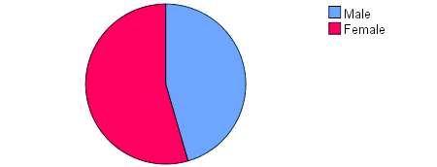
Figure 4: Gender distribution in the dataset
2.3 Mean and median of students who prefer strawberry and chocolate
The dataset provided is relatively varied. As a result, it is critical to examine the nature of the variation or distribution using measures of central tendency: mean, mode, and median. In the case of Ice-cream data, median and mean are considered to be the primary measures of central tendency. However, the data needed is focused on two out of three variables. As a result, it is difficult to extrapolate the mean and the median of two characteristics in a grouped dataset using SPSS. Nonetheless, the data has a mean of 1.82 and a median of 2.00. Such variations are indicated by the figure below.
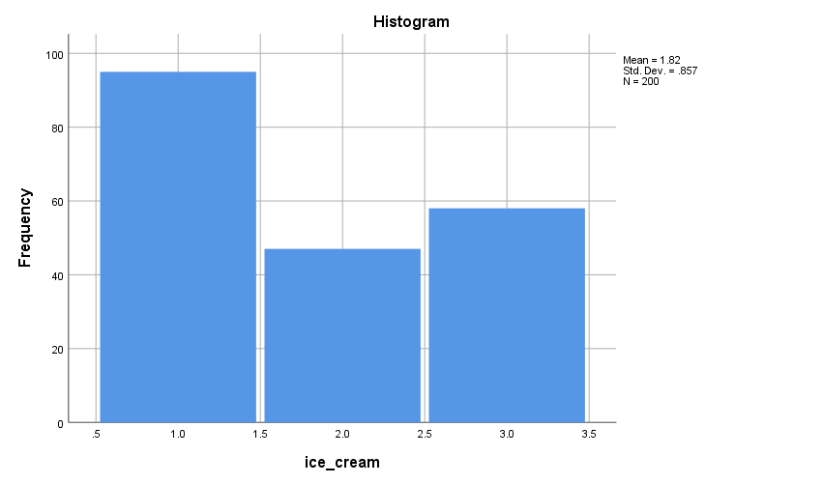
Figure 5: A histogram showing variation in the frequency of Ice-cream flavor with the number of students
2.4 clustering/classification options
Today, clustering has become a unique and critical function in data gaining and processing. When using excel, data clustering and classification are often difficult due to the need to fully understand the underlying mathematical and logical factions. This shortcoming has been well addressed by SPSS, where the classification process is relatively simple. The first step is to access the main menu and navigate to the analyze option. The analyze option contains a wide range of data handling techniques, including data classification. Amidst these sub-options, select classify to access further data classification and clustering options based on the specified model. In this case, the nearest neighbor model was selected. The process of accessing the nearest neighbor option in SPSS is in the figures below.
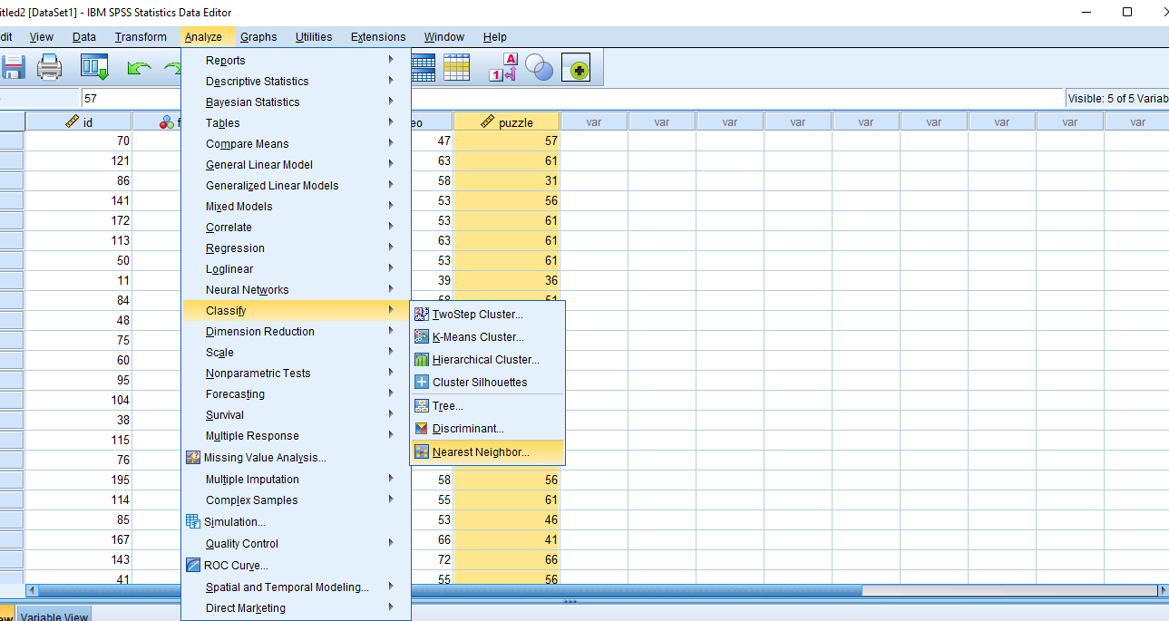
Figure 6: Accessing the Classification model for the data
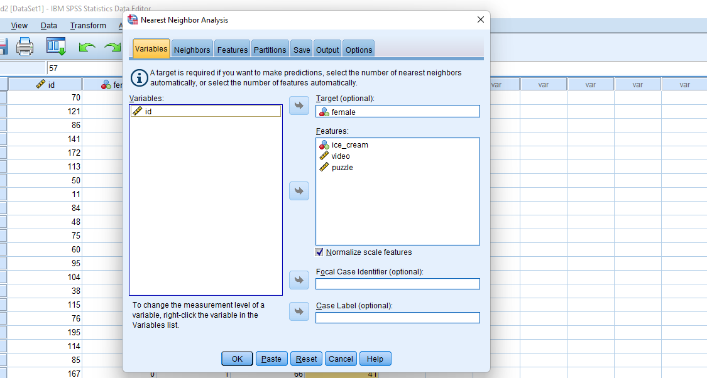
Figure 7: Separating Variables for classification

Table 3: Summary of a classification model
Case Processing Summary
 |  | N | Percent
Sample | Training | 148 | 74.0%
Sample | Holdout | 52 | 26.0%
Valid |  | 200 | 100.0%
Excluded |  | 0
Total |  | 200

The dataset contained a total of 200 records. During classification, a sample of 148 was used for training, while the remaining 52 were used for the holdout. The resulting classification included a valid dataset of 200 records, implying that no records were dropped during classification. Therefore, figure 8 below shows the variation in the distribution of the dataset based on similarity or closet point. The data shows that the majority of participants prefer vanilla ice cream flavor, with key variabilities being caused by video and puzzles. As a result, the distribution of male participants is oriented towards video and puzzles than ice cream. Nonetheless, the majority of the training dataset shows a centrality in distribution.
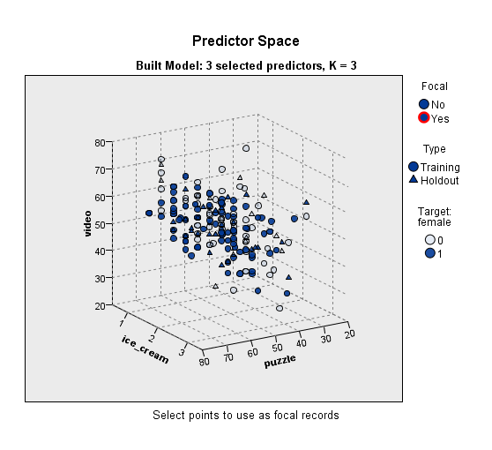
Figure 8: Final nearest neighbour classification

2.5 Data and text mining methods
The continuous need to grow and attain a competitive advantage has been observed across all businesses. As a result, the discourse in the modern business environment has been oriented towards the integration of data and adopting it for critical decision-making processes. In the process, businesses have focused on adopting efficient data collection methods, conducting trend analysis, and exploring new market opportunities. These investments have culminated in organizational across different leveraging data and text mining as one of the key data acquisition and integration.
The concepts of text and data mining are often used interchangeably. Despite that, evidence shows that a difference that exists between the two concepts. For instance, Zhou et al. (2016) describe text mining as a data clustering approach oriented toward the identification of instruct structures in text-based data. It focuses on classifying data into unique groups as predefined by a given user or the underlying purposes. In the case of data mining, the focus is on visual presentation; as a result, graphics and other visual elements associated with data points are utilized during the presentation. Given these inherent differences, it is critical to examine the most common techniques used for both data and text mining in a modern business environment.
Each approach (text and data mining) is usually accompanied by a wide range of techniques used for data collection and consolidation. An analysis of the underlying techniques shows that both approaches show the presence of classification as the most common approach to data and text mining. According to Zhou et al. (2016), classification in data mining can be considered to be a form of data clustering where comparable data points are collected and consolidated for comparative analysis. The approach is usually characterized by the designation of large groups associated with a target audience or target audience in which a given business can gain better insights input the markets. The most common classification techniques include logistic regression, nearest neighbors, decision trees, and the Naïve Bayes. In the case of text mining, classification is considered a type of supervised learning model. The technique is recognized for its focus on large processing with the ability to extract information based on the set topic and the underlying information. This approach allows for uncovering the right topics from large text-based data, thereby providing more insights into the datasets.
2.6 Advantages of Excel and SPSS as data handling and analytics software/tools
The provided ice crème datasets show the dynamics of integrating Microsoft Excel and SPPS as tools for data handling and analysis. An examination of the two software shows unique attributes that allow their effective application in data handling and analysis, the uniqueness of each software has been observed in its capacity to employ various functions, including data classification and basic analysis. Complex analytical processes such as measures of relationship can be used adopted using this software; hence, more detailed insights and data-driven decision-making (Lee & Peters, 2015). Therefore, the unique attributes of each software and their respective applications are highlighted in table 4 below.
Table 4: SPSS and Excel; differences and Advantages
Attributes | Statistical package for Social Sciences (SPSS) | Microsoft Excel
Field | The software covers the entire technological domain. As a result, it is often considered a superset of data science. | Primarily applicable to the discipline of computer science. It is usually associated with studies where data is collected and analyzed with different techniques or technologies.
The Industries | The software is usually used across a wide range of industries where data analysis is required. The most common use has been in research-based firms and other organizations that produce voluminous datasets to ease that analytical process. | Similar to SPSS, Excel is applicable in several industries that require data analysis. However, it is predominantly associated with accounting, especially in small and medium-sized firms and occasionally large-scale organizations.
Academics | SPSS has existed for over two decades. Its hesitance has been associated with the growth of IBM, which has been critical in improving and distributing the software. | Excel has been associated with the development of various branches of science. As a result, its existence and growth have been linked to changes in technology and overall needs.
Usage | Predominantly used to perform statistical calculations as per IBM guiltiness; however, it is not the only application of the approach. Evidence shows that it can be used in ultra-fast devices for real-time or near-real-time data analytics. | Excel has been primarily applied to store and manage data based on predetermined operations— the operations are usually defined by Microsoft. Amidst this usage, evidence shows that the software has the potential to be used for real-time or near-real-time maintenance of large volumes of data in a business environment.

REFERENCES
Nisbet, R., Elder, J. and Miner, G.D., 2018. Handbook of statistical analysis and data mining applications. Academic Press.
Baier, T. and Neuwirth, E., 2007. Excel:: COM:: $$\mathsf {R} $$. Computational statistics, 22(1), pp.91-108.
Carlberg, C., 2014. Statistical analysis: Microsoft excel 2013. Que Publishing.
Lee, N. and Peters, M., 2015. Business statistics using EXCEL and SPSS. Sage.
Laursen, G.H. and Thorlund, J., 2016. Business analytics for managers: Taking business intelligence beyond reporting. John Wiley & Sons.
Zhou, Y., Tong, Y., Gu, R. and Gall, H., 2016. Combining text mining and data mining for bug report classification. Journal of Software: Evolution and Process, 28(3), pp.150-176.

