

Student Name: Dhrumil Umesh Ahir
Student ID: 2336186
Module Code: LCMB7002
Module: Financial Management
Lecturer: MD Kalam

Submitted on: 20th August 2024

Table of Contents
Executive Summary 3
Part A: Introduction 3
Part B: Financial Performance Review 3
Key Financial Ratios of Next Plc 3
Evaluation of Financial Ratios of Next Plc 5
Comparison of Financial Ratios between Next Plc and ASOS Plc 9
Recommendation 13
Part c: Investment Appraisal 14
Estimation and Recommendation of the Two Projects 14
Critical Discussion of the benefits and limitations of the capital budgeting techniques 16
Non-financial factors required to be considered 18
Conclusion 18
References 19
Appendices 21
Appendix 1: Asos Plc. financial statement for 5 years 21
Appendix 2: Financial statement of Next Plc for the 5 years 26

Executive Summary
The report has covered the comparative analysis of Next Plc and its competitor Asos Plc. The Financial ratio calculation of Next Plc has been done along with the proper interpretation of the resources. The competitor’s financial ratio interpretation has also been done and a comparative analysis has been provided. Moreover, the capital budgeting techniques advantages and limitations has been done. From the given information estimations of IRR, NPV and ARR has been calculated. Along with that the nonfinancial factors that can be considered while investment appraisal also has been provided to give a detailed analysis.

Part A: Introduction
The chosen company for this report is going to Next Plc. which is a British retailer that was founded by J Hepworth and Son in the year 1864 and it all started as a tailor shop in Leeds. The company did undergo significant transformation and rebranding in the year 1982 and became the brand Next Plc. The business model of the company moves around designing and selling of clothes, footwear, accessories and other home products. It has 3 main channels retail stores, a strong online presence and also it has a catalog business which is called the Next Directory. The company also has a well-established presence in the UK with more than 500 retail stores with a growing international presence mainly with the help of online sales. The business model of Next also lays emphasis on quality and affordability which helps the company to target a broad customer base that ranges from young children’s to adults as well. As for the major competitors of Next it has mainly Marks and Spencer’s, John Lewis, H&M and Zara in the fashion industry. Over the recent years in the case of the leadership changes Amanda James stepped down as the Finance Director. One of the major hits that the company faced was the pandemic which heavily impacted their revenues from offline sources mainly due to the closing of stores. However, the company responded by strengthening its online platform and the logistics infrastructure so that they can handle their business properly.

Part B: Financial Performance Review

Key Financial Ratios of Next Plc
Next Plc (£, million)
List of Ratios | 2023 | 2022 | 2021 | 2020 | 2019
Profitability
Gross Profit | 43.21% | 43.57% | 38.00% | 41.04% | 39.63%
(GP/Sales) *100 | (2175.3/5034) *100 | (1972/4525.9) *100 | (1247.9/3284.1) *100 | (1640.5/3997.5) *100 | (1552.5/3917.7) *100
Net Profit | 14.12% | 14.65% | 8.73% | 15.26% | 15.29%
(NP/sales) *100 | (710.7/5034) *100 | (677.5/4625.9) *100 | (286.7/3284.1) *100 | (610.2/3997.5) *100 | (599.1/3917.7) *100
ROCE | 32.58% | 32.64% | 17.35% | 31.35% | 33.66%
Operating Income/(Total Assets - Current liabilities) | 941.5/ (3983.3-1093.3) | 905.4/ (3981.8-1208.1) | 444.5/ (3758.6-1196.8) | 853.9/ (3673.3-949.8) | 841.1/ (3742.6-1243.7)
Liquidity
Current Ratio | 2.04 | 1.99 | 1.91 | 2.06 | 1.59
(Current Assets/Current Liabilities) | (2234.5/1093.3) | (2407.2/1208.1) | (2288.6/1196.8) | (1955.4/949.8) | (1977.8/1243.7)
Quick Ratios | 1.44 | 1.47 | 1.46 | 1.50 | 1.19
(Current Assets-Inventory)/Current Liabilities | (2234.5-662.2)/1093.3 | (2407.2-633)/1208.1 | (2288.6-536.9)/1196.8 | (1955.4-527.6)/949.8 | (1977.8-502.8)/1243.7
Efficiency
Inventory Turnover | 85 | 88 | 88 | 75 | 72
(Inventory/COGS) *365 | (662.2/2827.7) *365 | (633/2625.3) *365 | (536.9/2231.7) *365 | (527.6/2584.2) *365 | (502.8/2562.2) *365
Receivable Turnover | 103 | 95 | 123 | 120 | 120
(Receivable/Revenue) *365 | (1425.5/5034) *365 | (1208.9/4625.9) *365 | (1108.1/3284.1) *365 | (1315.3/3997.5) *365 | (1285.4/3917.1) *365
Investment
Interest Coverage | 12 | 10.47 | 4.33 | 8.09 | 7.80
(Operating Income/Interest Expenses) | (941.5/77.9) | (905.4/86.5) | (444.5/102.7) | (853.9/105.6) | (841.1/107.9)
Equity Ratio | 0.29 | 0.25 | 0.18 | 0.12 | 0.10
(Shareholders Fund/Total Asset) | (1165.1/3983.8) | (1010/3981.8) | (660.9/3758) | (441.5/3673.3) | (366.2/3742.6)
Table 1: Financial Ratios of Next Plc
(Source: Self-Created)

Evaluation of Financial Ratios of Next Plc
Profitability Ratios

Figure 1: Profitability Ratio
(Source: Self-Created)
Gross profit is essentially the earnings of the company after covering the direct costs of producing or selling its products or services (Nariswari and Nugraha, 2020). In other words, it is like the money left over after paying for the raw materials and labor used to create the goods. It can be seen from Figure 1 that Next Plc has a good profitability ratio which signifies that the company is earning well and is having a good number of profits. Based on the 5 years the company has been growing in terms of its profitability with 2023 the Gap ratio can be seen as 43.21%. On the other hand, net profit is the final amount of money a company earns after all expenses have been paid. It is the bottom line in which the money left over after covering everything from producing the product to running the business and paying taxes (Mahdi and Khaddafi, 2020).
In the case of Net profit, the outlying year was 2021 which had a value of 8.73%. In the rest of the years the Np ratio hovered close to 15% with the lowest being 14.12% and the highest being 15.29%. In the situation of ROCE, it shows the ability of the business to generate profits from its capital (Ningsih and Sari, 019). From the Table above it can be observed that for the year 2021 the ROCE was as low as 17.35% which indicates that the company did not do particularly well in this year in terms of capital efficiency. The other 4 years the ROCE value was close to 32% - 33%, which shows that the company was generating enough profit from its capital. A good ratio for ROCE is above 20% and as in the case of this company except 2021 the rest of the years were very much above 30%.
Liquidity Ratios

Figure 2: Liquidity Ratio
(Source: Self-Created)
As in the case of Liquidity ratios it shows the ability of the company to write off its short-term obligations (Ningsih and Sari, 2019). As for Current Ratio, it is a snapshot of the ability of the company to pay its short-term debts using its current assets (Novyarni and Permana, 2020). In other words, it is like checking whether a person has enough cash on hand to pay their immediate bills. From the Figure 2, for all the years the current ratio was above 1.5, which indicates that the company was efficient enough to convert its assets to pay off the short-term liabilities. For the year 2023 and 2020 especially, the performance of the company was above the ideal ratio which should be 2:1. The values range between 2.04 and 2.06 which meant that in these 2 years the company had enough assets to pay off its liabilities twice. Quick ratio indicates the ability of the company to convert its assets into cash as fast as possible (Raimo et al., 2021). It is a more conservative way to measure the short-term liquidity of the company as it does not take into consideration the inventory. A good range of Quick ratio is 1:1 which means the short-term asset or liquid assets and current liabilities are similar. In the case of Next plc., For all the years the ratios were above 1 with lowest being 1.19 and the highest being 1.5 for 2019 and 2020 respectively.
Efficiency Ratios

Figure 3: Efficiency Ratio
(Source: Self-Created)
The two ratios that have been taken as a part of the efficiency ratio incorporate inventory turnover days and receivable turnover days. Receivables Turnover ratio measures the efficiency with which a company collects money owed to it by customers (Amanda, 2019). A high ratio means customers are paying their bills on time, while a low ratio might indicate payment problems. Inventory turnover shows the fastest way a company can sell its product (Nasution, 2020). A high turnover means products are selling well, while a low turnover might indicate slow sales or overstocking issues.
In the case of inventory turnover days, the value ranged between 72 and 88 with lowest being in the year 2019 and highest was in 2022 and 2021. These days indicate the number of days the company requires to sell its inventory. Next Plc requires 72 to 88 days in order to replace its inventory which is quite high for any company in the retail industry. On the other hand, Receivable Turnover days shows the number of days the company requires to collect its receivables from its debtors (Chasanah and Sucipto, 2019). In this situation also the company requires as high as 123 days which was in 2021 and as low as 95 days which was in 2022.
Investment Ratios

Figure 4: Investment Ratio
(Source: Self-Created)
The two types of ratios taken into account are Interest Coverage and Quick ratio both of which show the financial risk that is associated with the company (Sucipto and Chasanah, 2019). The interest coverage ratio shows the ability of the company to pay interest on its debts. A high ratio means the company can easily cover its interest payments, while a low ratio might indicate that the company might be facing some financial difficulty.
The interest coverage ratio is the highest in 2023 which is 12 and the lowest in 2021 which is 4.33. This indicates that the company has a high financial health and is able to cover its interest expense pretty easily. However, in 2021 it shows a pretty low interest coverage meaning the company could be facing financial distress. On the flip side the equity ratio shows the amount of the assets of the company that are financed by the equity of the shareholders rather than debt (Yanto et al., 2021). A high equity ratio means that the company relies less on borrowing money.
In the case of equity ratio there is a positive trend for the 5 years taken into account with the values starting from 0.10 to 0.29. A high equity ratio is an indicator of the ability of the company to use less debt to finance its assets. This creates a safe environment for the company during situations of financial distress as it will be able to pay off its debt easily.

Comparison of Financial Ratios between Next Plc and ASOS Plc
List of ratios | Asos Plc (£, million)
 | 2023 | 2022 | 2021 | 2020 | 2019
Profitability
Gross Profit | 41.10% | 43.63% | 45.43% | 47.42% | 48.81%
(GP/Sales)*100 | (1459 / 3549.5)*100 | (1717.5/3936.5)*100 | (1776.4/3910.5)*100 | (1547.4/3263.5)*100 | (1334.3/2733.5)*100
Net Profit | -6.29% | -0.81% | 3.28% | 3.47% | 0.90%
(NP/sales)*100 | (-223.1/3549.5)*100 | (-31.9/3936.5)*100 | (128.4/3910.5)*100 | (113.3/3263.5)*100 | (24.6/2733.5)*100
ROCE | -13.01% | -0.50% | 10.08% | 13.31% | 7.42%
Operating Income/(Total Assets - Current liabilities) | -248.5/(2625.6-715.2) | -9.8/(2996.9-1040) | 190.1/(2884.5-998) | 151.1/(1989.4-854.1) | 35.1/(1245.5-772.2)
Liquidity
Current Ratio | 1.73 | 1.49 | 1.56 | 1.19 | 0.81
(Current Assets/Current Liabilities) | (1234.5/715.2) | (1554/1040) | (1559.7/998) | (1019.8/854.1) | (623.2/772.2)
Quick Ratios | 0.65 | 0.46 | 0.75 | 0.57 | 0.11
(Current Assets-Inventory)/Current Liabilities | (1234.5-768)/715.2 | (1554-1078.4)/1040 | (1559.7-807.1)/998 | (1019.8-532.4)/854.1 | (623.2-536.8)/772.2
Efficiency
Inventory Turnover | 134 | 177 | 138 | 113.24 | 140
(Inventory/COGS)*365 | (768/2090.5)*365 | (1078.4/2219)*365 | (807.1/2134.1)*365 | (532.4/1716.1)*365 | (536.8/1399.2)*365
Receivable Turnover | 8 | 8 | 5 | 7 | 10
(Receivable/Revenue)*365 | (81.4/3549.5)*365 | (88.2/3936.5)*365 | (57.7/3910.5)*365 | (60.3/3263.5)*365 | (72.8/2733.5)*365
Investment
Interest Coverage | -5 | 0 | 14 | 16 | 18
(Operating Income/Interest Expenses) | (-248.5/53.2) | (-9.8/23) | (190.1/13.2) | (151.1/9.5) | (35.1/2)
Equity Ratio | 0.70 | 0.65 | 0.36 | 0.41 | 0.36
(Shareholders Fund/Total Asset) | (866.7/1234.5) | (1014.9/1554) | (1034/2884.5) | (810.3/1989.4) | (453.6/1245.5)
Table 2: Financial Ratios of ASOS Plc
(Source: Self-Created
Profitability Ratios
On the other financial health of ASOS Plc, competitors of Next Plc are evaluated also through profitability, liquidity, efficiency, and gear ratios. The profitability ratio is calculated to determine earning ability of a company as compared to its competitors in a financial year from its turnover (Husain and Sunardi, 2020). In the given case, The gross profit ratio of ASOS Plc for the financial five years is 41.10%, 43.63%, 45.43%, 47.42%, and 48.81% respectively. The company utilized 60% of its revenue to mitigate variable expenses in the fiscal year 2023 (Annual Report of ASOS Plc 2023). On the other hand, the gross profit margin of the company in the fiscal year of 2019 was 48.8% which represents that the company efficiently utilized its resources to generate higher sales revenue in 2023 as compared to 2019. The gross profit margin of Next Plc in 2019 was 39.63% which increased to 43.21% which shows that the efficiency of the company improved in the current period (Annual report of Next Plc 2023).
Therefore, the efficiency of both the chosen and competitor company to generate higher gross profit is enhanced in the current period as compared to the previous period of 2019. However, the gross profit margin of Next Plc is slightly higher in 2023 as compared to ASOS Plc as they generated higher revenue in that period. The net profit margin of Next Plc in 2023 is 14%, however, it was 15.29% in 2019. On the other hand, ASOS Plc’s net profit margin in 2019 was 0.90% which is reduced to -6% in 2023. The efficiency of Next Plc is higher as compared to its competitors to retain profit from its sales revenue through efficiently cut-off business expenses in the period from 2019 to 2023. The return on capital employed represents the capability of a company to generate profit by better utilization of assets.
In the given case, Next Plc’s return on capital employed for 2023 is 33% whereas it was 34% in 2019, however, the return on capital of ASOS Plc in 2023 is -13% and it was 7.42% in 2019 which represents that ASOS Plc better utilized their non-current assets in 2019 for this reason, the company generates an operating income of in £7.42 from every £100 of capital. On the other hand, Next Plc efficiently utilized its capital to produce operating profit in five years as compared to ASOS Plc. The comparison of profitability ratios between ASOS plc and Next Plc for the five financial years represents that Next Plc generates higher returns for their investors in five financial years compared to ASOS Plc which assists the company in attracting more investors and lenders to mitigate business expenses.
Liquidity Ratios
The liquidity ratios used to evaluate better management of working capital are represented through liquidity ratios, additionally, these ratios determine the ability of a company to cover its short-term current obligation in a specific financial year (Haralayya, 2021).
The current can be defined as the ability of the company to pay off its short term obligations (Dirman, 2020). The current ratio of ASOS Plc for the fiscal years 2023, 2022, 2021, 2020, and 2019 are 1.73, 1.49, 1.56, 1.19, and 0.81 which represent an upward trend as the liabilities of the company decline every year due to frequent payment of financial obligation. Therefore, the ability of the company increased in 2023 as compared to other financial periods to cover its short-term financial obligation. On the contrary, the current ratio of Next Plc in 2023 is 2.04 which was 1.59:1 in 2019. Thus, the liquidity position of Next Plc and ASOS Plc is enhanced in 2023 from the period 2019.
The quick ratio of ASOS Plc for the five fiscal years 0.65, 0.46, 0.75, 0.57, 0.57, and 0.11 respectively. The quick ratio of the company slightly improved in the fiscal years 2023 as compared to 2022 as liquidity position of the company enhanced due to current assets of the company increased for generation of higher sales revenue and frequent repayment of current obligation. However, the liquidity position of ASOS Plc is lower as compared to Next Plc as Next Plc generates higher sales revenue in five years compared to ASOS Plc which assists in maintaining higher liquidity. On the other hand, a quick ratio comparison between the chosen company and the competitor company represents that the liquidity of Next Plc is higher compared to ASOS Plc which assists Next Plc in generating higher income for its shareholders through in investing short-term securities.
Efficiency Ratios
The efficiency ratios are used to measure the financial health of a company in the utilization of assets and liability to generate revenue (Amanda, 2019). The inventory turnover ratio of ASOS Plc for five fiscal years is 134 days, 177 days, 138 days, 113 days, and 140 days respectively. The inventory turnover ratio of the company enhanced in the fiscal year 2023 compared to 2022 by 40 days. Therefore, the company better used assets in the financial year of 2023 as compared to 2022, for this reason, sales revenue increased in the current year compared to the previous period. In the given case, the inventory turnover ratio of ASOS Plc for the fiscal year 2023 is 134 days whereas Next Plc takes 85 days to replace its inventory. For these reasons, the sales revenue of Next Plc is higher compared to ASOS Plc for the fiscal year 2023. ASOS Plc’s inventory turnover days in 2019 was 140 days which slightly declined to 134 days in 2023, Therefore, the efficiency of the company was enhanced in 2023 to generate higher sales revenue in 2023.
The receivable turnover days of ASOS Plc for the fiscal year 2023 is 8 days which was 10 days in 2019 which represents that the collection period of the company was reduced due to sales improved 22% in 2023 as compared to 2019. Receivable turnover ratio of the company for the fiscal year 2022, 2021, and 2020 are 8 days, 5 days, and 7 days respectively. The receivable turnover days in 2022 is slightly decline as compared to financial period 2021 as the company sales product in cash for this reason, trade receivable reduce in previous period as compared to current period. Receivable turnover ratio in 2021 is declining as compared to 2022 which asssit the company to improve liquidity in the current period. Additionally, frequent collection of due of ASOS Plc is better as compared to Next Plc for the fiscal year 2023 as receivable turnover days of Next Plc and ASOS Plc are 103 and 8 days. Therefore, Next Plc better utilized its inventory to generate higher revenue whereas ASOS Plc efficiently utilized assets to maintain higher cash flow.
Investment Ratios
The investement ratios represent the portion of equity and debt utilized by a company to acquire assets as in the case a company uses debt financing higher than equity financing to mitigate operation expenses risk will be higher (Kim and Li, 2021). The interest coverage ratio of Next Plc for the financial year 2023 is 103 times which was 120 times in 2019, on the other hand, the interest coverage ratio of ASOS Plc for the financial year 2023 is negative whereas it was 18 times in 2019. Therefore, Next Plc has generated enough operating profit to mitigate its financial cost 103 times in 2023, however, ASOS Plc earned a negative profit, therefore, the risk of ASOS Plc is higher as compared to Next Plc. Thus, ASOS Plc is not able to borrow loans in future periods.
The equity ratio represents that ASOS Plc utilized 70% of shareholders' funds to purchase business assets in 2023 whereas Next Plc used 29% of Shareholders' fund to acquire assets of the company. Therefore, ASOS Plc utilized shareholders' funds to purchase assets, however, Next Plc used other financing sources. Therefore, the risk of Next Plc is higher, however, the company generates enough profit to mitigate its financial obligations.

Recommendation
The following way the company improves its financial management.
- The financial management of the company can be enhanced through planning, controlling monitoring, and organizing financial resources which assist the company in achieving its financial resources to achieve financial objectives for business growth and survival effective financial management is vital for the company.
- The company will be able to enhance its financial management by monitoring its financial position. The company is required to frequently monitor their business progress in order to improve its financial management.
- The company reducing its overhead expenses can improve its financial management in that case, the company is required to make relationships with more suppliers which will provide an opportunity to bargain prices that assist the company to purchase high-quality materials at lower prices. Additionally, outsourcing their business processes such as marketing and accounting to reduce costs.
- Additionally, effective cash flow management assists the company in managing its financial management as it provides an opportunity to invest in new business.
- The company has ensured that due are collected on time which assists the company to cover business expenses without taking additional financial risk.
- Effective financial management depends on the efficient maintained of finance. The company will be able to mitigate financial management problem by maintaining emergency fund for the company which assist the company to mitigates unexpected expenses.
- Automation in the business processes will assist the company in managing its finances.

Part c: Investment Appraisal

Estimation and Recommendation of the Two Projects
Payback Period
Years | Cash Flows |  | Cumulative Cash Flows
 | A | B | A | B
0 | -£80 | -£75 | -£80 | -£75
1 | £25 | £50 | -£55 | -£25
2 | £25 | £20 | -£30 | -£5
3 | £20 | £20 | -£10 | £15
4 | £55 | £20 | £45 | £35
PBP(in years) | 3+(10/55) |  | 3.18
PBP(in years) | 2+(5/20) |  |  | 2.25
Table 3: Estimation of Payback Period
(Source: Made by Self)
ARR
Years | Cash Flows |  | Depreciation |  | Accounting Profit
 | A | B | A | B | A | B
Year 1 | 25 | 50 | £20 | £19 | £5 | £31
Year 2 | 25 | 20 | £20 | £19 | £5 | £1
Year 3 | 20 | 20 | £20 | £19 | £0 | £1
Year 4 | 55 | 20 | £20 | £19 | £35 | £1
Average Profit |  |  |  |  | £11 | £9
Initial investment |  |  |  |  | £80 | £75
ARR |  |  |  |  | 14.06% | 11.67%
Table 4: Estimation of ARR
(Source: Made by Self)
NPV
Years | Cash Flows |  | Discounting Factor at 9.75% | Discounted Cash Flows
 | A | B | Discounting Factor at 9.75% | A | B
1 | £25 | £50 | 0.9111617312 | £23 | £46
2 | £25 | £20 | 0.8302157004 | £21 | £17
3 | £20 | £20 | 0.7564607749 | £15 | £15
4 | £55 | £20 | 0.6892581092 | £38 | £14
Total Present Value |  |  |  | £97 | £91
Less: Initial investment |  |  |  | £80 | £75
NPV |  |  |  | £17 | £16
Table 5: Estimation of NPV
(Source: Made by Self)
From the above tables it can be deduced that the payback period for project A is 3 days and for project B it is approximately 2 days. The ARR values came out to be 14.06% and 11.67% for Project A and B respectively. The NPV for Project A is £17 and for Project B is £16. From the above information it can be judged that the NPV is higher for project A which is a clear indicator that project A is profitable from the perspective of an investor. It can be said that the ARR shows the accounting profit of the project and also helps in quantifying the growth of the company and also helps in the forecasting of its revenue. From the above tables it can be concluded that Project B will have to be the best investment option for the company as it has a little bit lower NPV than project standing at £16. However, the payback period is very less as compared to Project A and the company can regain its initial investment within 2.25 days or approximately 2 days.

Critical Discussion of the benefits and limitations of the capital budgeting techniques
Capital budgeting techniques are essential tools that are required and used by businesses to evaluate potential investments and other projects (Siziba and Hall, 2021). The various budgeting techniques used are payback period, NPV, IRR and Profitability index.
NPV
The benefit of this technique is that it takes into consideration the time value of money while also discounting the future cash flows of the project to its present values so that a clear picture of the worth of the project can be estimated. Moreover, it also offers an easy measure of the value that an investment will add to the firm. If the NPV value is positive and higher than the other project, then the project could be accepted and in the case of a negative value it should be straightaway rejected.
On the contrary estimation of NPV could be a challenging endeavor especially for very complex projects with different types of cash flow patterns or for projects that are carried out in different stages. A very strong influence on NPV is the discount rate selection, but setting up the proper value of the project can be typically challenging and subjective. One important assumption of NPV is that cash inflows can be reinvested at the discount rate which does not necessarily reflect the reality of the situation all the time.
ARR
The Accounting Rate of Return (ARR) is a popular technique that calculates the discount rate at which the net present value of a project becomes zero. While its focus on rate of return resonates with many decision-makers, ARR is not without its limitations. For instance, projects with unconventional cash flows might yield multiple ARRs, which can complicate the analysis. Moreover, the assumption of the method that intermediate cash flows are reinvested at the ARR rate can change the true profitability of a project. Additionally, ARR fails to consider the scale of an investment, potentially leading to the selection of smaller, less impactful projects over larger, more promising ones.
Payback Period
The Payback Period is another commonly used technique that offers a simple and intuitive approach to assess the time required for an investment so that the initial cost can be recovered. Its simplicity is appealing, and it provides a quick gauge of the risk profile of an investment. Nevertheless, the payback period suffers from significant limitations which makes it not the ideal choice for making investment decisions. The fact that it ignores the time value of money, might potentially lead to suboptimal decisions. Furthermore, by focusing solely on the recovery period, it neglects the profitability of cash flows beyond that point. As a result, the payback period may favor short-term projects at the expense of more lucrative long-term opportunities.
Profitability Index
The Profitability Index (PI) offers a relative measure of profitability by dividing the present value of future cash inflows by the initial investment. While it incorporates the time value of money and provides a straightforward decision rule, PI is not all rosy and has its own limitations. The calculation of PI can be more complex than other methods, and it fails to consider the absolute size of an investment. Additionally, the close relationship between PI and NPV raises questions about its incremental value in the decision-making process as well.

Non-financial factors required to be considered
While financial metrics are crucial in capital budgeting, several non-financial factors must also be taken into account in order to make well-rounded investment decisions. These factors can significantly impact the success of a project even if the financial projections appear promising.
One of the critical non-financial factors is strategic alignment. A project should complement the overall strategic objectives of the organization and contribute to its long-term goals. For instance, investing in renewable energy helps the company to keep in line with sustainability goals, while expanding into a new geographic market supports growth strategies. Furthermore, operational considerations are also an essential part of the non-financial factors that need to be considered. A project might require additional resources, such as skilled labor or specialized equipment, which could impact the existing operations. However, assessing the availability of these resources and potential disruptions is a crucial part as well. Additionally, the complexity of the project and the capacity of the organization to manage it should be evaluated.
On the other hand, the organization must need to provide on the competitors as well. Proper identification of the competitors could be beneficial of the company as it could assist the organization implement strategic decision properly. The implementation of the strategic decision could create an impact on the business perfectly which as a result the proper growth of the business could be confront by the organization. Furthermore, the maintenance of the CSR is also an important matter to be considered. The implementation of the CSR could assist the organization to enhance their trust towards their stakeholders by which the business face profit properly.
Risk assessment is another non-financial factor that cannot be overlooked by the company. While financial models can incorporate some risk elements, there are often qualitative risks that require careful consideration. These include technological advancements, regulatory changes, and competitive pressures. Understanding these risks and developing mitigation strategies is vital for the success of the project. Lastly, social and environmental impacts should be evaluated by the company as well. Investors and stakeholders are increasingly considering the corporate social responsibility of their businesses. Projects that harm the environment or have a negative social consequence the company might face reputational risks. Conversely, projects with positive social or environmental impacts can enhance the image of the company and attract support.

Conclusion
This study has developed to analyze major recent events of Next Plc for the five years and the major competitor of the chosen company is ASOS Plc. Additionally, this study evaluates the financial performance of Next Plc for the five financial years which shows that the company efficiently performs in the current years as compared to the previous four financial years. On the other hand, a financial performance comparison has been made between Next Plc and ASOS Plc for five consecutive financial years which shows that the financial health of Next Plc is better compared to ASOS Plc. Different investment appraisal techniques are used to evaluate a better project after analyzing the risk and profitability associated with the investment.

References
Amanda, R.I., 2019. The impact of cash turnover, receivable turnover, inventory turnover, current ratio and debt to equity ratio on profitability. Journal of research in management, 2(2), pp.14-22.
Chasanah, N. and Sucipto, A., 2019. Liquidity ratio, profitability, and solvency on stock returns with capital structure as an intervening variable (study on food and beverage sub sector listed in Indonesia Stock Exchange (Idx) period 2013-2017). Ekspektra: Jurnal Bisnis dan Manajemen, 3(1), pp.52-68.
Dirman, A., 2020. Financial distress: the impacts of profitability, liquidity, leverage, firm size, and free cash flow. International Journal of Business, Economics and Law, 22(1), pp.17-25.
Haralayya, B., 2021. Ratio Analysis at NSSK, Bidar. Iconic Research And Engineering Journals, 4(12), pp.170-182.
Husain, T. and Sunardi, N., 2020. Firm's Value Prediction Based on Profitability Ratios and Dividend Policy. Finance & Economics Review, 2(2), pp.13-26.
Kim, S. and Li, Z., 2021. Understanding the impact of ESG practices in corporate finance. Sustainability, 13(7), p.3746.
Mahdi, M. and Khaddafi, M., 2020. The influence of gross profit margin, operating profit margin and net profit margin on the stock price of consumer good industry in the Indonesia stock exchange on 2012-2014. International Journal of Business, Economics, and Social Development, 1(3), pp.153-163.
Nariswari, T.N. and Nugraha, N.M., 2020. Profit growth: impact of net profit margin, gross profit margin and total assests turnover. International Journal of Finance & Banking Studies (2147-4486), 9(4), pp.87-96.
Nasution, A.A., 2020. Effect of inventory turnover on the level of profitability. In IOP Conference Series: Materials Science and Engineering (Vol. 725, No. 1, p. 012137). IOP Publishing.
Ningsih, S. and Sari, S.P., 2019. Analysis of the effect of liquidity ratios, solvability ratios and profitability ratios on firm value in go public companies in the automotive and component sectors. International Journal of Economics, Business and Accounting Research (IJEBAR), 3(04).
Novyarni, N. and Permana, R.Y., 2020, March. Effect of Current Ratio, Return on Asset, Net Profit Margin and Debt to Equity Ratio on Dividend Pay Out Ratio (For company listed in the LQ45 on Indonesian Stock Exchange). In Annual International Conference on Accounting Research (AICAR 2019) (pp. 41-45). Atlantis Press.
Raimo, N., Caragnano, A., Zito, M., Vitolla, F. and Mariani, M., 2021. Extending the benefits of ESG disclosure: The effect on the cost of debt financing. Corporate Social Responsibility and Environmental Management, 28(4), pp.1412-1421.
Siziba, S. and Hall, J.H., 2021. The evolution of the application of capital budgeting techniques in enterprises. Global finance journal, 47, p.100504.
Sucipto, A. and Chasanah, N., 2019. Effect Of Liquidity Ratio, Profitability, And Solvency On Stock Returns With Capital Structure As An Intervening Variable (Study On Food And Beverage Sub Sector Listed In Indonesia Stock Exchange (Idx) Period 2013-2017). Ekspektra: Jurnal Bisnis Dan Manajemen, 3(1), pp.52-68.
Yanto, E., Christy, I. and Cakranegara, P.A., 2021. The influences of return on asset, return on equity, net profit margin, debt equity ratio and current ratio toward stock price. International Journal of Science, Technology & Management, 2(1), pp.300-312.

Appendices

Appendix 1: Asos Plc. financial statement for 5 years
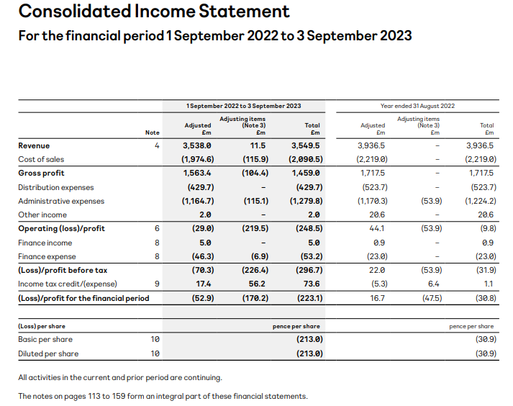
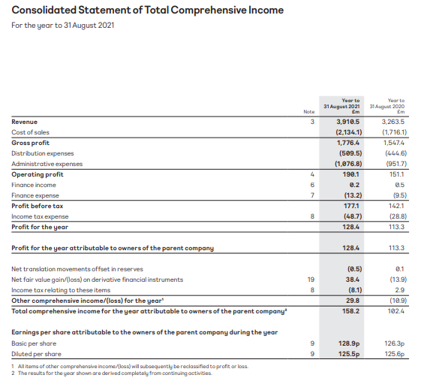
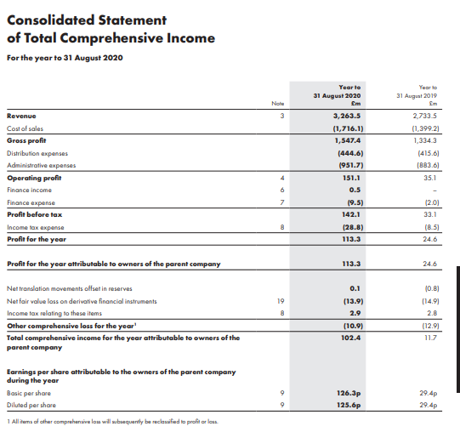
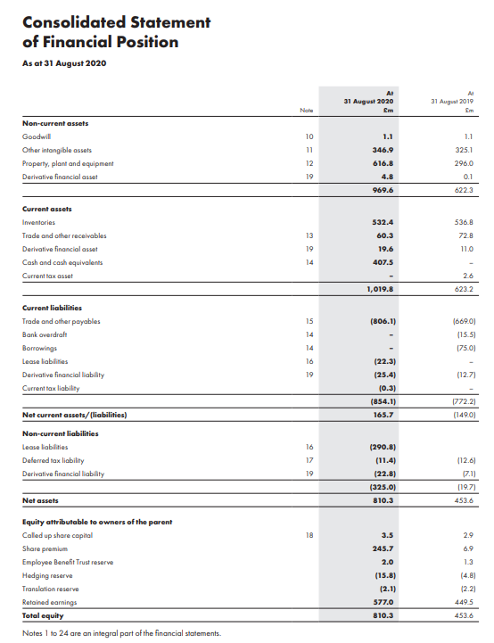
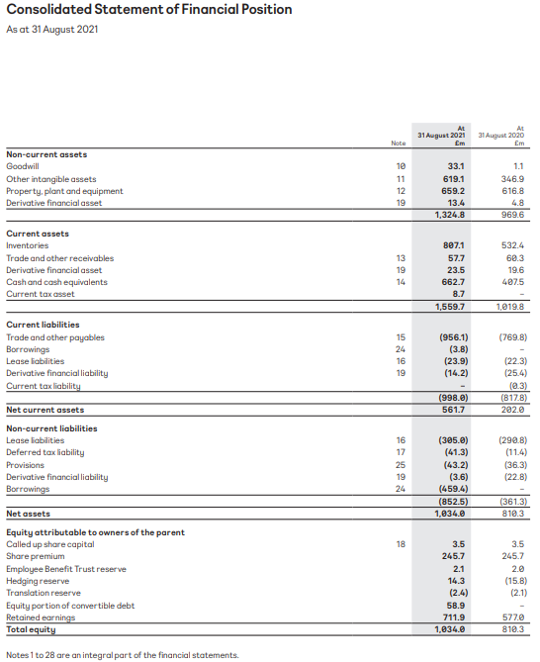
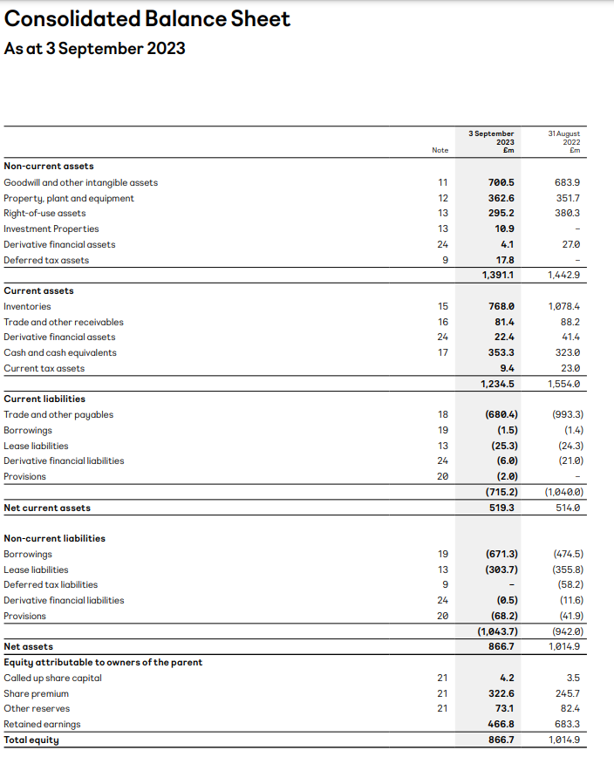

Appendix 2: Financial statement of Next Plc for the 5 years


