LANGUAGE, ‘MORAL ANTHROPOMORPHISM’, AND MORAL STANDING
Rebekah Humphreys, UWTSD, Lampeter, 20 Nov 2020.

Quotations
‘Kanzi had learned to comprehend and use printed symbols on his own without special training. He had also learned to understand many spoken words, even though he could not speak. He knew that words could be used to communicate about things he wanted or intended to do, even though those actions were not happening at the time of the communication. He could also purposely combine symbols to tell us something... we would have had no way of knowing otherwise. He recognized that two symbols could be combined to form meanings... He used this skill to communicate novel ideas that were his own... [W]hether or not he could be shown to possess a formal grammar, the conclusion remained that Kanzi had a simple language’ (Savage-Rumbaugh, el al., 1998, p.63).

‘Researchers who train animals to use a human-based code in order to study nonhuman cognition often lose sight of the code as an investigative tool and argue instead about the extent to which the code is equivalent to human language (Pepperberg 1993); that is, they compare human and nonhuman linguistic rather than cognitive abilities. Thus data and discussions about relative cognitive capacities are lost amidst open-ended debates about the extent to which a particular animal has acquired “language” or how well particular studies or procedures demonstrate linguistic competence (see, e.g., Premack 1986; K. Nelson 1987; Savage-Rumbaugh 1987; Seidenberg and Petitto 1987; Herman 1989; Schusterman and Gisiner 1989; Kako 1999). Such debates are based on the assumption that the extent to which an animal learns and uses a code indicates its cognitive capacities (Premack 1976; Terrace 1979)’ (Pepperberg, 1999, pp.34-35, 20).

‘[T]hinking cannot give us the world without language, which is why so many refutations of proposals that animals have consciousness are refutations of animal language, or at least of communications that have a syntax. This means that the picture of animal consciousness is a picture of a creature outside of time, an immortal creature in our terms, since for us syntax is the metric of time’ (Hearne, 1986, p.111, 22).

‘When first exposed to a mirror, the chimpanzees treated it socially, as if the reflection was a stranger. If gorillas find the gaze of strangers aversive, they have a strong motivation to avoid interacting with the mirror long enough to realise its function. That is, there is a difference in species-norm behaviour… than can account for early suggestion that gorillas don’t have an understanding of the self. Modification of the mark test, to account for the problem of motivation, found that gorillas do recognize themselves in mirrors’ (Andrews, 2012, p.14).

‘And various birds do from their warbling throats
At various times, utter quite different notes,
And some their hoarse songs with the seasons change’ (Montaigne).

‘The most wretched and frail of all creatures is man, and withal the proudest… ‘Tis by the same vanity of imagination that he equals himself to God, attributes to himself divine qualities, withdraws and separates himself from the crowd of other creatures, cuts out the shares of the animals, his fellows and companions, and distributes to them portions of faculties and force, as himself thinks fit How does he know, by the strength of his understanding, the secret and internal motions of animals?—from what comparison betwixt them and us does he conclude the stupidity he attributes to them? When I play with my cat who knows whether I do not make her more sport than she makes me? We mutually divert one another with our play. If I have my hour to begin or to refus, she also has hers… The defect that hinders communication betwixt them and us, why may it not be in our part as well as theirs? ‘Tis yet to determine where the fault lies that we understand not one another,—for we understand them no more than they do us; and by the same reason they may think us to be beasts as we think them… We must observe the parity betwixt us, have some tolerable apprehension of their meaning, and so have beasts of ours,—much about the same. They caress us, threaten us, and beg of us, and we do the same to them’ (Montaigne).

Michel de Montaigne, An Apology for Raymond Sebond, accessible at http://www.sophia-project.org/uploads/1/3/9/5/13955288/montaigne_sebond.pdf.
Pepperberg, Irene, The Alex Studies: Cognitive Communicative Abilities of Grey Parrots (Cambridge, Massachusetts and London: Harvard University Press, 1999).
Hearne, Vicki, Adam’s task: Calling Animals By Name (New York: Alfred A. Knopf, 1986).
Andrews, Kristin, ‘Beyond Anthropomorphism: Attributing Psychological Properties to Animals’, in The Oxford Handbook of Animal Ethics, eds. Tom L. Beauchamp and R. G. Frey (Oxford; Oxford University Press, 2012).
Savage-Rumbaugh, Sue, Stuart G. Shanker and Talbot J. Taylor, Apes, Language and the Human Mind (Oxford: Oxford University Press, 1998).

TERROR
‘When MR-2 took off on 31 January 1961, Goodall was in Africa, where she had recently started her research project on chimpanzees in what was to become Gombe Stream National Park in Tanzania. When, later on, she saw the footage of Ham recorded during his sixteen-minute ordeal and photographs taken upon recovering his capsule, she was horrified. “I have never seen such terror on a chimp's face,” she told me’ (‘Ham the astrochimp: hero or victim?: Spare a thought for Ham the Chimp, an object and victim in the human race for space’, by Henry Nicolls, The Guardian, 16 Dec 2013,).
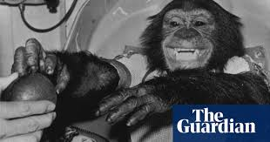

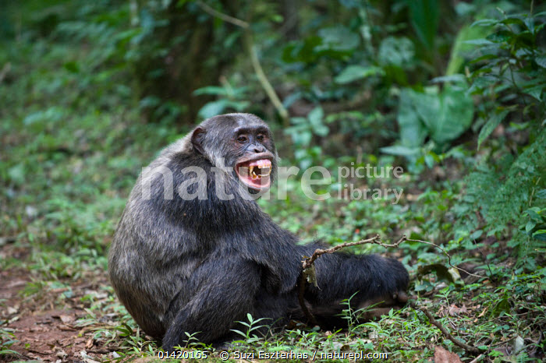
Terror – chimp in nature
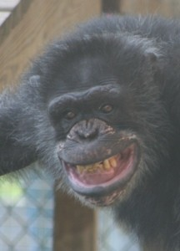 Animals in in entertainment

Smile



