Electronics assignment 1
Abstract
Today I am going to be taking about the experiment we did in the lab recently. We had to make up two different circuits, one high pass filter and one low pass filter. This was to see if changing the input frequency of each circuit would change the output voltage and attenuation.
Introduction
The two circuits that we tested were high and low pass frequency circuits. A low pass filter usually attenuates a high frequency and allows frequencies below the cut off point to pass through. Where as the high pass filter attenuates a low frequency and allows frequencies above the cut off to pass through. The different filters can be used for a few different applications. One of the applications of the low pass is to smooth a image and a high pass is used to sharpen a image. This report is going to cover the results I got throughout the experiment of high and low pass sharing results from both my physical circuit and my simulated circuit, to prove that my results are true and accurate. In addition to this ill use graphs to show my trends of each set of results so that it is easier to picture the pattern. I’ll explain why I think the input frequency effected the output voltage and attenuation. I will explain what components and voltages I used to set up and start the experiment to make sure it is successful.
Circuit descriptions
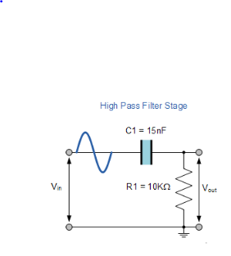
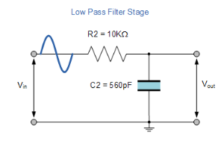
When making up both the high and low pass filter the circuits and parameters that we used were pretty similar for both. For the setup of the function generator for both we used a voltage of 5v peak to peak and a frequency of 100Hz to start. Then throughout both experiments we changed the frequency going in to each circuit in a range from the starting value of 100Hz to 300kHz. This range allowed us to find the cut off points of each circuit. When making the circuits we had to change the capacitors between each circuit to give us the high and low pass filter. For the low pass filter we used a 560pF capacitor and then for the high pass filter we used a 15nF capacitor. For both circuits we used 10k. we then used four small wires to connect up the circuit. Two of the wires we connected to a red and black crocodile clip wire for the input signal and voltage. the other two we used for the output but this time we connected them to a probe and the clip on the probe. This way we could measure the output voltage over the resistor in the high pass and the capacitor in the low pass. We then turned on the function generator and oscilloscope. We started at the low frequencies and slowly work our way up taking the output voltage after each change in frequency. After all our results were taken we could calculate the attenuation of each frequency. To calculate attenuation you use the formula: A = 20 x log Vin/Vout using excel made doing this very easy because once we had calculated one of them then we could just drag it down and excel would just workout the rest for us. Below are the circuit diagrams for each

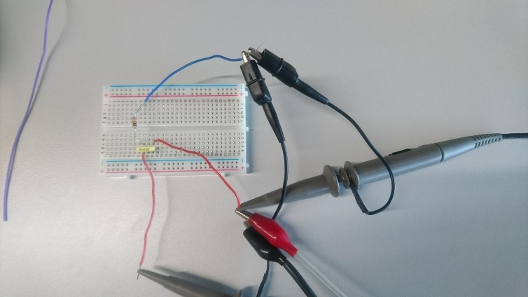
This is what our setup for high pass looked like. Our low pass looked the same but with the resistor and capacitor reversed with different values for the capacitor.
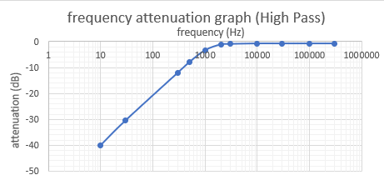
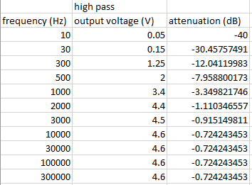
Results

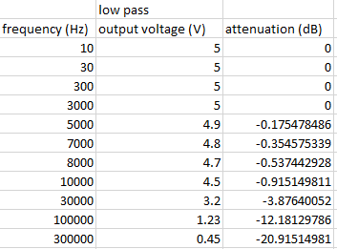
The high pass filter results show that once we got to 2000 Hz, the voltage output stayed roughly the same and leveled off as you can see from the graph.
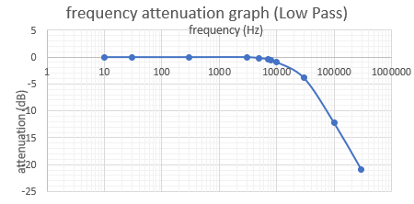

The low pass filter results so that in the low frequencies the output voltage was relatively high and stayed the same until we got to 5000 Hz where the frequency started to drop off. When the frequency was high we had very little output voltage.
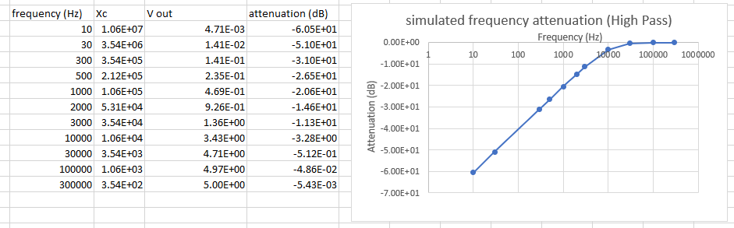
Simulated high pass

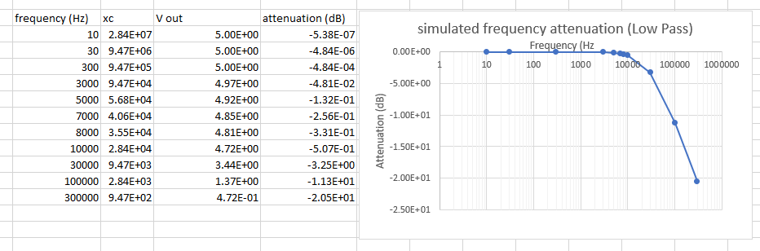
Simulated low pass

Discussion
In a high pass filter circuit there is one capacitor and one resistor. we can see that the capacitor reactance and output voltage changes depending on what the value of the frequency going in to the circuit is. where as the voltage stays the same and is unaffected by frequency change. This is why that in the table we can see that at low input frequencies there was a high attenuation. Attenuation is a ratio of the output voltage signal compared to the input voltage signal at a certain frequency. Attenuation is low when the filter isn’t blocking any frequencies from passing through but then increases when the filter has to start blocking out high or low frequency. This means that the output voltage of the circuit is due to the capacitance of a capacitor at different frequencies. A high pass filter can be made to modify, reshape or stop all unwanted low frequencies exiting it and allow high frequencies to pass through it. You can see that our results back up this theory. There is very little or next to no output voltage at low frequencies up to 300hz. Capacitive reactance makes capacitors good for leveling out dc power in, minimizing ripple or ac filters. This is because capacitors make a short circuit path for unwanted frequencies.
Similar to the high pass filter the low pass filter is constructed with the same components but different values for each resistor and capacitor. In a low pass filter we can see that at high frequencies when there was little voltage output and high attenuation because the resistor is holding back the voltage from the output. The voltage over the resistor would be high but the capacitor at this point there would be a low voltage. This is down to the capacitive reactance.

A good application for a high pass filter and low pass filters is a speaker. In a speaker a low pass filter will provide a path for low frequencies to the bass woofer and a high pass filter will provide high frequencies to the tweeter.

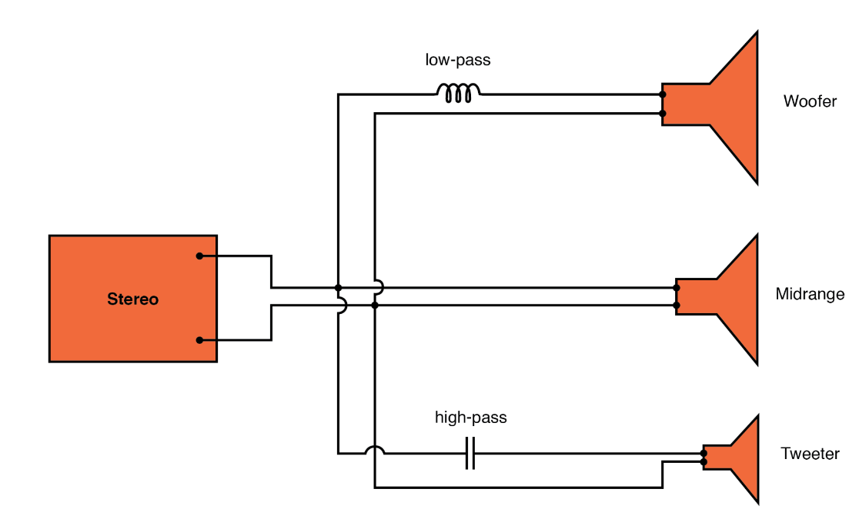

Conclusion
In this experiment we can see that both the filters were the opposite of each other. When the high pass filter was being tested on the low frequencies it had very little output voltage and the high frequencies had high voltage. On the other hand when we tested the low pass filter when the frequencies were set low the output voltage was high. The low pass filter allows circuits that have very low frequency to output a high voltage. I think that my results were accurate and are true because, when doing the experiment we made sure to use all the right equipment and made sure all our values were right. Using the oscilloscope made it clear when we didn’t have the right wires connected up because we knew roughly what value we should be getting and what the waves should look like. If it was wrong the oscilloscope showed lots of noise which showed us we were wrong. We can also prove that our results are true because after we did our practical experiment we did a simulated experiment where we started with all the frequencies we used from 10Hz to 300kHz and we worked through a number of equations to give us the simulated output voltage and attenuation.
References
I used this link first to research about why the high and low pass filters do what they do.
Passive Low Pass Filter - Passive RC Filter Tutorial (electronics-tutorials.ws)
I also used the power points on teams to help me understand the different parts of the filters.

I used this link for the applications of high and low pass filters:
https://www.allaboutcircuits.com/textbook/alternating-current/chpt-8/high-pass-filters/#:~:text=Using%20a%20stereo%20system%20as,inefficient%20for%20reproducing%20such%20sounds.
Equations I used were mostly from and assignment and the notes I made in class
I first used: A = 20 x log Vin/Vout to workout the attenuation
Then when simulating the equation I first used xc =1/(2*PI()*frequency*capacitor value) to workout the capacitance.
After I worked out the capacitance for the simulation I could work out the Vout =Vin*(resistor value /SQRT(resistor value ^2+ capacitance ^2)) to workout the voltage going out of the circuit for each frequency.
Finally I then used the same attenuation equation A = 20 x log Vin/Vout again to get the simulated attenuation.

