Community Engagement

Accor Report

Vasil Kalachev
Student number:1813111
Lecture’s name: Navami Leena
Course code: LCBB4002

Content
Introduction…………..3
Strategy………………..4
SWOT…………………..6
PEST…………………..11
Employees……………15
Accor’s Future………18
Accor’s Goals………..19
Conclusion……………21
References……………23

Introduction:

Accor Hotels group is massively big worldwide hospitality organisation. For the time of its foundation – 1967, Accor did and keep doing huge steps to become one of the most powerful organisations in world. Under their wing belongs hotels from different brands and standards they variety between low budget and economic to luxury with brands such of – Ibis, Sofitel, Mondrian, Novotel and many more spread in over 100 countries across he world.

Strategy:

Let’s find out what makes Accor so big in hospitality industry and try to analyse the organisation.
In 2017 Accor revenue and net income was nearly 2 billion in Euro. As it was already mention this is the only group of hotels that can something to offer in every market segment from upscale to economy and different group of people from leisure travellers to businessman and from individuals and families to groups that are looking where to stay at comfort and Accor can provide a huge range for their needs with varied pricing strategy for contrasting section in society .
As a part of their strategy to comfort their guest the French organisation offers different types of servicing and benefits like fast check-out, welcoming drinks, discounts rate, etc... They are in a business relationship with the one of the most luxury airlines – Qatar Airways and they mixed their benefits.
The organisation is also Eco-friendly and declared some policies like decide to reduce the food waste by 30% and has banned plastic straws and others.

SWOT Analyse:
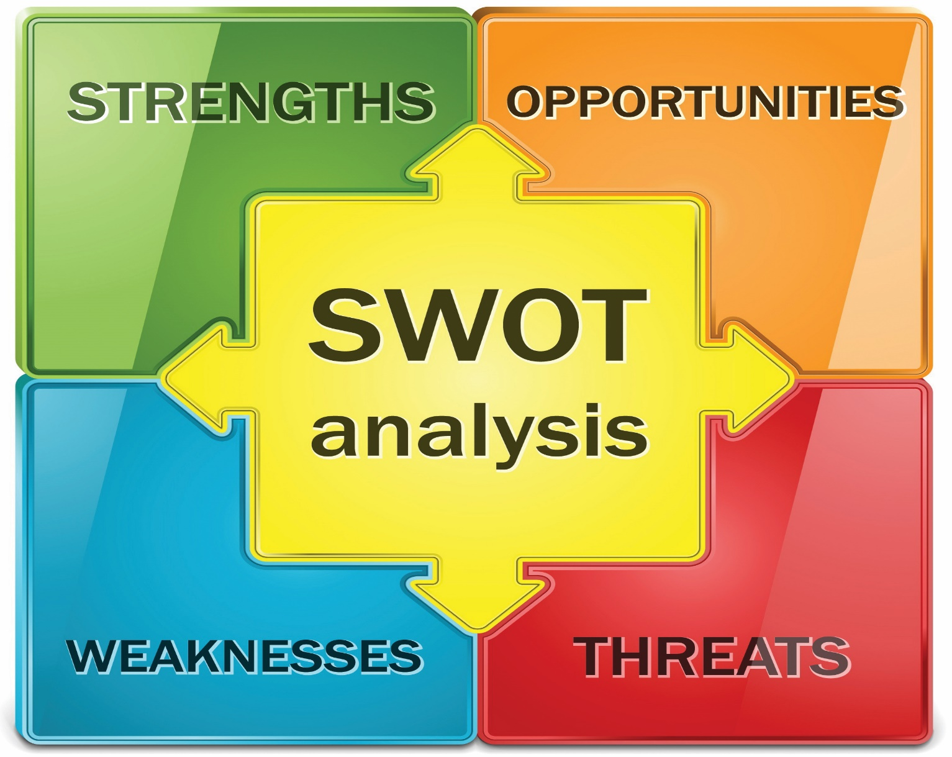
Strengths:
- Presence across segments - Accor Hotels has always contrasting offers to customers with any budget
- Network - Accor Hotels has a huge chain of hotels, resorts, and vacation properties all around the word and has over 4300 properties.
- Guest interaction – The main business philosophy of Accor Hotels is that guests are always made to feel welcome. Some of the features offered include lucrative loyalty programs, exclusive guest executives, and online check-in.
- Loyalty Programs - Accor Hotels is known to have one of the best loyalty programs in the business. Their frequent guests have access to a number of privileges such as free nights in collecting 2000 points complimentary upgrade to higher classrooms, exclusive access to private sales, online check-in and privileged checkout.
- Unique digital hospitality - The hotel chain maintains a database of over 60 million guests tracking their preferences and incorporating them into their services.

Weaknesses:
- Losing to online businesses - In the mid-tier and economy sections, Accor Hotels is losing its business to small hotels and online businesses like Airbnb or Oyo Rooms. The hotel chain has been investing heavily in enhancing their services as well as their food and beverages section for which there has been a huge cash outlay.
- Focus on franchising: Though franchising has helped the hotel chain cut its costs, the service levels, especially in their luxury hotels like Novotel, Sofitel, Fairmont, Banyan Tree, and Raffles, have suffered because of lack of adequate attention.

Opportunities:
- Growth in emerging economies: There is a huge scope for hotelkeeping business in emerging economies in Asia and Africa and there is a surge in tourists to these destinations. The growth of business in these regions have also resulted in the surge in the number of business travellers giving a boost to brands like Ibis.

Threats:
- Completion – There is serious competitors of Accor, worldwide brands such Hilton, Best Western, Starwood Hotels etc.
- Risks of foreign currency fluctuations – Most of the revenue is coming from International operations. In the past the company’s revenues were severely affected due to unfavourable foreign currency fluctuations. For example, during 2003, the weakening of Latin America and US currency reduced its revenues by 4.3% over 2002(datamonitor,2003)

PEST Analyse:

- Political factor - In globalized environment Accor the largest hospitality group in Europe now operates in 140 countries based in Every Cedex, France. Accor is highly influenced by the political and legislative conditions of these countries. In hotel industry, Accor French company still didn’t face any big threat because of their reduction in level of terrorism and also good relation with EEC country and others as well. Gettting and giving favour through business channel they still do their business with whole world.
- Economical factor - Accor is a more profitable organisation, between 2006 and 2012 in chain hotels is expected to rise by 5.7% a year, compared with an increase of 3.7% a year for the market as a whole. Economic factor are concern to Accor, because they are influenced on demand, cost, prices and profits. One of the most influence factors on the economy are acquisition, merger and demerger. In last year, Accor was increased its stake in Poland’s Orbis by 4.9%,from 40.58% to 45.48% at a cost of £42 million. From there financial report their earning objective is so good around the year.
- Socio-Cultural factor - Current situation indicate that Accor provide good service for customer they using 7 language through the online and graphics and maps also adding value to booking experience, which is due to variety of social changes. Demographic changes such as the aging population and an increase the female worker because the company believes that men and women at the heart of its strategy. The company also focus on their employer and to make an increased efforts more and more training place and of social advancement. Accor also provide franchises with added value and HR services and helping earth people they are involve in the Earth Guest programme with ECO and EGO and also developed corporate sponsorship for child aid, local aid, health, and cultural. In future Accor will continue to respect generation, cultural and professional differences
- Technological factors - Technology is the major macro-environmental factors which has influenced the benefits of both customer and company. customer satisfaction rises because the world moves so fast, goods are readily available and services are more personalized. so that Accor utilise the following technology-
- Websites and Hotel Booking
- Up to date information systems
- Electronic media card (pre paid card) becoming more demandable.

Employees of Accor:

People who works for Accor play the most important factor in the organisation to keep moving with successful steps and to eliminate any obstacles on their way. The organisation provides a great teaching ways for its new employees and 18 academic campuses. “Academie Accor Worldwide” network, whose ambition is to:

Help employees climb the corporate ladder, by developing qualification training programs for future.
Offer every year employee one training session a year, by reinforcing training in the workplace to improve quality.
“In 2010,171,000 employees took part in one more training courses, including over 142,000 non managerial staff. The training budget totalled 2.2% of payroll.”(www.accor.com)

Employee benefits:
Accor employees receive an incentive bonus and could be obtained company share.
Every employee receives a Bienvenue Card offering special advantages at all Group brands in every country where Accor is present.
A good management support has been providing to employee to feel free and enjoy the work.
Accor doors are always open for those who like to promote them.
Over 280 000 people are part of the French hospitality. Accor developing all talents:

Nearly 90% of managers got their job through internal promotions
Every year Accor welcomes several thousand interns and apprentices. Depending on job vacancies, work study contracts are transformed into permanent work contracts in one of the many Accor brands.
Accor strongly encourage:
An assessment interview with manager on a regular basis to take stock of career evolution.
People can easily have a position through job application.

Accor in Future:
For multinational company Accor, strategy plays a key role to take a place its operation in the diverse environment. As a service industry, the ability to meet the customer needs on a global basis is of growing strategic importance. Accor’s always focus on what the customer wants and not what the hotel firm believes is one of their marketing strategies. As a part of their customer service they introduced the new concept at Sofitel to offer ultimate sleeping comfort,it also changes its corpora culture to the changing customers’ needs. Having a corporate governance system to decentralised organization as it takes international expansion, matching its organization’s capabilities and competencies to the competitive conditions of the external environment. For example, in China Accor management consists of Chinese people in order to understand the culture, taste and preference existing there.

Accor’s goals:

Every marketing plan must include a control component that compares actual performance with the planned performance. Through collecting performance data the gaps between the objectives and the performance will be evaluated regularly to pursuer required corrective action. Creating implementation plans and strategies is the necessary to the day to day actions of making the dream a reality. In that case Accor faces in product development, marketing, accounting and human resources management as they strive to meet the company’s long term strategic goals. With a focus on growth, Accor should emphasize product development in order to meet the needs of a larger segment of the market. According to research some perceptible improvement are follows-

To improve how work together and how develop their people so that a high performance organisations.
To deliver an outstanding experience for all customers.
To improve the financial performance of the company and deliver for their shareholders.
To maintain and improve their performance quality of processes.
Conclusion:

Through business strategy Accor shows the best success when received the highest revenue 8.7%. The first half 2007,Accor pursued its asset-right strategy adapted to the risk-rewarded profile of each market segment and region. The organisation already presented their new business model to support and achieve organisation objective. Between 2006 and 2013, the number of overnight stays in chain hotels is expecting to rise by 5.7% a year compared with an increase of 3.7% a year for the market as whole. The supply and the demand chain will have better way to success in future. the business expansion will make the organisation stronger.

Accor will be a best global leader in near future. It makes a constant focus on the long term sometimes taking bold action but never excessive risk.

References

Marketing91com. 2019. Marketing91. [Online]. [2 May 2019]. Available from: https://www.marketing91.com/marketing-mix-of-accor-hotels/

Marketing91com. 2019. Marketing91. [Online]. [2 May 2019]. Available from: https://www.marketing91.com/swot-analysis-of-accor-hotels/

本網站由〔ugear 優吉兒網頁設計〕設計與製作. 2019. Hinton Information Services. [Online]. [2 May 2019]. Available from: http://www.hintoninfo.com/EN/ugC_MTIProduct_Detail.asp?hidMTIProductID=11784

Accorcom. 2019. Accorcom. [Online]. [2 May 2019]. Available from: https://group.accor.com/en

Hamel,G and C.K Prahalad,(1994). Competing for the Future Boston: Harvard business School press.

Aian M .Rugman and Richard M.Hodgetts,(2003). International Business.3rd ed. Pearson education ltd

Geof Lancaster and Ian Waddelow,(1998).Strategic Marketing Planning. Journal of marketing management 14.853-878.

Laurie J Mullins,(1995).Management and Organisational Behaviour.3rd ed. Pitman publishing.

Phillip Kotler, Jhon Bowen, James Makens,(2003). Marketing for Hospitality and Tourism. 3rd ed.Prentice Hall.

Jonson Scholl and Gerry,Keven,(1999).Exploring Corporate Strategy(Text &cases).6th ed.Prentice Hall Europe.

