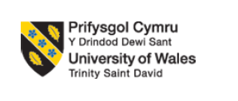

STUDENT NAME: MOHMEDKAIF HAMIDALI MANSURI

STUDENT ID: 2321459

PROGRAMME: MASTER OF BUSINESS ADMINISTRATION

MODULE: MARKETING MANAGEMENT

MODULE CODE: LCMB7024
LECTURER: DR LAILA MAAZOUZ
ASSESSMENT

COMPONENT 2: MARKETING PORTFOLIO

WORD COUNT: 2500

Table of Contents
Introduction 2
Element 1: Analysing segmentation, differentiation, targeting and positioning (STDP) for the new brand 2
Element 2: Marketing Mix 5
Element 3: Marketing Strategy Pitch 8
Element 4: Reflection 9
Conclusion 10
References 12

Introduction
A detailed analysis of specific markets is important to identify key trends, opportunities, and develop a new brand as per the market gaps. As per Mitchuk et al. (2023), detailed research on a specific market is important for formulating appropriate marketing activities by identifying target audiences. Unilever is a leading consumer goods company in global markets and offers more than 400 product brands that are sold in over 190 countries (Unilever, 2025). This marketing portfolio is going to discuss the launch and development of a new brand for Unilever that will offer organic baby care products and differentiate this brand from other competitors in global markets.

Element 1: Analysing segmentation, differentiation, targeting and positioning (STDP) for the new brand
Concept of the new proposed brand
The proposed new brand is “AuraNest Organic” by Unilever, which will offer baby care products that are manufactured from organic materials and plant-based ingredients. Offering specialised pure baby care products manufactured from plant-based ingredients and eco-friendly materials is the key concept of this new brand of Unilever. As mentioned by Pakkala and Bhat (2022), the behaviour of consumers is 100% influenced by offering care products for children that are manufactured from natural, eco-friendly and plant-based ingredients. It indicates that the new brand “AuraNest Organic” by Unilever will attract a large number of consumers in global markets that have positive interests and needs for 100% organic products for baby care.
Rationale for selecting the brand idea and appealing to the market based on market trends
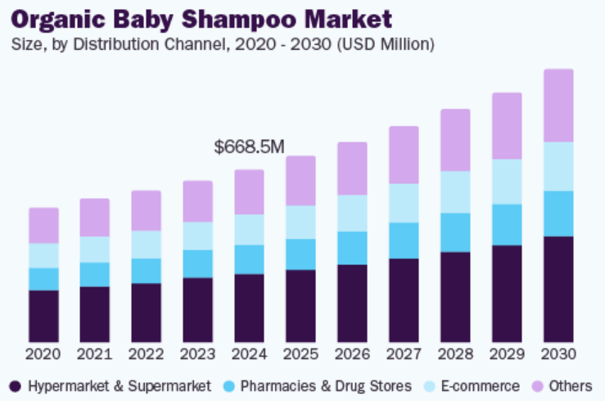
Figure 1: Organic baby shampoo market size
(Source: Grandviewresearch, 2025)
Consumer behaviour is changing rapidly in global markets, and a majority of customers are shifting their intention from buying traditional products to eco-friendly and green products. For instance, around 15% of UK consumers have purchased chemical-free conditioners, shampoo for children in 2023 (Knowledge-sourcing, 2025). It indicates an increasing awareness and demand among consumers to prefer organic care products for their babies to avoid any health-related issues. Apart from this, the market size of organic baby shampoo was around “USD 668.5 million in 2024”, and this growth will be 7.9% CAGR between 2025-2030 (Grandviewresearch, 2025). The increasing demand for organic and chemical-free care products for babies will help AuraNest Organic by Unilever to improve its brand appeal and generate a positive response from customers. It has been found that consumers are ready to pay 9.7% more for buying sustainable and eco-friendly products even during a high inflation situation (Pwc, 2024). It indicates the changing trends and behaviours of consumers towards buying eco-friendly products from the market. These changing trends and higher demands for sustainable products in the global market will help Unilever appeal to customers to select its new brand AuraNest Organic to get 100% pure organic care products for babies.
Market segmentation and targeting
Geographic segmentations | - Targeting consumers from global markets  - Targeting people in both rural and urban areas
Demographic segmentations | - Gen Z and millennial parents  - Targeting middle and high-income category people  - Parents who have 0-5 years children
Behavioural segmentation | - Targeting parents who are health-conscious and prefer 100% natural care products for their babies
Psychographic segmentation | - Targeting parents who are highly concerned about buying eco-conscious products
Table 1: Market segmentations
(Source: Self-Developed)
AuraNest Organic by Unilever will target Gen Z and millennial parents who have sufficient knowledge regarding shifting market trends towards buying organic and eco-friendly products. Apart from this, targeting parents, having 0-5-year-old children and being highly concerned about buying 100% natural products will be targeted by this new brand to increase its sales in global markets. Janwatsiri and Sangsingkeo (2022) mentioned that targeting Gen Z customers is a key strategy to drive the sales of eco-friendly as well as organic-based products in global markets. AuraNest Organic will target parents from the high and middle income categories to generate demand for some premium pricing organic care products for babies and gain market advantages.
Brand positioning
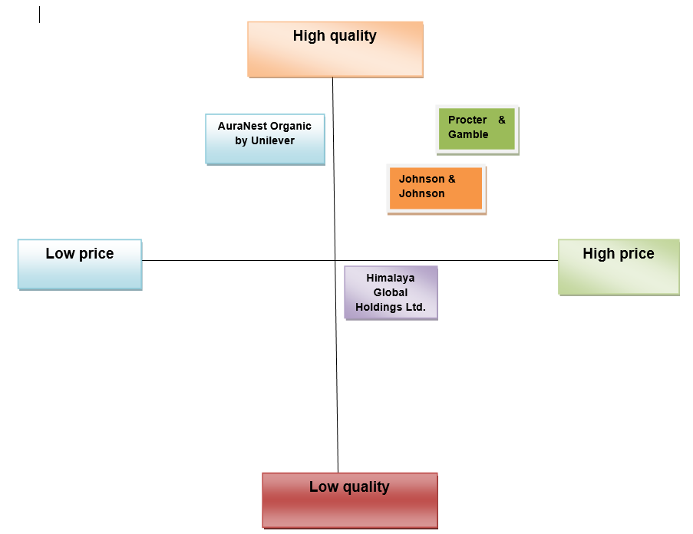
Figure 2: Positioning matrix
(Source: Self-Developed)
The market competition in the baby care segment is increasing gradually, which can create serious competitive threats for Unilever while launching its new brand AuraNest Organic. For instance, “Procter & Gamble (P&G)” and “Johnson & Johnson (J&J)” are the top two competitors that dominate the market of baby products and have a strong presence in global markets (Mordorintelligence, 2025). Considering these factors, AuraNest Organic by Unilever will offer a range of care products for babies that are manufactured from 100% natural and plant-based ingredients at an affordable price point to gain a competitive advantage. For instance, P&G has increased its product price to tackle the rising inflation and tariff costs in global markets (Reuters, 2025). Considering this situation, offering pure and natural care products for babies from plant-based ingredients with an affordable pricing point will give competitive advantage for Unilever to successfully launch its new brand in global markets.

Element 2: Marketing Mix
The application of marketing 4Ps gives better control for organisations on their marketing elements, such as products, promotions, place, price, to get competitive advantages. As stated by Hanifah et al. (2022), the use of the “4Ps marketing mix” enables organisations to set appropriate pricing and launch products. Set appropriate emotional approaches to positively influence the purchase decisions of consumers.
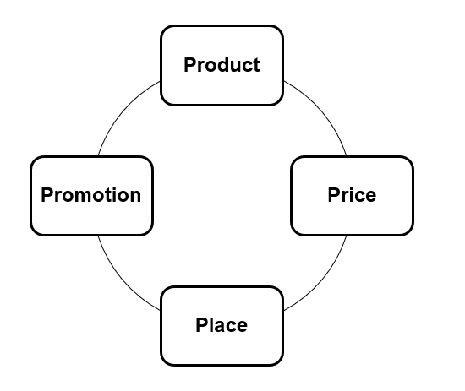
Figure 3: 4Ps of marketing mix
(Source: Self-Developed)
Product
The new Brand, AuraNest Organic is suggested to adopt a Quality-focused strategy in terms of attracting a wider range of consumers towards its organic baby care products. As per the opinion of De Giovanni (2024) quality-focused strategy is considered to be a business approach that prioritizes delivering high-quality products or services in terms of gaining competitive advantage, increasing customer satisfaction as well as building brand reputation. In this respect, the company is required to adopt strong leadership commitment, developing clear quality management plans as well as establishing a culture of continuous improvement. It has been recognised that AuraNest Organic can gain potential in differentiating its product compared to its competitors. However, Pargaonkar (2023) has contradicted that high implementation costs, potential rigidity, limited market scope and growth potential are considered to be the potential limitations of quality focused strategy. Based on this aspect, the company is required to develop a comprehensive plan in terms of defining objectives, strategies and enhancing availability of resources. Purnomo (2023) has highlighted that commitment to constantly assessing, analysing as well as improving processes, products, and services is crucial for implementing a product strategy. Thus, the above mentioned actions are required to be adopted by Unilever in terms of integration product strategy for its new brand, AuraNest Organic.
Price
The selection of an appropriate marketing approach by considering market trends, competitive positioning will help Unilever to launch its new organic care product lines for babies under the brand AuraNest Organic. Unilever can select the “penetration pricing” approach to offer organic care-based products for babies at an affordable range in the initial stage to capture a strong market gain. This strategy will provide greater scope for this brand to increase price based on the market demands, product quality in future. As mentioned by Erbil (2022), offering a new product range at an affordable price point during the initial offering to improve sales and customer retention are advantages of the penetration pricing tactic. Considering these factors, Unilever can set this pricing approach for selling products of its AuraNest Organic brand to attract Gen Z and millennial parents to buy care products for their babies that are manufactured from 100% natural and plant-based materials. For example, J&J will be a strong competitor of AuraNest Organic and strongly focused on innovation in product manufacturing to offer a range of products at a reasonable price (Jnj, 2025). In this regard, offering premium organic care products for babies at an affordable price range will add competitive value for this new brand of Unilever to attract customers and drive its sales in global markets.
Place
Opening product distribution centres, offering the product line of organic products linked to baby care at the right marketplace, will allow Unilever to sell products of its AuraNest Organic brand to global markets. Hwang and Youn (2023) mentioned that “brick-and-mortar stores” increase the physical presence of organisations in the marketplace and influence consumers to buy products by gathering product information. In this regard, AuraNest Organic by Unilever will sell its sustainable range of baby care-based products through its “brick-and-mortar stores” in different physical locations in global markets.
Selling the product range of the “AuraNest Organic” through different e-commerce channels will add competitive value to Unilever for driving sales and reach to a range of customers in a cost-effective manner. For instance, the e-commerce sales will be “4.3 trillion US dollars” in 2025, indicating increasing sales growth of e-commerce channels in global markets (Statista, 2025). Considering these factors, Unilever can collaborate with leading e-commerce channels such as Amazon, Flipkart to sell their products of AuraNest Organic to drive sales and profitability.
Promotion
The development of appropriate marketing tactics, campaign design and advertisement approaches will assist Unilever to promote its new brand AuraNest Organic that will offer a range of organic care products for babies. The selection of “social media (SM)” channels, such as Instagram, Facebook, will help this brand to provide advertisements of AuraNest Organic brand with detailed product-related specifications. The spending on SM advertisements in global markets is around “US$275.98bn” in 2025 (Statista, 2025). It highlights the demands of SM channels to ensure better promotion of brands and products among global marketers. Unilever can design an online campaign for SM channels, generate content on the organic care-based product range, and post reel videos on the product manufacturing to attract customers. For instance, posting short videos regarding manufacturing care products for babies with organic plant-based ingredients will increase brand transparency and can build positive trust among consumers.
Application of brand development strategy
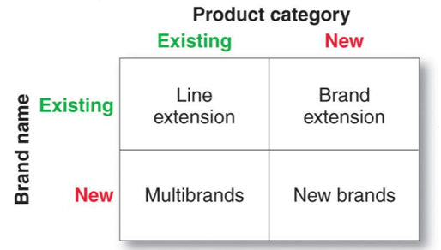
Figure 4: Brand development matrix
(Source: Self-developed)
A brand development strategy is considered to be a long-term plan to build a brand's identity, differentiate it from competitors, and create a connection with customers (Cid et al. 2022). Based on the above mentioned figure, Unilever has been suggested to adopt "New Brand” development strategies in terms of enhancing its business overall performances. In this respect, the company has developed the new brand “AuraNest Organic” , an organic baby care product that can help to reach a wider audience. The development of such a new brand can also help the company to enhance its brand image within the market.

Element 3: Marketing Strategy Pitch
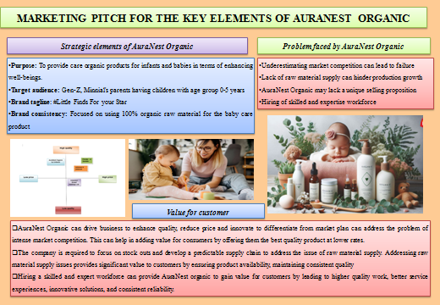
Figure 5: Marketing Pitch
(Source: Self-Developed)

Element 4: Reflection
Experience gain while developing brand concept and creating marketing strategies
The development of the new brand has helped to improve my critical thinking ability. However, in the initial stage of conducting the assignment I felt nervous on understanding the overall requirements. As per Raj et al. (2022), strong critical thinking ability helps an individual to make better decisions, solve problems more effectively, and improve communication skills. I have that understanding the key requirements for developing a new brand has helped to understand various aspects of marketing. The initial step in brand development has required a deep introspection in terms of defining the core identity. In this respect, I have selected the organic baby care product which can be attractive for the consumers.
I have recognised that Unilever has been one of the reported FMCG organizations and have a huge consumer base all across the global platform. I have selected Unilever as well as suggested the new Brand, AuraNest Organic. I believe that the most significant lesson was the necessity for a deeper understanding of the customer's world that comprises pain points, aspirations as well as values. I have also recognised that shift toward an empathy-driven approach involved extensive listening and feedback gathering, which in turn humanized the brand identity and sharpened the value proposition.
Key skills and insights gained
The overall process of developing the new brand concept and marketing strategies has helped to gain strategic thinking skills. As per Korteling et al. (2023), strategic thinking helps an individual to improve decision-making, adapt to change, solve problems as well as achieve long-term goals. Apart from this, I have gained huge knowledge of project management as well as enhanced my communication ability. I was required to communicate with my group members in terms of gaining new insights. Additionally, I have recognised that the necessity of using data analytic tolls is essential in terms of understanding the present market situation. Conducting the marketing strategy pitch has helped in enhancing my presentation and digital skills to great extent. As per the opinion of Sumaiya et al. (2022) strong presentation skills helps an individual to effectively communicate ideas, influence decisions, build confidence, and advance their career. Thus, the development of this presentation has highly influenced my personal skills and experiences.
Further improvement of the process
Conducting this overall portfolio, I have gained a wide range of critical and strategic thinking ability. In this respect, I believe that I can utilize such skills and experiences in my future projects development. I have acknowledged that lack of critical thinking ability has affected my working potential within this project. However, I have utilized my potential strengths that I have gained from this portfolio in coming times. Thus, I believe that getting an opportunity to make similar projects in the coming time can be more specific and attractive.

Conclusion
The above mentioned project concludes that offering specialised pure baby care products manufactured from plant-based ingredients as well as eco-friendly materials can be effective for Unilever. The portfolio indicates an increasing awareness and demand among consumers to prefer organic care products for their babies to avoid any health-related issues. Apart from this, AuraNest Organic by Unilever has focused on targeting Gen Z and millennial parents who have sufficient knowledge regarding shifting market trends towards buying organic and eco-friendly products. The new brand has been suggested to adopt a quality focused strategy in terms of promoting the product to a wider audience.

References
Cid, A., Blanchet, P., Robichaud, F. and Kinuani, N., 2022. A conceptual framework for creating brand management strategies. Businesses, 2(4), pp.546-561.Available at: https://doi.org/10.3390/businesses2040034 (Accessed on: 26 November 2025).
De Giovanni, P., (2024). The modern meaning of “quality”: analysis, evolution and strategies. The TQM Journal, 36(9), pp.309-327. Available at: https://doi.org/10.1108/TQM-12-2023-0413 (Accessed on: 26 November 2025).
Erbil, K., (2022). Penetration Pricing Strategy and Customer Retention–An Analysis. Journal of Positive School Psychology http://journalppw. com, 6(5), pp.7058-7072. Available at: https://www.researchgate.net/profile/Sarah-Azad-Fouad-Arif/publication/362113459_Penetration_Pricing_Strategy_and_Customer_Retention_-An_Analysis/links/638fb877e42faa7e759dbe0a/Penetration-Pricing-Strategy-and-Customer-Retention-An-Analysis.pdf (Accessed on: 26 November 2025).
Grandviewresearch, (2025). Organic Baby Shampoo Market Trends. Available at: https://www.grandviewresearch.com/industry-analysis/organic-baby-shampoo-market (Accessed on: 26 November 2025).
Hanifah, P., Nuringwahyu, S. and Krisdianto, D., (2022). Effect of 4P’S Marketing Mix on Purchase Decision. Marg. J. Manag. Accounting, Gen. Financ. Int. Econ. Issues, 1(4), pp.207-218. Available at: https://pdfs.semanticscholar.org/12f8/b88782a4982435ebc26847affc36d1b09273.pdf (Accessed on: 26 November 2025).
Hwang, J. and Youn, S.Y., (2023). From brick-and-mortar to livestream shopping: product information acquisition from the uncertainty reduction perspective. Fashion and Textiles, 10(1), p.7. Available at: https://link.springer.com/content/pdf/10.1186/s40691-022-00327-3.pdf (Accessed on: 26 November 2025).
Janwatsiri, M.P. and Sangsingkeo, N., (2022). Attitude towards buying behavior and expectation of Advertising media on organic skincare products in generation Z (No. 308244). Thammasat University. Faculty of Journalism and Mass Communication. Available at: https://digital.library.tu.ac.th/tu_dc/digital/api/DownloadDigitalFile/dowload/193609 (Accessed on: 26 November 2025).
Jnj, (2025). Johnson & Johnson’s approach to pricing. Available at: https://www.jnj.com/innovativemedicine/access-and-pricing (Accessed on: 26 November 2025).
Knowledge-sourcing, (2025). United Kingdom Baby Care Products Market Size. Available at: https://www.knowledge-sourcing.com/report/united-kingdom-baby-care-products-market (Accessed on: 26 November 2025).
Korteling, J.E., Paradies, G.L. and Sassen-van Meer, J.P., (2023). Cognitive bias and how to improve sustainable decision making. Frontiers in Psychology, 14, p.1129835. Available at: https://doi.org/10.3389/fpsyg.2023.1129835 (Accessed on: 26 November 2025).
Mitchuk, O., Fayvishenko, D., Lorvi, I., Konopliannykova, M., Chernobrovkina, S. and Sytnyk, O., (2023). Communication strategies of brand management and online marketing of digital products. Economic Affairs, 68(01s), pp.289-298. Available at: https://elibrary.kubg.edu.ua/id/eprint/48095/1/O_Mitchuk_EA_68_01s_BGKU.pdf (Accessed on: 26 November 2025).
Mordorintelligence, (2025). Baby Care Products Company List. Available at: https://www.mordorintelligence.com/industry-reports/baby-care-products-market/companies (Accessed on: 26 November 2025).
Pakkala, K. and Bhat, K.S., (2022). Literature review on consumer perception and buying behaviour on baby care products. International Journal of Management, Technology, and Social Sciences (IJMTS), 7(2), pp.2581-6012. Available at: https://www.academia.edu/download/100478968/39._Literature_Review_on_Consumer_Perception_and_Buying_Behaviour.pdf (Accessed on: 26 November 2025).
Pargaonkar, S., (2023). A comprehensive research analysis of software development life cycle (SDLC) agile & waterfall model advantages, disadvantages, and application suitability in software quality engineering. International Journal of Scientific and Research Publications, 13(8), pp.120-124. Available at: http://dx.doi.org/10.29322/IJSRP.13.08.2023.p14015 (Accessed on: 26 November 2025).
Purnomo, Y.J., (2023). Digital marketing strategy to increase sales conversion on e-commerce platforms. Journal of Contemporary Administration and Management (ADMAN), 1(2), pp.54-62. Available at: https://doi.org/10.61100/adman.v1i2.23 (Accessed on: 26 November 2025).
Pwc, (2024). Consumers willing to pay 9.7% sustainability premium, even as cost-of-living and inflationary concerns weigh: PwC 2024 Voice of the Consumer Survey. Available at: https://www.pwc.com/gx/en/news-room/press-releases/2024/pwc-2024-voice-of-consumer-survey.html (Accessed on: 26 November 2025).
Raj, T., Chauhan, P., Mehrotra, R. and Sharma, M., (2022). Importance of critical thinking in the education. World Journal of English Language, 12(3), pp.126-133. Available at: https://doi.org/10.5430/wjel.v12n3p126 (Accessed on: 26 November 2025).
Reuters, (2025). Procter & Gamble hikes US prices to blunt tariff hit as CEO transition looms. Available at: https://www.reuters.com/business/procter-gamble-hikes-us-prices-blunt-tariff-hit-ceo-transition-looms-2025-07-29/ (Accessed on: 26 November 2025).
Statista, (2025). E-commerce worldwide - statistics & facts. Available at: https://www.statista.com/topics/871/online-shopping/?srsltid=AfmBOopP3B12KyslNneShXAYZCiZLnjay6b5pQkFf4_tAY3KQ58FA0B8#topicOverview (Accessed on: 26 November 2025).
Statista, (2025). Social Media Advertising - Worldwide. Available at: https://www.statista.com/outlook/amo/advertising/social-media-advertising/worldwide?srsltid=AfmBOoq06R3sxzXtETQQD-gbapyK0vk7BEoLA0sCpFTTTTNFtJgZZ2WN (Accessed on: 26 November 2025).
Sumaiya, B., Srivastava, S., Jain, V. and Prakash, V., (2022). The role of effective communication skills in professional life. World Journal of English Language, 12(3), pp.134-140. Available at: https://doi.org/10.5430/wjel.v12n3p134 (Accessed on: 26 November 2025).
Unilever, (2025). Transforming our brands, transforming our advertising. Available at: https://www.unilever.com/sustainability/equity-diversity-and-inclusion/transforming-our-brands-transforming-our-advertising/ (Accessed on: 26 November 2025).

