Jomir Ali (2442127)

Module Number: ACCA4002
Lecturer: Redwan-Al-Amir
Date: October 2025
Group: 02
Student Name: Jomir Ali
Student ID: 2442127
University of Wales Trinity Saint David
CertHE Computing Skills for Workplace
Module: Computer Architecture and Operating Systems

Contents
Contents 1
Introduction 2
Key functions of general Operating Systems 3
Use of Windows OS CLI commands 5
Use of Windows OS scripts 9
Use of Linux OS CLI commands 11
Use of Linux OS scripts 16
Conclusion 17
References 18

Introduction

Operating systems are crucial to modern computing because they manage hardware resources and provide a framework for the execution of applications. They provide reliable, secure, and efficient system performance by acting as a bridge between users and computer hardware. This essay looks at the fundamental aspects of general-purpose operating systems, including file systems, memory management, process management, and security in Windows and Linux. It also examines real-world operating system interaction in both contexts using scripting and command-line interfaces. By combining theoretical concepts with practical applications, the essay demonstrates how operating systems enable effective system administration and automation.

Key functions of general Operating Systems

An operating system has two main purposes: it manages the computer's resources by allocating them to users and programs, and it provides a simpler, more user-friendly interface than the physical hardware. Most computers and their devices are complex and difficult to program directly. This complexity often comes from old hardware designs or the need to maintain compatibility with outdated systems.
The operating system takes care of these low-level details, even on simple single-user machines, and allows multiple programs to run at the same time. It controls how the computer's resources—such as the processor, memory, storage, printers, and network connections—are shared between programs. Besides the operating system, computer manufacturers also provide other useful system programs.
The connection between a user program and the operating system is made through system calls. These are special instructions that let a program request service from the operating system. In systems like UNIX, system calls are written as high-level language functions to hide hardware details and improve portability.
An operating system's several key functions include memory management, which involves assigning, releasing, and monitoring the computer's primary memory (RAM) for different applications. It entails controlling which processes receive memory and transferring data between main memory and secondary storage. The OS manages data transfer between the CPU and external devices by using device drivers, the kernel, and libraries to handle input and output (I/O).
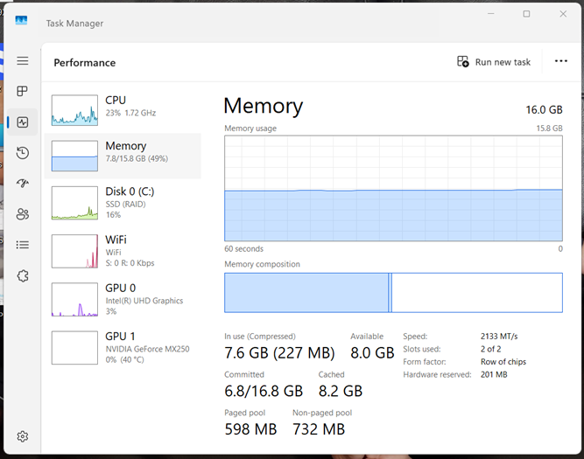
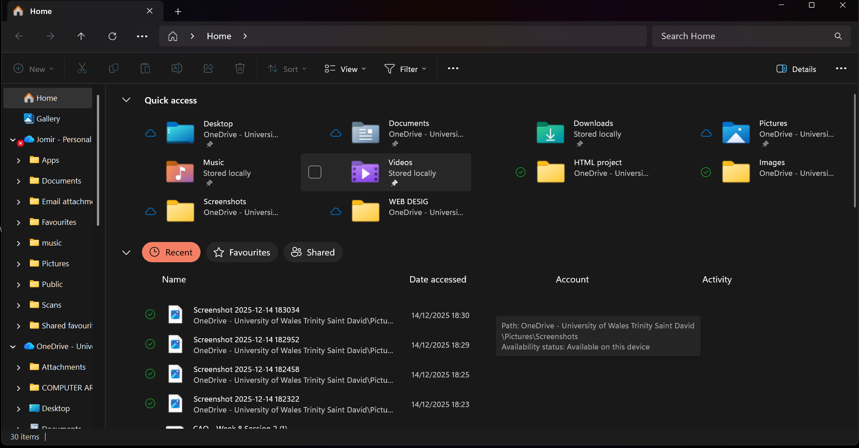
An operating system's file management features include the ability to create, access, change, and organise files and folders. Using a dedicated network operating system (NOS) or integrated OS features, networking on an OS system entails controlling communication and resource sharing.

One of the main functions of an operating system (OS) is process management, which manages the creation, scheduling, and termination of a "process"—a program that is running—over its whole lifecycle. It controls process states and guarantees effective use of system resources like the CPU and memory.
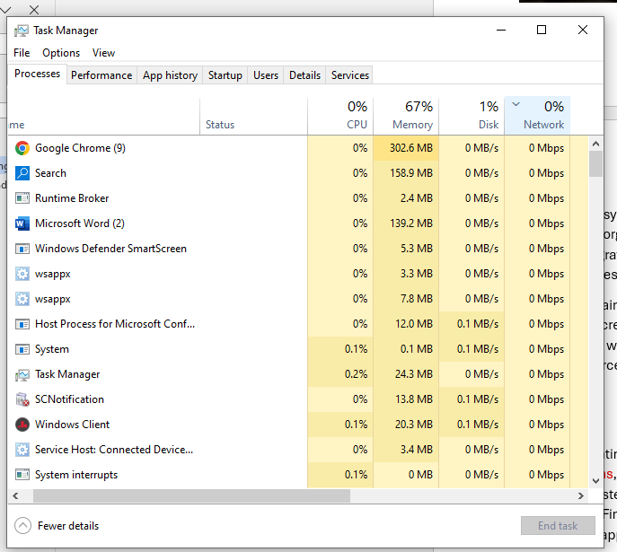

Modern operating systems also include extra features such as user login systems, security protections, virtualization (running multiple systems on one machine), and tools for monitoring system performance. They can detect and fix errors to keep the system stable and reliable. Finally, the operating system provides a platform for developers to build, test, and run applications more easily. [1]

Use of Windows OS CLI commands

The history of Windows operating systems is a fascinating tale of development, starting with MS-DOS, Microsoft's fundamental product for the original IBM Personal Computer. The first version, DOS 1.0 (1981), ran on just 8 Kbytes of memory and had a simple command-line interface.
Software evolved because of rapid hardware proliferation. DOS 2.0 (1983) added UNIX-like functionality, like I/O redirection and essential hierarchical directories for managing hard drives. New peripherals and networking technologies were supported by later DOS versions up to the mid-1980s, although they were still limited by backward compatibility constraints and did not take advantage of the sophisticated features of modern CPUs.
DOS had become outdated by the late 1980s. In 1990, Microsoft released Windows 3.0, a Graphical User Interface (GUI) built on top of DOS. Windows NT (1993), a powerful, 32-bit operating system created from the ground up to take advantage of the capabilities of contemporary microprocessors and provide pre-emptive multitasking, marked a significant change. NT 4.0 adopted the widely used Windows 95 style to standardise the user interface.
With Windows 2000, which included essential technologies for distributed computing like Active Directory, the evolution proceeded into the new millennium. With the release of Windows XP in 2001, the evolution from a basic assembly language application to a complex, scalable operating system family was completed. [2]

Command | Descriptions
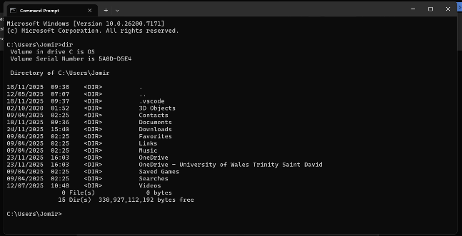  Figure1: dir | A directory listing of the files and subdirectories kept at a certain place in the file system can be obtained using the DIR command on Microsoft DOS. It is one of the most basic and commonly used commands in the Windows Command Prompt environment, enabling users to browse and examine the contents of folders.

Command | Description
Figure2: date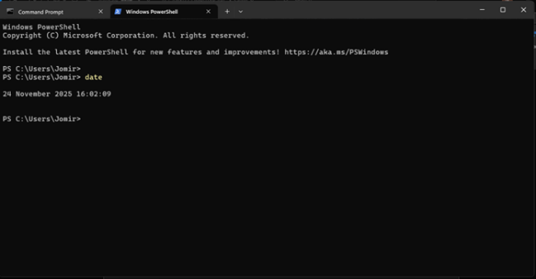 | On MS-DOS, the date command shows the current date of the system and lets the user manually alter it. It asks for input in a particular regional format, such as mm-dd-yy. The current setting is maintained when you hit Enter without entering a new date.

Command | Description
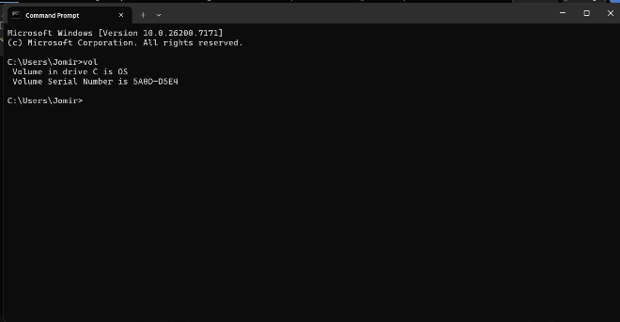  Figure 3: vol | The volume label and serial number of a disc drive can be shown with the internal vol command in MS-DOS and the Windows Command Prompt. If no drive letter is supplied (such as vol C:), it displays information for the current default drive. When utilised, it promptly delivers identifying information about the logical drive. Users cannot alter the label; that feature necessitates the use of a separate label command.

Command | Description
Figure 4: cls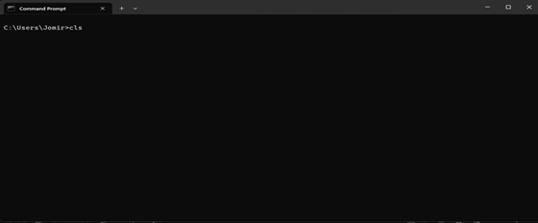 | To remove all text and output from the console screen, use the CLS command, a basic tool in Windows Command Prompt and MS-DOS. With the command prompt returned to the top-left corner of the window, this command creates a new, empty workspace by deleting all previously entered commands and their results. Without changing the command history itself, this step makes the screen easier to read and helps arrange it for future tasks.

Command | Description
Figure 5: tasklist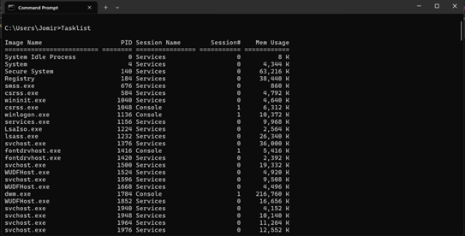 | In the Windows Command Prompt, all active processes and their memory usage are shown using the task list command on MS-DOS.

Command | Description
Figure 6: shutdown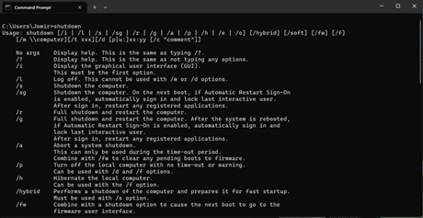 | A command-line interface for automating system power management functions, like shutting down, resuming, or logging off a local or remote Windows computer, is provided via the shutdown command.
Command | Description
Figure 7: print  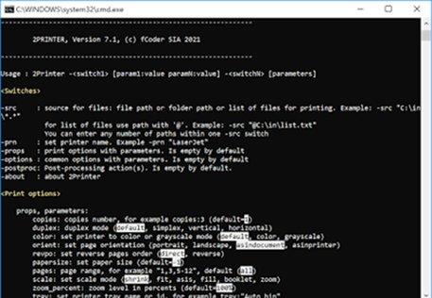 | In MS-DOS, the print command is an external command that transfers an ASCII text file to a designated printer. Basic print spooling, which enabled users to add files to a print queue and carry on using the computer for other tasks while printing took place in the background, was its main feature.

Command | Description
Figure 8: find  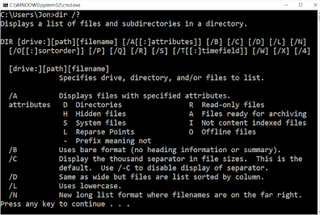 | In MS-DOS and Windows Command Prompt, the find command is a filter tool that looks for a given text string in one or more files. Every line that contains a match to the console output is shown. The find command is exclusively text-based and is mostly used for fast text file content filtering or rerouting the output of other commands, in contrast to the current Windows Search tool.

Command | Description
Figure 9: net user  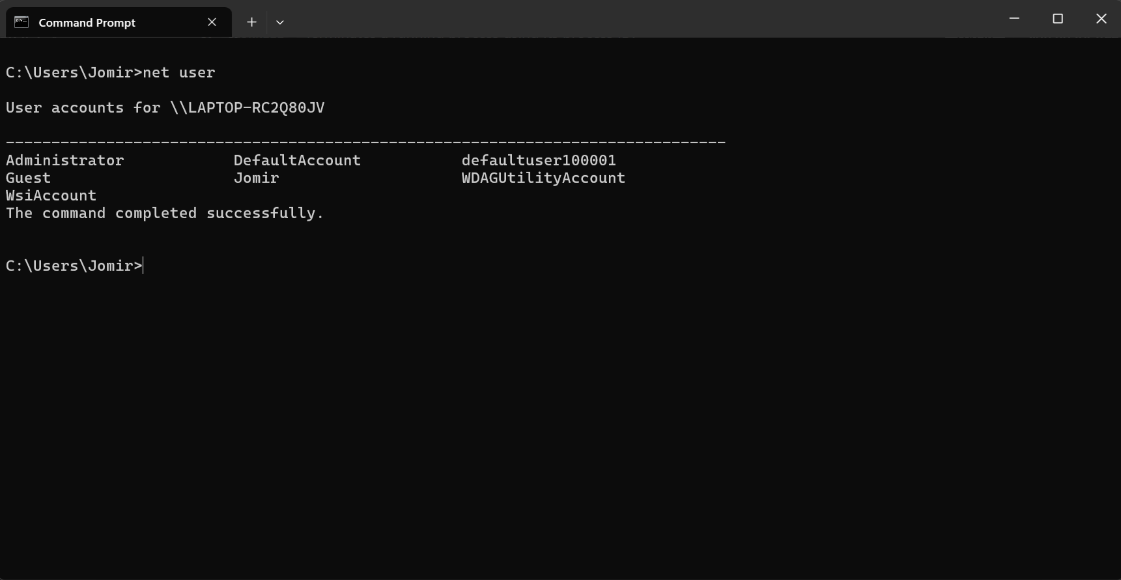 | On a Windows computer, you can create, view, edit, or remove user accounts with the net user command in MS-DOS (Command Prompt).

Command | Description
Figure 10: systeminfo  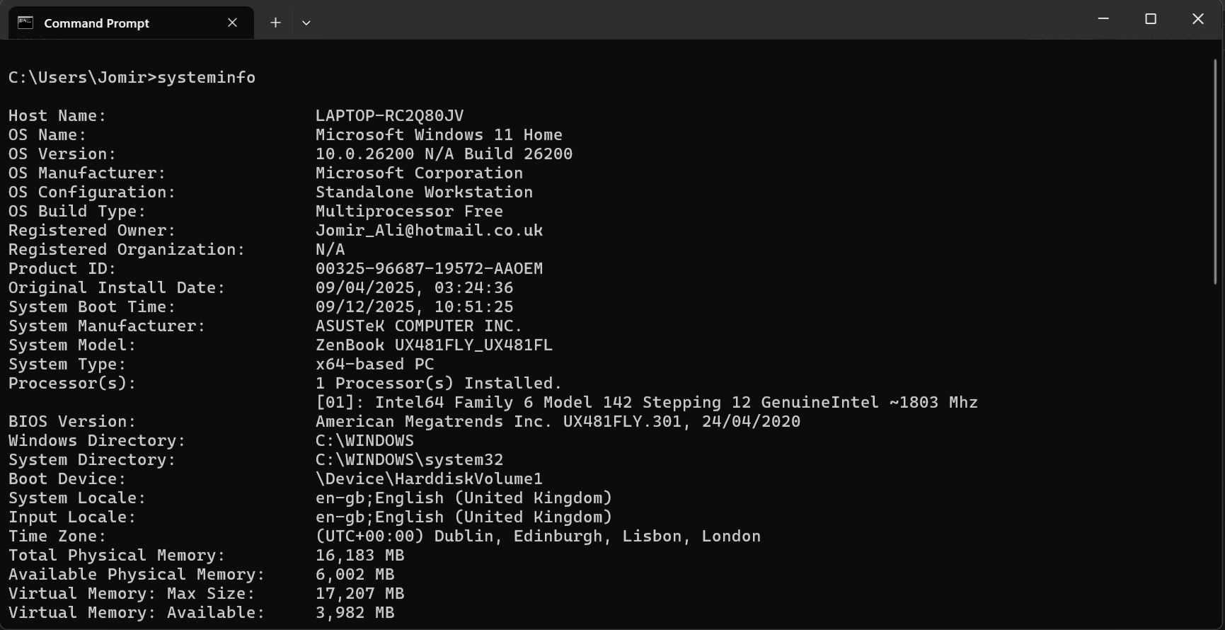 | The command "system info" in MS-DOS (Command Prompt) is used to show comprehensive details on the hardware, operating system, and system configuration of the machine.

Use of Windows OS scripts
Using commands in text files, primarily through PowerShell or older Batch files, Windows OS scripting automates processes. Substituting automated scripts for manual labour, it assists users and IT specialists in effectively managing system settings, files, users, and applications. Scripting speeds up and simplifies repetitive or difficult operations.
Running several commands from within a command shell is known as shell scripting. These commands are typically saved in a script or batch file, though they can be executed separately from the command line. The simplest scripting technique to learn is shell scripting, which has been around since the Microsoft Disk Operating System (MS-DOS) was first released.
This demonstrates how to use scripts to automate both simple and complicated administrative duties. Whether you are a network administrator or a typical Windows user, it focuses on real-world examples that you can apply right away. In addition to explaining features like Active Directory and Windows Management Instrumentation, it covers three primary scripting techniques: shell scripting, KiXtart, and Windows Script Host. Additionally, it presents substitutes like AutoIt and ScriptIt. This book, which offers instructions for both Windows NT and 2000, is a small, user-friendly tool that facilitates time savings and increased productivity. [3]
Windows OS scripts:
Figure 1: Note Pad input | Outcome
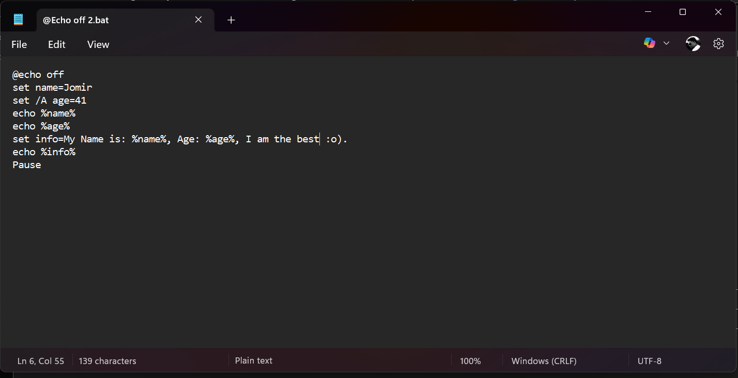 | 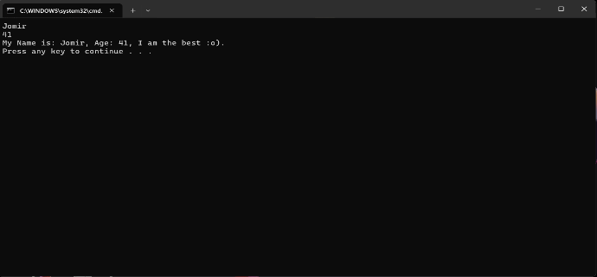
Figure 2: Note Pad input | Outcome
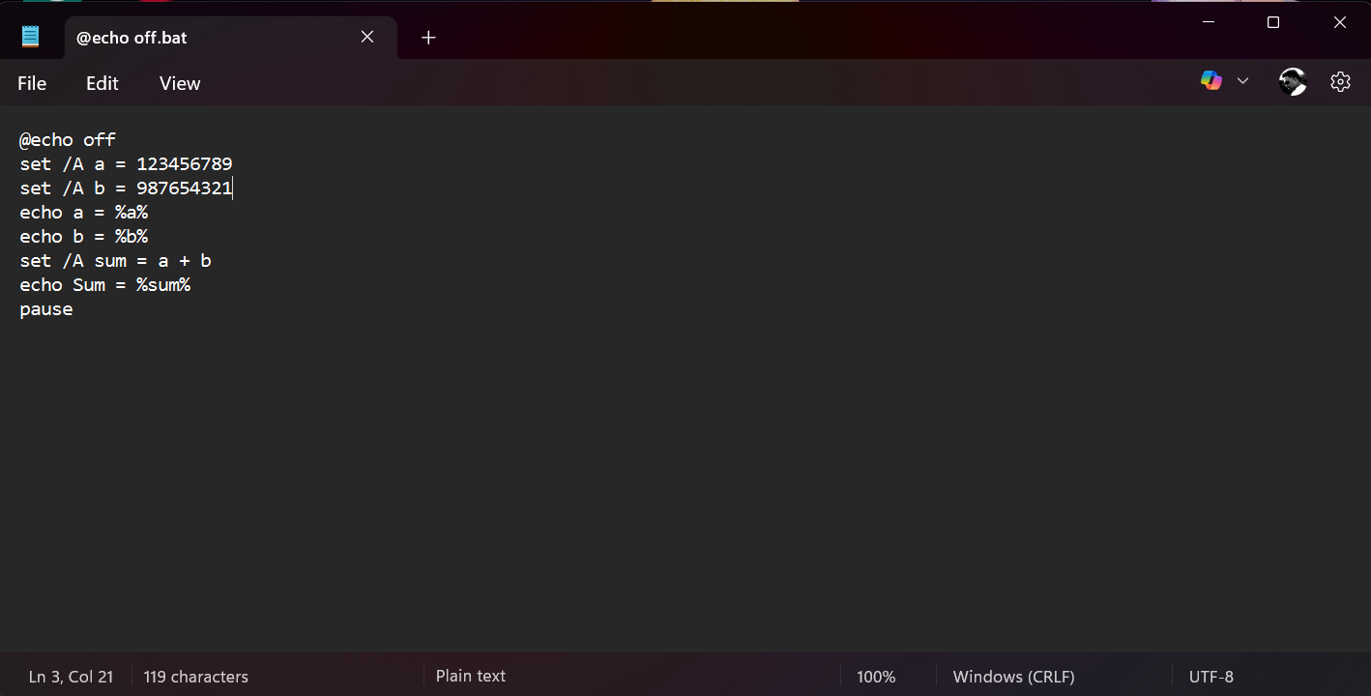 | 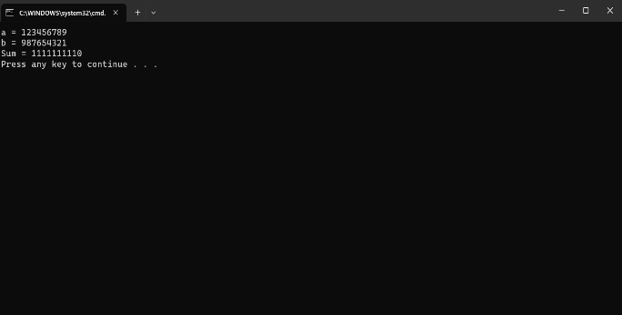
Figure 3: Note Pad input | Outcome
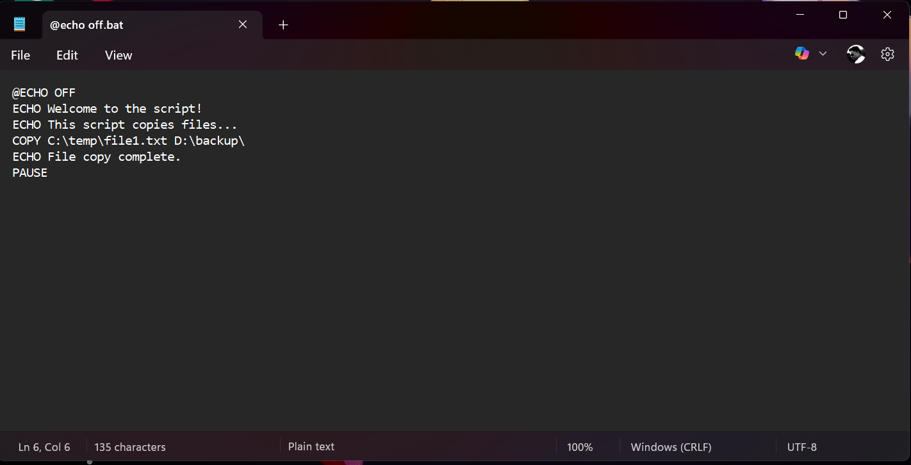 | 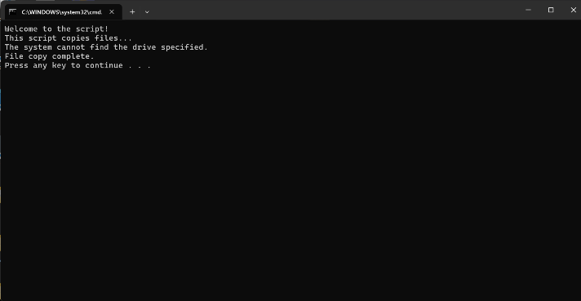

Use of Linux OS CLI commands

Command | Description
man | Displays the manual page for a command
cat | Concatenates and displays the contents of one or more files.
more | Displays the contents of a file one screen at a time
less | allows scrolling through the contents of a file with the up and down arrow keys
touch | creates a new empty file or updates the timestamp of an existing file
file | determines the type of a file based on its contents
find | Searches for files and directories based on various criteria
date | Displays or sets the current date and time
diff | Compares the contents of two files or directories and displays differences
wc | Displays the number of lines, words, and bytes in a file or the output of a command

Linux's powerful command-line interface (CLI) allows users to manage files, processes, and system features efficiently. One of the basic utilities is the man command, which displays the manual pages for every Linux program. These articles include syntax, parameters, and usage examples to help users understand and effectively implement commands. For instance, man ls shows detailed information on the ls command, while man -k search finds all commands related to a keyword.
File handling is made simpler with commands like cat, more, less, touch, and file. The cat command can display a file's contents and combine many files into one. While more and less allow paginated viewing for navigating large files, less offers sophisticated navigation and search capabilities. Touch creates new empty files or changes timestamps, but the file defines the type of file, which is essential for identifying unknown files.
File searches are made simpler by the find command. Recursive searches and complex criteria are supported, and files can be located by name, type, or size. The date command not only provides system date and time information, but it also allows formatting or time correction. Diff lets you highlight differences across files or folders while ignoring whitespace, case, and line endings. Finally, wc counts the lines, words, and bytes in files or command output for quick content analytics.
Together, these commands demonstrate the Linux CLI's versatility and efficiency, enabling users to automate tasks accurately, control system resources, and inspect files. Understanding these technologies is crucial for effective Linux administration and daily operations. [4]

Linux OS CLI commands:
Command | Description
Figure 1: PS AUX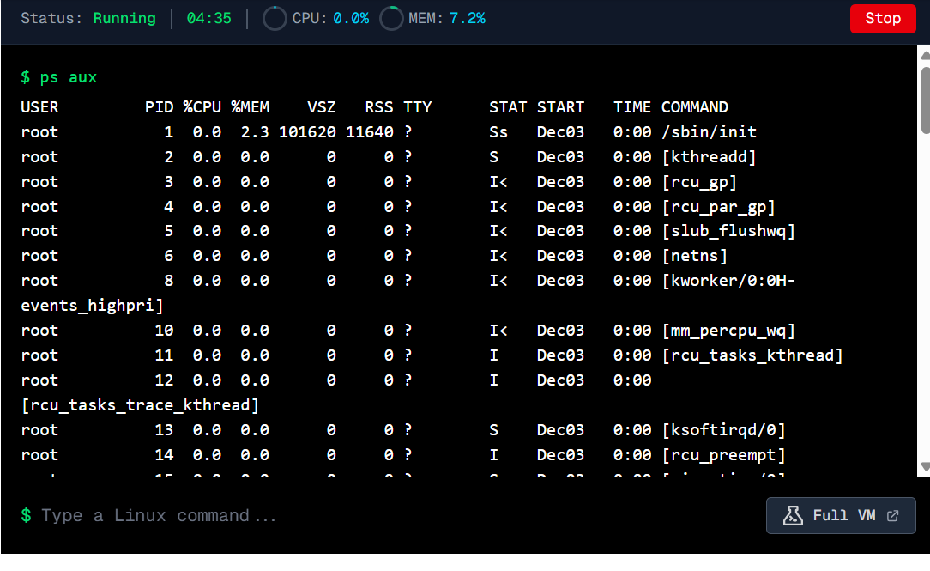 | With information like the process ID (PID), the owner of the process, CPU and memory use, start time, and the command that initiated each process, the PS AUX command enumerates all of the system's active processes.

Command | Description
Figure2: Date  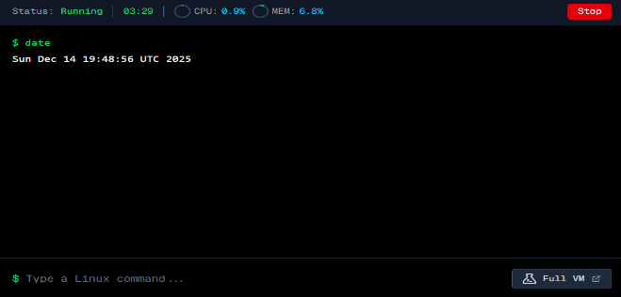 | The date command can be used to set or modify the current system date and time, in addition to displaying it in a legible fashion.

Command | Description
Figure 3: top n 1  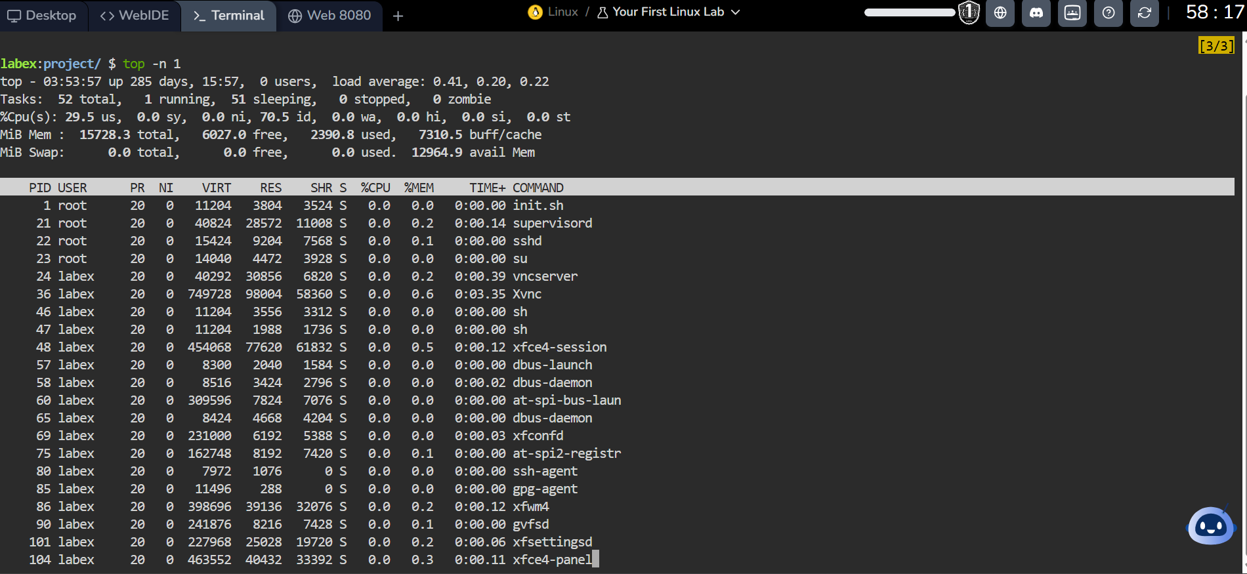 | A one-time, real-time snapshot of all active processes, including their CPU and memory consumption, process IDs, and other system resource details, can be obtained with the command top -n 1.

Command | Description
Figure 4: Clear  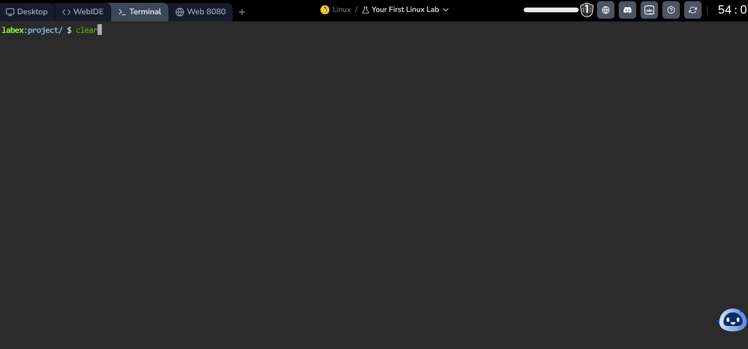 | The clear command creates a clean workspace without interfering with active processes by removing all prior text and output from the terminal screen.

Command | Description
Figure 5: Netstat -tulnp  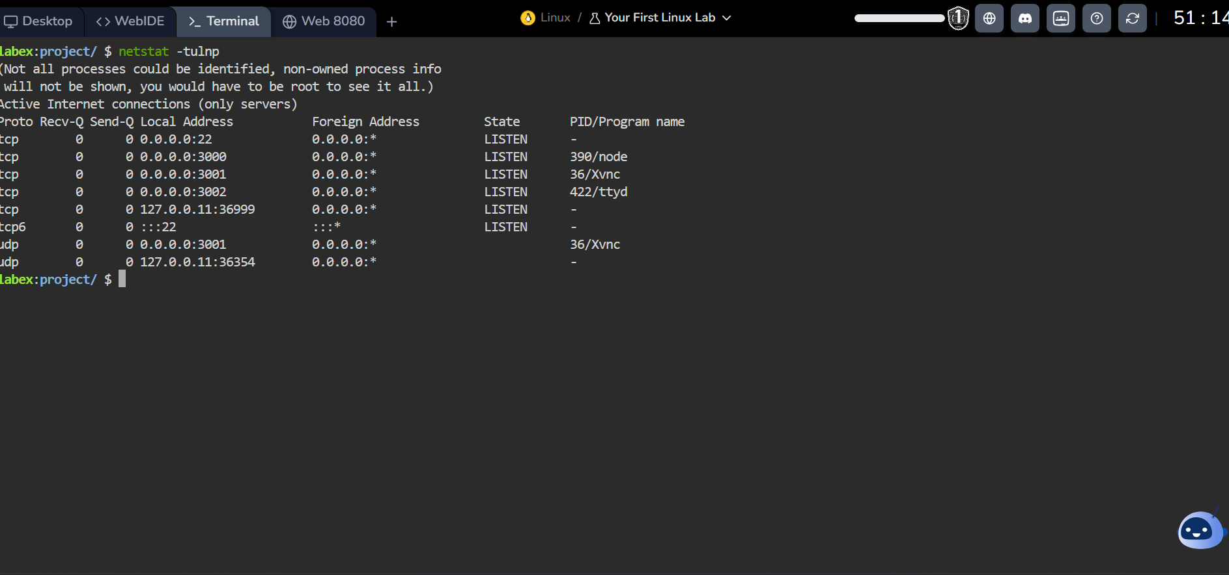 | The system's active TCP and UDP listening ports, together with the process IDs and application names that use them, are shown by the command netstat -tulnp.

Command | Description
Figure 6: Ping  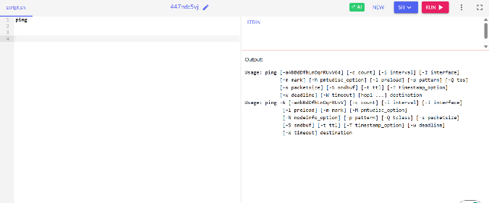 | By sending ICMP echo request packets to a target host and timing how long it takes to receive a response, the Linux ping program can be used to test network connectivity.

Command | Description
Figure 7: ss -tuln  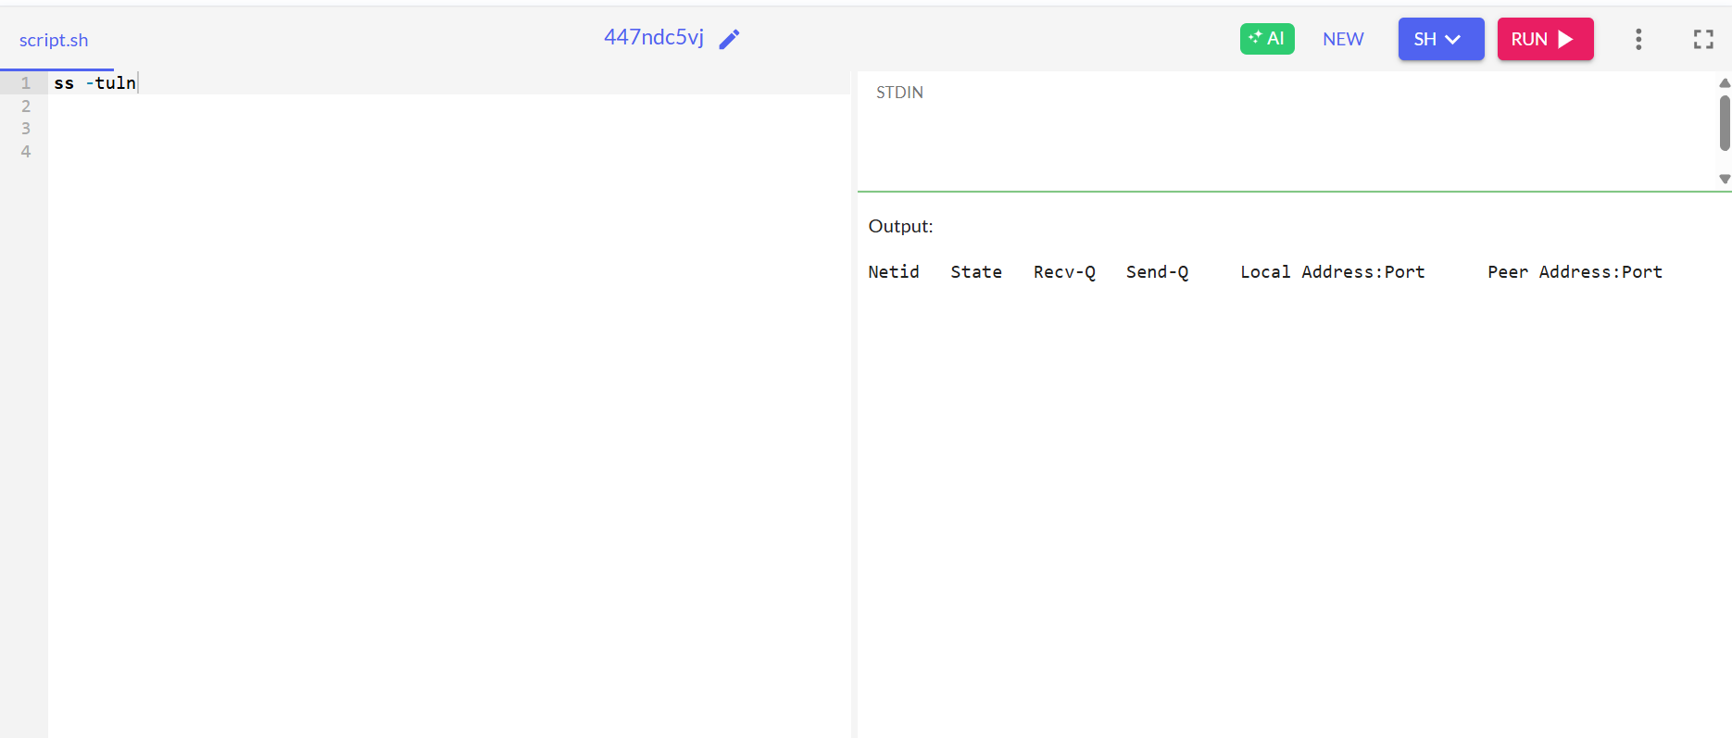 | Without resolving hostnames or service names, the ss -tuln command shows all TCP and UDP network ports that are open on the system.

Command | Description
Figure 8: kill -9 <PID>  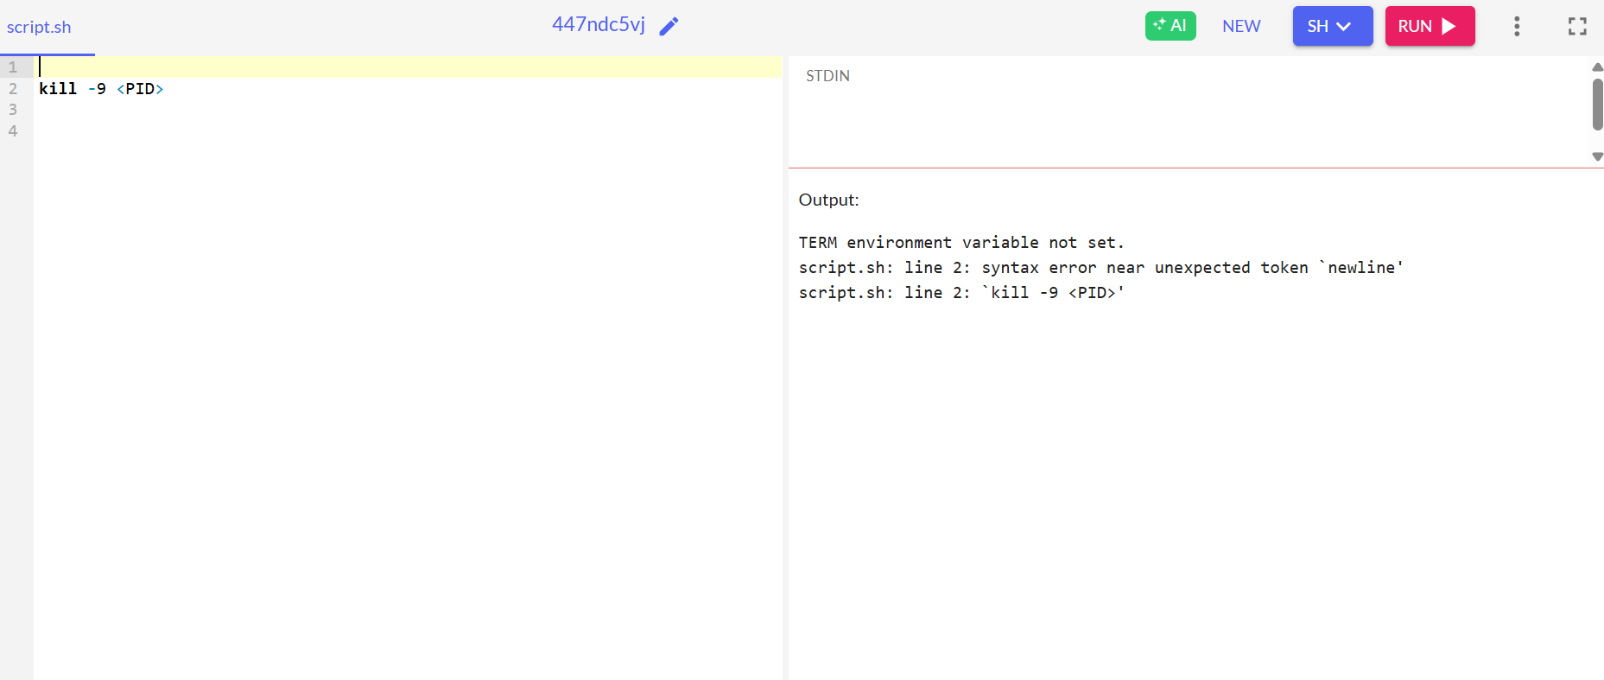 | By delivering the SIGKILL signal, the kill -9 <PID> command forcibly ends a process without letting it clean up.

Command | Description
Figure 9: uname -a  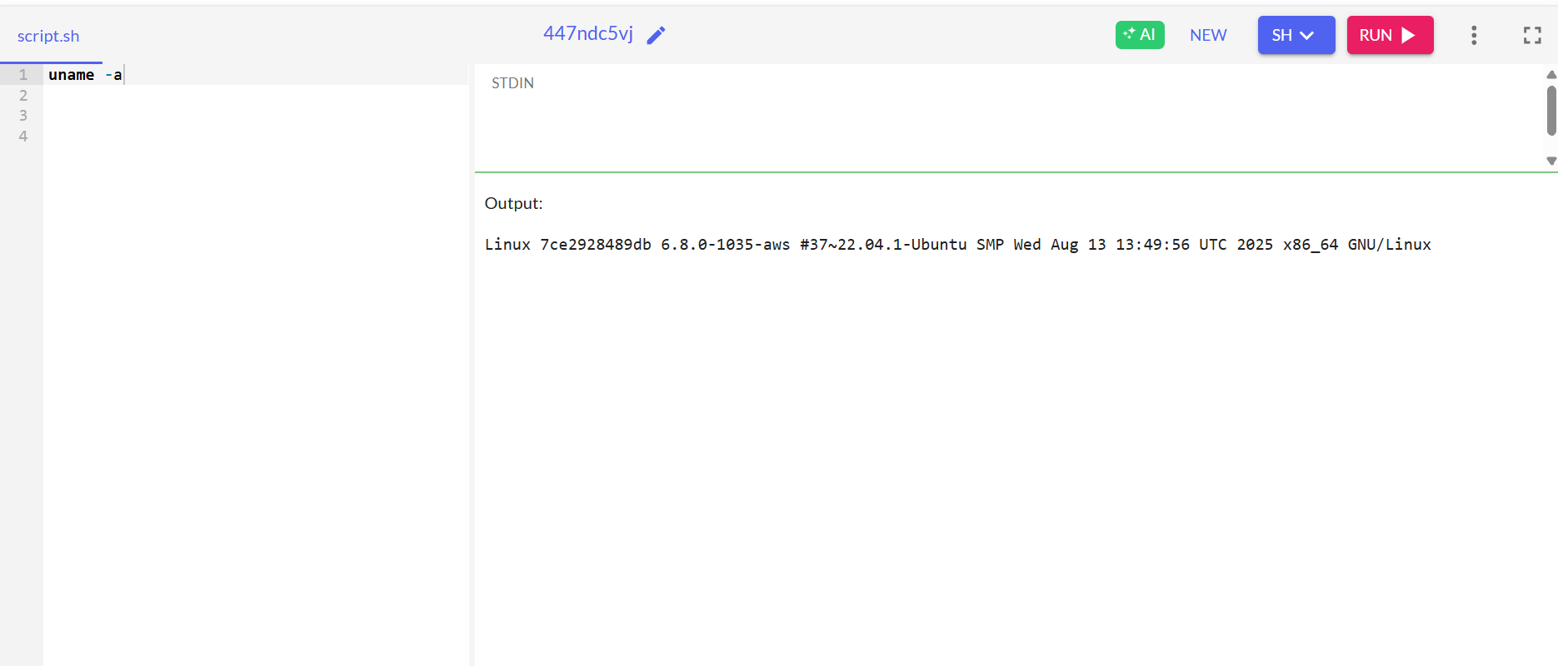 | The Linux kernel version, hostname, hardware architecture, and operating system specifics are all displayed by the uname -a command.

Command | Description
Figure 10: ls / find  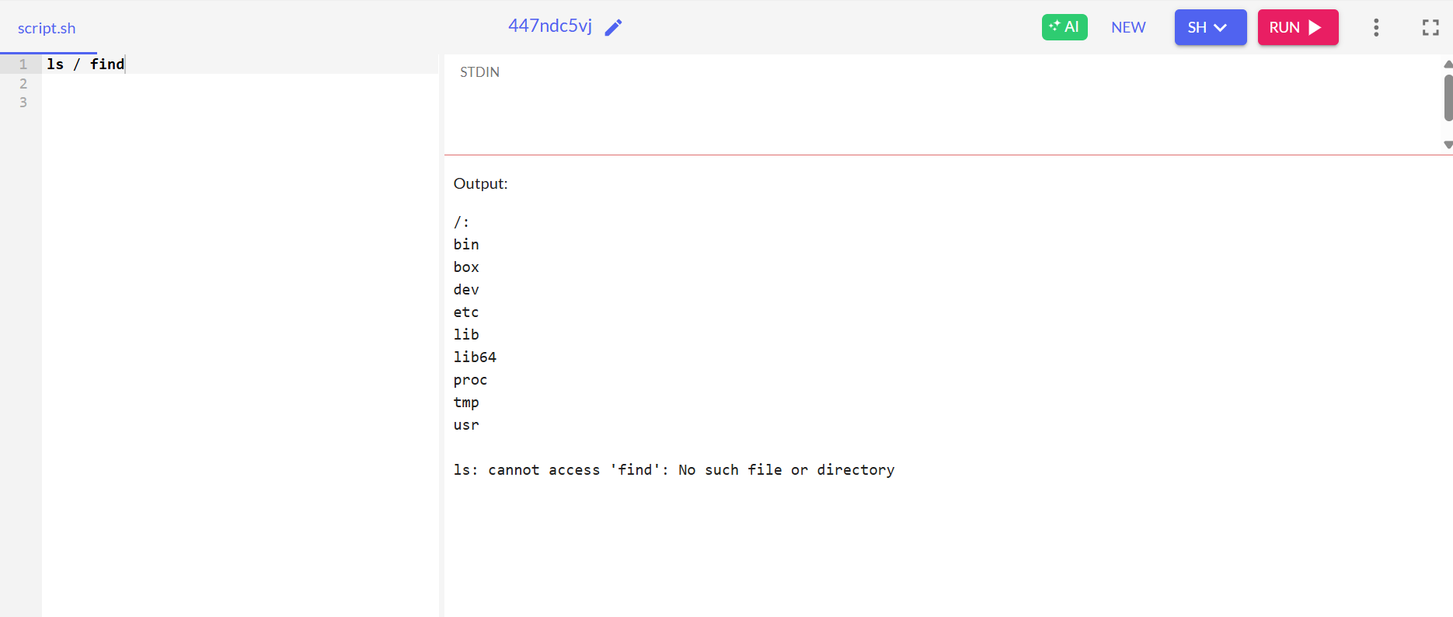 | While the find program looks for files and directories across directory trees using name, type, or other criteria, the ls command lists files and directories in a location.

Use of Linux OS scripts
In 1991, Linus Torvalds developed Linux, a Unix-like operating system. Because it is open source, it is highly configurable and freely available. Many Linux distributions, including Fedora, Ubuntu, Debian, and Kali Linux, have a GNU license that allows users to read, modify, and distribute the source code. One of the core components of Linux is the shell, which serves as an interface between the user and the operating system. By understanding instructions and running scripts, shells enable users to automate procedures and generate unique commands.
The two primary types of shells are graphical shells and command-line shells. Command-line shells provide a terminal for entering commands and are preferred by developers and scientists because of their speed and efficiency, whereas graphical shells provide windows and icons for interaction. The Bourne, C, Korn, Bash, Z, Tc, and Fish shells are just a few of the modern shells that have evolved from the original UNIX V6 shell. Each shell has unique features that are suitable for specific tasks, such as programming skills, user interface, security, and inter-process communication.
These shells can be compared by users to see which best meets their needs. Advanced users might prefer shells with powerful scripting and programming tools, whereas regular users might prioritise usability. Understanding shells and their characteristics is necessary to use Linux systems efficiently and adaptively. [5]

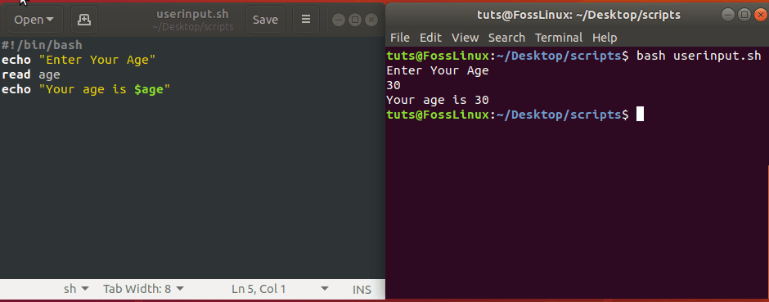
Figure1:

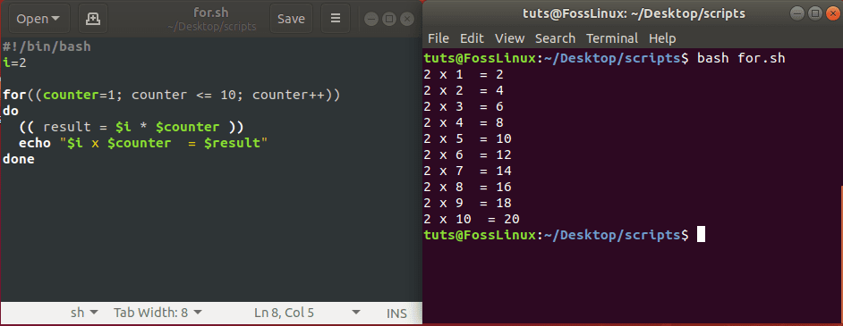
Figure2:

Conclusion
In conclusion, this study has demonstrated the critical role operating systems play in modern computing by managing hardware resources and providing a solid platform for application execution. Operating systems' basic features, such as process management, memory management, file systems, input/output control, and security, are essential for ensuring efficient, reliable, and user-friendly system performance. By comparing the Windows and Linux operating systems, the study has shown how different.
The examination of Windows scripting and command-line tools demonstrated how automating administrative and everyday tasks can boost productivity and system control. Similarly, the examination of shell scripting and Linux CLI commands showed the power, flexibility, and efficiency of text-based system control, particularly for system administrators and knowledgeable users. Linux's wide range of shells and open-source nature further increase its flexibility to meet different user needs.
The value of scripts and command-line interfaces in Windows and Linux highlights how important it is to understand operating systems outside of graphical user interfaces. Because it is necessary for effective system administration, troubleshooting, and automation in real-world computing contexts, operating system expertise is a basic prerequisite for IT and computing professionals.

References

[1] | W. Stallings, “THE WINDOWS OPERATING SYSTEM,” Prentice Hall Press, United States, 10 March 2011.
[2] | W. Stallings, “THE WINDOWS OPERATING PERATING SYSTEM,” Prentice Hall, 2008.
[3] | J. M. Torres, Windows Admin Scripting Little Black Book, United States of America : Steve Sayre, 2001.
[4] | M. Maleki, “Developers ultimate guide: Linux Bash scripting,” Seneca, 2022.
[5] | C. A. P. S. M. D. S. S. K. S. N. K. Abdullah Kidwai, “A comparative study on shells in Linux: A review,” ELSEVIER, p. 2613, 24 September 2020.

