

Developing Relationships and Workplace Achievements
Student Name:Andrei Amzulescu
Student Number:2124638

Table of Content

Introduction: 3
Project idea of Coca-Cola 3
Performance Management 3
PM cycle: 4
Planning- 4
Monitoring- 5
Reviewing- 5
Rewarding- 5
Critical evaluation: 6
360-degree feedback: 6
Management by objectives: 6
Individual Pay Related performance: 7
Personal Development Plan 8
Conclusion 10
Recommendations 10
References: 11

Introduction:
The main purpose of this assessment is to analyse the fruitfulness of a project of the company named Coca-Cola in an elaborate way. The key aspects of 360-degree feedback, Management by objectives, and Individual pay-related performance in terms of managing the attributes of the appraisal techniques and tools of all the employees and generalising the new project idea will be taken into consideration here. A proper definition of performance management and the effectiveness of its cycle will be generalised in this assessment also. At the end of the assessment, an aspect of the Professional Development Plan will be carried forward by fostering SMART objectives related to the project idea that is going to be fostered effectively in this assessment.

Project idea of Coca-Cola
Coca-Cola Europacific Partners (CCEP) fostered a 31 million pound investment in terms of boosting the facility of manufacturing in Wakefield, UK. With the help of technological advancement and the attributes of creativity, the company will be able to manufacture around 2000 cans every minute. The attributes of the new project are going to start in 2024. The capabilities of existing production of CCEP in terms of generalising the 330ml cans will be utterly benefited with the help of this project idea. On the other hand, the canning line is going to feature several technological advancements to mitigate the perspectives of consumption of water, energy, as well as carbon dioxide. The savings of energy as well as water can be put forward from the aspects of dry lubrication on the side of conveyors with the help of air rinsing facilities. The function of auto-sleep on the motors will also create a positive effect to reduce energy consumption effectively. The correlation of technological advancement as well as the justification of the investment scenario act like a touchstone of success for the upliftment of the company's new project. For that reason, the company can be able to manage a higher quality of products and boost the canning line properly (Cooke, 2023).

Performance Management
Performance Management can be defined as a continuous and ongoing process of clarification and communication of the responsibilities of the job, performance expectations, and priorities. It also fosters the aspects of development and planning to carry forward the individual scenario of employability skills. Performance Management is interrelated with the strategic goals of the organisations. The HR management of the companies helps to carry forward the performance of the employees in a fruitful way. They foster the aspect of initial meetings with all the employees, provide quarterly sessions of feedback, and arrange final meetings for evaluating the aspects of review efficiently. In this way, performance management can be redefined properly (Humanresources, 2023). The organisation behaviour theory of HRM rightfully delineates the key attributes of natural fundamentalism of positivity in a workplace. The working environment of the organisations and the key attributes of performance management can be fostered effectively with the help of theoretical instances. For that reason, HR management can be able to redefine performance management fruitfully. The fact can not be denied that the cultural aspects of the organisations and the increasing number of potential aspects of the employees are correlated with each other. For that reason, the organisation behaviour theory of HRM creates one of the most robust impacts of positivity in the entire workplace by communicating properly with all the employees (Shanaz, 2020).

PM cycle:
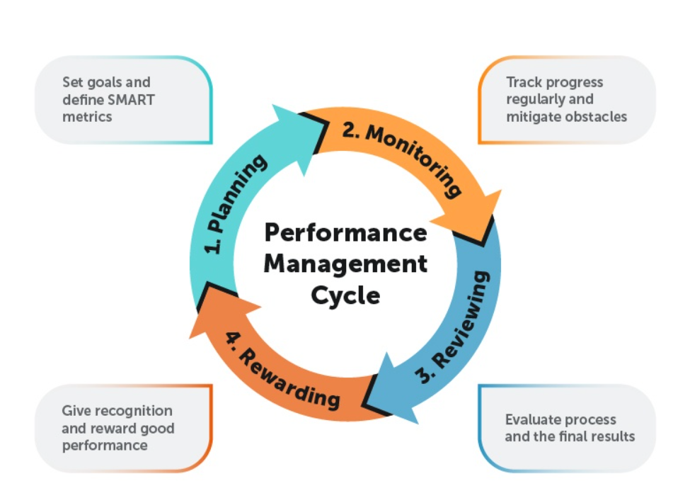
Performance Management Cycle
(Source- Andreev, 2023)
The performance management cycle is redefined as the model of management that assists all organisations in reaching the desired level of success through an organised process. The employees and the entire team of management can be able to foster the goals of organisations with the help of such a development process. It is defined as a part of the aspects of performance management strategy that delineates a four-step aspect of procedures such as planning, monitoring, the aspects of reviewing, and rewarding.

Planning-
Planning is an utterly important objective to carry forward the demands of success for any company. It is termed as a groundwork for generalising the rate of success fruitfully. The strategic development of business is involved in it. The SMART method is an utterly uplifting scenario for the planning process. All the different credentials such as Specific, Measurable, Attainable, Relevant, and Time-bound are correlated with the planning process. There is no doubt it acts as a touchstone of success for the upliftment of success of any company (Andreev, 2023). The managers of Coca-Cola also need to carry forward proper planning for the advancement of the new project efficiently.

Monitoring-
After the planning, the aspects of monitoring become inevitable to carry out the business demands as well as uplifting the performance management model efficiently. The HR managers try their level best to monitor the progress of the employees by communicating with them. If the employees can not be able to find the realm of positivity in the workplace, proper and suave communication can be utterly beneficial for reducing such gaps effectively (Andreev, 2023). A Motivation Theory of HR management is very useful in such a scenario where the employees can not be able to manage their credentials in the company. With the help of the theoretical views, the HR managers can motivate the employees and help them to become more successful properly. With the help of such theoretical stances, the managers of Coca-Cola can also be able to scatter a sense of positivity among all the employees to evaluate the rate of success (Shanaz, 2020).

Reviewing-
It is termed the third stage of the PM cycle. A proper evaluation of the employee's credentials can be generalised effectively when the review of the management can be defined well. With the help of a review system, the employers and the managers can be able to get the potential of all the employees and they can also help the relatively weak employees to get a sense of robustness from the workplace (Andreev, 2023). AMO theory of HRM i.e. Ability, Motivation, and Opportunity in terms of rendering the aspects of participation can be utterly effective to foster the review system properly. With the help of the theoretical view, the HR management of Coca-Cola can review the development of the employees and they can also be able to scatter a sense of positivity among all the employees to achieve the new project in the cliff of achievement (Shanaz, 2020).

Rewarding-
It is the last step of the cycle. After a successful elaboration of the above three steps, the managers provide rewards to the employees for generalising an aspect of success in the business sphere. With the help of such positivity, the employees can be able to stay connected with the business sphere and they can also foster influence in the work prosperously (Andreev, 2023). The Institutional Theory of HRM can be juxtaposed with this view. With the help of a proper reward system, the HR managers can be able to carry out the values of success in the entire institution and the employees can be influenced too. The managers and the leaders of Coca-Cola can also foster a reward system by focusing on the Institutional theory to attract workers in the business sphere and increase the rate of success for the project effectively (Shanaz, 2020).

Critical evaluation:

360-degree feedback:
This method helps to evaluate the performance of the employees and find out their effectiveness of work by analysing and supervising their operational process. In this stream, organisations are provided with resources about the operational process of the employees and help to reflect the strengths and weaknesses of the employees. This feedback model shows which of the operational parts of the business are weak and can be developed by increasing the effectiveness of their employees (Fleenor, et al. 2020).
Advantages:
- 360-degree feedback helps to provide a detailed analysis of the performance of the employees. For that, the business can understand which of their employees perform well and which are not (Qualtrics, 2023).
- It helps to evaluate the weak parts of the employees. For that, the business can make the necessary decision about developing the skills of the employees that can help to improve their productivity (Qualtrics, 2023).
Disadvantages:
- The process of the 360-degree review is complex. For that, if the process of feedback is not contained in a proper way then it can be the case of the wrong section of the organisation (Qualtrics, 2023).
- The process of 360-degree feedback takes too much time to analyse the skills of the employees and their performance. For that, the operational works of the business are going to be delayed (Qualtrics, 2023).
Effectiveness in Coca-cola:
- This approach can help Coca-Cola to support the cultural changes in the process of their employment. For that, the business can recognise which of their employees needs to be provided extra benefits to increase their level of motivation (Nystrom, 2019).
- It can help Coca-Cola to supervise their operational process properly and settle the issues of their employee as fast as possible. For that, they can improve their manufacturing capability (Nystrom, 2019).
- This technique is appropriate for Coca-Cola as it helps them to analyse overall skills and their performance in their operational process. To increase the effectiveness of their leaders this technique needs to be improved in Coca-Cola (Nystrom, 2019).

Management by objectives:
Management by objective is an effective objective to analyse the performance of the employees. In this process of analysis, businesses are provided targets or goals. The ability to achieve the targets of the employees helps to reflect their performance and effectiveness. By achieving the individual targets of the employees businesses can achieve their long-term and short-term goals which simplifies the growth of the business (Alkharabsheh, 2022).
Advantage:
- The structure of the MBO can help to improve the structure and communicational process of the organisations. For that, it can help to strengthen the commitments of the employees (Indeed, 2023).
- In the process of the MBO, the employees are able to make their decisions individually. For that the organisations can get more effective leadership and critical skills in the process of improving their operating process (Indeed, 2023).
Disadvantages:
- One of the biggest disadvantages of this method is the lack of employee training. For the lack of training, employees are rather unmotivated and the retention rate of the organisations is going to be poor (Indeed, 2023).
- This process of the MBO is too expensive for the organisation. In this process the needs to be maintained a long chain of management. For that, they need to spend more in the process of achieving the individual and overall goals of the organisation (Indeed, 2023).
Effectiveness in Coca-Cola:
- MBO can help the COCA-Cola to improve its process of decision-making. For that, the business can settle its operational disputes faster and achieve its productional goals faster (Scribd, 2023).
- It can help to provide a sense of direction to the employees of Coca-Cola. For that, they can make their individual decisions and increase their effectiveness to achieve their organisational goals and earn more benefits from the organisation (Scribd, 2023).
- MBO is an appropriate technique for Coca-Cola as it helps to increase their employee's sense in the process production which can increase their customer's satisfaction rate (Scribd, 2023).
- Coca-Cola needs to improve this technique to serve more effective targets for their employees. For that, we achieved the manufacturing goal of 2000 units of cans per minute (Scribd, 2023).

Individual Pay Related performance:
IPRP is an effective technique related to the payments of employees. In this technique, employees are paid as per performance. For that, the increasing numbers of the effectiveness of the employees and the improvement of performance can increase the benefits of the employees in the process of their operations. By using these payment systems businesses want to maintain the effectiveness of their employees and attract their attention to their overpayments for overworking (Touma, 2022).
Advantage:
- It can help to boost the motivation of the employees. For that, organisations can receive more focused and moral employees in the process of their operations (Indeed, 2022).
- It can help to increase the loyalty of the employees. With the increasing number of employees loyalty, the business can receive more experience and skills to improve their productivity (Indeed, 2022).
Disadvantages:
- It can increase the stress level of the employees as the payments of the employees are going to be depending on their performance (Indeed, 2022).
- In this process, the organisation is focused on serving individual goals to their employees. For that, the collaborative environments of the business are going to collapse (Indeed, 2022).
Effectiveness in Coca-cola:
- For this payment technique, Coca-Cola can receive more motivated employees which can help the business in the manufacturing capability and produce more cans in a short time.
- It helps the employees be effective of benefits as per their ability and skills. It helps them to stay motivated and reflects more engagement in their operational work.
- This payment technique is appropriate for Coca-Cola as it can help the business to increase its employee engagement and achieve its productional goals.
- This method of Coca-Cola needs to be improved to maintain the ethics and values of the organisation during the time of achieving the goals of the employees for their extra payments (Coca-Cola, 2022).

Personal Development Plan
Development Objectives | Priority | Activities to be undertaken | Resources | Target Start Date | Target End Date | Criteria for Success
Foster team working spirit in Coca-Cola to manage the workload of the new project | It is very important. | Carry forward a positive approach to the work, and help all the employees to foster their views. | Democratic approach, empathy of all the managers. | 26th December 2023. | 26th July, 2024. | By looking into the attributes of all the employees, By evaluating the rate of potential of the employees. The managers will check this.
Generalise the effectiveness of time management of the employees | Important | Encourage the employees to finish the work on time, and set up a proper working environment. | Proper communication, and delineation of effective schedule. | 20th December, 2023. | 20th August 2024. | The managers will check the progress by fostering the attributes of time among all the employees, by looking into the deadlines of the projects.
Render the aspects of communication | Very important | Providing encouraging speech, looking into the obstacles of the employees. | Professional attributes from the speakers, attaining effective seminars and workshops. | 18th December, 2023. | 18th November, 2024. | The managers will look into the progress by making proper communication with the employees.
Focusing on adaptability | Important | Help the employees sort out their problems and create a positive working culture. | The attribute of the HR managers is a proper reward system. | 22nd December, 2023. | 22nd October, 2024. | By focusing on the canning system, and the tech-savviness of the employees. The managers will look into this.
Enriching creativity skills | Important | Encourage the employees to solve problems with their dignified manners, Help them to be involved in the decision-making process. | Benevolence, and empathy of all the managers. | 28th December, 2023. | 28th September, 2024. | The HR managers will focus on indulging the employees in creative works and making sustainable canning perspectives in the working environment.

Conclusion
The assessment focused on a new project plan for Coca-Cola. The attributes of performance management and evaluation of the different vehicles had also been effectively taken into consideration here. After that, the assessment delineated a Professional Development Plan for the upliftment of project success for Coca-Cola.

Recommendations
- The managers of Coca-Cola need to follow a Democratic approach to leadership in the working environment. They should focus on the needs of the employees to delineate the project at a zenith of success (Beerbohm, 2015).
- The managers of the company also need to follow Maslow’s Hierarchy of needs theory to motivate all the employees. They should personally communicate with all the employees and try to scatter a sense of positivity among all of them (Rojas et al. 2023).

References:
Alkharabsheh, S.A.I., (2022). The Role of Human Resource Management in Improving Employee Performance According to Management by Objectives in Zain Telecom Group in Jordan. International Journal of Mechanical Engineering, 7(1), pp.1734-1740. Available at: https://kalaharijournals.com/resources/201-220/IJME_Vol7.1_214.pdf
Andreev, I. (2023) What is the performance management cycle? it’s model and stages, Valamis. Available at: https://www.valamis.com/hub/performance-management-cycle (Accessed: 02 January 2024).
Beerbohm, E., (2015). Is democratic leadership possible?. American Political Science Review, 109(4), pp.639-652. https://www.cambridge.org/core/journals/american-political-science-review/article/abs/is-democratic-leadership-possible/3ACF43843588374E21C00363D53280A8
Coca-Cola (2022) The Coca-Cola Company and Human Rights. Available at: https://www.coca-colacompany.com/content/dam/company/us/en/policies/pdf/human-workplace-rights/human-rights-principles/tccc-human-rights-brochure-employees-english.pdf (Accessed: 02 January 2024).
Cooke, E. (2023) Coca-Cola EUROPACIFIC Partners invests in UK manufacturing site, Just Drinks. Available at: https://www.just-drinks.com/news/signal-coca-cola-europacific-partners-invests-in-uk-manufacturing-site/?cf-view (Accessed: 02 January 2024).
Fleenor, J.W., Taylor, S. and Chappelow, C., (2020). Leveraging the impact of 360-degree feedback. Berrett-Koehler Publishers. Available at: https://books.google.co.com/books?hl=en&lr=&id=-SvJDwAAQBAJ&oi=fnd&pg=PP1&dq=360-degree+feedback&ots=llCU-A9-p5&sig=bShVVpWJmNKs2gfI-dm6wedSNZo&redir_esc=y#v=onepage&q=360-degree%20feedback&f=false
Humanresources, (2023). Performance management (no date) Human Resource Management. Available at: https://humanresources.ku.edu/performance-management#:~:text=What%20is%20Performance%20Management%3F,aligns%20with%20organizational%20strategic%20goals. (Accessed: 02 January 2024).
Indeed (2022) Pros and cons of the pay-for-performance model | indeed.com. Available at: https://www.indeed.com/career-advice/pay-salary/pros-and-cons-of-pay-for-performance (Accessed: 02 January 2024).
Indeed (2023) Management by objectives: Advantages and disadvantages. Available at: https://www.indeed.com/career-advice/career-development/management-by-objectives-advantages-and-disadvantages (Accessed: 02 January 2024).
Nystrom, D.C., (2019). 360-degree feedback: a powerful tool for leadership development and performance appraisal (Doctoral dissertation). Available at: https://core.ac.uk/download/pdf/36704205.pdf
Qualtrics (2023) Advantages and disadvantages of 360 feedback, Qualtrics. Available at: https://www.qualtrics.com/au/experience-management/employee/360-feedback-advantages/ (Accessed: 02 January 2024).
Rojas, M., Méndez, A. and Watkins-Fassler, K., (2023). The hierarchy of needs empirical examination of Maslow’s theory and lessons for development. World Development, 165, p.106185. https://www.sciencedirect.com/science/article/abs/pii/S0305750X23000037
Scribd (2023) Management by objectives at Coca-Cola, Scribd. Available at: https://www.scribd.com/document/465217418/management-by-objectives-at-coca-cola (Accessed: 02 January 2024).
Shanaz, T., (2020). The Underpinning Theories of Human Resource Management. University of Kurdistan, Hewler. ID, pp.02-19. https://www.researchgate.net/publication/340620672_The_Underpinning_Theories_of_Human_Resource_Management_Course_Advance_Human_Resource_Management_Prepared_by
Touma, J., (2022). Performance Appraisal Effect on Compensation. Journal of Human Resource and Sustainability Studies, 10(1), pp.1-12. Available at: https://www.scirp.org/journal/paperinformation?paperid=115424

