

BMSW4002: Effective Team Work and Communication
Anita Nan
Mohammed Shafi Mohammed Yar 2010170

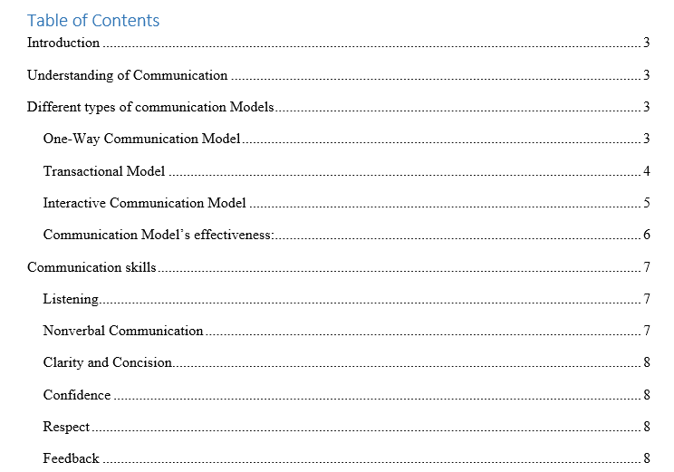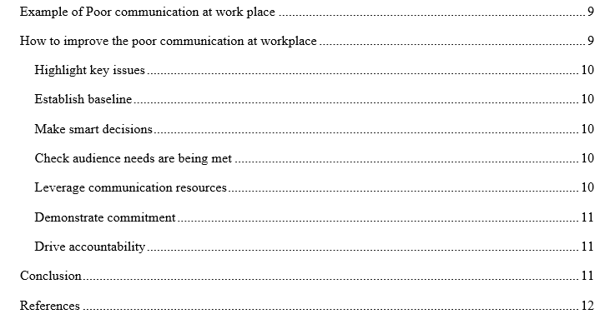

Introduction
Communication has now become significant. Human activity will come to a stop if there is no transmission. Very single human contact is only available by communicating. It is by large the lifeblood of every business organization. In contemporary trendy globalized advertise market, communicating effectively is beneficial to the survival and sustainability of every company. Building a team and supporting positive communication within the team are two separate tasks. Similarly, operating as a team manager is an entirely different situation (Nosek, 2013). He or she will encourages smoother advancement toward the mission and facilitates the team in overcoming the challenges. This report is based on the importance of communication within any organization, some theories and models of effective communication in workplace. This report also focused on how poor communication can effect organizational activities and how to improve this types of problems.

One of the really vital issues in the workplace is communication. Successful organizational organizations are characterized as the planning and improvement of a positive working environment. Communication is undoubtedly important in an organization. Besides this, strengthening corporate connectivity has developed as one of the most essential business requirements in 2020, and this trend is projected to continue (Baer, 2014). When an information is received and answered correctly, it is known to be accurate contact. Only because individual can conclude people are expressing thoughts and knowledge effectively in organization does not suggest it is.

Different organization follows different types of models for effective communication within the organization. Some models that commonly used for effective communication at workplace are described below: there are 3 model of communications verbal, non-verbal, textual. the most common model of communications is linear and interactional and transactional, as West and Turner (2007) each model sheds light on the development of communication but emphasise different parts of the communication process. Models of communications are conceptual models used to explain the human communication process, the first major model for communication was developed in 1948 by Claude Shannon and published with an introduction by Warren Weaver in Labs for Bell laboratories. Following the basic concept communication is the process of sending and receiving messages or transferring information from one part(sender) to another ( receiver)
Shannon Weaver model
Claude Channon and Weaver were engineers, who worked for Bell telephone laboratories in United States. Their goal was to ensure that telephone cables and radio waves worked at maximum efficiency, therefore they develop the Shannon Weaver model which expanded a mathematical theory of communication the Shannon Weaver model was developed in 1949 is referred to as the mother of all models.

It is sometimes related to as the linear model of communication since this took place in a straight line from sender to receiver that attempts to advise, reassure, or instruct (Swan, 2018). Understanding is only communicated from one point to another or to several points at about the same time in that same form of communication. There is no information transmitting from the receiving end. The receiver is passive in that same situation.
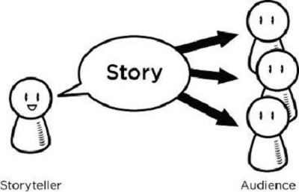
Figure: One-Way Communication Model
Sources: (Ford, 2009)
At media interviews and through television and radio broadcasting, one-way communications is sometimes used in order to communicate in current information also including weather information, information about upcoming disasters, services, and general observations (McCoy, 2017). The precise details and strength of ocean temperatures are transmitted or exchanged through one-way communication.

Transactional Model
The transactional model of communication leads to the interchange of messages or information between some of the sender and the recipient, in which everybody sends or receives messages in response. While all our ordinary communications are occurrences of transactional model communication, this model is a common way to communicate.
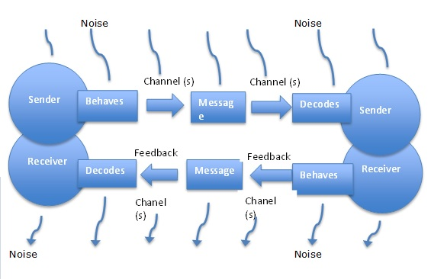
Figure: Transactional Model
Source: (Woods, 2010)
So if participants come with specific areas, know each other, or have the same political hierarchy, the transactional framework becomes more efficient and reliable (Horowitz, 2012). Each person responds differently on the basis on their context, experience, behavior, cultural norms, and self-esteem.

The convergence model is also another name for the interactive communication model. Per this model, the transmission of suggestions and messages operates in both forms, from source node to destination node and vice versa (Kislik, 2012). Information is transmitted between humans or systems in both verbal and nonverbal aspects. The sender sends a message to the target audience, who then becomes the sender and sends a clear message to main sender.
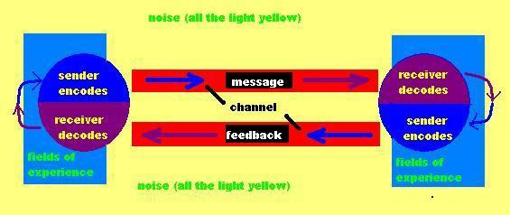
Figure: Interactive Communication Model
Source: (Nosek, 2013)
This model highlight reviews, demonstrating that dialogue is a two-way process rather than a one-way. Instead of transmitting information one direction, from sender to recipient, all participants sent information back and forth (Baer, 2014). Wilbur Schramm, a correspondence expert, advised that both the sender and the recipient view the message rather than adequately interpreting its significance. However, although this method is most often used either by Internet, communication is not generally simultaneous and also can take a little time.

Communication models are indeed the actual consequences of extensive research exploring numerous areas of communication (Swan, 2018). A relationship paradigm gives a systematic explanation of a system or structure, enabling the user to consider relevant considerations or configurations. Some effectiveness of communication models or organization are described below:
- Communication models succeed in determining and attempting to understand the characteristics and interactions of the communications protocol under concern.
- This types of Models reflect current opportunities for the organization on different forms of communication, aiding those in designing an effective communication system. They behave as a stimulant for contact researchers and students.
- Models are pictorial descriptions of the reforming process.
- Models of communication also forecast whether future communications will be more efficient or not. This models indeed forecast the achievement or failure with a certain communications method.
- This models allow firms in the description of phenomena by reporting the facts in a condensed manner that otherwise would be challenging or unclear.
- Organizations using communication models can analyze tough difficulties and deter them from occurring in the first place.

Communication skills
In every workplace, the opportunity to communicate comfortably with managers, colleagues, and employees is necessary. Workers of the present era would have to be able to communicate easily and receive messages in particular, such as over the internet, email, and social media (Ford, 2009). These communication can help individual to get promoted, and succeed in their career, as well as be competitive. Some communication skills that need to obtain by every employees and management has been discussed below:

Listening
Becoming a great listener is one of most great way to communicate with people. No one prefers trying to communicate with someone who has merely successful in providing him or her two cents that does not have the opportunity to listen to one of the other person. It would also be complicated to remember what someone are being expected to do because they are not a good listener. Devote considerable time practicing proactive listening (McCoy, 2017). Paying special attention with what the other person has been doing, asking questions for clarification, and paraphrasing what either says to support implementation are all good indications for listening to others at work place. Active listening helps individual to better appreciate what the other individual is thinking and adjust appropriately.

Nonverbal Communication
Nonverbal communication is body posture, eye contact, hand motions, and tone of voice of person. All this sign connect to the message that individual is attempting to communicate with other. Eye contact is also important while people are communicating with others; sometime individual need to look the people in the eyes to display that they are paying close attention to them and the interaction (Woods, 2010). Sometimes, when someone communicating, they need to pay attention to nonverbal signs of others. Nonverbal cues often articulate how a person is really feeling.

Clarity and Concision
Saying just about enough is the essential to good effective interactions in workplace; don't communicate too long or too little (Horowitz, 2012). Use that as few things as possible to express the message. Say thing that is more specifically and clearly, whether in person, upon this phone, or by email. If anyone keep on coming, the listeners will either tunes out or be confused of what they want.

Confidence
It is important to be confident about the connections with others. Trust demonstrates to coworkers that individual is believes in what they are saying and decide to carry through (Kislik, 2012). Holding eye contact or communicating in a strong yet polite tone will help person to exemplify confidence. Make sure the reaction don't appear like questions. Of course, people need to avoid becoming rude or insulting at workplace.

Respect
People would have been more capable of communicating with someone at workplace if they could show them that he or she do value them and their proposals (Nosek, 2013). Small moments such as using a person's name, making eye contact, and going to listen their spaces would make them understand respected. Also it is important to ignore distractions when on the phone and concentrate solely on the conversation.

Feedback
A deeply curious capacity is the ability to give and receive capital to expand. Managers and administration of that particular organization should be on the open for ways reasons to discuss positive input to staff, whether it be by correspondence, phone calls, or periodic implementation plans (Baer, 2014). Similarly, other party should also be willing to contemplate and even welcome other people's comments. Listen to the suggestions that received, ask clarifying questions if individual are puzzled about something like a problem, and make an attempt to incorporate the feedback towards effect.
When there is an inconsistency in what someone is said and what other is heard, is known as a poor communication emerges at workplace. In other words, the person to whom someone are speaking misinterprets what other are saying to them (Swan, 2018). There are many organization faced many problem because of poor communication practice within the organization.
One of my friend work at Nike as a sales officer, and from him I come to know that Nike face many business communication failure because of the poor communication culture within the organization. One of its popular case is, Nike has been among the greatest brands in the sneaker field since 1971, when another Swoosh logo was formally launched (Ford, 2009). Nike has solidified its position as its apparel industry's champion, featuring sponsorships some of the most areas usually in sports, which has a net profit of $36 billion. Despite these challenges, despite its reputation as one of the world’s most valuable clothing brands, Nike are seeing a few crisis management setbacks that precluded thorough repair.
In 2018, one of the female employee of Nike spoke out against the male-dominated system that fostered sexual abuse and sexism within the organization. It opened with an opinion survey of the company's Beaverton, Oregon headquarters by a group of women about their experiences. Then the findings had been sent to CEO Mark Parker (McCoy, 2017). In this case major communication complication that Nike face at that moment are, It took a disgruntled survey carried out by a number of subordinates to expose this hostile culture. A lack of confidence in HR of Nike, A representative who says he was ignorant of the subject Bottom-up coordination processes that are inefficient.
Then Nike took dramatic measures to address these problems, including the elimination of C-Suite employees, including the face of diversity and inclusion, the development of mandatory management training, a contribution to a more inclusive society, and an improvement of their HR practices and internal monitoring devices.
Poor communication management in Nike can be improve by doing below described issues:

Highlight key issues
Nike may maintain existing practices and the level of communications malfunctions, highlighting the problem like employee harassments that need to be addressed (Woods, 2010). Advanced statistics encourage one in identifying when to begin in way to produce the most effect or maximize a given result. This enables Nike to focus on the important opportunities for improvement, whether it's a formally recognized like timeliness or completeness, or an opportunity.

Establish baseline
If organization like Nile who are passionate about good communication, then company culture will consider a benchmark on which to evaluate development and performance, which will benefit from a preliminary evaluation of problem areas (Horowitz, 2012). This benchmark of organization will serves as the framework for comparing research efforts, helping Nike to see what is going well and where organization can make improvements for the future.

Make smart decisions
Many top members demand evidence to support communications recommendations. Evaluation will demonstrate the statistics behind employee’s activities, track improvement, and assist leadership in identifying where and when to make good decisions that can potentially help organization to meet company's market and communications goals.

Communication measurement of Nike should decide whether employees have obtained and appreciated key messages that employees intend to send, as well as whether the platforms using are active at delivering those key messages (Kislik, 2012). The findings will help organization to modify and focus future messages, while also reassuring staff that Nike care enough to listen to – and focus on their input.
Through all the right data, organization like Nike can dig down to see just how connectivity is functioning in various countries, departments, roles, or even at the level of the organization, and use the findings to even further manage communication capabilities (Nosek, 2013) . Perhaps better, Nike can halt what isn't performing and reallocate save the capital.

Demonstrate commitment
If organization like Nike are worried about changing relations, the act of measuring is a sign of improvement that workers can recognize (Baer, 2014). However, be wary of monitoring without resolving to action in order to remain effective in promoting improvement, organization would have to do more about the evidence showing improvement.

Drive accountability
The bottom line is that after all this reported gets done. If administrators and management of Nike became aware that their advertising strategies will be assessed, they will continue to start paying more attention to where or how they approach people.

Conclusion
In conclusion, communication is a fundamental dimension of the area of employment conducted in large company associations, but employees with greater report communication skills are in fierce competition. It extends amongst all aspects of the economy, including organizational, specialized, managerial, and effect on consumer behavior (Swan, 2018). Company contingency is the collaboration practiced by a partnership association with the intention of delivering desired outcomes. Really, corporate communications is a unique type of conversation that aims to meet the requirements of the industry. Innovative control objectives such as teamwork, insight, and representation rotate around interactions.

References
Ibrahim, M.M., El-Khedr, S.M. and Nosek, L.J. (2013) ‘Effective communication and job satisfaction among staff nurses working in pediatric intensive care units’.
Baer, D. (2014) ‘17 tactics for reading people’s body language’, Entrepreneur [Online].
Morrissy-Swan, T. (2018) ‘What your handshake says about you’, The Telegraph. Available at https://www.telegraph.co.uk/ men/ the-filter/ handshake-says
Ford, J.D. and Ford, L. (2009) ‘The Four Conversations: daily communication that gets results’, Berret-Koehler, CA, USA
McCoy, J. (2017) ‘A handy dandy guide on how to write social media posts: best practices, length and more.’
Woods, D. (2010) ‘Poor communication between managers and employees wastes time and impacts productivity’,
Horowitz, S. (2012) ‘The science and art of listening’, New York Times
Kislik, L. (2012) ‘Techniques that will help you speak truth to power’, Kislik Associates blogpost
McCoy, J. (2017) ‘A handy dandy guide on how to write social media posts: best practices, length and more’ Express Writers

