

GLOBAL MARKETING STRATEGY
M3X9086

TOMOS WATKIN BREWERY

1900066 | Theresa Loo Xuan Fei

Table of Content

Introduction

- Identify key market worth entering and recommended priority country/countries to establish contacts within.
  - Internal Analysis
    - Introduction of Company
    - Product Categories and Characteristics
    - Strength and Weaknesses
  - Macro Environment
    - PEST Analysis of Czech
    - PEST Analysis of Germany
    - PEST Analysis of USA
  - Micro Environment
    - Porter 5 Forces
    - Competitors Analysis
  - Socio-cultural Consideration
  - Operation Risk
  - Country

- Evaluate the possible options for entry to these new markets and provide the Board of Tomos Watkins with a recommended course of action that includes full justification for your choice that will best fit the company and its aspiration.
  - Mode of Entry
    - Suitable Timing and Location to Entry
    - Possible Options of Market Entry Strategies
    - Comparison between Market Entry Strategies
    - Recommended Market Entry Strategy

Conclusion
References

Introduction

The world is internationalizing at a rapid rate, and the alcohol industry is no exception. The rapid integration of the alcohol industry is becoming a catalyst for this process. Most players get closer and bigger and take over each other. This integration has made the industry more global and international.
The process of entering a new country is both exciting and challenging. The unknown behaviour of countries, their governments and their societies can present many challenges. Culture, social behaviour and economic conditions can be complex. Companies must conduct comprehensive analysis and strategies to enter new markets based on market research.

- Identify key market worth entering and recommended priority country/countries to establish contacts within.

  - Internal Analysis
    - Introduction of company
Tomos Watkin is a brewing company founded in 1995 by Simon Buckley. Tomos Watkin first operated at a small brewery in Llandeilo, Carmarthenshire, and then opened a large brewery in Swansea. Due to bad corporate governance, Tomos Watkin brewery run into liquidation and acquired by The Hurns Brewery in 2002 and it is now owned by Connie Parry which is a great Welsh business woman.. This is an iconic Welsh brand with slogan “Made in Wales, enjoyed worldwide”. The company's motto is "With Pride&Passion", and it is hoped that the customers will enjoy the beer, just as the company likes to make beer. The company is known for using the best ingredients, and the use of pure Welsh water is very popular throughout the country. Tomos Watkin is in the midst of growth and the company has a great opportunity to expand its market and gain more market share internationally.

    - Products Categories and Characteristics
Tomos Watkin has introduce few types, flavour and strength of beer:
Categories | Type | Flovour | Beer Strength
 | - Bitter  - Cider  - Dark Beer  - Lager  - Seasonal Ales  - Mini Kegs | - Fruity Beer  - Refreshing Beer  - Rich Beer  - Zesty Beer | - 4% Light Beer  - 5% Medium Beer  - 5%+ Strong Beer
Remarks | - The special edition seasonal ales is rare and is the most popular item.  - The company provide personalised labelled which makes customers feel more special. | - Fruity beer is infused with ripe and luscious flavours.  - Refreshing beer is an ice cold beer.  - Zesty beer has special punchy flavour which offer ultra-refreshing experience. | - Light Beer is the sign of the company which provide the taste that is not substitutable by other company.

    - Strength and Weakness
Strength: | Explanation
Positioned as a premium brand | Tomos Watkin has surplus value to the beers. The price of the beers is slightly higher than Czech’s beer. Tomos Watkin also provide a high quality of beer that is in line with local taste which is rich of foams.
Unique, unrivalled recipe | Tomos Watkin has an unrivalled recipe which produce unique and good flavour beers. The recipe is unrivalled from competitors to sustain its competitive advantage.
High quality control of beer | All the beers include domestic market and export items all have the same high quality of beer. The cold beer is refrigerated during the transportation to unsure the taste not change due to the temperature difference.
Controlled brewing process | The brewing process has been controlled strictly by the company to ensure the quality. Expertise and staff with skills and knowledge is hired to manage the quality of products and control the whole process.

Weakness | Explanation
Increase price of raw material and petrol | Tomos Watkin is highly rely on Wales’ raw materials and the prices is increasing which affect the profitability of the company. The adjustment of price might lead to decrease in customer. The increase in petrol price will lead to increase of price in transportation which also affect the profitability of the company.
Almost entirely dependent of male consumers and domestic market | As the company is in growing stage, the beer export in small quantities. The sales is almost depends on domestic market and male consumers. The stereotype of beer drink by men will niche the market and difficult to expand.

  - Macro Environment
    - PEST Analysis of Czech

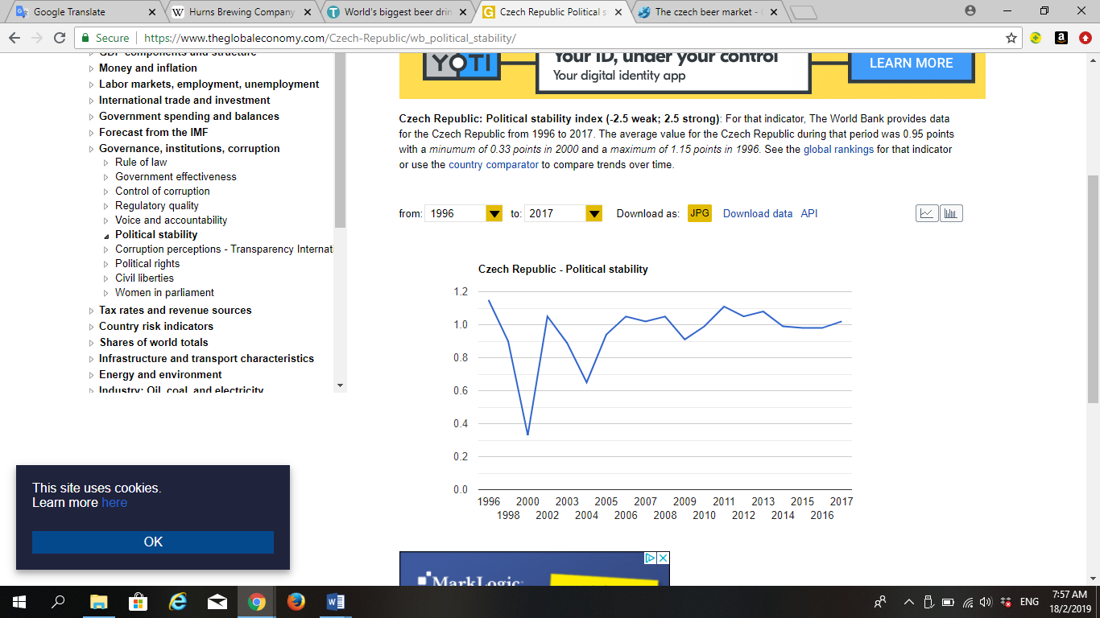
Figure 1: Czech Republic Political Stability

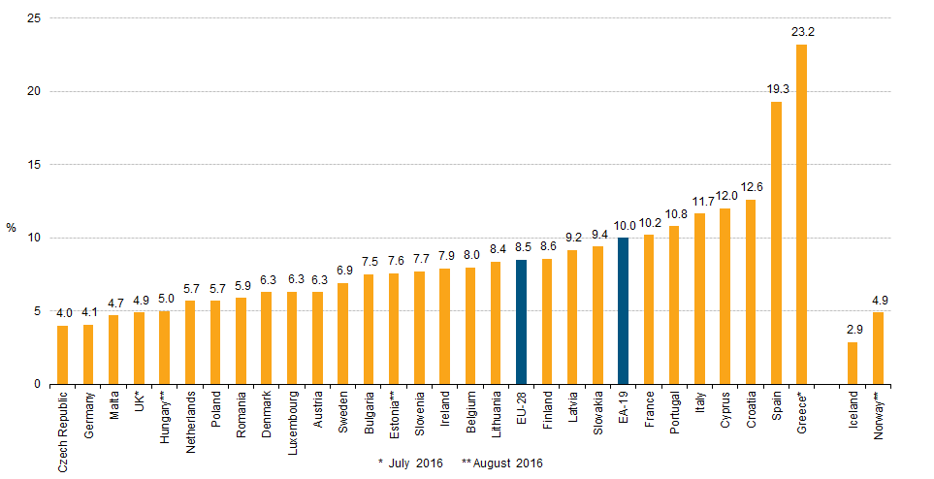
Figure 2: Unemployment Rate

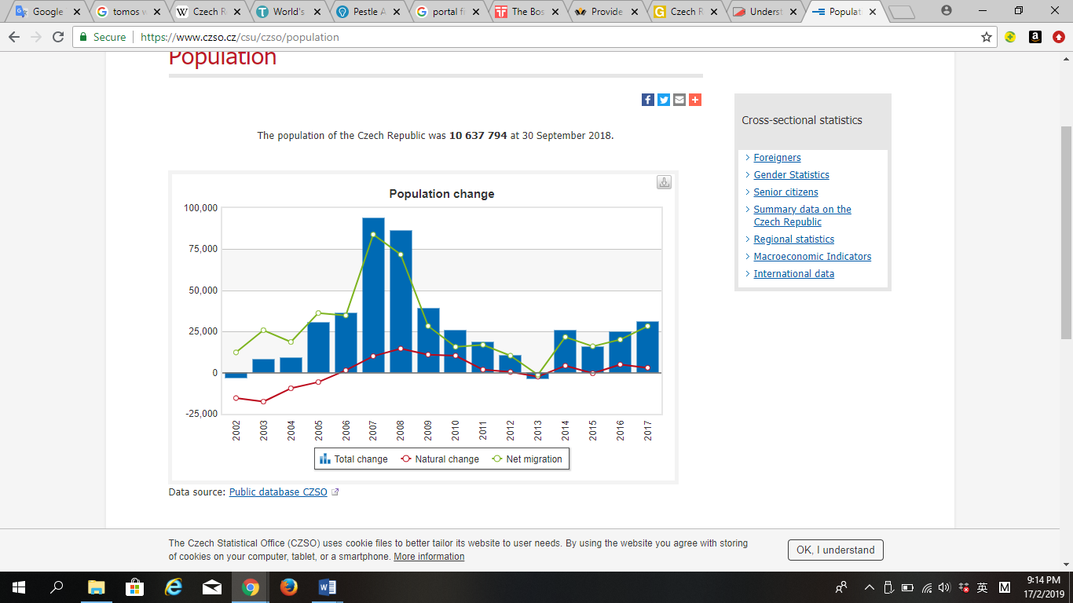
Figure 3: Population of Czech Republic

    - PEST Analysis of Germany

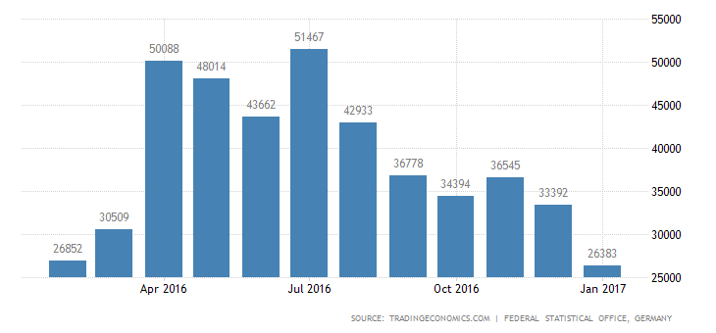
Figure 4: Germany Beer Import (Euro)

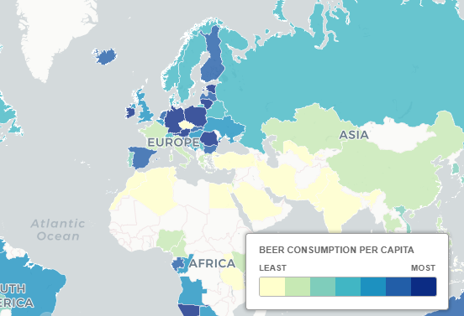
Figure 5: World Beer Consumption

    - PEST Analysis of USA

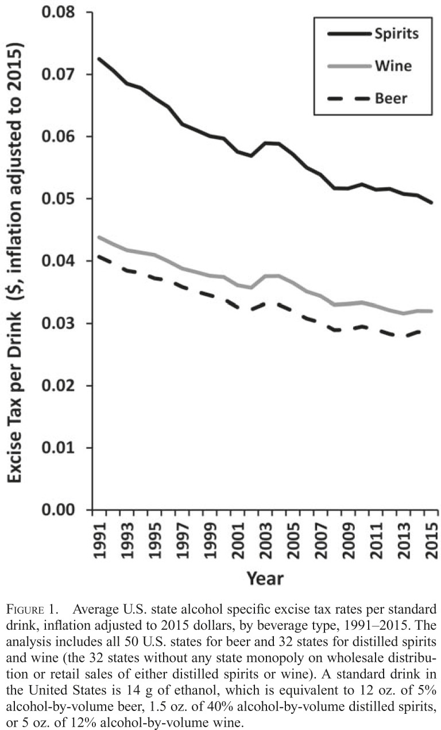
Figure 6: US Tax per Drinks

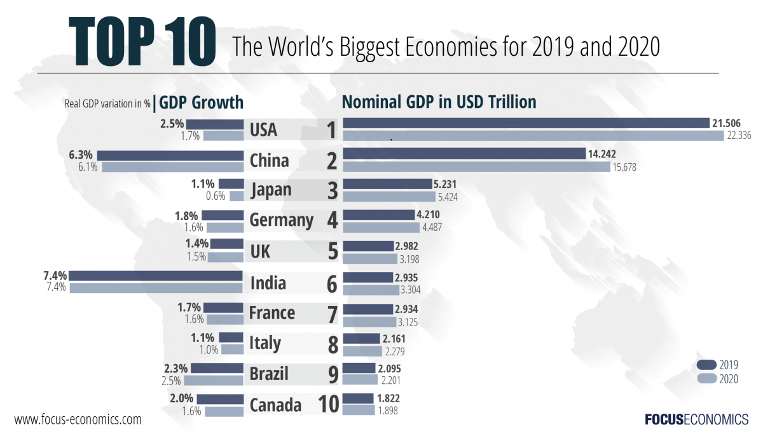
Figure 7: World Biggest Economy Countries

Figure 8: Language of the United States

  - Micro Environment
    - Porter Five Forces
Czech | Germany | USA
High Threat of New Entrance  - Government imposes high taxes and regulatory costs on the beer.  - Existing breweries have significant economies of scale as they are already mature and have brewed beer for quite some time. | High Threat of New Entrance  - Large economies of scale, brand loyalty and large capital requirements, product differentiation effects, distribution channels been limit to access, a large number of government regulations. | Medium Level of Threat of New Entrance  - New wholesalers lack experience and have little power because they have just begun.  - Industry barriers easier to access is that the ingredients and equipment that make beer are cheap.
High Buyer Bargaining Power  - The beer consumption market is very large.  - Industry faces low conversion costs, buyers are now easily moving from one brand to another.  - Standardization of products as beer cannot distinguished from its substitutes. | Increasing Buyer Bargaining Power  - Main buyer is distributors  - There are very few dealers on the market.  - Distributors industry is growing faster than the manufacturers' industries.  - New competition cannot occur. | Medium Level of Buyer Bargaining Power  - Distributors have the ability to control their profit margins and offer beer at a specific price.  - Consumers still have the power as able to choose what they want to consume a beer.
Low Supplier Bargaining Power  - Unable to maintain strong support for consumers.  - Reduction in beer conversion costs.  - Beer is not a differentiated product, so suppliers cannot charge consumers a particularly high fee. | Low Supplier Bargaining Power  - Brewers can buy existing equipment that is used or refurbished.  - There is a threat of supply integration.  - Larger brewing companies have enough money to buy land to grow their own raw materials. | Low Supplier Bargaining Power  - Increase amount of suppliers.  - The channels of beer are becoming more diverse.  - The conversion cost is low.  - There are plenty of alternatives.
Low Threat of Substitute Products  - The beer culture is deep in the body and is difficult to change their behaviour.  - Alternative product: cider, wine and soft drinks. | High Treat of Substitute Products  - Beer accounted for 19.4% and soft drinks accounted for 49.0% in beverage consumption. | Decreasing Treat of Substitute Products  - Local breweries offset the dominance of large companies by sneaking into community and producing products that consumer love.
High Rivalry among Competition  - The industry is currently in a growing phase of its life cycle.  - Existing players in the market will do everything possible to prevent any company entering the industry from blocking profit sharing.  - The major players in the industry are almost identical in terms of market strength and time of existence. | Moderate Rivalry among Competition  - The industry is experiencing significant concentration effects that will reduce competition.  - There are major obstacles to exit, which increases competition.  - The proposed joint venture MillerCoors will take action to reduce overall competition. | High Rivalry among Competition  - The demand for products is growing globally.  - Brewers cut prices to compete and get rid of inventory faster by increasing sales.  - Brewers also change their marketing strategies to attract attention by creating fluctuations in their beer style.  - US is crowded with beer brands.
(Provide an analysis of the UK Brewing industry, 2016) (Analysis of German Beer Companies, 2018)
(US Craft Brewing Industry Analysis., nd.)

    - Competitors Analysis

Czech Market
Tomos Watkin is popular in UK but new in Czech market. Pilsner Urquell can be the biggest threat to Tomos Watkin as it is the local brand and market leader in Czech. Pilsner Urquell has its uniqueness that cannot imitate by others until now. For Heineken, it is a global well-known brand and already has stable customer base. Tomos Watkin has to fight against the inertia customers to expand its market. Tomos Watkin have to beware of these two main competitors in every aspects:
 | Tomos Watkin | Pilsner Urquell | Heineken N.V
Country of Origin | Carmenthenshire, UK | Plzeň, Czech Republic | Netherland
Introduced | 1995 | 1842 | 1864
Available Country | 7 countries | 32 countries | 192 countries
Revenue (€) | (Not Available) | 580 million | 21.888 billion
Market Share (world) | 0.00037% | 0.001% | 9.3%
Market Share in Czech | - | 43% | 16.8%
Choice | 21 | 16 | 7
Own Website | Yes | Yes | Yes
Main Product | Cwrw Haf | Pilsner | Heineken
Uniqueness | Strong in character and flavour | Drink cold and with foam | Fresh, fruity aroma and a mild bitter taste
Main Ingredient | No colour malt, hops, yeast | Soft water, Malt, Hops, Yeast | Malted Barley, Hops, A-Yeast
Bottle Size | 500ml | 330ml, 500ml | 330ml, 650ml
Price per bottle(€) | 1.9 | 1.2, 1.54 | 2, 3.24
Taste | Good | Very Good | Moderate
Alcohol by Volume | 4.2% | 4.4% | 5%
Available in Czech | - | 177 years | 16 years

(Heineken, 2016) (Beer, nd.) (Heineken History, nd.) (Watkin, 2015) (Review: beer market in the Czech Republic, nd.)

Germany Market
In Germany market, Radegerger Brewery can be the biggest threat to Tomos Watkin as it is the local brand and market leader in Germany. Radeberger is exclusive in pilsner style, it is a great challenge for Tomos Watkin to seize for market share. For Carlsberg, it is a global well-known brand and already has stable customer base. Tomos Watkin have to beware of these two main competitors in Germany.
 | Tomos Watkin | Radeberger Brewery | Carlsberg A/S
Country of Origin | Carmenthenshire, UK | Radeberg | Denmark
Introduced | 1995 | 1872 | 1847
Available Country | 7 countries | 46 countries | 176 countries
Revenue (€) | (Not Available) | 1.9 billion | 9.8 billion
Market Share (world) | 0.00037% | 1.18% | 6.1%
Market Share in DEU | - | 12.8% | 3.8%
Choice | 21 | 1 | 38
Own Website | Yes | Yes | Yes
Main Product | Cwrw Haf | Pilsner | Carlsberg
Uniqueness | Strong in character and flavour | More hops taste, a full-bodied and complex taste | Balance of bitterness and sweetness, citrus hop aroma
Main Ingredient | No colour malt, hops, yeast | Malt, Barley, Hops, Yeast | Malted Barley, Hops, Hops Oil
Bottle Size | 500ml | 330ml, 500ml | 330,l. 500ml, 650ml
Price per bottle(€) | 1.9 | 2.10, 2.15 | 1.19, 1.60, 4.83
Taste | Good | Very Good | Good
Alcohol by Volume | 4.2% | 4.8% | 3.8%
Available in Germany | - | 147 years | 31 years
(Radeberger Pilsner, nd) (Our Standard, nd) (Carlsberg Group in Germany, n.d.) (Distribution of leading brewery groups market share in Germany as of 2014, 2016)

US Market
In US market, Anheuser-Busch can be the biggest threat to Tomos Watkin as it is the local brand and market leader in US. It has successfully monopoly US beer market and is a great challenge for Tomos Watkin to seize for market share. For MillerCoors, it is a joint venture global well-known brand, SABMiller & MolsonCoors, and already has large customer base. Tomos Watkin have to beware of these two main competitors in US.
 | Tomos Watkin | Anheuser-Busch | Miller Coors
Country of Origin | Carmenthenshire, UK | St.Louis, US. | Milwaukee, US
Introduced | 1995 | 1852 | 1855
Available Country | 7 countries | 50 countries | 80 countries
Revenue (€) | (Not Available) | 13.46 billion | 6.79 billion
Market Share (world) | 0.00037% | 19.7% | 9.6%
Market Share in USA | - | 41.6% | 24.3%
Choice | 21 | 33 | 51
Own Website | Yes | Yes | Yes
Main Product | Cwrw Haf | Bud Light | Coors Light
Uniqueness | Strong in character and flavour | Superior drinkability and refreshing flavour | Cold refreshment every time.
Main Ingredient | No colour malt, hops, yeast | Water, Barley, Hops, Rice | Water, Barley Malt, Corn Syrup (Dextrose), Yeast, Hop Extract
Bottle Size | 500ml | 335ml, 341ml, 473ml, 740ml | 335ml ,341ml, 473ml, 710ml
Price per bottle(€) | 1.9 | 1.87, 1.83, 1.98, 3.43 | 1.90, 1.83, 1.98, 3.30
Taste | Good | Very Good | Very Good
Alcohol by Volume | 4.2% | 4.2% | 4.2%
Available in USA | - | 167 years | 164 years
(Coors Light, nd.) (Sharing our passion for beer within the world., 2019) (A Surprising Range of Style, nd.) (Six Centeries of Brewing Histories, nd.) (the Company Snapshot, 2013) (THE U.S. BEER INDUSTRY 2017, 2018)
  - Socio-Cultural Consideration
Hofstede’s cultural dimension describes the impact of social culture on the values and the relationship between these values and the members’ behaviour. Below shows the culture difference between countries:
Czech | Germany | USA
High Power Distance Index (PDI).  This means that it is a hierarchical society. This means that people accept the hierarchical order in which everyone has a place or level and no further reasons are needed. | Low Power Distance Index (PDI).  It is highly fragmented and supported by a strong middle class. Direct and participatory communication and meeting styles are common, control is unpopular, and leadership is challenged. | Low Power Distance Index (PDI).  US is a liberal country that everyone is equal. In US organisations, hierarchies are established for convenience, and superiors are accessible, and managers rely on individual employees and teams to gain their expertise.
Individualism society.  This means that people highly prefer a loose social framework in which individuals only care for themselves and their immediate family members. | Individualism society.  It is most common to focus on parent-child relationships rather than aunts and uncles. People believe in the ideal of self-realization. The ideal is "honest, even if it hurts". | Individualism society.  Americans are the best joiner in the world but difficult to develop deep friendships. They are used to doing business with people they are not familiar with. In the business world, employees should be self-reliant and demonstrate initiative.
Masculinity society.  People “live in order to work”, managers should be decisive and confident, emphasize on fairness, and is struggle for competition, performance and conflicts. | Masculinity society.  The school system divides children into different types when they are ten. People have taken a lot of self-esteem from their work. Managers should be decisive and confident. The status is usually displayed, especially for cars, watches and technical equipment. | Masculinity.  Americans have the value of showing their "success" and life achievements and freely talking in public. Many US assessment systems are based on precise goal setting, and US employees can demonstrate how their work is performing through these systems.

High Uncertainty Avoidance Index (UAI).  Czech maintain strict beliefs and codes of conduct and cannot tolerate unorthodox behaviours and ideas. Time is money, people are eager to work hard, precision and punctuality are the norm, innovation may be resisted. | High Uncertainty Avoidance Index (UAI)  People are strongly inclined to deduct rather than generalize, whether it is thinking, presenting or planning. This is also reflected by legal system. The details are equally important to determine the decisive certainty of a topic or project. | Uncertainty Avoidance Index (UAI).  Americans tend to be more tolerant of anyone's thoughts or opinions and allow freedom of speech. At the same time, Americans don't need a lot of rules, and higher-scoring culture is less emotionally.
Long-term Orientation.  Czech culture has proven to be pragmatic. People believe that truth depends to a large extent on the situation, background and time. | Long-term Orientation.  They show the conditions that can easily adapt the tradition to change, strong savings and investment tendencies, frugality and perseverance to achieve results. | Short-term Orientation.  Americans are very practical and have strong idea of what is good and evil. US company measure performance in short term and publish profit and loss statement every quarter. It motivate individual to work hard to achieve results quickly in the workplace.
Restrained society.  People do not emphasis on leisure time and control the gratification of their desires. People with this orientation have the perception that their actions are restrained by social norms and feel that indulging themselves is somewhat wrong. | Restrained society.  The society is restrained by social norms. People rather work hard than relax and have the perception of relaxing makes people lazy. | Indulgence society.  People emphasize on work hard and play hard. People normally live in a relax mood. Also, the states have launched anti-drug wars and are still very busy, but the rate of drug addiction in the US is higher than in many other rich countries.

(Czech Republic Hofstede Insight, 2019)
(Country Comparison: Germany, 2019)
(Country Comparison: USA, 2019)
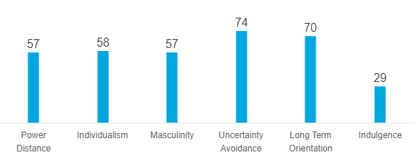
Figure 1: Czech Republic Hofstede Index
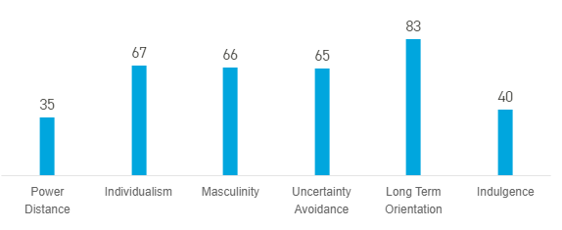
Figure 2: Germany Hofstede Index
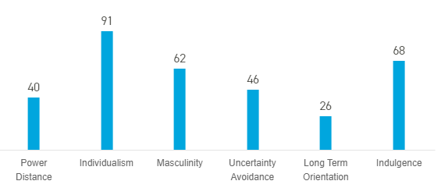
Figure 3: USA Hofstede Index
  - Operation Risk
Moving beers between countries.
Product | - Cold beer should store in specific temperature  - Bottle size, alcohol by volume
Market | - Market size of beer in Czech  - Trends/ Beer Culture  - High competition occurs in beer industry
Distribution Channel | - Transportation (Ship & Truck) and Storage  - Agent, Dealer, Wholesaler, Retailer
Company | - Company Objectives: To become the world largest brewery  - Expand size of company by expand market through oversea  - Company and marketing policy

  - Country

The country chosen is United States of America.

From the analysis above, we can see that the barriers to enter into US is easier than other countries and there is a low threat of substitute products as beer has accounted for 43% of all beverages. Also, English which is the national language in US has brings convenient for Tomos Watkin to enter the market as no translation work on documents and products is needed. This has save lots of preparation effort for Tomos Watkin and also can prevent occurs of culture blunders which could bring bad image.
US, the largest world trade country, bring lots of opportunities for every business, in aspect of expand market and expand reputation. Good relations with US companies is also help in expand market into other countries. From the competitor analysis, MillerCoors is joint venture of UK brewery and the recipe and operation is control by them. The huge market share of the products in US shows that the public has a high acceptance of UK beers.
One of the most important reason is that UK has a very close relationship with US. These two countries are linked by a common history, overlapping religions and common language and legal systems, as well as kinship dating back hundreds of years. The United States is the UK’s largest single export market, ( "Trade and Investment with the United States", nd.) and we can see that the two countries have a very close commercial relationship. Also, US president Donald Trump has claimed that US relationship with UK is “the highest level of special”. (Rigby, 2018)
From those great opportunities that other countries are not able to provide, US is the best country to first enter to the global market.
- Evaluate the possible options for entry to these new markets and provide the Board of Tomos Watkins with a recommended course of action that includes full justification for your choice that will best fit the company and its aspiration.

  - Mode of Entry
    - Suitable Timing and Location to Entry

Based on the previous researches, US is the most suitable country to entry. Therefore, one of the best times to start a new business in this country is few months before Oktoberfest which means during July or August. Due to festival, the business can offer different promotions to attract more customers towards their brand. The business also can sponsor beers on the festival to increase awareness and recognition. Therefore, starting a new business in US is more beneficial during the mentioned months. On the other hand, tourists will be visiting the country due to the festivals therefore their visit can be beneficial and profitable for the company.
Northeast is the best region to first locate the business as there is few a big capitals that crowded with people such as New York and Pennsylvania which can provide large capital base at the beginning. Also, those area are world trade hub, any information will be spread quickly throughout the country even globally. It is the best timing for Tomos Watkin to create brand awareness, recognition and image in US.

    - Possible Options for Market Entry

    - Comparison between Entry Strategies

Indirect Export | Direct Export | Foreign Direct Investment
Selling products to intermediaries before export | Takes full responsibility for getting products into foreign market | Company fully commit itself to internationalisation, set up company in foreign market
Risk-free to begin | Response of competition | High risk
Allow to concentrate on domestic business | Build expertise for foreign business | Build expertise and team at foreign country
Limited liability for product marketing. | Investment in people, time, money, process | Cost greater money and manpower
Uncomplicated | Complicated | Very complicated
Less profit | Greater potential profits | Greater return on investment
No control of foreign sales | Greater degree of control over sales | Full control of the sales, ability to finance and profits
Very rarely know who customers are | Know customers well and can get faster and direct feedback | Greater relationship with customers
Intermediary might not providing exclusive representation on the products | Present fully committed and engaged in export process, business trip is more efficient | Need full engagement in regulations, market condition, and the whole business process
Long-term outlook and goal may change rapidly, hard to redirect efforts | Greater flexibility to improve or redirect marketing efforts | Speed to react to market
Import tax barriers | Import tax barriers | Tax incentive
Reactive | Proactive | Very Proactive
(The Advantages and Disadvantages of Indirect Exporting, 2019)
(Direct Export Advantages and Disadvantages, 2019) (Amadeo, 2018)

    - Recommended Market Entry Strategy

Foreign direct investment can said to be the best strategy to entry a country as it exert greater control, return higher profits and also benefits the global economy. However, Tomos Watkin is a small company, it is lack of capital, expertise and ability to do foreign direct investment as it is the most expensive method and require lots of expertise to control over business and market in order to enter US market. Tomos Watkin is also not able to handle the risk if fail in investment, it could lead directly into liquidation. So, foreign direct investment is not suitable for Tomos Watkin at this time.
Indirect exporting is a good starting point for international involvement as it has lower risk, uncomplicated and less expensive. However, it limits the profits. The company cannot gain information of the customer and the market in order to redirect marketing efforts. Also, the intermediaries may not hardly push sales of the products as they may sell other competition products too. Even the risk is low, but it is not a good strategy for Tomos Watkin to enter as has no control over everything.
Direct exporting is better than indirect exporting for Tomos Watkin. Even it needs to invest in time, people, money and process, it is still able to handle by the company but not foreign direct investment as it required too huge amount of them. Direct exporting allows the company to have a better control on the foreign market, so the company can improve and redirect the marketing efforts to enhance the foreign business.
So, the recommended entry strategy is agent/distributors of direct export.
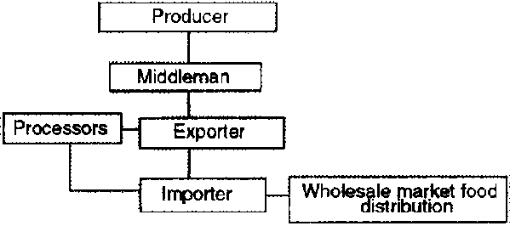
Figure 7: The Export Marketing Channel of Tomos Watkin Brewery

However, the strategy will change. If the market share of Tomos Watkin able to reach 5% in US market within 5 years, the company will consider to set an office at Pennsylvania and owned warehouse or wholly owned subsidiary in order to exert greatest control and hopefully reducing risks at the same time as the company has a stable customer base and is able to handle the greater risk at that time.
Conclusion

The growing market in US will provide Tomos Watkin Brewery with a great place to expand and build its brand. However, this fast-growing enticing market is full of uncertainty, such as unknown customer tastes and changing tastes, as well as strong presence and control of big players.
With its marketing capabilities gaining experience, Tomos Watkin is well-suited for direct export products that are sold directly to customers. Due to the rapid integration of the brewing industry around the world and even in US, Tomos Watkin had to consider the next step in the US expansion. The thriving market in US is the way to achieve the vision of becoming a world leader.

References

- "Eurostat: Euro area unemployment rate at 11.2%, Press release of 2 March 2015". (2017, October 10). Retrieved from Eurostat.
- (nd.). "Trade and Investment with the United States". UK: UK Trade and Investment.
- "Country Comparison: Exports". (2008, October 4). Retrieved from The World Factbook.
- "CPI 2009 table". (2012, May 11). Retrieved from Transparency International.
- "The Innovation Imperative in Manufacturing: How the United States Can Restore Its Edge". (2009, March). Retrieved from Boston Consulting Group.
- A Surprising Range of Style. (nd.). Retrieved from AB In Bev: https://www.ab-inbev.com/our-brands/our-beers.html
- Amadeo, K. (2018, November 6). Foreign Direct Investment, Its Pros, Cons, and Importance to You. Retrieved from the Balance small business: https://www.thebalance.com/foreign-direct-investment-fdi-pros-cons-and-importance-3306283
- Analysis of German Beer Companies. (2018, November). Retrieved from UK Essay: https://www.ukessays.com/essays/business/analysis-german-beer-companies-8637.php
- Beer, P. U. (nd.). Pilsner Lager: Learn what is Pilsner Beer and where to buy Pilsner Urquell Beer online. Retrieved from Plzen Guide: https://plzenguide.com/pilsner-beer-pilsner-urquell.html
- Benefits of Distributors. (nd.). Retrieved from The Reseller Network: https://www.the-reseller-network.com/content/118/benefits-of-using-distributors/
- Bud Light. (nd.). Retrieved from The Beer Store: http://www.thebeerstore.ca/beers/bud-light
- Carlsberg Group in Germany. (n.d.). Retrieved from Carlsberg Group: https://carlsberggroup.com/who-we-are/about-the-carlsberg-group/global-presence/germany/
- Christian Aspalter, K. J. (2009, March 10). Analysing the Welfare State in Poland, the Czech Republic, Hungary and Slovenia. An Ideal-Typical Perspective.
- Cocco, F. (2016, October 19). Israel and the US have the highest poverty rates in the developed world. Retrieved from Financial Times.
- Coors Light. (nd.). Retrieved from The Beer Store: http://www.thebeerstore.ca/beers/coors-light
- Coors Light. (nd.). Retrieved from Miller Coors: https://www.millercoors.com/beers/great-beers/coors-light
- Country Comparison: Germany. (2019). Retrieved from Hofstede Insight: https://www.hofstede-insights.com/country-comparison/germany/
- Country Comparison: USA. (2019). Retrieved from Hofstede Insight: https://www.hofstede-insights.com/country-comparison/the-usa/
- Cunningham, M. (1986). "Strategies for International Industrial Marketing". Croom Helm, 9.
- Czech Republic - Market Challenges. (2018, September 10). Retrieved from export.com: https://www.export.gov/article?id=Czech-Republic-Market-Challenges
- Czech Republic : Legal Environment. (2019, January). Retrieved from Santander Trade Porter: https://en.portal.santandertrade.com/establish-overseas/czech-republic/legal-environment?&actualiser_id_banque=oui&id_banque=44&memoriser_choix=memoriser
- Czech Republic Hofstede Insight. (2019). Retrieved from Hofstede Insight: https://www.hofstede-insights.com/country/czech-republic/
- CzechInvest. (nd.). Taxation System. Retrieved from Czech Invest: https://www.czechinvest.org/en/Doing-business-in-the-Czech-Republic/Taxation-system
- Czech-U.S. Relations. (2015, August 8). Retrieved from Embassy of Czech Republic in Washington: https://www.mzv.cz/washington/en/czech_u_s_relations/index.html
- Delaney, L. (2019, January 10). Direct Export Advantages and Disadvantages. Retrieved from the Balance small business: https://www.thebalancesmb.com/direct-exporting-advantages-and-disadvantages-1953310
- Delaney, L. (2019, January 9). The Advantages and Disadvantages of Indirect Exporting. Retrieved from the Balance small business: https://www.thebalancesmb.com/advantages-disadvantages-of-indirect-exporting-1953328
- Direct or indirect exporting, which is best? (nd.). Retrieved from Connect Americas: https://connectamericas.com/content/direct-or-indirect-exporting-which-best#
- Distribution of leading brewery groups market share in Germany as of 2014. (2016). Retrieved from Statista: https://www.statista.com/statistics/575229/brewery-groups-market-share-germany/
- Dumbrell, J., & Schäfer, A. (2009). America's 'Special Relationships': Foreign and Domestic Aspects of the Politics of Alliance. Political Science, 45.
- Embassador, F. (2004). "Declaration by the Franco-German Defence and Security Council". UK: The Original.
- European Union - Market Entry Strategy. (2018, February 7). Retrieved from export.gov: https://www.export.gov/article?id=European-union-Market-Entry-Strategy
- Export: direct or indirect? (nd.). Retrieved from Business.gov.nl: https://business.gov.nl/running-your-business/international-business/export/export-direct-or-indirect/
- Frue, K. (2018, April 5). PEST Analysis of the Beer Industry. Retrieved from Pestle Analysis: https://pestleanalysis.com/pest-analysis-of-the-beer-industry/
- Germany – The World's Automotive Hub of Innovation. (2015, April 25). Retrieved from Wayback Machine, Germany Trade & Invest, Ernst & Young European Automotive Survey 2013.
- Heineken. (2016, July 26). Five things you never knew about Heineken. Retrieved from TimeOut Singapore: https://www.timeout.com/singapore/bars-and-pubs/five-things-you-never-knew-about-heineken
- Heineken History. (nd.). Retrieved from Heineken International: https://www.dwcomm.com/static/products/files/36~History_of_Heineken.pdf
- Killian, J. H. (2012). "Constitution of the United States". USA: The Office of the Secretary of the Senate.
- Lapelosova, K. (2018, September 13). Understanding the Czech Republic's unique beer drinking culture. Retrieved from EatSipTrip: https://eatsiptrip.10best.com/2018/09/13/understanding-the-czech-republics-unique-beer-drinking-culture/
- Louis, F. R. (2019, February 27). U.S. Bureau of Economic Analysis, Gross Domestic Product [GDP]. Retrieved from FRED Economic Data: https://fred.stlouisfed.org/series/GDP
- Mazepus, A. (2016, August 5). Beer Culture In The Czech Republic, More Than Just A Drink. Retrieved from Youth Times Magazine: http://youth-time.eu/content/recommended/recommended-travel/beer-culture-in-the-czech-republic-more-than-just-a-drink/
- Naimi TS, B. J. (2018, January). Erosion of State Alcohol Excise Taxes in the United States. Retrieved from NCBI: https://www.ncbi.nlm.nih.gov/pubmed/29227230
- Our Standard. (nd). Retrieved from Radeberger pIlsner: https://www.radeberger.com/products
- Passive vs. Active Exporting. (2018, May 29). Retrieved from ICDTranslation: http://icdtranslation.com/passive-vs-active-exporting-and-why-translation-matters/
- PEST Analysis of USA, the Largest Economy of the World. (2014, December 21). Retrieved from Pestle analysis: https://pestleanalysis.com/pest-analysis-of-usa/
- Piercy, N. (1982). "Company Internationalisation: Active and Reactive Exporting". European Journal of Marketing, 26-40.
- Population. (nd.). Retrieved from Czech Statistical Office: https://www.czso.cz/csu/czso/population
- Porter Five Forces Analysis. (nd.). Retrieved from Fern Fot University: http://fernfortuniversity.com/term-papers/porter5/analysis/812-the-boston-beer-company--inc-.php
- Provide an analysis of the UK Brewing industry. (2016, 12 5). Retrieved from UK Essay: https://www.ukessays.com/essays/business/provide-an-analysis-of-the-uk-brewing-industry-business-essay.php
- Radeberger Pilsner. (nd). Retrieved from The Beer Store: http://www.thebeerstore.ca/beers/radeberger-pilsner
- Review: beer market in the Czech Republic. (nd.). Retrieved from ConBiz: http://www.conbiz.eu/information/articles/the-czech-beer-market
- Rigby, B. (2018, July 15). Backpedalling Donald Trump tries to warm up a cooling special relationship. Retrieved from Sky News: https://news.sky.com/story/backpedalling-donald-trump-tries-to-warm-up-a-cooling-special-relationship-11436115
- Scheb, J. M. (2002). An Introduction to the American Legal System. Florence, 6.
- Sharing our passion for beer within the world. (2019, January 1). Retrieved from AB In Bev: http://annualreport.ab-inbev.com/2018-at-glance/where-we-operate/
- Six Centeries of Brewing Histories. (nd.). Retrieved from AB In Bev: https://www.ab-inbev.com/who-we-are/heritage.html
- Smith, O. (nd.). World's biggest beer drinkers: Countries that drink the most beer per capita. Retrieved from Traveller: http://www.traveller.com.au/worlds-biggest-beer-drinkers-countries-that-drink-the-most-beer-per-capita-gvrbyr
- the Company Snapshot. (2013, July 6). Retrieved from SAB Miller.
- THE U.S. BEER INDUSTRY 2017. (2018). Retrieved from America's Beer Disributors: https://www.nbwa.org/resources/industry-fast-facts
- The UK Brewing Industry: PESTLE Analysis. (nd.). Retrieved from UK Essay: https://www.ukessays.com/essays/commerce/the-macro-environment-of-brewing-industries-commerce-essay.php
- Unemployment rates. (2016, September). Retrieved from EuroStat: https://ec.europa.eu/eurostat/statistics-explained/index.php/File:Unemployment_rates,_seasonally_adjusted,_September_2016.png
- US Craft Brewing Industry Analysis. (nd.). Retrieved from http://www.martygaal.com/words/microbrew.html
- Watkin, T. (2015, March 24). CHEERING NEWS AS TOMOS WATKIN BEERS GO ON SALE IN CHINA. Retrieved from Tomos Watkin: https://tomoswatkin.com/blogs/news/cheering-news-as-tomos-watkin-beers-go-on-sale-in-china
- Wright, G., & Czelusta, J. (2007). "Resource-Based Growth Past and Present". Natural Resources: Neither Curse Nor Destiny, p. 185.

