Week One Tutorial
Your task is to create a small application that makes use of the concepts covered in the lecture, include the use of variables for dynamic data storage, at least one conditional statement and one iterative statement.

Creating a Project

Open visual studio, click on the “File” menu option and hover or click on the “New” menu item. Following this select “New Project” from this context menu.
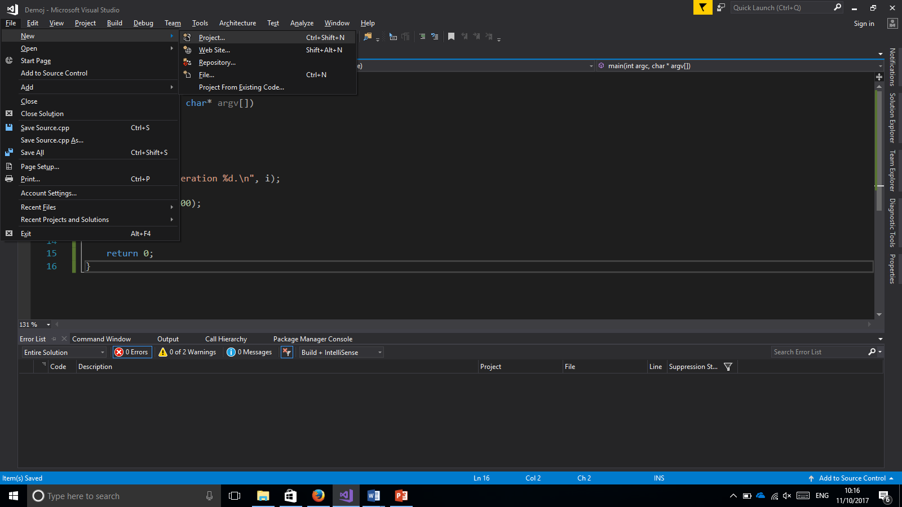

When the new project window appears it should look similar to the following:
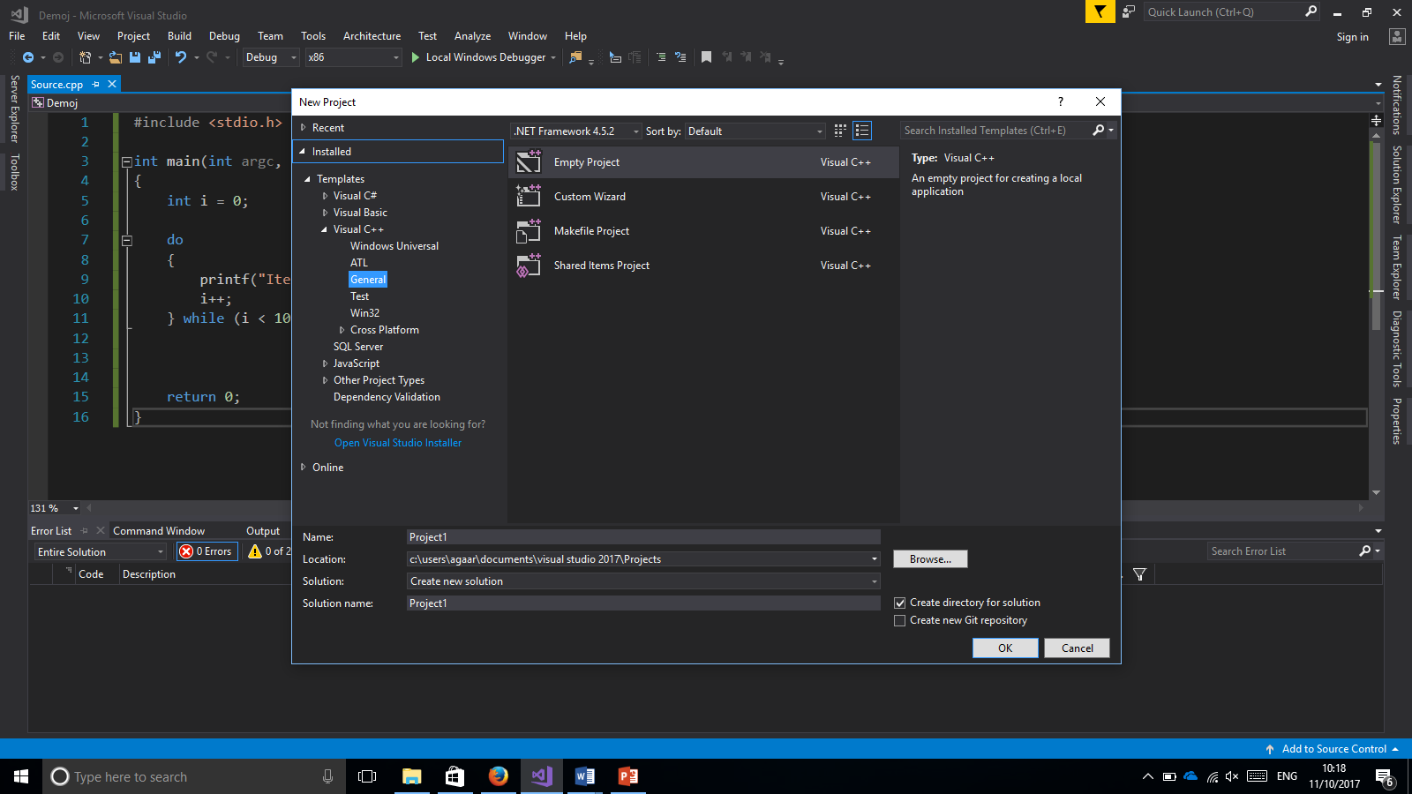
Within this window, provide your project a memorable or descriptive name by which you may refer to it at a later point. Leave the “Empty Project” item selected and click the “OK” button. Following completion of this process you will be presented with what looks like a blank window as shown below.
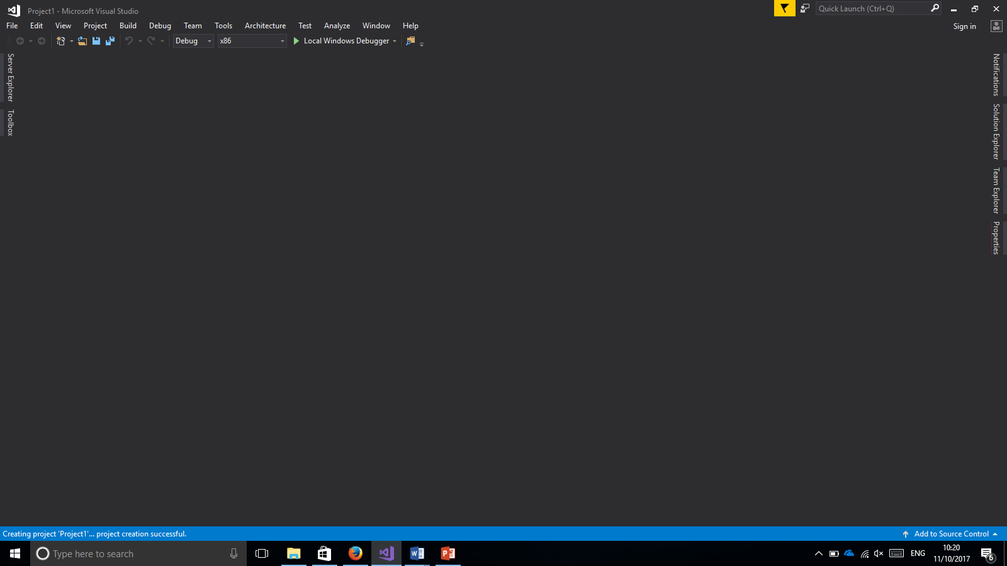

Within this window, select the “Solution Explorer” tab on the right-hand side of the window.
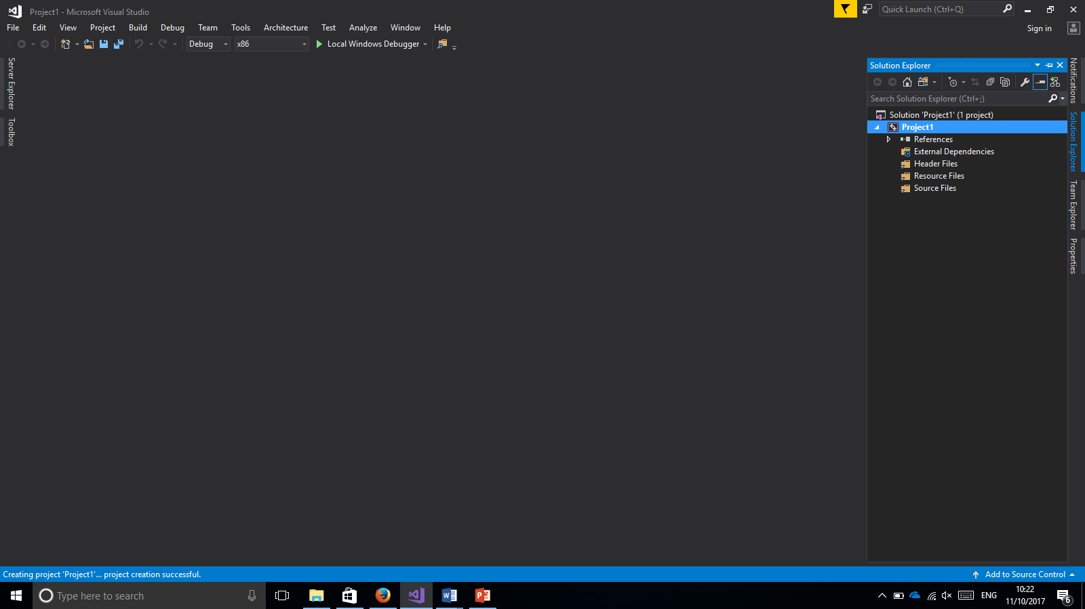
The panel that appears makes visible all of the files that are currently in your project, in addition provides a view of the structure of your project. Right click on the item that resembles the project name and a context menu should appear.

Navigate to the “Add” option within this menu and select “New Item”.
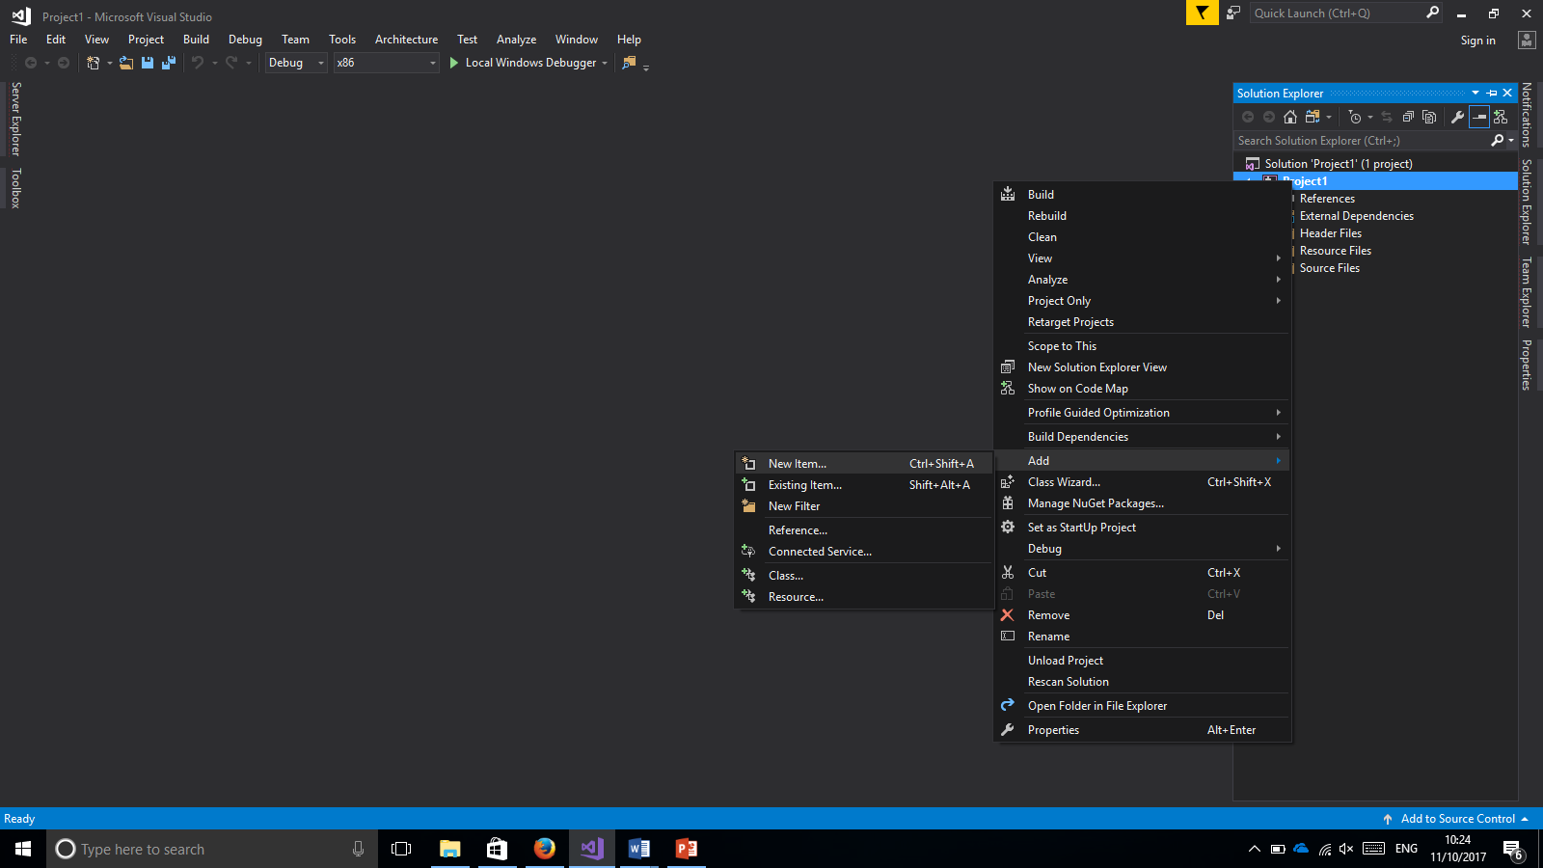

When the “New Item” window appears, this will look similar to the project creation dialogue, allowing you to choose the type of item and provide it with a descriptive name.

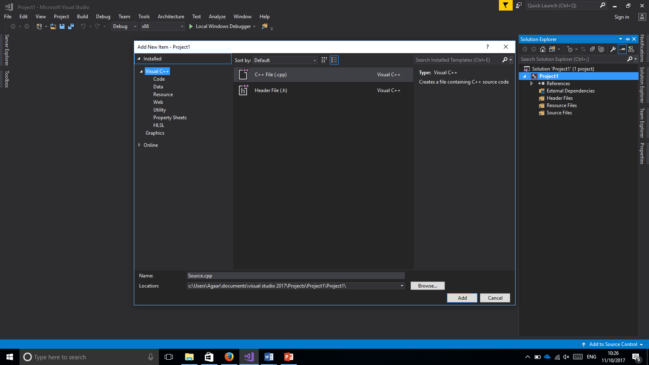
Leave the selection of file type as is, after having provided a name click the “OK” button.

