University of Wales Trinity Saint David

DISSERTATION PROPOSAL

Proposed research title: The impact of cultural awareness in multinational organizational productivity: An analysis of Tesco

Student name: Fikrie Lyumankova
Student ID: 2013439
Submission date: 09/05/2023
LCBB60000
Lecturer: Dr. Anupam Mazumdar
Supervisor: Charles Nwaogwugwu

Table of Contents
Introduction 3
Significance of the topic 3
Purpose of the research 3
Aim 4
Objectives 4
Research questions 4
Literature Review 5
Identifying ways of promoting cultural awareness in workplace 5
Analysing the impact of cultural awareness on productivity in workplace. 5
Impact of cultural awareness on employee productivity 6
Strategies to support cultural awareness in an organization. 6
Methodology 8
Research philosophy 8
Research methods 8
Research strategy 9
Sampling methods 9
Data collection methods 9
Interpreting data 9
Time prospects of the research (Gantt chart) 10
Ethical consideration of the research 10
Conclusion 11
References: 12

Introduction
Cultural awareness (Van Doorsselaere, 2021) is the understanding and exploration of individuals and other people's cultural backgrounds, practices, influence and business. It also involves identifying and respecting the similarities and differences among the different cultural groups. Cultural awareness promotes effective communication and successful globalization (Shao et al., 2021), and every organisation needs to prioritise cultivating cultural awareness. Multinational organisations' culturally more diverse and inclusive circumstances allow them to collaborate and interact easily. It also strengthens the work environment and promotes sustainability and productivity. Tesco is a British multinational retailer of general merchandise as well as groceries, and it has not only online stores but also it stores in different formats and sizes. The store is amongst the most largest and valuable market brands globally, providing ranging of products from food and drinks to electronic items and household products. Tesco has different shops in several countries, mainly in Europe. This research proposal aims to analyze and identify the impact of cultural awareness on multinational organizations’ productivity, where Tesco organization is chosen for the research.

Significance of the topic
Cultural awareness grows with time, and it implies that understanding the dynamic values and beliefs of different circumstances and cultures in order to create better opportunities and understanding, as well as respecting the different cultures not necessary therefore, employees or subordinates from dissimilar and unlike backgrounds can work in cooperation with the help of cultural awareness. In today’s globalized world, developing cultural awareness is needed to be done in the multinational company; therefore, it has a positive impact on teams and employees as they start to collaborate and interact with each other more and makes inclusive and productive working circumstances for themselves therefore; it’s essential to find out that how cultural awareness has the positive impact on the organization and how employees work together by increasing their productivity. As employees have different stereotypes, cultural awareness helps them understand each other’s backgrounds and working methods. It promotes positive working circumstances and increases the productivity of employees who work better for the organization.

Purpose of the research
It's important to analyze and identify the impact of cultural awareness on the multinational organization as it represents the employee's past, present and future and is tied to the history of humanity, which continues to be defining the hallmark. In order to continue fostering existing cultures and cultivating new features and subcultures within an organization, it's important to prioritize the essentialness of widespread cultural awareness. Therefore, it is important to analyze the influence and the importness of cultural awareness on Tesco, which will help businesses analyse the importance of cultural awareness and how it will help them improve their working circumstances and increase employees' productivity to perform better for the organization and make the organization successful.

Aim
The aim of the research is to analyse the impact of cultural awareness in multinational organisation productivity: An analysis of Tesco

Objectives
- To identify ways of promoting cultural awareness in the workplace.
- To analyse the impact of cultural awareness on productivity in multinational organization.
- To analyse how cultural awareness increase employee`s productivity in multinational organization
- To identify strategies to support cultural awareness in an organization.

Research questions
- How does lack of cultural awareness impact employee`s productivity in workplace?

Literature Review

Identifying ways of promoting cultural awareness in workplace
According to Rocha and Pinheiro, (2021) Cultural awareness it's a concept that has become increasingly essential in diversification and an interconnected globe as well as businesses. It refers to the individual personnel's ability to identify, recognise, understand, and appreciate the different beliefs and customs of different cultures. It is also referred to as the knowledge and sensitivity to different cultural differences, which includes origins, meanings and implications of university identifying and respecting the unique beliefs, values, and practices of different cultures. There are different ways to promote culture awareness in a workplace such as cultural awareness training, discussions and exchanging stories. Furthermore, there are different theories which fulfills the culture and productivity needs of the business. The Organizational Culture Theory (Zhen et al., 2021) demonstrate that, an organization's organizational culture, consisting of accepted beliefs, values, and standards, affects people's behavior. It implies that a strong and pleasant culture can increase productivity by coordinating employees' behaviors and encouraging collaboration. Next, the idea of Contingency theory holds that there is no single strategy for improving organizational culture and productivity. Instead, the best course of action depends on the unique circumstances and context. It implies that businesses must modify their cultures and procedures to meet the external circumstances they must deal with.

Analyzing the impact of cultural awareness on productivity in workplace.
Cultural awareness matters for different reasons as it influences the entire organization's work and circumstances, having a significant idea regarding cultural awareness will help employees to conduct positive communication (Bauer and Lim, 2019) with one another and develop strong relations. It also contributes to engagement in a better workplace as it promotes leadership roles, and leaders as well as bringing a diverse work culture. The outcome of it is that, the cultural connection strengthens and decreases the chances of cultural conflicts. Consequently, cultural awareness increases productivity at Tesco by developing brand loyalty with the help of empathy and cultural understanding. They showcase empathy towards different cultural groups and people to develop brand loyalty among them as well as improved its internal efficiencies with the help of giving training regarding cultural awareness, which will help them to increase the productivity of their employees and it will also help them to decrease their attrition with the help of cross-cultural training. By developing a better understanding of overseas markets with the help of cultural awareness, Tesco can increase its productivity and expand its business into more international markets.

Impact of cultural awareness on employee productivity
According to Obrenovic et al., (2020) in today's globalized world, cultural awareness is important for different organizations and multinational businesses to be successful. Senior administration of the organization can create better products and services and marketing campaigns to help them gather consumers' cultural preferences and attractions. Wentling (2000) argue that culturally aware employees are better able to communicate and comprehend one another's perspectives, preventing miscommunications and disputes. Open and honest communication encourages teamwork and collaboration, which boosts productivity. Employees are more inclined to value variety and alternative viewpoints when culturally aware. Sharing ideas and methods can promote greater problem-solving, creativity, and innovation. Culturally sensitive organizations highly value fostering an inclusive and courteous workplace. Employees are more engaged and committed to their work, which leads to increased production levels when they feel respected and valued for their cultural backgrounds. The disadvantage of it comes in various forms as, creating and maintaining a culturally conscious workplace requires a sustained investment of time, effort, and resources. To address these issues and guarantee productivity is not adversely impacted, organizations must invest in conflict management techniques, training, and the development of cultural competency. Cultural knowledge may not always eliminate language and communication difficulties that can occur in various workplaces. Differences in communication styles and languages might still influence productivity, necessitating extra work like language training and efficient translation technologies.

Strategies to support cultural awareness in an organization.
The impact of cultural awareness brings an increment in job satisfaction and engagement which help Tesco to have a successful profit revenue (Kang and Na, 2020). Additionally, Tesco uses cultural support strategies to look after their employees. The organization is aware that looking after their employees in a culture of trust and respect is crucial for a successful business. There are the different strategies that could help to support cultural awareness. Businesses might implement official initiatives and programs to support diversity and inclusion. These activities may include forming diversity task forces or committees, developing employee resource groups (ERGs) that concentrate on certain cultural or affinity groups, and planning diversity education programs to increase employee knowledge and foster understanding. Offering cross-cultural training programs aids in employees developing cultural sensitivity (Aleksić et al., 2019) and competency. The personnel participating in these programs will be taught about various cultural conventions, values, and communication styles through workshops, seminars, or online courses. Participating in events that honor various cultures helps promote cultural sensitivity and appreciation. Businesses can host events celebrating other cultures, food festivals, or cultural heritage months so staff members can talk about their customs, cuisines, and experiences.

Methodology
The process of identifying, selecting, processing, and analyzing of information on a topics research methodology. This part of the research allows the researchers to critically examine the studies and develop an efficient methodology.

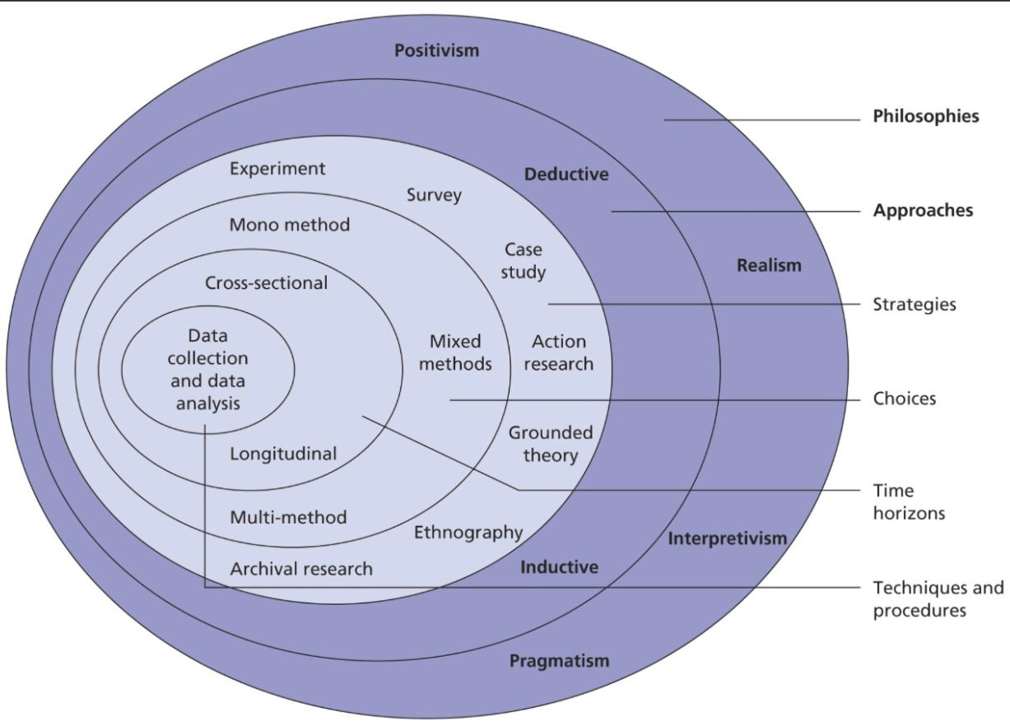
Figure 1: Research union
Source: (The innovidea, 2022)

Research philosophy
The research philosophy used for this research topic will be interpretivism as this is the method used to understand the reality of a person and their experience shaped by their social or historical perspective. The researchers have used the method to generate deep and rich understanding of the investigated phenomenon by questions and observation: therefore, the interpretivism is affiliated with collection data of qualitative methods. To develop different social realities and views the researcher will gather richness in the insides through the interpretivism method (Alharahsheh and Pius, 2020)

Research methods
Researcher will be using qualitative method in order to gain the information for research topic. The researcher will use different interviews, semi-interviews, questionnaires, case studies and published relevant resources to gain the theoretical concepts which are relatable to research topic. The reason for using qualitative research is it provides unique information which is easy to understand and gain from the accessible resources.

Research strategy
The research strategy used for this research proposal is the qualitative method researchers have used different theories and data in order to gain the appropriate information which is relevant to the research topic. The researchers have used the method to understand and interpret people experiences and attitudes as it generates non numerical data that is also known as idealistic or humanistic approach (Vibha, Bijayini and Sanjay, 2013)

Sampling methods
For this research topic the researcher will use convenience sampling method which is based on availability and willingness of participants as well as it allows them to decrease the bias involved in this research and help them to gain information based on theoretical perspectives, research questions and the findings that inform the study.

Data collection methods
With the help of semi structured interview researchers have collected data that help to explore particular topic of interest as it provides qualitative data to compare to previous or future data.

Interpreting data
Researchers have used thematic analyses method to interpret qualitative data. The researcher will use interviews to obtain various perspectives on a research question, and thematic analysis is widely used to analyze qualitative data. The researcher will use the framework of thematic analysis method build on theoretical concepts and data which is relevant to the research topic and based on that researchers have interpreted the data (Judger, 2016). With the help of in-depth understanding of different theoretical concepts and literature review s, the researcher will interpret data and finalize the research outcome.

Time prospects of the research (Gantt chart)
Fig: Gantt Chart
Source: (Created by Learner)
Activities | Week1 | Week2 | Week3 | Week4 | Week5 | Week6 | Week7
Introducing topic
Literature review
Methodology
Collecting data
Interpretation of data
Concluding outcomes
Submitting research work

Ethical consideration of the research
Researchers have used appropriate and legal research papers in order to gain information regarding research topic and research is aware of falsification and plagiarism along with academic integrity (Gamage et al., 2020) therefore with respect to Data Protection Act 2018 researchers have used legal information in order to elaborate the possible issues and factors of research topic.

Conclusion
The above research proposal successfully elaborated different factors regarding the research topic where research and objective and questions are developed and based on their literature review that is also given. The methodology used for the research topic is also aberrated and justifies each method and approach. The proposal also includes to find prospects of the research where different tasks, and for the task needed time of completion, is elaborated.

References:
Alharahsheh, H.H., amd Pius, A., 2020. A Review of key paradigms: positivism VS interpretivism. Global Academic Journal of Humanities and Social Sciences. Pp.39-43
Aleksić, A., Načinović Braje, I. and Rašić Jelavić, S., 2019. Creating sustainable work environments by developing cultures that diminish deviance. Sustainability, 11(24), p.7031.
Bauer, S. and Lim, D., 2019. Effect of communication practices on volunteer organization identification and retention. Sustainability, 11(9), p.2467.
Gamage, K.A., Pradeep, R.R., Najdanovic-Visak, V. and Gunawardhana, N., 2020. Academic standards and quality assurance: The impact of COVID-19 on university degree programs. Sustainability, 12(23), p.10032.
Judger, N., 2016. The thematic analysis of interview data: an approach used to examine the influence of the market on curricular provision in Mongolian higher education institutions. University of Leeds. Hillary place papers 3. Pp.1-7
Kang, S. and Na, Y.K., 2020. Effects of strategy characteristics for sustainable competitive advantage in sharing economy businesses on creating shared value and performance. Sustainability, 12(4), p.1397.
Obrenovic, B., Du, J., Godinic, D., Tsoy, D., Khan, M.A.S. and Jakhongirov, I., 2020. Sustaining enterprise operations and productivity during the COVID-19 pandemic:“Enterprise Effectiveness and Sustainability Model”. Sustainability, 12(15), p.5981.
Rocha, R. and Pinheiro, P., 2021. Business education: Filling the gaps in the leader’s awareness concerning organizational phronesis. Sustainability, 13(4), p.2274.
Shao, J., Tillaguango, B., Alvarado, R., Ochoa-Moreno, S. and Alvarado-Espejo, J., 2021. Environmental impact of the shadow economy, globalisation, trade and market size: Evidence using linear and non-linear methods. Sustainability, 13(12), p.6539.
Theinnovidea.com, 2022. [Online] Available through: https://theinnovidea.com/understanding-research-onion-for-research-methodology/ [Accessed: May 8, 2023)
Van Doorsselaere, J., 2021. Connecting sustainable development and heritage education? An analysis of the curriculum reform in Flemish public secondary schools. Sustainability, 13(4), p.1857.
Vibha, P., Bijayini, J., and Sanjay, K., 2013. Qualitative research. Scholarly Journal. Vol.4., Iss.3., pp1-2.
Wentlimg, R.M., 2000. Evaluation of diversity initiatives in multinational corporations. University of Illinois. HRDI. Pp.435-450
Zhen, Z., Yousaf, Z., Radulescu, M. and Yasir, M., 2021. Nexus of digital organizational culture, capabilities, organizational readiness, and innovation: Investigation of SMEs operating in the digital economy. Sustainability, 13(2), p.720.

