Module Name: Financial Management for the Hotel Industry
Module Code: BMIH5007
Assessment Component 1
Business Report - Comparison of Two Hospitality Organisations
Student Name: Elena-Gabriela David
Student ID: 2212249
Module lead : Tristan Hawkins

Word count : 2149
Executive Summary
The particular report will focus on the analysis of various insights of two large hotel brands in their country. The hotel brand is Shangri-La whose headquarters is in Hong Kong and Travelodge is in the UK. An in-depth analysis of their financial statements, their market positions, market shares and other relevant factors. Further, the report will also include some recommendations which will improve their business operations in their country and help to gain more market share effectively. Large hotel organisations have some financial commitments which are related to CRS policy. On the other part of the report, the organisation is Urban Heights Hotel conducting financial evaluation and analysis of the income statement and balance sheet. Analysing why the organisation's profits have declined. All of this major information will be addressed in the below report in detail.
Table of Contents
Introduction 4
1. Total Revenue 5
2. Market Position 8
3. Growth Potential 9
4. Financial Commitment to CSR (Corporate Social Responsibility) 10
Recommendations 12
Conclusion 14
References 15

Introduction
The main purpose of this report is to compare the Shangri-La Hotel and Travelodge Hotel in terms of several aspects. It includes revenue, market position, and growth potential. The report will take a deep analysis of their current position in markets and analyse their revenue to answer the asked areas. Understanding the total revenue of these hotels with a mild comparison. There market positions along with growth potential. Analysing the financial commitments to CSR and how it will benefit the business in a very significant manner. All of this will be incorporated in the component 1 of this assignment.

1. Total Revenue
The hospitality sector is one of the major and significant sectors of the country. It is responsible for generating major revenue as well as it is also responsible to contribute to the betterment of the country’s economy. Shangri-La and Travel Lodge are some major hospitality businesses in their country. However, the Shangri-La Hotels is a multinational hotel chain which was founded in the year 1971 by tycoon Robert Kuok. The headquarters is located in Hong Kong and the number of locations the business is present is 101 as of 2019 (Shangri-La Group, 2024). The property has over 100 luxury hotels in Africa, Asia, Europe, the Middle East, North America and Oceania. On the other hand, Travelodge Hotels Limited is a private company operating in the hospitality sector. It is present in the UK, Ireland and Spain. The business was founded in 1985 and the headquarters was located in Thame, United Kingdom. Number of locations the business operates is nearly 600 hotels in the UK, 11 hotels in Ireland and 6 hotels in Spain (Travelodge, 2024). These are some major insights of the hotels. Below is the full comparison of Shangri-La and Travelodge hotels in terms of financial aspects.
Aspects | Shangri-La Hotels | Travelodge Hotels
Sources of revenue | Hotels operations, associated properties, hotel management services and related services. The total revenue generated through providing lodges, food and beverages services and facilities. | Hotel operations, leased franchised and managed hotels, direct channels, diverse customer base, investment in brand propositions, hotel refit programme, opening of new hotels
Total revenue | For the full year of 2023, the hotels reported a revenue of RM 503.8 million (Around £87.95 million) up 39% from the previous year, 2022 (Shangri-La Group, 2024) | In the year 2023, the organisation's total revenue was “13.7 per cent to £1.03bn”. Due to this, the business has experienced long-term growth.
Profit margins | As per the year 2023 December, the profits for the hotel is about 4.65%. | In the year 2023, the budget hotel group boasted a 14.6% boost in earnings (Travelodge, 2024).
Table 1: Comparison of Shangri-La and Travelodge in terms of financial aspects
(Source: Created by the learner)
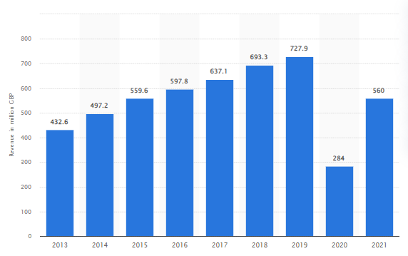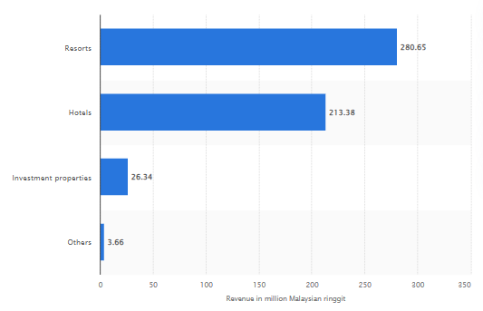
Figure 1: Comparison of revenue of Travelodge and Shangri-La
(Source: Statista, 2020)
The above-mentioned image is the revenue of these two hotels i.e. Shangri-La and Travelodge Hotels. It is seen that Shangri-La Hotels has made most of its profits from its resorts and hotels which is about 493.58 million dollars. On the other hand, Travelodge has made about 560 million dollars in the year 2021.
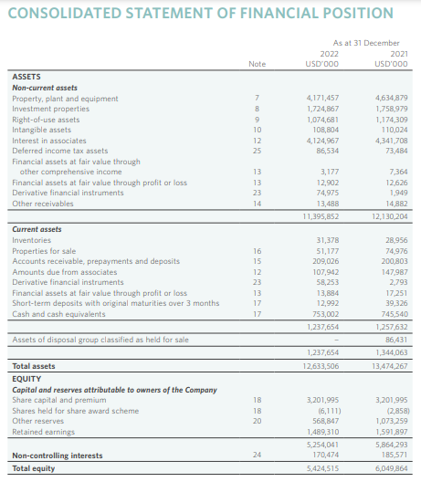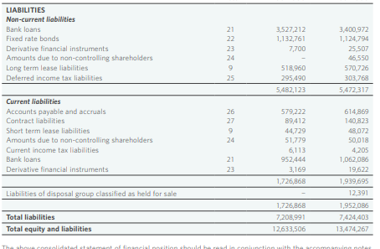
Figure 2: Financial position of Shangri-La Hotel
(Source: Shangri-La Group, 2024)
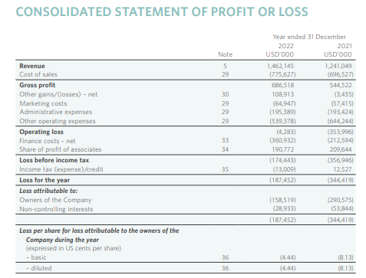
Figure 3: Profit and loss statement of Shangri-La Hotel
(Source: Shangri-La Group, 2024)
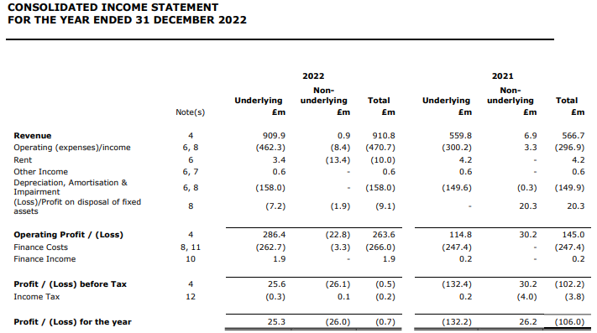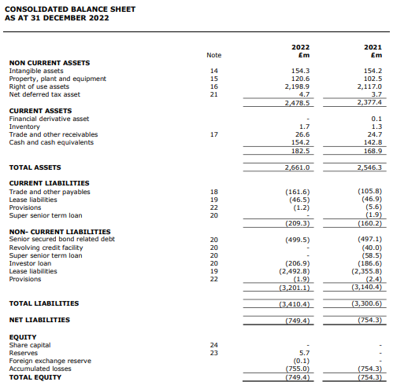
Figure 4: Financial position of Travelodge including Income statement and Balance sheet
(Source: Travelodge, 2024)

2. Market Position
In terms of market position both the hotels have come up with a large market share in their respective countries. They have a large and impactful presence which makes them relevant and strong in a very effective manner. Firstly, understanding the main components of marketing and how it is significant for businesses like this. The components are market position market share, customer demographics, and brand perception. However, the market position shows that the business is in which position how it can be improved and how it is benefiting the business. Moreover, market share is all about what percentage of share the hotel business has in the market as compared to their competitors. Customer demographic shows what type of customer the business targets and what the main demographics are. It can be their income, age, lifestyle and so on. Lastly, brand perception refers to brand awareness. It shows their brand image and how the business is serving the people to build a strong brand image.
Aspects | Shangri-La Hotels | Travelodge Hotels
Market position | The brand positions itself as a luxury destination. The business has high-end clients like business tycoons, celebrities and other sports stars. | The organisation positions itself in an affordable luxury range which is for business owners, and celebrities who are in their initial stages or not to pay more for a comfortable stay.
Market share | Shangri-La is a premium luxury hospitality organisation with a strong global presence of over 100 properties, catering to high-end customers and clients. It offers exceptional service (Shangri-La Group, 2024). | Travelodge has reported a record of financial results with revenue crossing Billions for the first time after its opening. Around 27% of customers use Travelodge in the UK (Travelodge, 2024). It indicates that the brand's position is high in the budget segment hotel market.
Customer demographic | Business travellers, young professionals and millennials in Greater China, Southeast Asia, Australia, Canada and Europe. | It has a mix of leisure and business customers, offering quality, affordable accommodation to a large customer base (Travelodge, 2024).
Brand perception | It is known for luxury, exceptional customer service, unique Asian hospitality and strong brand recognition (Shangri-La Group, 2024). | It is recognised for value-for-money accommodations, reliability and quality service appealing to budget-conscious travellers.
Table 2: Comparison of Shangri-La and Travelodge in terms of market position
(Source: Created by the learner)

3. Growth Potential
Almost every organisation needs to grow in terms of making profits, making a strong brand image and so on. It will assist the brand to make a strong market position as well as allow it to gain massive recognition in the market (Athari and Bahreini, 2023). In this context, the growth potential has been incorporated in the businesses of hospitality organisations named Shangri-La and Travelodge Hotels. These are the major hospitality brands providing quality service as well as allowing them to gain massive recognition within the sector. The growth potential has been incorporated by including these aspects examining expansion strategies, market opportunities, and potential barriers to growth.
Aspects | Shangri-La Hotels | Travelodge Hotels
Examining expansion strategies | The business is actively expanding its global presence via acquisitions of new property developments. The business is also targeting growth opportunities in key markets globally. The main priority is emerging markets. | The organisation is focusing on expanding its hotel portfolio within the UK and Spain via new openings. It will leverage its brand recognition and value propositions to drive growth in the budget hotel category. It will allow the brand to gain more market share effectively.
Market opportunities | The brand is capitalising on the increasing or growing demand for super luxury accommodations and experiences worldwide. The organisation is expanding into new and popular geographic regions with full potential and strategies. | The organisation is benefiting from the increasing demand for affordable range and quality hotel options in the United Kingdom and Europe. The hotel brand is targeting both leisure and business travellers and asking for value-for-money accommodations within these countries (Magazzino et al., 2023).
Potential barriers to growth. | The main barriers are extreme competition in the markets which are other luxury hotels champion brands. Adapting to changing customer demand and technological advancements is not an easy task for this brand globally. | The business is maintaining potential and managing costs in a very competitive market is difficult. Potential saturation of the budget hotel category in the UK and Europe.
Growth Potential | The growth potential of this hotel brand is high. As it majorly focuses on luxury experiences, worldwide presence, and strong brand recognition. All of this positions it well for continued growth in the high-end hotel market Magazzino et al., 2023). | The growth potential of this hotel brand is moderate. As it offers budget segment hotels it encounters some challenges in a highly competitive market.
Table 3: Comparison of Shangri-La and Travelodge in terms of growth potential
(Source: Created by the learner)

4. Financial Commitment to CSR (Corporate Social Responsibility)
The hotel organisation has some financial commitments to CSR which will help to gain massive recognition as well as help to build a successful business within the area.
Aspects | Shangri-La Hotels | Travelodge Hotels
CSR structure and reporting | Shangri-La has launched a two-year development strategy to improve its CSR activities and formalise its CSR structure for growth. The organisation has also launched its comprehensive sustainability report “Enhance, Enrich, Embrace” (Shangri-La Group, 2024). Majorly covering its progress in environmental protection and resource management. | The organisation also has a good CSR which is protecting nature and its elements very effectively. The business has incorporated three major key aims for sustainability plans. “Inclusive, Caring and Conscious”. These will allow the business to gain massive recognition within the area (Alatawi et al., 2023).
Environmental initiatives | The hotel organisation has incorporated major environmental initiatives. “Lowering single-use plastics, installing in-room filtered water taps, and promoting biodiversity conservation” (Shangri-La Group, 2024). | The hotel organisation has also followed environmental initiatives which will allow it to gain massive recognition within the area. The organisation tends to reduce its carbon emissions and manage energy consumption within the area.
Employee and community engagement | The organisation is treating their employees fairly and allowing them to gain massive opportunities (Lee et al., 2023) This opportunity for personal and professional growth will foster a diverse and inclusive workplace for all. | Travelodge also promotes an inclusive and healthy environment for all. The HR department of the organisation is responsible for the management of its workplace and training its employees to maintain a proper inclusive atmosphere within the business (Travelodge, 2024). The business also promotes employee growth by providing several initiatives for personal and professional development.
Supply chain management | The hotel business works with its supply chains to take care of its direct and indirect environmental impact and requires suppliers to meet local legal requirements related to the environment. | Travelodge is one of the major businesses which has good supply chain management. The business makes sure that the hotels are full of resources and also make sure they impact the area positively (Alatawi et al., 2023). The organisation manages its internal and external management of resources with effective supply chain management.
Table 4: Comparison of Shangri-La and Travelodge in terms of Financial Commitment to CSR
(Source: Created by the learner)
It is understood that both organisations have good CSR policies which will allow the organisation towards long-term growth. Both organisation has to incorporate Triple Bottom Line which is social, environmental, and financial. Additionally, this will allow the organisations to gain massive recognition while maintaining sustainability and improved financial performance.

Recommendations
It is seen and understood that both businesses have a massive impact within the sector which allows them to build a successful business. The organisation has strong financial growth and it needs adequate planning in terms of managing the business very effectively. Some of the recommendations have been provided for both organisations for long-term growth.
Shangri-La Hotels- The organisation focuses on expanding its presence in growing and emerging markets to sponsor the rising demand for luxury accommodations globally. The hotel organisation has to focus on a cost leadership strategy while gaining more customer attention in some other countries of the world. The particular strategy will allow the organisation to offer their service at a very reasonable rate yet it is high in quality (Ghazi et al., 2024). Additionally, it is understood that the business has a strong brand image and reputation for exceptional service which can be leveraged to penetrate new and emerging geographic locations in several countries. However, Shangri-La's present global footprint is very professional and it has gained major markets like China, Southeast Asia and so on.
Travelodge Hotels- The business has to explore opportunities for strategic outsourcing of non-core business functions to enhance business operations. To develop a strong brand image Travelodge has to implement advanced technologies within the organisation to provide effective customer service in the budget hotel category (Zientara et al., 2023). It is understood that outsourcing non-core functions like IT support, human resources or facility management. All of these have to be acquired by the business which will help to gain massive recognition within the sector.

Conclusion
Overall, it is understood that both the hotels which are Shangri-La and Travelodge have their own capabilities in terms of financial aspects. They have different financial revenue and profit margins in several countries. However, Shangri-La is one of the major luxury hotel chains across various countries. Travelodge lies in an affordable and targeted budget range of customers across the UK, Ireland and Spain. These are the major insights of these hotels in the context of financial management.

References
Alatawi, I.A., Ntim, C.G., Zras, A. and Elmagrhi, M.H., (2023). CSR, financial and non-financial performance in the tourism sector: A systematic literature review and future research agenda. International Review of Financial Analysis, p.102734.
Athari, S.A. and Bahreini, M., (2023). Does economic policy uncertainty impact firms’ capital structure policy? Evidence from Western European economies. Environmental Science and Pollution Research, 30(13), pp.37157-37173.
Ghazi, K.M., Salem, I.E., Dar, H. and Elbaz, A.M., (2024). Leveraging strategic leadership for boosting operational resilience in hotels: the role of crisis response strategies and e-readiness. International Journal of Contemporary Hospitality Management.
Lee, S., Yeon, J. and Song, H.J., (2023). Current status and future perspective of the link of corporate social responsibility–corporate financial performance in the tourism and hospitality industry. Tourism Economics, 29(7), pp.1703-1735.
Magazzino, C., Adedoyin, F.F., Bilgili, F. and Shahzad, U., (2023). If tourism induces the EKC hypothesis, how does governance moderate its impact in the EU without the UK?. International Journal of Sustainable Development & World Ecology, 30(6), pp.685-698.
Shangri-La Group, (2024). Our Presence. [Online] Shangri-la.com. Available at: <https://www.shangri-la.com/group/> [Accessed on: 27 Apr. 2024].
Statista, (2020). Shangri-La Malaysia: revenue by business segment. [Online] Available at: <https://www.statista.com/statistics/1199674/shangri-la-malaysia-revenue-by-business-segment/> [Accessed on: 27 Apr. 2024].
Statista, (2020). Travelodge UK revenue 2020. [Online] Available at: <https://www.statista.com/statistics/429089/travelodge-total-revenue-united-kingdom-uk/> [Accessed on: 27 Apr. 2024].
Travelodge, (2024). Travelodge | Great value hotels throughout the UK & Ireland. [Online] Travelodge. Available at: <https://www.travelodge.co.uk/> [Accessed on: 27 Apr. 2024].
Zientara, P., Adamska-Mieruszewska, J. and Bąk, M., (2023). Unpicking the mechanism underlying hospitality workers’ intention to join a union and intention to quit a job. Evidence from the UK. International Journal of Hospitality Management, 108, p.103355.

