
Program: Master of Business Administration
Module Name: Human Capital Management
Module Code: LCMB7023
Module Lecturer: Eno Maycock
Designing A Human Capital Architecture for Strategic Renewal
Student Name: Kirti Kalpeshkumar Patel
Student Id: 2537200

Table of Contents
1. Introduction 3
TASK A: SOCIALISATION, IDENTITY & BUSINESS ACTIVISM 3
2. Critical Evaluation of Traditional Onboarding vs Strategic Organisational Socialisation 3
2.1 Traditional Onboarding 3
2.2 Strategic Organisational Socialisation 4
3. Design a Structured Socialisation Framework for HUM 8
4. Developing Organisational Identification, Ethical Professionalism and Business Activism 9
4.1 Organisational Identification 9
4.2 Ethical Professionalism 10
4.3 Business Activist Mind-set 10
TASK B: JOB DESIGN 11
5. Innovative Job Design Strategy 11
5.1 Job Characteristics Model (Hackman & Oldham) 11
5.2 Job Crafting Theory 12
5.3 Skills-Based Architecture 13
6. How the Design Stimulates Motivation and Support Innovation 14
6.1 Intrinsic Motivation (Self-Determination Theory) 14
6.2 Innovation Outcomes 15
6.3 Critical Discussion 15
TASK C: REFLECTIVE REPORT 16
7. Using AI as a Decision-Support Tool Without Eroding Human Judgement 16
8. Personal Capability Development Plan 16
9. Conclusion 17
References 18
Appendices 22
Appendix 1: Difference between traditional onboarding and strategic organisational socialisation 22
Appendix 2: Strategic Socialisation Framework at HUM 23
Appendix 3: Personal Capability Development Plan 24

1. Introduction
The purpose of the report is to evaluate in which way a strategic human capital architecture addresses attrition challenges, on boarding, and engagement at the firm Helios Urban Mobility. It targets to raise future HR capability development, job design and socialisation to aid organisational renewal.

TASK A: SOCIALISATION, IDENTITY & BUSINESS ACTIVISM

2. Critical Evaluation of Traditional Onboarding vs Strategic Organisational Socialisation

2.1 Traditional Onboarding
Traditional onboarding is usually an administratively driven sort of procedure, and it’s meant to make sure things are compliant and that people are ready to work right away. It tends to be characterised by basic role-related training, health and safety requirements, employment contracts, and those formal induction sessions which follow organisational policies (Pinco et al. 2025, p.1).

Figure 1: Traditional Onboarding Characteristics
(Source: Self-Developed)
Strengths
In the point of view of strength, this traditional onboarding is scalable and cost-effective, and in the Helios Urban Mobility context, traditional onboarding includes the standardised orientation session as they run their business within Singapore, Berlin and London, covering data governance (such as GDPR compliance), cyber security awareness and AI system usage protocols therefore, it empowers the Helios Urban Mobility employees for rapid deployment to handle their operational roles and it is key in the evolving technology environments (Frögéli et al. 2025, p.12).
Limitations
In contrast, limitations arise as onboarding programmes concentrate basically on administrative orientation, and it has not met the cultural understanding and organisational commitment. As a result, these sometimes decrease psychological attachment, weak social implementation and passive learning behaviours (Alovius, S., 2023, p.13). In the context of the Helios Urban Mobility, high graduate attrition and an eight-month ramp-up period emphasised that staff are not change-efficient within productive organisational members.

2.2 Strategic Organisational Socialisation
On the other hand, strategic organisational socialisation prioritises onboarding through its extension within sustainable development procedures that concentrate on commitment formations, cultural alignment and identity construction (Chowdhury et al. 2022, p.1). The socialisation framework by Van Maanen and Schein’s (1979) offered a design lens by which firms can restructure efficient implementation procedures.

Figure 2: Socialisation tactics
(Source: Self-Developed)
A collective approach, in the context of Helios Urban Mobility, is accurate as graduate cohorts are socialised jointly to share the identity and establish peer learning networks (Arras-Djabi et al. 2025, p.4). Besides that, a formal approach is needed primarily for the reason of the AI-empowered mobility systems' complexity, but it must change within informal learning to influence innovation and autonomy.
The sequential structure should be employed to maintain transparency around the levels of career progression, and it lessens any ambiguity young employees experience when first entering the job. Therefore, a fixed timeline of levels has added to the predictability of work and to the tracking of individual performance (30-60-90-day review process) (Chong et al. 2024, p.1). The serial approach is required to maintain a process for the transfer of knowledge in geographically dispersed international teams through mentorship of young hires by veteran staff. The investiture approach must be implemented, as this acknowledges the previous academic backgrounds and existing skills of highly educated graduates and builds psychological safety.
Psychological Contract Theory

Figure 3: Psychological Contract Theory
(Source: Self-Developed)
Rousseau (1995) introduced the Psychological Contract Theory, which emphasised the implicit expectation among the employees and employers (Wibowo, 2022, p.149). Therefore, conventional onboarding sometimes develops a misalignment among the actual experience and promised organisational culture that drives the psychological contract breach. In the context of the Helios Urban Mobility, this mismatch contributes to the graduate turnover as purpose-driven work and expected structured development is expected by early career professionals.
Identity Construction Theory

Figure 4: Identity construction theory
(Source: Self-Developed)
Identity construction theory emphasises that staff develop both organisational and professional identities with the help of the meaning-making and social interaction procedure (Nguyen and Ngo, 2025, p. 3488). As per this model, when onboarding is weak, staff face issues in implementing their professional identity with the firm's actual purpose. However, when firms like HUM's values line up with individual aspirations like smart mobility, innovation and sustainability, staff of Helios Urban Mobility are more likely to develop long-term commitment and strong organisational identification.
Overall judgement
From analysing Appendix 1, it has been demonstrated that Helios Urban Mobility needs a strategic socialisation approach as its performance challenges are related to identity and engagement, not operational. Therefore, identity-driven implementation can raise long-term productivity and decrease attrition.

3. Design a Structured Socialisation Framework for HUM
A well-designed socialisation framework is offered to address Helios Urban Mobility onboarding inefficiencies that systematically accumulate over time, connections and established competence found in Appendix 2.
Stage Analysis
In the time of the pre-boarding stage, decreasing the uncertainty and managing expectations, mainly for graduate hires entering within a critical AI-related environment, is important. Research suggests that involving employees in the entry stage better contributes to higher retention rates and decreases cognitive shock when entering the organisation.
First 30 days: Formal learning: Employee takes time to understand both the technological aspect and the cultural context of the company. Mentoring is a key process during this phase that contributes to learning and reducing uncertainty.
Days 31-90: Contribution: Employee is actively involved in innovation projects and feels that his contributions align well with HUM’s tech-driven goals. Employees perceive a higher significance to the task (Khair et al. 2024, p.65).
Year One: Retention: Exposure to leaders and opportunity for internal career moves better support the employee's commitment.

Figure 5: Strategic Socialisation Journey at Helios
(Source: Self-Developed)
Justification
This model addresses directly the Helios Urban Mobility key issues through decreasing ramp-up time, strengthening organisational commitment and improving engagement. Therefore, through embedding identity formation within the design stages, Helios Urban Mobility changes to strategic human capital development from transactional onboarding.

4. Developing Organisational Identification, Ethical Professionalism and Business Activism

4.1 Organisational Identification
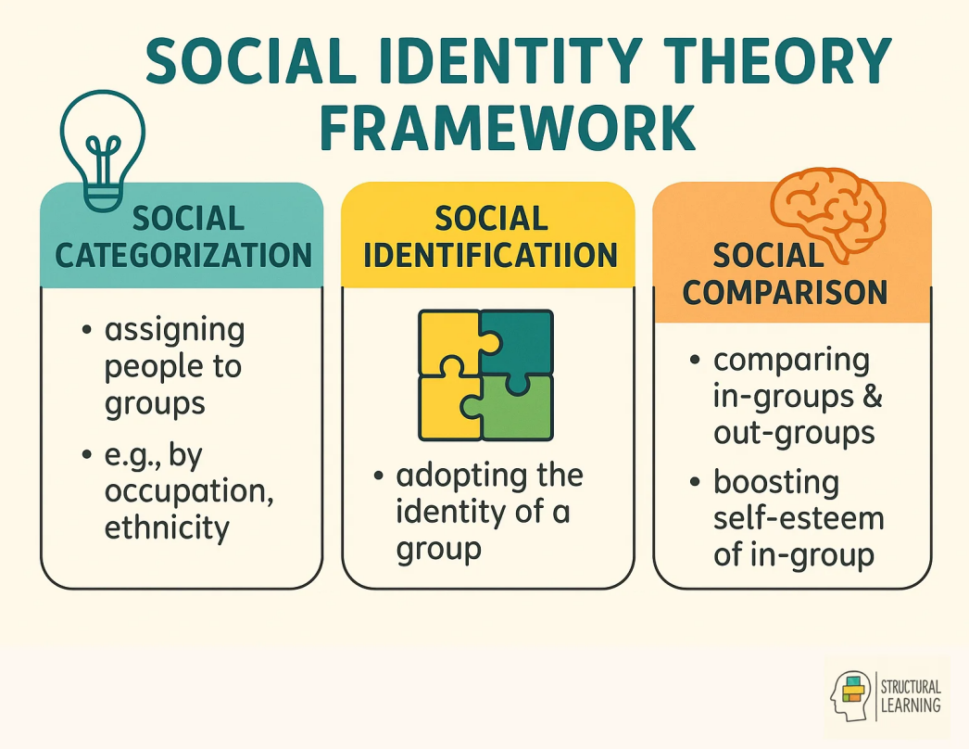
Figure 6: Social Identity Theory
(Source: Structural-learning, 2026)
Social Identity Theory emphasised that staff raise firm identifications when they experience a powerful sense of belonging and prioritise alignment (Structural-learning, 2026). In the context of Helios Urban Mobility, adopting this theory leads to internal collaboration, shared sustainability goals and purpose-driven communication that concentrates on smart mobility innovation, which decreases turnover and raises employee attachment.

4.2 Ethical Professionalism
In AI-enabled organisations like Helios Urban Mobility, Ethical professionalism is significant for the reason of their dependency on data-driven AI (El-Bassal et al. 2025, p.1). Therefore, staff within the organisation must be directed through leadership discussions, responsible AI principles and ethics training to give accuracy, transparency, accountability and link with the ESG expectations and raise stakeholders' trust.

4.3 Business Activist Mind-set
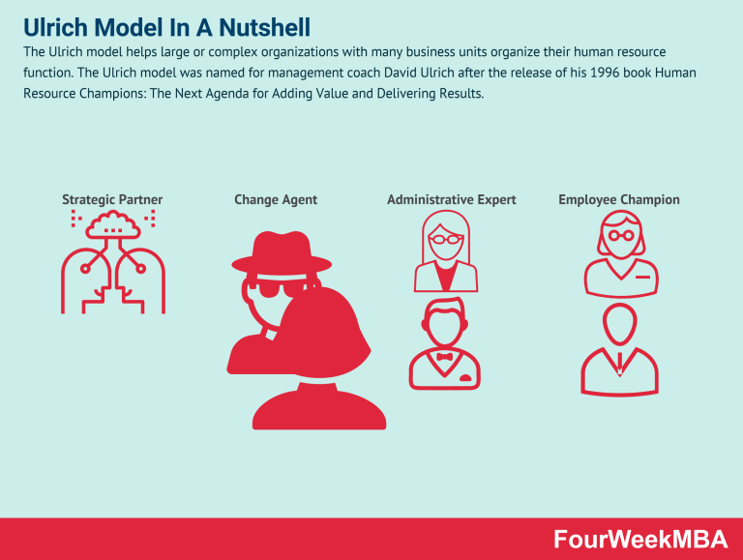
Figure 7: Ulrich Model
(Source: Structural-learning, 2026)
Ulrich’s HR evolution model supported the business activist mind set through outlining the transformation to a strategic partner from administrative HR that contributes to societal value and organisational value (Cuofano, 2024). In the context of Helios Urban Mobility, Ulrich’s HR evolution model illustrated that business activist mind-set acts as stakeholder advocates, innovation contributors, and sustainability champions. On the other hand, the stakeholder capitalism perspective gives assurance of value creation for the environment, employees, communities and governments, positioning Helios Urban Mobility as a responsible smart mobility innovator.

TASK B: JOB DESIGN

5. Innovative Job Design Strategy
Conventional job structures sometimes restrict innovation in fast-developing firms like Helios Urban Mobility, as AI-driven smart mobility strategies need continuous learning, collaboration and agility (Rouky et al., p.1). Therefore, slow down the innovation cycle, decrease cross-functional interaction, and flexibility is limited through the Fixed job descriptions. As a result, human entered and more dynamic job design approach is needed.

5.1 Job Characteristics Model (Hackman & Oldham)
Hackman & Oldham introduce the Job Characteristics Model, which offers a powerful foundation for restructuring roles to raise intrinsic motivation (Cuofano, 2024). Therefore, these models describe different dimensions such as skill variety and task identity. Task significance, autonomy and feedback.
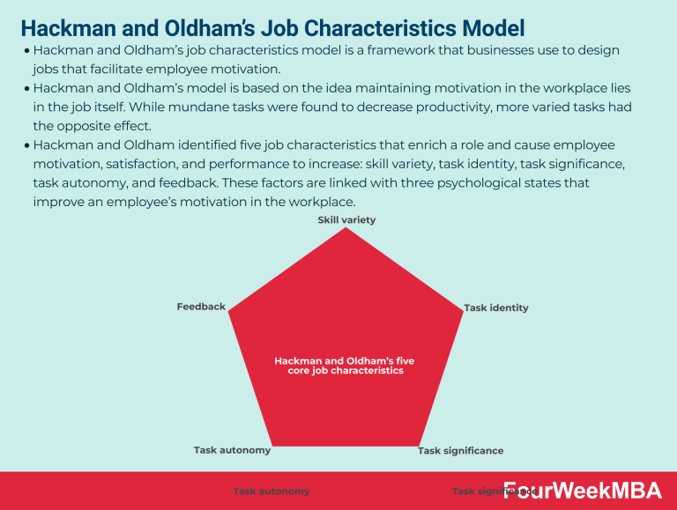
Figure 8: Job Characteristics Model
(Source: Cuofano, 2024).
Skill Variety: In Helios Urban Mobility, staff work with sustainability projects, urban mobility modelling, and AI analytics instead of narrow technical tasks (Meynhardt et al. 2024, p.23261). As a result, this decreases monotony and increases learning. Task Identity: Employees should own smart mobility solutions, complete components, traffic prediction models, and end-to-end development instead of fragmented tasks. Task Significance: Employees appreciate their work if they see that it has led to a reduction of pollution, congestion and enhanced transport efficiency of cities. Autonomy: Employees should be given autonomy to make decisions in the implementation of AI mobility solutions or experimentation to boost ownership and creativity. Feedback: Through performance analytics, city partnerships, and project dashboards, ongoing feedback promotes improvements in performance and learning.
On the contrary, implementation of this model comes with certain constraints in that it shows stable job designs and, in the case of Helios Urban Mobility, an environment in which AI keeps on transforming; this lack of flexibility is only achievable through adaptive measures (Iremadze, 2025, p.197).

5.2 Job Crafting Theory
Job Crafting Theory emphasised that staff within organisations emerge as active agents who redesign their jobs through meaning, relationships and altering tasks they attach to their work (Harju et al. 2024, p.68). Therefore, it raises the link among job demands and individual strengths and drives higher engagement and motivation. For example, Hitachi Rail has spent on urban rail signalling technology, which is almost C$100 million, that helps to raise the next generation, and it implements data analytics, cloud computing, 5G and AI that need collaboration among mobility planners, signalling experts, data specialists, and software engineers (Hitachi, 2024). It illustrated that on which way employees commit towards company and narrow job boundaries through engaging in cross-functional projects. It outlines the job crafting principles. In the context of the Helios Urban Mobility staff, like analysts and engineers, extend their responsibilities through engaging in sustainability projects and cross-functional innovations, which raise commitment and ownership.

Figure 9: Job Crafting Theory benefits
(Source: Self-developed).
In contrast, the adaptation of these models emerges with limitations, as in a coordinated and technical HUM atmosphere, unstructured and excessive job crafting misaligns the company's objectives and creates ambiguity (Kim, S.M., 2025, p.4). As a result, this job crafting must be directed through the transparency of managerial boundaries and linked with strategic goals that give assurance that flexibility raises instead ruin operational performance.

5.3 Skills-Based Architecture
Skilled based architecture known as a modern initiative that concentrates on the capabilities of organisational employees and their skills instead of fixed job titles (Nair et al. 2023, p.84). Rather than remaining in one particular position, employees shift roles among tasks and projects where their competencies are applicable; thus, the firms are better positioned to address emerging business demands. For instance, the firm Unilever implements an internal marketplace where it is known as Flex Experiences. Therefore, the platform empowers the staff to engage in cross-functional assignments, learning opportunities a short term projects depending on their skills instead of their formal job position (Bhalla et al. 2026, p.1). In the context of Helios Urban Mobility, adopting this approach would provide opportunities for employees to collaborate on sustainability projects, smart infrastructure, and AI where their expertise lies, boosting flexibility and employee growth. As a result, the firm Helios Urban Mobility get a chance to raise its internal mobility, employees' skill development and engagement opportunities.

Figure 10: Skill-based architecture helps employees
(Source: Self-developed).
In contrast, a skills-based architecture needs transparent governance and robust digital systems to restrict skills mismatches and give assured access to opportunities (Xu et al. 2026, p.5). Within Helios Urban Mobility, the mix of clear competency frameworks and continuous learning with a talent marketplace can raise innovation and retention.

6. How the Design Stimulates Motivation and Support Innovation

6.1 Intrinsic Motivation (Self-Determination Theory)
Self-Determination Theory emphasised motivation by relatedness, competence and autonomy (Gagné et al. 2022, p.1). Autonomy re-establishes jobs and offers freedom to employees to select projects, and within the HUM firm, autonomy is empowered through a skills-based talent marketplace and job crafting and permits the staff to select projects like smart city mobility analytics and AI-based traffic optimisation. Therefore, within this organisation, Competence is raised through building skills by working and within HUM, competence is raised with the help of the urban mobility projects, data analytics and AI within international hubs like Singapore and Berlin. At the end, relatedness is empowered with the help of the collaboration among the urban planners, data scientists and engineers working on shared smart mobility goals.
Through mitigating the three requirements, the job design raises intrinsic motivation and decreases dependency on external rewards, which helps the organisation in long-term engagement.

6.2 Innovation Outcomes
The proposed job design boosts innovation with the help of different mechanisms, like
Knowledge Sharing:
Skills-based mobility influences staff to shift across projects, across teams, and to raise knowledge diffusion
Continuous Learning:
Exposure to different projects gives assurance that employees constantly update skills associated with urban mobility and AI (Wajid Saad, 2025, p.1).

6.3 Critical Discussion
However, there are challenges in the new job design approach. Role ambiguity can be higher due to the lack of explicit role definitions, especially when a skills-based system is used. Therefore, manager resistance is also a potential problem, as they can be reluctant to lose the degree of control they traditionally have in designing work (Ofosu et al. 2023, p.1). There can be a substantial investment required in data management to support internal talent marketplaces.
These issues have been mitigated with the help of the
- AI-empowered talent platforms that align project needs with skills transparently
- Manager training to transform to coaching roles from control-based.

TASK C: REFLECTIVE REPORT

7. Using AI as a Decision-Support Tool Without Eroding Human Judgement
Within Human Resource Management, in my point of view, artificial intelligence is utilised widely to aid serious decision-making in particular areas like employees Management analysis, workforce planning and recruitment (inspired by Rodgers et al. 2023, p.1). I also see a risk through over-dependence upon artificial intelligence resulting in decreased human judgement, contextual understanding loss, and algorithmic bias in critical people-associated decisions.
In my daily life, I will utilise artificial intelligence to get support in my decision-making instead of being the decision-maker. As the artificial intelligence assist to predict the turnover risk and shortlisting candidates, but organisational HRs take final decisions by applying their contextual insights. I assure that artificial intelligence outputs are reviewed with the help of ethical evaluation and human oversight to restrict discriminatory outcomes and unfair results. The management is important to manage trust, transparency and fairness in the HR process.

8. Personal Capability Development Plan
In terms of capability development to improve my future employability in HR, I have found key areas that I need to work on. To improve my data literacy, I intend to finish training in tools like HR analytics and Power BI in the next 6 months, which would help me to analyse workforce data and present information for better decision-making [refer to appendix 3]. Therefore, I tried to raise my expertise in areas like AI that also help in HR to gain certification, and it concentrates on the application of AI in talent management and recruitment. It will take almost six months and will assist me in gaining knowledge about AI and how it is ethically implemented within HR systems.
To raise my strategic influencing skills, I tried to join the communication and leadership workshops, and it will take time of almost 1 year. These will empower me to encourage and engage stakeholders efficiently in companies' serious decision-making (inspired by Teng and Yue, 2023, p.1). Lastly, to increase my understanding about global mobility, I intend to conduct research on the topic through reading and studying case studies on different countries and regions in the next twelve months.
At the end, these capabilities will help me prepare as a future HR professional, and I will become able to mix global awareness, strategic insight and analytical thinking in continuous changing digital workplace.

9. Conclusion
It is concluded that the traditional onboarding approaches have been utilised within industries for the reason of scalability and simplicity; their efficiency in developing sustainable employee engagement raises questions about contemporary HR studies. Moreover, conventional onboarding commits to disengagement through treating staff as functional resources in stated of identity building actor.

References
Alovius, S., (2023) Utilization of Digitalization in the Onboarding Process: Case study. Available at: https://osuva.uwasa.fi/bitstreams/63c0da04-4bcc-476a-b961-f2123a5a5a19/download (Accessed on: 6 June, 2026)
Arras-Djabi, M., Kuyken, K. and Shimada, S., (2025) ‘Organizational Socialization Tactics in Japan’, Management international= International management= Gestión internacional, pp.1-23. Available at: https://hal.science/hal-05423925/document
Bhalla, M., Pandey, A., Verma, R. and Thakur, S., (2026) ‘Technology’s Role in Enhancing Employee Experience’, Available at: https://www.researchgate.net/profile/Ruchi-Verma-23/publication/404209787_Technology's_Role_in_Enhancing_Employee_Experience/links/69fc525c39e45e75a6dc0580/Technologys-Role-in-Enhancing-Employee-Experience.pdf
Chong, J.X., Gagné, M., Dunlop, P.D. and Wee, S., (2024) ‘Facilitating newcomer motivation through internalization: A self-determination theory perspective on newcomer socialization’, Human resource management review, 34(4), p.101041. Available at: https://www.sciencedirect.com/science/article/pii/S1053482224000317
Chowdhury, S., Budhwar, P., Dey, P.K., Joel-Edgar, S. and Abadie, A., (2022) ‘AI-employee collaboration and business performance: Integrating knowledge-based view, socio-technical systems and organisational socialisation framework’, Journal of business research, 144, pp.31-49. Available at: https://nul.repository.guildhe.ac.uk/id/eprint/1138/1/1-s2.0-S0148296322000819-main.pdf
Cuofano., G (2024) 5 Core Job Characteristics That Boost Employee Motivation. Available at: https://fourweekmba.com/job-characteristics-model/ (Accessed on: 6 June, 2026)
Cuofano., G (2024) Ulrich Model In A Nutshell. Available at: https://fourweekmba.com/ulrich-model/ (Accessed on: 6 June, 2026)
El-Bassal, N.A.M., El-Sayed, A.A.I. and Elgamal, H.G., (2025) ‘Empowering nurses in the AI era: investigating the interplay between professionalism, AI readiness, and self-efficacy’, BMC nursing, 24(1), p.1287. Available at: https://link.springer.com/content/pdf/10.1186/s12912-025-03896-y.pdf
Frögéli, E., Jenner, B. and Gustavsson, P., (2023) ‘Effectiveness of formal onboarding for facilitating organizational socialization: A systematic review’, PloS one, 18(2), p.e0281823. Available at: https://journals.plos.org/plosone/article/file?id=10.1371/journal.pone.0281823&type=printable
Gagné, M., Parker, S.K., Griffin, M.A., Dunlop, P.D., Knight, C., Klonek, F.E. and Parent-Rocheleau, X., (2022). Understanding and shaping the future of work with self-determination theory,’ Nature reviews psychology, 1(7), pp.378-392. Available at: https://www.nature.com/articles/s44159-022-00056-w.pdf
Harju, L.K., Tims, M., Hakanen, J.J. and Khapova, S.N., (2024) ‘Crafting for oneself while considering others: How the relational design of work shapes job crafting’,The InTernaTIonal Journal of human resource managemenT, 35(1), pp.67-97. Available at: https://research.vu.nl/files/362105526/Crafting_for_oneself_while_considering_others_how_the_relational_design_of_work_shapes_job_crafting.pdf
Hitachi (2024) Hitachi Rail invests C$100M+ in next gen urban rail signalling technology. Available at: https://www.hitachi.com/en-us/press/hitachi-rail-invests-c100m-plus-in-next-gen-urban-rail-signalling-technology/ (Accessed on: 6 June, 2026)
Iremadze, M., (2025) ‘PROMOTING VOLUNTEER MOTIVATION AND ENGAGEMENT USING THE AMO MODEL AND JOB CHARACTERISTICS MODEL’, Available at: https://admin.vectors.ge/custom-files/1766145968_17-MARIAM%20IREMADZE.pdf
Khair, H., Annisa, N., Pratiwi, R. and Rozak, A., (2024) ‘Leader-member exchange, perceived organisational support and job satisfaction: Mediating role of employee engagement’, Jurnal Manajemen, 28(1), pp.64-87. Available at: https://www.ecojoin.org/index.php/EJM/article/download/1638/1021
Kim, S.M., (2025) ‘Extending job crafting theory to precarious workers: a model of organizational job crafting for organizational justice’, International Journal of Organization Theory & Behavior, 28(1), pp.1-17. Available at: https://www.emerald.com/ijotb/article-pdf/28/1/1/9685277/ijotb-09-2023-0188.pdf
Meynhardt, T., Hermann, C. and Bardeli, J., (2024) ‘Connecting value creation for society with work engagement: the relevance of an organization’s public value as an extension of the job characteristics model’, Current Psychology, 43(27), pp.23260-23277. Available at: https://link.springer.com/content/pdf/10.1007/s12144-024-05922-9.pdf
Nair, S., Kaushik, A. and Dhoot, H., (2023) ‘Conceptual framework of a skill-based interactive employee engaging system: In the Context of Upskilling the present IT organization’, Applied Computing and Informatics, 19(1-2), pp.82-107.Available at: https://www.emerald.com/aci/article-pdf/19/1-2/82/39144/j_aci_2019_05_001.pdf
Nguyen, M.H. and Ngo, X.M., (2025) ‘An activity theory perspective on Vietnamese preservice English teachers’ identity construction in relation to tensions, emotion and agency’, Language Teaching Research, 29(8), pp.3486-3506. Available at: https://journals.sagepub.com/doi/pdf/10.1177/13621688221151046
Ofosu, R., Agyemang, E.D., Márton, A., Pásztor, G., Taller, J. and Kazinczi, G., (2023) ‘Herbicide resistance: managing weeds in a changing world’, Agronomy, 13(6), p.1595. Available at: https://www.mdpi.com/2073-4395/13/6/1595
Pinco, O., Salanta, I.I., Beleiu, I.N. and Crisan, E.L., (2025) ‘The onboarding process: a review’, Vilakshan-XIMB Journal of Management, 22(1), pp.2-13. Available at:https://www.emerald.com/xjm/article-pdf/22/1/2/10061544/xjm-01-2024-0008.pdf
Rodgers, W., Murray, J.M., Stefanidis, A., Degbey, W.Y. and Tarba, S.Y., (2023) ‘An artificial intelligence algorithmic approach to ethical decision-making in human resource management processes’, Human resource management review, 33(1), p.100925. Available at: https://www.sciencedirect.com/science/article/pii/S1053482222000432
Rouky, N., Benmoussa, O., Fri, M., Abourraja, M.N. and Ben-Bouazza, F.E., (2025) ‘Artificial Intelligence Applications for Smart and Sustainable Mobility as a Service Concept: A Systematic Literature Review’, Future Transportation, 5(3), p.122. Available at: https://www.mdpi.com/2673-7590/5/3/122
Structural-learning (2026) Social Identity Theory: How Groups Shape Learner Behaviour. Available at: https://www.structural-learning.com/post/social-identity-theories (Accessed on: 6 June, 2026)
Teng, M.F. and Yue, M., (2023) ‘Metacognitive writing strategies, critical thinking skills, and academic writing performance: A structural equation modeling approach’, Metacognition and Learning, 18(1), pp.237-260. Available at: https://files.osf.io/v1/resources/6rzkv/providers/osfstorage/63860449723a111d4618c9ef?format=pdf&action=download&direct&version=1
Wajid Saad, W.J., (2025) ‘Artificial Intelligence in Urban Transportation and Construction Projects: Enhancing Change Management and Safety Regulations for Smart Cities’, Available at: https://www.researchgate.net/profile/Fakhar-Abbas-20/publication/392708493_Artificial_Intelligence_in_Urban_Transportation_and_Construction_Projects_Enhancing_Change_Management_and_Safety_Regulations_for_Smart_Cities/links/684eebdddf3fa4286a40d383/Artificial-Intelligence-in-Urban-Transportation-and-Construction-Projects-Enhancing-Change-Management-and-Safety-Regulations-for-Smart-Cities.pdf
Wibowo, T.S., (2022) ‘Psychological contract theory relation to organizational citizenship behavior (OCB) of flight attendants’, International Journal of Science, Technology & Management, 3(1), pp.144-152. Available at: https://ijstm.inarah.co.id/index.php/ijstm/article/download/445/397
Xu, R. and Yan, Y., (2026) ‘Agent skills for large language models: Architecture, acquisition, security, and the path forward’, arXiv preprint arXiv:2602.12430. Available at: https://arxiv.org/pdf/2602.12430

Appendices

Appendix 1: Difference between traditional onboarding and strategic organisational socialisation
Traditional Onboarding | Strategic Socialisation
Compliance-focused | Identity-focused
Short-term orientation | Long-term integration
Information transfer | Commitment creation
The staff adapts to the system | The staff becomes part of the system
(Source: Self-developed)

Appendix 2: Strategic Socialisation Framework at HUM
Stage | Objectives | Key Activities | Expected Outcomes
Pre-Boarding | Reduce uncertainty | - Digital onboarding portal,  - Learning roadmap  - CEO welcome video | Psychological preparedness,
First 30 Days | Role clarity | - Structured induction,  - Cross-functional exposure  - Team immersion, | Faster adaptation
Day 31–90 | Capability development | - Innovation projects,  - Peer collaboration | Increased confidence
Year One | Career development | - Leadership shadowing,  - Career planning, | Talent retention
(Source: Self-developed)

Appendix 3: Personal Capability Development Plan
Capability | Current Position | Development Activities | Timeline
Data Literacy | Moderate | Power BI, Analytics Courses | 6 Months
AI in HR | Basic | AI-HR Certifications | 6 Months
Strategic Influencing | Moderate | Leadership Workshops | 12 Months
Global Mobility Awareness | Limited | International HR Research | 12 Months
(Source: Self-developed)

