
Engine Performance Characteristics
Callum Clement

Semester 2

Motorsport Technology
Andrew Harrison

2400570

Contents Page
Introduction 2
Evaluation 3
Conclusion 6
Reference List 7
Appendix 8

Introduction

This assignment will cover information gathered from a dyno test and with that data several graphs and charts will be produced making a comparison between SFC, torque and break power all against engine speed. Data such as corrected power, torque, BMEP, SFC and overall thermal efficiency will be calculated.

A written evaluation will be produced covering the aims for the test, the equipment and method used. It will contain all data results tables and graphical results and will include a conclusion for the test and how the test could have been improved.

Evaluation

A dyno test is used to calculate an engines power, torque and other factors. Our test aims are to collect engine data calculated from the dyno load and rpm and also to calculate the SFC and thermal efficiency based on our calculations and the measured fuel that has been used.

The setup used at UWTSD consists of a dynamometer, the engine which is being tested, sensor recording modules to provide the engine data and other fitted sensors to the computer, an exhaust extraction system which vents the engine exhaust gases out of the room making it safe to be in the room without breathing in the gases and a fuel supply board which measures the rate of fuel provided to the engine.

The fuel supply board uses a lift pump to extract the fuel from a fuel storage through a filter and then goes through a flow rate meter to the secondary swirl pot which essentially stores an excess of fuel to ensure there is no fuel starvation. This then travels to the main fuel pump then to the engine through a regulator. Any returned fuel travels through the cooling plate back into the secondary swirl pot.

The engine used was a Honda D16 1.6L VTEC engine from the early 2000s which was an import low power model fitted with an aftermarket air filter, with no silencer fitted to the engine just an external silencer with the exhaust extraction system. Some sensors monitored are the coolant temperature sensor and the lambda sensor. The throttle is controlled by the throttle actuator box and reads the throttle position level. The engine is connected to the dynamometer directly from the crankshaft via a driveshaft.

The dynamometer is limited to 10,000rpm and 230Kw and is an eddy current dyno where the inner core spins freely and is turned by the engine and the outer casing is fed by a current producing an electromagnetic field to produce a load on the engine. The outer casing tries to turn and is restricted by a string gauge which sends a voltage signal between 0 and 10 volts, which is used to calculate the load. The dynamometer is cooled by a coolant system pumping fresh coolant from a tank on the roof with radiators and fans reducing the coolant temperature.

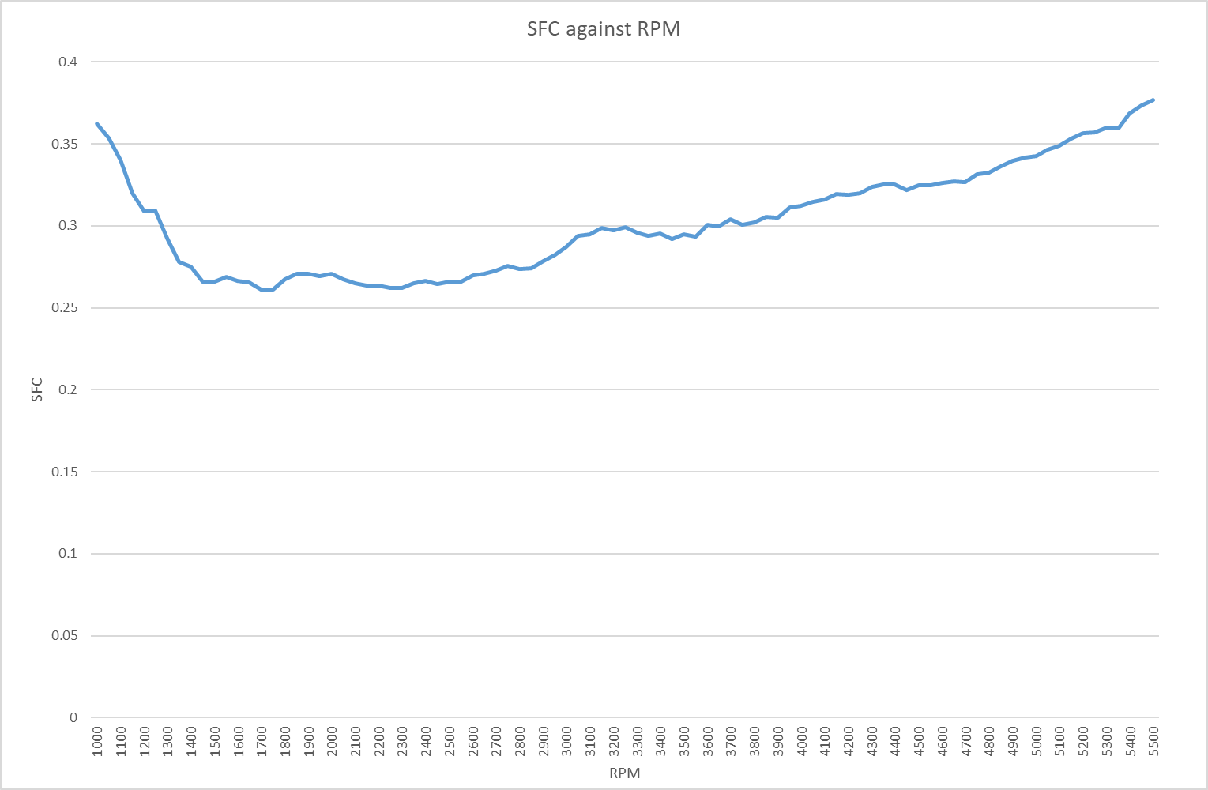
In figure 1 it shows a graph with SFC correlated against engine rpm. SFC meaning specific fuel consumption is the fuel rate required to produce a specific power output, the graph shows that it is significantly higher in the low rpms but also at the end as the rpm increases.
Figure 1
The main reasoning behind this is the air fuel mixture not providing an efficient combustion at the lower rpms where the mixture does not mix very well requiring a greater amount of fuel to produce the same level of power output and at the higher rpms the turbulent flow in the intake produces a poor and inefficient combustion.
It is also due to the frictional losses. At the low rpm the friction is high and with a low power output to overcome the frictional loss. At the mid-range rpms, the friction increases but the power output increases at a higher rate offsetting the frictional losses lowering the SFC but as the rpm reaches the higher ranges the power increase is negligible compared to the friction increase which then raises the SFC.

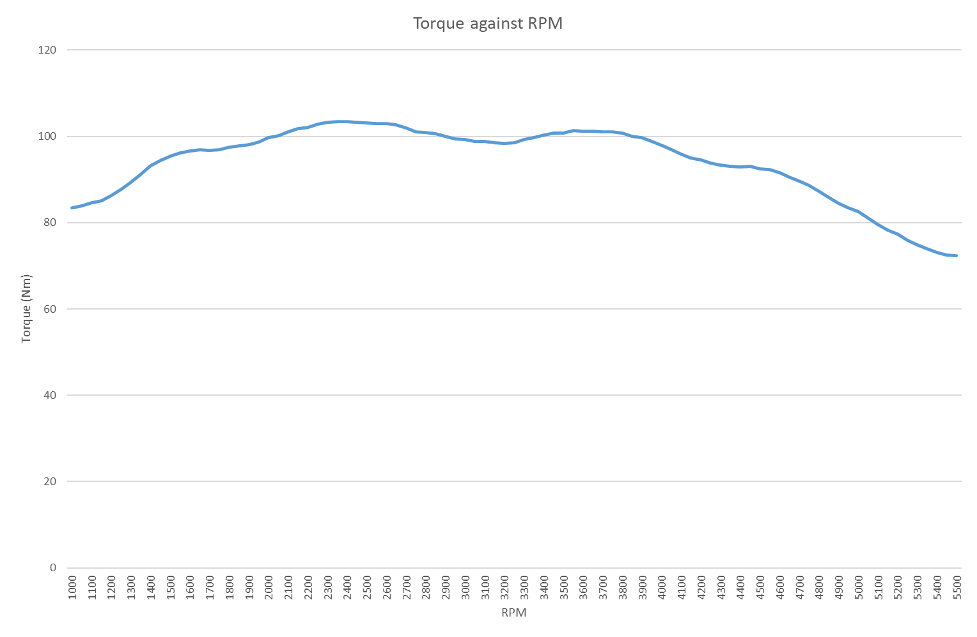
Figure 2 displays a graph showing torque against the rpm. The torque starts off around 80Nm of torque and slowly and steadily increases until around 2500rpm where it peaks and then decreases as the rpm increases. This is due to a few factors one simply being due to the efficiency of the combustion, the most efficient combustion is in the mid-range of rpm where you will have the highest torque and explains the drop off at the higher rpms. The main reason is due to volumetric efficiency which is the efficiency of the space available. Low rpms the engine is limited with the intake restrictions so the available space is not being completely utilized but this the efficiency increases above these low rpms and at the highest volumetric efficiency is where you will find the peak torque.
Figure 2

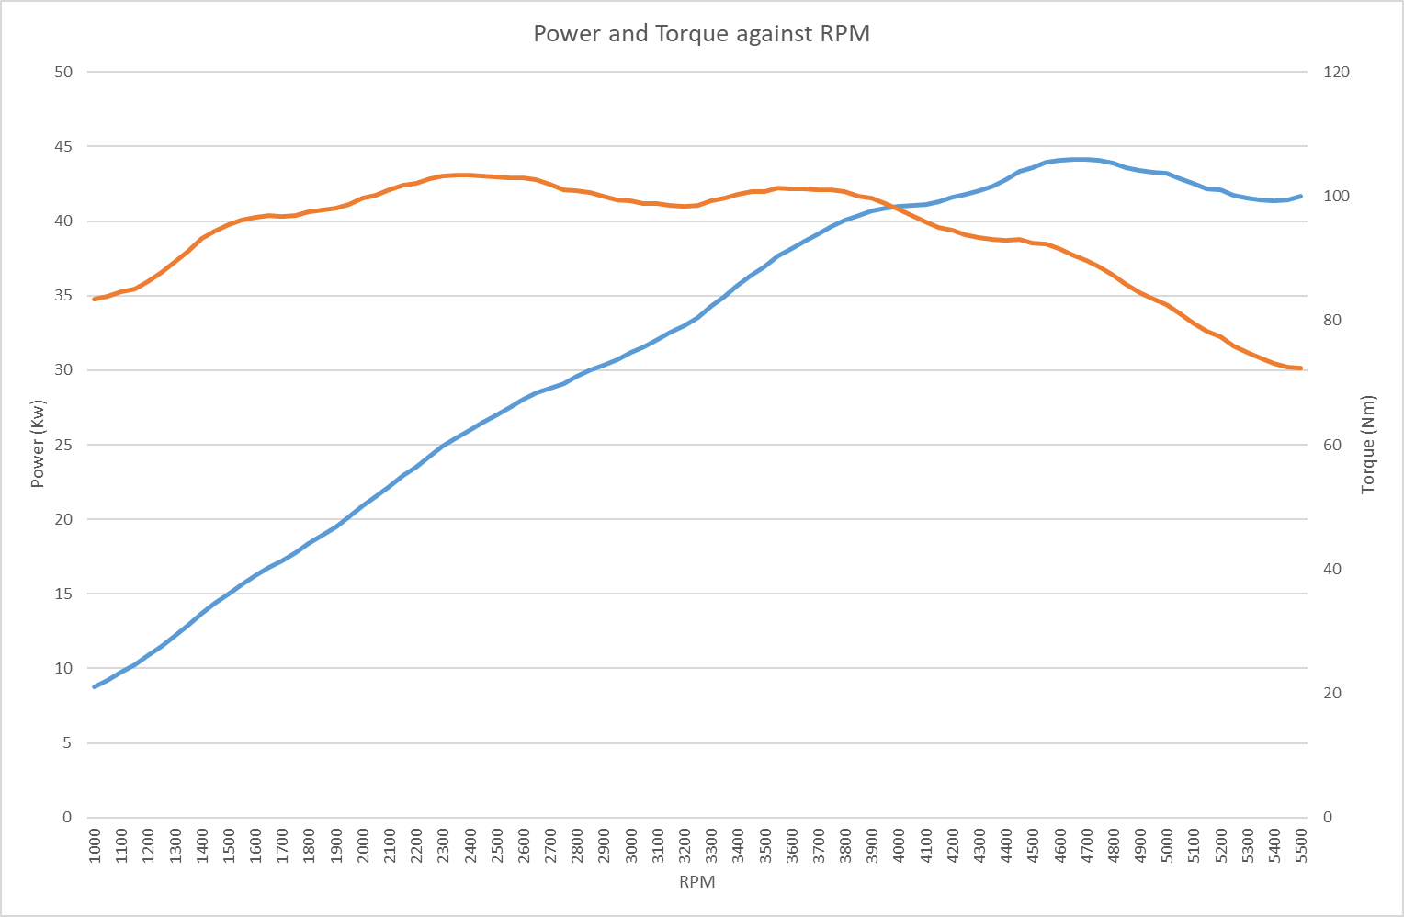
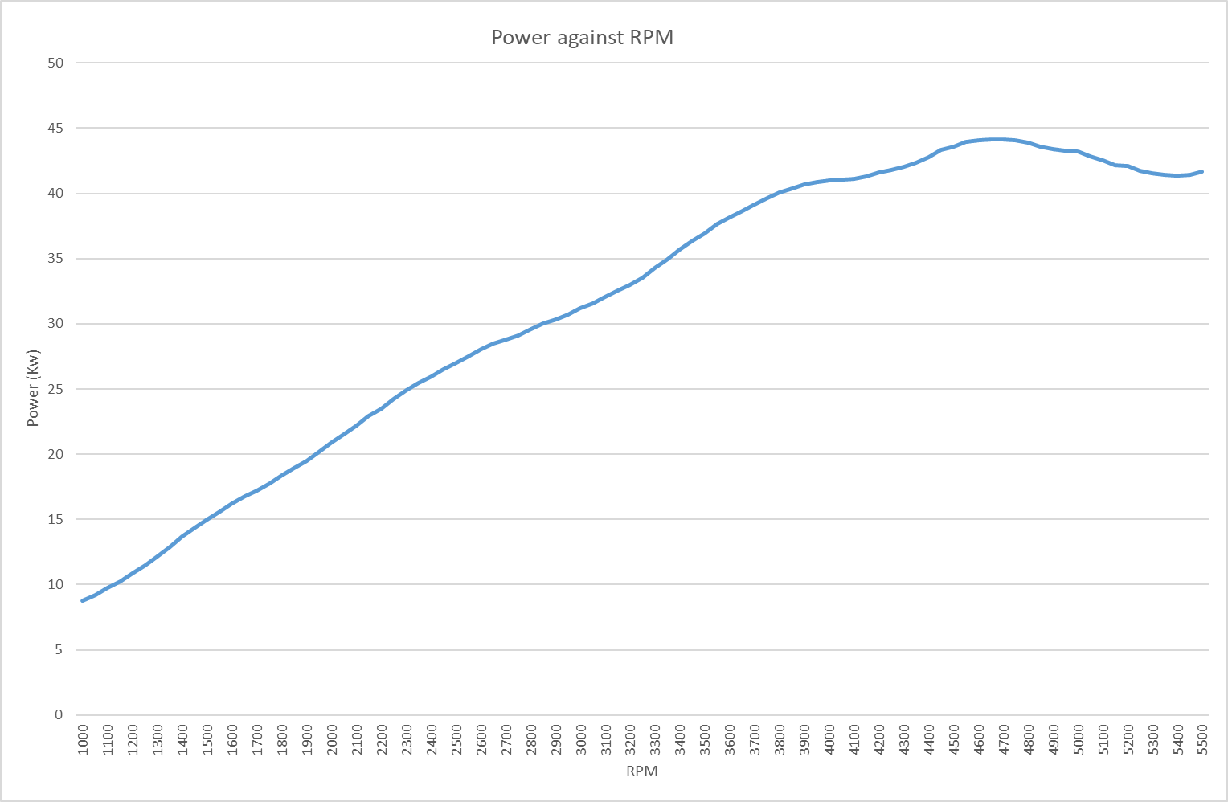
Figure 3 displays a graph showing power against rpm and the graph displays a very steady increase in power until around 4700rpm where the power peaks and then starts to fall off into the higher rev ranges. The power increases as the rpm increases, the volumetric efficiency increases allowing for a greater power output to be made by utilizing the full amount of space within the cylinder. At the higher rpms the engine is burning a higher volume of fuel in the same amount of time producing a greater output. In the higher rev ranges the power overcomes the increase in frictional losses which is why the increase initially is high but when it reaches high rpm around 4000rpm and above that increase is negligible compared to the friction.
Figure 4
Figure 4

Conclusion

From our collected data we can see that the engine is within the standard range for thermal efficiency peaking at 30% thermal efficiency and going as low as 21%. The engine does produce low torque and power levels, but the results are not alarming as this is an imported low power model and the thermal efficiency and SFC values support the torque and power numbers that we would expect.

Unfortunately, these results were not gathered ourselves as the dynamometer was not functional at the time of testing but these are previously gathered and accurate results. I feel as though even with this inconvenience I was able to use the data to calculate power, torque, SFC and thermal efficiency well but being able to physically perform the test and witness it would be a very big improvement overall on the test.

Reference List

'Torque and BHP explained' (2022) How a Car Works. Available at: https://www.howacarworks.com/technology/torque-and-bhp-explained
(Accessed: 27 March 2025)

Bosch, R. (2005) Automotive Handbook. 7th edition. Plochingen: Bentley Publishers

'Brake Specific Fuel Consumption (BSFC)' (2023) x-engineer.org. Available at:
https://x-engineer.org/brake-specific-fuel-consumption-bsfc/
(Accessed: 27 March 2025).

Appendix

Word Count – 1137 Words

