Bartosz Galantowicz

1700994

BSc Games Development

ACCA5012 Application Development

9th December 2019

Table of Contents

Introduction 3
Application Development Concepts 4
Cloud-based gaming 4
Requirements 6
The rules of the game 6
Design and Implementation 9
Start Scene 9
Levels 11
Scene Canvas 13
Characters and Items 15
Collision System 19
Camera 19
Evaluation 21
References 26
Bibliography 27

Introduction
The report is evidence of the knowledge in the field of application development that has been obtained for games development studies at the university. Besides, the main purpose of the report is the implementation and presentation programming skills and research methods for the given example. Therefore, the creation of the working, simple, 2d game is the objective. In the following report the modern, various application development concepts are disused focusing on the idea of cloud-based gaming. Moreover, the design of the application and each step of program development is contained in this document as well as its evaluation.

Application Development Concepts
Nowadays the games development industry is evolving together with technological changes. New inventions are used widely to improve man life, often one new idea is applied to the diversity of industries. Moreover, it is especially visible in the world of video games. Every day, developers try to find out and implement new original features to their games to catch the attention of potential customers and create new trends. If an invented idea became popular, then many video games studio try to experiment with it to release a profitable product. [1]
The list of the current trends in the game industry [1], [2]:
- Virtual Reality in gaming
- Mobile gaming
- Secondary screens for gaming
- Augmented reality
- Open-source gaming
- Blockchain-based games
- The rise of mini-games
- Games interaction with social media
- Popularisation of eSport
- Cloud-based games
- Mobile games for elderly
- Game streaming
- Popularisation of indie games

Cloud-based gaming
Modern AAA games shall impress the quality of graphics, and the companies take on each other to provide the best gaming experience, but it happens at the cost of minimum hardware requirements for the product. Thereby, game developers must consider the access of gamers to specific game machines and assess the market before they release a game. What is more, they may have an impact to increase sales of hardware and new generations of game consoles by the implementation of more realistic graphics and mechanics in games. Gamers demand more realism, more freedom of choices, more challenges and grand show for virtual reality.
Therefore, a new kind of service has been created – Cloud-based gaming, which may revolute games industry and open new ways to get around new recipients – the new trade area. Moreover, the technology uses internet connection to transfer what can be seen and heard during gameplay on the target device from the servers which are running the very game. Such a device may be a mobile phone, tv or any device which is internet enabled [3].
Cloud-based gaming is based on servers which are connected to gaming machines and handling the inputs and outputs requests from the user somewhere in the world and the sent data may not only be procced on personal games machines. The idea becomes very tempting for businessmen who found out the investment opportunity. PlayStation Now or GeForce Now are good examples of the brands who already achieved many and they are experimenting with cloud gaming. Namely, they created services which encourage people to pay some money for a huge library of games without bothering users with the minimal requirements of the newest productions by providing them with the entertainment via the Internet connection. Basically, it works similar to services which provide access to movies or series (e.g. Netflix, Amazon Video) [4].
Pros and Cons of the cloud-based gaming technology
Advantages | Disadvantages
No need for Expensive Hardware Investments or Upgrades | Video compression of the retrieved game’s output.
Play games on any operating system or device. | Cloud gaming services require a large amount of bandwidth. They may use more than 3 GB per hour in bandwidth.
Integrate gaming into TVs and other devices. | Cloud-based gaming has more latency than powerful personal hardware.
Instant playing because a game’s data is stored by servers.
Prevent illegal distribution of games.
Popularisation of video games.

Requirements
The game development idea is to create a simple 2D platformer game, which is programmed in the Unity game engine in C# programming language. Furthermore, the application must meet with the requirements for the given assignment.
The requirements of the application
- The application requirements:
- Allowing players to moth both directions.
- Creating a minimum three levels.
- Displaying player status.
- Objectives to achieve for the player.
- Randomly creation of the environment in the game.

The rules of the game
Player has control over the main character in the game. The hero can move, jump and shoot by using specific inputs from the keyboard and mouse.
Left Arrow, A – move player moves left.
Right Arrow, D – player moves right.
Up Arrow, W – player jumps.
Left Mouse Button – player shoots.
Throughout the gameplay, a user has to deal with enemies and obstacles. The player may use its adroitness to overcome the danger or just use its gun to destroy some of them. The game is lost if the player health is equal 0 or it falls down into a gap between platforms.
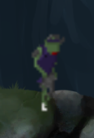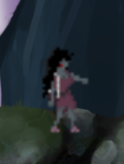
Fig.1 The examples of enemies which maybe meet in the game.
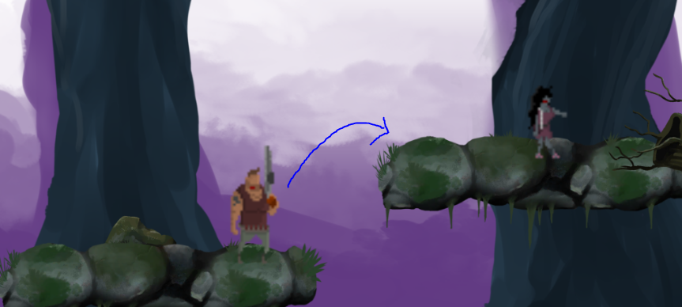
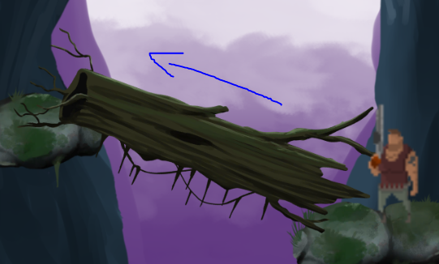
Fig.2 The examples of obstacles in the game.
To accomplish the level of the game the player must collect some antidote from the current level. However, it may also avoid them until it decides. One of the reasons is that the user would like to score more points for destroying enemies and then collect the required number of antidotes for progressing to the next stage.

Fig.3 The example of the UI which is displaying the required number of antidotes to accomplish the level.
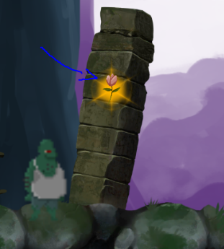
Fig.4 The example of the antidot to collect during the game.

Design and Implementation
The design concept of the application is inspired by zombie-survival games. Thereby, the atmosphere of the production and gameplay is dark and heavy. It may help players to integrate with the in-game world. What is more, the player is able to control the main character, who is a survivor from the zombie apocalypse and its main objective is to collect antidote and destroy or jump over hordes of zombies.
Before coding and setting up Unity, I decided to gather the essential assets relevant to the idea of mine. I possessed the sounds, sprites and UI elements from bundles I had already obtained in the past, and from the assets provided by the tutor.
The very first screen is the main menu. User can start the game, go to options to change the music volume or exit the application. The text on the buttons has different sizes and they change colours when the user manipulates them.

Start Scene
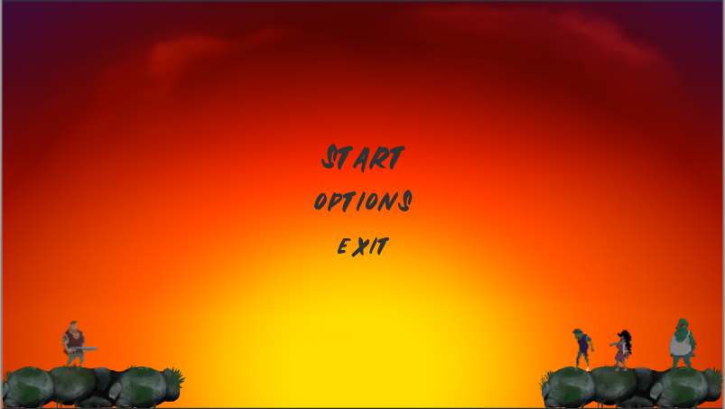
Fig.5 The main menu scene looks.
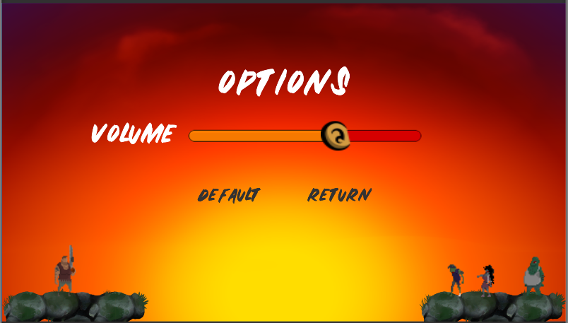
Fig.6 The options screen. Players may change the music volume by using the slider or to set back to the default value by clicking the “DEFAULT” button.
Accordingly, at the start scene, the game manager starts to work. This script is responsible for handling gameplay and it also contains singleton pattern to keep the most important features like a player statistic, music or game progress between scenes.
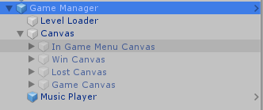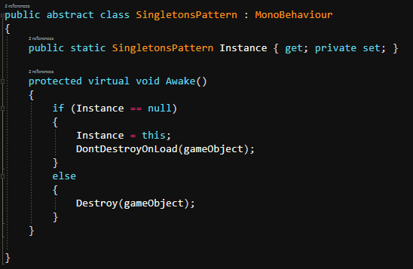
Fig.7 The Game Manager game object uses a singleton pattern to avoid duplication and maintain data between levels.

Levels
Nevertheless, to control scenes, the Level Loader script is programmed. The script is made of simple functions which manage and return scenes status. It is basically used for obtaining information about scene management.
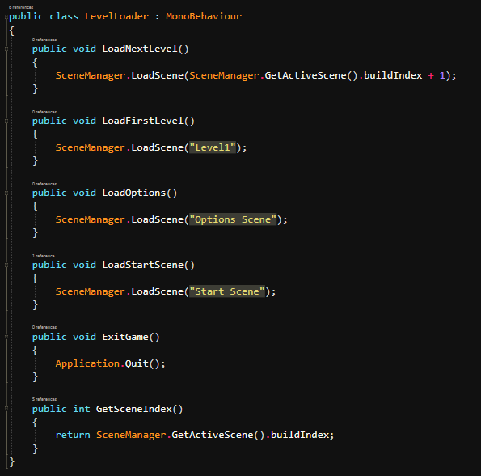
Fig.8 The implementation of the Level Loader script.
When the start level is loaded the other script called Scene Controller generates the level by combining given prefabs together.
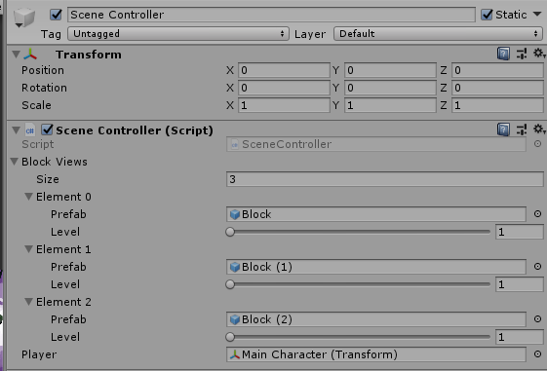
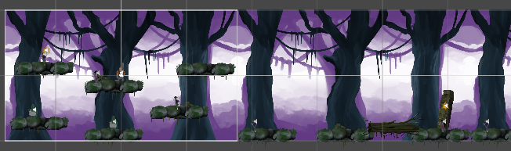
Fig.8 The scene controller generates blocks, which are the environment of the game.
Each created block is contained with background, surrounding images, platforms, colliders, spawners and at least one antidote game object.
The spawners due to Spawn Manager script spawn enemies after the whole scene is generated. Besides, the script counts all spawn points in the scene and then randomly generate the enemy type.
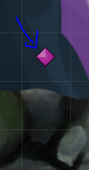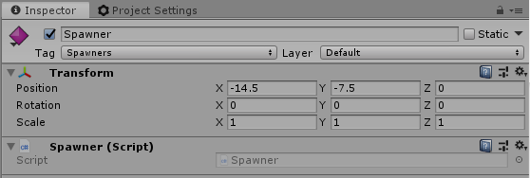
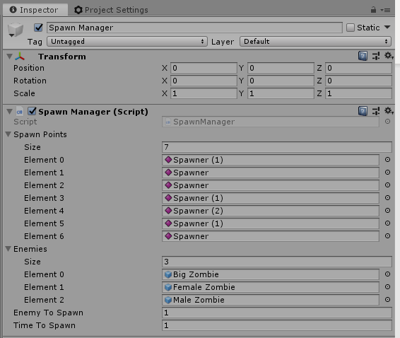
Fig.9 The spawner example in the scene and the specification of Spawn Manager.

Scene Canvas
Additionally, the level display different types of canvas. The main canvas while the game session is Game Canvas which shows the health and score of the player as well as the current time and number of antidotes to collect. Those numbers are controlled by the game manager.
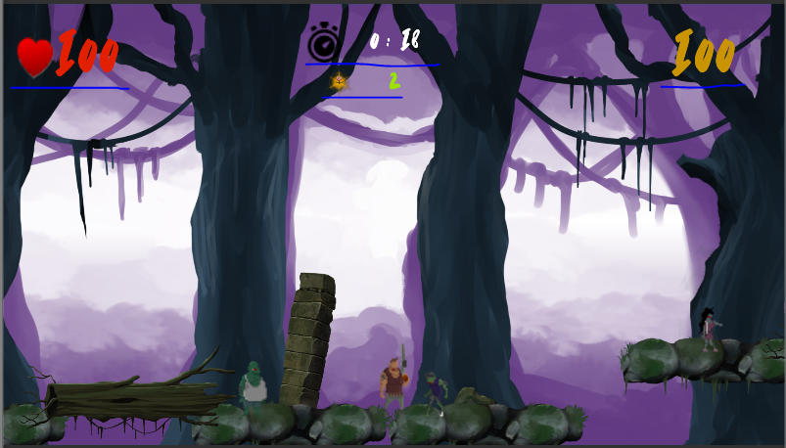

Fig. 10 The example of using Game Canvas.
If the player press escape button In-Game Menu Canvas pops up and the game is paused. From this panel, a user may choose to restart the game, go to options or to exit to the start scene.
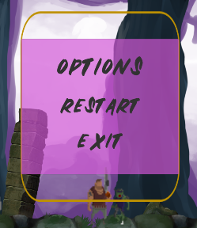
Fig. 11 The example of the In-Game Menu Canvas.
Additionally, when the player lost the game the Lost Canvas is displayed. Similarly, if the player won the Won Canvas is shown up.
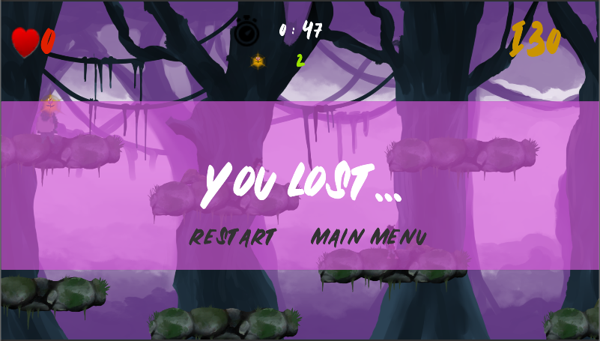
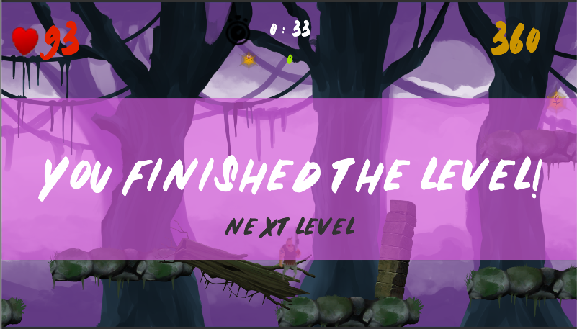
Fig.12 The examples of the game result canvas.

Characters and Items
The concept of characters and their mechanism are simple for the requirements of the game. Therefore, it was decided to minimalize the numbers of accessed characters to four, which one is the hero. It is worth to indicate the composition of the old-school pixel art of the creatures with fitted coloured background and layout.

Fig.13 The main character model.
Nevertheless, the hero is controlled by the player and it is allowed to perform a programmed action such as moving, jumping and shooting. Moreover, the player character and enemies are animated and react for the specific states.
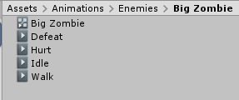
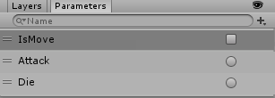
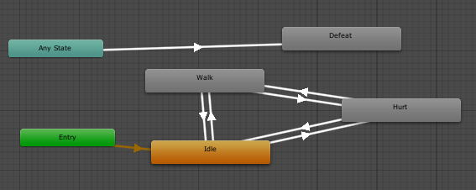
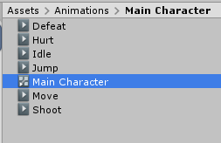
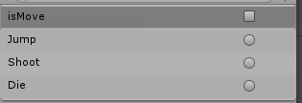
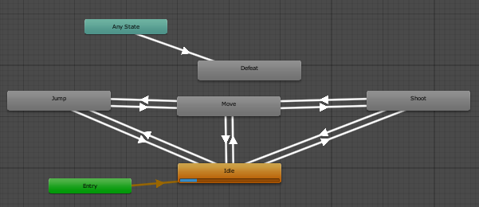
Fig.14 The animation system for enemies and the main character.
If the player is hurt by zombies or the player shoot one of the enemies, then the additional visual effects are played by the code.
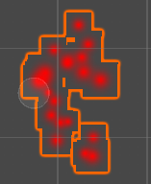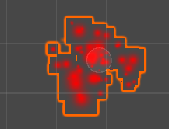
Fig.15 The examples of particle effects created for the visualisation of the special effects.
However, the sound effects are also implemented to the characters to make the game more enjoyable and characteristic. Despite the main music theme, the creatures can make a sound depending on the situation. For example, [5] [6] [7] [8] enemies rows during attacks and the player says “Jump” while jumping.
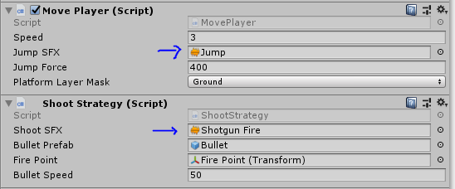
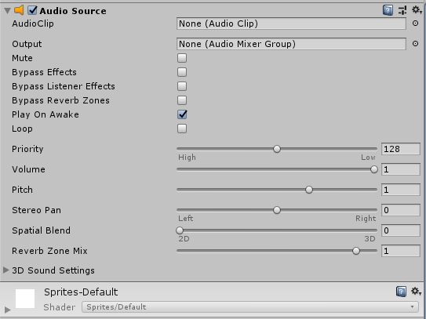
Fig.16 The examples of attached sound effects to the script and audio source component. In the game, the main camera is responsible for listening to the audio events via an audio listener component.
Because of the needs of something collectable, the prefab of antidot was created by joining two sprites together. An antidote is a game object which may be collected by the player and is required to gather it to progress levels.
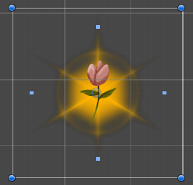
Fig.17 The antidote prefab.

Collision System
The collision system in the game is based on collision layers and for preventing errors in the code triggers and colliders method check the condition first.
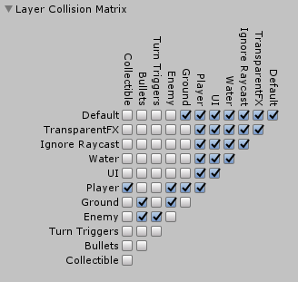
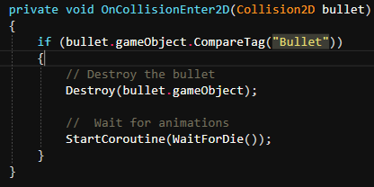
Fig.18 The examples of layer collision matrix used in the game and the piece of code detecting if the collider game object is a bullet.

Camera
There is one camera in the game, and it is set to orthographic projection. Further, the camera is also the audio listener and it contains the Camera Follow Script, which allows following the given target through the gameplay. The important function of this script is setting the maximum and minimum of horizontal and vertical view, presented to the application user. Namely it states the gameplay environment length.
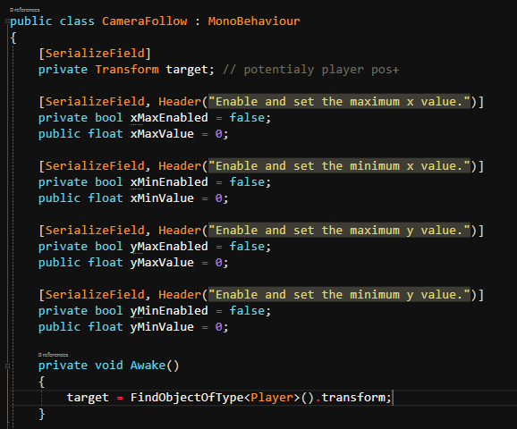
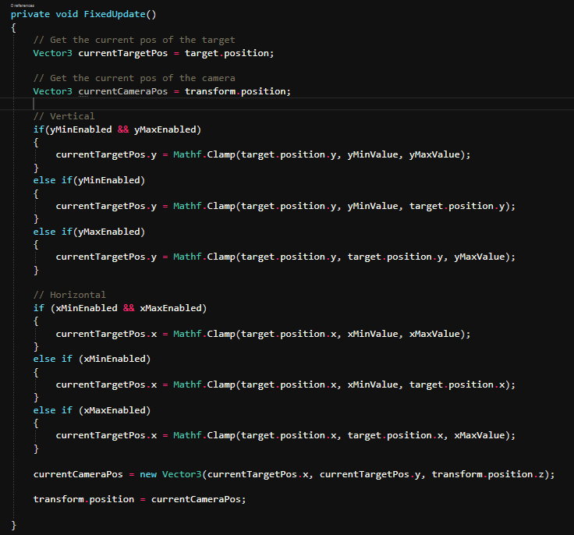
Fig.19 Example of setting the main camera in the code.

Evaluation
Through the development of the game, some issues were occurring. The following examples are describing some problems which were tested and solved.
Problem 1:
Test case description: The camera should follow the player, but not exceed the boundaries of the first and last generated block to avoid displaying blank spots outside the environment of the game.
Condition: Prevent the main camera to go further than the left side of the very first generated block and the right side of the last block for the given level.
Steps: Find the coordinates where the main camera should not exceed the boundaries of the
gameplay.
Test data: Camera Follow Script
Expected result: Stop at the provided position.
Actual result: Camera stops at the set position.
Status: Pass
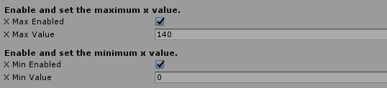
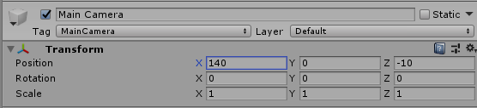
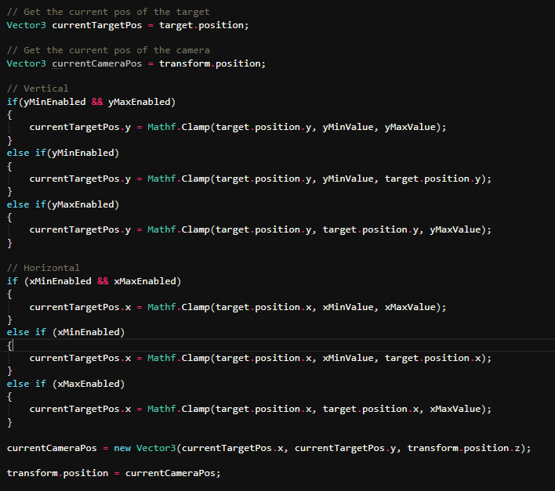
Fig.20 The main camera stops moving while reaching the given coordinates for the x-axis.
Problem 2:
Test case description: The game manager must be loaded at the very beginning of the game scene and cannot be destroyed between scenes.
Condition: Game Manager is loaded at the beginning and it is not destroyed between scenes.
Steps: Implement a singleton.
Test data: Game Manager
Expected result: The game manager is loaded and after the scene is changed it is displayed under the DontDestroyOnLoad bar in the hierarchy window.
Actual result: The Game Manager is displayed in the hierarchy window under the DontDestroyOnLoad bar.
Status: Pass
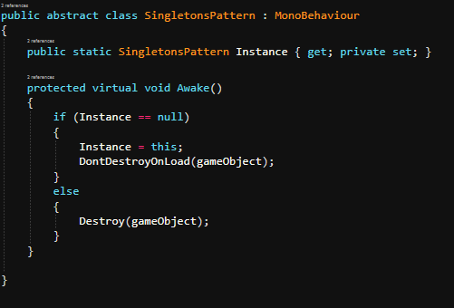
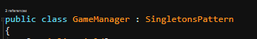
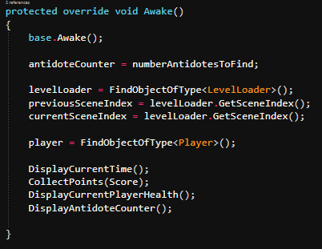
Fig.21 The Game Manager class inherits from the Singletons Pattern class. Therefore, the instance of the game manager is not destroyed on the loading of a new scene.
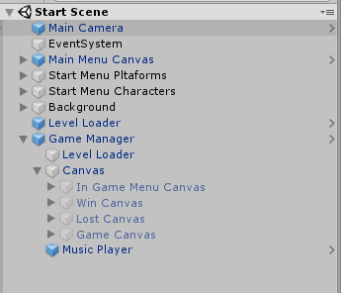
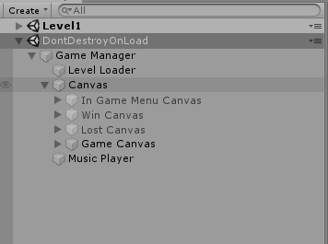
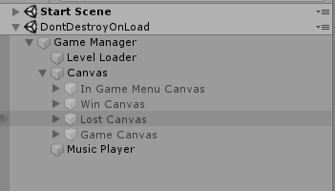
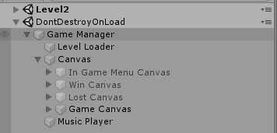
Fig.22 The game manager is created at the very first displayed scene. After starting to play the game object is not destroyed and it is passed to the other scene. However, if we back to the main menu again the same game manager will replace the other existed in that scene.

Summarising
Games development is a complicated process, because it involves many aspects of programming, designing or creating arts. The huge role in this process plays the time, and good preparation before starting coding and setting scenes. During work on the project, a lot of work was focused on setting assets and providing the compatibility between scenes. The other conclusion is that coding game is a very efficient way to learn to programme as the effects are easily visible in the game engine.
Nevertheless, the created application needs some polishing and more tests to conduct. The proposed changes worth considering in the future are mainly regarded to animations, creation of more advanced blocks of platforms, implementing the greater amount of sound effects, providing additional objectives for the player and creating the scoreboard.
Although the created game is not perfect the feeling of gameplay is enjoyable and easy to use. Furthermore, the atmosphere of the game and its design is suitable for the chosen concept.

References

[1] | WePc, “2019 Video Game Industry Statistics, Trends & Data,” November 2019. [Online]. Available: https://www.wepc.com/news/video-game-statistics/.
[2] | L. Brown, “Digital Video Game Trends and Stats for 2019,” 24 January 2019. [Online]. Available: https://filmora.wondershare.com/infographic/video-game-trends-and-stats.html.
[3] | J. Nelius, “What you need to know about the current state of cloud gaming,” 5 March 2019. [Online]. Available: https://www.pcgamer.com/uk/what-you-need-to-know-about-the-current-state-of-cloud-gaming/.
[4] | J. Roach, “The Best Cloud Gaming Services of 2019: Wave of the Future,” 24 October 2019. [Online]. Available: https://www.cloudwards.net/top-five-cloud-services-for-gamers/.

Bibliography

[1] | Brackeys, “Brackeys,” [Online]. Available: https://www.youtube.com/user/Brackeys.
[2] | GameDevHQ, “GameDevHQ - Learn Game Dev,” [Online]. Available: https://www.youtube.com/channel/UCR_3ge9-CEhA6USXMuthwDw.
[3] | GameDev.tv, “Complete C# Unity Developer 2D: Learn to Code Making Games,” October 2019. [Online]. Available: https://www.udemy.com/course/unitycourse/.
[4] | M. Geig, Sams Teach Yourself Unity Game Development in 24 Hours, Gliwice: Helion, 2015.

