University of Wales Trinity Saint David

School of Engineering

Probability of Detection and Probability of Sizing Analysis



Wesley Patrick – 1701708

MSc Automotive Engineering

Structural Integrity and Materials Evaluation – ACEA7013

Table of Contents
1.0. Introduction 2
2.0. Background Research 3
2.1. Non-Destructive Testing 3
2.2. Probability of Detection (POD) 4
2.3. Probability of Sizing (POS) 6
2.4. Testing Methods 7
2.4.1. “â versus a” Method 7
2.4.2. Hit and Miss Method 7
3.0. Data Analysis 8
4.0. Conclusion 19
5.0 References 20

Table 1 - Comparison of conventional NDT methods (Keprate, 2016) 5
Table 2 - Operator Data Table 8

Figure 1 - Non-Destructive Testing Methods - Cost Vs Effectiveness (Keprate, 2016) 4
Figure 2 - Number of publications relating to POD (Keprate, 2016) 5
Figure 3 - Operator 1 estimate against true size graph 9
Figure 4 - Operator 2 estimate against true size graph 10
Figure 5 - Operator 3 estimate against true size graph 11
Figure 6 - Operator 4 estimate against true size graph 12
Figure 7 - Operator 5 estimate against true size graph 13
Figure 8 - Operator 6 estimate against true size graph 14
Figure 9 - Operator 7 estimate against true size graph 15
Figure 10 - Operator 8 estimate against true size graph 16
Figure 11 - Operator 9 estimate against true size graph 17
Figure 12 - Operator 10 estimate against true size graph 18

Introduction
Non-destructive testing or NDT is a testing and analysis method used in industry to evaluate the properties of a material or component for characteristics, through the method of analysing multiple specimens (TWI, 2021). NDT can also be used to find welding defects or defects in a material or structure without causing damage to the specimens and in many cases without the need to take the specimen out of its operation area or be disassembled.
NDT has become a vital tool across many industries with NASA driving research into the reliability of predicting reliability in the testing methods, also known as probability of detection and sizing. With many publications and regulations created around the probability of detection, the field has become highly accurate over the past sixty years and is ever developing.
This report will cover the history of NDT focusing on POD and POS, along with their uses, methods, reliability and development. The main body of this report covers a comparison of data sets collected from ten operators of an Ultrasonic thickness gauging method. They will be compared on their ability to detect and size 21 defects in a specimen ranging from 0.25mm to 7.5mm, from here a conclusion can be drawn on which operator was able to detect and size the defects to the highest degree of accuracy.

2.0. Background Research

2.1. Non-Destructive Testing
Non-destructive testing refers to an array of material testing techniques that allow inspectors or operators to inspect the properties of a material without causing damage to the material or specimen, as opposed to destructive testing which may test the upper constraints of a material based on the failure point. Some key benefits of non-destructive testing include; cost, as the specimen can be reused or placed back into operational service; safety, as many of the methods are not harmful to humans except radiography; efficiency, as the tests can be completed quickly but thoroughly which can be crucial to a job or project; and accuracy, as research has been put into non-destructive testing the accuracy of the tests and reliability of the findings are reaching ever increasing levels (Flyability, 2021).
Although non-destructive testing has always been used as people have always looked, listened and touched objects which could be as simple as a visual inspection of a tool for imperfections or a skilled blacksmith listening to the pitch change as he shapes a material, non-destructive testing really became effective with the creation of technology during World War 2. Some technologies developed prior to the war or between the wars were then adapted for use with military machinery, due to extremely tight restrictions on materials, cost, and time destructive testing was not always an option and therefore testing methods that didn’t affect the usability of the part which was a major driving factor (WorldofNDT, 2020).
as stated previously, the main reason for using non-destructive testing methods over destructive testing methods is that the specimen can be reused, thus reducing the manufacturing costs, however non-destructive testing methods are expensive due to the amount of tests that need to be carried out. False reading and inaccurate or unreliable tests also add to the cost of the specimen testing, in a worst-case scenario this cost is increased further if the specimen in question is damaged or fails. The figure below describes the relationship between cost and effectiveness, it can be clearly seen that for a conventional use ultrasonic will offer the best effectiveness although sits in the middle ground of cost and effectiveness when compared to more advance non-destructive testing methods (Virkkunen, 2021).

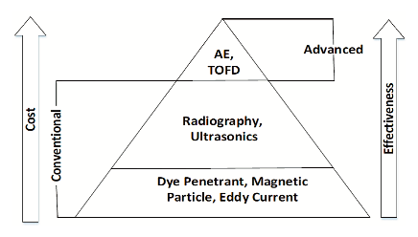
Figure 1 - Non-Destructive Testing Methods - Cost Vs Effectiveness (Keprate, 2016)

2.2. Probability of Detection (POD)
The use of the probability of detection is the process of quantifying the effectiveness of a non-destructive testing method as well as its accuracy, it is not necessarily the testing method at fault when the probability of detection plot is produced as there are many human factors that can affect the outcome of the results (Keprate, 2016). As Tidstrom states “Unreliable NDT is useless, therefore the probability of finding a defect in the component structure plays a very important role” (Tidstrom, 2004). During the space race that began in the sixties NASA realised the potential usefulness of probability of detection when undergoing the design and construction of the space shuttle in order to meet the damage tolerance requirement. Their method of focusing on the largest possible defects that could possibly be missed by a non-destructive testing method, rather than the focus being on the smallest defect that could be missed. This method proved more reliable as attempting to isolate the smallest defect can be unreliable and inconsistent. Coined as “The NASA methodology of quantifying NDE capability” the research was incorporated into the standard NASA-5009, soon after being adopted by the US Air Force in document MIL A-83444 (Keprate, 2016).
The continuation of research into non-destructive testing methods and probability of detection can be seen in the table below, since its adoption in 1973 by NASA there has been an enormous spike in the number of papers published, most notably in the last fifteen years. As the technology of testing has been incorporated into many industries the reliability and consistency can only be improved due to enhancement for specific environments and materials. The figure below shows the number of publications dating back from 1975 up to 2011, initially research was slow in terms of publications although as stated in more recent times that number has increased dramatically.

Table 1 - Comparison of conventional NDT methods (Keprate, 2016)

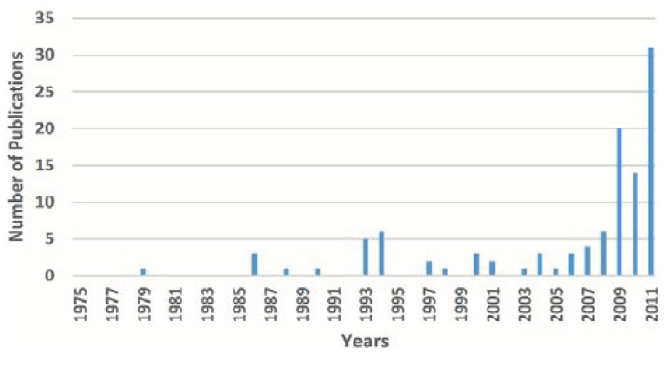
Figure 2 - Number of publications relating to POD (Keprate, 2016)
As probability of detection concepts became more widespread the acceptance and usage in mechanical engineering but in other industries with continued adaptations and development for their intended use. Test specimens are used to quantify the accuracy and reliability, the test specimens have a known number of defects with a range of size. The POD is then determined by observing the NDT methods ability to detect these flaws. As an example, for every 100 components, if 95 of them are identified as containing defects then the probability of detection is 95% for that method, in many cases this percentage is also coupled with a degree of confidence which is the ability of estimation. With the example method, if it comes with a 90% degree of accuracy then there is a 10% chance that the 95% POD is an over estimation of the true probability of detection (Raj, et al., 2002).
A study conducted by HSE concludes that many operators of non-destructive testing equipment, and those around the industry, still misread probability of detection curves as it would be reasonable to assume that with such a wide range of testing equipment, they will produce varying curves and results. The probability of detection curves are dependent on a wide array of external factors such as the material, the geometry of the specimen and the defects themselves (georgiou, 2006). For this reason, it is vital that for each different specimen be it material, geometry, or usage needs to be separately formulated so that a greater understanding of the probability of detection can be reached.
Probability of detection curves are plotted against the ‘a’ size of a researched defect, and they describe the variability of the influential parameters of an inspection for each method of non-destructive testing. Many publications are available with guidance on how to determine an accurate probability of detection curve. One such publication is a handbook, MIL-HDBK-1823A, which is described as “Providing Uniform Guidance for Establishing NDT Procedures for inspecting Flight Propulsion Systems” is derived from many of the early developments in the field to deploy the statistical methodology in the aeronautics industry. The aforementioned publication has also been used as a framework to develop several reports from the European Network for Inspection and Qualification (ENIQ), which is a driven network that handle the reliability and effectiveness of non-destructive testing methods in the nuclear power industry (Calmon, 2016).

2.3. Probability of Sizing (POS)
Probability of sizing is defined by the ability to detect the correct size of a defect that has been detected, although it is used as a term it is simply the accuracy of estimating the size of the defect. Determining the correct size of a defect is a vital tool for a non-destructive in industry to comply with safe working limits of a specimen or system, such as wear, corrosion, crack growth, and general assessments of the parts safe working condition (Visser, 2002). For this reason, probability of sizing is crucial due to the inaccuracy being the difference between a safe and a dangerous component or system. Ultrasonic non-destructive testing helped boost the reliability of the probability of sizing due to the ability to tailor the testing procedure to the specimen and is now favoured in industry when analysing inaccessible defects such as inside boilers or defects that are beneath the surface of the material (Moles, 2009)

2.4. Testing Methods
There are two industry standard methods to estimate the probability of detection, these are the “â versus a” approach and the “hit and miss” approach. Although both methods require different levels of quantity and quality of input data, it can be assumed that there will be a degree of overlapping results and have a contrast of characteristics such as the limitations.

2.4.1. “â versus a” Method
The “â versus a” approach requires a minimum of 30 defects in the test specimen along with signal strength recordings of “â” and a crack length of “a”. a second test specimen is also required with no defects to complete a noise independent of defect investigation. It has been suggested by Virkkunen that this approach can be difficult in practice due to the human factor, this method is mainly reserved for highly automated systems where human error is insignificant and a single detection describes the defect fully. The method does however consider information other than the signal strength but still may not fully describe the defect fully and is therefore generally preferred when the inspection is not fully automated (Virkkunen, 2019)

2.4.2. Hit and Miss Method
The hit and miss approach to probability of detection requires twice the number of defects which range from “likely to detect” to “unlikely to detect”, the method also incorporates the operator’s judgement into the approach. This method has been described as more robust than the aforementioned approach due to the extent of the input data. The method works on the ability to “hit” a defect or “miss” it known as the direct result. The probability of detection is evaluated based on the end results only and are therefore not compromised if the operator’s judgment is not known and will not degrade the validity of the results. As much of the signal strength data is not included in the analysis of the specimen Virkkunen describes this method as “wasteful” (Virkkunen, 2019).

3.0. Data Analysis
The table below shows data collected from ten operators of ultrasonic testing equipment; a test piece was supplied that had 21 defects of a known size. The measurement of the defects is recorded in millimetres. Using the data recorded each operator’s data was plotted against the true size data, with the addition of a “true line” which intersects the diagonal points, the operator’s accuracy can be determined. By analysing the operator graphs a conclusion can be drawn to what range of defects are recorded with the most accuracy and where the accuracy is lacking, as points that appear above the “true line” are overestimated with points under being over estimated.
Table 2 - Operator Data Table
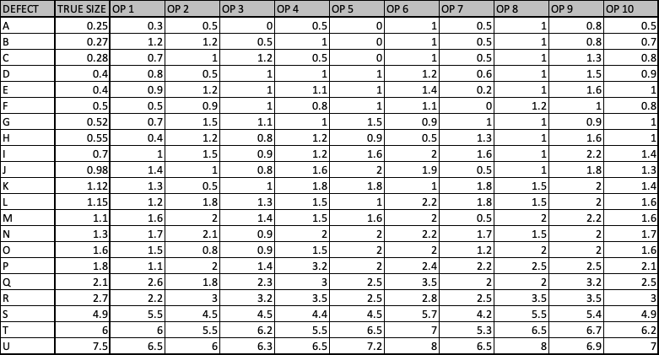

Figure 3 - Operator 1 estimate against true size graph
The results of operator 1 shows a trend that begins overestimating smaller defects that are under 1.5mm and ends by underestimating the larges defect by 1mm. whilst overestimating smaller defects is not so bad as more information can be gathered about these defects if they are reported to be closer than previously thought to the safe limit, an underestimation of a larger defect even by a small amount could be the difference between a safe component and a potentially dangerous one, especially if it were deemed safe and placed back into operation.
Similarly, to operator 1, operator 2 shows significant overestimation in the smallest of defect sizes. The difference to the previous operator comes in the larger defect sizes where they are consistently underestimated, by 1.5mm in the case of the largest defect. This high end inaccuracy could potentially lead to a very dangerous scenario as larger defects appear to be reported with a greater level of inaccuracy as the size increases. This operator’s trend line is also further from the gradient of the true line than the first operator meaning the degree of accuracy is visibly lower.

Figure 4 - Operator 2 estimate against true size graph
Operator 3 shows an overestimation in defects smaller than 1mm, but then begins to underestimate the defects between 1mm and 2mm.due to this inconsistent inaccuracy in the lower region it could be deemed that operator 3 is not as reliable as the first two operators. There is also a missing value of the smallest defect which has a size of 0.25mm, it could be assumed that as this defect develops and grows that it would be detected at a later date however depending on the application of the specimen this conclusion cannot be drawn as certain industries operate with extremely low tolerance levels.

Figure 5 - Operator 3 estimate against true size graph
Operator 4 shows a similar trend to that observed with operator 2. The lower end defect size is consistently overestimated showing an almost parallel trend with no underestimations, this operator is also discredited in the higher end defect size as all three of the larger defects are underestimated pulling the overall accuracy level down. As expected, this operator shows a similar accuracy level to that seen in operator 2 as a similar R² value is displayed.

Figure 6 - Operator 4 estimate against true size graph
Operator 5 has a trend line which appears to match the true line most accurately although significant overestimation of the lower end defects an misses three out of the ten defects smaller than 1mm, of sizes 0.25mm, 0.27mm, and 0.28mm. With a degree of overestimation and near accurate results of defects greater than 1mm this operator does score highly in terms of reliability but is hampered by the missed defects and a slight underestimation of the larger defects albeit by a maximum of 0.4mm.

Figure 7 - Operator 5 estimate against true size graph
Operator 6 shows a consistent over estimation across the full range of defect sizes with only one underestimation recorded at 0.12mmbelow the actual size. The trend line produced by this data set is almost parallel to the true line, this consistent over estimation does reduce the accuracy level of the operator although could be considered a “safety buffer” to ensure that underestimation does not occur. By consistently overestimating the defect size more investigation is required to determine the true size of the defect thus costing more money and time.

Figure 8 - Operator 6 estimate against true size graph
Similar to operator 3, operator 7 shows great inaccuracy in the lower end of the defect size scale with no consistency between under or over estimation, from here the trend only gets worse as no defects over 2mm are over estimated. This data is unreliable and could potentially lead to serious damage to the component or system.

Figure 9 - Operator 7 estimate against true size graph
With a very similar trend to operator 6, operator 8 has overestimated all but one of the defects which has been underestimated 0.1mm. once again this consistent overestimation could be used as a safety buffer although the results are significantly closer than those observed in the operator 6 data set. This operator does struggle to detect any defects below 1mm as there are no data points below this point. As stated above it is preferred to overestimate opposed to underestimation due to all the potentially dangerous defects being detected earlier although this would lead to more testing to investigate the true size costing more money and time before the specimen or component can be returned to operation.

Figure 10 - Operator 8 estimate against true size graph
Operator 9 shows similar results to those observed with operator 5, with a similar trend line. The difference between these operators is that operator 9 has manage to detect and overestimate all but the largest defect which has been reported as 0.6mm below its actual size. When compared to operator 8 at the lower end of the scale there is a much more erratic point plot around the trendline with the average measurement being higher than that recorded by operator 8. Across the full defect scale this operator could be considered to be reliable as all bar one of the defects has been overestimated and appear close to the true line with few anomalies, the underestimation of the largest defect size may throw into question the reliability of this operator when detecting larger defect sizes in defects over 7mm.

Figure 11 - Operator 9 estimate against true size graph
Operator 10 shows a similar trendline to the one observed in the operator 9 data set however does have a lower average as the estimate trendline crosses the true line at 4.8mm. Operator 10 has achieved the highest accuracy level being closest to the true line with an R² value of 0.99. Operator 9 overestimates the lower defects on average by 0.82mm and operator 10 overestimating the same region of defects by 0.36mm on average, this data is coupled by the fact that operator 9 underestimates the largest defect by 0.6mm and operator 10 underestimating the same defect by 0.51mm. this operator has the highest determination out of all 10 operators, the coefficient of determination assesses the strength of the linear relationship between the two variables thus determining that operator 10 has the closest linearity (Bloomenthal, 2021).

Figure 12 - Operator 10 estimate against true size graph

4.0. Conclusion
In conclusion it is clear that non-destructive testing methods have come on leaps and bounds in the past 50 years, this is clear from the extensive research kicked off from NASA. Further conclusions can be made with regards to the reliability and accuracy of non-destructive testing methods through research, development, an implementation of POD, this is clear from the number of publications that have been released in recent times. Non-destructive testing can still be quite costly due to the repeat testing and calibration of the equipment and can be either enhanced or hampered by the operator as there is still a human factor in many of these methods. Although the cost of analysis can initially be high and labour intensive this is a far better solution than leaving components and systems untested potentially leading to catastrophic results, with this said a safe component or system is every manufacturer/operator’s top priority and reducing accidents and damage saves the company money in the longer term.
During the analysis of the operator data there was a slight consistency across all ten operators as the smaller the defect size the less likely it was to be detected and sized correctly, this consistency was also seen at the larger end of the scale with the largest defect being undersized by 8 of the operators. This under sizing could lead to suggest that this method of testing is not suited to sizing defects larger than 7mm, however this cannot be concluded without further testing with a sample containing a range of defects in the larger end of the scale. The claim that larger defects are harder to size accurately has been backed up by Kurz where similar patterns in defect detection and sizing were observed (Kurz, 2009).
On the basis of operators, it was clear that operator 10 showed a higher accuracy level when detecting all of the defects with the highest coefficient of determination. It is also worth stating that operators 6 and 8 showed a good level of accuracy and safety as most of their points were consistently overestimated with their trendlines almost parallel to the true line. As stated, this over estimation builds in a safety factor as growing defects will be detected sooner, although would lead to higher costs to determine the true size of the defects and thus more time out of usage or operation.

5.0 References
Bloomenthal, 2021. Coefficient of Determination. [Online]
Available at: https://www.investopedia.com/terms/c/coefficient-of-determination.asp
[Accessed 2 1 2022].
Calmon, 2016. The Use of Simulation in POD Curves Estimation. Magny-les-Hameaux, World Conference on NDT.
Flyability, 2021. NDT (NON-DESTRUCTIVE TESTING): WHAT IT IS, COMMON METHODS & INDUSTRIES, AND HOW DRONES CAN HELP. [Online]
Available at: https://www.flyability.com/ndt
[Accessed 31 12 2021].
georgiou, 2006. Probability of Detection Curves, London: HSE.
Keprate, A., 2016. Probability of Detection: History, Development and Future. Pipeline Technology Journal, 8(2), pp. 41-45.
Kurz, 2009. POD determination using ultrasound phased array for considering NDT in probalistic damage assessments, Stuttgart: Materials Testing Institute University of Stuttgart.
Moles, 2009. Accurate Defect Sizing Using Phased Array and Signal Processing, Toronto: University of Toronto.
Raj, B., Jayakumar, T. & Thavasimuthu, M., 2002. Practical Non-Destructive Testing. 2nd Edition ed. Kalpakkam: Woodhead Publishing Limited.
Tidstrom, 2004. Estimation of Probabilities of Detection for Cracks in Swedish Nuclear Power Plants, Uppsala: s.n.
TWI, 2021. WHAT IS NON-DESTRUCTIVE TESTING (NDT)? METHODS AND DEFINITION. [Online]
Available at: https://www.twi-global.com/technical-knowledge/faqs/what-is-non-destructive-testing
[Accessed 30 12 2021].
Virkkunen, 2019. Comparison of "â versus a" and Hit & Miss POD Estimation Methods: A European Viewpoint. Journal of NDT, 1(1), p. 13.
Virkkunen, 2021. NDT Reliability. [Sound Recording] (European Structural Integrity Society).
Visser, D. W., 2002. POD/POS curves for non-destructive examination, London: HSE.
WorldofNDT, 2020. History of Non Destructive Testing (NDT). [Online]
Available at: https://worldofndt.com/history-of-non-destructive-testing/
[Accessed 31 12 2021].

