
Certificate of Higher Education Skills for the Workplace (Health & Social Care)
Case Study Mrs Thompson
Component 2:
Keeran Wahid
2522889
LCHS4003
25/07/2026

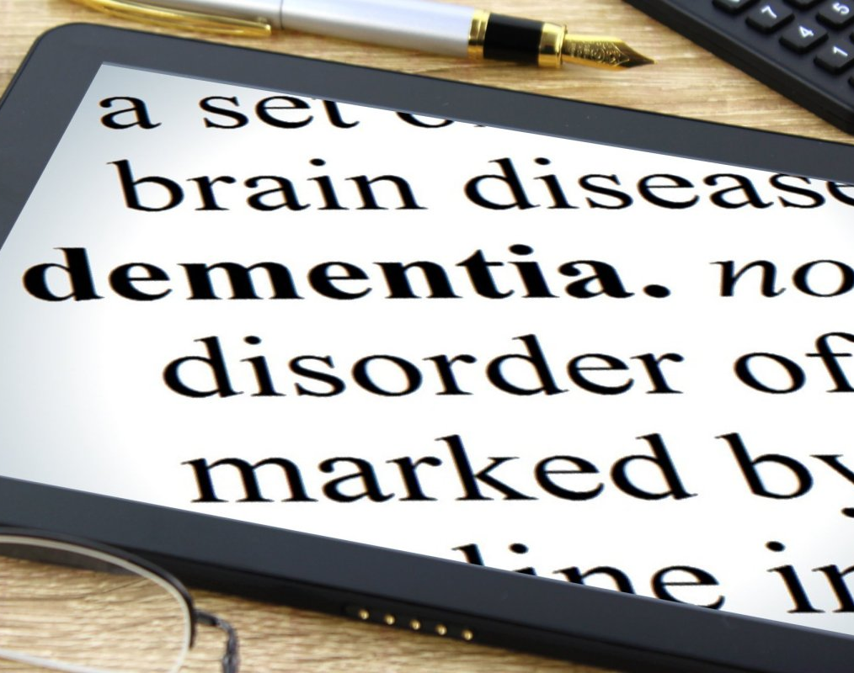
pneumonia

Introduction

Mrs Thompson is an 84-year-old woman who lives alone in sheltered housing and receives domiciliary care twice daily. Following her discharge from hospital after pneumonia, concerns have arisen because she missed medication for two days and was later found outside in cold weather without appropriate clothing. Her mild dementia may affect her memory, understanding and ability to manage risks. However, a diagnosis of dementia does not automatically mean that she lacks capacity. Her situation requires person-

​

CASE STUDY: MRS THOMPSON

Introduction

Mrs Thompson is an 84 year old woman with mild dementia who has recently been discharged after pneumonia. She lives alone and receives domiciliary care twice daily. She has missed her medication for two days, has increased confusion and been found outdoors without suitable clothing indicate risks deterioration health, medication harm, self-neglect and reduced safety. Her support must therefore be person-centred, legally compliant and coordinated across services. Person centred dementia care recognises the individual’s dignity, preferences, abilities and right to participate in decision making; evidence also associates it with reduced distress and improved quality of life (Kitwood, 1997; Kim and Park, 2017; NICE, 2018)

Effective Communication, Record-Keeping and Collaborative Working in Mrs Thompson’s Care

Effective communication

Effective communication helps professionals identify changes in Mrs Thompson’s condition, reduce anxiety, support medication adherence. Although dementia can affect memory and language, staff should still speak directly to her and involve her in decisions (Brooker, 2007, NICE, 2018).

Staff should communicate in a quiet environment, use short sentences, allow extra time and repeat information when needed. Pictures, written instructions and medication charts may also help. Non-verbal signs such as facial expressions and behaviour should be observed for pain, fear or confusion.
Communication skills training has been shown to improve carers’ knowledge, competence and interactions with people living with dementia (Eggenberger, Heimerl and Bennett, 2013; Morris et al., 2018).

The Shannon and Weaver model shows that communication can be affected by “noise,” such as television, anxiety, jargon or hearing loss (Shannon and Weaver, 1949). Staff should reduce these barriers and check understanding by asking Mrs Thompson to repeat information in her own words.

Reasonable adjustments under the Equality Act 2010 may include large print information, longer appointments and reminder devices. Her consent should be obtained before sharing information.
The Mental Capacity Act 2005 requires capacity to be presumed unless proven otherwise, and any decision made on her behalf must be in her best interests and use the least restrictive option (Mental Capacity Act 2005; Department for Constitutional Affairs, 2007).

Administrative skills, record-keeping and data protection

Effective administration supports continuity of care, patient safety, risk management and professional accountability. Mrs Thompson’s records should document medication that has been administered or missed, changes in confusion, physical symptoms, unusual behaviour, accidents, referrals and actions taken. Following the missed medication, staff should record the affected doses, her condition, immediate risks, advice received and any professionals or relatives contacted. The incident in which she was found outdoors without suitable clothing should also be documented and reported in line with organisational safeguarding procedures (NMC, 2018; NHS England, 2021; DHSC, 2025). The NMC Code requires professionals to keep clear, accurate and timely records relevant to their practice.

Records must be factual, accurate, complete and written at the time of the event or as soon as possible afterwards. Each entry should include the date, time, author’s name and professional role. For example, “Mrs Thompson was found outside at 7:30 a.m. without a coat” is more objective than “Mrs Thompson behaved irresponsibly.” Direct observations should be clearly distinguished from professional opinions or information provided by others. Judgemental language, unclear abbreviations and unsupported assumptions should be avoided. Any correction must remain identifiable, dated and traceable (NMC, 2018; NHS England, 2021).

Accurate documentation enables the GP, community nurse, pharmacist and care agency to recognise patterns and coordinate Mrs Thompson’s care. Repeated medication omissions may indicate the need for a medication review, reminder device, increased supervision or reassessment of her care needs. Poor record keeping may contribute to missed treatment, duplicated work, delayed safeguarding action and uncertainty about professional responsibility (NMC, 2018; NHS England, 2021).

The Data Protection Act 2018 and UK General Data Protection Regulation apply to Mrs Thompson’s paper and electronic records. Her personal information must be processed lawfully, fairly and transparently, collected for specified purposes, limited to what is necessary, kept accurate, retained only for as long as required and protected against loss or unauthorised access. Health information concerning dementia, pneumonia and medication is special-category data and requires both a lawful basis under Article 6 and an appropriate condition under Article 9 of the UK GDPR (Data Protection Act 2018; ICO, n.d. -b).

Electronic records should be protected through individual user accounts, secure passwords and role-based access. Paper records should be stored securely and accessed only by authorised staff. Record-retention and disposal arrangements should follow the NHS Records Management Code of Practice and organisational policies (NHS England, 2021; ICO, n.d. -b).

Confidentiality does not prevent necessary and proportionate information-sharing for direct care or safeguarding. Mrs Thompson should normally be informed about what information will be shared, with whom and for what purpose. Information may be shared without consent where there is an appropriate lawful justification, such as protecting her vital interests or preventing serious harm. The information shared should be relevant and limited to what is necessary, and the decision and reasons should be recorded (ICO, n.d.-b; DHSC, 2025).

Mrs Thompson’s missed medication, increased confusion and unsuitable clothing may indicate self-neglect. Under section 42 of the Care Act 2014, a local authority must make, or arrange for others to make, enquiries when it has reasonable cause to suspect that an adult has care and support needs, is experiencing or is at risk of abuse or neglect, and is unable to protect herself because of those needs. However, concerns about self-neglect must be assessed individually and do not automatically result in a statutory section 42 enquiry (Care Act 2014; DHSC, 2025).

Collaborative and multi-agency working
Mrs Thompson’s needs require coordinated support because they involve dementia, physical health, medication and possible self-neglect (NICE, 2018; Care Act 2014). Domiciliary carers can report changes in her daily functioning; the GP can assess cognition, illness and medication; the community nurse can monitor recovery; the pharmacist can review prescriptions and adherence aids; and social-care staff can
reassess her care and safeguarding needs (NICE, 2017; NICE, 2018). NICE recommends person-centred, coordinated dementia care and access to a named professional who helps the person navigate services (NICE, 2018; NICE, 2019).

Effective collaboration requires timely referrals, shared care plans, multidisciplinary reviews and clear responsibilities (NICE, 2018; NMC, 2018). The plan should identify who monitors medication, contacts relatives, reviews cognition and responds to further incidents. “SBAR (Situation, Background, Assessment and Recommendation) can improve handovers and reduce missing information (Müller et al., 2018).

Barriers may include incompatible records, unclear roles, staff turnover and confidentiality concerns (Müller et al., 2018; DHSC, 2025). These can be reduced through named contacts, secure information-sharing, regular reviews and clear escalation procedures. Mrs Thompson should remain involved so that decisions respect her wishes, independence and right to the least restrictive care (Mental Capacity Act 2005; NICE, 2018).

Conclusion

Mrs Thompson requires respectful communication, accurate records and coordinated multi agency care. Communication should be adapted to dementia while protecting her dignity, equality and involvement in decisions (Kitwood, 1997; Equality Act 2010; Mental Capacity Act 2005; NICE, 2018). Clear documentation supports continuity, helps professionals recognise deterioration, reduces medication errors and strengthens safeguarding responses (Dimond, 2015; NMC, 2018; NICE, 2017). Collaboration between carers, the GP, community nurse, pharmacist, family and local authority should produce a shared plan covering medication, cognition, safety and escalation (Care Act 2014; Müller et al., 2018; NICE, 2018; NICE, 2019). Immediate priorities should include a health and medication review, reassessment of her care
package and proportionate consideration of self-neglect risks (NICE, 2017; DHSC, 2025). All interventions should reflect Mrs Thompson’s wishes, decision-making capacity and right to the least restrictive support (Mental Capacity Act 2005; Department for Constitutional Affairs, 2007; Brooker, 2007).

Reference List
Alzheimer’s Society (n.d.) How to communicate with a person with dementia. Available at: Alzheimer’s Society website (Accessed: 24 July 2026).

Brooker, D. (2007) Person-Centred Dementia Care: Making Services Better. London: Jessica Kingsley Publishers.

Caldicott, F. (2013) Information: To Share or Not to Share? The Information Governance Review. London: Department of Health.

Care Act 2014, c. 23. London: The Stationery Office.

Data Protection Act 2018, c. 12. London: The Stationery Office.

Department for Constitutional Affairs (2007) Mental Capacity Act 2005: Code of Practice. London: The Stationery Office.

Department of Health and Social Care (DHSC) (2025) Care and Support Statutory Guidance. Available at: GOV.UK (Accessed: 24 July 2026).

Dimond, B. (2015) Legal Aspects of Nursing. 7th edn. Harlow: Pearson.

Egan, G. (2014) The Skilled Helper: A Problem-Management and Opportunity-Development Approach to Helping. 10th edn. Belmont, CA: Brooks/Cole.

Eggenberger, E., Heimerl, K. and Bennett, M.I. (2013) ‘Communication skills training in dementia care: a systematic review of effectiveness, training content and didactic methods in different care settings’, International Psychogeriatrics, 25(3), pp. 345–358.

Equality Act 2010, c. 15. London: The Stationery Office.

Information Commissioner’s Office (ICO) (n.d.-a) A Guide to the Data Protection Principles. Available at: ICO website (Accessed: 24 July 2026).

Information Commissioner’s Office (ICO) (n.d.-b) Special Category Data. Available at: ICO website (Accessed: 24 July 2026).

Kim, S.K. and Park, M. (2017) ‘Effectiveness of person-centred care on people with dementia: a systematic review and meta-analysis’, Clinical Interventions in Aging, 12, pp. 381–397. doi: 10.2147/CIA.S117637.

Kitwood, T. (1997) Dementia Reconsidered: The Person Comes First. Buckingham: Open University Press.

Mental Capacity Act 2005, c. 9. London: The Stationery Office.

Morris, L., Horne, M., McEvoy, P. and Williamson, T. (2018) ‘Communication training interventions for family and professional carers of people living with dementia: a systematic review of effectiveness, acceptability and conceptual basis’, Aging & Mental Health, 22(7), pp. 863–880. doi: 10.1080/13607863.2017.1399343.

Müller, M., Jürgens, J., Redaèlli, M., Klingberg, K., Hautz, W.E. and Stock, S. (2018) ‘Impact of the communication and patient hand-off tool SBAR on patient safety: a systematic review’, BMJ Open, 8(8), e022202. doi: 10.1136/bmjopen-2018-022202.

National Institute for Health and Care Excellence (NICE) (2017) Managing Medicines for Adults Receiving Social Care in the Community. NICE guideline NG67. London: NICE.

National Institute for Health and Care Excellence (NICE) (2018) Dementia: Assessment, Management and Support for People Living with Dementia and Their Carers. NICE guideline NG97. London: NICE.

National Institute for Health and Care Excellence (NICE) (2019) Dementia. Quality standard QS184. London: NICE.

NHS England (2021) Records Management Code of Practice 2021. London: NHS England.

NHS England (2023) Towards a Unified Vision of Nursing and Midwifery Documentation. London: NHS England.

Nursing and Midwifery Council (NMC) (2018) The Code: Professional Standards of Practice and Behaviour for Nurses, Midwives and Nursing Associates. London: NMC.

Shannon, C.E. and Weaver, W. (1949) The Mathematical Theory of Communication. Urbana, IL: University of Illinois Press.

