- PROJECT MILESTONE
BY JETSE MARTIN

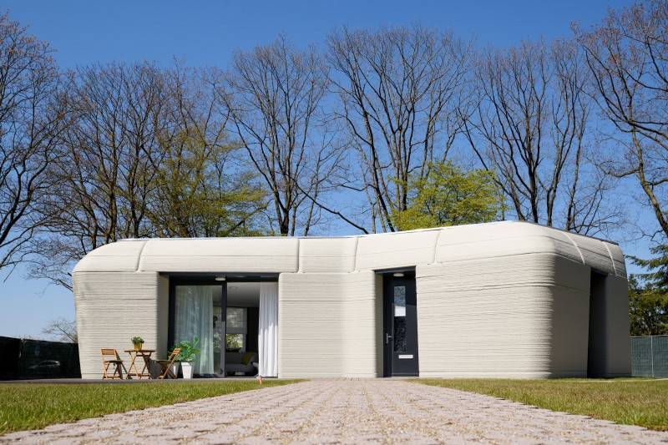

Table of Contents
1 Title Page
2 Introduction
3 Project Milestone
3.1Background Information
3.2Key Stakeholders
4 Design and Engineering
4.1 Design Principles
4.2 Engineering specifications
5 Construction Process
5.1 Construction timeline
5.2 Construction methods and techniques
5.3 Challenges during construction
6 Conclusion
7 Reference List

- Introduction
The Milestone project based in Bosrijk Eindhoven the Netherlands, is the first residential 3d printed homes in Europe. Phase one of the project will be outlined and aims to build 5 residential single storey houses of which the first was completed in 2021. The project is a milestone hence the name in what can be achieved using 3d printing concrete in constructions and is paving the way for future bigger projects aiming at building 2 storey houses, making 3d printing as efficient and effective as possible. This report aims to showcase the flexibility of 3d printing, how it can be used to make a bespoke house for the resident’s needs, using concrete in ways traditional building cannot do so, whilst aiming to be sustainable and energy efficient.
- Project Milestone
  - Background Information
The Project is located on the new housing estate of Meerhoven, Boswijk in the Netherlands. The first five houses being made are single storey dwellings, of which the first has been completed
The purpose of the project is to demonstrate that building a commercial house using 3d printing techniques is a realistic construction method for future building of housing on a commercial scale and can be prefabricated and brought to a site for assembly, it also wanted to showcase that this can be done more sustainably than current construction methods using very few materials to make the structure. “These efficient and inexpensive systems could help the increasing demand for efficient, affordable housing with its pioneering systems that has potential to change the way we building the mass housing” (Fırat, et al., 2018, p. 261)

  - Key Stakeholders
The project is a joint venture between 5 stakeholders. Together they are perfectly equipped to undertake and complete the task, bringing together, an innovative municipality (Municipality of Eindhoven) whom are looking to be at the forefront of innovation, a university (Eindhoven University of Technology (TU/e)) that has the equipment technology and experience in 3d printing concrete, a construction company (Van Wijnen) that has a vast knowledge of building for the future and a leading in affordable housing. Materials and concrete expert (Saint-Gobain Weber Beamix) with knowledge of building using concrete 3d printed walls. The last being the consultancy firm (Witteveen + Bos) whom are there to oversee the design and management for the construction of the project, being leaders in construction of 3d printing construction projects since 2013 notes 3Dprintedhouse (2024)
- Design and Engineering
  - Design Principles
Rob Wolfs, et al., (2023) state:
The first house of project Milestone is a single-storey dwelling, covering an area of approximately 94 m2. This area is enclosed by multiple 3D printed concrete wall elements, which are curved both in- and out-of-plane. All printed wall elements are load-bearing, so no conventional (reinforced) cast concrete is applied internally. This followed from the leading structural design principle to demonstrate the potential of 3DCP to use material efficiently, rather than copying established structural principles for single story dwellings.

Fig 1. Rob Wolfs, et al, (2023). 3D Printing of the first part of wall type A on the structural floor (left), and the second part of the same wall on the print bed (middle), and printing the final part of type B (right).

The main design principles and architectural features are to demonstrate the freedom of geometry that are possible when using 3d printing, the house is meant to represent a boulder that has been dropped into the environment. Secondly the process of constructing the building in section off site like prefabricated houses was important to show that this can be a consistently produced product.
  - Engineering specifications
The main materials used for the house where concrete, commercially available 3D printed mortar (Weber 3D 145–2). The walls were filled with an open cell structure insulation and bonded with steel connecting elements note Rob Wolfs, et al (2023). A waterproof membrane was used to make the roof fully waterproof. The idea was to use as little materials as possible.
Rob Wolfs, et al., (2023) state:
All printed wall elements are load-bearing, so no conventional (reinforced) cast concrete is applied internally. This followed from the leading structural design principle to demonstrate the potential of 3DCP to use material efficiently, rather than copying established structural principles for single story dwellings.
Fig 2. Rob Wolfs, et al., (2023). Schematic representation of test setup for Test 1 Centric loading to 19 kN. (left) and Test 2 Centric loading to 10kN and Eccentric loading to 2.4kN and 3kN for deformation (right). On both tests, 5 sensors where placed horizontally to test for deformation.
- Construction Process
  - Construction timeline
The project started back in 2015 when Eindhoven University of Technology started researching how best to build the walls to the structural properties and strengths needed. After rigorous testing, the first house was completed in 2021 and is currently inhabited. The next 4 houses are to be completed by 2025. The project wants to build on the success of the first 5 houses and is currently in the process of making a two storey 3d printed house notes 3Dprintedhouse (2024)
  - Construction methods and techniques
As discussed in section 4.2 the main construction technique for the house is using 3d printing of concrete wall and floor elements. This is the first house of its type in Europe and does not use any current construction techniques. What has been done is show case what they hope to become a new construction method. A prefabricated concrete cast 3d printed house build without the need for secondary internal structural bearing walls. In the future the hope is to be able to fulfil this whole process on site without the need for costly and often logistically difficult transport issues.
  - Challenges during construction
The main difficulties of this project are stated by Rob Wolfs, et al., (2023):
Firstly, due to the inclination of the Type B walls, an internal wall geometry had to be applied to prevent object failure both during printing and in-use, which is not desirable from a sustainability perspective. Secondly, the connecting to other building components, such as the foundation piles, window framing, and roof structure, required significant extra attention. More generally, this introduces an apparent contradiction between complete geometrical freedom of design and limiting the complexity in the building process.
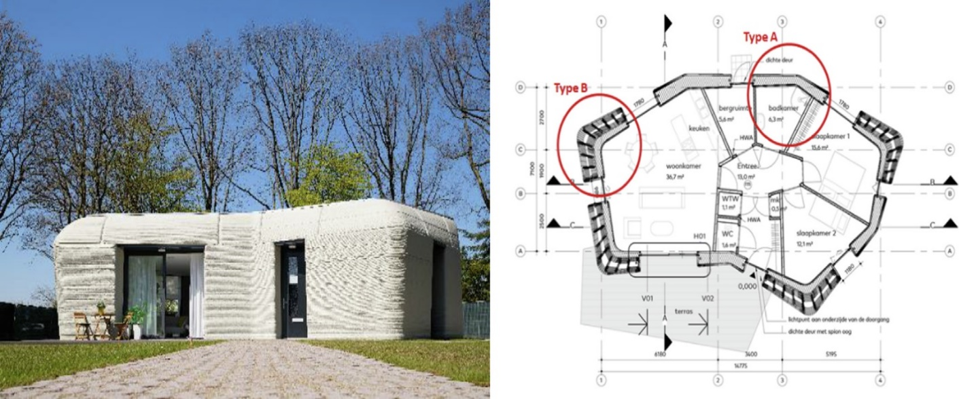
Fig 3. Rob Wolfs, et al., (2023) The first 3D printed house of Project Milestone (Photo by Bart van Overbeeke) and its floor plan.

- Conclusion
The aim of the project was to make a house that can be reproduced on scale in future for housing estates in a more efficient way then is done. However, this did not come without its challenges. The initial research stage was extensive and there have been difficulties in the integrity of the wall elements at the required thickness to make them sustainable, the fitting of components was also difficult. The first house in project milestone has been a success and has showcased the possibilities of 3d printed design and its flexibility and potential to be sustainable.
- References
3dprintedhouse. (2024). Our Partners. 3dprintedhouse. Available at: https://www.3dprintedhouse.nl/en/partners/ (Accessed 27 November 2024)
3dprintedhouse. (2024). Project Milestone. 3dprintedhouse. Available at: https://www.3dprintedhouse.nl/en/project-info/project-milestone/ (Accessed 22 November 2024)
3dprintedhouse. (2024). Research Program. 3dprintedhouse. Available at: https://www.3dprintedhouse.nl/en/project-info/research-program/ (Accessed 24 November 2024)
Fırat, S., Kinuthia, J. and Abu-Tair, A. (2018) Proceedings of 3rd International Sustainable Buildings Symposium (ISBS 2017), Lecture notes in civil engineering. Available at: https://doi.org/10.1007/978-3-319-64349-6. (Accessed 24 November 2024)
Wolfs, R., Bos, D., & Salet, T. (2023). Lessons learned of project Milestone: The first 3D printed concrete house in the Netherlands. Materials Today : Proceedings. https://doi.org/10.1016/j.matpr.2023.06.183 (Accessed 20 November 2024)

