DS 1 JORGE PATRICIO MENA MENA

My Screenshots/Photos
- Please add 4–6 screenshots or photos of your digital life.
- You can use your phone or laptop.
- For each screenshot, write one or two sentences explaining what it shows.

Screenshot/Photo 1

I often use Instagram to scrolling reels; I watch reels about my friends or people on the wed side. For many reasons; I spend time on this app because I like

Screenshot/Photo 2

WHATSSAPP, Is the main app I use to keep in touch whit my family.
Because my family live on Ecuador, I usually keep in touch with my brothers and sisters, but my parents don’t use mobile phone are old school.

Screenshot/Photo 3
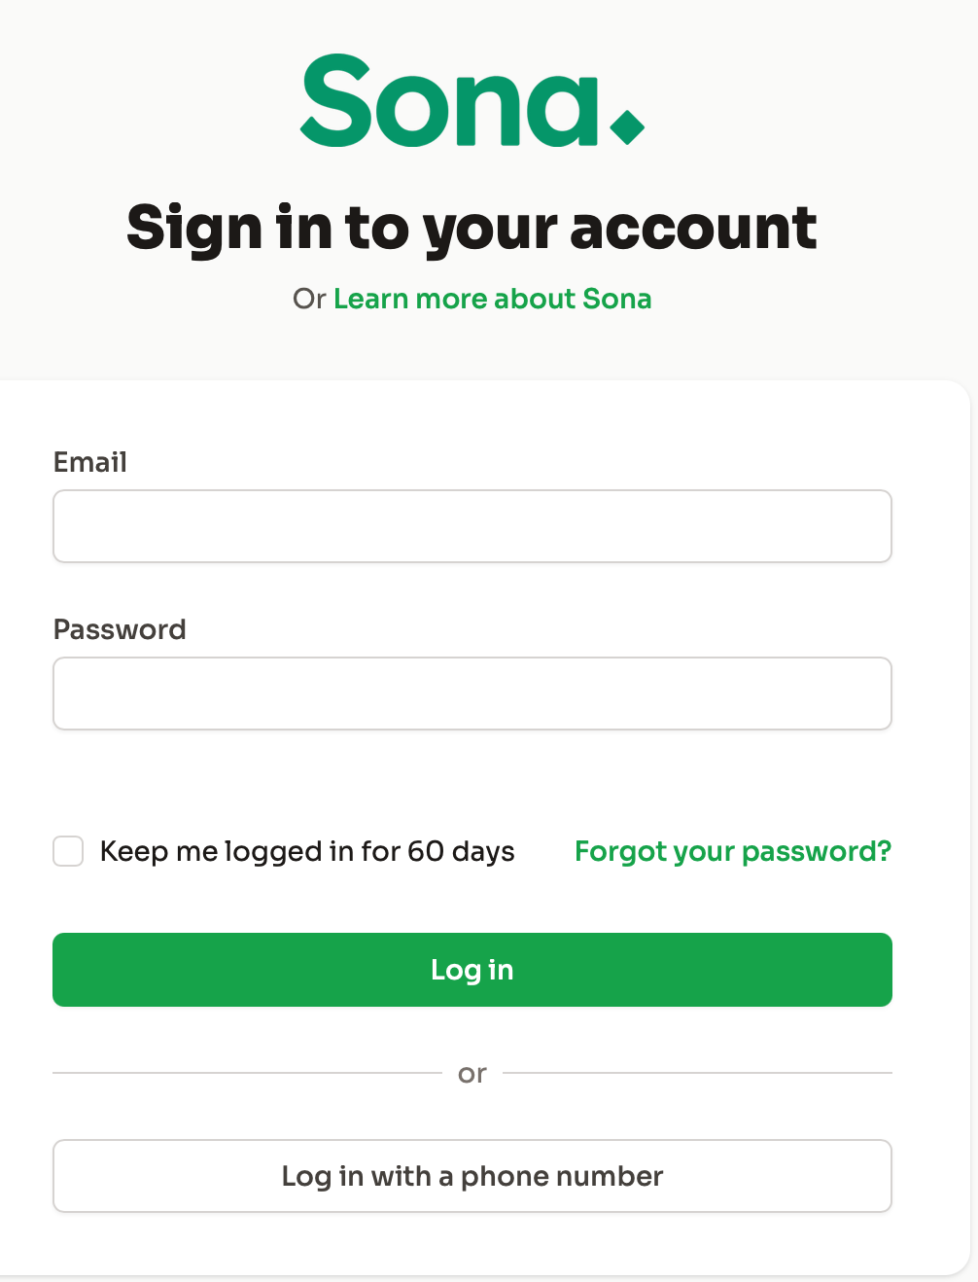
Son is the app that typically used in a business setting. I use it to track my time at work (clock in and clock out) and to check overtime, workdays, and days off.

Screenshot/Photo 4

Slack is a communication app used in the workplace. I use it every day to check update, delivery information, and instructions from my company

Screenshot/Photo 5

Amazon is large company that specialises in online shopping. I frequently use it to buy household items and personal products from home.

Screenshot/Photo 6
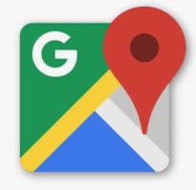
Google Map is the main app I use to find direction and plan my journeys between home and work, It helps me choose the best route and estimate my travel time.

My Short Reflection
- Write 5–8 simple sentences about your digital life.
- You can use the sentence starters below if helpful.
I use digital tools to communicate with my family and to help me at work.
I feel confident when I use WhatsApp and other family app.
I want to improve my digital skills and learn how to use new applications.
I often use WhatsApp, Slack, Sona, Google Map and Amazon
Sometimes I feel nervous when I must learn something new on a computer.

Sentence starters
- I use digital tools to …
- I feel confident when I …
- I want to improve …
- I often use these tools: …
- I sometimes feel nervous about …
- I hope this module will help me …
- Digital skills are important for me because …
You can write more if you want.

Submission Checklist
Before you submit, please check:
​​​ ☒ I added 4–6 screenshots
☒ I wrote short sentences for each screenshot
☒ I wrote my short reflection
☒ My work is my own
☒ My file opens correctly
​​☒ My file opens correctly

