5/3/2024
Assessment 1:
Networks and Cyber Security Essentials (ACCA4024)
Aliu Djalo (2117368)

UNIVERSITY OF WALES TRINITY SAINT DAVID

Table of Contents:
TASK 1: 3
a. Based on the background and introduction provided, the author will explain how the NIST Cybersecurity Framework helps safeguard digital assets and personal data in today's society. 3
b. How can the tools Nmap and Wireshark be utilized in the reconnaissance stage of a cyber-attack? 4
1. Nmap: 4
2. Wireshark: 4
c. Cyber-attacks and mitigations strategies: 5
1. WannaCry: 5
1.2 TeleRAT: 6
2. Whaling: 6
2.1 Pharming: 7
Task 2: 8
a) Using a network diagram (topology) or illustrations, create a secure network design incorporating two specified design principles focused on achieving high availability. 8
1. Redundancy at each layer: 9
2. Fault Tolerance: 9
3. Load balancing and resilience: 9
b) Which software and hardware technologies can be implemented to enhance network security during its operation? Provide detailed explanations on the functionality of the proposed technologies, making reasonable assumptions. 10
1. Firewalls: 10
2. VPN gateways: 10
3. Network device backup and recovery: 10
4. Zero trust network access (ZTNA): 10
5. Email security: 10
6. Network segmentation: 11
I. Intro to Packet tracer Certification: 11
II. Palo Alto Network Security Fundamentals 12
III. Cybersecurity Foundation: 12
Conclusion: 13

Abstract:
Data security and asset protection are critical in today’s digital environment. In order to reduce cyber threats, this report will explain in detail about NIST cyber security framework, Network architecture principles, Malware examples such as WannaCry and TeleRAT, reconnaissance tools like Nmap and Wireshark, phishing attempts like Whaling and Pharming and finally security technologies to mitigate cyber threats.

Introduction:
In the world of cybersecurity, cybercriminals invest time in planning and go through various stages such as cyber kill chain or attack life cycle before starting an attack. To protect digital assets and personal data, businesses require cybersecurity experts. In order to attack an Organisations, cybercriminals use advanced strategies, beginning with reconnaissance to find weak points of the target. Organisations can strengthen their defences by using the NIST cyber security framework. The author of this report will go through the types of attacks that many organizations are facing today and the ways that those attacks could be mitigated.

TASK 1:

Based on the background and introduction provided, the author will explain how the NIST Cybersecurity Framework helps safeguard digital assets and personal data in today's society.

The national institute of standards and technology (NIST) cybersecurity framework servers as a critical tool in the ongoing battle to protect digital assets and personal data in today’s society. It helps businesses of all size better understand, manage and reduce their cybersecurity risk and protect their networks and data. [1]
It core functions are to identify, protect, detect, respond, recover and aid businesses in their effort to spot, manage and counter cybersecurity events promptly.
In the context of challenges and opportunities in cybersecurity, the framework plays a vital role in several keyways. [2]
- Risk-based approach: To focus on identifying and prioritizing risks based on their potential impact on digital assets and personal data is very essential in an environment where threats are constantly evolving.
- Adaptability: One of the strengths of the NIST framework is the way it adapts to various sectors, size and organizational kinds. It offers a flexible collection of principles and best practices that can be adjusted to match the demands and risk profiles of various businesses, this adaptability is crucial in tackling the different and changing cybersecurity threats that enterprises confront across industries. [3]
- Comprehensive Guidance: The framework addresses several aspects of cybersecurity, such as: risk management, threat detection, incident response and recovery. by giving complete guidance on these critical areas, the framework help businesses develop cybersecurity plans that handle the entire cyber kill chain, from reconnaissance to post-attack recovery. [4]
- Integration with existing practices: The NIST framework is designed to complement, not replace, existing cybersecurity procedures and standards. It integrates smoothly with other frameworks such as ISO 27001 or COBIT, by allowing organisations to use their existing cybersecurity investments while benefiting from the framework’s extra guidance.
- Continuous Improvement: The framework emphasises the need for ongoing development in cybersecurity processes. It encourages businesses to regularly analyse their cybersecurity posture, identify areas for improvement and execute changes accordingly. This iterative strategy is critical in a climate where cyber threats are continually evolving, assuring organisations' resilience in the face of new challenges.[5]

How can the tools Nmap and Wireshark be utilized in the reconnaissance stage of a cyber-attack?

Nmap:
Nmap is an open-source Linux command-line tool that can be used to find hosts and services in a network and to detect installed applications in order to gather information on the target system details. It uses a variety of scan techniques. It can be used to access the perimeter of the network and determine potential entry for an attack during a reconnaissance phase. [6]
Examples: suppose that an attacker is intent to penetrate a company network, they can use Nmap to scan the network which involve sending packets to the target’s IP address and analyse replies to see which ports are open. This will allow them to gain access into the services running on the target systems. [7]

Wireshark:
Wireshark is a widely used open-source network analyser that can capture and display data packets sent over the network. It allows users to view content of packets and analyse network traffic in real-time. In the reconnaissance stage, Wireshark can be invaluable to gather information on network communications patterns, finding possible security vulnerabilities and discovering suspicious or unauthorised activities. [8]
Examples: An attacker can use Wireshark to capture network traffic in the target environment, in the same way as in the corporate network infiltration scenario, the attacker could gain a better understanding of the type of traffic passing through the network, including protocols and communication patterns among hosts and security weaknesses like unencrypted data transfer or plaintext authentication by analysing intercepted packets, this information can help an attacker to identify potential entry points or weaknesses in the network infrastructure that can be exploited during subsequent phases of the attack. [9]

Cyber-attacks and mitigations strategies:

WannaCry:
WannaCry is an example of a type of cyber extortion malware known as crypto ransomware, used by hackers to extort payments. The ransomware does this by either encryption important files and prevent the user from reading them or shutting down the user’s device so that they cannot use it. [9]

Mitigation strategies for WannaCry:
- Patch management: the exploitation of known vulnerabilities such as WannaCry can be prevented by ensuring all systems are regularly updated with the latest security patches. The risk of infection can be reduced by promptly applying patches like MS 17010.
- Always backup: regularly backing up important data and maintaining offline backups can mitigate the impact of a ransomware attack like WannaCry. But keep in mind that backups alone are not enough to protect against data loss from attacks, especially if companies are exposing privileged credentials to attackers. [10]
- Block Internet Access: The Microsoft SMB protocol is intended for internal use, so the network should not be open to Internet SMB packets. Another important preventive measure is to implement port filtering, which will block all versions of SMB at the network's boundary.
- Security awareness training: To prevent the initial infection of WannaCry, employees should be educated about the dangers of clicking on suspicious links or downloading attachments from unknown sources. Awareness training may also teach employees how to recognize phishing messages, which are often used as a delivery mechanism for ransomware. [11]

TeleRAT:
TeleRAT is a trojan that targets android devices, which can be accessed remotely through your mobile device, it masquerades as legitimate applications, which are often distributed through third party app stores or malicious websites. After installation, TeleRAT gives attackers remote control of the infected devices, stealing confidential information, recording audio or video and carrying out more malicious activities without the user’s knowledge. [12]

Mitigation strategies for TeleRAT:
- User awareness training: To prevent TeleRAT infections, it is important to educate users on the risks of downloading apps from untrusted sources and ensuring that they use safe browsing practices. To download apps, users should be cautious and not click on malicious links or advertisements that could lead to the installation of malware.
- Security updates: The risk of TeleRAT infection can be mitigated by encouraging users to update their devices with the most recent security patches and software updates. Manufacturers are regularly updating the operating systems and applications of their devices with updates to address identified vulnerabilities, as well as addressing security issues.
- App whitelisting: To prevent the installation of unauthorised applications such as TeleRAT, implementing app whitelisting policies may be helpful. Organizations can reduce the risk of malware infection if users are restricted to installing authorized applications from trusted sources. [13]

Whaling:
Whaling is a highly targeted phishing attack that targets high profile individuals within an organization, such as executives and senior managers. Attackers impersonate these individuals and send convincing emails to employees, usually requesting sensitive information or authorisation of financial transactions. [14]

Mitigation Strategies for Whaling:
- Email authentication: DMARC (Domain-based message authentication, reporting and conformance) is a mechanism that can be used to detect and spot email spoofing attackers, which are frequently used in whiling. It gives businesses visibility into email traffic coming from their domains and let them define policies regarding the handling of unauthenticated emails.
- Staff training: It can help reduce the likelihood of success in compromise if employees are trained regularly on cyber security best practices and it will give them more awareness about whiling attack tactics. Especially, when it comes to sensitive information or financial transactions, staff should be trained to verify the authenticity of an email request.
- Two-factor authentication: To reduce the risk of unauthorised access from whiling attacks, two factor authentication for sensitive actions such as wire transfers or access to critical systems may help. If the attackers were able to compromise staff credentials, they would still need an additional form of authentication in order to carry out a malicious activity.
- Four eye principle: The most common type of whiling aims to generate financial transactions by pretending to be the chief executive and making contact with a key finance staff member. Four eye is a policy requiring at least two people to agree on an important transaction irrespective of who requested it or what urgency the message sounds like. [15]

Pharming:
Pharming is a type of cyber attack that sends legitimate website traffic to bogus ones, which are unknown to the user. Attackers usually exploit vulnerabilities in DNS servers to redirect users to sites where they are going to be tricked into revealing personal data such as login credentials or financial information. [16]

Mitigation Strategies for Pharming:
- Secure DNS configuration: The risk of pharming attacks can be mitigated by ensuring that DNS servers are configured securely and regularly updated. Best practices in DNS security, for instance the use of DNSSEC (Domain Name System Security Extensions) to cryptographically sign DNS responses and prevent DNS spoofing attacks should be implemented by organisations.
- Network monitoring: to deploy network visibility solutions can help organizations to identify and mitigate pharming attacks in real-time by monitoring DNS traffic for any sign of suspicious activities. [17]
- Web browser: Click only on URLs that begin with HTTPS, avoid the ones that are HTTP. The “S” indicates that the site is securely protected by a trusted security certificate.
- Endpoint protection: Use a secure program that monitor malware, such as an antivirus, this type of program will stop the comprised file from running, preventing hackers from placing their payload on your organization’s network when the threat is identified. [18]

Task 2:

Using a network diagram (topology) or illustrations, create a secure network design incorporating two specified design principles focused on achieving high availability.
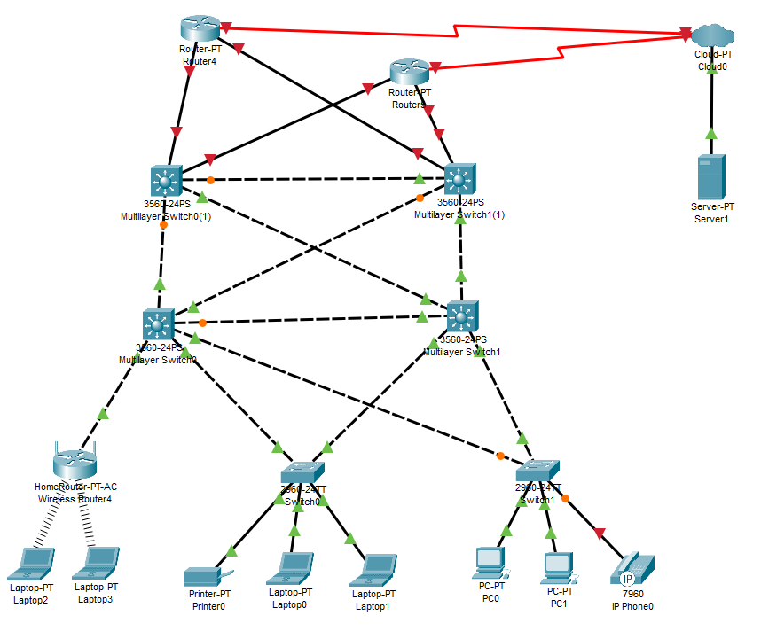
The author has designed a Three-Tier architecture network diagram. He will explain how this network provide high availability, eliminate single points of failure and provide reliable crossover.

Redundancy at each layer:
- Access Layer: At this layer, there are 2 switches and a wireless router, each connected to multiple PCs, laptops, a printer and a phone. This redundancy reduces downtime, by ensuring that, in the even of a switch failure, the other switch can provide connectivity to the devices attached to it.
- Distribution Layer: At this layer, two multilayer switches are installed and connected to the switches from the Access layer. They are also connected to each other, giving traffic other routes and redundancy. If one distribution switch fails, the other can still handle the traffic, ensuring continues network operation.
- Core Layer: Same to the distribution layer, two multilayer switches each connected to the Distribution layer and interconnected to each other. This redundancy ensures that the other core switch and router can continue to provide network connectivity while maintaining high availability in case of failure of a single core switch or connection to one router. [19]

Fault Tolerance:
The topology improves fault tolerance and minimises the risk of simple points of failure by deploying redundant devices and links at each layer of the network. Traffic can be rerouted through redundant paths to allow the network to continue operating as normal when a device or link fails. [20]

Load balancing and resilience:
By using multiple paths between devices, the topology allows load balancing and resilience. For instant, to avoid congestion and optimise network performance, traffic can be distributed across multiple links between switches at different layers. In addition, traffic can be rerouted through alternative routes to ensure resilience and maintain high availability in case of congestion or failure of one route. [21]

Which software and hardware technologies can be implemented to enhance network security during its operation? Provide detailed explanations on the functionality of the proposed technologies, making reasonable assumptions.

Firewalls:
One of the most fundamental network security appliances is firewall. Like many other security devices, firewalls can be purchased as software or hardware. With the use of firewalls, your internal network and the public internet are kept apart. They can prevent connections from particular IP addresses, ports and computers or networks that meet additional requirements. The majority of firewalls are set up to automatically block incoming traffic, giving your network a basic level of security.

VPN gateways:
VPN technology allows remote users to access the company’s network security by creating secure encrypted connections over untrusted networks. It provides confidentiality, integrity and authenticity of the data transmission. by ensuring that sensitive information is protected from eavesdropping and unauthorised access.

Network device backup and recovery:
It can be difficult to apply and undo configuration changes when there are so many distinct network devices. Additionally, in the case of a disaster, it is challenging to quickly recover a large number of separate devices. For these raisons, it is important and useful to centralized backup and recovery for network devices. [22]

Zero trust network access (ZTNA):
A user’s access is granted by zero trust access network according to the precise function they perform on the network. Each person is only allowed access to certain processes or apps that are necessary for them to effectively preform their jobs.

Email security:
Email security is designed to stop users from unknowingly divulging private information or enabling unauthorized access to the network through an infected email. Emails containing potentially harmful threats will be warned about or blocked by this security feature.

Network segmentation:
It divides the network into several sections and each act as its own network. In order to improve performance, localise problems and increase security, the administrator can control access to each of these smaller networks. [23]

Intro to Packet tracer Certification:
file:///C:/Users/2117368/Downloads/AliuDjalo-ACCA%204024%20Introd-certificate.pdf
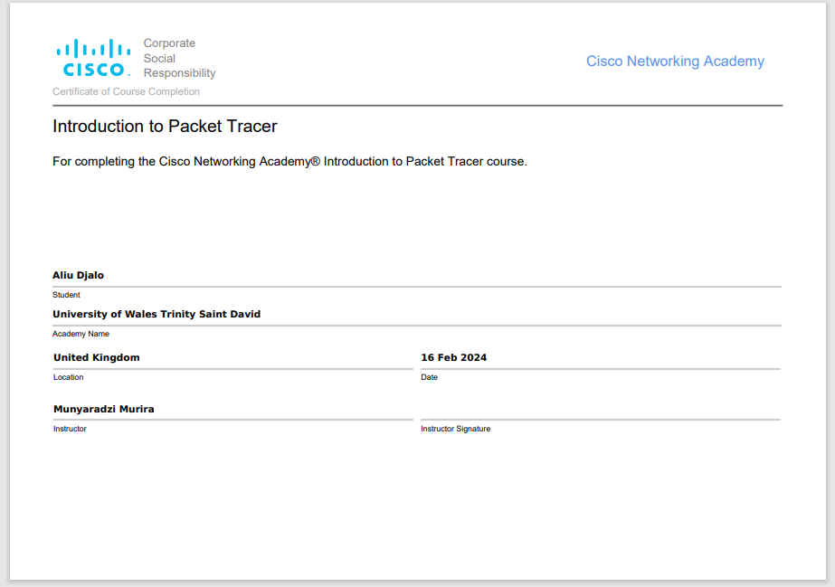

Palo Alto Network Security Fundamentals
Network_Security_Fundamentals_Student_Certificate.pdf
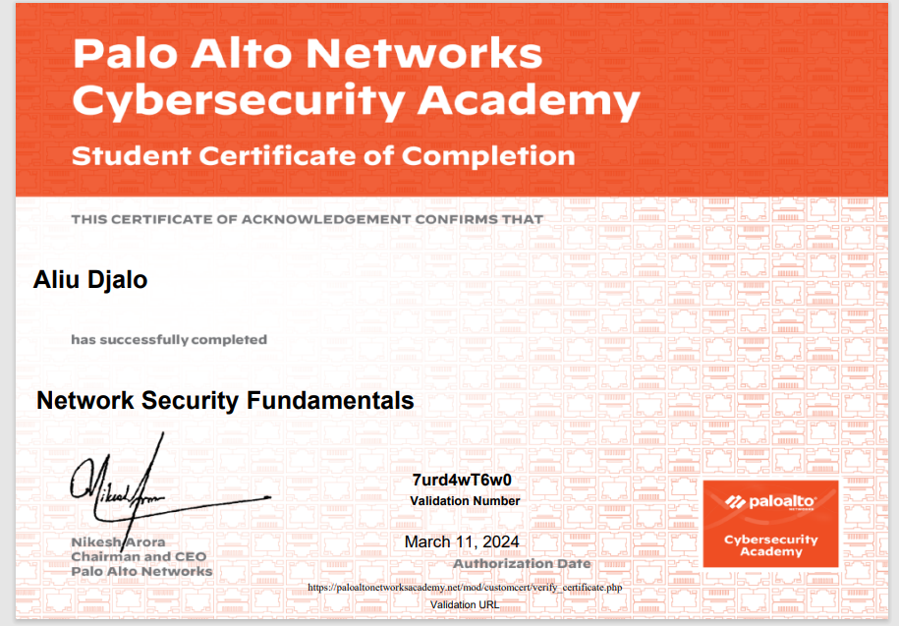

Cybersecurity Foundation:
Cybersecurity_Foundation_Student_Certificate.pdf
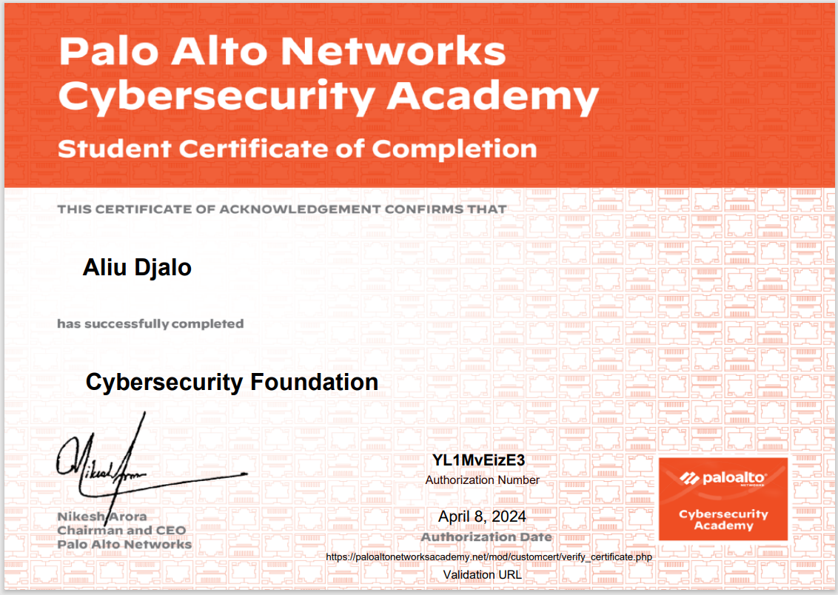

Conclusion:

As cyber threats evolve, proactive steps are essential. Putting the NIST Cybersecurity Framework into practice offers a structured method for protecting assets. The author has learned a lot through this report and he is looking to continue doing more research based on certain areas in order in enhance his knowledge on the subject.

References:
[1] (). Understanding the NIST cybersecurity framework. Available: https://www.ftc.gov/business-guidance/small-businesses/cybersecurity/nist-framework.
[2] (). NIST Cybersecurity Framework Core Explained. Available: https://www.cybersaint.io/blog/nist-cybersecurity-framework-core-explained#:~:text=The%20core%20functions%20are%20to,technical%20and%20business%2Dside%20stakeholders.
[3] Jim Boehm , Nick Curcio, Peter Merrath, Lucy Shenton, and Tobias Stähle. Jim Boehm , Nick Curcio, Peter Merrath, Lucy Shenton, and Tobias Stähle. The risk-based approach to cybersecurity. The risk-based approach to cybersecurity. 2019. Available: https://www.mckinsey.com/capabilities/risk-and-resilience/our-insights/the-risk-based-approach-to-cybersecurity.
[4] (Jul 26,). How to Adopt and Adapt NIST Information Security Framework at Your Organization. Available: https://manula-udu.medium.com/how-to-adopt-and-adapt-nist-information-security-framework-at-your-organization-73b8150b2d43.
[5] (February 18,). Complete Guide to the NIST Cybersecurity Framework. Available: https://reciprocity.com/resource-center/complete-guide-to-the-nist-cybersecurity-framework/#:~:text=The%20framework%20is%20structured%20around,Detect%2C%20Respond%2C%20and%20Recover.
[6] (OCTOBER 2,). What is Nmap and How to Use it – A Tutorial for the Greatest Scanning Tool of All Time. Available: https://www.freecodecamp.org/news/what-is-nmap-and-how-to-use-it-a-tutorial-for-the-greatest-scanning-tool-of-all-time/.
[7] (August 19,). Six practical use cases for Nmap. Available: https://www.redhat.com/sysadmin/use-cases-nmap.
[8] (January). Wireshark. Available: https://www.techtarget.com/whatis/definition/Wireshark.
[9] (). What Is Wireshark and How Is It Used?. Available: https://www.comptia.org/content/articles/what-is-wireshark-and-how-to-use-it.
[10] (). WannaCry . Available: https://www.malwarebytes.com/wannacry.
[11] 5/30/17, 5/30/17.
[12] (March 22,). Android Trojan Leverages Telegram for Data Exfiltration. Available: https://ttcsirt.gov.tt/android-trojan-leverages-telegram-for-data-exfiltration/.
[13] (May 2,). WHAT IS APPLICATION WHITELISTING?. Available: https://www.crowdstrike.com/cybersecurity-101/application-whitelisting/.
[14] (30 April). Business email compromise: defending your organisation. Available: https://www.ncsc.gov.uk/guidance/business-email-compromise-defending-your-organisation.
[15] (May 15,). Whaling Attack. Available: https://ironscales.com/guides/phishing-prevention-best-practices/whaling-attack.
[16] (). Fundamentals of cyber security - AQA. Available: https://www.bbc.co.uk/bitesize/guides/znnny4j/revision/4.
[17] (). Pharming. Available: https://www.zimperium.com/glossary/pharming/.
[18] March 20, 2023.
[19] Kevin Dooley. Kevin Dooley. Network redundancy and why it matters. Network redundancy and why it matters. Available: https://www.auvik.com/franklyit/blog/simple-network-redundancy/#:~:text=Network%20redundancy%20is%20the%20process,another%20can%20automatically%20take%20over.
[20] (). What Is Fault Tolerance?. Available: https://www.fortinet.com/uk/resources/cyberglossary/fault-tolerance#:~:text=Fault%20tolerance%20is%20a%20process,operating%20despite%20failures%20or%20malfunctions.
[21] May 3, 2023.
[22] (). What Are Network Security Devices?. Available: https://www.restorepoint.com/topics/what-are-network-security-devices.
[23] (). Types of Network Security Protections. Available: https://www.fortinet.com/resources/cyberglossary/what-is-network-security.

