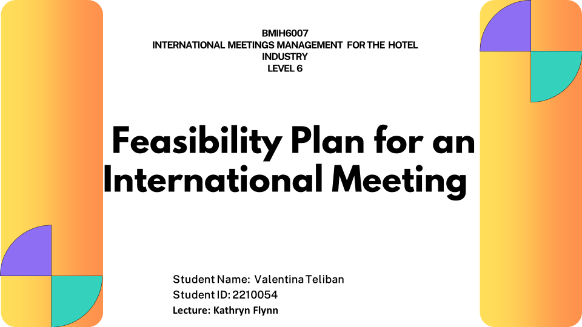

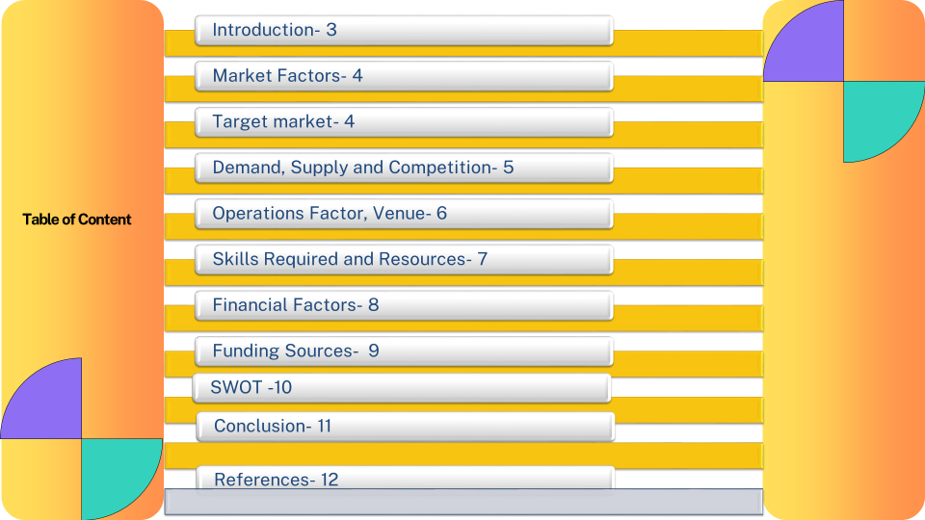

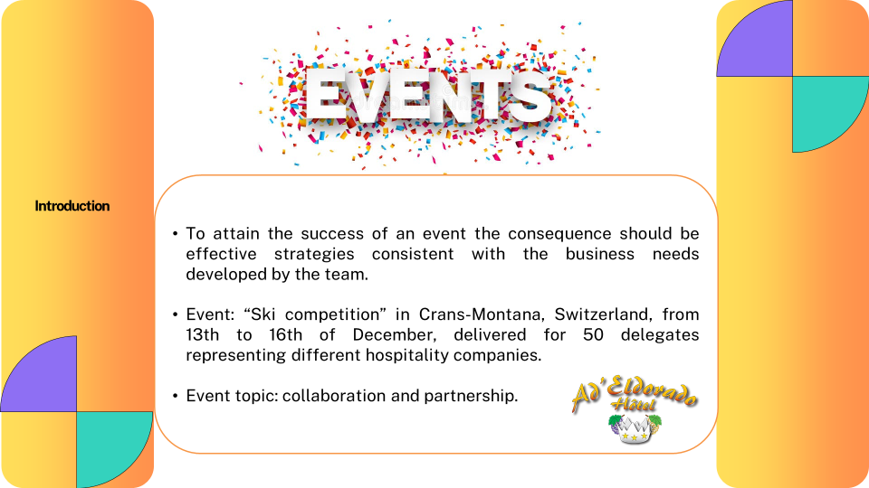

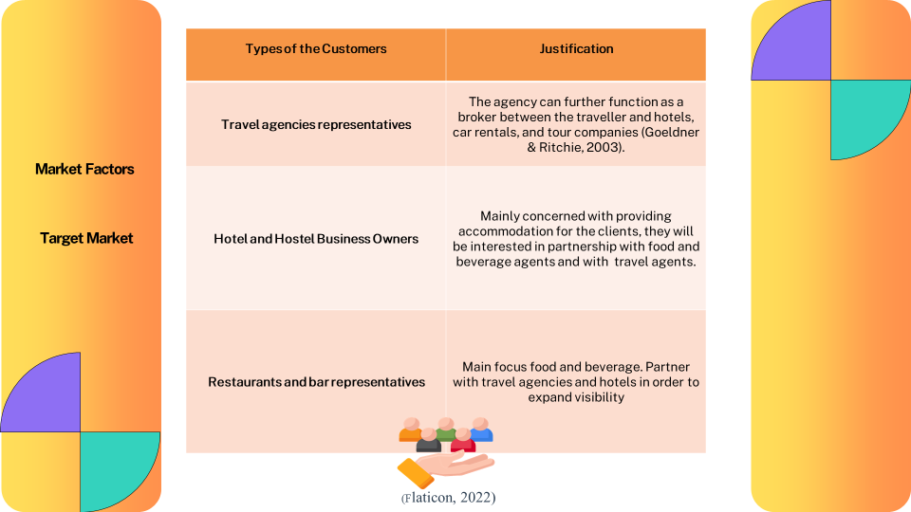

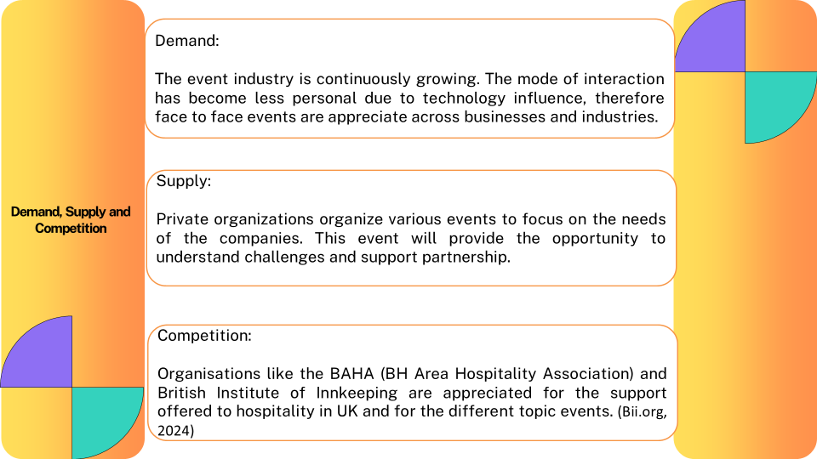

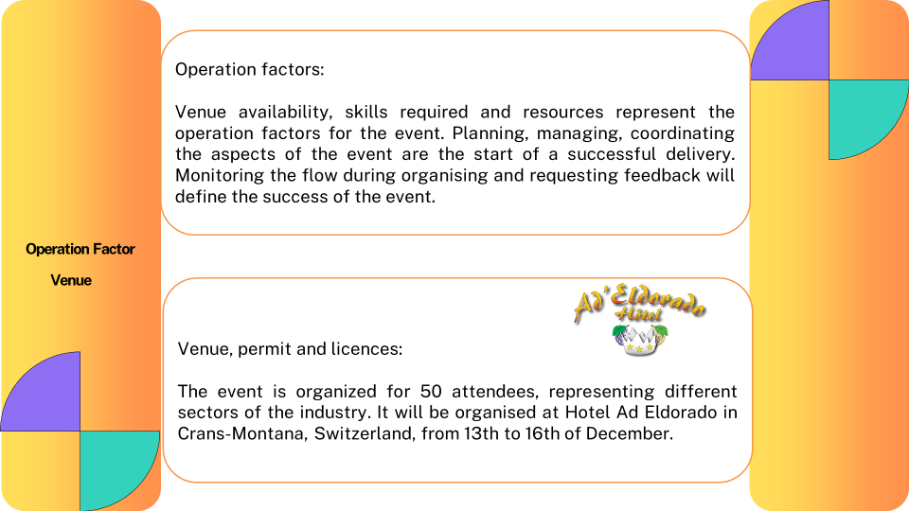

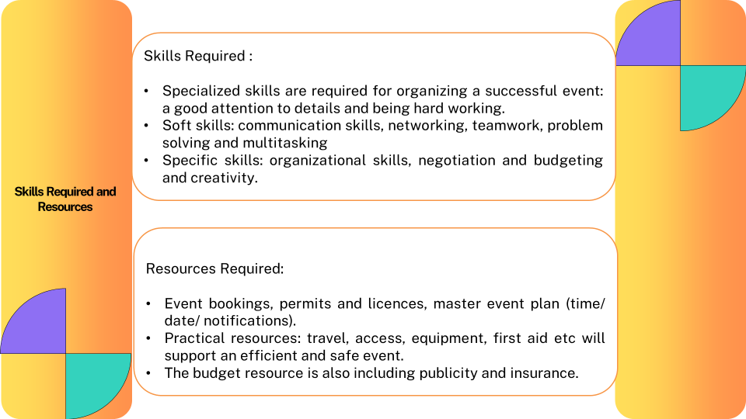

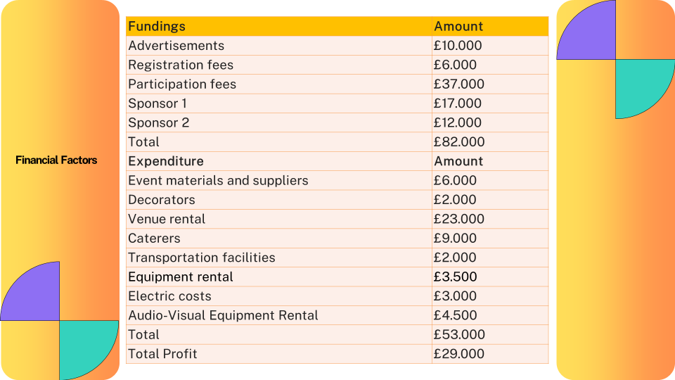

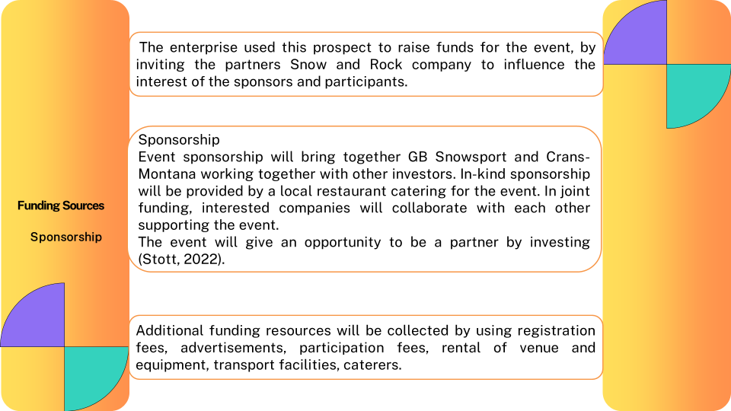

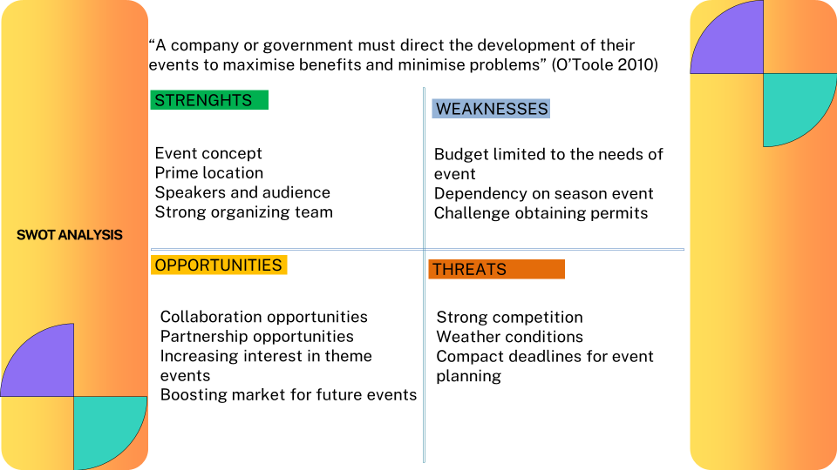

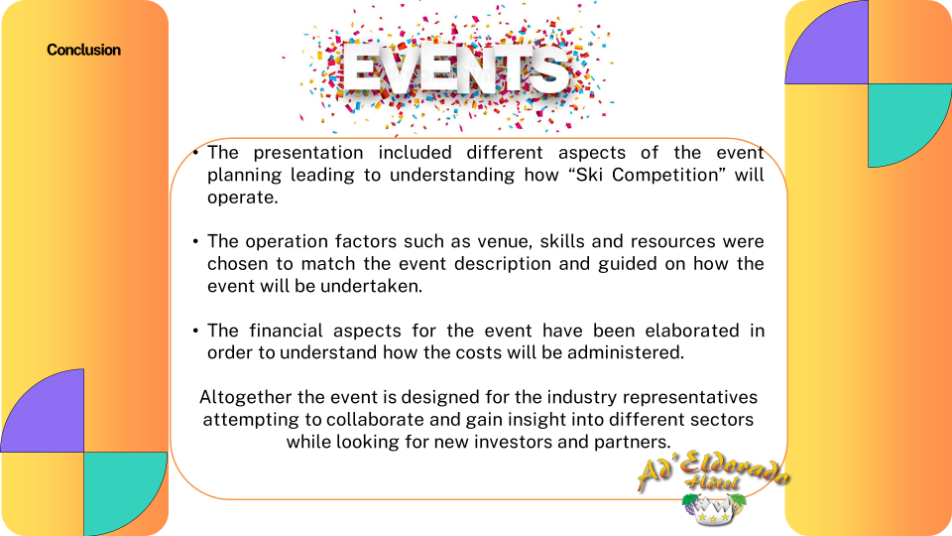

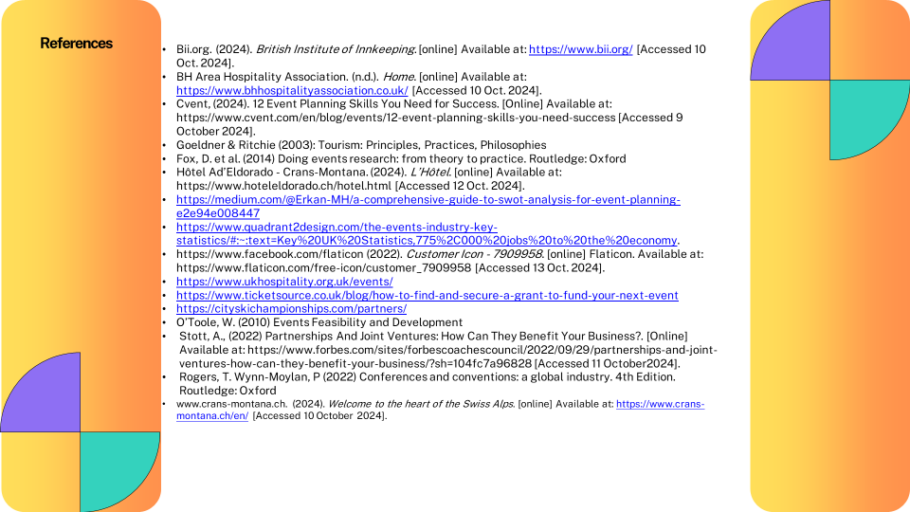

- Bii.org. (2024). British Institute of Innkeeping. [online] Available at: https://www.bii.org/ [Accessed 10 Oct. 2024].
- BH Area Hospitality Association. (n.d.). Home. [online] Available at: https://www.bhhospitalityassociation.co.uk/ [Accessed 10 Oct. 2024].
- Cvent, (2024). 12 Event Planning Skills You Need for Success. [Online] Available at: https://www.cvent.com/en/blog/events/12-event-planning-skills-you-need-success [Accessed 9 October 2024].
- Goeldner & Ritchie (2003): Tourism: Principles, Practices, Philosophies
- Fox, D. et al. (2014) Doing events research: from theory to practice. Routledge: Oxford
- Hôtel Ad’Eldorado - Crans-Montana. (2024). L’Hôtel. [online] Available at: https://www.hoteleldorado.ch/hotel.html [Accessed 12 Oct. 2024].
- https://medium.com/@Erkan-MH/a-comprehensive-guide-to-swot-analysis-for-event-planning-e2e94e008447
- https://www.quadrant2design.com/the-events-industry-key-statistics/#:~:text=Key%20UK%20Statistics,775%2C000%20jobs%20to%20the%20economy.
- https://www.facebook.com/flaticon (2022). Customer Icon - 7909958. [online] Flaticon. Available at: https://www.flaticon.com/free-icon/customer_7909958 [Accessed 13 Oct. 2024].
- https://www.ukhospitality.org.uk/events/
- https://www.ticketsource.co.uk/blog/how-to-find-and-secure-a-grant-to-fund-your-next-event
- https://cityskichampionships.com/partners/
- O’Toole, W. (2010) Events Feasibility and Development
- Stott, A., (2022) Partnerships And Joint Ventures: How Can They Benefit Your Business?. [Online] Available at: https://www.forbes.com/sites/forbescoachescouncil/2022/09/29/partnerships-and-joint-ventures-how-can-they-benefit-your-business/?sh=104fc7a96828 [Accessed 11 October2024].
- Rogers, T. Wynn-Moylan, P (2022) Conferences and conventions: a global industry. 4th Edition. Routledge: Oxford
- www.crans-montana.ch. (2024). Welcome to the heart of the Swiss Alps. [online] Available at: https://www.crans-montana.ch/en/ [Accessed 10 October 2024].

