STRATEGIC MANAGEMENT ANALYSIS: A COMPREHENSIVE STUDY OF PEPSICO'S GLOBAL STRATEGY AND COMPETITIVE DYNAMICS

Table of Contents
Introduction 3
PepsiCo: An Overview 3
Rationale for Selection 3
Preview of Main Points 3
2. External Context: Macro and Micro Environment Analysis of PepsiCo 4
PESTEL Analysis for PepsiCo in the UK 4
Micro Environment: Porter's Five Forces Analysis for PepsiCo in the UK's Beverage and Snack Industry 9
Strategic Group Analysis for the Beverage and Snack Industry 12
3. Internal Analysis and PepsiCo's Competitive Advantage 13
Application of the VRIO Framework to PepsiCo's Resources and Capabilities 13
Value Chain Analysis of PepsiCo's Operations and Strategic Capabilities 16
SWOT Analysis of PepsiCo 19
4. PepsiCo's Competitive and Development Strategies 20
Analysis of PepsiCo's business-level strategies 20
Insights into PepsiCo's corporate-level strategies 21
Use of the Game Theory to Understand PepsiCo's strategic decisions in the competitive market 22
5. Strategy Implementation, Global Strategy, and Organizational Aspects 24
PepsiCo's modes of Foreign market entry 24
The organizational culture, structure, and Leadership at PepsiCo 24
Discussion on PepsiCo's stakeholder mapping and its importance in their strategy 26
6. Ethical, Sustainability, and CSR Considerations at PepsiCo 27
Analysis of PepsiCo's Stance on Ethical Issues, Sustainability, and CSR 27
The impact of governance, sustainability, and CSR on PepsiCo's strategic development 28
7. Conclusions, Recommendations, and Strategic Evaluation 29
Summarizing key findings from the PepsiCo analysis 29
Recommendations for PepsiCo moving forward 30
Strategic evaluation using insights from the case studies on strategy formulation and choices 30
8. Reflection 31
9. References 32
Appendices 36
Appendix 1: The brand value of the most valuable soft drink brands Worldwide in 2022 36
Appendix 2: Leading soft drink brands in the United Kingdom 2022, by convenience sales value 36

Introduction

PepsiCo: An Overview
PepsiCo, which was established in 1898, has developed into one of the biggest food and beverage businesses in the world. The firm works internationally, providing goods to customers in more than 200 countries and territories ((PepsiCo, 2023). Its portfolio is varied and includes snacks, drinks, and nutrition items. Pepsi, Lay's, Gatorade, Quaker, and Tropicana are just a few of its well-known brands. PepsiCo has throughout the years prioritised sustainability, governance, and corporate social responsibility in addition to product innovation, making it a relevant topic for strategic study.

Rationale for Selection
PepsiCo was selected for the focus of this strategic study for a variety of reasons:
- Global Presence: Due to PepsiCo's extensive worldwide presence, there are several opportunities to study strategic management, from small company operations to global endeavours.
- Diverse Portfolio: PepsiCo offers a platform to investigate both business-level and corporate-level initiatives using a variety of drinks, snacks, and nutrition items (PepsiCo, 2023).
- Sustainability and CSR: Strategic sustainability is essential in the current corporate environment (Haseeb et al. 2019). In line with the module's emphasis on moral issues, sustainability, and corporate social responsibility, PepsiCo's recent efforts in water stewardship, sustainable packaging, and community participation provide a fertile field for examination.
- Contemporary Challenges: PepsiCo works in a highly competitive environment where it must contend with shifting customer preferences, market dynamics, and international uncertainty. Due of this, frameworks like Porter's Five Forces, PESTEL analysis, and the VRIO framework-all of which have been covered in the accompanying notes-can be used to the topic.

Preview of Main Points
This report aims to provide a thorough strategic analysis of PepsiCo by examining its internal and external surroundings, competitive and development strategies, and approach to sustainability and CSR. The study will clarify how PepsiCo solves major issues and takes advantage of opportunities to establish and retain a competitive edge in the global market by utilising the models, theories, and frameworks from the strategic management module.

2. External Context: Macro and Micro Environment Analysis of PepsiCo

PESTEL Analysis for PepsiCo in the UK
In light of the particular possibilities and constraints faced by the area, this PESTEL study offers a personalised perspective of the macro-environmental variables impacting PepsiCo's activities in the UK (Pan et al. 2019).
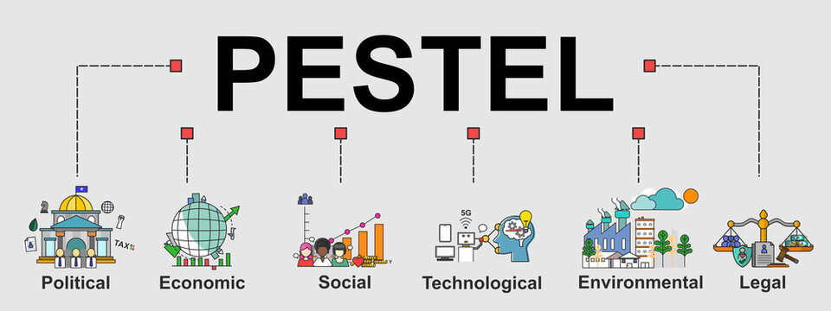
Figure 1: PESTEL analysis concept
(Source: Developed based on Pan et al. 2019)
Political Factors
- Brexit Implications: PepsiCo may be affected by the UK's withdrawal from the European Union in terms of market access, supply chain logistics, and trade tariffs (Gerassimidou et al. 2022).
- Regulations on Sugary Drinks: The composition of PepsiCo's products is directly impacted by the UK government's aggressive regulation of sugary beverages to fight obesity (Allen and Allen, 2020).
Economic Factors
- Consumer Spending: Sales may be impacted by UK economic downturns, inflation rates, and shifts in consumer spending power. As seen by the GDP growth rate of around 4.05% in 2022, the UK economy is functioning well (O'Neill, 2023).
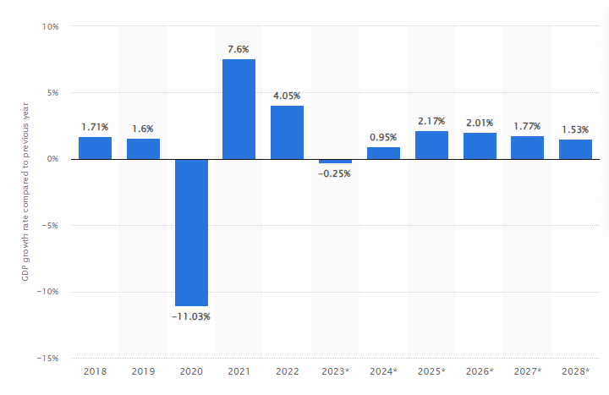
Figure 2: GDP growth rate in the United Kingdom 2028
(Source: O'Neill, 2023)

In contrast, the inflation rate decreased to 7.9% in June 2023, indicating that things had stabilised since their peak (Clark, 2023). This economic climate predicts that enterprises will thrive there. For PepsiCo, a strong UK economy implies more people will spend money, particularly now that food inflation is on the rise, which suggests a boost in demand for food items. The UK's robust consumer market, therefore, gives an opportunity for PepsiCo to profit from.
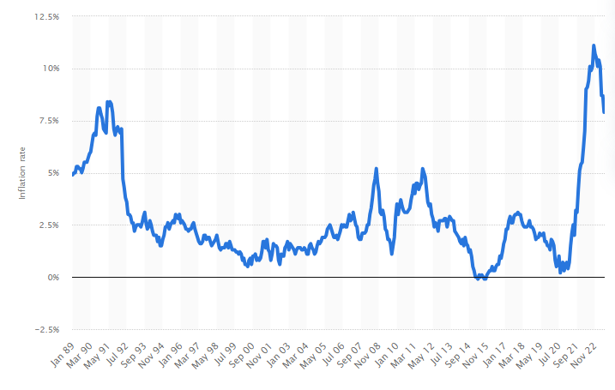
Figure 3: Inflation rate in the UK 1989-2023
(Source: Clark, 2023)
- Currency Fluctuations: The strength of the British pound, particularly after Brexit, may have an impact on PepsiCo's regional revenue and expenses.
Social Factors
- Health and Wellness Trends: The active efforts they make to eat healthfully were highlighted by 61% of UK respondents in 2023 (Kunst, 2023). Due to the fact that many of PepsiCo's products include sugar and may thus contribute to obesity, this trend emphasises an issue for the company. PepsiCo must innovate if it wants to remain competitive in the UK market, where consumer awareness of health issues is growing. By providing healthier drink and snack options, the brand will not only be able to meet the tastes of its target market but will also be able to maintain its position and expand its market share.
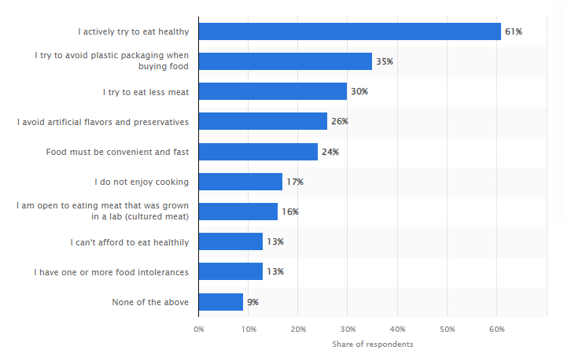
Figure 4: Attitudes towards food in the UK 2023
(Source: Kunst, 2023)
- Cultural Preferences: PepsiCo must satisfy the distinct tastes and preferences of British customers, particularly when it comes to the flavours of snacks and beverages.
Technological Factors
- Digital Commerce: According to forecasts, the UK's e-commerce industry will generate 194.1 billion US dollars in sales by 2027 (Statista, 2023). This increase demonstrates how popular internet purchasing is in the UK. This development offers a fantastic opportunity for PepsiCo. PepsiCo may profit as online shopping develops popularity by boosting its presence on e-commerce platforms and using digital marketing methods. By doing this, PepsiCo can serve the UK's tech-savvy customers, ensuring the brand maintains its leadership in the industry and benefits from the change to online shopping.
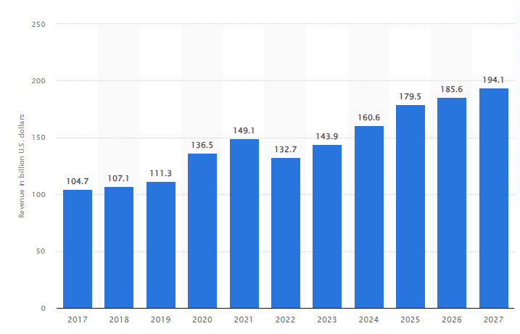
Figure 5: Total retail e-commerce revenue in the United Kingdom 2017-2027
(Source: Statista, 2023)
- Tech-driven Supply Chain: PepsiCo can implement tech-driven solutions for effective logistics and distribution thanks to the UK's sophisticated infrastructure.
Environmental Factors
- Sustainability Initiatives: The UK has shown its commitment to sustainability by cutting its per-person CO2 emissions by 56% since 1970, to 5.2 metric tonnes in 2021 (Tiseo, 2023). This considerable reduction highlights the UK's emphasis on the environment. This trend offers a very obvious direction for businesses like PepsiCo. The UK market favours environmentally good practises, which encourages PepsiCo to source sustainably and use environmentally friendly packaging. In addition to being morally right, aligning with these environmental ideals is a calculated effort to appeal to UK consumers, maintaining PepsiCo's relevance and competitiveness in a market that places a premium on green activities.
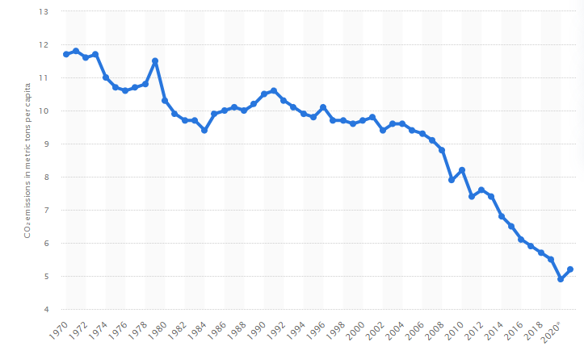
Figure 6: Carbon dioxide emissions per capita in the United Kingdom 1970-2021
(Source: Tiseo, 2023)
- Carbon Emissions: The production procedures and transportation options made by PepsiCo may be impacted by carbon emission regulations in the UK.
Legal Factors
- Food and Beverage Regulations: The UK has strict laws governing the safety, labelling, and advertising of food and beverages (Facioni et al. 2020). For PepsiCo to preserve its market position and image as a trusted brand, compliance is essential.
- Labour Laws: Operations choices made by PepsiCo may be influenced by employment and labour regulations in the UK, notably those pertaining to worker benefits and rights.

Micro Environment: Porter's Five Forces Analysis for PepsiCo in the UK's Beverage and Snack Industry
This Porter's Five Forces study gives a thorough insight of the competitive dynamics and forces that exist within the UK snack and beverage sector that are important to PepsiCo. It describes the difficulties and possibilities the business could encounter in this particular microenvironment (Shi et al. 2021).
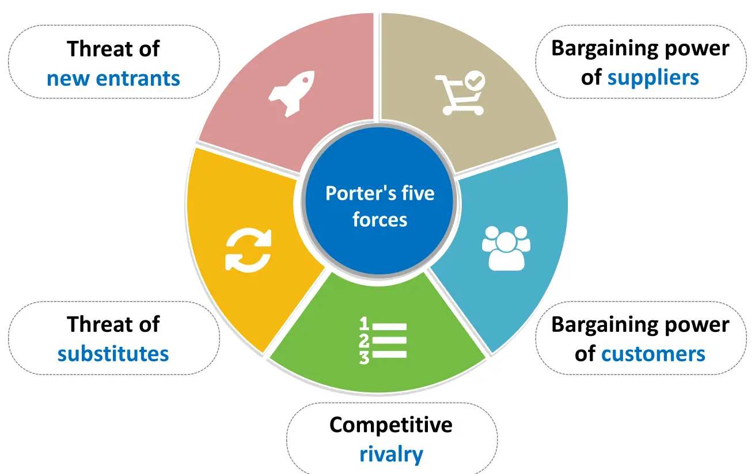
Figure 7: Porter’s Five Forces concept
(Source: Developed based on Shi et al. 2021)
Forces | Power | Discussion
Threat of New Entrants | Low | Capital Requirements: Establishing a presence in the beverage and snack industry requires significant capital investment, making it challenging for new players to enter.  Brand Loyalty: PepsiCo, with its established brands like Pepsi, Lay's, and Quaker, enjoys strong brand loyalty, which acts as a barrier to new entrants. In the year 2022, Pepsi came in at number two, with a market cap of over 21 billion dollars (Ridder, 2023).[Refer to Appendix 1]  Distribution Channels: In the UK, PepsiCo's well-established distribution networks might be difficult for new competitors to immediately duplicate.
Bargaining Power of Suppliers | Moderate | Limited Suppliers: Ingredients like sugar, certain flavours, or raw materials may only have a small number of suppliers, which strengthens their negotiating position (Baker et al. 2020).  Integration: Wherever feasible, PepsiCo integrates vertically to lessen its reliance on outside suppliers and weaken their negotiating position.
Bargaining Power of Buyers | Low | Product Differentiation: Despite the availability of competitors, PepsiCo products' distinctive flavour and brand may make consumers less willing to accept lower prices.  Retailer Dominance: Large UK retailers like Tesco and Sainsbury's might put pressure on prices, which would affect PepsiCo's profits (Paavola and Cuthbertson, 2022).
Threat of Substitute Products | Moderate | Health Trends: Fruit juices, herbal drinks, and nutritious snacks may serve as alternatives to standard sodas and chips as the movement towards health and well-being grows (Prahl, 2023).  Diverse Portfolio: Due to PepsiCo's extensive product lineup, which includes both drinks and snacks, they are able to satisfy a wide variety of customer demands, which lessens the overall danger.
Competitive Rivalry within the Industry | High | Major Competitors: Sales of soft drinks in the UK in 2022 showed fierce rivalry. In convenience shops, Coca-Cola had the most sales with 732 million British pounds. PepsiCo's Pepsi Max, with 567 million pounds in sales, came in second place (Ridder, 2022). Even while Coca-Cola continues to dominate, Pepsi Max's quick rise highlights the market's intense competitiveness. Although other businesses compete for market share, it is clear that these two industry titans have a heated competition. The research emphasises how fiercely competitive the UK soft drink business is, with firms always coming up with new products to win over consumers. [Refer to Appendix 2]  Market Growth: The beverage and snack sector in the UK is expanding moderately, which fuels fierce rivalry as businesses compete for market share.  Product Innovation: Competitors' frequent product introductions and developments might exacerbate competition.
Table 1: Porter’s five force analysis of PepsiCo
(Source: Self-developed)

Strategic Group Analysis for the Beverage and Snack Industry
This Strategic Group Analysis gives a quick overview of the various business groups within the beverage and snack sector and how they strategically position themselves (Struckell et al. 2022). Understanding these groupings is useful for PepsiCo in identifying immediate rivals, possible risks from emerging brands, and chances for cooperation or greater differentiation.
1. Global Beverage and Snack Giants
- Companies: PepsiCo, Coca-Cola, Nestlé, and Mondelez International.
- Characteristics: These businesses have a substantial R&D portfolio, a high brand awareness, a widespread worldwide presence, and a broad range of products (Wood et al. 2023).
- Strategies: They emphasise new product development, international growth, and cultural sensitivity.
2. Health-focused Brands
- Companies: Innocent Drinks, KIND Snacks, and Vita Coco.
- Characteristics: These products place a strong emphasis on natural ingredients, health advantages, and often use a "clean-label" strategy (Brownbill, 2020).
- Strategies: Using marketing efforts that are specifically targeted, premium product positioning, and health trends.
3. Private Labels or Store Brands
- Companies: Products sold under the names of well-known stores like Sainsbury's, Tesco, and Asda.
- Characteristics: They appeal to customers on a tight budget since they are often less expensive than their branded equivalents (Beattie, 2023).
- Strategies: Price parity, effective use of shelf space within respective retail chains, and speedy trend adaptation.

3. Internal Analysis and PepsiCo's Competitive Advantage

Application of the VRIO Framework to PepsiCo's Resources and Capabilities
This VRIO research sheds light on the assets and skills that PepsiCo uses to maintain a competitive advantage in the market (Johnson, 2020). It highlights the areas where the business has a persistent advantage and the ones where it has to strengthen its skills in order to keep up its leading position.
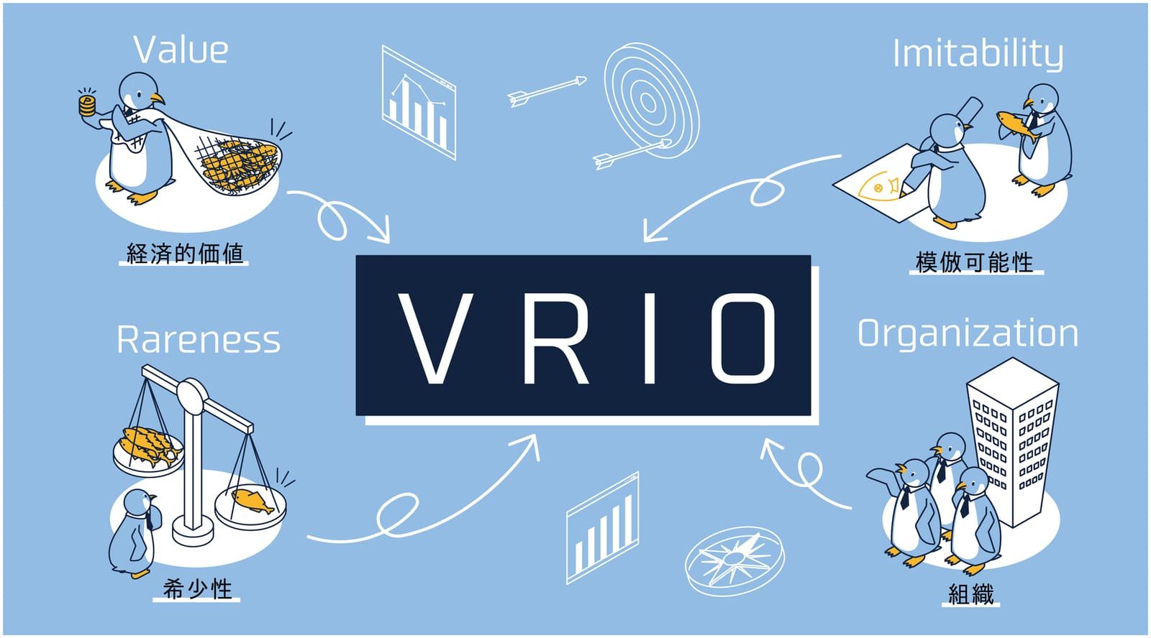
Figure 8: VRIO analysis framework
(Source: Developed based on Johnson, 2020)
Brand Equity
- Value: Due to its widespread brand awareness, PepsiCo generates tremendous value through influencing customer choice and loyalty.
- Rarity: Strong brands are not uncommon in the beverage and snack sector, but fewer brands have acquired the kind of worldwide awareness and trust that PepsiCo's brands have.
- Imitability: The brand equity that PepsiCo has developed over many years is difficult for rivals to replicate.
- Organization: PepsiCo is effectively set up to use marketing, product placement, and R&D to leverage its brand equity.
- Competitive Advantage: Sustained
Global Distribution Network
- Value: Due to PepsiCo's large distribution network, even in distant locations, its goods are always accessible.
- Rarity: The breadth and depth of PepsiCo's distribution are unmatched by many rivals.
- Imitability: Similar worldwide networks would take tremendous funding and effort to establish.
- Organization: To manage and optimise its distribution, PepsiCo has put in place effective processes and partnerships.
- Competitive Advantage: Sustained.
R&D Capabilities
- Value: PepsiCo can innovate thanks to R&D, developing new goods and adjusting to shifting customer demands.
- Rarity: Even though many businesses engage in R&D, PepsiCo's dedication to innovation is noteworthy. PepsiCo made approximately $771 million in R&D investments in 2022, underscoring its special dedication to innovation (Ridder, 2023). PepsiCo consistently prioritises R&D despite fierce competition, particularly from Coca-Cola, demonstrating its desire to be a market innovator leader.
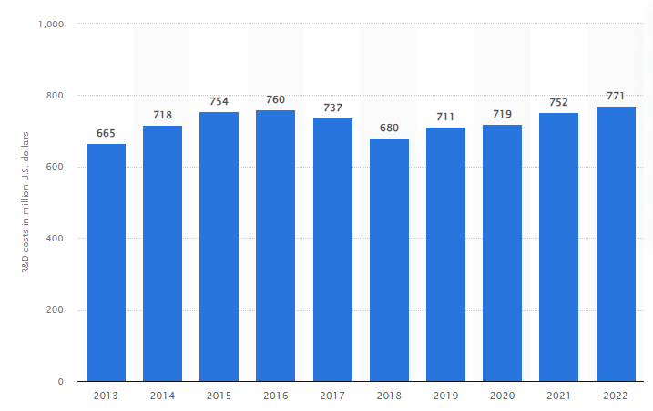
Figure 9: PepsiCo's R&D costs worldwide 2013-2022
(Source: Ridder, 2023)
- Imitability: Competitors may boost their R&D expenditures, but PepsiCo's patented ideas and breakthroughs cannot be copied.
- Organization: PepsiCo has a systematic approach to R&D to make sure that results are properly incorporated into the creation of new products.
- Competitive Advantage: Temporary (due to the industry's rapid rate of innovation)
Diverse Product Portfolio
- Value: PepsiCo is able to meet the various demands and tastes of consumers by providing a broad selection of goods.
- Rarity: Few rivals have as broad a product range across categories as PepsiCo.
- Imitability: While competitors can expand their product lines, achieving the breadth and depth of PepsiCo's portfolio is challenging.
- Organization: PepsiCo has systems in place to manage, market, and distribute its vast product range efficiently.
- Competitive Advantage: Sustained

Resources & Capabilities | Value | Rarity | Imitability | Organization | Competitive Advantage
Brand Equity | Yes | Yes | No (Hard to imitate) | Yes | Sustained
Global Distribution Network | Yes | Yes | No (Hard to imitate) | Yes | Sustained
R&D Capabilities | Yes | Yes | Yes (Can be imitated with investment) | Yes | Temporary
Diverse Product Portfolio | Yes | Yes | No (Hard to imitate) | Yes | Sustained
Table 1: VRIO analysis of PepsiCo
(Source: Self-developed )

Value Chain Analysis of PepsiCo's Operations and Strategic Capabilities
It is clear from the value chain analysis that PepsiCo's advantages include a broad distribution network, potent marketing skills, effective management, and a focus on R&D and technology (Dubey et al. 2020). Combining these factors gives PepsiCo a competitive advantage in the beverage and snack sector.
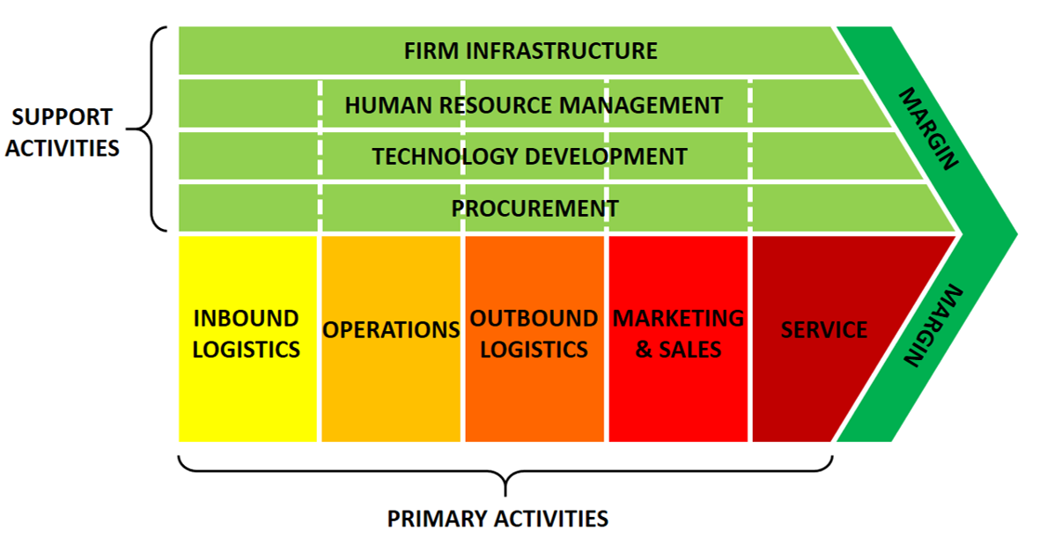
Figure 10: Porter’s value chain analysis Framework
(Source: Developed based on Dubey et al. 2020)
Inbound Logistics
- Activities: Acquiring basic commodities including sugar, maize, and flavourings. establishing connections with regional vendors.
- Value Addition: PepsiCo maintains positive working ties with suppliers, guarantees a consistent supply of premium ingredients, and can therefore bargain for lower rates.
Operations
- Activities: Manufacturing procedures such snack baking and frying as well as product packing.
- Value Addition: PepsiCo can efficiently service local markets because to its extensive worldwide production network. Modern manufacturing techniques increase productivity and guarantee product quality.
Outbound Logistics
- Activities: Distribution of goods to merchants, supermarkets, and in certain areas, directly to customers.
- Value Addition: PepsiCo guarantees that its goods are easily accessible, even in rural areas, thanks to a huge distribution network.
Marketing & Sales
- Activities: Promotional activities, internet marketing, joint ventures with other firms, and advertising campaigns.
- Value Addition: Strong marketing initiatives increase brand recognition and loyalty. Sales and product testing are fueled by partnerships and marketing. PepsiCo's strong marketing approach is shown in its $3.5 billion yearly advertising budget. In the US alone, $224 million was spent in 2019 on Pepsi brand promotion (Faria, 2023). This large investment increases brand identification and loyalty while also demonstrating PepsiCo's dedication to maintaining its position as a leader in the rapidly changing beverage industry.
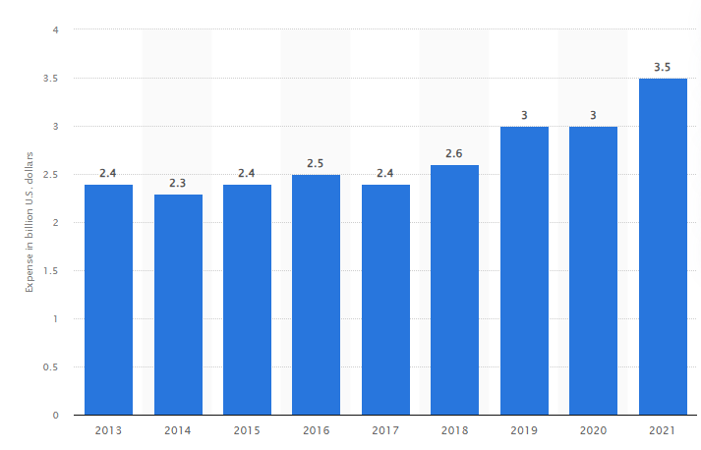
Figure 11: PepsiCo: ad spend worldwide 2013-2021
(Source: Faria, 2023)
Service
- Activities: Customer service after the transaction, managing customer comments, and resolving any product-related issues or recalls.
- Value Addition: PepsiCo can immediately fix any difficulties and preserve the image of its brand by keeping the lines of contact with customers open.
Support Activities
- Infrastructure: A strong corporate infrastructure that supports PepsiCo's many business divisions and maintains operational cohesion is required due to the company's worldwide presence.
- Human Resource Management: PepsiCo employs 315,000 employees worldwide as of 2022 (Ridder, 2023). PepsiCo emphasises strong human resource management, concentrating on talent development, training, and employee welfare in order to manage this large workforce. Insuring operational effectiveness and coordinating the personnel with PepsiCo's worldwide goals are the goals of this strategic HRM strategy.
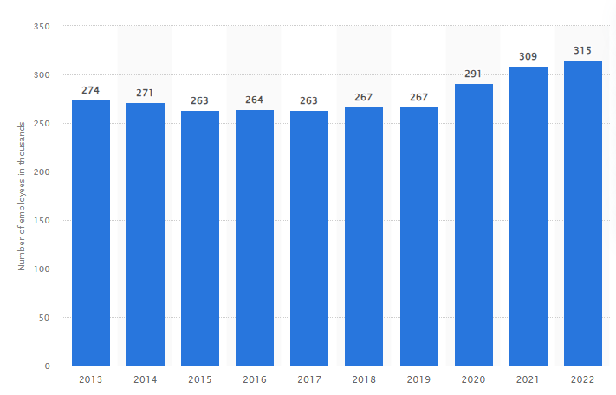
Figure 12: PepsiCo's number of employees worldwide 2013-2022
(Source: Ridder, 2023)
- Technology Development: Technology is integral to PepsiCo's operations, from R&D in product creation to the use of sophisticated analytics in marketing.
- Procurement: PepsiCo obtains the best rates and conditions for its raw materials and other needs thanks to strategic procurement choices (PepsiCo, 2022).

SWOT Analysis of PepsiCo
Strengths  - Strong global brand recognition  - Diverse product portfolio reducing dependence on a single segment.  - Efficient global distribution network (Wood et al. 2021).  - Effective marketing and advertising campaigns. | Weaknesses  - Dependence on third-party bottling companies might lead to supply chain issues.  - Some products in the portfolio are seen as unhealthy, contributing to global obesity and health issues.  - Legal challenges and controversies in some markets.  - Currency fluctuations affecting global revenues.
Opportunities  - Expansion into emerging markets.  - Product innovations catering to health-conscious consumers.  - Further strategic acquisitions to enhance product range.  - Leveraging technology for better customer engagement and operational efficiency. | Threats  - Intense competition from other beverage giants, especially Coca-Cola (Zhang, 2019).  - Fluctuations in raw material prices.  - Health regulations leading to potential product bans or restrictions.  - Changing consumer preferences moving towards non-carbonated and organic beverages.
Table 3: SWOT analysis of PepsiCo
(Source: Self -developed)

4. PepsiCo's Competitive and Development Strategies

Analysis of PepsiCo's business-level strategies
As one of the world's leading companies in the food and beverage sector, PepsiCo uses a variety of business-level strategies to retain its competitive position and meet the varied demands of its clients in different areas. Based on the case study and the notes, the analysis is as follows:
- Cost Leadership: PepsiCo aims to create items at a cheaper cost than its rivals via economies of scale, supply chain efficiency, and operational excellence. They are able to cut per-unit expenses because to their extensive worldwide presence and large manufacturing volume. This enables them to provide goods at competitive rates in very price-sensitive markets (Castillo‐Apraiz and Matey, 2020).
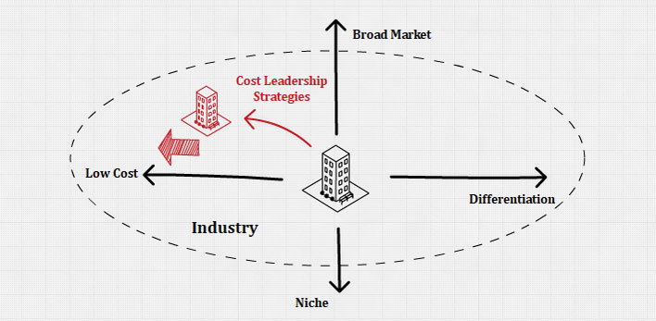
Figure 13: Cost leadership strategy concept
(Source: Developed based on Castillo‐Apraiz and Matey, 2020)
- Product Differentiation: PepsiCo is about more than simply fizzy beverages. They've expanded their product line over time to include healthy alternatives including juices, hydration choices, and wholesome snacks. This tactic is highlighted by brands like Tropicana, Quaker Oats, and Gatorade (Jallow, 2021). They consistently prioritise R&D, which results in new products that are adapted to local tastes and preferences.
- Market Penetration: PepsiCo concentrates on bolstering its presence and increasing market share in mature areas by making use of its robust distribution network, marketing initiatives, and customer loyalty programmes.
- Sustainability and Ethical Practices: PepsiCo has included sustainability into their business strategy in response to rising customer awareness of ethical and environmental challenges. Their emphasis on carbon footprint reduction, water conservation, environmental packaging, and ethical sourcing is growing.

Insights into PepsiCo's corporate-level strategies
The corporate-level strategies of PepsiCo include choices about the scope and direction of the organisation as a whole. PepsiCo's business strategy have changed throughout time, enabling it to stay competitive, diversify its holdings, and expand into new areas. Here is some information on their corporate-level plans based on the case study and the notes:
- Diversification: Diversification has been a key business strategy for PepsiCo. The corporation, which was first recognised for its main brand, Pepsi, has since expanded its range of goods to include snacks, juices, and other drinks. With the purchase of names like Tropicana, Quaker Oats, and Gatorade, this diversification is clearly obvious. PepsiCo can protect itself from market segment-specific risks because to its diverse product range.
- Geographic Expansion: PepsiCo has operations in more than 200 nations, and its goods are adapted to suit regional tastes and preferences. PepsiCo explores development prospects and reduces the risks associated with saturated markets by entering new markets, particularly developing economies.
- Acquisitions and Mergers: The business strategy of PepsiCo heavily emphasises strategic acquisitions. PepsiCo has been able to broaden its product line, penetrate new markets, and acquire a competitive advantage thanks to the acquisitions of Frito-Lay, Tropicana, and Quaker Oats, among other companies. These purchases aim to add brands that support PepsiCo's mission and core values in addition to broadening the product line.
- Backward Integration: PepsiCo often employs backward integration, where they buy or create skills to manufacture their raw materials, to assure quality, save costs, and have greater control over its supply chain. For instance, they have made investments in agricultural ventures to get premium raw materials for their goods (He et al. 2022).
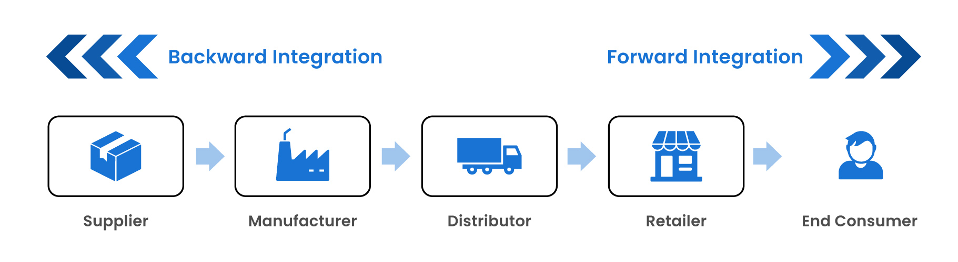
Figure 14: Backward Integration strategy
(Source: Developed based on He et al. 2022)

Use of the Game Theory to Understand PepsiCo's strategic decisions in the competitive market
At its core, game theory is a mathematical instrument used to examine the tactical interactions between many players in a situation where each player's fate is determined by the actions of the others. This may be used in the business world, especially in the beverage sector, to comprehend competitive actions and countermoves between enterprises. Game Theory may provide light on PepsiCo's strategic choices in light of its size and the severe rivalry it confronts, particularly from The Coca-Cola Company, its arch-rival. Based on the notes and PepsiCo's background, the following interpretation is presented:
Nash Equilibrium in Advertising Wars: In the past, Pepsi and Coca-Cola have engaged in aggressive marketing efforts. When PepsiCo chooses an advertising plan, supposing Coca-Cola's approach is fixed, and vice versa, a Nash Equilibrium results (Shahid and Ashfaq, 2021). The result is a situation where neither business would wish to unilaterally change their advertising campaign in light of the other business's plan. This explains why both businesses continue to invest much on advertising.
Product Launch and Countering: Every time PepsiCo introduces a new product variety or enters a new beverage market, it prepares for possible responses from rivals, particularly Coca-Cola. PepsiCo will anticipate Coca-Cola's action if it offers a new sugar-free variety, either introducing a counterproduct or stepping up promotion for an already existing product. PepsiCo uses game theory to plan these product introductions in advance.
Pricing Wars: Pricing tactics used by PepsiCo and its rivals often mimic the "Prisoner's Dilemma" from game theory (Kolhe et al. 2021). Both PepsiCo and Coca-Cola will make significant profits if they opt to retain their high pricing. The one with the lower price, however, may earn greater market share at the expense of a smaller per-unit profit if the other does not cut its price to gain market share. Both might see lower earnings if they both lower their pricing.
Entry and Exit in Markets: PepsiCo considers likely competition responses before entering a new market or geographic area. For instance, if PepsiCo considers joining a niche beverage market, it will watch out for actions by current market participants and possible entry from other sizable rivals. This strategic decision-making process has its roots in game theory, where the benefits of entering are compared against possible competitive responses.
Collaborative Games: Not every situation in game theory involves competition. There are times when working together may be advantageous to both parties. In the past, PepsiCo has partnered with other companies or even prospective rivals for particular regions or product categories. PepsiCo can determine when cooperation triumphs over competition by using Game Theory to examine the possible outcomes.
In the end, game theory provides a methodical approach to comprehend the competitive environment and foresee actions and countermoves. Employing such theoretical frameworks is essential for a global juggernaut like PepsiCo, operating in a highly competitive industry, to preserve its edge and make wise strategic choices.

5. Strategy Implementation, Global Strategy, and Organizational Aspects

PepsiCo's modes of Foreign market entry
PepsiCo has used a variety of methods to reach international markets throughout the years, guaranteeing a strong worldwide presence. Based on market dynamics, regional culture, and competitive factors, the corporation has effectively combined its global strategy. Following are a few of the main entrance methods:
- Direct Exporting: To begin with, PepsiCo exported directly to expand into new countries. If necessary, this means transporting the local product with minor adjustments to overseas markets (Cassia and Magno, 2022).
- Licensing and Franchising: PepsiCo has granted local businesses licences to manufacture and market its goods in several areas. With this plan, PepsiCo lowers its risk and gains access to regional knowledge.
- Joint Ventures: In several nations, PepsiCo has established joint ventures with regional companies. PepsiCo benefits from shared risks and local expertise thanks to this approach. For instance, PepsiCo and Tingyi, a renowned beverage business in China, have a joint venture.

The organizational culture, structure, and Leadership at PepsiCo
The organisational features of PepsiCo have proved essential to its worldwide success;
Culture: Performance-driven culture is something PepsiCo takes great pleasure in. "Performance with Purpose," the company's slogan, stands for its dedication to producing elite financial performance while fostering sustainable development (Burr and Cheung, 2021). The business promotes an atmosphere where workers are encouraged to contribute new viewpoints and question the current quo because it values creativity, honesty, and respect for others.
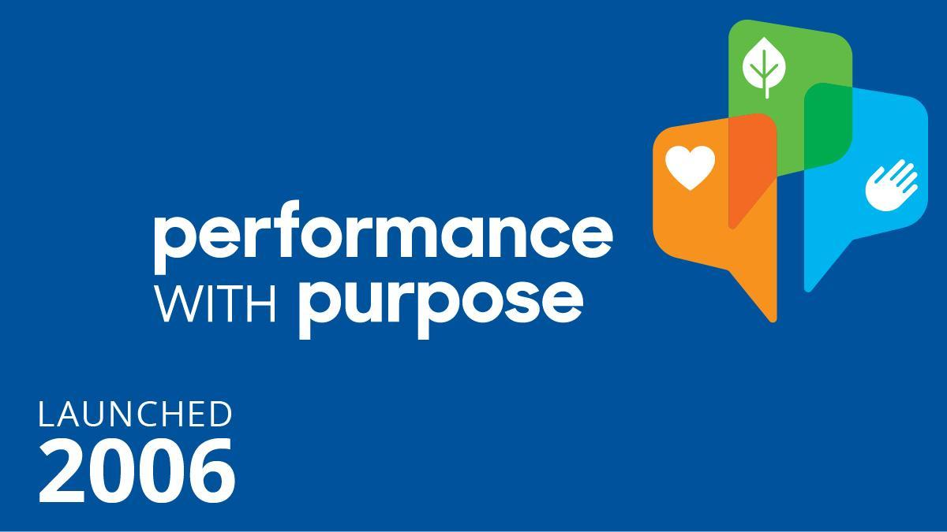
Figure 15: Performance with Purpose
(Source: Burr and Cheung, 2021)
Structure: Based on its product lines and international activities, PepsiCo has a divisional organisational structure. Due to this framework, PepsiCo is able to adapt to local market situations while upholding international standards. Even if each division has considerable autonomy, they all support the overall business plan.
Leadership: The vision and strategies of PepsiCo have been significantly influenced by its leadership. Stakeholder involvement, sustainability, and innovation have been highlighted by leaders like Indra Nooyi (Nooyi and Govindarajan, 2020). The PepsiCo leadership is renowned for its futuristic outlook, emphasising long-term development and stakeholder value.
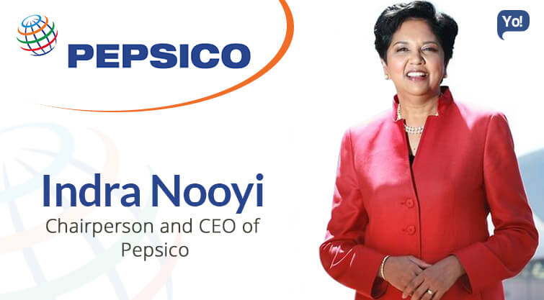
Figure 16: CEO of PepsiCo
(Source: Nooyi and Govindarajan, 2020)

Discussion on PepsiCo's stakeholder mapping and its importance in their strategy
Stakeholder mapping is a crucial tool for PepsiCo since it enables the corporation to identify and rank stakeholders according to their impact and level of interest in the business;
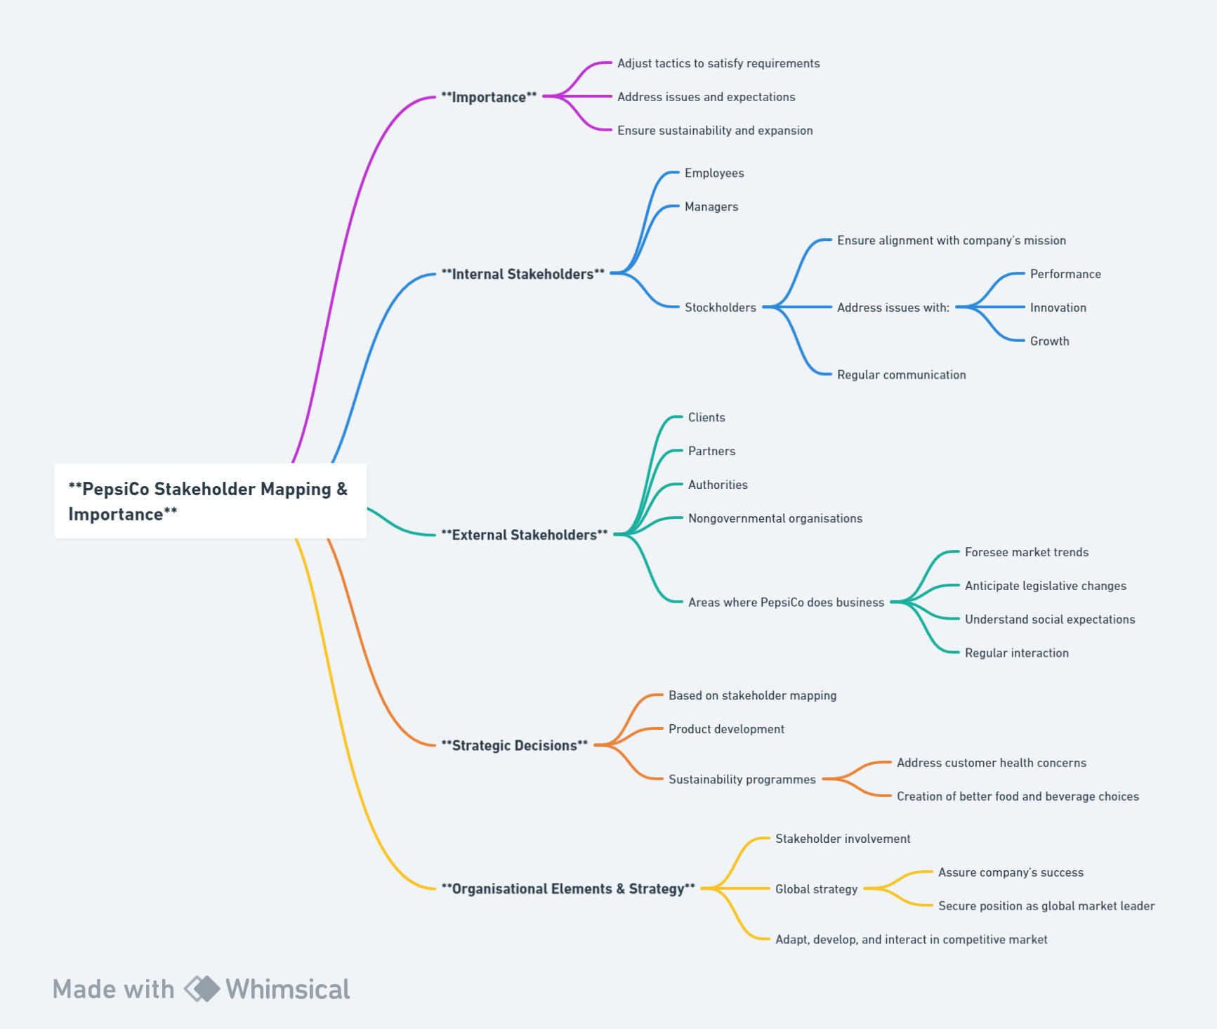
Figure 17: Stakeholder map of PepsiCo
(Source: Self-developed)
Importance: PepsiCo may adjust its tactics to satisfy certain requirements, issues, and expectations by knowing its stakeholders. The sustainability and expansion of the business depend on this connection.
Internal Stakeholders: Employees, managers, and stockholders are all included in this (PepsiCo, 2023). In order to ensure alignment with the company's mission and to solve issues with performance, innovation, and growth, PepsiCo regularly communicates with this group.
External Stakeholders: This category consists of clients, partners, authorities, nongovernmental organisations, and the areas where PepsiCo does business. PepsiCo can foresee market trends, legislative changes, and social expectations by interacting with these stakeholders.
Strategic Decisions: Many of PepsiCo's strategic choices, from product development to sustainability programmes, are based on stakeholder mapping. For instance, addressing customer health concerns prompted the creation of better food and beverage choices.
In the end, PepsiCo's organisational elements, stakeholder involvement, and worldwide strategy are intertwined, assuring the company's success and securing its place as a global market leader. In the intensely competitive global beverage and snack market, the firm stands out for its capacity to adapt, develop, and interact.

6. Ethical, Sustainability, and CSR Considerations at PepsiCo

Analysis of PepsiCo's Stance on Ethical Issues, Sustainability, and CSR
PepsiCo's "Performance with Purpose" goal makes clear how committed the company is to moral behaviour, environmental sustainability, and corporate social responsibility (CSR). This strategy is focused on generating superior financial performance while promoting sustainability across the company.
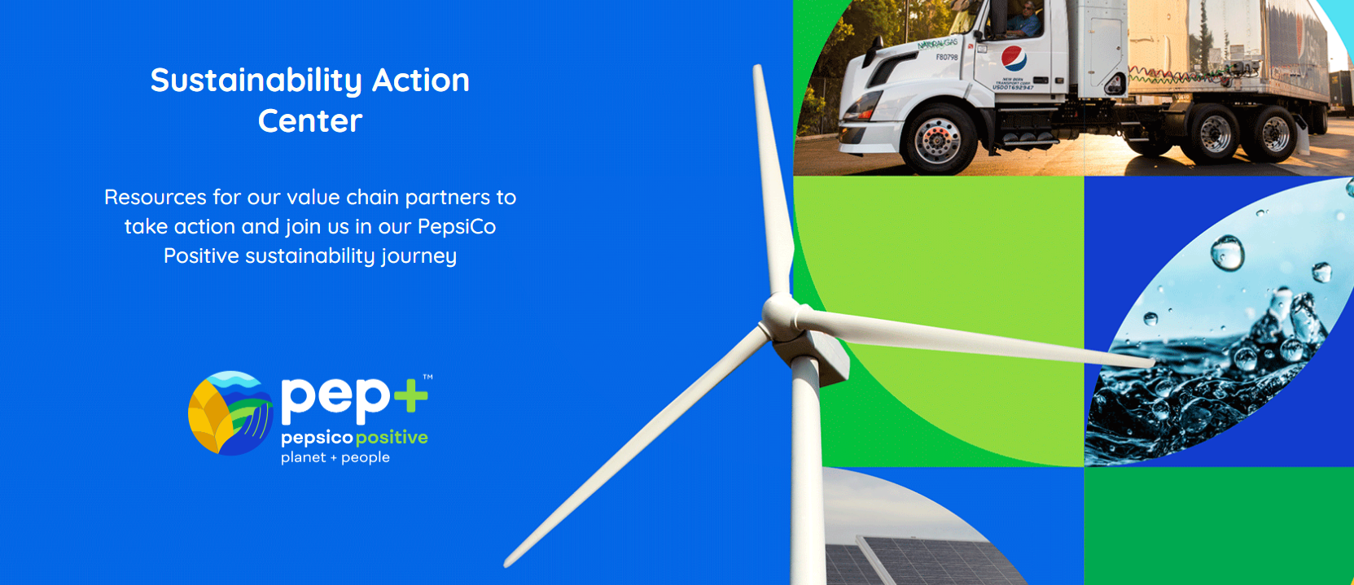
Figure 18: Sustainable plan of PepsiCo
(Source: PepsiCo, 2022)
Ethical Considerations
- Supply Chain Integrity: PepsiCo has strict requirements for suppliers to follow, including no child labour, fair pay, and secure working conditions.
- Product Responsibility: PepsiCo has pledged to lowering the amount of added sugars, salt, and saturated fats in its products in response to growing health concerns throughout the world.
Sustainability
- Water Stewardship: PepsiCo has efforts to increase water-use efficiency in its operations and has achieved significant reductions in water consumption because it recognises water as a crucial resource.
- Packaging and Waste: The objective of PepsiCo is to make all packaging recyclable, compostable, or biodegradable. The company is continually looking for methods to minimise its packaging impact (PepsiCo, 2022).
- Climate Impact: The value chain-wide greenhouse gas emissions of PepsiCo will be greatly reduced.
Corporate Social Responsibility (CSR)
- Empowering People: PepsiCo makes investments in its workers through fostering inclusion, diversity, and gender balance.
- Supporting Communities: PepsiCo supports a range of issues via its foundation, including promoting access to nutrition, empowering women and girls, and disaster assistance.

The impact of governance, sustainability, and CSR on PepsiCo's strategic development
The three pillars of governance, sustainability, and CSR are crucial in determining PepsiCo's strategic course;
- Governance: Strong governance practises at PepsiCo guarantee openness, responsibility, and moral behaviour. Investors, customers, and other stakeholders now have more confidence because to this governance. Additionally, it has made it possible for PepsiCo to successfully traverse several regional regulatory contexts.
- Sustainability: Sustainability is now a crucial component of PepsiCo's strategy rather than merely a trendy concept. PepsiCo is tapping into a burgeoning market of environmentally concerned customers as well as securing the future of its operations by concentrating on sustainable practises. Cost reductions and improved operational efficiency have also resulted from sustainable practises.
- CSR: Through its CSR programmes, PepsiCo has improved the perception of its brand, encouraged customer loyalty, and forged close links with the community (Vishwanathan et al. 2020). By supporting causes that matter to its customer base, PepsiCo solidifies its position in the market and seizes fresh chances.
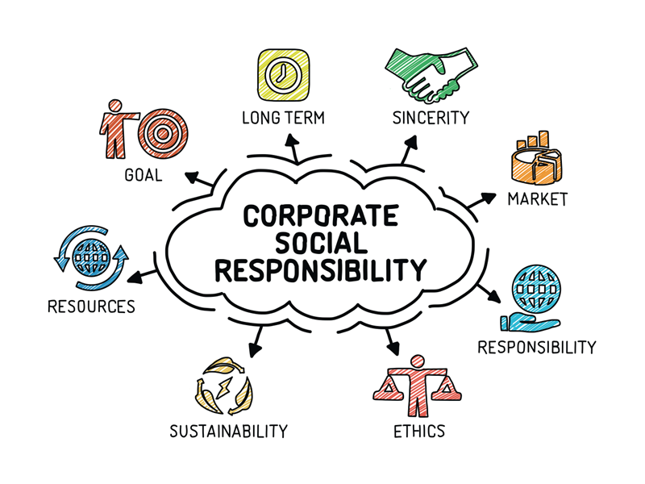
Figure 20: CSR concept
(Source: Developed based on Vishwanathan et al. 2020)
In summary, PepsiCo's ethical position, environmental efforts, and CSR activities are tied to its strategic goals. PepsiCo guarantees that development is all-encompassing, sustainable, and in line with the expectations of its stakeholders and the more general demands of society by incorporating these factors into its basic business plan.

7. Conclusions, Recommendations, and Strategic Evaluation

Summarizing key findings from the PepsiCo analysis
The thorough strategic study of PepsiCo yields the following major conclusions:
- Global Presence: PepsiCo's goods are popular all throughout the globe, giving them a significant global presence. Its broad range of products satisfies various regional customer tastes.
- Adaptive Strategy: In order to adapt to shifting customer demands, particularly those pertaining to health and wellness, PepsiCo has consistently changed its business tactics.
- Ethical and Sustainable Commitment: The business' "Performance with Purpose" mission places a strong emphasis on moral behaviour, environmental responsibility, and corporate social responsibility.
- Innovative Approaches: From product development to market launch, PepsiCo has used cutting-edge techniques to keep one step ahead of rivals.

Recommendations for PepsiCo moving forward
The investigation has led to the following suggestions for PepsiCo:
- Health and Wellness: PepsiCo should keep coming up with new ideas and broaden its selection of healthier goods in light of the worldwide trend towards healthy eating and drinking habits.
- Digital Transformation: Utilise digital technology to boost consumer interaction, the efficiency of the supply chain, and data analytics for market insights.
- Sustainable Packaging: PepsiCo should step up its efforts towards eco-friendly packaging options in light of growing worries over plastic waste.
- Localize Offerings: PepsiCo should further adapt its goods to regional tastes and preferences while keeping its worldwide trademarks.

Strategic evaluation using insights from the case studies on strategy formulation and choices
Gaining understanding from the many case examples presented in the notes;
- Diversification: PepsiCo might consider entering adjacent areas or businesses by using its brand power, similar to Virgin's diversification approach.
- Strategic Alliances: Strategic partnerships may allow quick entrance into new markets or industries, as evidenced in the General Electrics Joint Ventures instance. More of these should be considered by PepsiCo, particularly in developing areas.
- Sustainability: PepsiCo can better integrate sustainability into its business model, not only as a CSR activity but as a key business strategy, by taking inspiration from Coca-Cola's sustainability report.
- Mergers and Acquisitions: The Groupon case study demonstrates both the advantages and drawbacks of M&As. When making acquisitions, PepsiCo should use strategic judgement and ensure complete due diligence and post-acquisition integration.
In the end, PepsiCo is a major player in the food and beverage sector on a worldwide scale. However, the organisation must continue to be flexible, inventive, and dedicated to its basic principles due to the dynamic nature of this market and changing customer preferences. PepsiCo can achieve sustainable growth and market leadership by implementing the suggestions and routinely assessing its tactics against industry standards.

8. Reflection
My comprehension of the complex procedures involved in developing, putting into practise, and assessing strategies in multinational businesses has significantly developed during the strategic management module. The study of PepsiCo highlighted the significance of adaptable tactics in a constantly changing market and shed light on the actual implementation of theoretical frameworks. The assignment emphasised the value of coordinating company operations with social, ethical, and environmental obligations—a concept that resonates in modern strategic management debate. The module's different analytical tools and models were also made more useful by being included into a real-world situation. Overall, my experience has been really rewarding, improving both my analytical skills and my understanding of the difficulties of strategic decision-making in multinational corporations.

9. References
Allen, W.M. and Allen, K.J., 2020. Should Australia tax sugar‐sweetened beverages?. Journal of Paediatrics and Child Health, 56(1), pp.8-15.
Baker, P., Machado, P., Santos, T., Sievert, K., Backholer, K., Hadjikakou, M., Russell, C., Huse, O., Bell, C., Scrinis, G. and Worsley, A., 2020. Ultra‐processed foods and the nutrition transition: Global, regional and national trends, food systems transformations and political economy drivers. Obesity Reviews, 21(12), p.e13126.
Beattie, R., 2023. Bringing Loyalty To Life: How to earn, build and leverage enduring customer loyalty. SRA Books.
Brownbill, A.L., 2020. Marketing and Consumer Perceptions of Sugar-Containing Beverages Positioned as Healthy or as Having Health-Related Benefits (Doctoral dissertation).
Burr, J.F. and Cheung, C.P., 2021. Cannabis and Exercise Performance: Current Evidence. Sport Sci Exch, 29(2), pp.1-5.
Cassia, F. and Magno, F., 2022. Cross-border e-commerce as a foreign market entry mode among SMEs: the relationship between export capabilities and performance. Review of International Business and Strategy, 32(2), pp.267-283.
Castillo‐Apraiz, J. and Matey, J., 2020. Customizing competitive strategy to entry timing: Implications for firm performance in the pharmaceutical industry. Managerial and Decision Economics, 41(6), pp.976-985.
Clark, D., 2023. Inflation rate for the Consumer Price Index (CPI) in the United Kingdom from January 1989 to June 2023. Statista. Available at: https://www.statista.com/statistics/306648/inflation-rate-consumer-price-index-cpi-united-kingdom-uk/#:~:text=Inflation%20rate%20in%20the%20UK%201989%2D2023&text=The%20UK%20inflation%20rate%20fell,inflation%20rate%20since%20March%202022.
Dubey, S., Singh, R., Singh, S.P., Mishra, A. and Singh, N.V., 2020. A brief study of value chain and supply chain. Agriculture Development and Economic Transformation in Global Scenario, pp.177-183.
Facioni, M.S., Raspini, B., Pivari, F., Dogliotti, E. and Cena, H., 2020. Nutritional management of lactose intolerance: the importance of diet and food labelling. Journal of translational medicine, 18, pp.1-9.
Faria, J., 2023. PepsiCo's advertising expenses worldwide from 2013 to 2021. Statista. Available at: https://www.statista.com/statistics/286547/pepsico-advertising-spending-worldwide/
Gerassimidou, S., Lovat, E., Ebner, N., You, W., Giakoumis, T., Martin, O.V. and Iacovidou, E., 2022. Unpacking the complexity of the UK plastic packaging value chain: A stakeholder perspective. Sustainable Production and Consumption, 30, pp.657-673.
Haseeb, M., Hussain, H.I., Kot, S., Androniceanu, A. and Jermsittiparsert, K., 2019. Role of social and technological challenges in achieving a sustainable competitive advantage and sustainable business performance. Sustainability, 11(14), p.3811.
He, P., He, Y., Tang, X., Ma, S. and Xu, H., 2022. Channel encroachment and logistics integration strategies in an e-commerce platform service supply chain. International Journal of Production Economics, 244, p.108368.
Jallow, A., 2021. A strategic case study on PepsiCo. Available at SSRN 3828353.
Johnson, W.H., 2020. Managing global strategy: developing an effective strategy in international business. Routledge.
Kolhe, R.L., Joshi, A., Mate, P.V., Gupta, D.S. and Patil, D., 2021, June. A Pedagogical Adoption of Game Theory to Finance Technology in Big Data Analytics. In 2021 5th International Conference on Trends in Electronics and Informatics (ICOEI) (pp. 1727-1735). IEEE.
Kunst, A., 2023. Attitudes towards food in the UK as of March 2023. Statista. Available at: https://www.statista.com/forecasts/997914/attitudes-towards-food-in-the-uk#:~:text=When%20asked%20about%20%22Attitudes%20towards,than%20500%20industries%20and%20topics.
Nooyi, I.K. and Govindarajan, V., 2020. Becoming a better corporate citizen. Harvard Business Review, 98(2), pp.94-103.
O'Neill, A., 2023. United Kingdom: Real gross domestic product (GDP) growth rate from 2018 to 2028. Statista. Available at: https://www.statista.com/statistics/263613/gross-domestic-product-gdp-growth-rate-in-the-united-kingdom/
Paavola, L. and Cuthbertson, R., 2022. Redefining capabilities as drivers of adaptation, incremental change, and transformation: Recognizing the importance of strategic and operational intent on performance. Journal of Management & Organization, 28(3), pp.522-539.
Pan, W., Chen, L. and Zhan, W., 2019. PESTEL analysis of construction productivity enhancement strategies: A case study of three economies. Journal of Management in Engineering, 35(1), p.05018013.
PepsiCo, 2022. Annual report. Available at: https://www.pepsico.com/investors/financial-information/annual-reports-proxy-information
PepsiCo, 2023. About. https://www.pepsico.com/who-we-are/about-pepsico#:~:text=Global%20Leader%20in%20Convenient%20Foods,and%20territories%20around%20the%20world.
PepsiCo, 2023. Our Products. https://www.pepsico.com/our-brands/creating-smiles/our-products
PepsiCo, 2023. Stakeholder engagement. Available at: https://www.pepsico.com/our-impact/esg-topics-a-z/stakeholder-engagement
Prahl, V.J., 2023. Body Messengers: A Planetary Archetypal Guide for Health Patterns, Well-Being, and Self-Healing. Balboa Press.
Ridder, M., 2022. Brand value of the most valuable non-alcoholic beverage brands worldwide as of 2022. Statista. Available at: https://www.statista.com/statistics/603922/brand-value-non-alcoholic-beverage-brands-worldwide/
Ridder, M., 2022. Leading soft drink brands ranked by convenience sales value in the United Kingdom in 2022. Statista. Available at: https://www.statista.com/statistics/629118/soft-drink-brand-ranking-in-the-united-kingdom-uk-by-convenience-sales-value/
Ridder, M., 2022. Research and development (R&D) costs of PepsiCo worldwide from 2013 to 2022. Statista. Available at: https://www.statista.com/statistics/536965/pepsico-s-r-and-d-costs-worldwide/
Shahid, S.E. and Ashfaq, A., 2021. Coca-Cola and PepsiCo advertising in Pakistan: Changing trends of cultural values manifested in television commercials. Journal of the Research Society of Pakistan, 58(2), p.270.
Shi, C., Agbaku, C.A. and Zhang, F., 2021. How do upper echelons perceive porter’s five forces? Evidence from strategic entrepreneurship in China. Frontiers in Psychology, 12, p.649574.
Statista, 2023. United Kingdom (UK): retail e-commerce revenue forecast from 2017 to 2027. Available at: https://www.statista.com/forecasts/477091/e-commerce-revenue-forecast-in-the-united-kingdom
Struckell, E., Ojha, D., Patel, P.C. and Dhir, A., 2022. Strategic choice in times of stagnant growth and uncertainty: An institutional theory and organizational change perspective. Technological Forecasting and Social Change, 182, p.121839.
Vishwanathan, P., van Oosterhout, H., Heugens, P.P., Duran, P. and Van Essen, M., 2020. Strategic CSR: A concept building meta‐analysis. Journal of Management studies, 57(2), pp.314-350.
Wood, B., Baker, P., Scrinis, G., McCoy, D., Williams, O. and Sacks, G., 2021. Maximising the wealth of few at the expense of the health of many: a public health analysis of market power and corporate wealth and income distribution in the global soft drink market. Globalization and Health, 17, pp.1-17.
Wood, B., Williams, O., Baker, P. and Sacks, G., 2023. Behind the ‘creative destruction’of human diets: An analysis of the structure and market dynamics of the ultra‐processed food manufacturing industry and implications for public health. Journal of Agrarian Change.
Zhang, Z., 2019. Risk Analysis of Two Leader Drink Company: PepsiCo and Coca-Cola. Asian Business Research, 4(3), p.42.

Appendices

Appendix 1: The brand value of the most valuable soft drink brands Worldwide in 2022
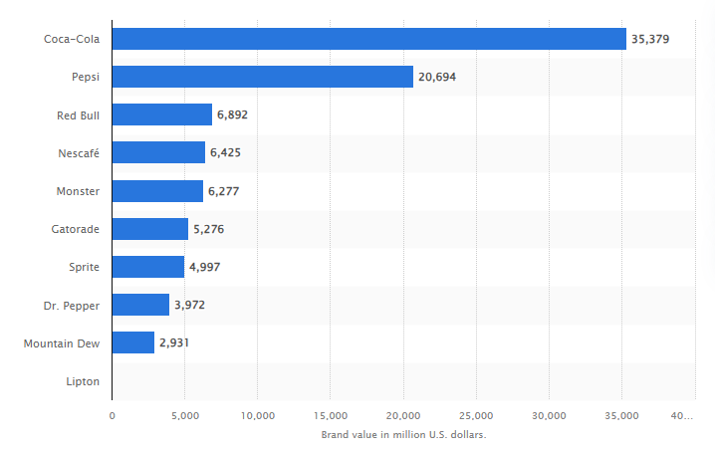
(Source: Ridder, 2022)

Appendix 2: Leading soft drink brands in the United Kingdom 2022, by convenience sales value
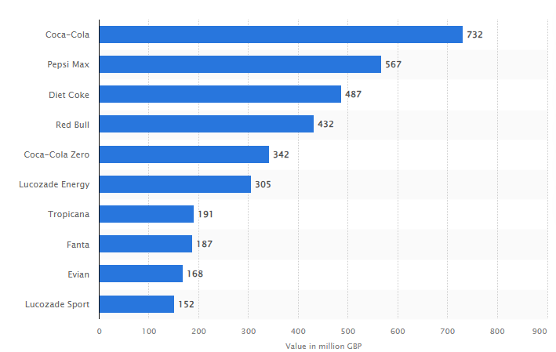
(Source: Ridder, 2022)

