
art of communication
[Document subtitle]

BMSW4002_LON
FILARET-GABRIEL HADIMBU 1913395
UNIVERSITY OF WALES TRINITY OF SAINT DAVID
LECTURER AKINSEYE ALUKO

ART OF COMMUNICATION

Communication is the element that sustains society. Even though it is written, oral communication, even signs, symbols, images, gestures, it is a vital element, and we can see this every day in every activity of each individual: the meaningful glances that lovers throw. , mimesis is taken by someone when he enjoys something or when he is dissatisfied, gestures that suggest various feelings of one person towards another, or even an essay written for an exam. All of this is a tiny part of the universe called "communication." Thus, this active element of society, as its potential was discovered, was developed to its maximum capacity, being pushed beyond its traditional boundaries of intrapersonal communication (communication between the individual and himself), interpersonal, or group, taking the form of mass communication.
Mass communication is defined as "the production and dissemination of messages by an institutionalised media system to a diverse and large audience". On the surface, this kind of communication seems to be one of the simplest; some images are transmitted and sounds on TV, internet or radio that the individual accesses at the touch of a button, but this is only an illusion.
As we understood earlier, the field of communication is of extraordinary complexity, of a depth that has been reached only through the adoption of techniques, the creation of analyses and classifications so that this art can be disseminated and spread.
All over the world mass communication has become a field with a multitude of colours, shapes and sizes in the current public space, various strategies of manipulation being adopted, in marketing and other fields of work as social living introducing the viewer in an alternative, fascinating world.
The strategies behind these effects consist of a series of long-calculated techniques by which this kind of communication was born.
Today the media have a powerful impact on individuals and contribute to the process of education and social action of them. Their influence, whether healthy or limited, has been a significant concern of researchers in the Communication Sciences for many decades.
Verbal communication is the transfer of information through oral language, between a transmitter and a receiver. Communication is part of everyday life and is the way we convey ideas, feelings, emotions and opinions, to socialize, negotiate and influence.
The sender must convey the message clearly and organized in order to preserve and promote the interest of the receiver. The listener is interested in information only if the communicator proves self-confidence, convincing gestures and gentleness. Communication skills are essential for a good manager - to promote open communication, concise messages, feedback, recognition of non-verbal messages and mutual understanding within the team.
Effective communication involves mastering three fundamental types of skills:
• effective presentation of information to the target audience, or expressive skills - these are necessary to convey the message through words, facial expressions and non-verbal language;
• understanding the answers received from others or listening skills - are used to obtain information from others, to clarify the messages received and to understand what the sender feels and thinks;
• choosing the most appropriate communication channel and the technical knowledge for using this channel, or skills of coordinating the communication process - these help us to recognize the necessary information and to respect the rules of communication and interaction.
Expressive skills are the most important in communication because half of the meaning of the message is transmitted through non-verbal communication or body language and 40% through verbal language, in tone and inflexions of voice, speech rhythm, accentuation of words, pauses between words, verbal tics. Only 10% of the message is sent, respectively received, through what we actually say.
Nonverbal communication between people is communication by sending and receiving nonverbal clues. This includes the use of visual cues such as body language, physical posture, tone of voice, and physical contact. It may also include chronology and oculesis, the act of looking during speech and listening, the frequency of gaze, patterns of visual fixation, pupil dilation, and blinking rhythm.
Just as speech contains nonverbal elements known as paralinguistics, such as voice quality, rhythm, tone, volume, and speech style, as well as prosodic features such as rhythm, intonation, and accent, so written texts have nonverbal elements such as it would be the handwriting style, the spatial arrangement of the words or the physical appearance of a page. However, much of the study of nonverbal communication has focused on the interaction between individuals and can be classified into three main areas of analysis:
- the environmental conditions in which communication takes place,
- the physical characteristics of communicators,
- the behaviours of communicators during interaction.
Nonverbal communication involves conscious and unconscious coding and decoding processes.
Coding is the activity of generating information through facial expressions, gestures and body postures.
Encoded information uses signals that could be considered universal.
Decoding is the interpretation of information from the sensations transmitted by the communicator.
Decoded information uses the knowledge that one can have about the sensations received. For example, raising two fingers up may make the decoder understand from previous experiences that this means the number two.
Interpersonal communication is the essential characteristic of humanity and, at the same time, its most significant achievement. People can turn meaningless words into spoken and written words, through which they can make known their needs, desires, ideas and feelings.
Interpersonal communication is a complex process that can be described, in simplified terms, in that a Sender and a Receiver exchange messages with each other, messages that contain both ideas and feelings.
The sender encodes messages using items verbal, vocal and visual. Words form the verbal element.
The vocal element includes tone, voice intensity and "language music". The visual element incorporates everything the Receiver sees. It may seem surprising, but the visual, non-verbal element is the most substantial, the one that attracts and retains the attention of the Receiver in the first place. The vocal and verbal elements follow only the visual one. The Receiver receives the messages and decodes them, putting in order and interpreting the three elements, according to their own experiences, beliefs and needs.

Shannon and Weaver Model of Communication
It is often said that we live in the information age when computers and network technologies have made it possible to overcome the time and space limitations imposed by communications. Communication now has higher speed, higher capacity, more flexibility and new types of messages.
International Journal of Soft Computing (1): 12-19, 2012
ISSN: 1816-9503 D Medwell Journals. 201 2

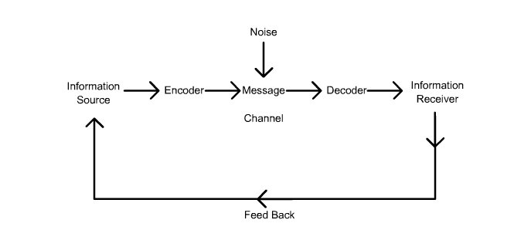
Figure content uploaded by Souza R.C. F
This scheme was created intentionally to show how information flows from one interlocutor to another and can be affected by various ways and noises.
It is often said that we live in the information age when computers and network technologies have made it possible to overcome the time and space limitations imposed by communications. Communication now has higher speed, higher capacity, more flexibility and new types of messages.

The Schramm model of communication seeks to explain how meaning is transferred between individuals, corporations, and others.
The Schramm model of the communication process
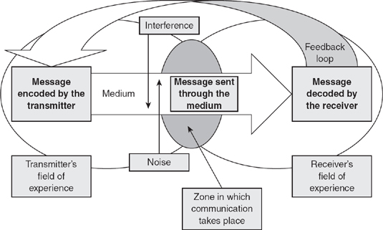
The most commonly taught and widely used theory of communication is that proposed by Wilbur Schramm in the late 1940s. The Schramm model views communication as a process that takes place between a sender (transmitter) and a receiver: there will be also a message, and a medium through which the message can be transmitted (Schramm, 1948).
The Schramm Model of Communication By: Jim Blythe In: Key Concepts in Marketing DOI: http://dx.doi.org/10.4135/9781446221617.n46Subject: Marketing (general)

"The very attempt to speak does not speak much." Communication plays a crucial role in our lives, as people change their ideas, information, feelings, opinions by communicating. Formal communication is one that goes through predefined channels of communication throughout the organization. On the contrary, Informal Communication refers to the form of communication that flows in any direction, i.e. moves freely in the organization.

Communication could be verbal - spoken or written or non-verbal, i.e. the use of sign language, body movements, facial expressions, gestures, eye contact or even tone of voice.
In an organization, there are two channels of communication - formal communication and informal communication. People are often confused between these two channels, so this is an article that explains the difference between a formal and informal communication network.
Definition of formal communication
Communication in which the flow of information is already defined is called official communication. The communication follows a hierarchical chain of command established in the organization itself. In general, this type of communication is used exclusively at work, and employees are required to follow it while performing duties.
Definition of informal communication
Communication that does not follow any pre-established channel for transmitting information is known as informal communication. This type of communication moves freely in all directions and is therefore very fast and quick. In any organization, this type of communication is very natural, because people interact with each other about professional life, personal life and other issues.
Example: Exchange of feelings, occasional discussions, gossip.
Key differences between formal and informal communication
- Formal communication is also known as official communication. Informal communication is also known as the vine.
- In formal communication, the information must follow a chain of command, in informal communication can move freely in any direction.
- In formal communication, a complete secret is kept, but in the case of informal communication, maintaining secrecy is a challenging task.
- Formal communication is written, while informal communication is oral.
- Formal communication is time-consuming, unlike informal communication, which is fast and quick.
- Formal communication is more secure than informal communication.
- In an official communication, documentary evidence is always available. On the other hand, in the case of informal communication, supporting documents are not available.
- the communication style refers to the set of manifestation characteristics, characteristic of a person in the communication process.
If we were to give a definition, we could say that communication style is the way in which a person transmits, using verbal and nonverbal elements, the information in social interactions. In this way, we will be able to realize how that person is and how he tends to relate to those with whom he interacts. Awareness of our own communication style and the style of others is a starting point when we want to improve our communication skills.
Each person has a unique way of communicating.
We can say that the style of communication is an indicator of how an individual structures his social relationships. Therefore, the way in which he processes the information and the way in which he transforms it into acts of behaviour, into practical, social or evaluative judgments, is determined by three elements:
-attitude - as a way of relating the individual to social life, to other individuals and to himself;
- learned communication model - assertive, non-assertive, aggressive or manipulative;
- the person's temperament.
In order to communicate successfully, in order to reach our goal, it is necessary that before transmitting our message, we first understand ourselves, to understand our thoughts, ideas, states (emotional feelings) and only then we address the discussion partner, taking into account the environment and context.
All human interactions are based on communication, in one form or another. The very purpose of communication is to convey our message to the discussion partner, clearly and unambiguously. This involves an effort both on our part as transmitters and on the part of the recipient of the message, the receiver. In fact, communication is a success, when both parties (the sender of the message and the one who receives it) understand the same information as a result of the communication process.
In order to convey the message successfully, in order to make ourselves clearly understood, it is necessary for our thoughts and ideas to be well structured, before transmitting them further. Sometimes what we really think goes wrong in the ears of the discussion partner, because we did not know how to elaborate the message clearly and concisely or we were overwhelmed by emotions.

REFERENCES

- Certificate in Higher Education: Skills for the Workplace Student Yearbook, Andrew Maund, Michaela Schriek, Paul K. Tinkler
- Bailey, Sandra (2009). "Couple Relationships: Communication and Conflict Resolution" (PDF). MSU Extension. 17: 2. Archived from the original (PDF) on 2017-12-15. Retrieved 2016-12-05 – via George Mason University Libraries.
- Trenholm, Sarah; Jensen, Arthur (2013). Interpersonal Communication Seventh Edition. New York: Oxford University Press. pp. 360–361.
- Roy M. Berko, et al., Communicating. 11th ed. (Boston, MA: Pearson Education, Inc., 2010) 9–12
- "Important Components of Cross-Cultural Communication Essay". Studymode.com. Retrieved 2017-05-01.
- The business student`s guide to study and employability, Peter Morgan, 2017, ISBN 978-1-4462-7412-5
- Daniel Chandler, "The Transmission Model of Communication", Aber.ac.uk Archived January 6, 2010,
- 17th World Congress on Ergonomics Ergonomics, workload and ubiquitous: a case study Souza R.C. F. Humberto Malard Monteiro Rodrigo Peronti Santiago
- Harper, Douglas. "communication". Online Etymology Dictionary. Retrieved 2013-06-23.
- "Types of Body Language". Simplybodylanguage.com. Retrieved 2016-02-08.
- (Burgoon, J., Guerrero, L., Floyd, K., (2010). Nonverbal Communication, Taylor & Francis. p. 3)
- Ferguson, Sherry Devereaux; Lennox-Terrion, Jenepher; Ahmed, Rukhsana; Jaya, Peruvemba (2014). Communication in Everyday Life: Personal and Professional Contexts. Canada: Oxford University Press. p. 464. ISBN 9780195449280.
- Turner, L.H., & West, R.L. (2013). Perspectives on family communication. Boston: McGraw-Hill.
- Hayes, Andrew F. (31 May 2005). Statistical Methods for Communication Science. Taylor & Francis. pp. 8–9. ISBN 9781410613707.

