Community sports planning and delivery
Sharnelle Saint
Mark Napieralla
2204577

Context page
Page 1 – current barriers to sports participation in deprived communities
Page 2 – operational plan to increase sports participation in areas of Swansea

Current barriers to sports participation in deprived areas
“These disparities in youth sport participation are unfortunately pervasive and may be the result of multiple barriers including financial and time constraints, limited resources and the inability to access facilities both in and out of school, lack of familial support.” (2021, by the American College of Sports Medicine). This statement shows us that the barriers of sport come through financial problems this shows that some youth people cannot afford the kit, subs for training, or they could even be a carer and not spoken up about it, there could be many reasons to why finance is a problem within youth participation.
“A European researcher on sport and inequalities, Professor Kay drew clear links between falling numbers of sport across the ages in Scotland and levels of deprivation and education. However, she believes that organisations and individuals involved in community sport are well placed in the UK to respond to the challenge of poverty, and calls on the Scottish Government to take the lead.” (30th June 2023, by David Ferguson).
“Beyond the ability to engage in sports due to financial restraints, many youth experience negative health outcomes in regard to management of their injuries. Even if access to sports exits for many youth, disparities in how their sport-related injuries are managed can prevent return to play.” “Insurance status plays a larger role in determining access to sporting activity. As with other aspects of the health care system, difficulty in accessing care for sports injuries exits with public/no insurance. For many schools, athletic trainers provide both acute/sub-acute medical care for students in need. The ability to treat injuries, guide care, and act as an advocate can provide front line care for sports injuries for many pediatric and adolescent athletes.” (Disparities in Youth Sports and Barriers to Participation - PMC (nih.gov) )
“There was a negative relationship between Index of Multiple Deprivation and the distance to the nearest parkrun event: the (population-weighted) Pearson and Spearman correlation coefficients were-0.15 and –0.18, including a small negative correlation. This means that more deprived LSOAs tended to have shorter distances to the nearest parkrun event, i.e. better geographic access.” ( Multiple deprivation and geographic distance to community physical activity events — achieving equitable access to parkrun in England - ScienceDirect )
““Access to sport and physical activity in England is still not close to being a level playing field,” Hollingsworth said. “Too often, people in low-income communities don’t have access to the same facilities or opportunities as wealthier areas.” according to Sport England, the most active place in the country has almost double the activity levels of the least active place (81% compared with 43%), while lifespan can vary by nine years depending on where someone lives. Hollingsworth said needs to change. “It’s very clear that we’re very good in this country in providing sport and physical activity for the majority,” he said. “But we need to devote more of our focus and energy addressing the stubborn inequality of the third of people who don’t get the 30 minutes of weekly recommended activity.”” (6th November 2023, by Sean Ingle)

Operational plan to increase sports participation in areas of Swansea
Local Authority | SWANSEA
Year | 2024
Student Name | Sharnelle Saint
Project Focus | STREET GAMES
Time of year | SUMMER- APRIL - JULY
Funding from street games | £2000

Background research – Include research here into the area of Swansea and information that has helped you reach a decision on activities to be planned and developed.
The most deprived areas within Swansea are Townhill, Penderry and Mynyddbach (27th November 2023, by Swansea council). The main area out of these three which is the most deprived would be Penderry, this is because the population in Penderi exhibits a range of health and wellbeing issues and covers the most deprived are in Swansea with nearly 50% of cluster network patients living in the 20% most deprived areas. Penderi has a larger number of patients who are unemployed and/or single parents (13th September 2021, by the NHS). So, by doing activities for this area, it would help them improve their mental health and their wellbeing by improving blood pressure, improve cholesterol levels, improve blood flow, keep your weight under control (decreasing obesity cases) and prevent boneless. By doing these activities for this community it would bring them together and would improve their social skills.
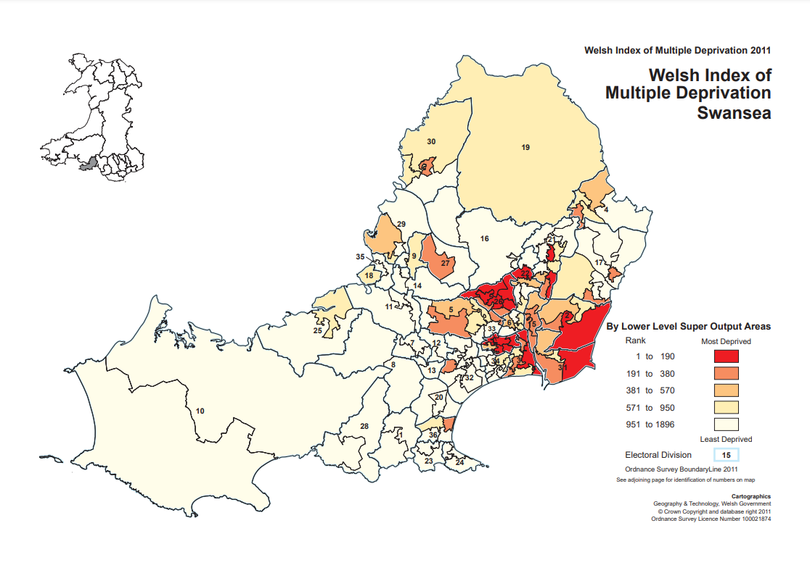
This is a map shows the main deprived areas within Swansea.
PLANNED ACTIVITIES
IDENTIFIED  ACTIVITY / PROJECT INCLUDING NAME / LOCATION / DAY /TIME | HOW WILL THE PROJECT BE DEVELOPED? WHAT WILL IT LOOK LIKE? HOW WILL IT BE PROMOTED? WHO WILL DELIVER IT? | WHO ARE THE PARTNERS THAT WILL HELP DEVELOP THE SESSION? WHAT WILL BE THEIR INVOLVEMENT? | WHAT WILL SUCCESS LOOK LIKE. START / MIDDLE / END OF PLAN
Doorstep sport  Basketball sessions  LC2 (closest leisure centre within Swansea)  Time – Monday 6 – 7pm | Basketball Wales will coach this session in the LC2 sports hall, this session will involve instructions for beginners of basketball, it will show them the foundations of basketball and then lead into more advanced skills. After coaching all the skills needed for basketball the session will then go into a game situation and the participants will then put what they have learnt to use. This session will be promoted through posters and social media in the leisure centre, schools and on lampposts around the local area, to get as many people to the event as possible. These sessions will be delivered by coaches that have come from the basketball Wales group. The only equipment needed for this session is basketballs and cones, as the leisure centre would supply the hoops needed. | For this session my partners would be basketball Wales, by having these as partners they will develop the session as they would have been trained up by professionals. | All the participants have a good day while participating, however only a few people turn up for the session. For example, eight people turn up to the session and the second session 12 people turn up.
Doorstep sport  Running sessions  Swansea Harries Athletics Club (closest running track within Swansea)  Time – Thursday 5 – 6:15pm | The running session I have decided to do will be run by Wales Athletics at the Swansea Harries Athletics Club. They will be taking control of the session as they know the correct techniques for the specific tracks and courses, so this would reduce injuries, so they are able to carry out the activities correctly. For this session I will promote it through again social media and posters within schools, the athletic club and in shops to get as many participants as I possibly can. | Wales Athletics will be my partners for this session as they would be trained to do all the activities correctly to reassure no one comes out with an injury when taking part in the athletics. | The people that turn up enjoy their session and continue to participate. For example, 14 people turn up to the first session and then the second week we have 18 people turn up.
US Girls  Football sessions for girls only  3G pitch at Cefn Hengoed Community School and Leisure centre (nearest 3G pitch within Swansea)  Time – Wednesday 6 - 7pm | This activity will commence in Cefn Hengoed Community School and Leisure Centre on the 3G pitch. This session will be run by the Football Association of Wales, as they now how to plan out a perfect session, and they will know how to keep all the girls that are participating engaged within the session and make sure they are enjoying their time. I will promote these activities via social media so get my target audience attention, and I would also make posters and post them in schools leisure centres and in shops. The equipment I would need it footballs and cones as the 3G pitch would have football posts already there. | Football association of Wales would become my partners within this session as they are professionally trained and know what a football session should look like so if there are any problems within my session then they can point them out and correct my mistakes. | Keeping the girls engaged and making sure that the girls are enjoying the sessions this is the key thing to keep the girls to keep participating within sports and getting them to gain the confidence to be involved in sport.
Club One  Rugby sessions for boys and girls  Swansea Uplands Rugby Football Club (closest rugby club within Swansea)  Time - Tuesday – 6-7pm | For this activity I would have the Welsh Rugby Union to run it as they are fully qualified and know how to keep participants entertained and they know what they are doing so the children do not get bored throughout the session. This activity will take part in Swansea Uplands Rugby Club. I will promote this session again through social media as it is the best way to get my target audience attention, through posters in shops, school, leisure centres and on lampposts to make sure the locals see them and know it is happening. The equipment that I would need would be rugby balls and cones as the rugby club would already have rugby posts. | For my final session my partners would be the Welsh Rugby Union, this is because they know how far they can push participants and they would also help me to perfect my rugby training sessions. | Each participants enjoy and coaches which could be students, get the coaching experience and going into coaching a session themselves.

Costings

Activity / project / session | Resources Needed | Estimated spend | Estimated Income Generated For / by the activity / session
Example  Skate and Scoot Session | Coach to provide instruction  1000 Promotional postcards | 12 sessions @ £10 = £120  £365  Total spend- £485 | £1 per session  £240 income  Total income- £240
Basketball sessions  Collaborated with basketball Wales | Coach to give clear instructions  Access to the LC2 Sports hall  Access to socials media  100 Posters | 12 sessions  £10 = £120  £0  £120  Total spend - ££240 | £2 per session  Aiming for 15 participants = £30 £30 x 12 = £360  £360 income  Total income = £360
Running sessions  Collaborated with Wales Athletics | Coach to give clear instructions  Access to Swansea Harries Athletics Club  Social media access  25 posters | 12 sessions  £7.50 = £90  £3.20 x 18 = £57.60  £0  £30  Total spend - £177.60 | £3 per session  Aiming for 18 participants = £54  £54 x 12 = £648  Total income = £648
Football session girls only  Collaborated with Football Association of Wales | Coach to give clear instructions  Access to 3g pitch at Cefn Hengoed Community School  Social media access  50 posters | 10 sessions  £10 = £100  £200 full pitch + VAT  £0  £60  Total spend = £360 + VAT | £4 per session aiming for 20 participants = £80  £80 x 12 = £960  Total income = £960
Rugby sessions  Collaborated with Welsh Rugby Union | Coach to give clear instructions  Access to Swansea Uplands Rugby Club  Social media access  500 posters | 18 sessions  £10 = £180  £100  £0  £600  Total spend - £880 | £2 per session  Aiming for 20 participants = £40  £40 x 18 = £720  Total income = £720
 |  | Total Cost of plan-  = £ | Estimated funds available-  £2000 + Totals from above  = £2700

https://www.swansea.gov.uk/wimd2019?lang=en

