Research Proposal assignment- Shared spaces

Research Proposal Assignment: Shared Spaces

1 Introduction 3
2 What is it? 3
2.1 The Inventor 3
2.2 The principles 3
2.3 The Psychology 4
2.3.1 Edge friction 5
2.3.2 Psychology of the drivers 5
3 Pro's 5
3.1 Safely 5
3.2 More Space 5
3.3 Cities, Old market towns and Villages 6
4 Con's 6
4.1 Disable people 7
4.2 People upstanding on how to uses these system 7
4.3 Missed use of the system 7
5 Case Study 7
6 Future 9
7 Conclusion 10
8 Bibliography 11

Introduction
For this assignment, I am going to describe and analysis the urban design and planning called “shared spaced”. By doing this document will be the basis for a possible dissertation for next year.

What is it?
So, what is shared space regarding planning and urban design? It is a method to make roads in villages, towns and cities more a public area, to make traffic move more freely and safer. However, as I going to cover in the principles the way they do this is abit different that you would think and because of this, as well committees do not like this method. But like the invertor I think this method is the UK’s and even Europe towns and cities best method to use.

The Inventor
The inventor is Hans Monderman from the Netherlands and his jobs were a traffic engineer and safety officer until he died in 2008. In his early life he trained as civil engineer as well a driving instructor, however this before he studied traffic engineering and accident investigation. and in the 80’s he was pointed safety officer of the Province of Friesland, so you could say that he has a lot of skill in this area. Using his knowledge of safety, human psychology and traffic, he came up with the shared space road that both cars and people could use at the same time.
Currently his work is taken up by a person call Ben Hamilton-Baillie as I cover later with the shared space in poynton.

The principles
The principles were dividing driving and other road user made a disconnection between drivers and other people in their environment caused most of the accidents at crossings. As well all the signs, kerb, lights and road marking made them feel safe, so they take more risks. So shared spaces when being installed would remove all sign, kerb-stones, lights and marking, so it made the driver feel unsafe with in turn made them more careful and drive slower. And as they were impairment the drivers stop for people to cross the road because they were not waiting a light, so a few seconds waiting was nothing. Figre1 is a picture of a street before and after the design was implemented (Exhibition-Road London).

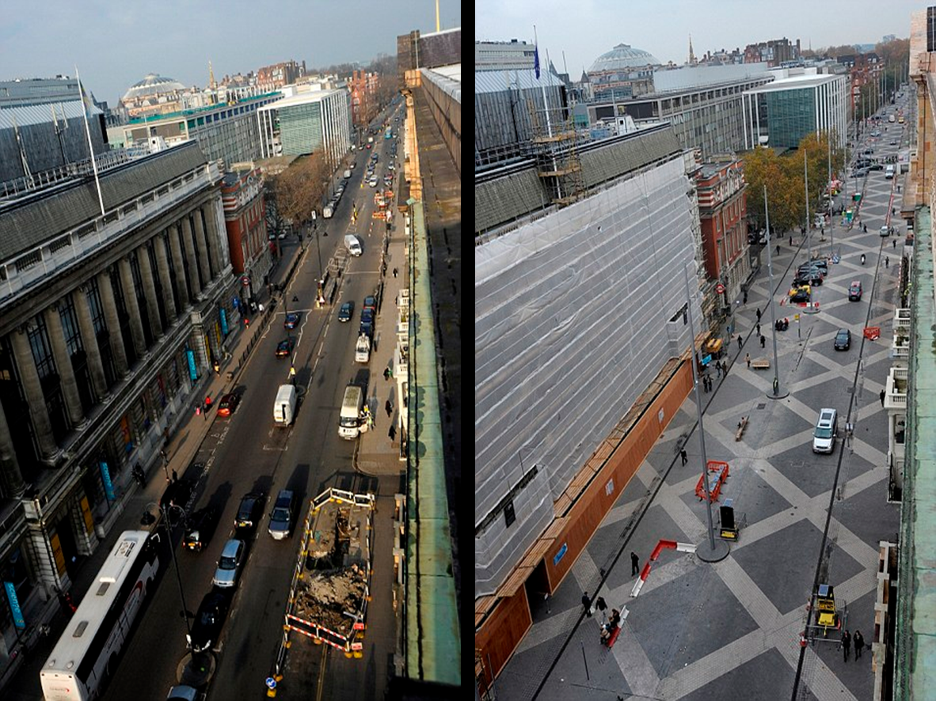
Figure 1
In this picture of Exhibition-Road London before and after the shared space was constructed you may see many different between the two, for example the spaces on the surface, this is make the driver visionally aware of their speed, as well make the driver aware that it not a normal road, as well you may see that they are 2 dark lines on the side of the marking where the paths are, but cars can still park and cross these lines. It hard but you can see that all traffic signs and lights have none allowing traffic to move its own way. And the final parts you may see is the centerline and road marking are gone and replace by vertical comments this is to slow down and keep driver on guard for people walking out on to in front of them.

The Psychology
This method of planning and design in town and cities, work by change the mental state of the drive as I cover in the last part by making driver and people feel that they are part of the same environment and uses that the fact the human is a social race and can solve puzzles and problem by nature. But for safety they but controls, put large tall object in the driver peripheral vision (edge friction)

Edge friction
Edge friction is objects or changes in colors in the driver peripheral vision to make the driver reduce their speed without think about. For example, on highways you tend to have walls or nothing on the side of the road this a louds the driver reaches the speed limit with being distracted by an overload of information, however when you get to slow speed areas you tend to see tall objects make the driving stay under the limit.

Psychology of the drivers
The basic trough process of a driver is to get from point to get from A to B the fastest and safety way, so when you have lots of sign, marking and light, planner unintentionally leading drive into a fake sense of safety as well as remove them from the local environment. As well as that there have been studies that show if you make driver feel like idiots, they will be idiots on the roads. So, with these to factor that the driver is treated like idiots and fake sense of safety, driver will drive faster and have a higher change of taking risk. However, if you remove all of them, drivers will find a way through the system as well because the time normally save they do give way to people more.

Pro's
There are many pros to this method of urban design, where are most safety, space saving and improve socially in towns.

Safely
On 1st glance of the method has many hazards like remove all current safe measure, however in act in work very well just over ½ major accidents did not happen on streets after the method is installed for example install at Ipswich accidents drop from 23 over 3 years to only 1 a year, at not just that the safety spaces in London all had 60% decreased in accidents. This is because you are making the hazard aware that they are a hazard, with will make them take their time. However, with safety the is one problem if an accident happens on the road due to the lower kerb and no barrier the cars can very easily be push off the road on to the path area.

More Space
With this method the road does not have more space for bikes and people because of traffic is moving most of the time, so you can reduce the number of lanes that is needing to support the traffic demand. this allows the street to have a more to become more a social because their space for street artist/ performers to do their job, or space to put in anytime the council thing the area might need. For example, on poynton’s shared they got abit outside the church which is big enough for a log car to be there without block the road, nor people using the “path” area. Picture blow (figure 2 shows their area outside the church.
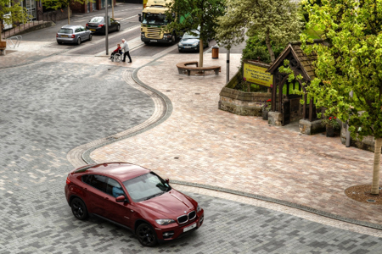
Figure 2

Cities, Old market towns and Villages
Cities, old market towns and villages normal have one big problem with their road system which is they have one or more main road cutting through the area, this normal divide the area up because people would normally dodge main road if they are on foot. But which shared space the road tends to be easier to cross this aloud the two side of the main road to join (people may will to go to shops that they normally would not. As well most road in UK and Europe are small road with mean that shared space would help most road to be more use able. Because it would mean that path can be wider.

Con's
There are many cons in this method, which has caused problem for method. For example, blind people are the main problem.

Disable people
Disable people are the most at harm when using this method because there no crossing for them to know how to use this method or cannot used without significant risk. For example, blind people have the biggest problem with this method of planning from their dogs not knowing where to cross because of their training and impartment a system for them to use like zebra crossing.

People upstanding on how to uses these system
People young and old may not know, how used this system/ method of which can cause problem because there be using highway code which is not that good on a road redesign design where no one have right of way. So, people may need to be told how to use it.

Missed use of the system
As well this method is open to problems of miss use. For example, of this is if an old woman wanted to cross the road some driver may speed to, so they do not have to stop for her trapping her on one side. This is a miss used because the point is the traffic light have mean remove to save drivers time so in turn for the drivers to let people across. As well a proper problem for this method is that current in the world now there is a lot of problems regarding terrorism and mental health and the fact that barrier and kerb are lower mean that people can be more at harm way if one of these “incident” happens, however they are rare but to do need to think about it.

Case Study
My case study is going to be on poynton’s shared space in the north-west England where they had a main road running through the middle of the town which has caused a divide between to two side ever side of the road due to the number of cars running through the town, so the local council got an architect (Ben Hamilton-Baillie) and his company to redesign the main junction and the roads that feeds into the junction. Below is the poynton’s main junction before the shared space scheme was installed
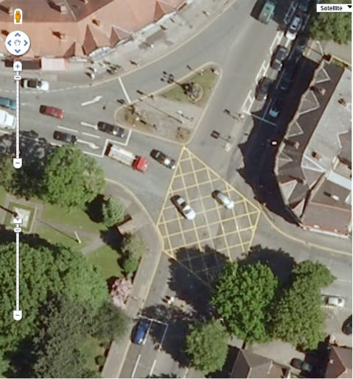
Figure 3
If you look the image you can see that it a has may big wide road with a lot of marking all over. As well the junction a few lights on the top part h on for people who are walking across the road. The road does not look I like it should be there, at not in a town with that wide. As well the road does not fit in with the design of the buildings. So, the was change to the image on the next page.
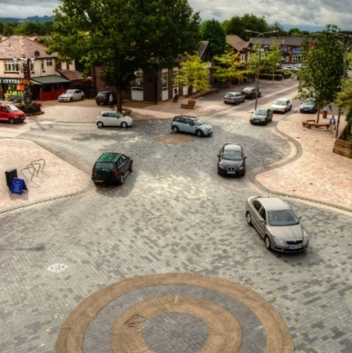
Figure 4
When this was under planning poynton public was spilt they was not new to the shared space because one the road in poynton (church lane). However, must of the public trough that it was not going to work because they change from a two-lane approach zone to a 1 lane.
In poynton they design they the shared space for blind people because you can see the tactile pavement showing where path is and where the road is. As well because no kerb and smaller road wide it makes it easier for any disability to cross.
And the final bit people for poynton say that I make road more socially safer and better than what because driver are having to use the high way code and driver a wave member of the public over the road a lot more. Poynton is to me want we should look as an example for share space because it was properly design and implemented in to the high-street and connecting to 2 halves of the town.

Future
The future of this planning design is in limbo since in 2015 the method was under review in the UK’s government, which the government saying to councils has been told to hold and review all shared space under construction or being planned to ensure that there is safety measure in the design and plans. There two companies that are working on the safety design one company is a Dutch firm who works with the Danish Building research institute which has researched a lot into shared spaces where they even have come up design too help blind people and guide dogs by using textured blocks. The other is a UK firm founded Ben Hamilton-Baillie how work on as an architect on poynton’s shared space. But any way in the UK they more than likely will not be built until in clear up its design for disable people.

Conclusion
My conclusion is share space are brilliant for the UK’s Roads, if they are implemented correctly and has been design for better of people with disability because now 70% of disable people say that they do not like the shared space scheme. As it is around the same for the rest of the British public like the system of urban planning what was in place before.

Bibliography

https://nyc.streetsblog.org/2008/01/11/hans-monderman-in-memoriam/ accessed on 02/01/2018 at 13:33
figure 1- http://www.mark-making.com/wp-content/uploads/Exhibition-Road-Before-And-After.png accessed on 02/01/2018 at 14:01
figure 2- https://www.bing.com/images/search?view=detailV2&ccid=N7n5Arxr&id=728AFB4143E601A1AE70DD991B6C768E2D75C5CB&thid=OIP.N7n5ArxrwEwG48OMJESVoAHaE8&q=poynton+shared+space&simid=607986896649523050&selectedIndex=5&ajaxhist=0 accessed on 04/01/2018 at 11:03
https://www.youtube.com/watch?v=VUbsFtLkGN8 accessed on 04/01/2018 at 11:07
http://www.transportforall.org.uk/about/news/new-report-calls-for-a-moratorium-on-shared-space-schemes accessed on 04/01/2018 at 11:22
https://www.gov.uk/government/news/new-guidance-on-the-design-of-shared-space-streets accessed on 04/01/2018 at 12:11
figure 3 https://www.bing.com/images/search?view=detailV2&ccid=Pr2xpgcF&id=30021E0026A040B0D2410C118245880D89D3D931&thid=OIP.Pr2xpgcFqGMGETdvB9vb6AEsDW&q=poynton+shared+space&simid=607999017014854213&selectedIndex=13&ajaxhist=0 accessed on 08/01/2018 at 11:34
figure 4- http://www.russellpreston.com/blog/wp-content/uploads/2013/04/Poynton-Shared-Space.jpg accessed 08/01/2018 at 11:43
https://www.youtube.com/watch?v=-vzDDMzq7d0&t=2s accessed 08/01/2018 at 12:10

