DIGITAL SURVEYING AND HIGHWAY DESIGN SEMESTER 3

Contents
Introduction and purpose of survey 1
Survey Area Definition 2
Access 3
Scanning Position 3
Lighting Conditions 4
Environmental Conditions 4
Building Occupancy 4
Part 2: Practical survey: pages 7-9
Part 3: Measurement and analysis: pages 9-11

Introduction and purpose of survey
The building surveyed for this assignment is the IQ building at UWTSD Swansea, The IQ Building at the University of Wales Trinity Saint David is a modern teaching, research, and innovation facility found on the SA1 Swansea Waterfront. Opened in 2018 as part of the University’s Innovation Quarter development, it provides approximately 10,100 m² of space dedicated to higher education, research, and collaboration.
The purpose of this survey was to capture the internal layout of a university corridor (UWTSD IQ Building) and surrounding building areas using terrestrial 3D laser scanning technology. The objective was to create an accurate digital record of the building that could later be used for extracting measurements, producing floor plans, and supporting future maintenance or refurbishment work.
Traditional surveying methods rely on tape measures or total stations, which can be time-consuming and require multiple visits to site. Laser scanning offers a faster alternative by capturing millions of measurement points in a matter of minutes. These measurements form a point cloud that accurately represents the geometry of the building.
The survey focused on recording the dimensions of corridors, doorways, walls, windows and other permanent building features. High positional accuracy was required because the processed scans would later be used to obtain reliable measurements.

Survey Area Definition
The survey area consisted of an internal university corridor together with the adjacent circulation space. The survey included:
- Corridor walls
- Doors and door frames
- Floor and ceiling surfaces
- Structural columns where present
- Junctions between corridor sections
The survey excluded external building areas, service rooms and occupied offices that were inaccessible during the survey period.
The required level of detail was sufficient to identify architectural features and allow dimensional measurements to be extracted from the processed point cloud. High overlap between scan positions was required to ensure successful registration of individual scans into one complete model.
The areas measured in the survey include the level 1 corridors as well as open planned study/ break rooms. Connecting these corridors is an extra room which contains the entrances to more classrooms. There are many doors within the corridors which are omitted in the survey although the entrances are acknowledged and apparent in the floor plan created. The classroom doors being involved in the floor plan created extra variables to consider when completing the survey of the floor plan as the measurements were minorly affected.

Survey equipment
The survey was completed using a terrestrial 3D laser scanner mounted on a stable tripod. Although the exact scanner model was not recorded, the equipment could collect high-density point cloud data.
Additional equipment included:
- Adjustable tripod
- Survey targets or natural reference features for scan registration
- Spare batteries
- Data storage device
- Laptop for transferring data if required
- Personal Protective Equipment (high-visibility vest and safety footwear where applicable)
Site Conditions
A site assessment was carried out before scanning commenced.

Access
The survey area was accessible through the university building's main entrance. Permission was obtained before the survey commenced, ensuring minimal disruption to staff and students.

Scanning Positions
Multiple scan positions were selected along the corridor to minimise blind spots caused by walls, doors and furniture. Each scan overlapped with neighbouring scans by approximately 30–50%, allowing accurate registration during processing.
Scanner locations were selected to provide clear lines of sight while avoiding obstruction of emergency escape routes.

Lighting Conditions
Although laser scanners are largely independent of lighting conditions, sufficient internal lighting was maintained to assist equipment setup and photographic documentation. Artificial lighting within the building provided consistent visibility throughout the survey.

Environmental Conditions
The internal environment was stable with no significant weather effects. Temporary movement from students and staff presented the main challenge, as moving people can introduce noise into point cloud data.

Building Occupancy
The survey was carried out during a relatively quiet period to minimise pedestrian traffic. Occupants were informed where necessary, and scanning was paused whenever large groups moved through the corridor.
Survey Structure

The survey followed a structured workflow.
First, the survey area was inspected to identify suitable scan locations. The scanner was then positioned on the tripod and levelled before each scan.
A full 360-degree scan was captured at each location. After each scan completed, the scanner was moved to the next planned position while maintaining sufficient overlap with previous scans.
Photographs of the scanner locations and surrounding environment were taken as evidence of survey completion.
Following fieldwork, the scan data would normally be transferred into software where individual scans are registered into a cloud. Quality checks would then verify alignment before measurements are extracted.

Health and safety

Health and safety formed an important part of survey planning.
The scanner and tripod were positioned so they did not create trip hazards. Equipment was never left unattended in pedestrian walkways.
Surveyors remained aware of building occupants throughout the survey and ensured emergency exits remained unobstructed.
Manual handling techniques were used when transporting equipment between scan positions.
Electrical hazards were minimal because the scanner operated using rechargeable batteries.

Risk Assessment
Trip hazards | Injury to building users | Position equipment carefully and use warning signage where needed
Moving students and staff | Scan interference and collisions | Survey during quieter periods
Manual handling | Muscle strain | Carry equipment correctly using suitable techniques
Equipment Damage | Loss of data | Secure scanner avoid sharp movements
Obstructions | Missing data | Overlap positions so no data is missed
Fire evacuation | Delay in response time | Keep escape routes clear and plan the proceedings

Limitations
Several limitations were identified during planning.
Moving people could appear within the cloud, reducing data quality in some locations. Furniture and temporary obstacles could also create shadow areas where the scanner was unable to capture data.
The unknown scanner specifications prevented optimisation of scan resolution and scanning speed. Furthermore, access restrictions meant that only internal circulation areas were surveyed rather than the complete building.
Despite these limitations, careful planning and multiple scan positions ensured that the survey objectives could be achieved while maintaining good spatial coverage.
Conclusion
Careful planning is essential for successful laser scanning surveys. Defining the survey objectives, selecting appropriate scan positions, assessing site conditions and identifying operational risks all contribute to producing accurate data. The survey plan developed for the university corridor provides a structured approach that supports efficient fieldwork and reliable measurement extraction during post-processing.

Part 2: practical survey
The survey was carried out inside the university corridor using a terrestrial 3D laser scanner mounted on a tripod. Before scanning began, the survey area was inspected to confirm suitable scanner positions and ensure safe access throughout the corridor.
The survey generally followed the original survey plan. Multiple scan positions were established along the corridor to maximise coverage and minimise areas hidden behind walls, doors and fixed furniture. The scanner was levelled at each location before a full scan was completed. Adequate overlap was maintained between neighbouring scans to support accurate registration during processing.
Evidence of the survey included photographs showing the scanner positioned within the corridor, the surrounding environment and the various scan locations. These photographs demonstrate that the survey was completed on site and provide a record of equipment placement.
Most aspects of the survey proceeded as expected. Access to the corridor was straightforward, and the internal lighting provided suitable visibility during equipment setup. The stable indoor environment meant that weather conditions did not affect data collection.
Some practical adjustments were required during the survey. Pedestrian movement from students and university staff occasionally interrupted scanning. Rather than continuing while people were moving through the scanner's field of view, scanning was paused until the area became clear. This reduced unnecessary noise within the point cloud.
Another challenge involved temporary obstructions such as furniture and open doors. Additional scan positions were introduced where necessary to improve visibility around these obstacles and reduce shadow areas.
The tripod required careful positioning to avoid obstructing the corridor while still achieving clear sightlines. Maintaining overlap between scans required careful planning because some corridor sections contained corners that restricted visibility.
Overall, the laser scanning process proved efficient. Compared with traditional tape measurements, the scanner captured a significantly greater amount of information within a relatively short period. Instead of measuring individual dimensions manually, the scanner created a complete digital record that could later be measured repeatedly without returning to site.
The main lesson learned from the practical survey was the importance of planning scanner positions before data collection begins. Good overlap between scans and awareness of pedestrian movement both contribute significantly to successful scan registration and final point cloud quality. Although minor changes were required during the survey, the objectives of capturing the internal corridor layout were successfully achieved.

Part 3: Measurement and analysis

Following completion of the field survey, the processed point cloud was used to obtain building measurements. The digital dataset provided an accurate three-dimensional representation of the surveyed corridor and surrounding building features.
Measurements extracted from the point cloud included the overall corridor dimensions together with the sizes of selected doors and windows. These measurements could be taken directly from the software without revisiting the site, demonstrating one of the major advantages of laser scanning technology.
The point cloud also allowed measurements to be verified from multiple viewpoints, reducing the likelihood of human error. Because millions of survey points were collected, additional dimensions could be obtained whenever required without carrying out another field survey.
Compared with traditional manual measurement methods, laser scanning offers significant advantages.
Firstly, data collection is much faster. While manual surveying requires individual measurements to be recorded separately, laser scanning captures the entire environment during each scan. This reduces the amount of time spent on site and minimises disruption to building users.
Secondly, laser scanning provides higher levels of accuracy and completeness. Manual measurements are more susceptible to recording errors and omitted dimensions, particularly within complex building layouts. The point cloud records virtually every visible surface, providing a comprehensive digital record of the surveyed environment.
Another important advantage is data preservation. Once the point cloud has been processed, additional measurements can be extracted at any time without revisiting the building. This is particularly valuable for refurbishment projects where accurate existing-condition information is essential.
However, laser scanning also has some limitations. The equipment is more expensive than traditional surveying tools and requires specialist software and trained operators. Processing large point cloud datasets can also require significant computing resources.
Overall, laser scanning provides substantial improvements in efficiency, accuracy and data completeness when compared with traditional manual measurement techniques. Although the initial investment is greater, the technology offers considerable benefits for modern building surveying by reducing fieldwork time while producing a permanent digital record of the building.
Ultimately the laser scanner produced a much clearer floor plan with scales to be able to measure. when completing the measurements on the floor plan, it is more difficult to collect the smaller areas to measure. for example, small edges of walls are challenging to measure accurately when the scale is 1:200. This could cause inaccurate measures. However, for larger walls and measurements the laser scanner gives clear and accurate measures which gives great value to the modern techniques of surveying.

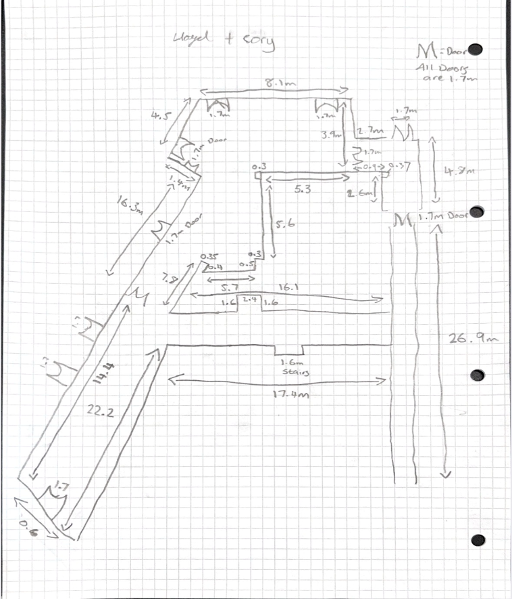
Here is the floor plan I measured using traditional manual techniques.
Doors: 11 each measuring 1.7m
Corridor walls: 169.1m

Here is the scan of the floor plan created by the laser scanner.
Doors:12 again measuring at 1.7
Corridor Walls 185m


