INEQUALITY AT WORKPLACE – INDIVIDUAL REPORT

Student Name: Denis Onyebuchi Egbula
Module code: BWSW4004
Student Number :2020982
Lecturers Name: Charles Oham
Assignment: Title Problem Solving and Decision Making

Table of Contents
1. Introduction 3
2. Inequality in Workplace (Tesco) 3
2.1 Scope of the Problem 4
2.2 Identification of the Problem 4
2.3 Impact of the Problem 5
3. Analyzing Information on Inequality in Tesco’s Workplace 5
3.1 Cause-effect Analysis 6
4. Alternative Solutions on the Problem 7
5. Application of Decision-making Techniques to Evaluate a Range of Solutions and Identifying the most Appropriate Option 7
5.1 SWOT Analysis 7
5.2 Risk Analysis 8
6.Developing a Plan for Strategic Implementation of the Solution using Adkar model 9
6.1 Identification of the Possible Solutions to the Workplace Inequality Problem in Tesco 10
6.2 Evaluation and Underpinning of the Most Appropriate Solution 11
6.3 Action Plan 12
7. Communicating the Solution with Tesco Stakeholders 12
8. Administering, Monitoring and Reviewing Techniques to Ensure the Success of the Solution 13
9. Conclusion 14
References 14
Books & Journals 14
Webpages 15

Executive Summary
Inequality and discrimination in the workplace influence the down growth of performance and a healthy workplace environment. Gender, age, or racial discrimination impacts a person’s psychological state and make him/her depressed. This eventually causes leaving the company or charging against the company policy. Tesco is a UK based grocery retailer which has been facing such discriminatory issues for some years. The report will be contemplating and illustrating the issues to resolve the matter with
essential steps and ideological establishment in the workplace.

1. Introduction
Discrimination in the workplace is a prevalent matter in worldwide organizations. The social psychology of discrimination postulates that discrimination is a social sickness that can only be diagnosed and removed by symptomatic therapy. The salary pay gap, reward unfairness and discriminatory activities for religious belief are very common in many organizations. The report will discuss the referendum and pre-existing conditions of discrimination in Tesco, the UK based grocery retailer. The report will discuss the problem and the alternative solutions. The report will articulate ideas and key problem identification to create step by step solution strategies to the problem. The report will also provide an action plan to execute the solutions effectively.

2. Inequality in Workplace (Tesco)
According to Kalev and Deutsch (2018, p. 258), inequality in the workplace creates management issues and reduces the CSR reputation of a company. It tampers with the status of a company and distracts new talent from applying for a job in the company. Tesco is one of the most recognizable grocery chains and retailers in the UK. The company has recently faced a gender discrimination case where a 39-year-old lady filed against the branch manager to clear out her dues after she decided to leave the job on short notice (Simpson, 2021)‌. The legislative policies of the company clearly state to clear out convenient finance within two weeks of resignation ‌ (Boyd, 2021). The gender, age and community discrimination cases are faced by Tesco multiple times after 2007.

2.1 Scope of the Problem
According to Scarborough et al. (2019, p. 194), gender inequality and racial discrimination are the two most prevalent discriminable activities in the business sector. Further, age discrimination and discrimination on religious belief are some important discrimination bases that are seen in workplaces. According to Berrey et al. (2017), the continuity of such illegal behavior is thoroughly being observed and negotiated. Companies are enabling policies, and the government is bringing up new legislation.
These legislative actions and multidisciplinary actions are working to an extent. However, the prevalence of the matter is not reducing expectedly. According to Resnick and Galupo (2019, p. 1381), the salary increment, promotion, reward, bonus programs, recruitment and leave permission are being provided unfairly based on gender, age, and race. This is raising questions regarding the executive actions and laws in the UK.

2.2 Identification of the Problem
According to Willman and Pepper (2020, p. 520), discrimination and inequality in the workplace are some of the most prevalent issues in companies that severely impacts the internal performance, reputation and even lawsuit budget of the company. Tesco has a massive employee base with 45% female, 51% male and other genders working in the company. The company has faced gender discrimination issues regarding the pay scale gap thrice in the last 4 years (Simpson, 2021)‌. The company has also faced an age discrimination matter regarding due clearance in 2021. however, the gender discrimination index in the company is higher than 8.1 which calls for immediate action and intervention.

2.3 Impact of the Problem
Inequality in the workplace creates performance issues, safety issues, ethical issues and makes employees feel less valued for the organization. Tesco has more than 4,22,000 employees worldwide. Among them, 3,28,000 employees operate in the UK. The company has a significant workplace mapping that allows Tesco to recruit employees from different demographics and regions in the UK (Simpson, 2021)‌. The inequality problem has created ethical problems where many employees filed against the workplace policies of Tesco. The company has lost £350,660 for the lawsuit clearance in 2018-19. This is affecting Tesco’s reputation in the market. The company has lost around 880 of its employees in 2020 (International Finance Desk, 2018)‌.
Moreover, Tesco is facing reduced performance growth which is reflected in its online and offline departments where the company has faced a loss of 6.98% market share and 12.65% market share respectively.

3. Analyzing Information on Inequality in Tesco’s Workplace
Almost 8.2 million employees in the UK feel discriminated against in the workplace. According to the current polled survey by BBC, it was reported that approximately 1,200 Tesco employees feel discriminated against for the behavioral approach of their peers and the salary gap (Simpson, 2021)‌. The gender discrimination case against the company was filed recently in June 2021, where a woman was reported to fight the pay scale gap in the supply department and won against the administration in the company (International Finance Desk, 2018)‌. Almost 26.13% of employees admitted to being confronted by such activities before. Almost 32.4% of female employees stated that they are discriminated against by pay scale and promotion in departments like production, supply, transport as these jobs require physical effort.

3.1 Cause-effect Analysis
Since Tesco has a significant number of employees working in the supply, production, transport and maintenance departments, the gender pay gap is comparatively higher. The employment in the company incorporates employees from different areas of the UK where gender discrimination are not much sensitive. The company also has a majority employment of male employees that makes Tesco rely on male employees more than female employees.
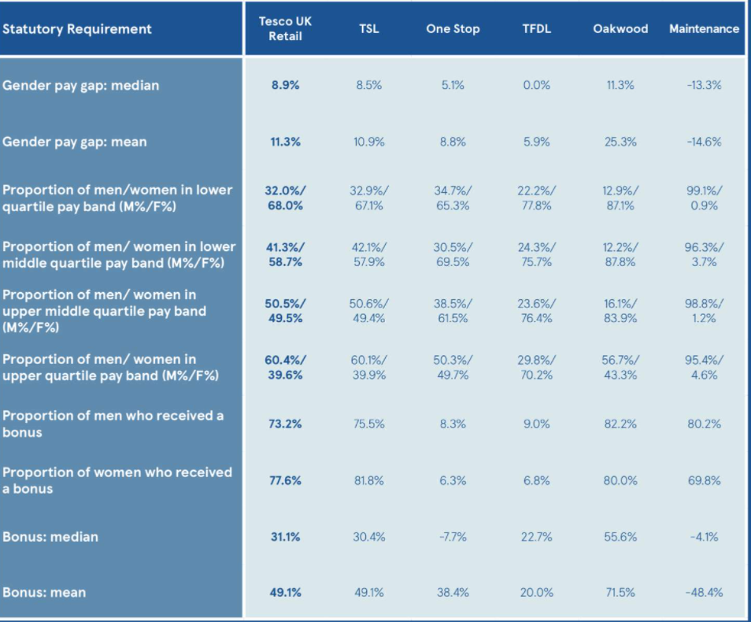
Figure 1: Tesco’s Employment Gender Ratio
(Source: International Finance Desk, 2018)

4. Alternative Solutions on the Problem
Establishing Rules and Regulations with Clear Demonstration
Tesco can establish clear instruction in their policies and employee legislation regarding modern discriminatory activities in the workplace. This can be administered by the HRM, and the following actions can be delivered to employees through the mail.
Creating Disciplinary Guidelines for Discriminatory Activities
Tesco can frequently notify disciplinary guidelines to the workplace notice box where the employees can clearly see which level of actions can be taken for discrimination among employees. This can be administered by managers and HRM and monitored thoroughly.
Constantly Educating Employees to Prevent Discrimination in the Workplace
Tesco can educate employees regarding the consequences of discrimination. According to Aksoy et al. (2019, p. 169), some motivational events can be arranged to demonstrate the various perspectives of the matter that can allow employees to understand the ethical aspect of non-discrimination and its purposes for social integrity.

5. Application of Decision-making Techniques to Evaluate a Range of Solutions and Identifying the most Appropriate Option

5.1 SWOT Analysis
Strengths  Tesco has a massive employee’s structure with several legislative associates and potential HRM for administering anti-discrimination.  Tesco has a 45% female employee base with 13 of them having a place in the board of directors panel (Simpson, 2021)‌. | Weaknesses  Tesco has been faced multiple discrimination cases in last four years.  According to Dashper (2019, p. 545), Tesco is being charged £350,000 for its pay scale gap case in June 2021.
Opportunities  Tesco has a significant recognized structure and opportunity for proving its CSR and employment policies in the next year business plan.  According to Dashper (2019, p. 545), the new recruitment opening will be a significant opportunity for the company. | Threats  Tesco CEO has recently said that discriminations in the company is a rumored matter, and they are not going to compromise business decisions by taking proactive steps on it.  M&S and Morrison’s are constantly promoting their employee programs and attracting interested talent in the UK market.
Table 1: SWOT Analysis
(Source: Created by Author)

5.2 Risk Analysis
Risks | Highly likely | Possible | Highly Unlikely
Low Male Participation |  | Possible
Increased Demands of female employees |  |  | Highly Unlikely
Funding Hindrance | Highly Likely
Table 2: Risk Analysis
(Source: Created by Author)

6.Developing a Plan for Strategic Implementation of the Solution using Adkar model

(Source: created by Author)

D

A D K A R
(Source: Created by Autor)

Awareness
Organizations immediately needs to convey clear instructions to their employees about the need to embrace equality and no discriminations. The clear instruction of the following rules regarding a conversation with employees needs to be displayed in board notification about this new change and giving them time to ask questions and explaining the reason for this new change
Desire
Looking at the outcome of this new change and identifying those that are willing to follow suit if the employers are resisting the change. Address the reason why and explain to them why the need for this new inequality change is important.
Knowledge
Provide trainings and courses about inequality and give reason why it’s bad to treat others differently.

Ability
Plan practice runs, before the change is fully implemented monitor the performance immediately after that and gets constructive feedbacks set goals
Reinforcement
Monitoring that all plans put in place for inequality is being followed, rewarding, and encouraging those that keep following the new process.

6.1 Identification of the Possible Solutions to the Workplace Inequality Problem in Tesco
Delivery of clear instruction for anti-discriminatory rules
Tesco immediately needs to convey clear instructions regarding which activities will be classified as gender or age discrimination. The clear instruction of following rules regarding a conversation with employees needs to be displayed in board notification.
Clear Guideline for disciplinary actions
Tesco needs to provide detailed guidelines for disciplinary actions which will be taken while witnesses in a discriminatory activity. According to Willman and Pepper (2020, p. 520), the employees need to be informed to report any unequal behaviors to their peers. The management and team leaders need to be thoroughly checked and monitored by HRM.
Equal pay policy
The company is required to change its salary structure in every department (SME Loans, 2021)‌. The salary in the production, manufacturing, transport, or maintenance department needs to be based on the daily quantity of work. The salary can be reduced but with reduced roles and responsibilities.
Monthly Seminar for inequality in Workplace
Tesco needs to inform HRM to arrange monthly events, seminars, and meetings regarding the workplace inequality matter. The managers will be allotted responsibilities to report to the head office regarding any discriminatory behaviors among employees and then will take disciplinary actions after arranging explanation sessions with the accused.

6.2 Evaluation and Underpinning of the Most Appropriate Solution
Tesco needs to take clear instructions of disciplinary actions for workplace inequality. This will improve the criticality of the situation. Any type of pay scale gap or late payment needs to be punished accordingly (SME Loans, 2021)‌. This will make employees aware of the criticality of the situation. This can deliver a clear demonstration of the severity of the activity. Tesco needs to educate employees on the role of preventing discrimination by reporting it immediately to HRM. This will increase the job satisfaction of female employees.
Moreover, the company is required to arrange frequent meetings and programs when the managers can educate employees on that matter and allow them to support the achievement of female employees. This will keep employees engaged and involved in the psychological betterment process.

6.3 Action Plan
Solutions | Description | Time Duration
Create Clear Demonstration of Anti-discrimination in Company Policy | - Administer policy alteration.  - Notify restrictions and instructions in paper and digital media. | By December 2021
Create rules and Guidelines for Disciplinary Actions | - Gather employees and create disciplinary rules.  - Create guidelines and share them with all employees for disciplinary punishments. | By January 2022
Educate Employees through Meetings and Seminars regarding Gender Neutrality | - Arrange events for gender neutrality seminars  - Celebrate gender neutrality in office and cultural events. | By July 2022
Table 3: Action Plan
(Source: Created by Author)

7. Communicating the Solution with Tesco Stakeholders
Tesco needs to deliver mails and notifications in the employee applications. The managers are required to set meetings for the matter more than one time to finally take it seriously. The company needs to take interactive communication with male and female employees and discuss which particular action can resolve minute matters in certain departments. The pay scale strategy can make everyone actively engage in the matter. According to Bruns (2019, p. 91), the managers need to frequently appreciate the achievement of female employees to motivate them and make them feel valued for the company. Further, changing work hours for mothers and old employees can increase their job satisfaction and create space for new recruitment.

Figure 2: Tesco Changing Workhours for Female Employees
(Source: SME Loans, 2021)

8. Administering, Monitoring and Reviewing Techniques to Ensure the Success of the Solution
Tesco managers, HRM and leaders can monitor the intervention with proper review strategy. The company needs to arrange a weekly common hall box review program where every employee can anonymously complain of discriminatory behaviors (SME Loans, 2021)‌. This way, the manager can mention and resolve the matter without mentioning any name and avoid conflict. Any serious discrimination can be discussed with HRM to take serious action against it. Reviewing the progress and betterment of the process can allow other employees to participate in this process and become more liberal.

9. Conclusion
Inequality activities in the workplace impact the performance matrix, communication matrix and management efficiency. Tesco, being a major grocery retailing business in the UK obtains the responsibility of sustaining proper equality in the workplace. Any types of discrimination of salary payment, employee behaviors, unethical workplace environment should not be tolerated by the managers. The report has discussed and explained the fundamental elements that inhibit discrimination in the workplace and analyzed them to the social extent. The report has composed some solutions and executed the solutions with an action plan. After that, the report also has provided techniques to monitor and review the effectiveness of the strategies implemented for the mentioned problem in Tesco.

References

Books & Journals
Aksoy, C.G., Carpenter, C.S., Frank, J. and Huffman, M.L., 2019. Gay glass ceilings: Sexual orientation and workplace authority in the UK. Journal of Economic Behavior & Organization, 159, pp.167-180.
Berrey, E., Nelson, R.L. and Nielsen, L.B., 2017. Rights on trial: How workplace discrimination law perpetuates inequality. University of Chicago Press.
Bruns, B., 2019. Changes in workplace heterogeneity and how they widen the gender wage gap. American Economic Journal: Applied Economics, 11(2), pp.74-113.
Dashper, K., 2019. Challenging the gendered rhetoric of success? The limitations of women‐only mentoring for tackling gender inequality in the workplace. Gender, Work & Organization, 26(4), pp.541-557.
Kalev, A. and Deutsch, G., 2018. Gender inequality and workplace organizations: understanding reproduction and change. Handbook of the Sociology of Gender, pp.257-269.
Resnick, C.A. and Galupo, M.P., 2019. Assessing experiences with LGBT microaggressions in the workplace: Development and validation of the microaggression experiences at work scale. Journal of homosexuality, 66(10), pp.1380-1403.
Scarborough, W.J., Lambouths III, D.L. and Holbrook, A.L., 2019. Support of workplace diversity policies: The role of race, gender, and beliefs about inequality. Social Science Research, 79, pp.194-210.
Willman, P. and Pepper, A., 2020. The role played by large firms in generating income inequality: UK FTSE 100 pay practices in the late twentieth and early twenty-first centuries. Economy and Society, 49(4), pp.516-539.

Webpages
Boyd, L. (2021). How to Prevent Workplace Discrimination. [online] Available at: https://www.lbmc.com/blog/how-to-prevent-workplace-discrimination/ [Accessed 1 Dec. 2021].
International Finance Desk (2018). Tesco faces equal pay claims of £4 billion in terms of gender discrimination. [online] Available at: https://internationalfinance.com/tesco-aces-equal-pay-claims-of-4-billion-in-terms-of-gender-discrimination/ [Accessed 5 Dec. 2021].
Simpson, E. (2021). Tesco staff win legal argument in equal pay fight. [online] Available at: https://www.bbc.com/news/business-57343892 [Accessed 10 Dec. 2021].
SME Loans. (2021). Gender Discrimination In The Workplace Statistics 2021 (UK). [online] Available at: https://www.smeloans.co.uk/blog/gender-discrimination-in-the-workplace/ [Accessed 12 Dec. 2021].

