Assignment 2 — Project Management & Innovation
AI-Powered Email Verification System for Improving Lead Quality
Module: Changemakers: Creativity and Value Creation
Module Code: ACCA5033
Programme: BSc Applied Computing
Student Name: Aleem Uddin Ali
Student ID: 2442557
Submission Date: 20 August 2026

Table of Contents
1. Introduction 3
2. Task 1 — Project Management 3
2.1 Project Scope 3
2.2 Proposed Solution 4
2.3 Technologies and Resources 4
2.4 Development Method 4
2.5 Project Schedule 5
2.6 Constraints 6
2.7 Project Design 6
Design 1 — System Architecture 6
Design 2 — Entity Relationship Diagram 7
3. Task 2 — Enterprise 7
3.1 PEST Analysis 7
3.2 SWOT Analysis 8
3.3 Legal Considerations 9
3.4 Ethical Considerations 9
3.5 Startup Concept, Strategy and Business Type 9
3.6 Funding Options 10
4. Task 3 — Project Reflection 10
4.1 Skills Development 11
4.2 Social and Business Impact 11
4.3 Risks, Challenges and Mitigation 12
5. Conclusion 13
References 14
Appendices 16
Appendix A — Detailed Risk Register (Summary Note) 16
Appendix B — Detailed PEST/SWOT Source 16
Appendix C — Detailed Project Schedule 16
Appendix D — Technical Evidence Summary 16
Appendix E — Business and Funding Analysis 16

1. Introduction
Bad email and contact information negatively affect CRM lead management. Outdated or incorrect addresses are a drain on outreach efforts and diminish the confidence in lead-quality. Fit for use is not limited to accuracy of data quality research and challenges are still large in data intensive environments [2].
This report proposes project-management and enterprise analysis for a proposed system using AI to verify emails and enhance lead quality. VerifyLead: A multi-layered service designed to perform the basic checks (syntax, domain, DNS/MX), and (optionally) the advanced checks (constrained SMTP probing and assistive AI/ML scoring) and report the status and confidence.
To show coherent planning, technical design and enterprise positioning, in an academic timeframe, with a single thread of the enterprise, VerifyLead, from management, design and enterprise analysis. Task 1 relates to project management and design, Task 2 to enterprise analysis, and Task 3 to reflecting on skills, social contribution and risk mitigation.

2. Task 1 — Project Management

2.1 Project Scope
The issue is that there's weak email/ contact information, which makes it difficult to qualify the leads. For the primary stakeholders and users, sales teams, marketing teams, lead generation businesses, and CRM/data-management teams that rely on reliable contact records for outbound activities and pipeline reporting.
The goal is to develop, construct and run a lead verification system using AI to enhance lead quality. Planned objectives are (1) to build a working prototype pipeline, (2) to test behaviour with labelled or synthetic samples (with clear metrics) and (3) to develop clear, analytical assessment of potential lead-quality effects. These are proposed plans, not empirical claims made.
Features include scope: syntax, domain and DNS/MX checks, optional SMTP probing, optional AI/ML scoring, confidence/status outputs, storage, basic UI/API, and export/reporting. Out of scope: full CRM, marketing automation, campaign sending, payments/social login and enterprise multi-region production infrastructure. This boundary helps to manage the schedule risk and ensures the level of focus on the quality of assessment is on verification of the product, not on neighbouring product areas that would increase the delivery risk.

2.2 Proposed Solution
VerifyLead is a multi-stage verification process. Users send e-mails through UI/API, which results in a job being created in the back end, normalised addresses and executes ordered checks. Core stages include structural and mail-routing evidence, while optional stages include more advanced signals as appropriate, technically and ethically. A decision layer provides status (valid, invalid, risky, or unknown) and reason codes prior to storage and reporting with a high level of confidence.
The tutorial steps: syntax → domain → DNS/MX → decision/scoring → database → reporting. Optional path: Constrained smtp probing & assistive AI/ML classification. Delivering optional stages in isolation ensures delivery when there is time uncertainty and network uncertainty, and will leave a useful prototype even if delivery of advanced stages is delayed. The evidence is based on the well-known mail-routing practice (MX) and an explicit unknown band does not impose false certainty on the evidence.

2.3 Technologies and Resources
Aside from unnecessary complexity, selection is based on feasibility, explainability and low cost. The backend is based on node.js/TypeScript, typed APIs and rapid iteration; the ERD is stored in PostgreSQL (or SQLite locally); a modular engine is used for the stages, and DNS libraries are used for MX lookups, while SMTP and ML are optional and limited. The proposed prototype stack avoids paid verification APIs, with the exception of the usual limitation of developer time, and free-tier hosting.
Component | Proposed Approach | Why Appropriate | Key Constraint
Backend/API | Node.js + TypeScript | Typed APIs; fast iteration | Batch concurrency
Database | PostgreSQL / SQLite | Fits relational ERD | Ops overhead if hosted
Verification engine | Modular stage functions | Core vs optional separation | Integration effort
DNS/MX | Resolver libraries | Mail-routing practice [7] | Timeouts/failures
AI/ML (optional) | Rules + light classifier | Assistive, transparent scoring [8] | Limited eval data
Hosting | Local/Docker/free-tier | Budget-appropriate delivery | Free-tier limits
Table 1. Technology and resource summary for the proposed VerifyLead prototype.

2.4 Development Method
The reason for choosing lightweight Agile is that it is technically uncertain, offers some advanced stages and has a short delivery time. Increments can show a usable core path which can be used for SMTP/ML polish. The research validates Agile as a way to deal with complexity and emphasizes human factors of success: team skill and team engagement [3, 4] and the negative impact of sub-optimal teams on innovation [5]. With early discovery of DNS/SMTP limits, late redesign cost is less, and the order of core validation - optional stages later continues to be the rule with Waterfall. This helps to maintain innovation within academic limits.
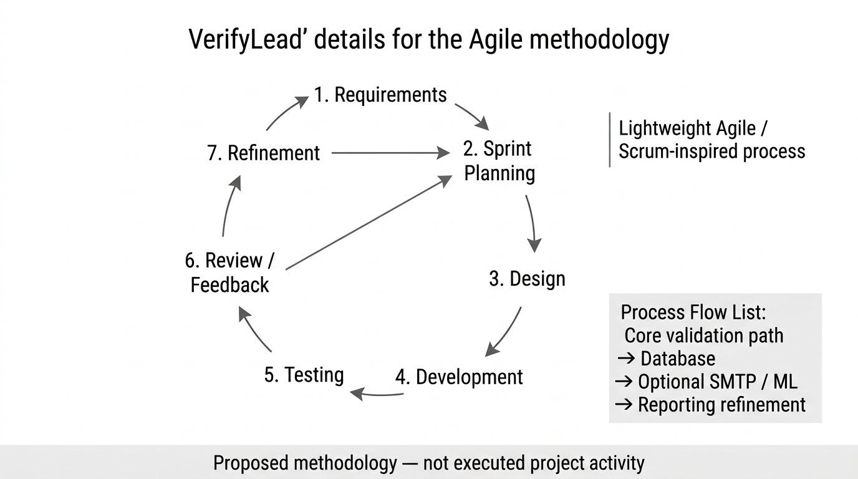
Figure 1. Proposed Agile development cycle for VerifyLead.

2.5 Project Schedule
The proposed plan involves a 9-week period for initiation and requirements, followed by a research and scope freeze, design of architecture and ERD, design of the engine and AI/ML approach, prototype and integration, testing, evaluation and refinement, documentation and final review. Early weeks are for defining a problem and collecting information; mid weeks are for creating Design 1 and Design 2 and later weeks are for testing and thoughtful consideration based on available information only. Gantt is a planning artefact, it does not contain task completion information.
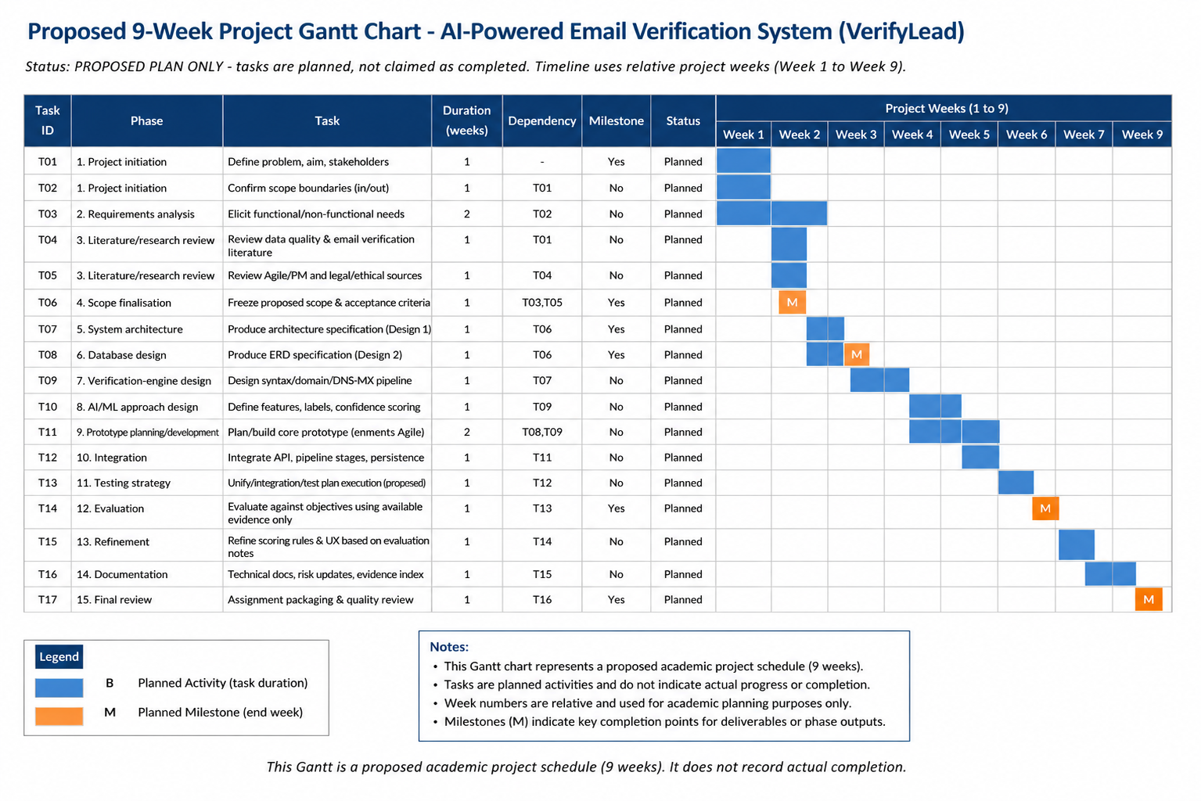
Figure 2. Proposed 9-Week Project Gantt Chart.

2.6 Constraints
Academic timebox, budget constraint on infrastructure, DNS/network dependency, ethical/policy limits on SMTP probing, lack of evaluation data in AI/ML and considering emails as personal data are all constraints. These build on the MoSCoW prioritisation and on explicit labelling of the optional stage of the prototype, to ensure that the prototype is deliverable without jumping the gun on what can be claimed with a degree of certainty, given the uncertainty of the real world and limited evaluation samples.

2.7 Project Design

Design 1 — System Architecture
This architecture consists of several layers: UI/API client, backend API, orchestrator, core validators, optional SMTP/ML, decision/scoring, database, reporting. Clients connect with HTTPS/REST, DNS and optional SMTP are external services. Security features include authentication, least privilege and purpose limited logging. Validators make it possible to achieve Agile increments, and reports are critical in order to allow the operators to interpret the status and confidence, rather than on a binary pass/fail label alone. This is a design that is suggested for Design Piece 1 and not a system that has been deployed.
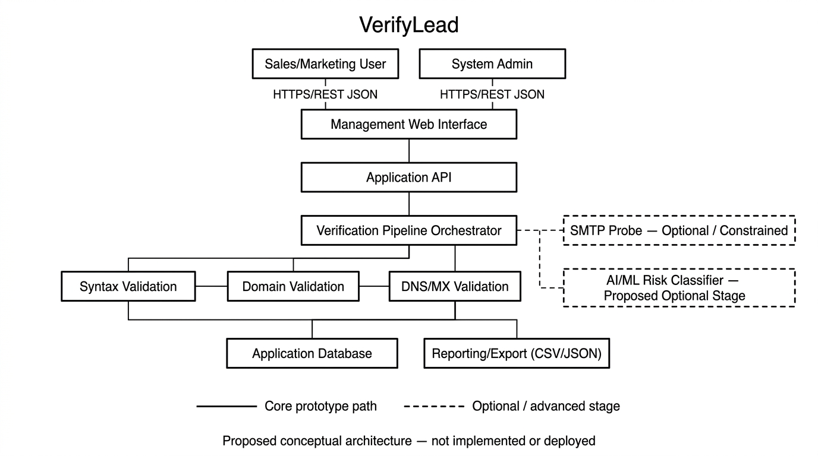
Figure 3. Proposed System Architecture for VerifyLead.

Design 2 — Entity Relationship Diagram
Entity Relationship Diagram is the name of the design.
The model is based upon entity-relationship model [6]. The entities that are proposed are User, VerificationJob, EmailRecord, VerificationResult, ValidationStageResult and AuditEvent. Jobs are one-to-many with email, email is one-to-one with final results and one-to-many with the evidence in the stage. The schema is kept intentionally small to ensure that there is not CRM-like complexity beyond its scope and it is easily auditable for decisions on how to verify it.
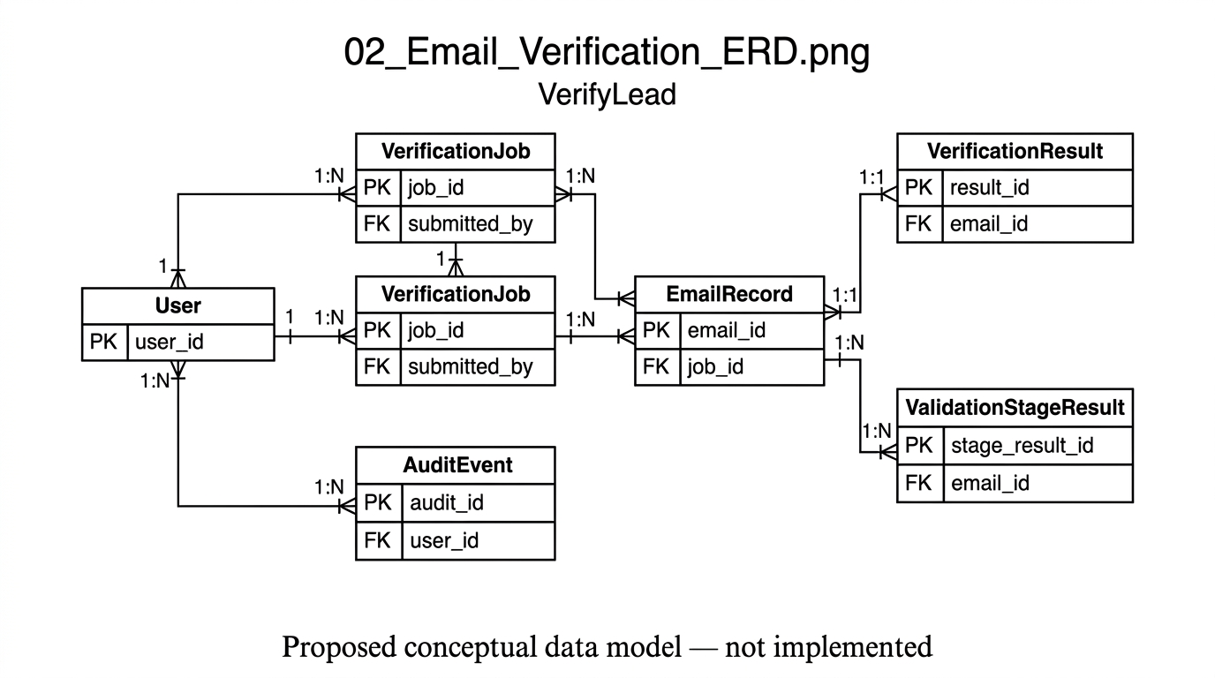
Figure 4. Proposed Entity Relationship Diagram for VerifyLead.

3. Task 2 — Enterprise

3.1 PEST Analysis
Politically, emails could be personal data and marketing falls under PECR, while the UK data-protection expectations can still be complied with, and privacy can be designed to be transparent, thus becoming a trust differentiator. From an economic perspective, demand is to minimize wasted outreach and costs early require low cost hosting. Socially, we don't want to have high tolerance for intrusive practices, so it makes people less willing to be aggressive and looking for spam. The technological standards of mail-routing allow DNS/MX checks [7] and DQ-aware ML with cautious scoring [8] but still, external DNS dependency is a risk.
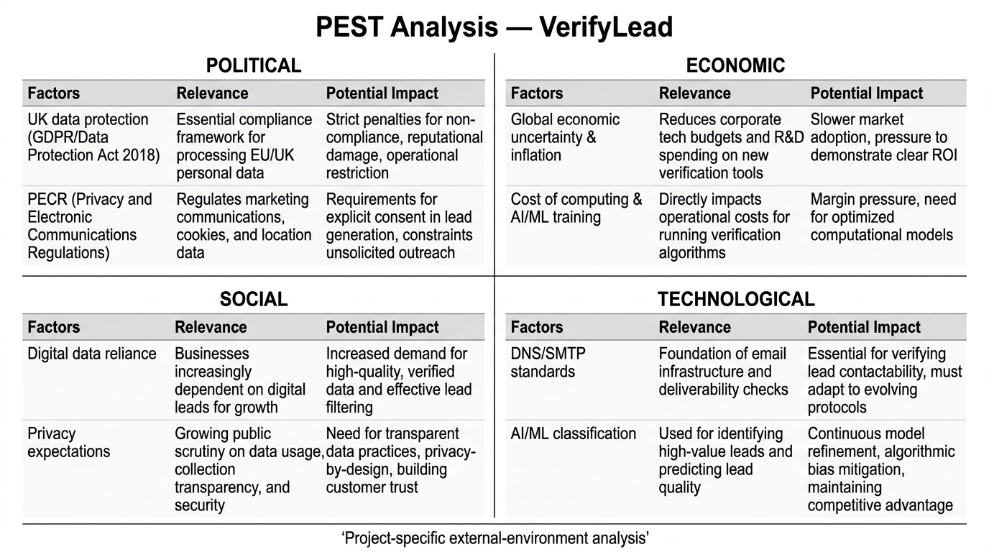
Figure 5. PEST analysis for VerifyLead.
Factor | Implication for VerifyLead | Response
Political | Data protection / PECR adjacency | Minimisation; transparency
Economic | Cleaner-list demand; low budget | API freemium; free-tier stack
Social | Trust / anti-spam expectations | Unknown band; acceptable use
Technological | DNS/MX yes; ML uncertain | Core first; optional ML/SMTP
Table 2. Condensed PEST implications for VerifyLead.

3.2 SWOT Analysis
Weaknesses: not well integrated with data quality/lead quality [1] and [2] and coherent architecture/ERD artefacts, design is explainable. Strengths: production accuracy evidence is lacking, SMTP/ML uncertainty, and there is no capacity of a single student in the academic timebox. New opportunities: B2B use of cleaner contacts/positioning that respects privacy as a differentiator. Threats: risk of non-compliance with regulations, different verification tools and output misuse for unsolicited messaging.
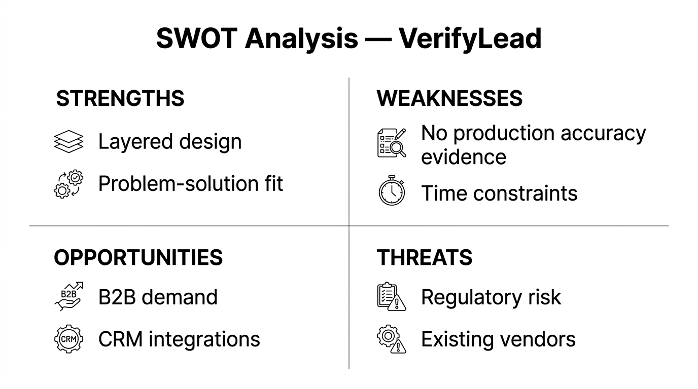
Figure 6. SWOT analysis for VerifyLead.

3.3 Legal Considerations
Emails can identify individuals and should be treated as personal data by default. Lawful processing, minimisation, retention limits, and security are design requirements rather than optional extras. VerifyLead may be a processor for customer lists under instructions and a controller for its own account data. PECR mainly regulates sending marketing email [12]; verification is not itself a lawful-sending mechanism, and customers remain responsible for compliant outreach. AI scoring may trigger DPIA consideration [13]. This is not legal advice; it identifies regulatory themes that should shape architecture and operating procedures.

3.4 Ethical Considerations
Responsible Automation can help to reduce false-positives and false-negatives, and minimize over-claiming, with confidence scores, an unknown band, reason codes and human review hooks. Assistive ML should be explainable (fallback to rules) [8] [14]. Conservative thresholds and operator override limit the unfair flagging of the atypical but valid addresses. Acceptable use framing is required or verification is not made to be a facilitator for unsolicited messaging.

3.5 Startup Concept, Strategy and Business Type
VerifyLead is recommended to become a B2B API-first lead verification company, not just a marketing automation company. The audience includes business-to-business (B2B) organizations, such as sales/marketing operations and lead generation organizations. The customer problem is unclean contact lists, the value proposition is automated layered verification, with clean status/confidence outputs which will enable cleaner CRM hygiene. This assumes that it's a conceptual SaaS/API model, and that there are no validated revenue numbers. Advantage(s) intended: explainable staged results, privacy conscious defaults, not unverifiable market-share claims.
Strategy is based on lean experimentation: test the core path, gain knowledge from the small prototypes, and then scale up the integrations [9, 10], using innovation as "real-life" rather than novelty [11]. Staged Growth - prove trustworthy core verification before CRM Connectors. Guidance for business structure in the UK can be used for a private limited company, and possibly for a sole trader for first experiments [15]. Ltd is advised if you want to go beyond academic prototype.
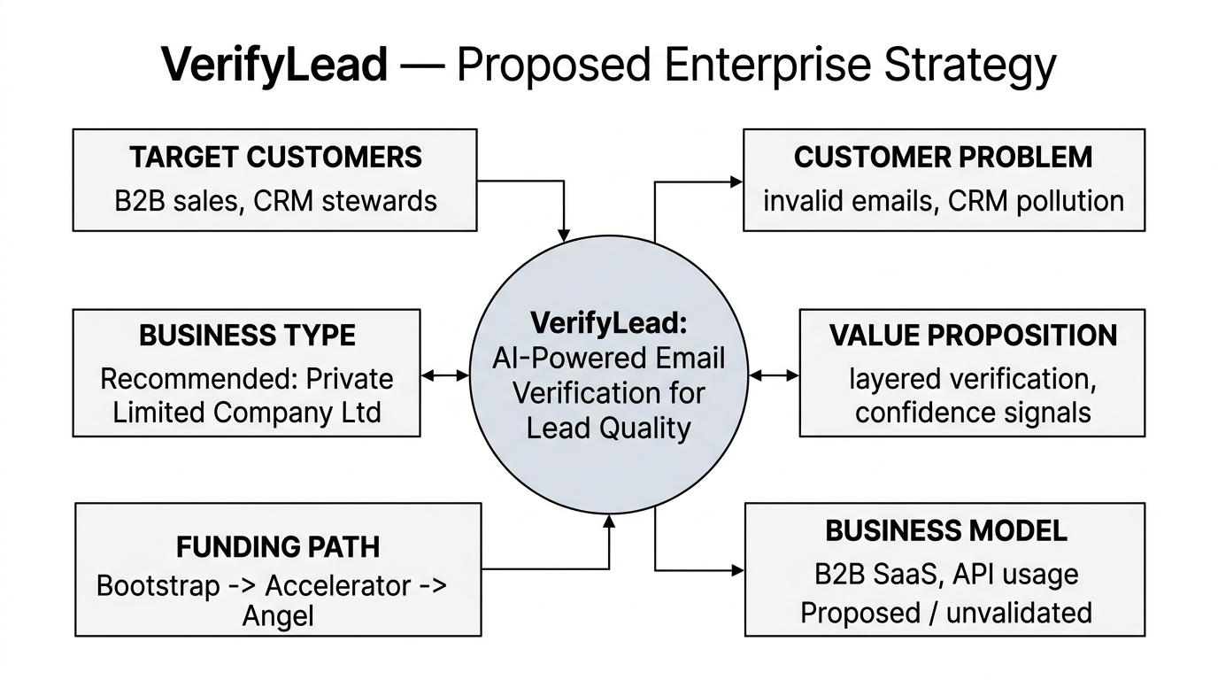
Figure 7. VerifyLead business strategy overview.

3.6 Funding Options
No moneys have been secured. Early options: Bootstrapping, limited capital in return for control; grants if applicable come into existence; later on, accelerator and/or angel funding upon a demonstrated prototype. Venture capital before traction – strategic investment after MVP from CRM/data vendors could become applicable via distribution partnerships. Funding decisions should be based on the stage risk rather than seeking funding too early.
Funding Type | Likely Stage | Suitability for VerifyLead
Bootstrapping | Idea → MVP | High for early prototype
Grants | Pre-seed / R&D | Medium if eligible
Accelerator / angel | MVP → early traction | Medium after demo
Venture capital | Seed+ traction | Low initially
Strategic investment | Post-MVP | Medium via integrations
Table 3. Funding options relevant to VerifyLead (none obtained).

4. Task 3 — Project Reflection

4.1 Skills Development
Planned activities involve project management (scope, Gantt, risk), architecture design and ERD design, back end / API thinking (Node.js / TypeScript), AI / ML (precaution), data-quality understanding [8], research synthesis, business analysis for VerifyLead and qualitative risk management. Prioritisation practice is informed by agile human factors too [4]. Design trade-offs are clearly communicated and skills in communication are reinforced. This means that this is a development that one might expect from project work, rather than professional mastery.
Skill | Project Activity | Expected Development
Project management | Scope, Gantt, risks | Planning under constraints
Software architecture | Architecture design | Layered component reasoning
Database design | ERD specification | Normalisation and FK modelling
Backend/API | API/pipeline design | Service contract design
AI/ML literacy | Optional scoring design | Responsible assistive ML awareness
Business analysis | PEST/SWOT/funding | Enterprise product framing
Table 4. Skills-development summary (expected development, not claimed mastery).

4.2 Social and Business Impact
The idea behind the value chain is that if there is poor data quality, leads can be unreliable, wasted resources can be used, then verified, better data fitness, more clarity in lead qualification, and potentially the possibility of more efficient processes [1][2]. The sales/marketing staff, data stewards, and organisations looking to get cleaner CRM hygiene can all benefit from this. These are possible results only; there are no efficiency, conversion or satisfaction claims. Ethics are not an addendum to social value, but are inherent in it because of limitations such as: residual unknown statuses, blind over-trust in confidence scores, misuse risk.
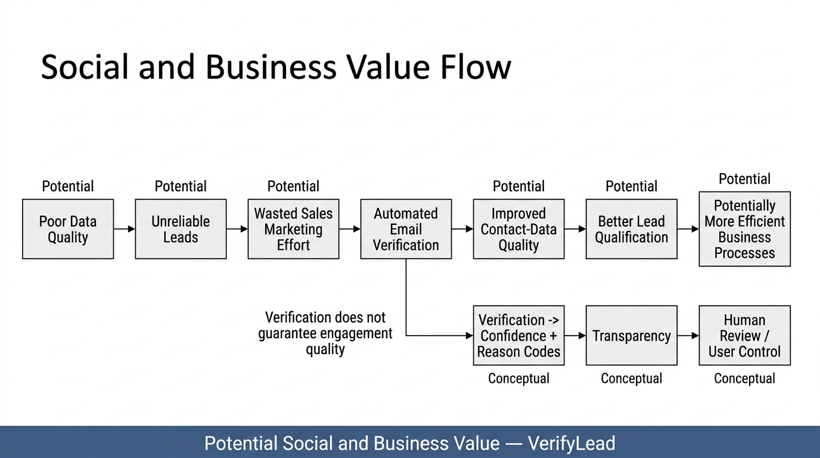
Figure 8. Proposed value-creation chain for VerifyLead.

4.3 Risks, Challenges and Mitigation
Risks are the product of probability (1-5) multiplied by impact (1-5). Limited academic time (16) is critical and mitigated by Agile core-path priority, with deferring of optional SMTP/ML polish also. Layered checks, unknown/confidence bands, minimisation, retention limits, considering DPIA are all mitigations against high risks of inaccurate decisions, privacy/compliance failure (score 15). Risk of security breach is low but impact is high, so it is best to have credentials that are authenticated, in HTTPS, and hashed, as well as to have the least-privilege access, even as a prototype.
The other risks are high are false positive/negative, DNS instability, SMTP/ML uncertainty, weak evaluation data and scope creep. Responses are conservative thresholds, degrade to unknown behaviour, optional stages, labelled synthetic/public samples only and a written out of scope list. Contingencies don't just create evaluation issues; they negate weak stages and further evaluation claims. These scores are not empirical incident frequencies, but are given high priority to controls.
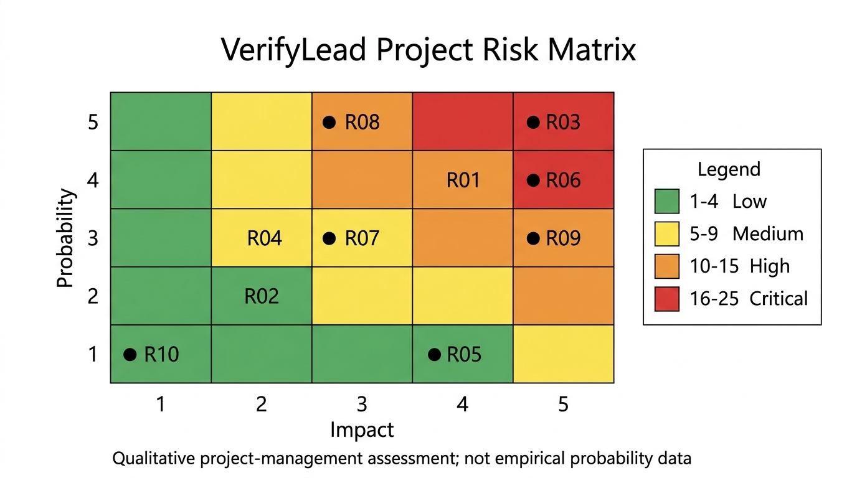
Figure 9. VerifyLead project risk matrix.
Risk | Score | Level | Primary Mitigation
Limited project time | 16 | Critical | Core-path Agile prioritisation
Inaccurate decisions | 15 | High | Layered checks + unknown band
Privacy/compliance failure | 15 | High | Minimisation; DPIA review
False +/− outcomes | 12 | High | Conservative thresholds
SMTP/ML uncertainty | 12 | High | Optional stages; rule fallback
Table 5. Summary of major project risks and mitigations (planned assessments).

5. Conclusion
This report proposes a unified framework for project management and creating a business model for an AI based email verification solution for better lead quality. Task 1 identified the concept of controlled scope, a node.js/TypeScript approach, the concept of Agile delivery, a development process that takes 9 weeks and the architecture/ERD designs. Task 2 highlighted the following without invented finance – VerifyLead was placed through PEST/SWOT, legal/ethical constraints, strategy, business form and funding options. In Task 3, attention was drawn to the skills, potential impact and risk mitigation. There are clear academic and technical constraints while there are technical choices: core versus optional stages, unknown outcomes, and minimal data model, all of which are tied to enterprise and ethical constraints. In general, the draft is proponents of a controlled prototype path, instead of unverified commercial claims.

References
[1] R. Y. Wang and D. M. Strong, "Beyond Accuracy: What Data Quality Means to Data Consumers," Journal of Management Information Systems, vol. 12, no. 4, pp. 5–33, 1996, doi: 10.1080/07421222.1996.11518099.
[2] L. Cai and Y. Zhu, "The Challenges of Data Quality and Data Quality Assessment in the Big Data Era," Data Science Journal, vol. 14, p. 2, 2015, doi: 10.5334/dsj-2015-002.
[3] D. Baxter and N. Turner, "Why Scrum works in new product development: the role of social capital in managing complexity," Production Planning & Control, vol. 34, no. 13, pp. 1248–1260, 2021, doi: 10.1080/09537287.2021.1997291.
[4] L. Barros, C. Tam, and J. Varajão, "Agile software development projects–Unveiling the human-related critical success factors," Information and Software Technology, vol. 170, p. 107432, 2024, doi: 10.1016/j.infsof.2024.107432.
[5] S. Khanagha, H. W. Volberda, A. Alexiou, and M. C. Annosi, "Mitigating the dark side of agile teams: Peer pressure, leaders' control, and the innovative output of agile teams," Journal of Product Innovation Management, vol. 39, no. 3, pp. 334–350, 2022, doi: 10.1111/jpim.12589.
[6] P. P. Chen, "The entity-relationship model—toward a unified view of data," ACM Transactions on Database Systems, vol. 1, no. 1, pp. 9–36, 1976, doi: 10.1145/320434.320440.
[7] J. Klensin, "Simple Mail Transfer Protocol," RFC 5321, IETF, Oct. 2008. [Online]. Available: https://www.rfc-editor.org/rfc/rfc5321
[8] M. Priestley, F. O'Donnell, and E. Simperl, "A Survey of Data Quality Requirements That Matter in ML Development Pipelines," Journal of Data and Information Quality, vol. 15, no. 2, pp. 1–39, 2023, doi: 10.1145/3592616.
[9] N. Bocken and Y. Snihur, "Lean Startup and the business model: Experimenting for novelty and impact," Long Range Planning, vol. 53, no. 4, p. 101953, 2020, doi: 10.1016/j.lrp.2019.101953.
[10] R. Harms and M. Schwery, "Lean Startup: Operationalizing Lean Startup Capability and testing its performance implications," Journal of Small Business Management, vol. 58, no. 1, pp. 200–223, 2020, doi: 10.1080/00472778.2019.1659677.
[11] T. M. Amabile and M. G. Pratt, "The dynamic componential model of creativity and innovation in organizations: Making progress, making meaning," Research in Organizational Behavior, vol. 36, pp. 157–183, 2016, doi: 10.1016/j.riob.2016.10.001.
[12] Information Commissioner's Office, "Electronic mail marketing," ICO, UK. [Online]. Available: https://ico.org.uk/for-organisations/direct-marketing-and-privacy-and-electronic-communications/guide-to-pecr/electronic-and-telephone-marketing/electronic-mail-marketing/
[13] Information Commissioner's Office, "When do we need to do a DPIA?," ICO, UK. [Online]. Available: https://ico.org.uk/for-organisations/uk-gdpr-guidance-and-resources/accountability-and-governance/data-protection-impact-assessments-dpias/when-do-we-need-to-do-a-dpia/
[14] Information Commissioner's Office, "Guidance on AI and data protection," ICO, UK. [Online]. Available: https://ico.org.uk/for-organisations/uk-gdpr-guidance-and-resources/artificial-intelligence/guidance-on-ai-and-data-protection/
[15] UK Government, "Comparing business structures," Business.gov.uk. [Online]. Available: https://www.business.gov.uk/support/business-structures-governance-and-ethics/comparing-business-structures/

Appendices

Appendix A — Detailed Risk Register (Summary Note)
The complete risk register (R01 - R14) is kept in the file Assignment_2_Project_Analysis.xlsx (Risk_Register sheet) and Project_Data/risk_data.csv. Scores use Probability × Impact on a 1–5 scale with levels Low (1–4), Medium (5–9), High (10–15), and Critical (16–25).

Appendix B — Detailed PEST/SWOT Source
The Phase-1 workbook sheets PEST and SWOT include extended PEST and SWOT rows, comprising strategic responses and a mapping of evidence.

Appendix C — Detailed Project Schedule
Task level dependency, milestones and Week 1-9 allocations are logged in the Gantt sheet of Assignment_2_Project_Analysis.xlsx and in the Project_Data/gantt_data.csv. The proposed schedule is shown in a graphical manner in figure 2.

Appendix D — Technical Evidence Summary
Under Assignment_2_Phase1/Technical/ are architecture and ERD narrative specifications, analysis of the methodology of Agile and legal/ethical research notes. A machine readable ERD schema can be found in erd_schema.json.

Appendix E — Business and Funding Analysis
The Business_Analysis workbook sheets and the Funding workbook sheets provide information about business model elements, business-type comparison notes and funding-option detail. The figures for no receipts or revenue forecasts are not claimed.

