  BA Business Management  Data Handling & Business Intelligence  LCBB5000  Lecturer:  Zahra Mohammadnazari | Ivaylo Todorov  Student ID: 2132919

Table of Contend

- Introduction…. 3
- What is the mean processing time when using Hadoop…… 3
- What is the median processing time when using Spark….4
- On which date did R have the highest processing time…5
- What is the standard deviation for processing time when using Python…6
- Which tool or platform had the lowest average processing time across the dataset…7
- Can you interpret the difference in processing times across different tools or platforms…9
- Excel functions - IF, PIVOT TABLES, CHARTS AND GRAPHS….9
- What is the correlation between processing times of Hadoop and Tableau, scatterplot of the two variables…10
- Conclusion…... 11
- References…... 12

In the modern digitized world, the collection, structuring, processing, and analysis of large databases occupies an increasingly large place. This supports strategic decision-making, improves workflow, predicts consumer attitudes, improves customer service, improves product quality.
Referring to Galetsia (2020) using these features, large databases can be more easily structured. This helps in easier selection of data in studies, conducting tests, also contributes to easier analysis of a large database.
A task has been assigned to analyse a set of data. The objectives are to understand (present and analyse) the performance indicators of popular analysis tools, which can lead to optimization of care for the patients of the Green Med healthcare organization. Both MS Excel and the health organization's recently acquired SPSS software will be used to analyse data and present results.
The Excel statistical software will be used to discuss and analyse the first task of the GreenMed_Healthcare_2023 dataset.
- What is the mean processing time when using Hadoop?
“Apache Hadoop is an open source, Java-based software platform that manages data processing and storage for big data applications” (Databricks, 2023)
According to Hayslett (1995, pp. 17) “mean” in statistics is the middle of the largest and smallest numbers chosen for observations. It is obtained by adding all the numbers and dividing them by their total number.
To find "the mean processing time" of Hadoop, a separate pivot table is created with the Hadoop data. Then "average" is selected in the values column. The calculations show that the mean processing time is 2.776889208.
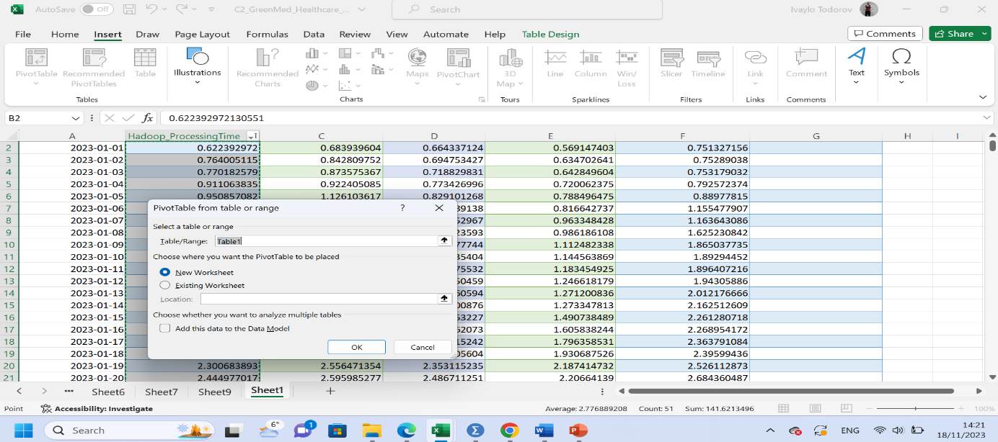

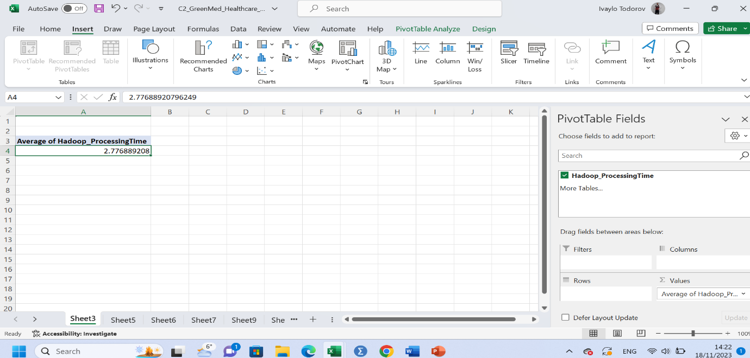
- What is the median processing time when using Spark?
According to Lydersen (2020), to determine the median of a number of series, the numbers must first be arranged in order from least to greatest. The median position is 50% of the set numbers. It is found by adding the number of numbers + 1 and dividing them by 2. If the numbers are an odd number (1,2,3,4,5,) the median is the middle number (3). If they are an even number (1,2,3,4,5,6) the median is 2 numbers (3 and 4) and the middle is found between them. (3+4/2= 7/2= 3.5) The median is equal to 3.5.
To calculate the result, use the function "Median (C25, C26)". The median processing time when using Spark is 2.730981216.

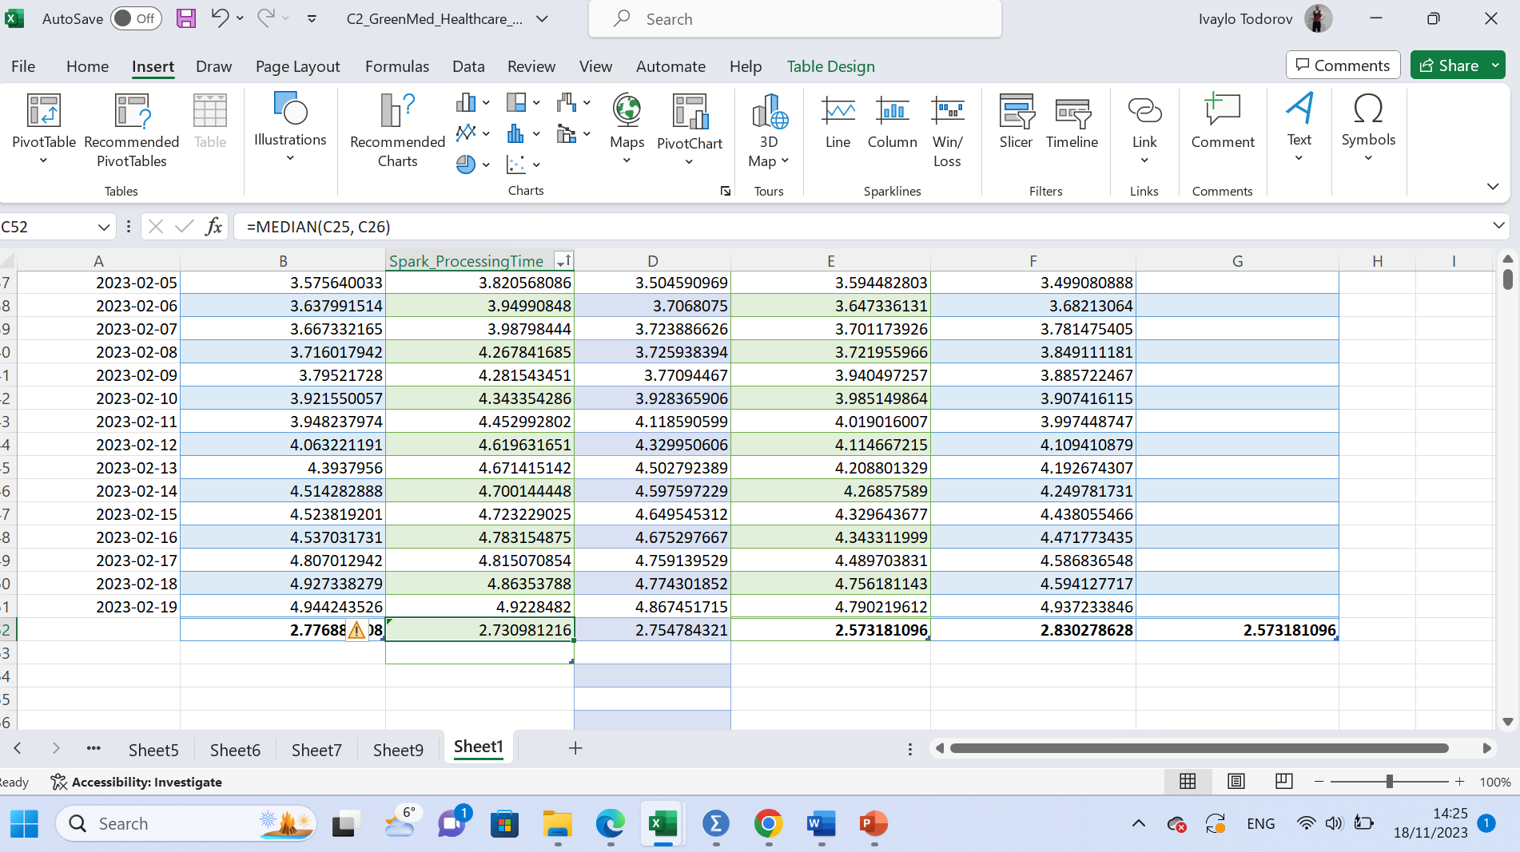
- On which date did R have the highest processing time?
To determine "On which date did R have the highest processing time" we must first order the data for the times from smallest to largest. Mark R_Processing_Time, insert, table, and create a table with this data. Then, Date and the "sort from smallest to largest" function.
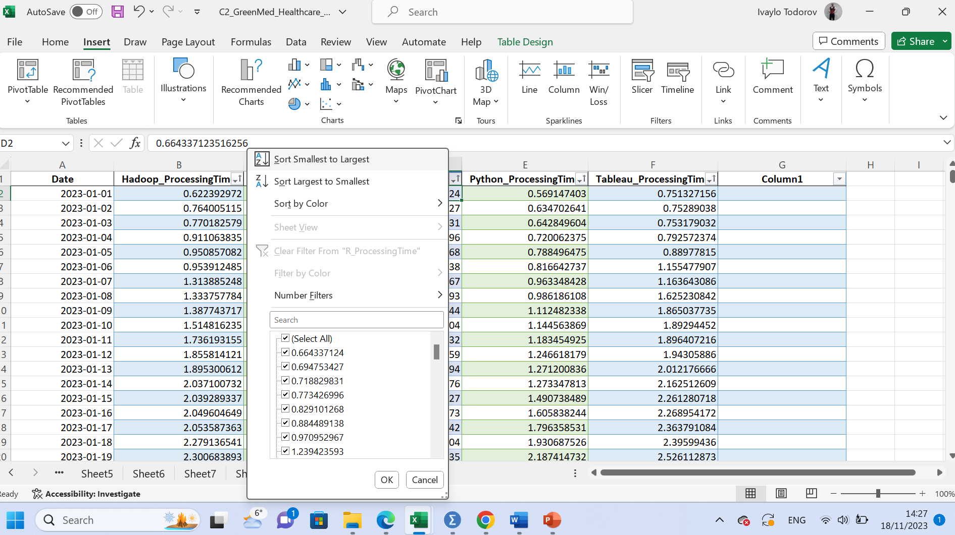

Another option is to create a pivot table. In the value column, select "Max of R_Processing_Time, insert". The result shows that the maximum is equal to 4.86745171509106.
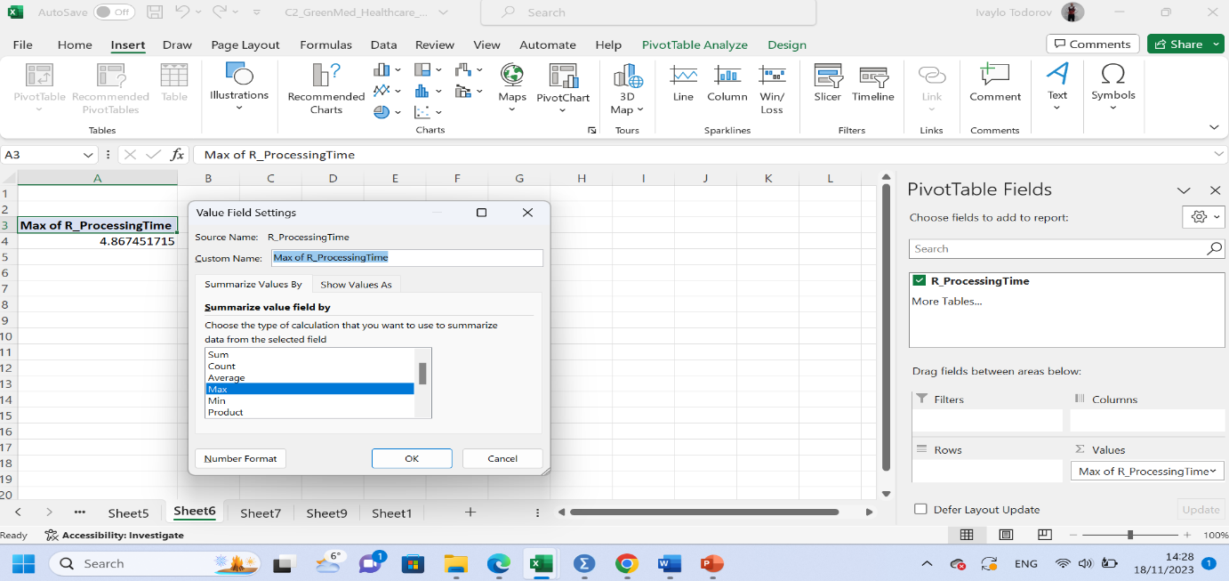
R has the highest processing time on 16/1/2023.

- What is the standard deviation for processing time when using Python?
According to Wachs (2009) the amount of variation in a measured process characteristic is described by the standard deviation. The standard deviation calculates how much a measurement should be expected to deviate from the mean. The Dispersion in the data is greater when the standard deviation is larger.

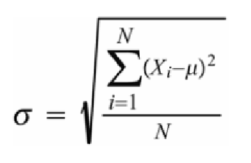
Formula 1. “Standard deviation”
“Essentially, the formula tells us to do the following:
1. Compute the process average µ
2. Subtract the process average from each measured data value (the Xi values)
3. Square each of the deviations computed in step 2.
4. Add up all the squared deviations computed in step 3.
5. Divide the result of step 4 by the sample size.
6. Finally, take the square root of the step 5 result” (Wachs, 2009)
To determine "What is the standard deviation for processing time when using Python" a pivot table is created. In the values column, select "StdDev of Python_Processing_Time". The result shows that the standard deviation for Python is 1.297205735.

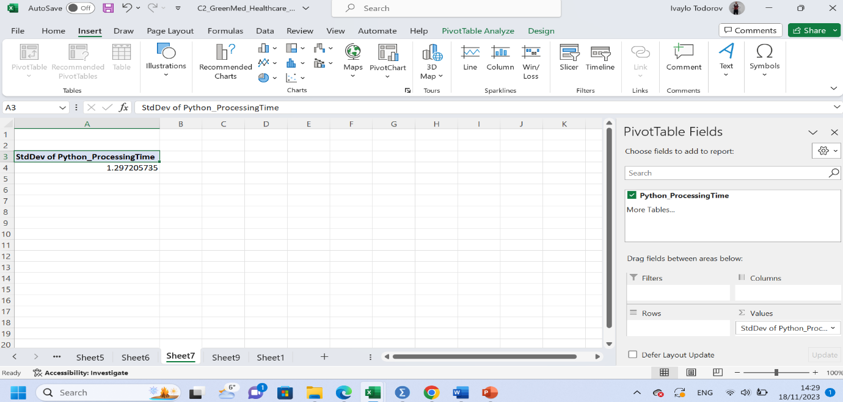

- Which tool or platform had the lowest average processing time across the dataset?
To find the average value of each indicator in the general table, mark each column with data separately and select from the menu "Formulas" -> Auto sum -> Average.
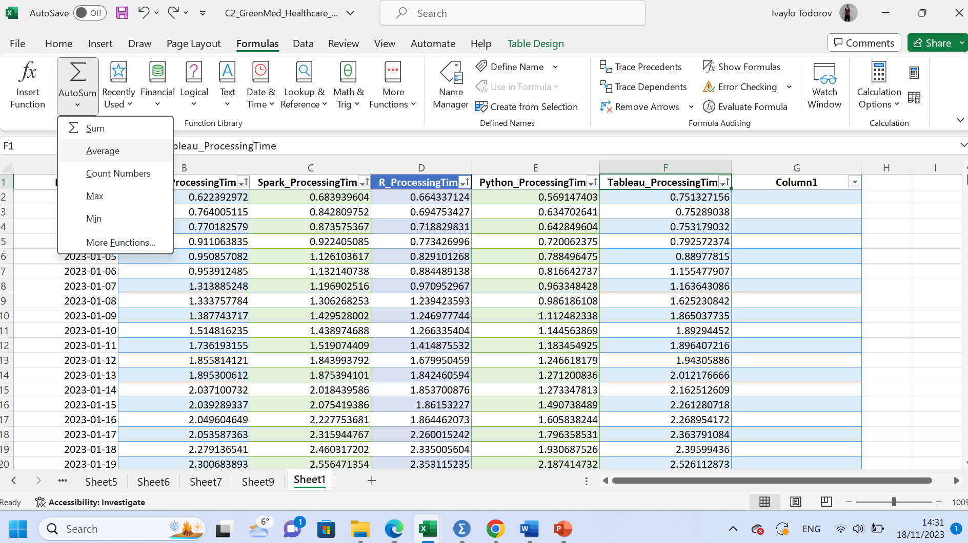

Then to find the lowest average processing time across the dataset the "Min" formula is used, which will show the lowest of the selected values.

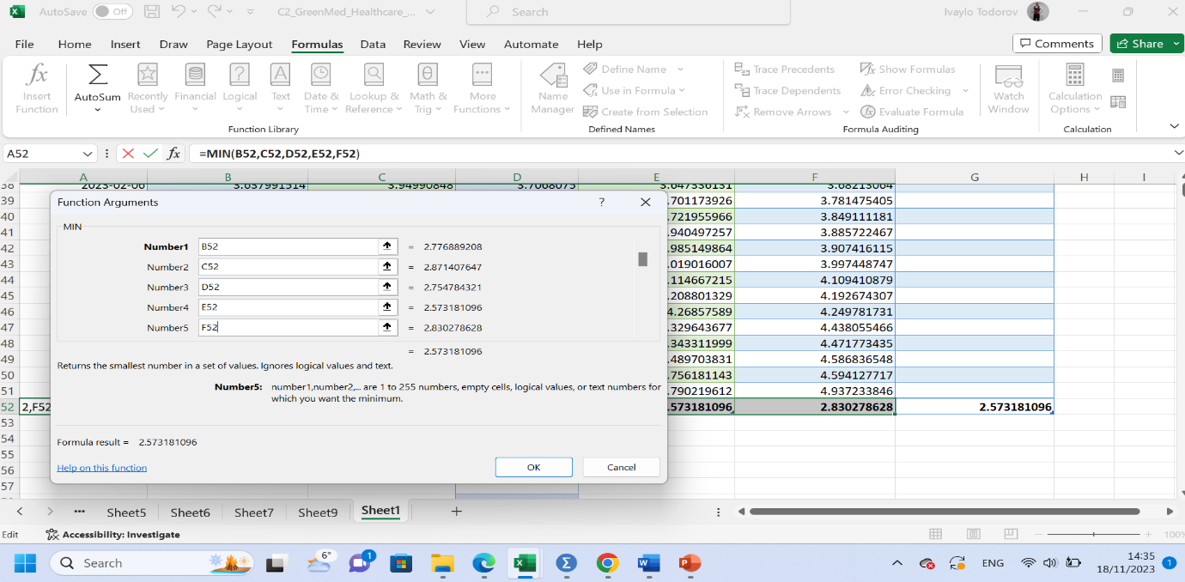

The result obtained shows that the lowest average value is on the Python platform - 2.573181096.

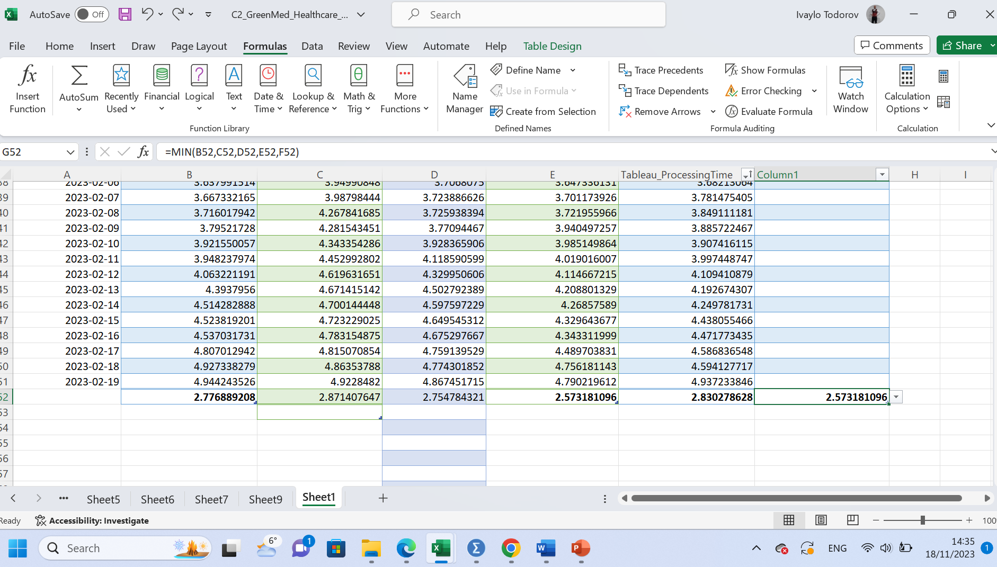

- Can you interpret the difference in processing times across different tools or platforms?
Using different Excel formulas, different values such as - fastest or slowest average time, fastest processing time, slowest processing time for each instrument can be determined or compared.
In point 5, the lowest average speed of processing time is calculated. The tool with the lowest time is the Python platform. Based on the same data, we can point to the platform with the highest average processing time, and that is Spark. Finding the minimum processing time (using the "MIN" formula) determines the platform with the slowest processing time. This is the Python platform with time- 0.569147403101106. The formula "MAX" (or sorting the values in ascending order) determines the highest processing time value for each platform. The platform with the highest processing time is Hadoop - 4.94424352555822. After collecting, structuring and summarizing data, the obtained results are presented for analysis. To make them understandable and readable, to improving the clarity, the values are presented in tables, charts, graphs, etc. “Charts help you visualize your data in a way that creates maximum impact on your audience.” (Microsoft, 2023) Charts can have a different shape and structure depending on the data they represent - pie, bar, line, column, etc.
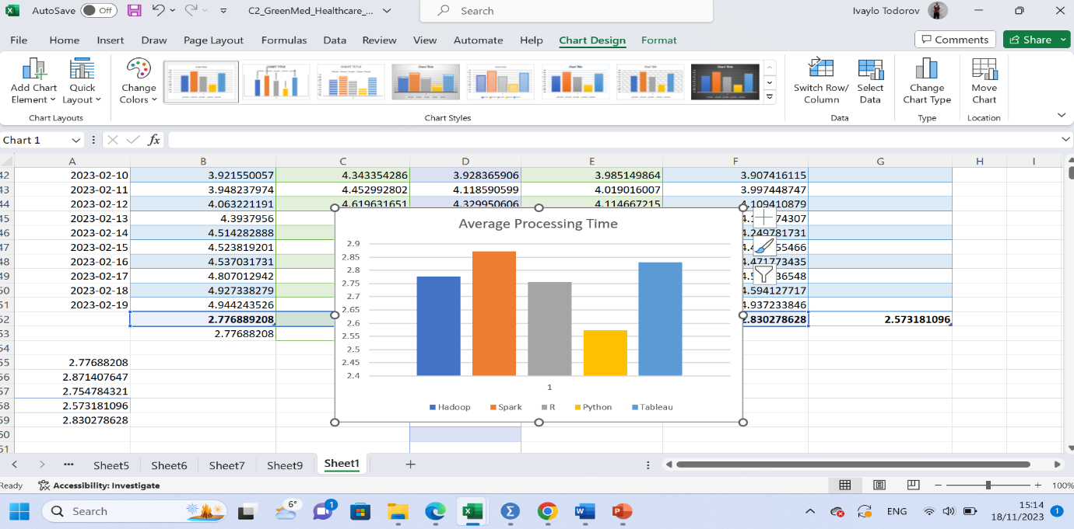

The "IF" function enables the output of a precisely defined result subject to compliance with certain conditions. Example: If processing time is greater than 2.5, show "tool name".

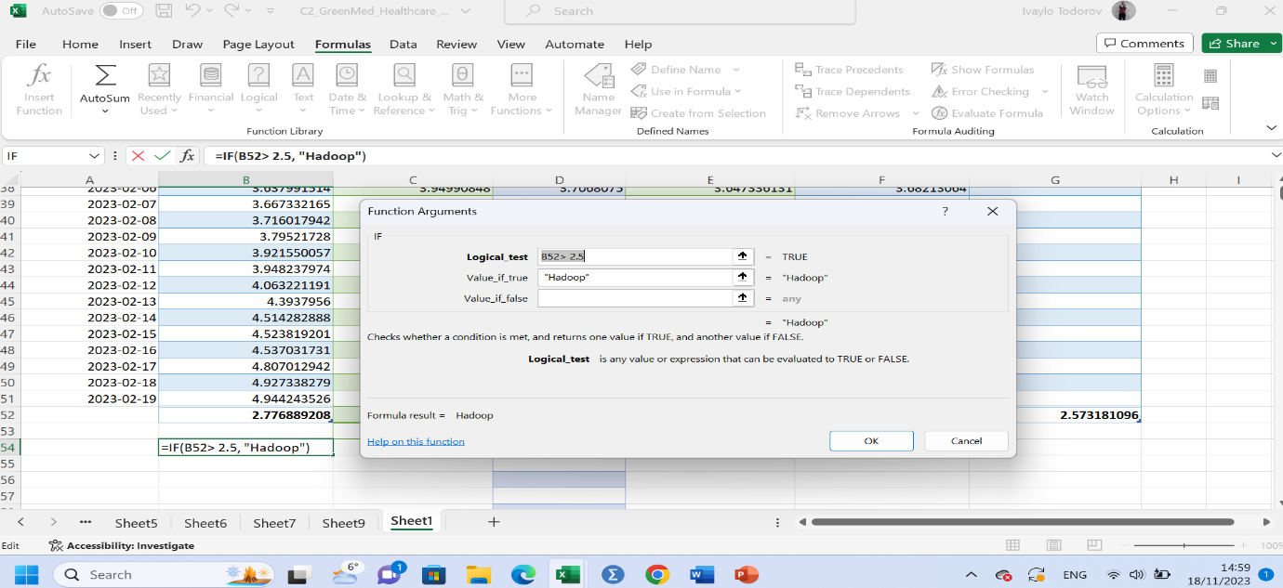
Different conditions can be set, only one condition, and an option for one and/or the other (IF (AND), IF (OR). Different options of the IF function return different results. The result may also have a reverse sign/wrong answer. (IF (XOR))
Apart from Excel, SPSS is another tool that is used for visual representation of quantitative data. One of the SPSS functions is a graphical representation of correlations of at least two or more cases (the result). According to Gogtay and Thatte (2017) The relationship between two or more quantitative variables is a definition used for the term correlation.
The assumption of a linear relationship between the data is the basis of correlation analysis. The analysis measures the strength and direction of the relationship between variables. The resulting result has a value between "1" and "-1". The result cannot exceed these values (for example, it cannot be "1.5" or "- 2"). A correlation obtained with a value of "0" indicates that there is no linear relationship between the two values. A obtained correlation with a value of "1" indicates that the variables are very strongly interrelated in a positive manner. Example - the more we run, the more energy we expend. A obtained correlation with a value of "-1" indicates that the variables are very strongly correlated in a negative manner. Example - the more time we spend watching TV/video games, the less time we spend outside the house.
The collected Hadoop and Tableau database will be used to calculate the correlation.
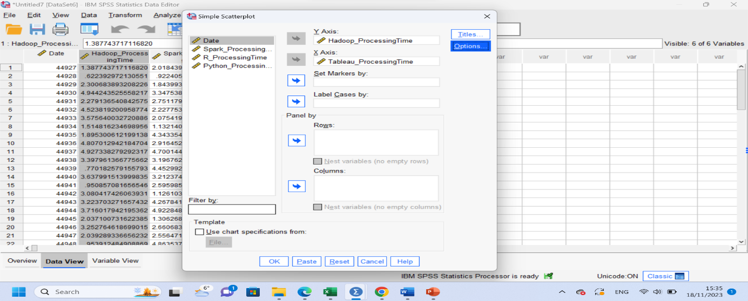
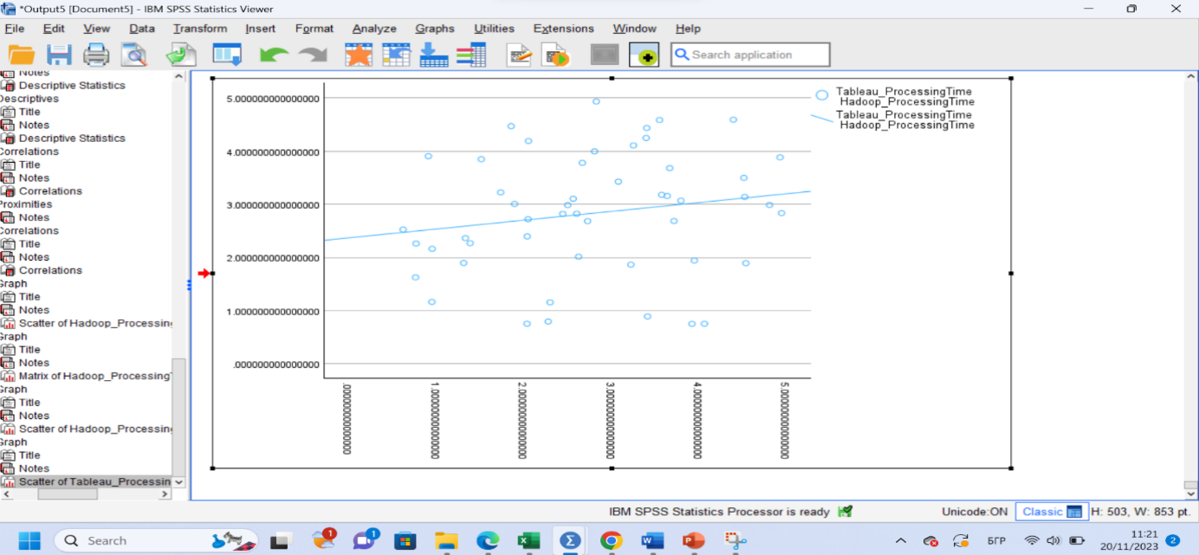

After the correlation analysis of the collected data for Hadoop and Tableau, the graph shows a weak correlation between the two tools in a positive manner. This is more visible in the placement of the line visualizing the correlation. The line has a small angle approaching "0". This means that the correlation is very weak. The conclusion based on the graph and calculations is that the time users spend working with Hadoop is not directly proportional to the time they spend working with Tableau. Another conclusion that can be made is that the two tools have different functions and different applications in different business areas that are not directly related.
In conclusion, after the analysis using Excel and SPSS of the fellow databases of Hadoop, Python, R, Tableau and Spark, it was found that the fastest average processing time is that of Python. However, depending on the volume and type of information collected about its patients, GreenMed Innovations must determine which platform/s it will work with to achieve faster and better results. This in turn will lead to better service and satisfaction of patient needs.

References
Databricks, 2023. What Is Hadoop?. [Online]
Available at: https://www.databricks.com/glossary/hadoop
[Accessed 3 11 2023].
Galetsia, P. K. K. &. K. S., 2020. Big data analytics in health sector: Theoretical framework, techniques and prospects. International Journal of Information Management, Volume 50, pp. 206-216.
Gogtay, N. a. T. U., 2017. Principles of Correlation Analysis. Journal of The Association of Physicians of India, Volume 65, pp. 78-81.
Hayslett, H. T., 1995. Statistics. Oxford: Simple Books.
Lydersen, S., 2020. Mean and standard deviation or median and quartiles?. [Online]
Available at: https://tidsskriftet.no/en/2020/06/medisin-og-tall/mean-and-standard-deviation-or-median-and-quartiles
[Accessed 13 11 2023].
Microsoft, 2023. Create a chart from start to finish. [Online]
Available at: https://support.microsoft.com/en-us/office/create-a-chart-from-start-to-finish-0baf399e-dd61-4e18-8a73-b3fd5d5680c2
[Accessed 23 11 2023].
Wachs, S., 2009. What Is a Standard Deviation and How Do I Compute It?. [Online]
Available at: https://www.integral-concepts.com/wp-content/media/What-is-a-Standard-Deviation-and-How-do-I-Compute-It.pdf
[Accessed 15 11 2023].

