INTRODUCTION
Data security is a multi-faceted concept involving technology, procedures, and human elements. Relying solely on technical solutions like passwords, biometrics, and firewalls is inadequate for countering information threats. A holistic approach, integrating various measures, is crucial for system security and data protection. This includes processes like user onboarding and offboarding, as well as human factors such as adherence to regulations, employee training, and setting an example in leadership. The evolution of information security is increasingly focusing on a governance-centric and people-centric approach. The emergence of IT governance highlights the intersection of business and IT management, driven by the 'information economy.' This convergence necessitates that leaders at all organizational levels comprehend the decision-making and oversight processes related to IT, especially in managing information security risks. Risk management has become a significant concern. Legislation and regulations related to information are becoming more critical for organizations. This includes data protection, privacy, breach norms, computer misuse, and investigatory powers regulations, presenting a complex array of often conflicting requirements that directors must navigate. The growing need for a comprehensive information security framework is evident, providing global context and coherence to compliance efforts. As the intellectual capital value of 'information economy' entities rises, their commercial success, profitability, and even stock value increasingly hinge on the security, confidentiality, and integrity of their information assets. The expansion and scale of the ‘information economy’ have spawned new global threats and vulnerabilities for networked organizations. The UK pioneered the first global standard for information security management, BS7799, which has now been integrated into the ISO/IEC 27000 series of international standards on information security. ISO/IEC 27001, a key standard in this series, has been updated to reflect the latest international best practices. Businesses are progressively requiring their suppliers to comply with these standards. Adherence to these standards allows company directors to adequately respond to the myriad challenges mentioned, assuring customers and regulatory and judicial authorities of their commitment to information security.
SURVEY OF SECURITY FRAMEWORKS
Understanding information security behavior can be likened to the way we secure our homes. Imagine a homeowner who burglar-proofs all the windows but leaves the front door unlocked when they leave. This action renders the security measures ineffective due to the homeowner's behavior. Similarly, organizations may implement security controls like anti-virus software, firewalls, and passwords. However, these measures become pointless if employees share passwords or use dial-up connections that bypass the firewall. The conduct of employees must be guided and supervised to ensure they follow security protocols. Management is responsible for establishing and communicating clear security guidelines—also known as components (as discussed in sources like Tudor, 2000; ISO 17799, 2005)—before expecting employees to adhere to a strong information security culture. Researchers and organizations have outlined these components and strategies for their implementation (ISO 17799, 2005; Tudor, 2000; McCarthy & Campbell, 2001; Teufel, 2003). Information security components are the foundational principles necessary for establishing and upholding information security, including policies, risk assessments, technical controls, and awareness of security. These elements are part of an information security governance framework, which shows how these components interact. This framework helps organizations understand what is needed for a comprehensive information security strategy. It integrates technical, procedural, and people-focused components to foster an appropriate level of security awareness and reduce risks to information assets.
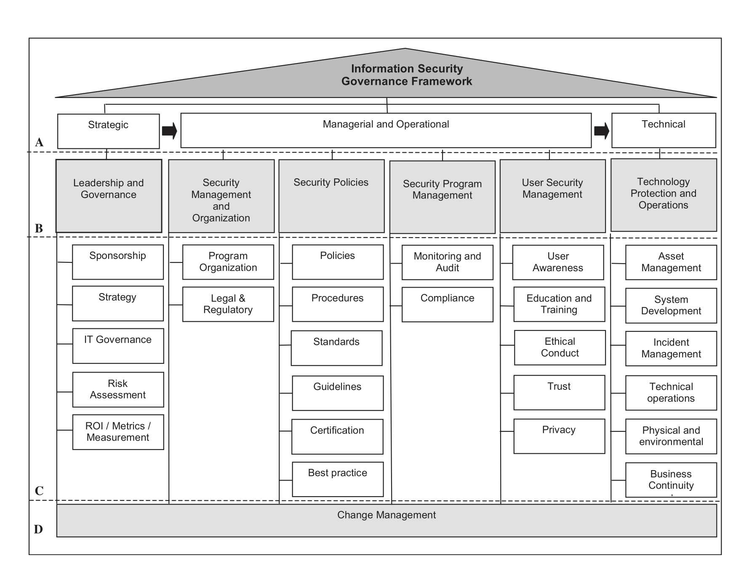
Figure 1. Information Security Governance framework.
A Fresh Perspective on Information Security Governance Framework: Implementing the Capability Maturity Model.The Capability Maturity Model, as conceptualized by McCarthy & Campbell in 2001, offers a comprehensive suite of security controls designed to safeguard information assets from unauthorized access, alteration, or destruction. This model adopts a holistic approach to information security, integrating seven primary control levels, which are detailed in Table 1.
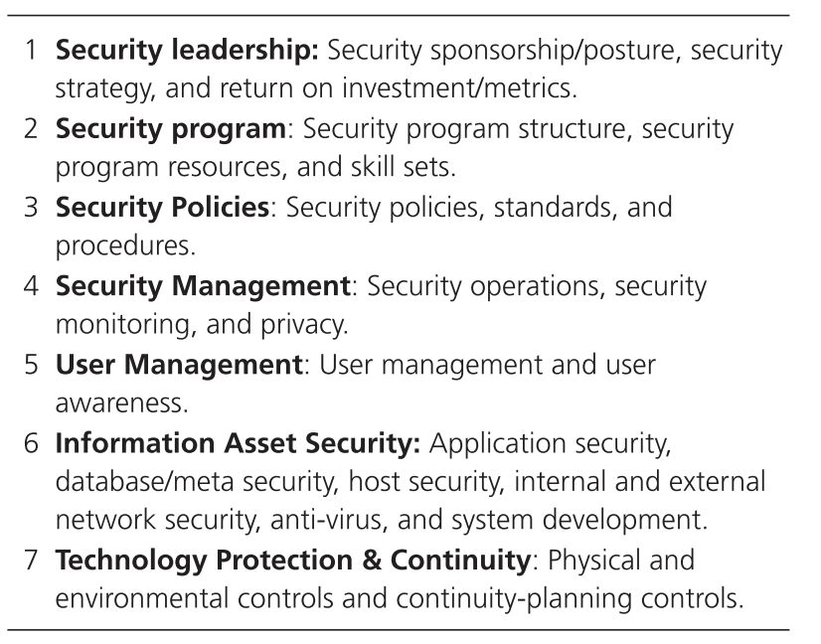
Table 1. Controls Levels of the Capability Maturity Model
The initial stage of the Information Security Governance framework emphasizes the crucial role of leadership in security, highlighting the need for an executive-level security representative and a comprehensive information security strategy. This sets the foundation for implementing both long-term and short-term security strategies within an organization. Following this, a well-defined security program should be established, outlining specific roles and responsibilities related to information security. This includes positions like information security officers, network specialists, anti-virus experts, database specialists, and Helpdesk staff.
The third tier involves crafting security policies, standards, and guidelines to guide information security implementation, addressing technical, procedural, and human elements of security. These form the basis for integrating security management into daily operations, including monitoring both users and technology. The next step ensures user awareness of these policies and effective management of user profiles. Finally, the framework focuses on safeguarding information assets, incorporating technological aspects like secure firewalls, networks, and databases. The last layer is technology protection, which covers not only IT infrastructure and continuity but also encompasses business continuity and disaster recovery.
The Capability Maturity Model's goal is to begin at a strategic level and progress down to technological aspects, following the guidance from strategic levels. It's used to evaluate current security capabilities and risks, and to design solutions for risk mitigation. These solutions, along with monitoring capabilities, are then integrated into existing processes.
In light of economic constraints, minimal investment options are explored. Educating employees about potential threats and careful information handling is a feasible, low-cost measure. This approach enhances security, allowing funds to be allocated to developing a robust security system rather than rectifying data loss consequences. Additionally, certification, particularly the ISO 27000 series standards, is suggested for effective information security and risk management. While 60% of organizations adhere to these standards, 40% do not. The ISO 27000 series offers flexibility in setting security levels, not mandating certification. Only 15% of organizations have obtained the ISO 27001 certification, indicating a gap in awareness and adoption, especially considering the severity of modern information threats.
Various security models, both 'hard' (mathematical) and 'soft' (quality-based), assist in creating solution architectures. However, due to the potential for false reliability and the need for comprehensive understanding in hard models, soft security and privacy models are often more effective. Solution architecture development requires a threat model, understanding common attack vectors, and a balance between hard and soft modeling approaches.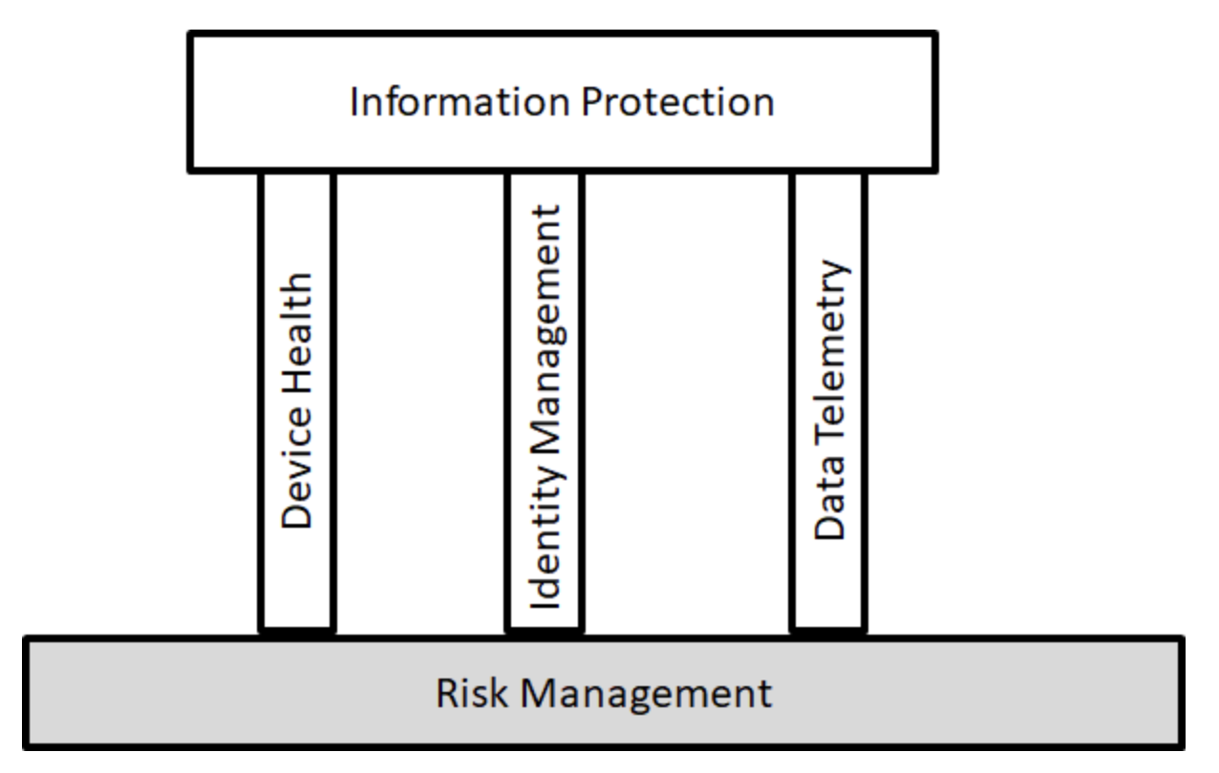
Figure 2.Risk Management
ATT&CK
The MITRE ATT&CK framework is a comprehensive knowledge base that includes information about cyber adversary tactics and techniques observed in the wild. This curated database is used by cybersecurity professionals to understand and better prepare against cyber threats. ATT&CK stands for Adversarial Tactics, Techniques, and Common Knowledge, emphasizing its focus on the entire lifecycle of a cyber attack.
Developed by the MITRE Corporation, a not-for-profit organization that provides engineering and technical guidance to the federal government, the ATT&CK framework was initially created for a research project in 2013 and released to the public in 2015. Since then, it has been widely adopted by security teams across various sectors for enhancing their defenses against cyber threats.
The framework is structured in matrices that cover different environments, such as enterprise IT, mobile, and industrial control systems (ICS). For example, the ATT&CK for Enterprise matrix catalogs tactics and techniques used against Windows, macOS, Linux, and cloud environments.
Tactics in the ATT&CK framework represent the objectives that an adversary may want to achieve, such as gaining initial access, executing code, or exfiltrating data. Techniques are the specific methods used to accomplish these tactics, and they often come with detailed descriptions, mitigation strategies, and examples of real-world usage.
Cybersecurity teams use the ATT&CK framework for various purposes, including:
Developing threat intelligence and analytics.Enhancing detection capabilities by understanding the behaviors of adversaries.Adversary emulation and red teaming to test defenses.Assessing and improving the organization's security posture.
Compared to other models like the Cyber Kill Chain, the ATT&CK framework provides a more granular and comprehensive view of an adversary's actions from both the attacker and defender perspectives. This approach allows security teams to better classify attacks, evaluate their defenses, and communicate about threats using a common language.For those looking to implement or work with the ATT&CK framework, MITRE provides resources like introductory blog posts, eBooks, and even tools like the ATT&CK Navigator to visualize and work with the matrix. There are also community contributions and presentations available that showcase practical applications of the framework.In essence, the ATT&CK framework is a living document that continues to evolve with contributions from the cybersecurity community, making it an invaluable resource for staying ahead of cyber threats.
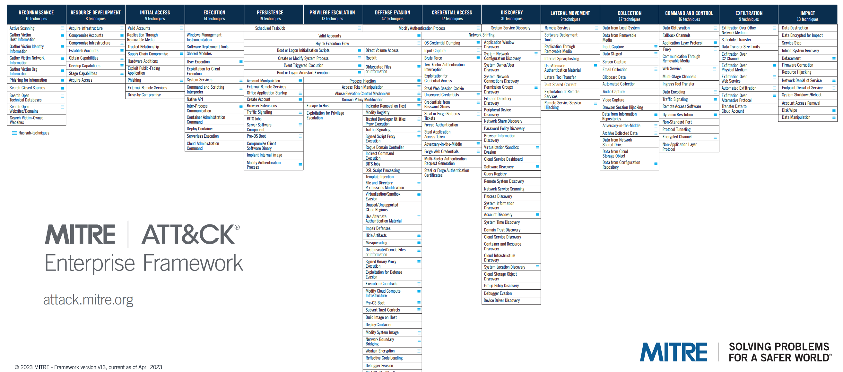
Figure 3.ATT&CK Enterprise Framework
Jericho Security Model
The Jericho™ Security architecture framework is founded on a set of core principles. Employing the Jericho model for security offers several benefits:A security architecture constructed based on the Jericho conceptual framework emphasizes adaptability while prioritizing the protection of key security assets vital to stakeholders.It facilitates the creation of secure processes in collaboration with other businesses and trusted partners.The model streamlines the utilization of public networks and cloud-based solutions.It is designed with a focus on leveraging open principles and utilizing open-source solution components.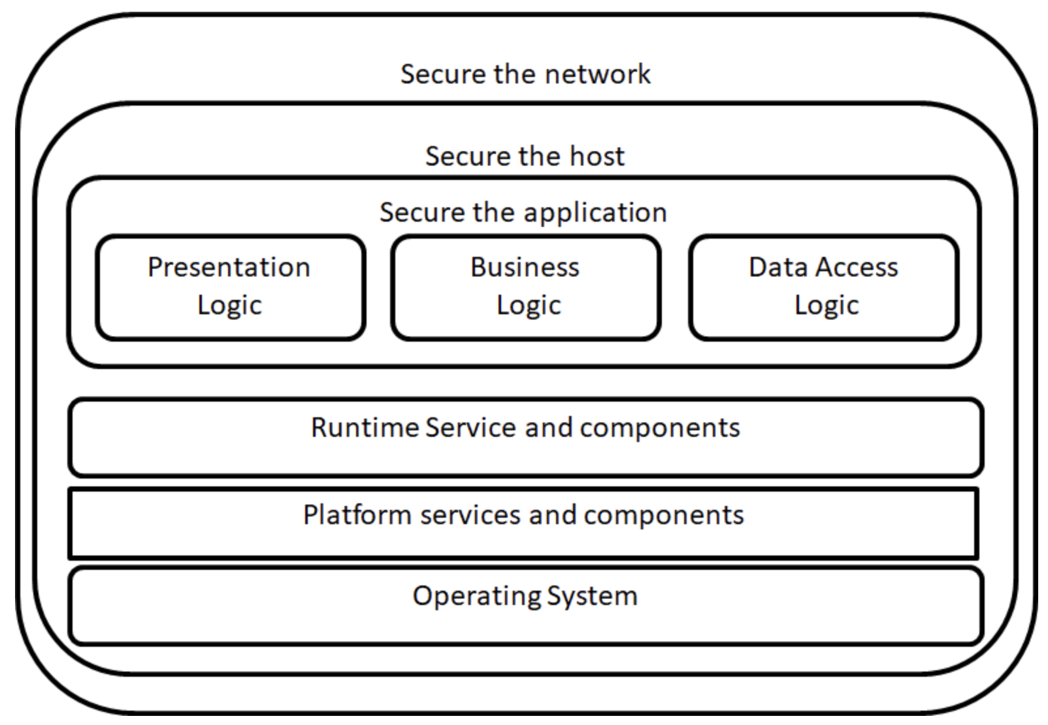
Figure 4.Jericho Security Model
Unfortunately,the Jericho framework, while often perceived as an open security framework, is actually under copyright by The Open Group (refer to the references chapter for detailed information about this model). It involves trademarks, and all related publications are copyrighted. Nonetheless, thanks to the efforts of numerous contributors, the knowledge developed within the Jericho working group remains accessible. The Jericho Forum®, a part of The Open Group, was established in January 2004 and has since ceased activity. Despite this, the forum's approach to security continues to be relevant and influential in the field.
NIST Cloud Computing Security
The National Institute of Standards and Technology (NIST) provides detailed guidance on securing cloud-based operations for organizations. These guidelines encompass various elements of cloud security, such as access management, challenges in security and privacy, and tailored advice for public cloud computing.
NIST's Special Publication (SP) 800-210 offers broad guidance on access control in cloud systems, focusing on the unique security challenges within the three primary cloud service models: Infrastructure as a Service (IaaS), Platform as a Service (PaaS), and Software as a Service (SaaS). This document underscores the need to comprehend cloud computing's inherent features that impact access control designs, including extensive network access, shared resources, swift scalability, measurable services, and data sharing practices. It also presents specific guidelines for designing access controls in IaaS, PaaS, and SaaS, highlighting their distinct attributes and furnishing recommendations for various cloud systems to support future implementations.
Additionally, NIST SP 800-144 specifically addresses security and privacy in public cloud computing. Acknowledging the evolving nature of cloud computing, characterized by scalable on-demand resources, this publication details the relevant security and privacy challenges and considerations necessary for organizations when using public cloud services.
A key point in SP 800-144 is the insistence that responsibility for security and privacy in cloud environments cannot be entirely transferred to the cloud provider; it remains an essential duty of the client organization. Essential advice includes thorough planning of security and privacy measures in cloud solutions, understanding the public cloud environment provided, ensuring that cloud solutions meet the organization's security and privacy standards, and retaining responsibility for the security and privacy of data and applications in cloud setups.
These NIST guidelines aim to support system managers, executives, information officers, security experts, IT program managers, system and network administrators, and users of public cloud services in making well-informed decisions about adopting cloud technology and sustaining strong security and privacy measures.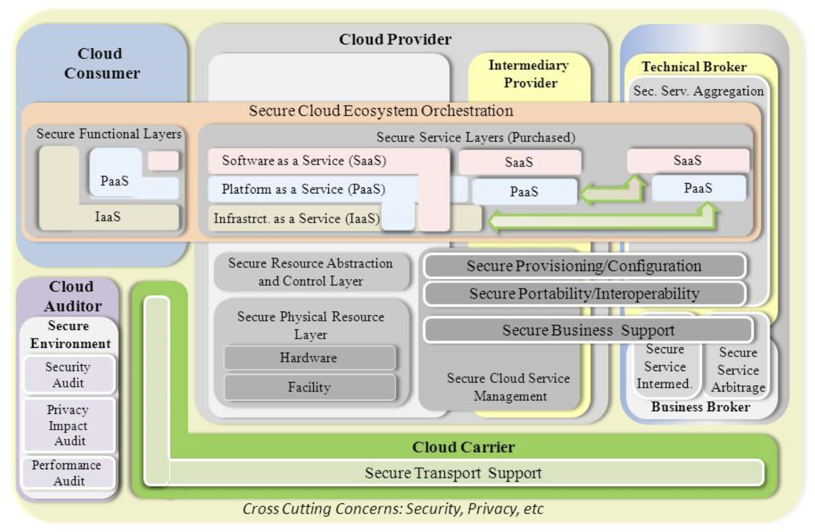
Figure 4.NIST Cloud Computing Security Reference Architecture
OpenTitan Security Model
OpenTitan represents an open-source initiative dedicated to creating a clear, superior reference design and integration guidance for silicon-based root of trust (RoT) chips. The project aims to enhance the transparency, reliability, and security of the silicon RoT for various stakeholders including enterprises, platform providers, and chip manufacturers. Managed by lowRISC CIC, OpenTitan fosters collaboration to develop high-quality, open intellectual property that can be implemented as a comprehensive, feature-rich product.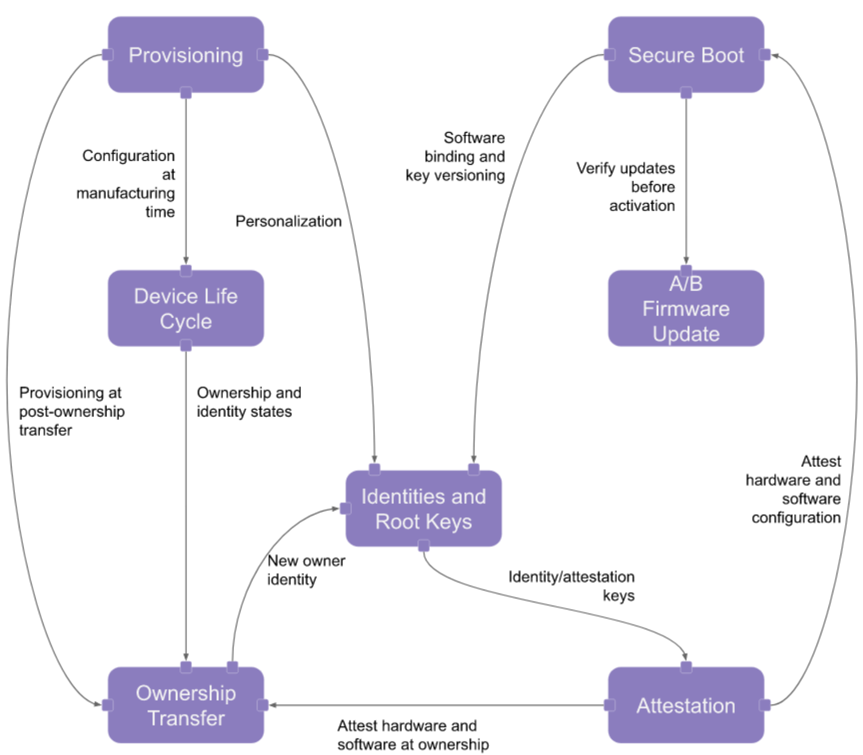
Figure 5.OpenTitan Security Model
The surge in electronic medical records (EMR) use has led to a parallel increase in data produced by the healthcare sector, often referred to as "Big Data." This data is predominantly unstructured and requires specialized big data analytics methods for processing and extracting meaningful information. With the shift towards electronic patient information in hospitals and other healthcare facilities, the need for Big Data technologies to effectively manage and interpret this data is more critical than ever. Additionally, this data is typically sensitive and demands a highly secure handling environment. However, implementing current security algorithms is challenging due to the significant time and resources required. Existing security protocols in Big Data are insufficient in safeguarding sensitive healthcare information, leading to data that is both diverse and insecure.To address this, we introduce the Secure Pattern-Based Data Sensitivity Framework (PBDSF). This framework employs machine learning techniques to identify common attributes of patient data, data frequency, and various coding patterns used in specifying particular conditions, thereby ensuring the security of sensitive information. PBDSF utilizes the Hadoop ecosystem and is founded on the Hadoop Distributed File System (HDFS). This forms the basis for our machine clusters that process Big Data. Key functions of this framework include pinpointing sensitive information within vast data sets and encrypting data deemed sensitive.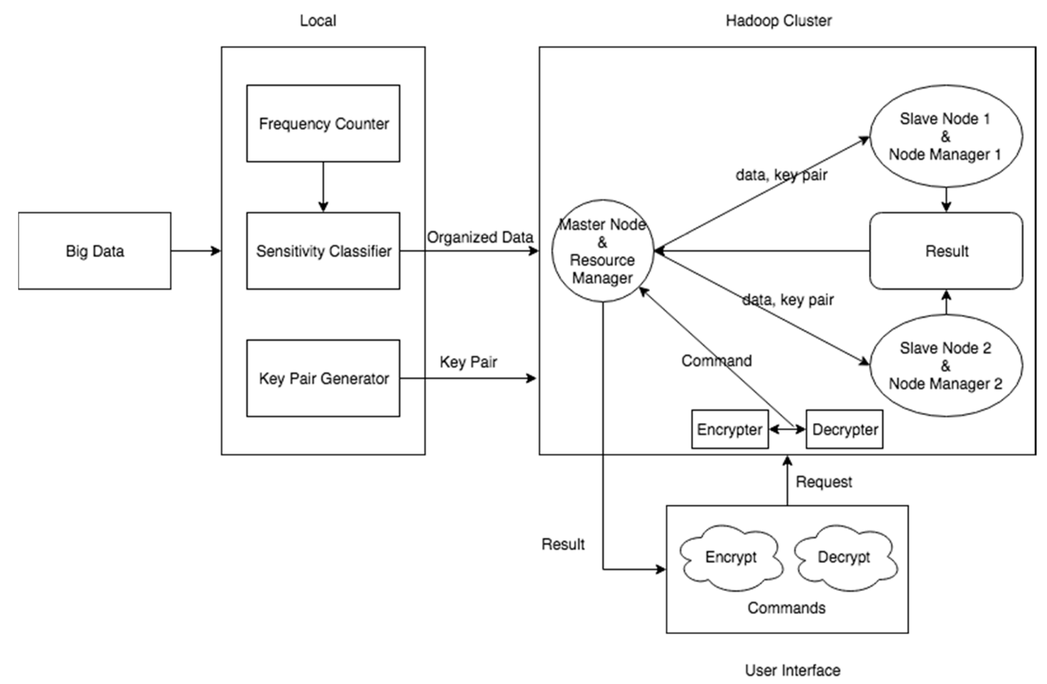
Figure 6.Secure Pattern-Based Data Sensitivity Framework
Author[8] We have developed a Secure Pattern-Based Sensitivity Framework tailored for handling Big Data in the healthcare sector. This innovative framework diverges from traditional methods of data classification. Instead, it leverages the specific semantics present in Electronic Medical Records (EMRs) to determine the sensitivity level of data, considering the frequency of its occurrence. To secure the large volumes of data, we chose Elliptic Curve Cryptography (ECC) due to its smaller key sizes, which offer enhanced security levels compared to RSA. ECC also has a quicker response time because it demands less processing power and memory, making it a highly effective solution for securing Big Data. Additionally, our framework is fully automated, streamlining the process from data request to data access.
Looking ahead, we plan to incorporate privacy-preserving techniques into the framework. This enhancement will facilitate secure data sharing across healthcare industries, further expanding the framework's capabilities and applications.
Health Care Data and Cloud
Big Data applications in healthcare encompass a range of critical functions[1][2]:
Epidemic Prevention: Big Data played a pivotal role in halting the Ebola virus spread in Africa by tracking population movements. This data helped determine optimal locations for treatment centers and informed decisions on movement restrictions.
Enhancing Quality of Life: Today's smartphones, apps, and health gadgets collect health data, offering insights to improve quality of life and prompt medical intervention when necessary. By uploading and integrating this data with existing datasets, it's possible to foresee health issues and suggest lifestyle changes for better health.
Optimizing Clinical Trials: Analyzing extensive data on potential participants can pinpoint the most suitable candidates for clinical trials, enhancing their effectiveness.
Preventing Avoidable Deaths: Ongoing monitoring of medical conditions allows for early warning signs, enabling preventive measures. By comparing patient data with existing datasets, potential risks can be identified early.
Detecting Drug Side Effects: Long-term patient data can reveal noticeable side effects of medications, providing valuable insights for healthcare providers.
Assessing Disease Risks from DNA: Analyzing family health histories and DNA can indicate potential medical conditions a patient may face.
As technology integration and data collection in healthcare continue to grow, so does the volume of available data. This expanding dataset offers immense opportunities for research and analysis. Utilizing predictive analytics and Business Intelligence (BI), these large datasets can generate targeted knowledge, enabling informed decisions in healthcare. This not only has the potential to save lives but can also make treatments more cost-effective and enhance operational efficiency in the healthcare sector.
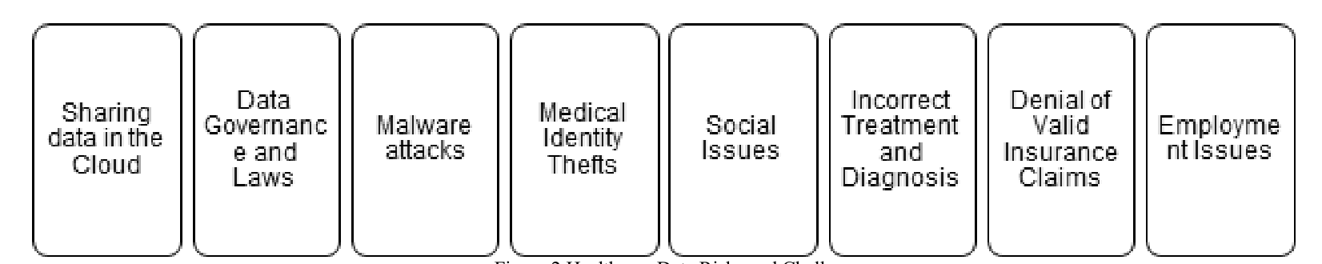
Figure 7. Healthcare Data Risks and Challenges
Today's Big Data environments in healthcare encounter various challenges[4]:
Data Sharing and Cloud Technologies: Healthcare data from different sources can be amalgamated in the cloud for insights into treatments and diagnoses. However, sharing data through cloud environments raises security concerns, especially in contexts lacking robust healthcare security practices.
HIPAA Compliance and Data Safety: Healthcare data centers are mandated to comply with HIPAA certification, which ensures the presence of security policies and procedures but does not dictate specific data safety implementations. The influx of data from multiple sources also imposes additional demands for storage, processing power, and high-speed networking.
Security Threats: The healthcare industry is increasingly targeted by attacks such as Distributed Denial of Service (DDoS), malware, and Medical Identity Theft, both from internal and external sources. The privacy of healthcare data in Electronic Health Records (EHRs) or Personal Health Records (PHRs) is crucial. The risks associated with data exposure and individual identification include[5][6][7]:
Medical Identity Theft: This involves the unauthorized use of an individual's personal information for financial gain and is a prevalent privacy breach in healthcare.
Social Implications: Disclosure of health conditions can lead to undesirable social consequences.
Insurance Fraud: Stolen identities can be used to fabricate medical bills and file fraudulent insurance claims.
Erroneous Treatment: Alteration of medical data can result in incorrect patient treatment.
Misdiagnosis: Inaccurate medical information can lead to wrong diagnoses or inappropriate treatment plans, endangering patient health.
Health Insurance Issues: Fraudulent claims can deplete health insurance benefits, leaving patients unable to claim further insurance.
Design for NatureGarden Data Security Management
Other standard encryption methods were found to be less efficient, thus, couldn’t outperform the FHE solution as a result. In comparison to the AES, RSA, and RC6 algorithms, the FHE took less time during the encryption process. Moreover, the FHE technique took less time than other methods when it comes to data decrypting. Thus, the FHE took less time than other
To address the information system security, governance, and compliance needs of NatureGarden (NG), a comprehensive approach that encompasses several key areas is required. Here is a strategic framework that can be used to guide the development of a robust security posture for NG:Develop a comprehensive information security policy that addresses the use of personal devices (BYOD), wireless network security, online and social media presence, data protection, and intellectual property rights.Establish a governance structure that includes roles such as a Chief Information Security Officer (CISO) and Information Security Governance Committee to oversee policy implementation and compliance.
Conduct a thorough risk assessment to identify threats to the wireless network, BYOD vulnerabilities, online threats, and risks to intellectual property.Develop a risk mitigation plan that includes security controls, response strategies, and continuous monitoring.Implement a secure wireless architecture with strong encryption, secure access points, and network access control (NAC) to manage device connectivity.Establish security requirements for personal devices accessing the network, such as mandatory use of anti-virus software, encryption, and secure configuration settings.Utilize data loss prevention (DLP) technologies to safeguard sensitive data and encryption for data at rest and in transit.Deploy multi-factor authentication (MFA) for accessing the company’s network and resources.Implement the principle of least privilege and role-based access control (RBAC) to ensure users have access only to the resources necessary for their roles.
As technology advances, new vulnerabilities and data protection challenges arise. Regularly updated standards can address emerging risks associated with new technologies like cloud computing, IoT devices, and artificial intelligence.The threat landscape is dynamic, with cybercriminals continuously developing new tactics. Updated regulations can mandate the adoption of the latest security measures to protect against such evolving threats. With more personal data being collected by companies, there's a higher risk of data breaches. Updated regulations can enforce stricter data protection measures, thereby safeguarding consumer information.Standards like ISO/IEC 27001 are benchmarks for best practices in information security. When these standards are updated, organizations must follow suit to remain compliant, thus ensuring they are implementing recognized best practices.In a globally connected economy, data often crosses international borders. Updated regulations can help harmonize data protection laws across different jurisdictions, facilitating international business and data transfers.Society's understanding of privacy rights is continuously developing. New regulations can reflect current ethical and legal expectations regarding personal data, privacy, and consent.
Reference
[1] J. D. Halamka, “Using Big Data to Make Wiser Medical Decisions,” Harvard Business Review, 2015. [Online].Available: https://hbr.org/2015/12/using-big-data-to-make-wiser-medical-decisions.
[2] B. Marr, “How Big Data Is Changing Healthcare,” Forbes,2015. [Online]. Available: http://onforb.es/1bfRQ0b.
[3] L. Griebel, H.-U. Prokosch, F. Köpcke, D. Toddenroth, J.Christoph, I. Leb, I. Engel, and M. Sedlmayr, “A scoping review of cloud computing in healthcare.,” BMC medical informatics and decision making, vol. 15, p. 17, 2015.
[4] H. Kupwade Patil and R. Seshadri, “Big Data Security and Privacy Issues in Healthcare,” in 2014 IEEE International Congress on Big Data, 2014, pp. 762–765.
[5] W. C. Figg and H. J. Kam, “Medical Information Security,”International Journal of Security, vol. 5, no. 1, pp. 22–34, 2011.
[6] E. Srimathi and K. A. Apoorva, “Preserving Identity Privacy of Healthcare Records in Big Data Publishing Using Dynamic MR,” International Journal of Advanced Research in ComputerScience and Software Engineering, vol. 5, no. 4, pp. 968–973,2015.
[7] W. Gillette and T. B. Patrick, “Medical identity theft: an emerging problem for informatics.,” AMIA Annual Symposium proceedings AMIA Symposium AMIA Symposium, p. 964,2007.
[8] Yiu Chung Yau and Praveen Khethavath, “Secure Pattern-Based Data Sensitivity Framework for Big Data in Healthcare,” 978-1-7281-0886-5/19 ©2019 IEEE BCD 2019, May 29-31, 2019, Honolulu, Hawaii

