The deformation of a copper pellet hitting a steel plate

By Thomas Appleby (2217664)

Introduction

The most common form of pellet used for pest control is a lead pellet, this is because it has the best stability during flight due to its greater weight to size ratio meaning you can have smaller pellets that are just as effective. With the government looking to pass a law in 2023 banning the use of lead rounds in the use of shotguns and air-rifles with an 18 month phase out period, people are already starting to look at alternatives to lead, one of the most promising new materials that is looking to be used is copper.

The reason for the government's ban of lead based ammunition is due to its toxicity and its damage to the environment. Copper isn’t a toxic substance so it would be a more sustainable ammunition. The ecological benefits is the main reason that manufactures are looking into the metal. Copper is already being used for grouse as they tend to live in wetlands and boggy environments, and as of the 25th February 2021 is illegal to use lead in wetlands[1] hence the change.

The reason I chose to use a steel plate as the target material is due to it being a commonly used material for targets on a range. Another reason that I used steel as opposed to skin is that flesh is very difficult to model using a johnson cook method. Steel also makes sense because people can get sensitive to the connotations of a model if flesh is involved.

Table of contents

Introduction | 1
Method | 3
Results | 4
Reflection | 9
References | 10

Table of Figures

Figure 1 | 4
Figure 2 | 5
Figure 3 | 5
Figure 4 | 6
Figure 5 | 6
Figure 6 | 7
Figure 7 | 7
Figure 8 | 8
Figure 9 | 8
Figure 10 | 9
Figure 11 | 9

Method

I started off by trying to find the johnson cook values for copper. The Johnson-Cook model is a way of showing the plasticity of a material using the hardening behavior and the strain rate dependance of the yield of stress. I used the website MatWeb to find an array of required values such as density and tensile stress[2]. The rest of the data required I used scientific papers to see what values they used when modeling with copper. I used the same methods to find the information I needed about the steel using MatWeb to get the vast majority of the data required and the rest from various scientific papers.

Once I had inputted all of the johnson cook values of the materials I made a circular plate of steel to act as a target, this was fairly simple in terms of setting up then I placed nodes on the target to make the center where I would be hitting the plate with a pellet, a lot finer so that I would get a better model when it runs.

The modeling of the pellet was slightly more difficult as I had to produce a mushroom like shape with a hollowed out center. Getting the shape I wanted was harder than I thought as its difficult to judge how a fully formed 3D shape will look when you are drawing half in 2D then making 3D. I made several practice models of the pellet before I was satisfied that it looked right. Then once it was 3D I simply put a standard mesh on it and left it as is because it doesn’t need different densities of mesh in different parts of the pellet.

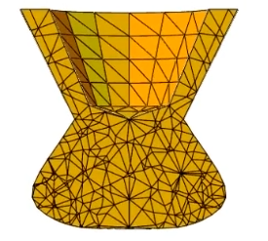
Figure 1

Results

On my first test the run didn’t go as planned as the pellet bounced off the steel plate. I looked into what could have been caused at the speed the pellet was traveling at there should have been some deformation. After doing some digging I discovered that some of the values I had for copper were wrong making it impossible for it to deform in the correct way.
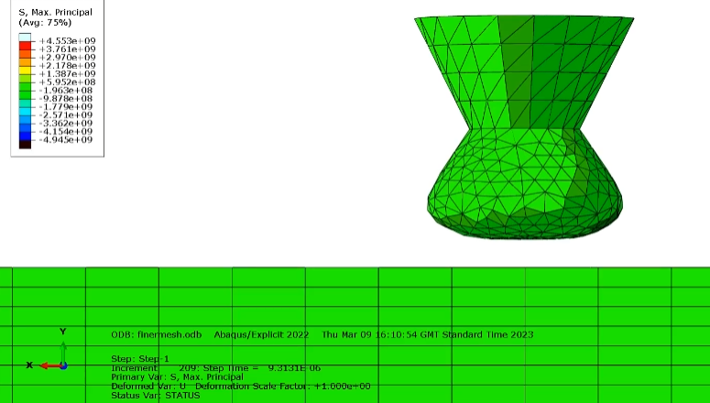
Figure 2
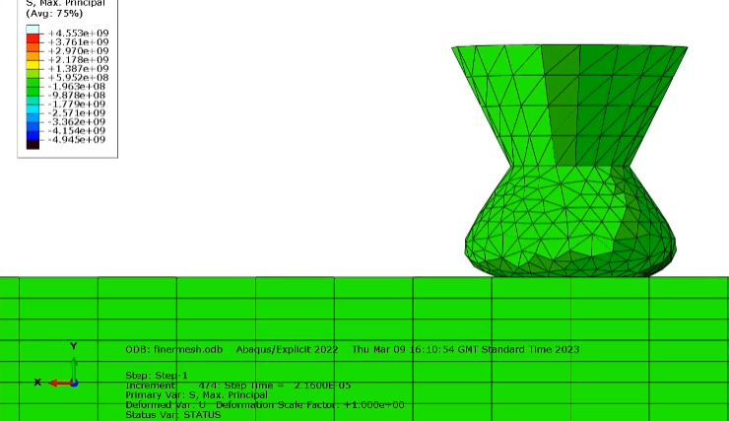
Figure 3
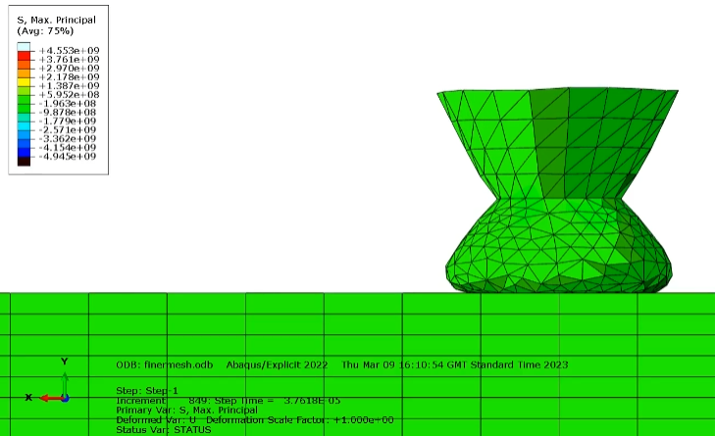
Figure 4
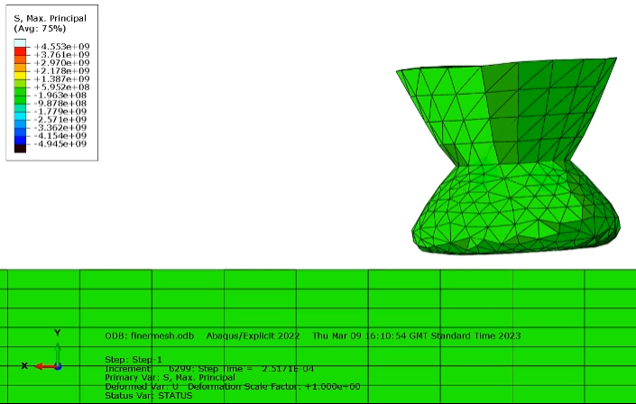
Figure 5
As you can see there was some slight deformation on the copper but it was much harder than it should have been.

Once I had sorted the issue I re-ran the test and got the results I had been looking for the first time. It clearly showed the deformation and was closer to what you would expect if you were to undertake this study in real life.
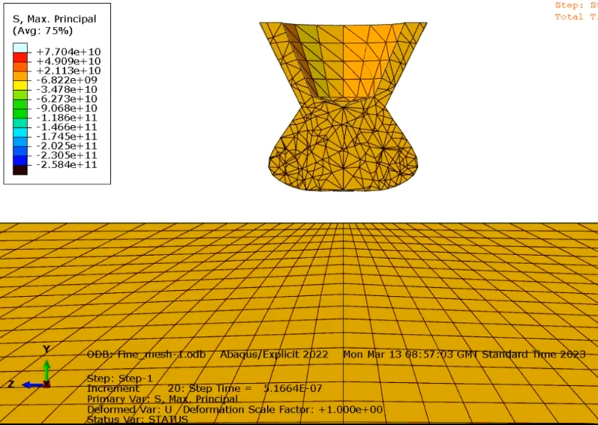
Figure 6
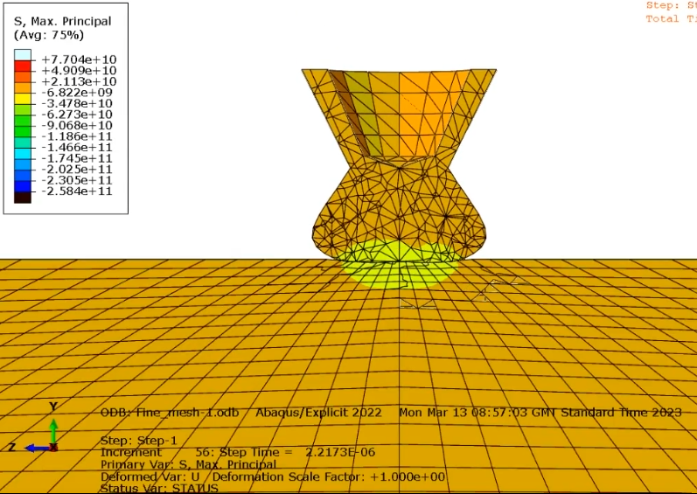
Figure 7
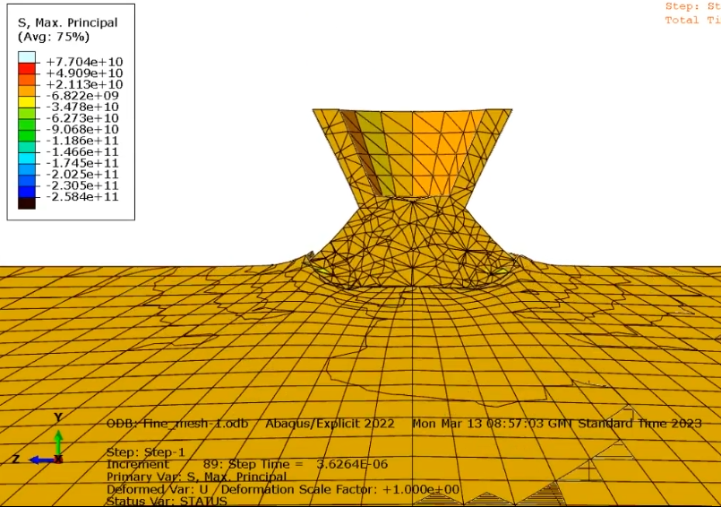
Figure 8
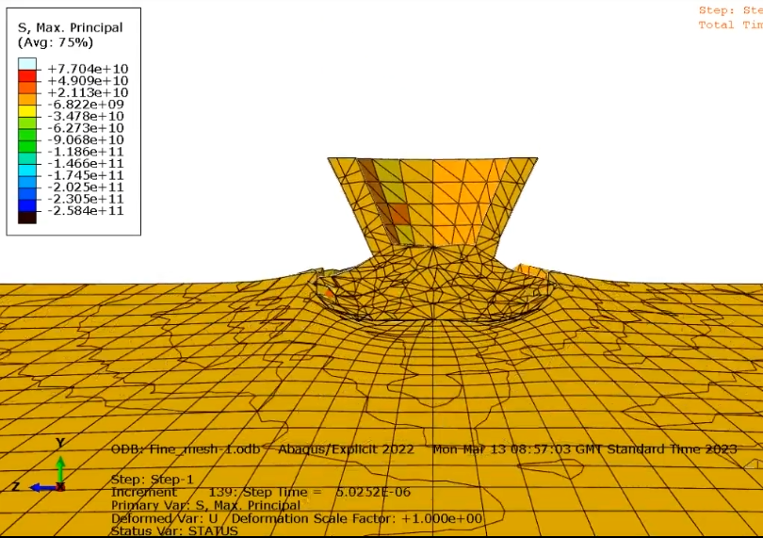
Figure 9
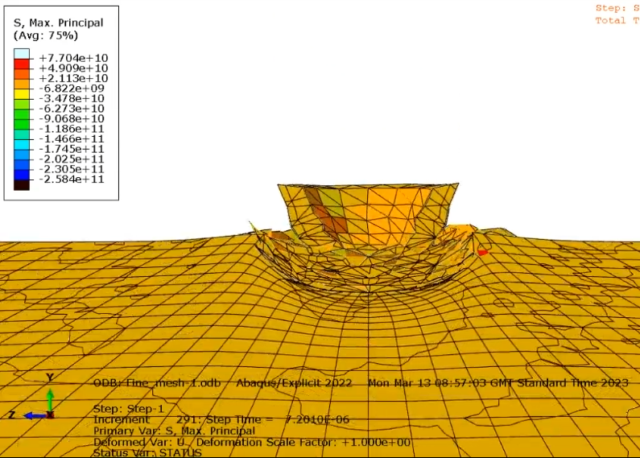
Figure 10
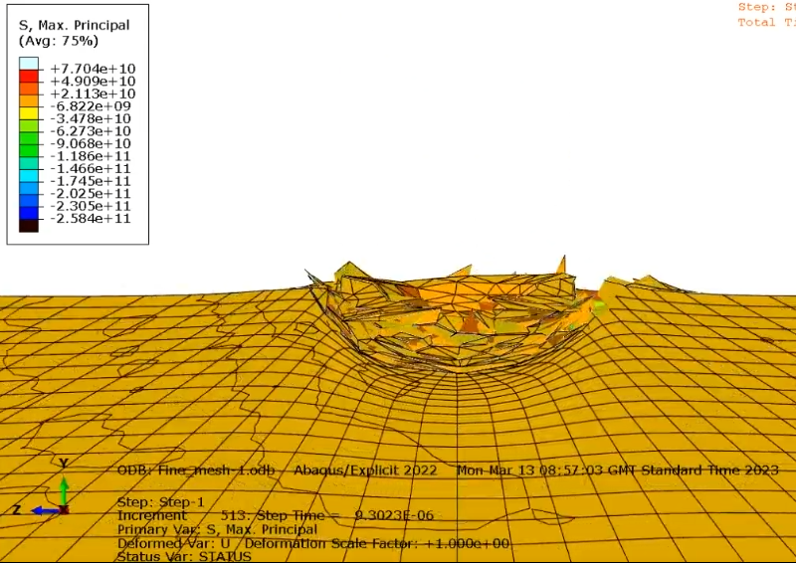
Figure 11

As you can see the model clearly shows that the pellet crumples on itself as what you would expect if you were to actually run this trial.

Reflection
If I were to undertake this task again I would change the range of the max principles so you could see the waveform produced when the pellet hit the plate. Another thing that I could have changed up was showing the effect that a lead pellet would have on hitting the plate or I could have shown the affect the pellet has on the steel at different speeds.
References

[1] The European Commision, ‘‘amending Annex XVII to Regulation (EC) No 1907/2006 of the European Parliament and of the Council concerning the Registration, Evaluation, Authorisation and Restriction of Chemicals (REACH) as regards lead in gunshot in or around wetlands’’, Commission Regulation (EU) 2021/57 pp 1-7, 2021

[2] MatWeb, ‘‘Copper, Cu; Annealed’’ [Online], Available: https://www.matweb.com/search/DataSheet.aspx?MatGUID=9aebe83845c04c1db5126fada6f76f7e&ckck=1. [Accessed 10 May 2023]

