Student name: Georgiana Izabela Cosor
Student ID number: 2127686
The assignment title: Planning and Delivering an International Meeting/Event.
Module: International Meetings Management for the Hotel Industry
Module code: BMIH6007

Table of Contents
1 Introduction 3
2 The Event Cycle 3
2.1 Initiation 3
2.2 Planning 4
2.3 Implementation 4
2.4 Closure 4
2.5 Evaluation 4
3 Event concept 5
4 Aim and Objectives of the conference 6
5 Event Operations 7
6 Event Budget 8
6.1 Cost breakdown 9
6.2 Revenue Stream 9
6.3 Funding allocation and resources 10
6.1 Forecasting profit and loss 10
7. SWOT Analysis 10
7.1 Strength 10
7.2 Weakness 10
7.3 Opportunities 10
7.4 Threats 11
8. Pestle Analysis 11
8.1 Political 11
8.2 Economical 12
8.3 Social 12
8.4 Technological 13
8.5 Environmental 13
9. Cultural and Situational Considerations 13
10. Importance of the Cultural and Situational Considerations 13
11. References 14

Introduction
A Hospitality industry conference was held on February 27 with the aim of digital transformation. The theme of the conference is tech magization in the hotel industry to enhance users' experience and reduce overall operational costs. The conference location will be in Central London the mode of the event will be through live broadcast along with online access options given to those audience who are ready to attend the event when it happens. The Tech Magization event for the Hotel industry is chosen for the exploration and implementation of smart cutting-edge technologies for streamlining hotel operations and improving user experience. The core purpose of this event is to reduce operational costs to satisfy customers and align them with industry needs and trends for digital transformational needs. The Tech-magization for Hotels is the best event to showcase innovative advanced technologies in the hospitality sector. It will address the need for digital transformation and enhance customer experience. The event will include professionals and leaders from the hospitality and tech industry to explore AI, IoT, and mobile technologies tailored for hospitality (Hoyer et al., 2020). The following report will include an event cycle for all the activities at the event. It will define the event concept to the guests and provide them route to the event. It will also include the major aims and objectives of the event and define the operations and skills required for the event. The report will allocate the event budget and industry trends and factors that can impact the event. In last the report will provide cultural and situational considerations for the event.

The Event Cycle
The event cycle is defined as a process that includes the planning, organization and evaluation of an event or conference. It includes five steps that are initiation, planning, implementation, closure and evaluation phases. This event cycle will guide organizers to manage and deliver an event successfully (Shone and Parry, 2019).

Initiation
The main idea and concept of the Tech-magization conference evolved from the need to modernize and integrate technology in the hotel industry. The primary goal is to demonstrate the latest strategies and innovations to enhance overall operations and guest experience at hotels. The major objective is to improve industrial knowledge through technological integration provide networking opportunities and provide effective actionable information to the participants (Lee et al., 2023). The major stakeholders in this conference include hotel managers, technology and hotel industry experts, event sponsors organizers and participants.

Planning
To plan an event budget, scheduling and venue selection are the essential components. For Tech-Magization Conference budget includes cost for venue rentals, setting up technology, speaker fees, logistics and marketing. The conference can also seek sponsorship and collaborate with companies to offset costs. The location for the conference is selected which is central London while selecting a venue it should be considered that it has an advanced technological infrastructure for showcasing innovative technologies. The location should be central to attract a larger audience. Create a timeline for the event for the selected date 27th February for event marketing and registration of participants. After selecting the venue next step is to arrange audio-visual equipment, catering and seating arrangements and supporting staff.

Implementation
Effective management and coordination between teams are major components for the successful implementation of events. The teams should coordinate with one another to manage registration, guide participants and handle queries and technical difficulties (Freeman et al., 2015). The communication should be clear among staff and vendors so that sessions are done on time and according to plan.

Closure
After the event, the managers should conduct briefing sessions to identify strengths and areas of improvement. Collecting feedback after an event is an important activity to gather insights about the event and explore participants' experiences and suggestions for arranging future events. The feedback can be conducted in the form of surveys (MacIntosh, 2018).

Evaluation
Evaluation of events includes performing performance analysis and developing reports. Performance analysis can be done by gathering feedback from participants and to analyze if event performance aligns with its goals. The organizers can prepare a report that provides details about the success, challenges and outcomes of the event.
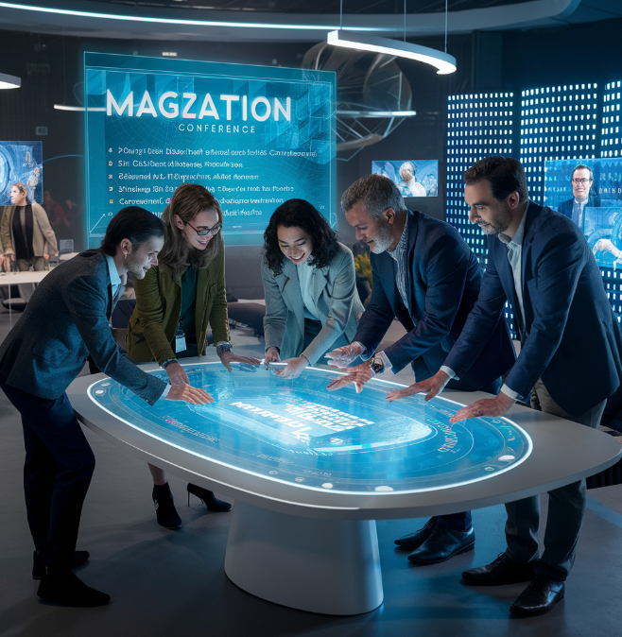
Figure 1: Event planning

Event concept
The event is for the Tech-Magization Conference for Hotels focused on integrating advanced and latest technologies to optimize hotel operations and to improve overall guest experience. The conference aims to showcase technological factors like AI, IoT and mobile technologies for sustainable hotel operations and provide essential tools to hotel managers so that can achieve a competitive advantage in the highly competitive hotel industry.
The first day of the conference will start with the registration process for each participant. The participants will be provided them an opportunity to collaborate with industry professionals and peers. The conference will start with an introductory speech from an expert from the hotel sector. the first session will occur in the smart room where participants are allowed to explore IoT, AI, AR and VR devices. The smart room will demonstrate this innovation exclusively and with live actions. The live demonstration will show the practical implementation of the latest technologies (Wu and Rao, 2017). The participants are allowed to explore vendor booths and be involved in networking. The afternoon session will be based integration of mobile technologies and their effective usage and discussion on the roundtable. The day will end on a relaxing night where participants can enjoy cocktails and have the opportunity to further connect with industry experts.
The second day of the conference begins with a networking breakfast which starts with an introductory speech. The speech will highlight the technological trends and innovation in the hotel industry. These sessions will include topics like data analytics, security enhancement robotics and automation and their effectiveness in the hospitality sector. The conference will arrange workshops that will give practical experience in using the latest technologies and tools. Participants will be given various opportunities they visit the exhibition hall where vendors can display their tech products. Participants can engage in sessions in the afternoon through virtual reality and its application to the hotel sector and the need for the latest high-speed connections (Kreiss and McGregor, 2018). After this session, all the participants' tech and hotel industry experts will have a panel discussion to identify challenges and opportunities related to digital transformation in the hotel industry. The conference and day will end with a summary of key points of the event, future recommendations and a thanks note. The final session will help participants to make their connections strong and discuss collaborations.
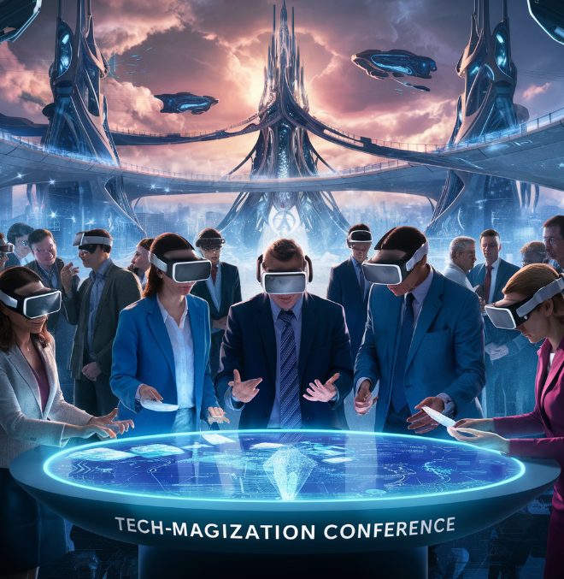
Figure 2: Tech-Magization Conference

Aim and Objectives of the conference
The Tech-Magization Conference aims to empower hotel professionals with essential tools and knowledge to effectively integrate the latest technologies in their operations to enhance guest experience. The SMART objectives of this aim are:
Objective 1: to enhance knowledge and understanding of the latest hotel technologies
Specific: to provide comprehensive understanding and educational material about the latest hotel industry technologies. These technologies include IoT, AI, mobile technologies and AR/VR technologies.
Measurable: To ensure that 90% of participants showcase that their level of understanding increases about the use of technologies.
Achievable: Live demonstrations, attractive workshops and clear insights show the practical implications of these technologies.
Relevent: to address the evolving need of hotel professionals so that they can stay up to date about the ever-changing technological landscape.
Time-bound: the objective should be achieved in two days of the conference.
Objective 2: To promote partnership and networking opportunities
Specific: to provide a platform to develop meaningful relations with industry experts and tech vendors.
Measurable: Participants should develop at least 300 connections through the conference and sessions
Acheivacvle: Start various networking opportunities for informal discussion these include breakfast and lunch sessions.
Relevant: develop collaborations and partnerships so that they can successfully integrate technology in the hospitality sector
Time-bound: make sure that these partnerships are developed and reported by the end of the conference.

Event Operations
In the hospitality industry, everyday operations and activities are significant to enhance their performance and productivity. By leveraging the technology implementation in the event planning which may include financial resources of the hotel. However, the amalgamation of the skills, abilities, and resources makes the operation successful(Russotto et al., 2021). Furthermore, Event panning is essential while conceptualizing the overall event, the resources acquired and accessible, setting aims and objectives, and providing the timeline through which all the tasks are to be accomplished within the required time frame(Bossey, 2020). Subsequently, communication skills are the essential skill for planning and executing a successful event. The event organizer must effectively collaborate with the vendors, teammates, clients and other technical staff. Clear and concise communication demonstrates the task responsibilities towards the team workers. However, when the task is clear and completely understood by the workers then they can perform with excellence rather than having any ambiguity which leads to failure of the event. (Bladen, 2022)

However, the event organizer must have problem-solving skills as there are some challenges and problems that arise during the planning of the event, however, problem-solving skills are essential to resolve conflicts and misleading. As these small conflicts arise to big picture towards miserable circumstances (Cegla et al., 2019). Furthermore, the ability to resolve conflicts quickly and maintain a positive environment at the workplace with the best-recommended solution to unexpected issues and problems is considered valued towards their job. furthermore, an event organizer must have risk management skills in which they identify the potential of the risk and also induce the strategies to overcome and mitigate the risk da factors which accelerate and hinder performance. Thus, leadership skills are also necessary for assigning the task according to the employee's abilities and willingness. Lastly, technology implementation is necessary and essential for improvement in performance (Parent and Ruetsch, 2020).

Event Budget

In the hospitality industry, the budget allocation of the event may include both the income and the expenditure. However, the income may include sponsorships and tickets. Therefore, the expenditure includes the venture booking cost, marketing and promotional activities cost, staffing and employees’ wages, and other food and beverages (Rogers and Wynn-Moylan, 2022). However, income-generating tactics include increasing attendance through focused marketing, obtaining endorsement through connections and proposal entries, and soliciting grants through initiatives. Efficient budget control assures monetary viability and the event's successful implementation (Dwivedi et al., 2020).

6.1 Cost breakdown

Characteristics | Description | Estimated cost
Venue charges | Booking Cost for the venue space for one day | £5,000
Marketing and staffing cost | Advertisement, digital presences, promotional activities, security, technical staff and event organizer chargers | £7,000
Catering | Food and beverages for the audiences | £10,000
Technology implementation | Internet availability, Virtual Reality (VA) | £5,000
Total Cost | Overall Estimated budget cost | £27,000

6.2 Revenue Stream

Resource Allocation | Description | Estimated Revenue
Sponsorships | The stakeholders or the share partners support financially to the event. | £12,000
Exhibitors charges | The tech organizations who are showcasing their products at the event | £6,000
Ticket charges or entry fees | For the attendees who attend the exhibition | £5,000
Total Cost | Overall Estimated Revenue stream | £23,000

6.3 Funding allocation and resources
The multi-pronged strategy requires working at multiple places with quality of work. Furthermore, the two-pronged strategies may include the effectiveness of the stakeholder’s sponsorships and the partners in the hospitality industry (Buttle and Maklan, 2019).

Forecasting profit and loss

= £ 27,000 (Expenditure) - £ 23,000 (Revenue stream) = £4,000 (profit)

By considering the financial resources this overview reflects a big picture of monetary policy by upholding the the digital presence and the use of artificial intelligence in the tech-magnetization conference (Benckendorff et al., 2019).

7. SWOT Analysis

Strength
- Tech-magization may enhance and improve customer experiences by embracing technological implementation.
- Further, the streamlined process of the hotel includes providing the best customer services to the clients such as conveniences and personalized information which aid event organizers to enhance their productivity.
- The competitive edge towards tech-magization by integrating the valuable data and insight of the customer enables profound marketing efforts and other personalized customer experiences (Ivanov et al., 2019).

Weakness
- The issue which magnetisation faces is privacy concerns, as the data of customers is saved in the records but can be misused which demolishes customer trust.
- Depending on technologies makes it susceptible to disturbances such as power failures or system malfunctions, which can influence customer pleasure.

Opportunities
- The opportunities may include technological advancement, continuous efforts and progress that may enhance the customer experiences
- Market consideration and expansion may include the tech-savvy by innovative technology implications.
- Collaborating with son sponsors, and partners may enhance effective communication which facilitates driving the solutions and makes them differentiable then their competitors.

Threats
- Cyber security and other frauds.
- Rapid changes in technology may hinder use the of technology.
- Communication barrier.
- Government policies and regulations may hinder event management.

Pestle Analysis

Political
The political factors may have significant influences on event management in the UK. However, data protection law, GSPR, ADDA, CCPA, intellectual property and other cyber security policies.
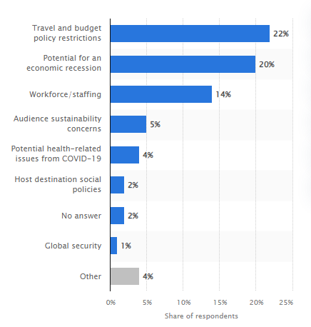
Figure 4: policies rules and regulation
Source: Statista, 2024

Economical
Economic issues such as currency exchange rate variations, labour expenses, and economic downturns can affect the affordability of technological investments as well as consumer expenditure on travel.

Social
Includes target audiences in decision-making within the tech-magization. The location includes urban centres criticizing the attendees from the UK cities in the hospitality sector. this involves innovation and sustainability and individuals who are eager to adopt new and creative techniques. this involves generating networking, learning new things, customer engagement, influencing industry and opportunities investment.

Technological
This includes the implementation of AI, mobile technology, IoT and other mobile technologies. Hands-on experience with cutting-edge technology applications.

Environmental
Sustainability commitments and green practices, environmentally conscious stakeholders and enhancing the brand image.

Cultural and Situational Considerations
The Tech-Magization conference for the hotel should consider various technological and cultural considerations. Some of these are:
- Due to the increase demand for the latest and innovative technologies hotel industry is focused on implementing AI and IoT technologies
- As participants are from diverse backgrounds the conference should develop sensitive and inclusive communication strategies (Nam et al., 2017).
- Rapid technological change shows that participants have different levels of technological interest which shows that future sessions should be developed for beginners and advanced level tech—savvy users.
- The COVID-19 pandemic shows the need for digital technology solutions to provide safe and resilient options for travel in the hotel industry (Ndou et al., 2022).

Importance of the Cultural and Situational Considerations
The significance of the cultural and situational consideration can be in terms of enhancing collaboration, and communication, with the diversified individual. Further, the involvement in the norms, values, and cultural diversity is by recognizing the adapting the marketing strategies, reducing the conflicts and issues, and enhancing the opportunities in the global market with sustainability (Martins et al., 2019).

References

Benckendorff, P.J., Xiang, Z. and Sheldon, P.J., 2019. Tourism information technology. Cabi.
Bladen, C., Kennell, J., Abson, E. and Wilde, N., 2022. Events management: An introduction. Routledge.
Bossey, A., 2020. Accessibility in all areas? UK live music industry perceptions of current practice and Information and Communication Technology improvements to accessibility for music festival attendees who are deaf or disabled. International Journal of Event and Festival Management, 11(1), pp.6-25.3
Buttle, F. and Maklan, S., 2019. Customer relationship management: concepts and technologies. Routledge.
Cegla, J., Neely, R.D.G., France, M., Ferns, G., Byrne, C.D., Halcox, J., Datta, D., Capps, N., Shoulders, C., Qureshi, N. and Rees, A., 2019. HEART UK consensus statement on Lipoprotein (a): A call to action. Atherosclerosis, 291, pp.62-70.
Dwivedi, Y.K., Hughes, D.L., Coombs, C., Constantino, I., Duan, Y., Edwards, J.S., Gupta, B., Lal, B., Misra, S., Prashant, P. and Raman, R., 2020. Impact of COVID-19 pandemic on information management research and practice: Transforming education, work and life. International journal of information management, 55, p.102211.
Freeman, R., Miller, D. and Newcomer, L., 2015. Integration of academic and behavioural MTSS at the district level using implementation science. Learning Disabilities: A Contemporary Journal, 13(1), pp.59-72.
Hoyer, W.D., Kroschke, M., Schmitt, B., Kraume, K. and Shankar, V., 2020. Transforming the customer experience through new technologies. Journal of interactive marketing, 51(1), pp.57-71.
Ivanov, D., Dolgui, A. and Sokolov, B., 2019. The impact of digital technology and Industry 4.0 on the ripple effect and supply chain risk analytics. International journal of production research, 57(3), pp.829-846.
Kreiss, D. and McGregor, S.C., 2018. Technology firms shape political communication: The work of Microsoft, Facebook, Twitter, and Google with campaigns during the 2016 US presidential cycle. Political Communication, 35(2), pp.155-177.
Lee, K.L., Wong, S.Y., Alzoubi, H.M., Al Kurdi, B., Alshurideh, M.T. and El Khatib, M., 2023. Adopting smart supply chain and smart technologies to improve operational performance in the manufacturing industry. International Journal of Engineering Business Management, 15, p.18479790231200614.
MacIntosh, E., 2018. Young athlete major event experiences: brand co-creators and ambassadors. In Major Sporting Events (pp. 114-129). Routledge.
Martins, F., Sofiya, L., Sykiotis, G.P., Lamine, F., Maillard, M., Fraga, M., Shabafrouz, K., Ribi, C., Cairoli, A., Guex-Crosier, Y. and Kuntzer, T., 2019. Adverse effects of immune-checkpoint inhibitors: epidemiology, management and surveillance. Nature Reviews Clinical Oncology, 16(9), pp.563-580.
Nam, K., Dutt, C.S., Chathoth, P., Daghfous, A. and Khan, M.S., 2021. The adoption of artificial intelligence and robotics in the hotel industry: prospects and challenges. Electronic Markets, 31, pp.553-574.
Ndou, V., Mele, G., Hysa, E. and Manta, O., 2022. Exploiting technology to deal with the COVID-19 challenges in travel & tourism: A bibliometric analysis. Sustainability, 14(10), p.5917.
Parent, M.M. and Ruetsch, A., 2020. Managing major sports events: Theory and practice. Routledge.3
Rogers, T. and Wynn-Moylan, P., 2022. Conferences and conventions: A global industry. Routledge..
Russotto, V., Myatra, S.N., Laffey, J.G., Tassistro, E., Antolini, L., Bauer, P., Lascarrou, J.B., Szułdrzyński, K., Camporota, L., Pelosi, P. and Sorbello, M., 2021. Intubation practices and adverse peri-intubation events in critically ill patients from 29 countries. Jama, 325(12), pp.1164-1172.
Shone, A. and Parry, B., 2019. Successful event management: a practical handbook. Cengage learning.
Wu, H.R. and Rao, K.R. eds., 2017. Digital video image quality and perceptual coding. CRC press.

