
  - Component 1 E-Portfolio

CertHE computing skills for the workplace

Student full name: Hasnain Akhtar Student ID: 2512913 Module Name: Learning in the Digital Era Assignment Module Code: ACCA4025_BIRM Lecturer’s Name: Masud Siddiqui Date of Submission: 9th March 2026 Name of the University: University Of Wales Trinity Saint David Campus Name: Birmingham

TABLE OF CONTENTS
Contents
E-PORTFOLIO LINK 2
SCREENSHOT OF E PORTFOLIO COVER PAGE/ WELCOME PAGE 2
TASK 1 SCREENSHOT OF 3
ESSENTIAL SKILLS 3
REFLECTION 4
TASK 2 SCREENSHOT OF 5
MIND MAP 5
(LINK TO MIND MAP) 5
THE ACADEMIC POSTER 6
(LINKS TO ACADEMIC POSTER) 6
TASK 3 SCREENSHOT OF AUTOMATIC REFERENCING TOOL 7
TASK 4 SCREENSHOT OF EACH PAGE OF E-PORTFOLIO 8

E-PORTFOLIO LINK
Hasnain's E-portfolio

SCREENSHOT OF E PORTFOLIO COVER PAGE/ WELCOME PAGE

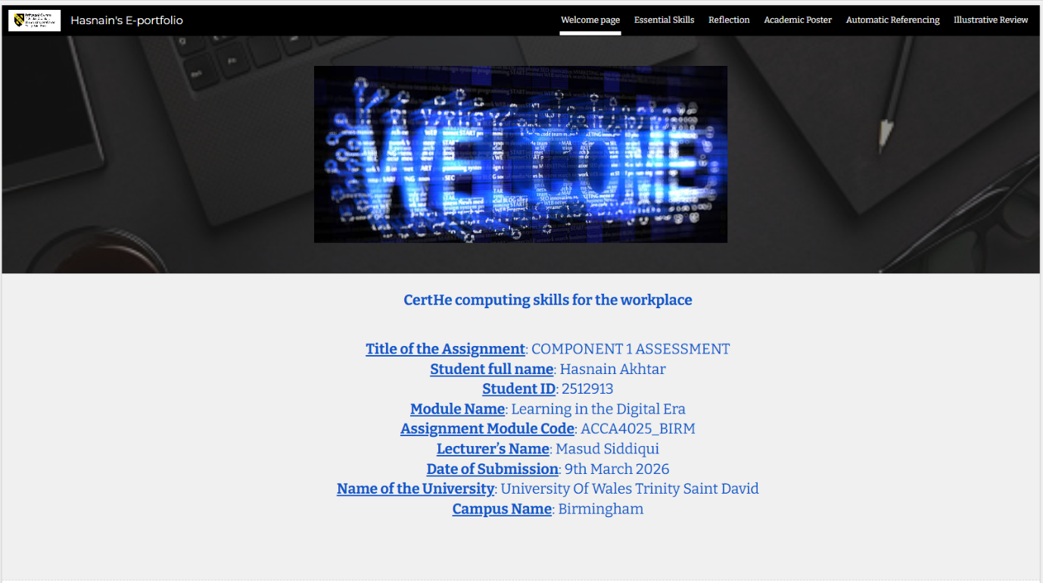

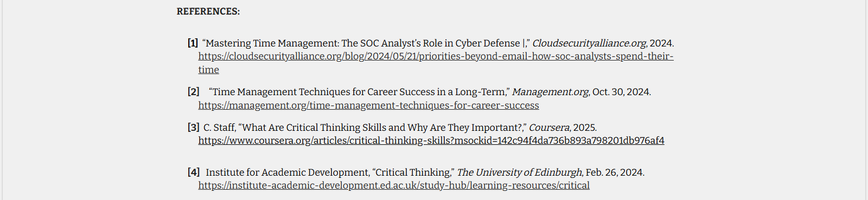
TASK 1 SCREENSHOT OF

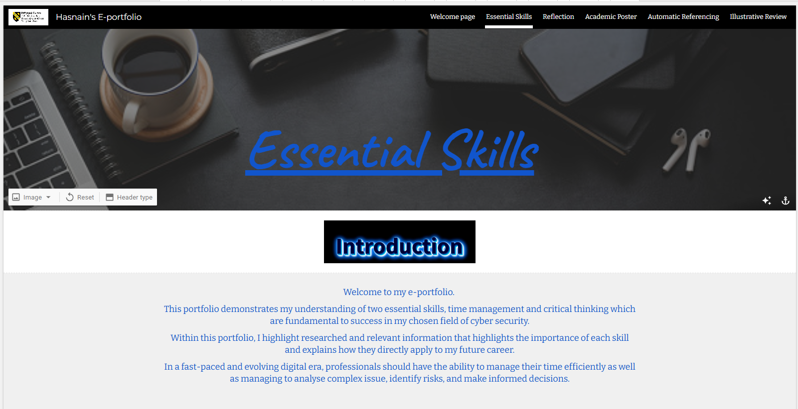
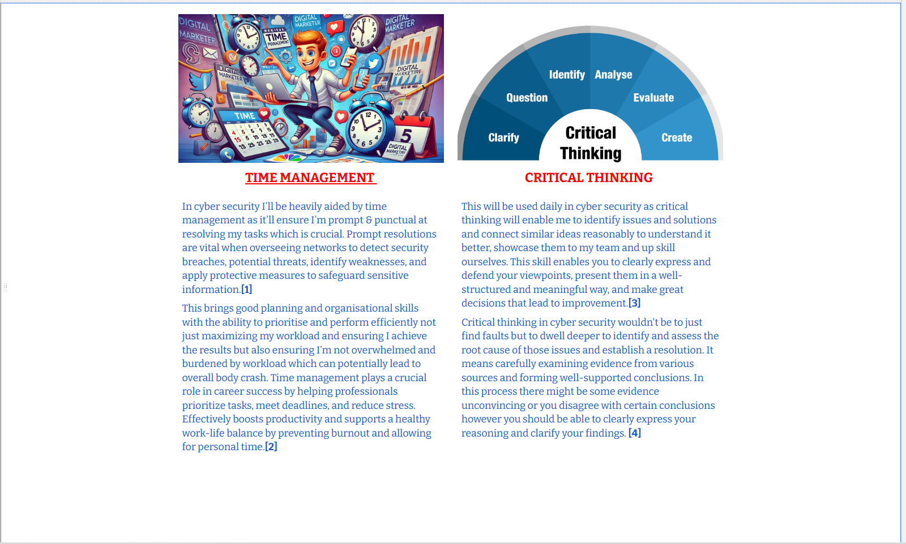
ESSENTIAL SKILLS

REFLECTION
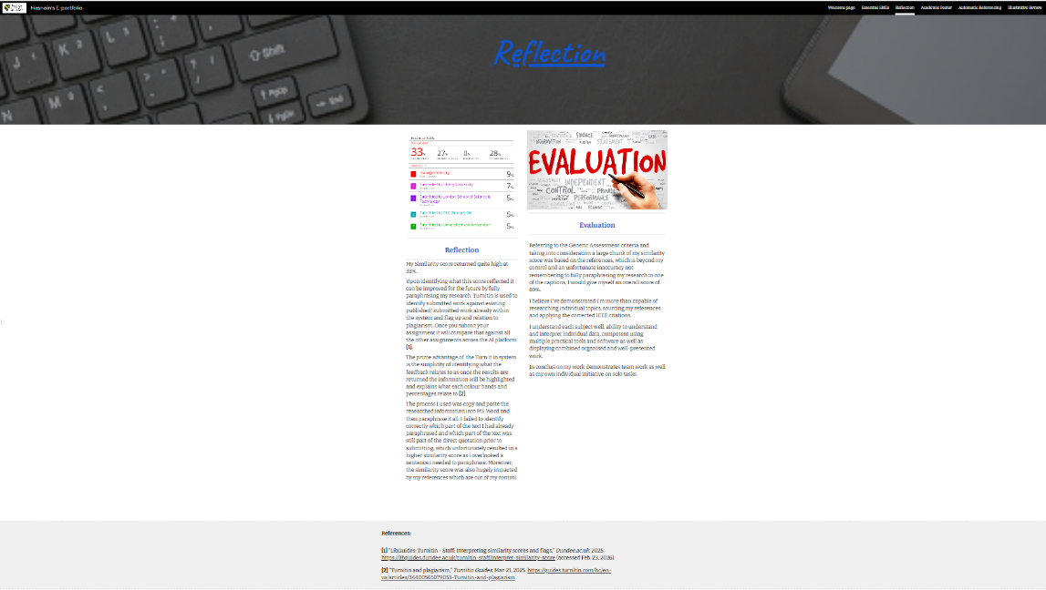

TASK 2 SCREENSHOT OF

MIND MAP
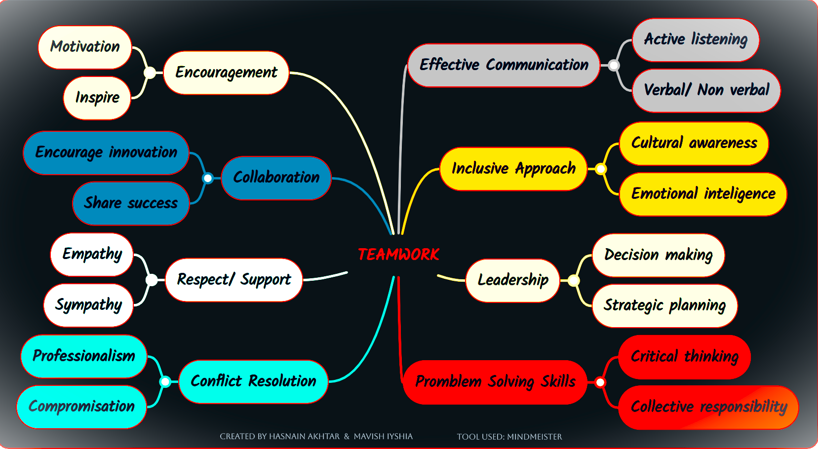

(LINK TO MIND MAP)
https://mm.tt/map/3947473128?t=4XSdRoWWZ6

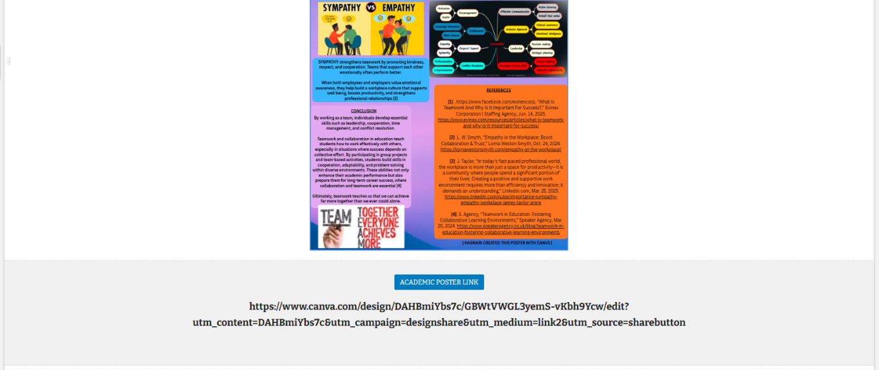
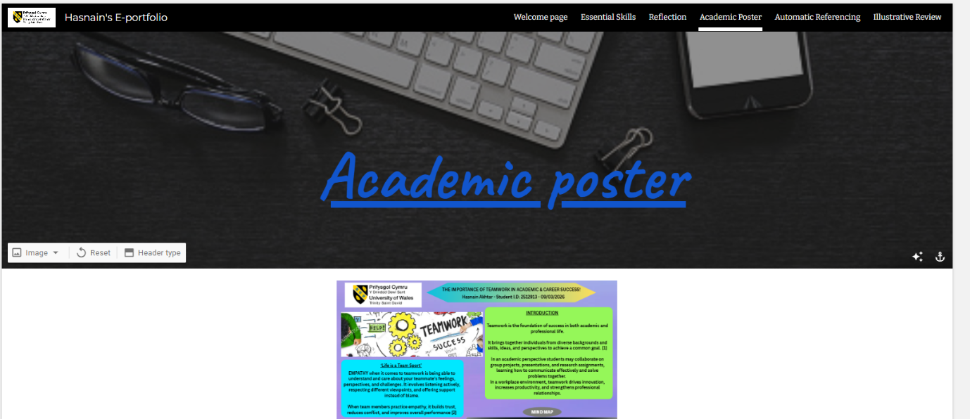
THE ACADEMIC POSTER

(LINKS TO ACADEMIC POSTER)
(Public view link) https://www.canva.com/design/DAHBmiYbs7c/vNN2ro6mug2np5LJfG1q7Q/watch?utm_content=DAHBmiYbs7c&utm_campaign=designshare&utm_medium=link2&utm_source=uniquelinks&utlId=h2f09a1312f
(Standard link)
https://www.canva.com/design/DAHBmiYbs7c/GBWtVWGL3yemS-vKbh9Ycw/edit?utm_content=DAHBmiYbs7c&utm_campaign=designshare&utm_medium=link2&utm_source=sharebutton

TASK 3 SCREENSHOT OF AUTOMATIC REFERENCING TOOL
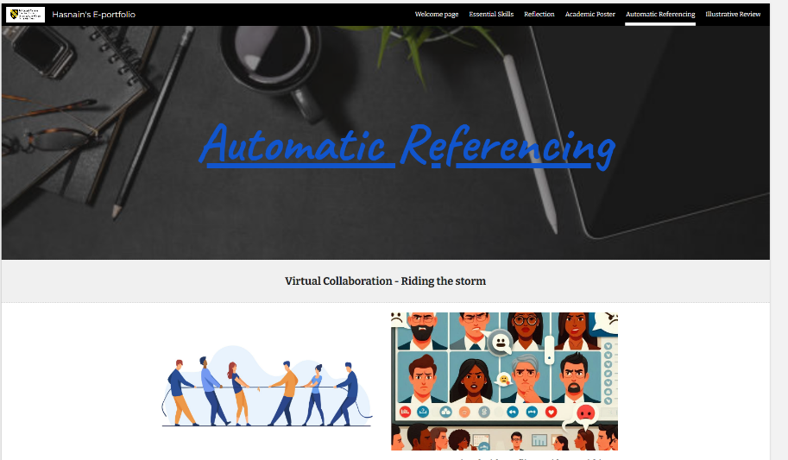
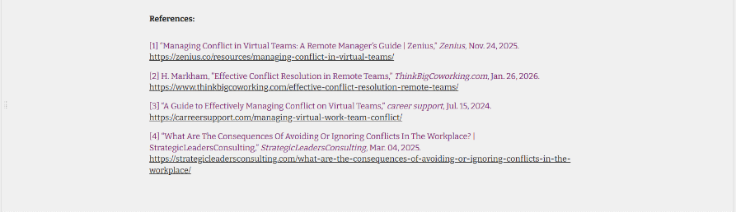
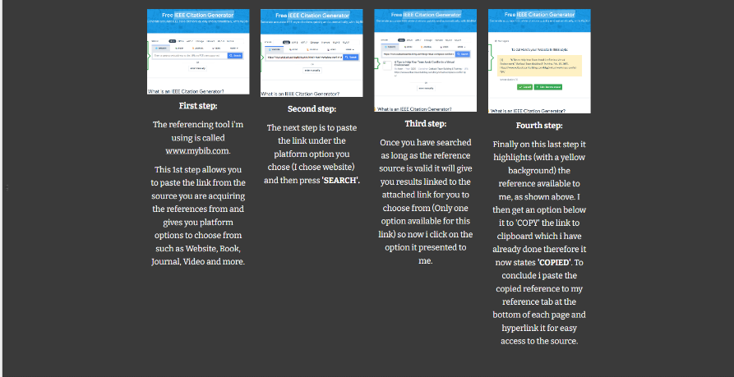
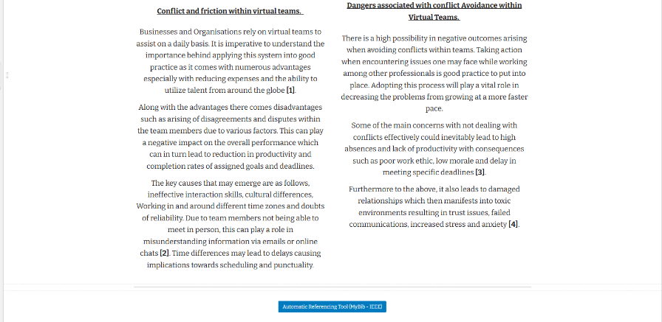

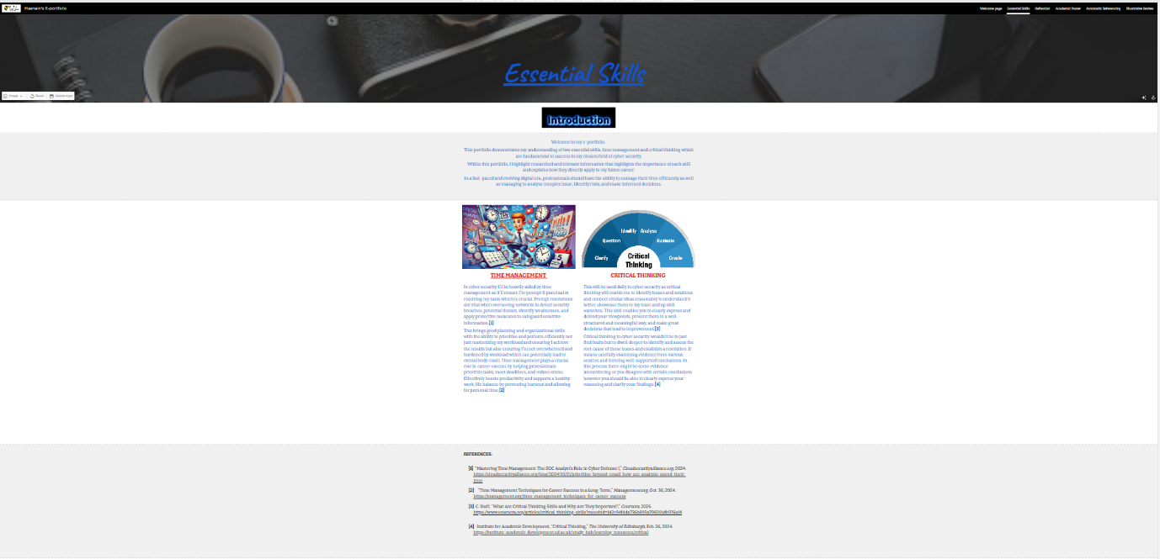

TASK 4 SCREENSHOT OF EACH PAGE OF E-PORTFOLIO




