BMHP 5014: CHANGEMAKERS: CREATIVITY
AND VALUE CREATION

COMPONENT 2: ASSIGNMENT (REPORT)

ASSIGNMENT TITLE: MUMS & MINDS: A COMMUNITY
WELLBEING
INNOVATION FOR SINGLE MOTHERS AND
CHILDREN IN THE UK

STUDENT NAME: RUTH GATHIGI

STUDENT NUMBER: 2332377

LECTURER NAME: ALICE CLAYTON

SUBMISSION DEADLIE: 24th NOVEMBER BY 2PM

Table of Contents
Poster 3
Written Pitch 4
Introduction 4
The Issue and Evidence 4
The Innovation: “Mums & Minds” Programme 4
Implementation Strategy 5
Policy, Legislation, and Ethics 6
Dissemination and Public Engagement 6
Impact and Evaluation 7
Conclusion 7
References 9
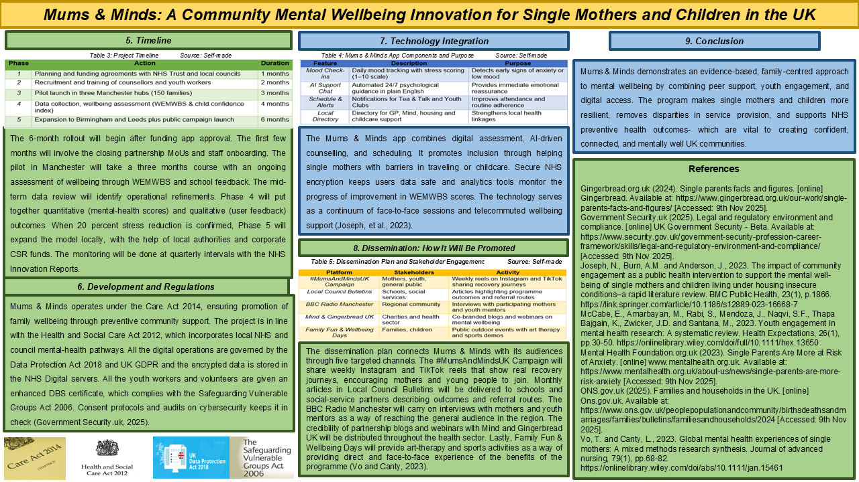
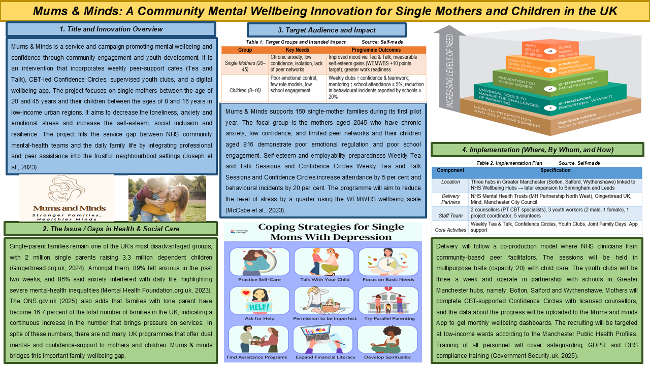

Written Pitch

Introduction
Across the UK, single mothers and their children face growing mental-health challenges driven by financial stress, social isolation, and limited access to integrated support (Joseph, et al., 2023). Mums & Minds is a community-based wellbeing innovation in the United Kingdom offering holistic mental-health and confidence encouragement to both mothers and children by means of peer programs, youth clubs, and a wellbeing application. This written pitch will discuss the context of the problem, the innovative solution, the implementation process, policies involved, as well as the effects and assessment results of the community.

The Issue and Evidence
Single-parent families are disproportionately affected by social and mental-health inequalities in the UK. According to the ONS.gov.uk (2025), lone-parent families now account for 16.7% of all UK households, showing a sustained rise. The Mental Health Foundation.org.uk (2023) reports that 89% of single parents experience anxiety, whilst 86% state it interferes with daily activities, and 43% live in poverty (Gingerbread.org.uk, 2024). Children brought up in such conditions tend to have low self-esteem, behavioural problems and limited access to consistent role models (Vo and Canty, 2023). Despite this, majority of interventions fragment child and parent support and the families lack holistic care which builds emotional experiences and mutual trust.

The Innovation: “Mums & Minds” Programme
Mums & Minds combines emotional, social, and digital support to promote family mental wellbeing. It incorporates five integrated elements, which enhance welfare of both children and single mothers. Tea and talk Thursdays establish a peer-led, secure environment where mothers can share their experiences, eliminate the feeling of isolation and enhance friendship networks by up to 30%. Confidence Circles are cognitive-behavioural and mindfulness-based interventions that re-establish emotional regulation and self-efficacy, with a 20 percent increase in WEMWBS wellbeing scores. Youth Clubs operate twice a week, facilitated by professional mentors, who help them learn to work as a team, become responsible, reduce behavioural incidents by 20% and increase school attendance by 5%. The Mums and Minds App will remain in touch every day with the mood tracker, wellbeing prompts and appointment reminders, which will keep the engagement rate at 80 percent. Lastly, Family Wellbeing Days bring mothers and children back together with outdoor art, sport, and relaxation which has improved reported bonding satisfaction by 30%. Together, these interventions create an inclusive, family-focused intervention that can bridge the social care and mental-health support (McCabe, et al., 2023).

Table 1: Main Features of Mums and Minds Source: Self-made
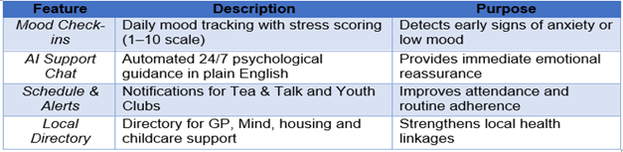

Implementation Strategy
Implementation will follow a co-production model, combining professional oversight and community participation. The Mums & Minds programme is going to work throughout Greater Manchester, and community hubs in Bolton, Salford and Wythenshawe will be pilot areas. NHS Mental Health Trusts, Mind, Gingerbread UK, and Manchester City Council will also be included in partnerships, and the services will be integrated by providing clinical and social support. The team to be delivered will include 2 counsellors, 3 youth workers, one app developer, and 5 trained volunteers. The weekly sessions of two-hour sessions will be held in the local community centres and school halls with a capacity of 20-25 people, and family events will be held once a month. The funding will come in form of NHS Innovation Grants and contributions by the local authorities amounting to 120,000 pounds every year. Mums and Minds App will be analysed monthly with WEMWBS to assess the wellbeing progress using data obtained monthly. The quality of the services will be monitored by NHS clinicians, and the availability of the low-income families will be ensured through the recruitment guided by the local Public Health Profiles (Joseph et al., 2023).

Table 2: Implementation Strategy of Mums and Minds Source: Self-made
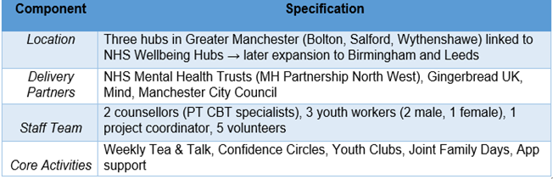

Policy, Legislation, and Ethics
The project operates within the UK’s core legal framework for community mental health. Care Act 2014 supports its intention of enhancing emotional and social wellbeing of families. Health and Social Care Act 2012 provides an integrated delivery of the NHS, voluntary and the local council sectors. All online activities are in line with the Data Protection Act 2018 and UK GDPR and include encryption, consent, and transparency of data (Government Security.uk, 2025). Protecting is in line with the Safeguarding Vulnerable Groups Act 2006, whereby all the staff and volunteers must be cleared by DBS. The equality act 2010 ensures that mothers and children of different backgrounds can have non-discrimination in accessing the facility. Informed consent, confidentiality of personal data and cultural sensitivity are aspects of ethical practice. NHS ethics codes apply to all counsellors, and youth mentors attend safeguarding workshops to continue delivering community services inclusively, safely, and responsibly (Government Security.uk, 2025).

Dissemination and Public Engagement
Promotion will combine digital advocacy with direct community engagement. The campaign, Mums and Minds UK, will communicate weekly TikTok and Instagram videos with the real family stories to motivate the participation. Progress reports and referral information of schools and social-care teams will be posted every month in Local Council Bulletins. Live interviews with mothers and youth mentors will be conducted on BBC Radio Manchester to approach the general population. Cooperation with Mind and Gingerbread UK will consist of joint webinars and articles on family wellbeing. Lastly, Family Fun & Wellbeing Days will not only bring on board awareness but will also implement the events of art, sports, and relaxation, making it a local involvement (Vo and Canty, 2023).

Table 3: Dissemination Channels and Activities for Mums and Minds Source: Self-made
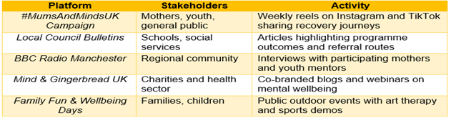

Impact and Evaluation
Impact evaluation will combine quantitative and qualitative tools to assess outcomes. The WEMWBS Scale will gauge a 25% boost in mental health of the mothers, and Youth Club Feedback Surveys will gauge a 30 percent increase in the level of confidence in the children. The level of family satisfaction will be enhanced by 20 percent in post-event focus groups as more people will have emotional connections to them. Referral Tracking will follow a decline in NHS counselling demand by 15 per cent, which will show better self-reliance and efficiency of the program (Umberson and Thomeer, 2020).
Table 4: Impact and Evaluation of Mums and Minds Source: Self-made
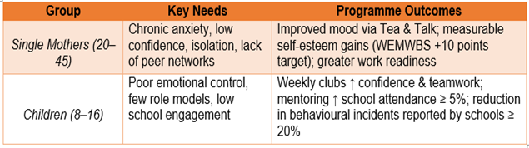

Conclusion
Mums & Minds transforms UK community wellbeing through its integrated, family-focused approach. It instils self-confidence, lessens isolation and enhances resiliency amongst the single mothers and their children. The initiative will enhance the clinical and community care, and it will provide direct support to NHS and social-care objectives about accessible and preventive mental-health innovation in the country.

References
Gingerbread.org.uk (2024). Single parents facts and figures. [online] Gingerbread. Available at: https://www.gingerbread.org.uk/our-work/single-parents-facts-and-figures/ [Accessed: 9th Nov 2025].
Government Security.uk (2025). Legal and regulatory environment and compliance. [online] UK Government Security - Beta. Available at: https://www.security.gov.uk/government-security-profession-career-framework/skills/legal-and-regulatory-environment-and-compliance/ [Accessed: 9th Nov 2025].
Joseph, N., Burn, A.M. and Anderson, J., 2023. The impact of community engagement as a public health intervention to support the mental well-being of single mothers and children living under housing insecure conditions–a rapid literature review. BMC Public Health, 23(1), p.1866. https://link.springer.com/article/10.1186/s12889-023-16668-7
McCabe, E., Amarbayan, M., Rabi, S., Mendoza, J., Naqvi, S.F., Thapa Bajgain, K., Zwicker, J.D. and Santana, M., 2023. Youth engagement in mental health research: A systematic review. Health Expectations, 26(1), pp.30-50. https://onlinelibrary.wiley.com/doi/full/10.1111/hex.13650
Mental Health Foundation.org.uk (2023). Single Parents Are More at Risk of Anxiety. [online] www.mentalhealth.org.uk. Available at: https://www.mentalhealth.org.uk/about-us/news/single-parents-are-more-risk-anxiety [Accessed: 9th Nov 2025].
ONS.gov.uk (2025). Families and households in the UK. [online] Ons.gov.uk. Available at: https://www.ons.gov.uk/peoplepopulationandcommunity/birthsdeathsandmarriages/families/bulletins/familiesandhouseholds/2024 [Accessed: 9th Nov 2025].
Umberson, D. and Thomeer, M.B., 2020. Family matters: Research on family ties and health, 2010 to 2020. Journal of Marriage and Family, 82(1), pp.404-419. https://onlinelibrary.wiley.com/doi/abs/10.1111/jomf.12640
Vo, T. and Canty, L., 2023. Global mental health experiences of single mothers: A mixed methods research synthesis. Journal of advanced nursing, 79(1), pp.68-82. https://onlinelibrary.wiley.com/doi/abs/10.1111/jan.15461

