

DETECTION OF DISTRIBUTED DENIAL OF SERVICE ATTACKS TARGETING THE CONTROL PLANE IN SOFTWARE DEFINED NETWORKS
By Che Stephen Morris
Supervisor: Nitheesh Kaliyamurthy

Project submitted as part of the requirements for the award of
BSc (Hons) Computing (Computer Networks and Cyber Security)
April 2025

Declaration of Originality
I, Che Stephen Morris declare that I am the sole author of this Project; that all references cited have been consulted; that I have conducted all work of which this is a record, and that the finished work lies within the prescribed word limits.

This work has not previously been accepted as part of any other degree submission.

Signed : Che Stephen Morris
Date : 29/04/2025

FORM OF CONSENT
I Che Stephen Morris hereby consent that my Project, submitted in candidature for the BSc (Hons) Computing (Computer Networks and Cyber Security), if successful, may be made available for inter-library loan or photocopying (subject to the law of copyright), and that the title and abstract may be made available to outside organisations.

Signed : Che Stephen Morris
Date : 29/04/2025

Copyright Acknowledgement
I acknowledge that the copyright of this project report, and any product developed as part of the project, belong to University of Wales Trinity Saint David, Swansea.

ABSTRACT/SYNPOSIS
This project investigates the detection of Distributed Denial of Service attacks specifically targeting the control plane of Software Defined Networks. SDNs are designed to decouple the control and data planes to allow for better network programmability and management; however, this becomes a point of failure for SDN as the centralization of the control plane does allow for the entire network to be taken down by one DDoS attack. The research in this project aims to evaluate detection strategies that can sort normal network traffic from malicious traffic in real time without compromising the network or making false positives.

A systematic literature review took place that aimed to categorize existing detection methods into three main types of approaches which were, intrusion detection systems, anomaly-based detection and machine learning. These were analysed based on various factors such as detection accuracy, scalability and suitability for SDN. Machine learning methods were found to be the best approach offered, with certain models achieving over 99% accuracy.

Building upon this knowledge, a simulated SDN environment was made using Mininet and a modified SDN controller that was integrated with open source machine learning and statistical based DDoS detection, like the ones covered in the literature review. The tests included both simulated normal traffic and a simulated ICMP flood DDoS attack. This was then evaluated by using the flow count and the dataset provided was also evaluated for extra insight, finding out that it’s based on variables such as flow speed entry and source IP variation. The detection method used there had a high detection accuracy and did not provide a single false positive during testing, solidifying the fact that machine learning is an extremely viable solution for real-time DDoS protection within SDN.

The project concludes that a lightweight, flow-based machine learning approach tends to offer the best approach for protecting SDNs against DDoS attacks upon the control plane; although, future work should focus on exploring more hybrid models, broader attack types and testing upon larger more realistic topologies that mimic networks like universities or enterprise networks.
Contents
Copyright Acknowledgement ii
Chapter 1 1
1.1 Introduction 1
1.2 Aim 2
1.3 Objectives 2
1.4 Structure Of The Project 3
Chapter 2 - RESEARCH & REVIEW OF LITERATURE 4
2.1 Introduction 4
2.2 Methodology 6
2.3 Detection Techniques for DDoS attacks in SDN 7
2.3 anomaly based detection 9
2.4 MACHINE LEARNING APPROACHES 11
2.5 Conclusion 14
Chapter 3 - RESEARCH METHODOLOGY 16
3.1 Introduction 16
3.1 RESEARCH PHILOSOPHY 16
3.2 RESEARCH APPROACH 16
3.3 TIME HORIZON 17
3.4 Research strategy 17
3.5 RESEARCH METHOD 17
3.6 Conclusion 18
Chapter 4 - DESIGN & IMPLEMENTATION 19
4.1 Introduction 19
4.2 problem formulation 19
4.3 Design 20
4.4 Implementation 21
4.5 Conclusion 27
Chapter 5 – Testing and Evaluation 28
5.1 INTRODUCTION 28
5.2 Normal traffic testing 28
5.3 ATTACK TRAFFIC TESTING 29
5.4 DATA COLLECTION 30
5.6 FLOW COUNT ANALYSIS 32
5.8 evaluation 34
Chapter 6 - CONCLUSIONS AND RECOMMENDATIONS 35
6.1 Summary 35
6.2 Conclusion 36
6.3 RECOMMENDATIONS for Further Research 37
Chapter 7 - REFLECTIONS 38
chapter 8 – REFERENCEs 39
GLOSSARY 41

ACKNOWLEDGEMENTS

Mam and Dad – first for creating me, secondly for supporting me through university the last few years, much appreciated.

The Wig and Pen – one of the main stays, really spurred me on throughout the last year, where I learned much about alcohol consumption, really supported me mentally, always there when I need it.

WEETABIX (Kai, Owain, Patrick, Josh & Sam) – best butties, much reassurance, many good times.

2018 Blue Dacia Sandero 0.9L LCE Laureate (OV18 AEM – CAT S) – reliable travel, brought me back and forth university the last year, has only broken down once, hopefully never again.

Beaton, Alan & Jockey.

Chapter 1

Introduction

Throughout this chapter, what the project will be about will be covered, some of the initial aims and objectives of my project and how the project will be structured. This section will also briefly be covering some of the methodologies that will be used moving forward but this will be expanded on further into the project in a later chapter. Software Defined Networking (SDN) is an innovative type of networking that separates the control plane from the control plane, allowing for more centralized network management through software-based controllers. The control plane decides how data should be forwarded and is managed by a SDN controller, the data plane on the other hand is responsible for forwarding the packets based on the instructions that it receives from the controller. Communication between the two planes is done through a few standardized APIs such as OpenFlow or Ryu. There are different ways of using SDN; for example, there are centralized and distributed controller models, both offering their own advantages with regards to scalability and fault prevention.

The main key difference between SDN and the architecture of traditional networks is their structure and how they operate. Traditional networks rely on hardware where the control and data planes are combined, making management less flexible as everything is done device to device. SDN separates these functions, allowing for better control and much easier network programmability. The table below will illustrate some of the other key differences between SDN and traditional networks:
Feature | Traditional Networks | SDNs
Control Plane | Centralized in SDN controller | Distributed across all devices
Data Plane | Separated from control plane | Integrated with control plane
Network Management | Centralized, programmable and automated | Manual configuration on all devices – slower.
Scalability | Highly scalable, easily expanded | Scaling is difficult and time consuming
Flexibility | Very flexible, easy to adapt network as and when needed | Difficult to adapt quickly, must be done on multiple devices

As this project moves forward, the project will investigate the vulnerability of the control plane to DDoS attacks and propose security strategies that address such critical vulnerabilities whilst also maintaining the reliability and performance that SDNs are known for. The research will primarily focus on detection mechanisms rather than mitigation or recovery strategies. General SDN security concerns may also be mentioned, but the primary focus will be on detecting DDoS attacks within the control plane. Through the examination of existing materials and practical investigation, this research will contribute to protecting SDN infrastructure against modern day evolving threats.

Aim
The main aim of this report is to investigate and evaluate existing methods of detecting DDoS attacks that target the control plane within SDNs.

Objectives
The objectives are to:
- To conduct a literature review of current DDoS attack detection methods focused on the control plane in SDN, completed in 6-7 weeks.
- To identify, justify and apply research methodologies to analyse and compare existing DDoS detection techniques, completed in 2-3 weeks.
- To organise and explain existing DDoS detection methods based on their architecture, detection approach and performance, completed within 6-7 weeks.
- To critically analyse the strengths, limitations and the effectiveness of the identified DDoS detection methods, completed within 3 weeks.

Structure Of The Project

This project will be split into three main parts.

Firstly, the project will begin with an extensive review of existing literature and case studies relating to the security and risks that come with the use of Software Defined Networks. This includes making myself familiar with the architecture of SDNs and how they work on their own, identifying common security risk and challenges faced and understanding how said risks are currently dealt with and mitigated in the real-world. The findings from this part will be extremely important as they will establish the direction this project goes in and will bring me extensive knowledge that will be used going forward.

The second part of the project will focus on the design and implementation of the previous research. This will include coming up with the actual problem we have at hand as I can then get more specific with what vulnerabilities and threats that SDN faces that I’ll be primarily focusing on. A virtual environment will be used to put to the test the existing and my proposed security and mitigation strategies, evaluating their effectiveness and reliability, as to not actually damage any real SDN systems. The tools and software that I’ll be using for this will also be covered within this section, this part is important as I’ll be bridging the gap between my research and practical application.

The third and final part of the project will present what I have found out through the course of this investigation. The results of the experiments ran throughout part two will be covered here and will be analysed to determine how effective my proposed security strategies are when put under pressure and compared to how they perform when put against the existing measures. I will then conclude the project with a summary of everything and the key things I’ll be taking away from running this project.

Chapter 1 has covered a background summary of the report, breaking down and specifying aims and objectives.

Chapter 2 will focus on researching and reviewing literature based around SDN security and will provide background knowledge as to what is being done and why.

Chapter 3 will dive into my research methodology and why it’s been chosen and how it benefits the project.

Chapter 4 will primarily cover the design and implementation stage of the project and will mostly be the meat and bones of the project.

Chapter 5 will be an evaluation of everything I’ve done so far and if it met the objectives and aim set in Chapter 1 and will also compare my work to other works.

Chapter 6 will be the conclusion of the project and should summarise everything I’ve covered and gone through during the project.

Chapter 2 - RESEARCH & REVIEW OF LITERATURE

Introduction
SDN represents a huge shift in how networks are designed, managed and secured. By decoupling the control plane from the data plane, SDNs introduce a more centralized and programmable approach towards network management, helping to improve the scalability, automation and flexibility for network administrators. The SDN architecture is commonly organized into three layers: the application layer, where network services and applications set how the network should behave; the control layer, where the SDN controller is and decision making is done; and the data layer, where both physical and virtual devices forward traffic according to what they’ve been told by the SDN controller. Communication between all layers is done through northbound and southbound APIs, using protocols such as OpenFlow to allow for direct management of underlying network devices.

Despite all these advantages, the centralized nature of SDNs introduces some unique security challenges. The main challenge is the fact that the control plane becomes a critical single point of failure, making it a huge target for DDoS attacks. A successful DDoS attack against the SDN controller can overwhelm it completely which can lead to disrupted network management and bring the entire network to a halt. Attackers can also exploit vulnerabilities within the controller communications, they can overload APIs or they could flood links between the network to make it an even bigger issue. As well as these, SDN remains vulnerable to other threats, including unauthorized access, topology poisoning, man-in-the-middle attacks and control plane hijacking, which can further disrupt the network operations.

As traditional networks distribute control across multiple network devices, which can offer some resilience to such attacks, SDNs centralize the control. Whilst as mentioned this can become a point of failure, it also allows for more advanced security techniques like real-time monitoring and dynamic threat detection and mitigation, which can really outperform more traditional approaches.

As in recent times SDNs has become more relied upon, securing the control plane against DDoS attacks has become a pressing concern, and that starts with detecting them. This literature review will aim to examine existing detection methods, attempting to compare and identify which ones may be the best to use and what their strong and weak points are.

Methodology
For this project, a systematic literature review approach will be used to ensure the comprehensive but unbiased review of existing literature related to the detection of DDoS attacks targeting the control plane in SDNs. The review will aim to gather knowledge on attack vectors, detection strategies and security challenges in SDNs. Throughout the course of the review, there will be two main areas focused upon; these will be:
- Detection & mitigation techniques for DDoS attacks within SDN
- Challenges with both detecting and mitigating DDoS attacks
Focusing on these three areas should ensure a nice structure to the review and ensure that the review remains focused on topic.

To identify relevant studies, a search was conducted on IEEE Xplore, as it was found that it tended to be better for computing literature when compared to other databases like ACM Digital Library and ScienceDirect. After a fair bit of messing around with different keywords and Boolean operators, it was found that the following combination worked best:
- (("DDoS" OR "Distributed Denial of Service")
- ("detection" OR "identification" OR "anomaly detection" OR "intrusion detection")
- ("Software Defined Network" OR "SDN")
- ("OpenFlow" OR "Mininet" OR "Ryu" OR "Floodlight" OR "ONOS")
- ("machine learning" OR "deep learning" OR "AI" OR "pattern recognition")
- ("real-time" OR "scalability" OR "performance evaluation"))
The original search term that was used returned 500 or so papers, through adding a few more of the above search terms and applying some inclusion and exclusion criteria, it was brought down to 33 relevant literatures, not all will be used.
The inclusion criteria I chose for the literature was:
- Conference papers
- Studies published in the last 10 years (2015-2025)
- Research that focuses on SDN security and DDoS protection / mitigation
The exclusion criteria I chose for the literature was:
- Journal papers (the 5 that were available were of no interest)
- Duplicate publications
- Studies without technical details / papers on only general cyber security

2.3 Detection Techniques for DDoS attacks in SDN
Intrusion Detection Systems (IDS) play a big part in securing SDNs against various threats, especially DDoS attacks. IDS will continuously monitor network traffic and therefore can keep an eye out for any malicious activities or any anomalies that may indicate that an attack is likely to occur. IDS benefits hugely from the centralized control and programmability of SDNs, allowing for real time traffic analysis and adaptive security measures. Modern IDS implementations though can also utilise machine learning and flow-based analysis to help enhance their accuracy and efficiency.

A study by S. Banerjee & P. S. Chakraborty proposes the use of an IDS system for both detection and mitigation of DDoS attacks in SDNs, but whilst also integrating machine learning techniques [1]. Their model consisted of two modules, one ‘Signature IDS’ which leveraged the machine learning techniques, these being Naïve Bayes and K-Nearest Neighbours and the other module being a ‘Three-Way Handshake Mechanism’, which worked to identify threats by analysing open connections and blocking them using the access control list [1]. The study concluded that integrating a machine learning based approach in combination with IDS was a decent implementation for detecting and mitigating DDoS attacks, leading to a 93.3% accuracy rate, but did also note that further improvements could enhance the accuracy and efficiency in handling attack patterns as it was found that it tended to struggle with larger datasets [1].

Another study by T. Abdoul Karim, K. Konate & M. M. Soidridine proposes again the use of an IDS system with integrated machine learning, as it seems that many IDS systems tend to do in recent years, but this time it wants the machine learning algorithms to run supervised [2]. Their study used Snort Network Intrusion Detection (NIDS) for real-time monitoring and mitigation and used K-Nearest Neighbours (KNN), Support Vector Machine (SVM) and Naïve Bayes for the actual detection and classification of network traffic, with the latter being like the previous study. The approach for DDoS detection was trained using a dataset, CIC-DDoS2019, which is a dataset that contains various types of attacks, including TCP-SYN flood and UDP flood attacks, ensuring that the method would be good for all round detection and mitigation [2]. Once an attack was detected, the IP address and the port was added to a blacklist, preventing further malicious traffic from attempting to attack the SDN controller [2]. They found that SVM was the best algorithm to use, with an accuracy of 98.5%, and that Naïve Bayes was the worst approach in this scenario, being sat behind at only 80.65% [2].

Out of all the papers in the review, these two were the only two that experimented fully with an IDS system, most others were either entropy-based, anomaly-based or fully machine learning based.

Comparing the two, both focus on detection and mitigation and both use machine-learning based IDS systems, but both take different approaches to achieve their goals. The first paper introduces and IDS with two modules and once an attack was identified it was manually placed in an Access Control List, to block further connections and to be reviewed later [1]. It explored two main different machine learning algorithms, Naïve Bayes and KNN, and evaluated their performance in detecting attacks, but isn’t a very specific way of detecting attacks as it doesn’t focus on any specific DDoS attack type and lacked real-time mitigation [1].

The second study can be said to be more of a real-time and practical method. It integrates Snort NIDS with machine learning, which allows for dynamic and real-time attack mitigation and detection. This means that when compared to the first study, this one does not rely on an access control list and instead can actively detect malicious traffic and can block it in real time [2]. It focuses on the two most common methods of DDoS, TCP-SYN and UDP flood, and does quite a good job at it, with SVM becoming the victor in their research and has almost a 99% accuracy rate [2]. They also used a widely recognised model for their research, the CIC-DDoS2019 dataset, which allows for a better all-round approach [2].
Overall, between the two, the second study is the stronger approach. This is due to the higher accuracy, real-time mitigation and the more practical integration. Thinking specifically of SDN, it would be better suited for use in a real-world environment as it provides quick detection and quick response, which are extremely important when thinking of the bigger picture. The first study, whilst being quite innovative with the two-module design, lacks scalability and efficiency. A future improvement for this could be to combine the identification mechanism from the first study with the real-time mitigation from the second study, which would provide more of a hybrid IDS solution.

anomaly based detection
Anomaly based detection is a technique that aims to identify DDoS attacks by monitoring for unusual or unexpected changes within network behaviour and traffic. Unlike other methods of detection, it does not rely on known attack patterns, making it quite effective for detecting new or evolving threats Within SDNs, anomaly detection can measure things like traffic volume, flow counts and controller performance to spot signs of an ongoing attack. It can offer the advantage of early detection but can also sometimes suffer from false positives if fluctuations in network activity are mistaken for an attack.

A study by M. A. Setitra et al discusses a method of anomaly-based detection that explores potentially relocating the DDoS detection from the control plane to the data plane, whilst also utilizing programmable devices and the P4 language [3]. The P4 language is a high-level programming language designed for controlling how network devices process packets. Through utilizing the data plane for the actual DDoS detection, this can allow for traffic patterns to be monitored and anomalies to be identified in real time, allowing for attacks to be identified faster, it would also lessen the stress on the SDN controller, allowing for resources for other tasks. The study concluded that delegating DDoS attack detection to the data plane allowed faster identification of attacks and concluded by talking about how important the collaboration of the control and data planes are [3].

Another study by W. Sun et al discusses another approach to anomaly-based DDoS detection by combining entropy analysis with deep learning [4]. This approach proposed utilising Renyi entropy to monitor changes within network traffic randomness to find anomalies and then triggering an alert when significant deviations occur [4]. This method is extremely lightweight and fast but sometimes can trigger false positives. To solve the false positive issues, they then used a BiLSTM-RNN model to sort traffic based on extracted flow features, therefore utilising the fast responsiveness of the entropy-based anomaly detection and the high accuracy of the deep learning model, which led to them achieving a detection accuracy of over 98%, whilst not overloading the SDN controller [4].

Traditional networks can also rely on anomaly-based detection sometimes, mostly focusing on sampling anomaly detection due to the high demands of inspecting each packet in real time; however, sampling detection can allow certain DDoS attacks to completely bypass detection. A study by Ahmed and Kim proposes utilising the centralised control and programmability of SDNs to overcome said limitations [5]. They propose using complete flow statistics from OpenFlow switches and dynamically updating the flow rules to circumvent an attack, this would allow for SDN to detect and mitigate DDoS attacks much earlier and with even greater precision [5]. To achieve this, they proposed the use of flow examination, which they suggested could highly improve detection accuracy and alleviate resource constraints which are usually associated with anomaly detection methods and that transitioning to this type of detection would maintain high detection rates.

Another study focusing on anomaly-based detection was undertaken by Gonzalez and Charfadine [6] where they developed a real-time anomaly detection framework for SDN, utilizing live traffic analysis integrated with machine learning models trained on flow-based features, allowing them to achieve high detection accuracy and even allowed for automated mitigation against DDoS attacks. They concluded that their algorithm outperformed other methods such as decision tree and support vector machines for detecting traffic anomalies [6].

Each study offers a unique take on anomaly-based detection for DDoS attacks on SDN and each comes with its own use cases, they all provide an improvement over more traditional DDoS detection methods; however, their suitability can depend on the SDN deployment. Setitra et al ‘s P4 based method [3] seems like it could be ideal for high performance or more modern programmable networks where speed and controller resources are crucial; however, it’s reliance on more specialized software means that it may not be easily added to more older networks. Sun et al’s combination of entropy analysis and deep learning techniques [4] in comparison has a decent balance of speed and accuracy, meaning that it would be great for SDNs with computing resources to spare. Ahmed and Kim’s flow statistical approach [5] would work well in environments where scalability isn’t an issue and would offer very high detection precision without losing any through packet sampling. The last one, Gonzalez and Charfadine’s more machine learning approach [6] could work and be adapted for SDN but feels more like it would be practical for more traditional networks. It does need a lot of maintenance though; it would need constantly updated training data so may not be practical. Overall, the choice of method needs to consider the hardware that it’s working with, the traffic patterns and the reliance on network resources.

MACHINE LEARNING APPROACHES
Machine learning based approaches are used to identify DDoS attacks within SDN by learning patterns and features within network traffic that split normal network behaviour from potential malicious network behaviour (floods etc). Unlike other methods, it does not rely on manually defined rules, meaning that it can be great for adapting to new and evolving attack strategies. Within SDNs specifically, machine learning models tend to be trained on flow statistics, traffic anomalies and behaviour patterns to automatically detect and sometimes even mitigate attacks in real time. This approach tends to offer very high detection accuracy and adaptability but can also face challenges such as needing large and high-quality training data that needs to be constantly updated or could even drift off what it focuses on if there is a significant change in network conditions.

A study by Alashhab et al [7] focuses on a machine learning based approach for detecting and mitigating DDoS attacks within SDN environments. They proposed using an online machine learning model using a Stochastic Gradient Descent optimizer combined with an Explainable Boosting Machine classifier, allowing for their proposed idea to process live traffic and update itself as and when needed using online sources to adapt to new and evolved attack patterns, even including zero-day attacks [7]. Their model was trained using traffic generated in a simulated environment using Mininet and the Ryu controller, including both normal and attack traffic. During experimentation with their model, they found that it achieved a 99% accuracy with very low false positive rates, outperforming most other machine learning techniques [7].

Another study by Mankawade et al [8] proposes a dynamic framework for DDoS attack detection and mitigation in SDN networks using a Decision Tree classifier, which leans back into anomaly-based detection slightly. Unlike the previous study, it uses decisions trees it reintroduces rules, being simple “if then” rules, allowing for it to be easily implemented into a controller like OpenFlow or Ryu. They trained the decision tree based on a dataset containing both normal and malicious traffic, allowing their model to recognise changes in network traffic that suggest a DDoS attack is taking place [8]. They compared their model to different machine learning models (Logistic Regression, Random Forests & Naïve Bayes) and found that their Decision Tree proposal achieved the best accuracy at 96.91% [8].

A similar study by Alomin et al [9] also proposes a Decision Tree method combined with machine learning but specifies on low-rate DDoS attacks. Their decision tree model was trained on flow-based features such as Source IP Generation Speed, Flow Entry Rate, Flow Success Ratio, Packet Load Variance and Byte Load Variance, which were all extracted from simulated traffic using Mininet [9]. The model was used to sort incoming traffic into normal or anomalous in real time, which they achieved a 91% detection accuracy with.

A study by Alhamami and Albermany [10] also focuses on detecting DDoS attacks in SDN using machine learning algorithms and decided to use Mininet to simulate their tests, managed this time by an OpenDaylight controller. They trained and tested using five different models: XGBoost, Logistic Regression, Support Vector Machine, K-Nearest Neighbours and Naïve Bayes. They found that XGBoost achieved the best overall performance reaching 99.26% accuracy, Logistic Regression achieved a 99.24% accuracy, SVM and KNN were slightly less efficient than both and Naïve Bayes showed extremely weak results, with lots of false positives [10].

Another study by Isyaku et al [11] aims to compare 8 machine learning algorithms for DDoS detection and mitigation within SDN networks, primarily focusing on balancing accuracy, prediction time and learning time. They also used a dataset generated in a Mininet-based SDN setup with a Ryu controller, extracting six flow-based features to train and test models on, these included: Decision Tree, Random Forest, Logistic Regression, Gradient Boosting, Naïve Bayes, K-Nearest Neighbours, Support Vector Machine, and Multilayer Perceptron. Decision Tree and Random Forest achieved the highest detection accuracy at 99.86%, followed by Gradient Boosting at 99.71% and SVM at 99.62%, while Naïve Bayes had the lowest accuracy at 97.16% [11]. In terms of prediction time, Naïve Bayes was the fastest (144.5 seconds), although at the cost of lower accuracy, whereas Random Forest had the longest prediction time (572 seconds) [11]. For learning time, Decision Tree was the quickest to train (22,229 seconds), making it highly efficient for real-time updates, whereas Multilayer Perceptron had the longest training time [11]. Overall, their study concluded that Decision Tree and Random Forest offered the best trade off between high accuracy and efficient model training, making them both good choices for real-time DDoS protection.

When comparing all five studies, there are clear differences with how machine learning is applied for DDoS detection in SDN. Alashab et al [7] offer a online machine learning model using a Stochastic Gradient Descent optimizer with an Explainable Boosting Machine classifier, leading to real-time adaptability to evolving and new types of attacks, alongside low-rate attacks and zero-day attacks, achieving a 99% accuracy. Mankawade et al [8] meanwhile use a Decision Tree based framework, which is sort of rule-based but is very simple and can be easily integrated into existing networks and devices, leading to a 96.91% accuracy. Alomin et al [9] also proposed a Decision Tree approach, but focused specifically on flow-based features, to target low-rate DDoS attacks, leading them to a 91% detection accuracy, lower but decent for the type of attack it’s targeting. Alhamami and Albermany [10] decided to test multiple types of machine learning models including XGBoost and SVM but found that XGBoost was the most effective leading to a 99.26% accuracy. The last study by Isyaku et al [11] was a comparison of eight different machine learning algorithms, concluding that Decision Tree and Random Forest offered the best trade offs between accuracy (up to 99.86%) and efficiency in prediction and learning time, which is important in SDN environments. Across all the studies it was found that whilst models like EBM and XGBoost may generally be more accurate, Decision Trees consistently showed a strong performance, coming with added benefits of simplicity, interpretability and faster deployment within SDN environments.

Conclusion

This chapter & literature review has reviewed the current detection methods for DDoS attacks against the control plane of SDNs. The review examined three categories of solutions: Intrusion Detection Systems, Anomaly-based Detection Techniques and Machine Learning Techniques. Across all these categories and all literature reviewed, it was found that the need for quick, lightweight and scalable solutions was a consistent theme between almost every paper, likely due to the nature of SDN being that everything is on a time frame and is quite performance sensitive.

The intrusion detection system approaches often tend to struggle with dynamic and quickly changing traffic patterns that are typical in SDN networks. Anomaly-based methods improve responsiveness as they can detect changes from normal behaviour, but if not carefully set can tend to suffer from a high rate of false positives. In comparison, the machine learning approaches, particularly the ones utilising Random Forests and XGBoost, offer an extremely improved detection accuracy, faster adaptation to attack patterns and better scalability across networks. Many of those models have achieved high detection rates, often around or exceeding 99% in experimental tests, although work still must be done to apply them to large-scale real-world examples.
A recurring theme across the review was that hybrid systems are also quite popular, usually utilising anomaly-based detection alongside machine learning or other classification methods which also seem to be quite promising. Some methods also chose to distribute the detection into the data plane to help reduce processing load on the control plane, allowing for the network to run smoother.

Ultimately though, no single detection method seemed to be suitable for all SDN environments, each study worked in different situations and circumstances. The most effective solutions seemed to be aware of the situation at hand, balanced detection and precision, worked well on the hardware it was given, and some had the ability to change and adapt to new and evolving attacks. Future research should probably continue to prioritize the development of lightweight but scalable models that focus on real-time deployment and minimizing the operational overhead upon the SDN controllers. It should also focus on maintaining the security and reliability of the control plane so therefore should be creating solutions that can easily adapt and evolve as and when threats do, having a decent approach to detection in the future.

Chapter 3 - RESEARCH METHODOLOGY

Introduction
This chapter details the research methods and procedures that will be used to evaluate existing DDoS detection strategies for SDNs. The goal is to describe the research approach that will be used in detail to allow the research to be replicated in the future. The report will focus on implementing and assessing detection techniques in a simulated SDN environment using Mininet. This research methodology will also be guided by the layers of the research onion.

3.1 RESEARCH PHILOSOPHY
The research philosophy that this project will follow will be positivism. As the project is focused on something that is both observable and measurable, specifically network behaviour under attack compared to normal behaviour. The positivism research philosophy was chosen since it tends to align well with experiments that involve controlled environments, measurements and statistics. This will work well here as the project will be ran in a Mininet controlled environment and has both measurables and statistics. The advantages of using a positivism philosophy is that it allows for repeatable experiments and this project is designed to be repeatable by anyone who may read it. There is only one main disadvantage that comes with this philosophy, and it is that it may not display how the experiment may perform under real-world network behaviour. This is due to the project being completely simulated within Mininet.

3.2 RESEARCH APPROACH
The research approach that the project will take is deductive reasoning. This is because the project will test a specific hypothesis, that being that a DDoS protection model can effectively and efficiently detect DDoS attacks within SDN). The advantages of this are that it tends to be well suited for validation within experiments and for statistical testing. It does come with the disadvantage of having limited flexibility when coming to unexpected findings, but this will be fine as there will be analysis performed after the fact, so they can be observed there.

3.3 TIME HORIZON
The project will follow a cross-sectional time horizon. This is due to the data being collected over several sessions, instead of being collected over multiple years or months as that time simply is not available. The advantage of using a cross-sectional time horizon is that results can be gathered faster, which makes it appropriate for the timeline of the project. The only real disadvantage is that it means that long-term patterns will not be captured, but if the project was to be ran by someone over a longer time frame, they would be.

3.4 Research strategy
The research strategy chosen for this project, unsurprisingly, is experimental. It was chosen since experiments allow for variables to be changed, meaning that the network under attack and under “normal” traffic can be performed, allowing for analysis and comparison and allowing the detection accuracy to be investigated. This comes with the advantage of relationships being able to be established between things (cause and effect) but does come with the disadvantage of the experiment may not one to one mimic a real-world environment, as that will be much more complex than the experiment undertaken.

3.5 RESEARCH METHOD
The project uses a quantitative experiment method, since numeric data will be collected from the SDN network, processed and the analysed. The project will use Mininet to simulate the network and either Ryu or ONOS for the SDN controller, will be done during the design phase. It’s also likely that the normal traffic will be simulated using either ping or iperf and the attack traffic will be done using hping3.

Conclusion
This chapter has outlined the research methodology that will be used to carry out the rest of the project. It has detailed the research philosophy (positivism), approach (deductive reasoning), strategy (experimental) and method (quantitative) that have been selected to attempt to best meet the objectives of evaluating DDoS detection within an SDN environment. Each decision was justified upon the requirements of the project and attempted to highlight both the advantages and limitations that may be imposed by each method. The project attempts to utilise the controlled and simulated ways of using Mininet combined with a measurable and repeatable experiment that will allow for a focused analysis and evaluation. It is quite clear that the complexity and scalability of a real-world example will not be fully replicated, but the chosen methodologies attempt to try and ensure that the results will be reliable, valid and useful for future research regardless. The next chapter will focus on the actual design & implementation of the project.

Chapter 4 - DESIGN & IMPLEMENTATION

Introduction
This chapter will outline the design and implementation of the experiment setup that will be used to analyse DDoS detection strategies within a SDN environment. It will describe the problem being addressed, the tools that will be used, the overall design of the network topology within Mininet and the steps taken to setup and utilise Mininet itself. The following chapter will be structured in a way that should ensure that the project can be replicated by any reader and suitable for a meaningful evaluation towards the end.

problem formulation
The problem being addressed in this project is the challenge of accurately detecting DDoS attacks against the control plane of an SDN. Due to the centralized nature of SDN controllers, they can be a prime target for attackers and a successful attack on the control plane can bring an SDN to its knees and cause significant disruption across the entire network. Therefore, it is essential for existing detection methods to be tested and evaluated to understand how effective they can be under an actual attack.

To address this problem, a simulated SDN environment will be created using Mininet, a lightweight network emulator on Ubuntu that allows the creation of custom topologies. An SDN controller, either Ryu or ONOS, will be used to manage the network and act as the “real” SDN controller. Normal traffic and attack traffic will be sent towards the network to evaluate the ability of said detection strategies and test how well they differentiate between genuine traffic and malicious traffic.

A selection of tools and hardware have been selected and are as follows:
- A personal computer with an AMD Ryzen 5800x 8 core processor, RTX 4070 and 32GB of RAM in terms of hardware
- Mininet, will be used to simulate the network topology and generate traffic
- Ryu or OOS, will be used to act as the SDN controller and manage network flow
- Wireshark, may be used for packet capture and traffic analysis
- Hping3, will be used to simulate DDoS attacks

The problem will be addressed by:
- Setting up a basic SDN network within Mininet with multiple hosts and switches
- Connecting the SDN network to a controller (Ryu or ONOS)
- Generating normal and attack traffic
- Collecting statistics and network behaviour data
- Analysing the data to assess how the detection methods perform
The goal will be to measure and evaluate detection accuracy and false positive rates under controlled experiment conditions, providing an insight into how practical and reliable DDoS detection strategies can be within SDN.

Design
The design of the experiment was partly guided by the literature review completed earlier, which highlighted just how critical the issue of DDoS attacks to the control plane could be and how important flow-based analysis is for effective detection. As a result of this, the experiment has been structured to simulate both realistic network conditions and attack conditions, allowing for the evaluation of the detection techniques under a controlled environment.

The experiment is designed around a virtual network topology created with Mininet. The topology contains multiple hosts and switches connected to an SDN controller (either Ryu or ONOS), simulating a small-scale but somewhat realistic network. Normal and attack traffic will flow through the network and data will be gathered for analysis.

The design structure will be as follows:
- The hosts will generate normal traffic and attack traffic.
- The switches will forward traffic and collect data
- The SDN controller will manage the flow of the network, just as a normal SDN controller would
- Wireshark will be used to capture data for later analysis

The justification of the tools used is as follows:
- Mininet was selected as it allows for quick deployment and flexibility in designing the network topology without the need to purchase expensive physical hardware
- Ryu/ONOS controllers were chosen because they are open-source and tended to be the most used throughout the literature review, they also allow easy access to data that may be needed for the analysis and testing
- Wireshark will provide detailed packet captures for the analysis in the future

The structure provided should ensure that the experiment accurately reflects both normal and attack scenarios within SDN environments. It also should allow for repeatable and controlled testing, making sure that testing is reliable and meaningful.

The project aims to test and analyse a machine learning detection method that uses a dataset to determine how it’s determining an attack and normal traffic. The project will use a publicly available open source edited Ryu controller that was found on GitHub [12] that includes DDoS detection using machine learning and statistical methods, that GitHub project already includes a topology, but the project will use its own. The topology the project will use will utilise 2 switches with 10 hosts, 5 hosts per switch, as shown in the diagram below. The Ryu controller also includes its own dataset, in result.csv, that it uses to determine whether traffic is an attack or genuine, so we can also look at that during the analysis. It also makes the analysis slightly easier as it exports a csv whilst the controller is running showing the data and flow counts from the controller, good for later analysis.

Implementation
The following section will outline the step-by-step procedure that was followed to implement the designed SDN environment and conduct the analysis of the DDoS techniques. Each step of the setup will be documented to ensure that it is repeatable.

The first step was to setup the environment, for this I installed Ubuntu 22.04.5, not Ubuntu 24 as that doesn’t seem to be fully compatible with Ryu quite yet, which I won’t show here as that is self-explanatory and then git cloned Mininet (https://github.com/mininet/mininet) and installed it with the following command.
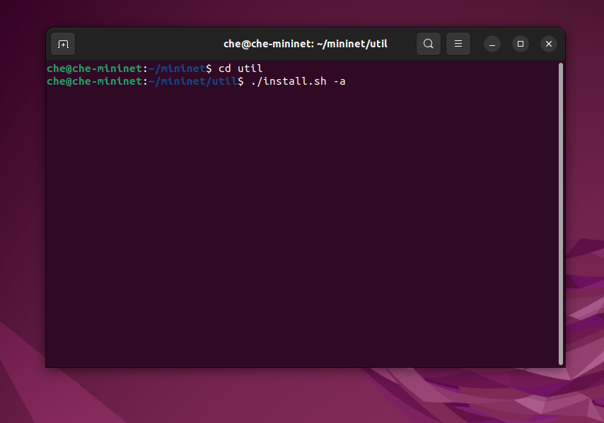
Figure 1 Installing Mininet

The second step was to install Ryu, which again was setup from a git clone of the GitHub repository (https://github.com/faucetsdn/ryu), this was done through the setup python script.
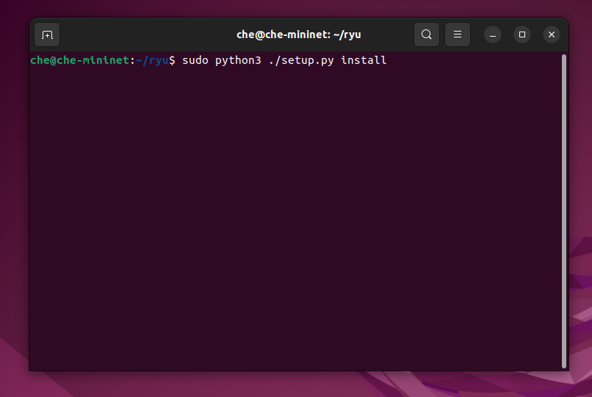
Figure 2 Installing Ryu

The third step was to install Wireshark, which will possibly be used to investigate network data later down the line, this was done through using apt-get.
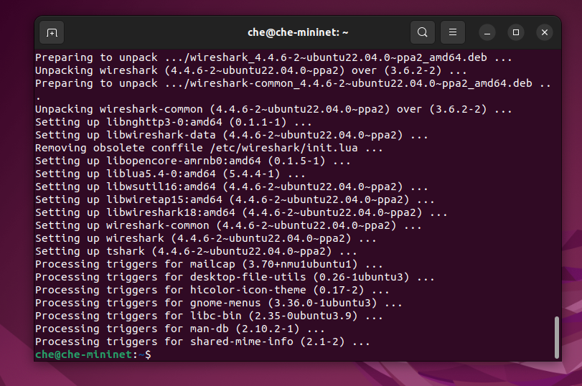
Figure 3 Installing Wireshark
The fourth step was to clone the GitHub repository [12] that is intended to be used for the Ryu controller and DDoS detection, we will only be using the Ryu controller and the dataset from this, this project will build its own topology, but will still utilise ping and hping3, like the project there.
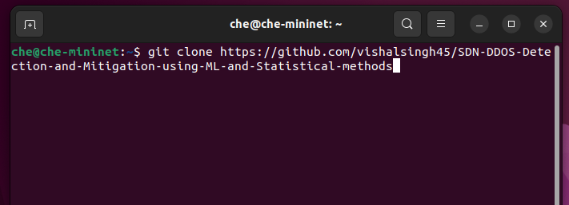
Figure 4 Cloning GitHub Repository

The next step was to create my topology within Mininet and link it to the Ryu controller, this was done through Python and was as previously mentioned, 2 switches with 5 hosts each. The network will be on 10.10.1.0/24.
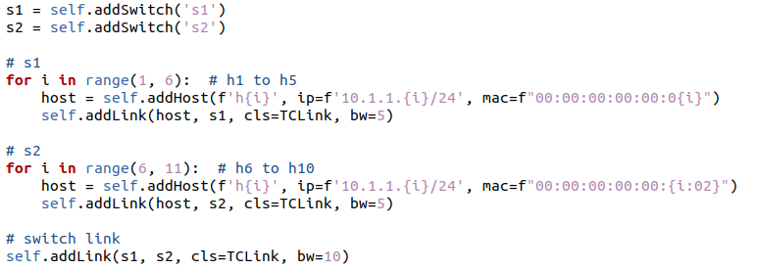
Figure 5 Creating the Topology
To link the network to the Ryu controller, the Ryu controller code was checked, and it was hosted on 127.0.0.1, so the topology was pointed towards that controller as c1.
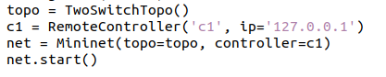
Figure 6 Linking to Ryu Controller
The next step is to start both the Ryu controller and the Mininet topology, since the Ryu controller automatically logs data and the flow counts, there will be no need for anything else to be open, as they can be analysed separately later.
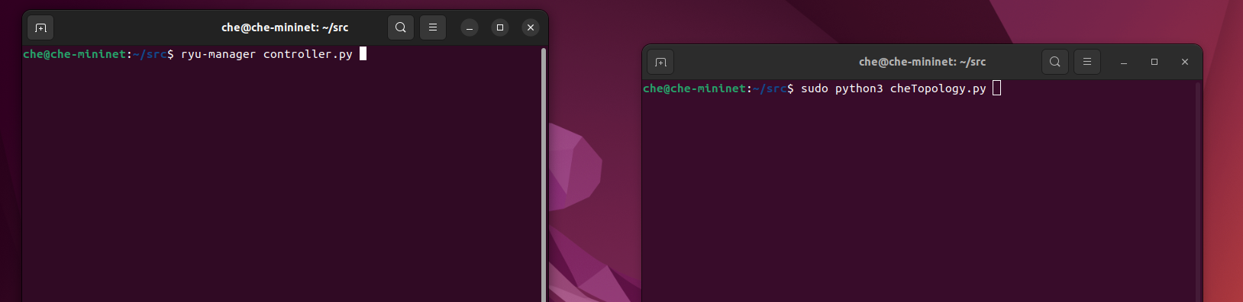
Figure 7 Starting the Controller and Mininet Topology

The next step was to test if the detection works, to do this h1 pinged h2 normally for a while to make sure it could detect normal traffic without a false positive, which was fine so then moved on to testing if it could detect an attack. The included attack.sh file was used here, which begins an ICMP flood (ping packets), from random addresses at increasing intervals with a total of either 1000 or 500 packets.

After running them both and switching to letting it run an attack through hping3, it seemed as if it detected the attack traffic almost immediately and flagged it up as attack traffic.
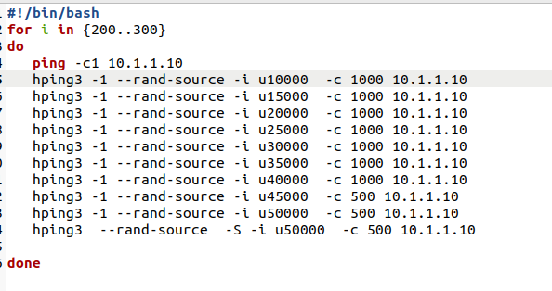
Figure 8 attack.sh
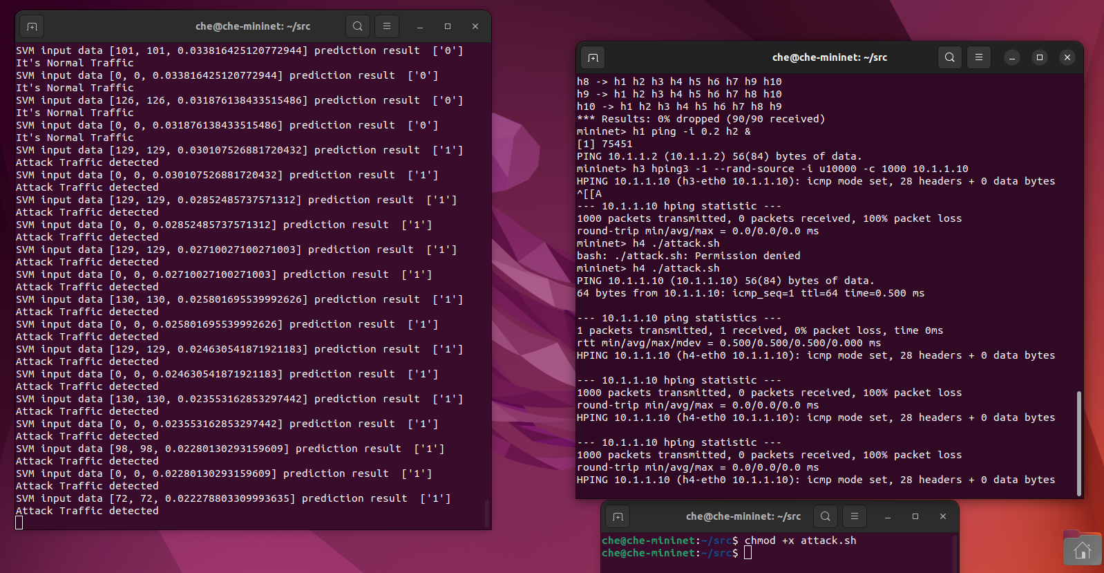
Figure 9 Mininet and Ryu Controller Running
The generated csv files, switch_1_flowcount.csv and switch_2_flowcount.csv and the dataset, result.csv, are then moved to a local machine for analysis at a later date.

Figure 10 Files

Conclusion
This chapter went through the design and implementation of the setup that will be used to examine a DDoS detection strategy within an SDN environment. The challenge of detecting attacks on the control plane were addressed through the creation of a controlled and simulated network using Mininet and an open source Ryu controller that was found on GitHub that included machine learning based detection and logging methods, including its own dataset.

A custom network topology was created for the project, which consisted of 2 switches and 10 hosts (5 hosts each) and both normal and attack traffic was successfully generated and tested against the SDN controller to ensure that they work before the experiment takes place. Tools like hping3 will be used as well to simulate an ICMP attack. Each step was documented to create a series of reproduceable steps.

As the preprogrammed Ryu controller logs flow counts into a CSV file, it means that the analysis to be completed later will be easier than expected as an evaluation of the detection method can be done quicker. The virtualized SDN environment is now ready for the controlled experiment and analysis, with everything set in place ready to go. The next chapter will now build upon the setup and will carry out the experiment properly, not just a once run over as a test.

Chapter 5 – Testing and Evaluation

5.1 INTRODUCTION
This chapter will outline the testing and evaluation phase of the project. It will document the commands and procedures used during the experiment and will show the process using screenshots. It will describe what is happening through each phase of testing so that it can be reproduced easily. The goal will be to validate that the selected DDoS detection solution can determine what is normal traffic and what is attack traffic.

5.2 Normal traffic testing
To test that the Ryu SDN controller can successfully determine what is normal traffic without flagging it up as attack traffic mistakenly, simple normal ping echo requests were sent between h1 and h2 within the Mininet environment. This was to ensure that the DDoS detection would not mistakenly start blocking ports if that was enabled if it was not necessary, leading to users being blocked for no reason and disrupting network traffic without an attack even being launched.
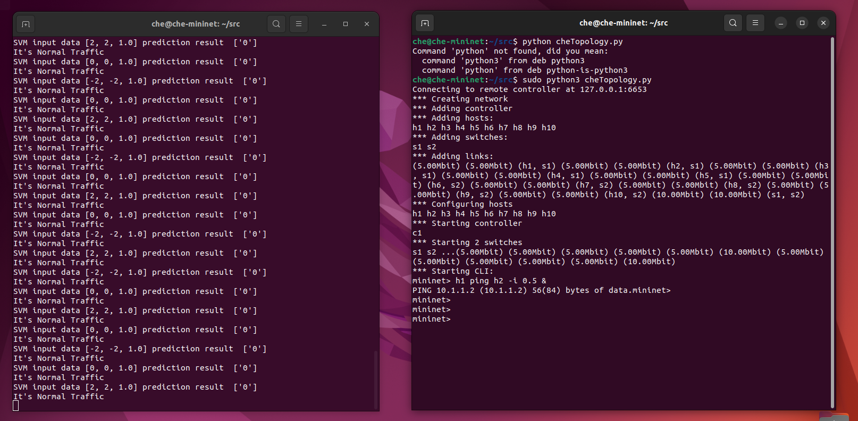
Figure 11 Host 1 pinging Host 2, SDN traffic shown on left
This test involved the first host pinging the second host which generated continuous ICMP echo packets between the two that attempt to represent normal traffic within a network. During this, the detection in the Ryu controller was monitored to observe what it was classing the activity as.

It was shown that the detection classed the activity as normal traffic, showing that it does not think they are suspicious based off the traffic and has not classed it as an attack, so there are no false positives at this point in the test.

5.3 ATTACK TRAFFIC TESTING
To simulate a DDoS attack on the network, a script ‘attack.sh’ was executed on h3. This script uses hping3 to flood the controller with ICMP packets from randomly generated fake IP addresses, which attempts to mimic a distributed attack. This test is to see whether the detection can identify the sudden huge change in traffic and flag it correctly as an attack.

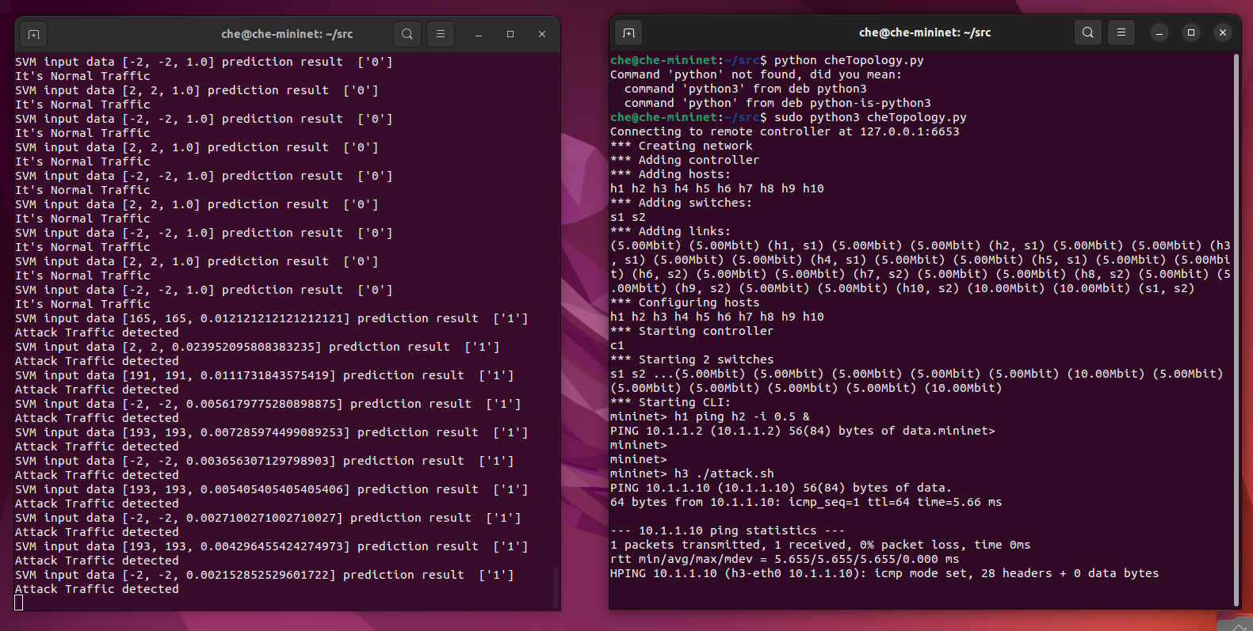
Figure 12 Host 3 performing an ICMP flood on the SDN controller
When launching the hping3 script on host 3, the network started receiving an extremely high amount of traffic, as the detection on the SDN controller is fed a dataset of a similar type of attack, it immediately flagged the newly received traffic as attack traffic.

It was observed though multiple tests that sometimes the detection can be a bit slower than you may expect, it may take 3 or 4 updates on occasion for the traffic to be flagged as attack traffic, sometimes it may show that it’s still normal traffic, but does adjust accordingly quite quickly. In this run though, there were no delays and nothing was classified incorrectly.

5.4 DATA COLLECTION
During the test, the protection on the Ryu SDN controller automatically generated some CSV files that logged flow statistics, and one already came included that was the dataset for the detection, these files were:
- Switch_1_flowcount.csv, recorded flow counts and timestamps for Switch 1
- Switch_2_flowcount.csv, recorded flow counts and timestamps for Switch 2
- Result.csv, the dataset that is used to detect an attack

Figure 13 Switch_2_flowcount.csv – same format as Switch_1_flowcount.csv


Figure 14 result.csv
These CSV files will be used shortly for analysis, so that we can see why it’s detecting what it’s detecting and how it came to that conclusion and what the flow counts mean and such. The dataset in result.csv can also be studied and we can gather how it comes to the conclusions that it does. They can also be used for seeing how traffic volume changes during normal traffic and attack traffic.

5.5 TESTING SUMMARY
The testing phase has demonstrated excellently how effective machine learning DDoS detection can be on SDN when combined with machine learning. Normal traffic was handled without any issues and was not flagged mistakenly and when the controller was suffering from an ICMP flood attack, the detection correctly identified the traffic as attack traffic immediately. Data was also logged as you would expect, providing a solid foundation for the upcoming analysis.

5.6 FLOW COUNT ANALYSIS
The flow count log files from both switches (switch_1_flowcount.csv & switch_2_flowcount.csv) showed a stable flow count of 71 during normal traffic conditions with no significant increase of change in those values, which confirms that the network operated as expected prior to the launch of the DDoS attack.

Figure 15 & 16 Flow count under normal traffic and attack traffic
As soon as the DDoS attack was launched, it showed a sharp and steady increase in traffic, where it was then flagged as attack traffic on the Ryu controller, but is still quite low for a DDoS attack, perhaps due to only host 3 launching an attack, it would have been much higher had multiple hosts been attacking the controller at the same time. Only the flow count from switch 1 was shown here as both files contained pretty much the same conclusion. This proves that the detection was able to identify an attack based solely on statistical changes within the network.
5.7 DATASET ANALYSIS
The core dataset, result.csv, includes a dataset performed on a similar setup provided by the author of the detection and Ryu controller. This is worth analysing as we can attempt to figure out how the attacks were detected using that dataset. The format of the file is shown below:

Figure 16 result.csv
Reading through the python code for the detection within Ryu controller, the columns are as follows:
- Column A is Speed of Flow Entries (sfe), the change rate of flow entries
- Column B is Speed of Source IPs (ssip), number of new unique source IPs
- Column C is Ratio of Flow Pairs (rfip), ratio of bidirectional flows
- Column D is Type, labels whether it’s an attack or not, 0 = normal and 1 = attack

A quick analysis of those columns provided me the following:
Feature | Normal (average) | Attack (average)
Sfe | 6.33 | 67.62
Ssip | 4.89 | 67.61
Rfip | 0.97 | 0.0001

There is quite a difference in those numbers when compared to normal and attack traffic. Both sfe and ssip tend to surge during attacks, due to the sudden appearance of new flows and source IP addresses whilst the rfip value dropped dramatically, which is quite consistent with DDoS attacks as bidirectional traffic usually yields a higher number as hosts are replying to each other whilst DDoS attacks cause no reply due to the devices being overwhelmed, leading to one-way traffic, leading to an extremely low number.

5.8 evaluation
The outcome of both the testing and the analysis phase seem to support the effectiveness of the machine learning detection method. The detection method demonstrated:
- High sensitivity to attack patterns, it detected attack traffic quickly and consistently
- No false positives, proven by correctly flagging consistent and steady ICMP traffic with a high rfip as normal
- Effective dataset, all 3 given parameters (sfe, ssip, rfip) were useful and were a great choice in telling the difference between attack and normal traffic
The findings here are in alignment with some of the literature previously reviewed that was also on machine learning, particularly the ones that focused on flow-based analysis, granted they were on a larger scale than this. The fact that this detection approach relies on statistical behaviour can also allow it in the future to adapt to varying attack patterns.

This experiment proves that flow-level analysis in combination with machine learning can offer a practical and efficient approach for DDoS detection in SDN environments.

Chapter 6 - CONCLUSIONS AND RECOMMENDATIONS

Summary
The project has investigated the detection of DDoS attacks that target the control plane of SDNs. It began with a systematic literature review covering primarily SDN architecture and methods of DDoS detection that are quite common and have been researched and proposed in the past, how they work and how successful and efficient they are at detecting and sometimes even mitigating attacks. The three detection methods explored were Intrusion Detection Systems, anomaly-based methods and machine learning methods, with each method evaluated based on how well the research performed.

The methodology went over how the experiment would be done moving forward, ending up that the project would follow a positivism, deductive, experimental and quantitative approach. It also briefly touched on the tools that would be used for the project, but this was mostly in the design stage.

In the design stage, it was said that the project would be done on a virtual testbed using Mininet and a modified Ryu SDN controller that would include an open source built in DDoS detection method that used flow-based statistical analysis and machine learning. A topology was then created to be used to test the detection under normal and attack traffic.

The testing and evaluation stage showed the detection’s ability to determine which was normal and attack traffic. Normal traffic was correctly identified and so was an ICMP-based DDoS attack on the controller, both identified consistently and correctly without any false positives. Analysis of the dataset used by the detection showed that there were a fair few metrics used to determine what traffic was what and looking at the flow counts from the testing, did extremely well.

Overall though, the project did quite well in bridging what was learned in the literature review and the practical implementation, showing that what was learned about machine learning was correct and is quite reliable when simulated.

Conclusion
The project aimed to explore and evaluate existing methods for detecting DDoS attacks that targeted the control plane of SDNs. Through using a systematic literature review, multiple detection strategies were identified and analysed, highlighting whilst traditional methods may be useful, with SDNs being as dynamic as they are, they tend to benefit more from more real-time solutions like a machine learning approach due to their high speed, high accuracy and ability to adapt. They can also work even better when integrated with other methods like decision trees or statistical analysis.

A simulated SDN environment using Mininet was then created using a modified open source Ryu controller which was capable of both statistical and machine learning DDoS detection. Normal and attack traffic were simulated, and the flow count was recorded to evaluate how well the detection worked. The results showed that the detection method could accurately tell the difference between normal and attack traffic.

The project successfully met the aim of evaluating a DDoS detection method in SDNs. The method used showed quite promising results, like the conclusions shown from the literature review. Machine learning techniques, especially when used with some flow-based features, proved effective both in the test shown here and in the literature for DDoS detection in an SDN environment.

6.3 RECOMMENDATIONS for Further Research

The project produced some good results, but there are areas where future development and research could be made:
- Covering different types of attacks would be a good start, this testing focused primarily on ICMP flood attacks. In the future the detection model could work to include other types of attacks like TCP SYN floods, HTTP floods and low-rate DDoS attacks, like what was covered in the literature review.
- Real-time mitigation could be tested, the protection that came with the Ryu controller did support this but was not tested, rate limiting or port blocking could be introduced for this.
- Potentially a hybrid detection model could be tried next time, combining the machine learning and statistical analysis approach with anomaly-based detection could potentially further improve the accuracy.
- Testing on a bigger scale would be useful, the Mininet test was limited in its size and may not reflect how it would work on perhaps an enterprise network, so a larger scale could tell how useful the detection would be in a real-world situation.
- Attempting to try this on a controller that isn’t Ryu, like ONOS or OpenDayLight potentially as most in the literature review also used Ryu for their experiments and testing.

Further expanding on those areas, and others, would contribute to building more reliable and even more intelligent SDN infrastructure, especially as DDoS attacks continue to get more and more sophisticated.

Chapter 7 - REFLECTIONS
The aim of this project was to investigate and test methods of detecting DDoS attacks that target the control plane within SDNs. Reflecting on the project though, the objectives set out at the beginning of the project were achieved and the project progressed quite well into a decent investigation with both a dive into literature and a good go at practical testing.

In terms of the objectives:
- Conduct a literature review of current DDoS attack detection methods focused on the control plane in SDN: This was achieved quite well, quite a range of studies were reviewed, not as many as I would have liked, but the categories that were covered set a solid foundation for the rest of the project.
- Identify, justify and apply research methodologies to analyse and compare existing DDoS detection techniques: This was also achieved, the selected methodology I feel were appropriate for this project and made sure that the project followed the right lines all the way through.
- Organise and explain existing DDoS detection methods based on their architecture, detection approach and performance: This was also achieved, each method reviewed in the literature review went into quite a bit of detail into how they worked and how effective they were, comparing each at the end and identifying which were the best for the job and why.
- Critically analyse the strengths, limitations and effectiveness of the identified DDoS detection methods: This was achieved, the testing and evaluation stage of the project supported what was found out during the literature review and allowed for a good look at the advantages and disadvantages of a machine learning approach, focusing more on statistics than was first thought.
On a more personal level, the project went smoothly but did have its challenges. The most notable hurdle that was faced during the project was the fact that Ryu just flat out refused to work on Ubuntu 24.04, meaning that everything that was done the first time around had to be completely scrapped and the OS had to be reverted to an older version in Ubuntu 22.04.

Another challenge was trying to understand the Python code used for the Ryu controller which included the detection method, I had never personally worked with Ryu or Mininet before this, whilst I am quite familiar with Python, it was a huge learning curve. The fact that it was found and utilised here though was a life saver and really made things easier.

The use of the pretrained model worked extremely well as it also logged the flow count statistics in real time, allowing for a nice and easy analysis.

Time management was mostly effective, some things I did later than I would have liked, but most ended up being on schedule and I didn’t need to reschedule too much.

chapter 8 – REFERENCEs

[1] S. Banerjee and P. S. Chakraborty, "To Detect the Distributed Denial-of-Service Attacks in SDN using Machine Learning Algorithms," 2021 International Conference on Computing, Communication, and Intelligent Systems (ICCCIS), 2021. doi: 10.1109/ICCCIS51004.2021.9397068.
[2] A. K. Tahirou, K. Konate and M. M. Soidridine, "Detection and Mitigation of DDoS Attacks in SDN Using Machine Learning (ML)," 2023 International Conference on Digital Age & Technological Advances for Sustainable Development (ICDATA), 2023. doi: 10.1109/ICDATA58816.2023.00019.
[3] M. A. Setitra, et al., "Toward Delegating the Detection of DDOS Attacks to the SDN Data Plane: A Security Perspective," 2023 20th International Computer Conference on Wavelet Active Media Technology and Information Processing (ICCWAMTIP), 2023. doi: 10.1109/ICCWAMTIP60502.2023.10387071.
[4] W. Sun, Y. Li and S. Guan, "An Improved Method of DDoS Attack Detection for Controller of SDN," 2019 IEEE 2nd International Conference on Computer and Communication Engineering Technology (CCET), 2019. doi: 10.1109/CCET48361.2019.8989356.
[5] M. E. Ahmed and H. Kim, "DDoS Attack Mitigation in Internet of Things Using Software Defined Networking," 2017 IEEE Third International Conference on Big Data Computing Service and Applications (BigDataService), 2017. doi: 10.1109/BigDataService.2017.41.
[6] C. Gonzalez and S. M. Charfadine, "IoT Flooding Attack Defense in SDN: A Real-Data Machine Learning Approach," 2023 1st International Conference on Advanced Engineering and Technologies (ICONNIC), 2023. doi: 10.1109/ICONNIC59854.2023.10467864.
[7] A. A. Alashhab, et al., "Online Machine Learning Approach to Detect and Mitigate Low-Rate DDoS Attacks in SDN-Based Networks," 2023 IEEE International Conference on Artificial Intelligence in Engineering and Technology (IICAIET), 2023. doi: 10.1109/IICAIET59451.2023.10291787.
[8] A. M. Mankawade, et al., "A Dynamic Framework for DDOS Attack Detection and Mitigation in Software Defined Network Using Machine Learning," 2024 International Conference on Intelligent Systems for Cybersecurity (ISCS), 2024. doi: 10.1109/ISCS61804.2024.10581222.
[9] H. Alomin, A. Gargouri and M. Ali Ghorbel, "Enhancing Network Security in SDN: Detecting Low-Rate DDoS Attacks Using Decision Trees," 2024 IEEE International Conference on Advanced Systems and Emergent Technologies (IC_ASET), 2024. doi: 10.1109/IC_ASET61847.2024.10596216.
[10] K. Alhamami and S. Albermany, "DDOS attack detection using machine learning algorithm in SDN network," 2023 Al-Sadiq International Conference on Communication and Information Technology (AICCIT), 2023. doi: 10.1109/AICCIT57614.2023.10218194.
[11] B. Isyaku, et al., "Performance Comparison of Machine Learning Classifiers for DDOS Detection and Mitigation on Software Defined Networks," 2023 IEEE International Conference on Automatic Control and Intelligent Systems (I2CACIS), 2023. doi: 10.1109/I2CACIS57635.2023.10193601.
[12] V. Singh. "SDN-DDOS-Detection-and-Mitigation-using-ML-and-Statistical-methods." GitHub. https://github.com/vishalsingh45/SDN-DDOS-Detection-and-Mitigation-using-ML-and-Statistical-methods

GLOSSARY
DDoS – Distributed Denial of Service
SDN – Software Defined Networking
SDNs – Software Defined Networks

