MSc Digital Transformation
For the Health and Care Professions
BMDS7005

Evaluating Optimal Use of SystmOne in Medium-Secure Mental Health Care

Dissertation submitted in partial fulfilment of the award of
Master of Science in Digital Transformation for the Health and Care Professions

Dr Stephen Djeagbo
2211947
6 May 2025

Acknowledgements

This dissertation was made possible by the generous contributions of many individuals in my professional and private life.
I would like to first and foremost extend my deepest appreciation to my supervisor, Mr Edward Conley, who showed genuine interest in this study and my personal development. His constant encouragement, constructive criticism and mentorship were instrumental in producing this work. Additionally, his continued prompting and encouragement throughout the course got me this far. Without Ed, I would most certainly have given up due to extreme demands at work and home. His dedication to the cause is deeply appreciated.
I am also indebted to all Healthcare Professionals at Langdon Hospital and Devon Partnership NHS Trust who took time out of their busy schedule to respond to the survey and their willingness and enthusiasm in sharing their insight, expertise and experience with me for this study. The feedback and suggestions received were very helpful. Of particular note are Mr Rafael Sorribas, Ms Jean Simpson, and Ms Tracy Hedgley for the extra discussions and support provided.
On a personal note, I want to thank my wife, Dr Philomina Poku, for her unwavering belief in my abilities and her constant encouragement. Her love and support propelled me to go on when the going got tough. I say thank you for being there for Dewi and me.
To my parents, Mr and Mrs Djeagbo and family, thank you for the love and various contributions that have helped shape my life to this day.

TABLE OF CONTENTS
1 INTRODUCTION ……………………………………………………………… Page 4
2. PROJECT AIM.............................................................................................. Page 6
3. PROJECT OBJECTIVES……………………………………………………… Page 7
4. LITERATURE REVIEW.……………………..………………………………... Page 7
5. METHODOLOGY……………………………………………………………... Page 11
6. RESULTS……………………………………………………………………… Page 15
7. DISCUSSION………………………………………………………………….. Page 45
8. STRENGTHS AND LIMITATIONS………………………………………… Page 49
9. CONCLUSION AND RECOMMENDATIONS…………………………… Page 50
10. REFERENCE LIST…………………………………………………………… Page 50
11. APPENDIX – DISSERTATION PLAN …………………………………….. Page 53
12. APPENDIX- ETHICS FORM………………………………………………… Page 58

DECLARATION
I declare that this dissertation was produced by me and did not include work generated by Artificial Intelligence (AI) or an external agency.
1. INTRODUCTION
Devon Partnership NHS Trust (DPT) is an NHS organisation in the Southwest of England, serving people in Devon and the wider South West Region with mental health, learning disability, and neurodiversity needs. Services encompass a wide range of specialties, including secure care at Langdon Hospital.
The Langdon Hospital, located in Dawlish, Exeter, provides low and medium-secure care for males with mental health difficulties who have come into contact with the legal system in the United Kingdom. The Dewnans Centre at Langdon Hospital serves as the Medium Secure Unit, whereas Chichester House serves as the Low Secure Unit. The offences committed by these patients are often considered serious and include both violent and non-violent offences like murder/homicide, grievous and actual bodily harm, sexual offences, stalking and harassment, hostage taking and common assault, just to name a few. This group of patients, who by definition are high-risk individuals, receive appropriate and tailored treatment in a safe and secure environment. The Dewnans Centre, therefore, serves as the foundation for these high-risk individuals needing medium-secure care. At any given time, there are about 450 people within the area who require low or medium-secure mental health care. (Devon Partnership NHS Trust, 2023).
The healthcare professionals involved in the care of these high-risk but vulnerable individuals include Consultant Psychiatrists, Specialty Registrars and Clinicians, Mental Health Nurses, Psychologists, Occupational Therapists, Physical Therapists, Pharmacists, Social Workers, Chaplaincy, Advocates, Administration Staff and Security personnel within the organisation. These professionals work closely with other professionals within secure services across the country (High, Medium and Low Secure Hospitals), the NHS and others outside the NHS, namely, prison officers, solicitors, judges, lawyers and police officers.
To improve patient care, healthcare facilities and IT functionality in the Southwest of England, Devon Partnership NHS Trust replaced CareNotes Electronic Care Record with SystmOne (Electronic Health Care Record) EHR in November 2023 to support its digital transformation. This was a significant milestone in the One Devon Vision: ‘’ equal chances for everyone in Devon to lead long, happy and healthy lives’’. (Devon Partnership NHS Trust, 2023)
The introduction of SystmOne EHR to Mental Health Services in Devon aimed to ensure the unification of electronic patient records and standardisation of care pathways within Devon and the entire Southwest. The platform provides a connected and integrated care record across the different services in the region, including Mental Health, General Practices, Community, Urgent Care and Maternity services. This approach improves coordination among healthcare professionals and ensures a more comprehensive understanding of patients’ needs. (TPP SystmOne EHR, 2023).
The planned change of electronic care record from CareNotes EHR to SystmOne EHR did not, however, go as planned. Before its introduction in November 2023, many of the healthcare professionals at the Dewnans Centre of Langdon Hospital had mixed feelings about the proposed Electronic Health Record. This was partly because they had become accustomed to the previous platform (CareNotes EHR) and were hesitant about a new system which were expected to come with its challenges. A more significant problem at the time was the fact that the majority of health professionals who were the proposed users of the new electronic care record (SystmOne EHR) knew very little about the platform. They were hardly involved in discussions, and up until the day SystmOne EHR was introduced, the professionals were not sure if SystmOne EHR would indeed go live. This led to a state of anxiety and panic among the healthcare professionals on 1 November 2023 when SystmOne EHR went live.
Since its introduction, the majority of healthcare professionals have raised concerns about the way it was introduced and the overall functionality of SystmOne EHR. There has been confusion among different teams and within teams about how different tasks should be performed. This has resulted in the loss of information, especially when patients move teams. Also, accessing old records has been challenging for the healthcare professionals who have to use a long, winding process to retrieve information, which sometimes results in the platform freezing. As a result, many healthcare professionals stopped trying to retrieve this vital piece of patient record and have resorted to locally saved data or information from colleagues.
Rich Picture.
The context of what has been described above has been illustrated with a rich picture in figure 1 below.
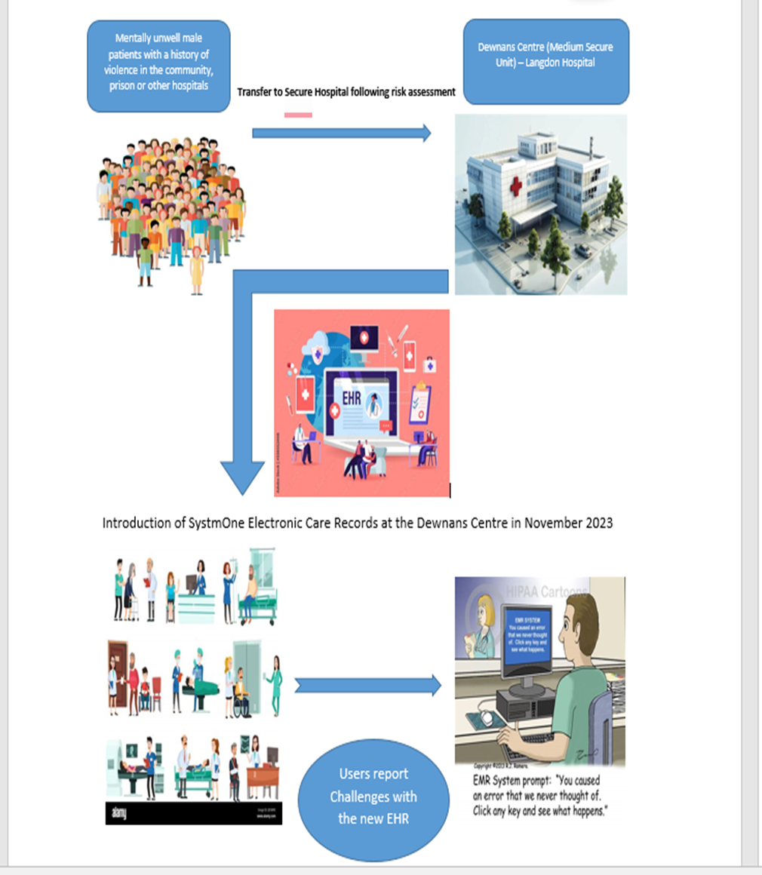
Figure 1- Rich picture illustrating the context of the problem situation at the Dewnans Centre (Medium Secure Unit) – Langdon Hospital.
2. AIM OF THE STUDY
In a Medium Secure unit, the challenges outlined in the preceding section could result in or have resulted in dire consequences for the healthcare professionals, the patient under their care and the wider public.
Therefore, the primary aim of this study is to evaluate the optimal use of SystmOne EHR within this unique secure setting, focusing on how well it meets professional needs, supports patient care, and integrates with the workflows of varied healthcare professionals.
3. OBJECTIVES.

To achieve the aim stated above, the study will focus on the following objectives:
- To document the benefits, limitations and challenges encountered by the users of SystmOne EHR since its introduction and rollout at the Dewnans Centre (MSU) - Langdon Hospital
- To evaluate the usability of SystmOne EHR at the Dewnans Centre (MSU)-Langdon hospital
- To evaluate the attitudes of the Healthcare Professionals at the Dewnans Centre (MSU) towards the use of SystmOne HER as well as the support systems in place.
- To identify the alignment between individual roles, tasks, and technology use.
Achieving these objectives would provide valuable evidence and insight into the planned implementation and use of SystmOne EHR and the challenges thereafter.

4. DIGITILISATION IN MENTAL HEALTH SERVICES WITH A FOCUS ON SECURE CARE.
Mental disorders, including substance misuse disorders, are a global concern as they contribute to the financial burden on patients, their families and communities. Comorbidity with other medical conditions and lower life expectancy have been associated with individuals with mental illnesses. (Busch AB et al, 2018)
Globally, they remain a leading cause of disability, leading to a significant reduction in their quality of life. They cannot participate in production and labour due to losing control of their consciousness and behaviour. It is therefore an area that needs attention and improvement. (Wu Y et al, 2023)

With the advancement of digital technologies, electronic health records have become the preferred method for recording, storing, retrieving and collating health records. (Samadbeik et al, 2020). Worldwide, the interest in Electronic health records cannot be overestimated. The potential to improve the quality of care as well as reduce the cost involved is a major factor for this interest. Apart from improving the quality of care, they also reduce negative outcomes for patients as well as improve clinical research and its benefits. (Boonstra et al, 2014)

Other ways in which Electronic Health Records improve patient safety include the use of alerts and reminders, quick access to patient information, clear risk documentation, and increased time with patients due to decreased time with paper documentation. (Upadhyay, S (2022)
Despite the known benefits of electronic health records on patient outcomes, their introduction to psychiatry services, particularly forensic psychiatry, has been slow and delayed and often met with challenges from providers, healthcare professionals, software, and hardware. This has often led to problems like a lack of access to important patient information for healthcare professionals in the field. Also, the exchange of information between psychiatry services and other services is difficult and delayed due to the new models of healthcare coordination and integration. (Busch AB et al, 2018).
In forensic psychiatry, technological advancement has reduced the use of paper for data storage and transfer, taken away problems with illegible handwriting and improved coordination of processes which are key components in delivering high-quality forensic mental healthcare. Additionally, Electronic health records provide real-time measurement of standards set down by regulatory bodies and therefore improve compliance with these legislative standards of care. They therefore improve safety measures. If used effectively, Electronic Health Records can make the community safer for all. An independent enquiry in the UK, after a homicide, revealed the lapses in information sharing that could have prevented the sad event. (Mohan D, 2023)

The implementation and use of applications and software, however, do not come without challenges. It is therefore prudent to review the first-hand experiences of healthcare professionals to identify the costs and benefits of implementing these Electronic Health Records. Some challenges documented in the literature include the time-consuming nature of Electronic health records, reduction in face-to-face interactions with patients, lack of an integrated electronic health record system resulting in different facilities using their own electronic health records and complexity of the system. (Upadhaya, S. 2002).
The successful implementation of Electronic health records is largely dependent on usability and fit with clinical processes. Additional challenges are encountered in mental health settings due to the personal and detailed nature of assessments carried out. (Zurynski Y et al, 2020)
Several factors have been identified as contributory factors towards the success or failure of a change. These are grouped into individual factors, technology or tools available and task-related challenges. A user’s attitude towards change and technology, their skill set and other factors will contribute to the use of the new technology. In addition, the task to be performed is complicated and time-consuming will act as a challenge. The availability of the hardware needed to assess the technology could also play a vital role. (Ammenwerth Et al 2006). Other challenges include confusing displays and layouts on screens, extraneous information and burdensome workflow sequences. (Ratwani et al, 2018)
Research has shown that health professionals spend a considerable amount of time entering data gathered from interactions with patients. For example, physicians in ambulatory care have been reported to spend only 27% of their time with patients and 49% of their time on Electronic health records and desk work. Another study showed that primary care physicians spent 52% of their time on Electronic health records tasks. This time-consuming nature of data input has increased the need for medical scribes and secretaries, which adds to the cost of running healthcare facilities. Additionally, therapeutic relationships are known to be affected when the practitioner takes down notes on a computer during the session. This has been put down to the fact that the therapist cannot maintain good eye contact and show empathy while looking at a screen and keyboard. (Roth Et Al, 2021)

For a successful implementation of a major project like SystmOne EHR, a detailed process must be followed to support the various stakeholders. The period of transition, known as cutover, is critical to the success of this change, as it could lead to a lot of service disruptions. This is even more critical in secure service. The process to ensure a smooth transition includes preparation activities, stakeholder training, preliminary activities for the cutover day, and activities for the cutover day itself, ongoing support for users and testing of the plan. Following its implementation, it is expected that a team of experts will continue with process optimisation, remote assistance, as well as ward-based support, especially in the early weeks of implementation. For technology to be adopted fully, there need to be adaptation of work practices, reorientation, and organisational change far beyond what is initially apparent. (Tsiknakis et al 2009).

Training opportunities for health care professionals on the use of electronic health records also play a major role in the successful implementation and use of the software. (Samadbeik et al 2020)

Usability is defined as ‘’the extent to which the technology can be used efficiently, effectively, and satisfactorily based on system design, as well as how it’s customised in the clinical environment to the specific workflows that clinicians employ’’ (Ratwani et al, 2018). When usability is improved, it will lead to the improvement of care and safety, as well as reduce the risk of errors. This efficiency will allow health care professionals to spend more time with their patients. It is therefore key for Care providers to ensure that the software and applications introduced are usable. (Kern et al, 2012).
Literature Search
For this study, a number of databases were visited online. The most used database was PubMed. Other databases visited were psych info, Ebooks, Medline, google, journals and other online libraries like the online library for the University of Wales Trinity Saint David and the Royal College of Psychiatrists. A search was done with the following words of ‘’Electronic health record’’, ‘’Psychiatry’’ and ‘’secure care’’. These returned a combined number of eight thousand, four hundred and forty-one (n=8441) articles, journals and books. Seven thousand, nine hundred and eighty-five (n=7985) of these were from the databases and four hundred and fifty-six (456) were from other internet searches on Google and other search engines. After screening, duplicates were removed. Further screening of the two thousand and fifty-six remaining articles revealed one thousand, eight hundred and two (1802) articles with no relevance to the topic. Two hundred and fifty-four (254) of the remaining articles had full texts. Two hundred and seven of these were excluded based on various reasons like the texts not being available and others not relevant to this study. The remaining 47 articles were included in the final literature review. The PRISMA flow chart (Figure 1) below illustrates the processes involved
Figure 1. PRISMA flow chart
Number of additional records identified through searching other sources (Google, online libraries (UWTSD, RCpsych, DPT)
N=456

n=23

Records identified through database search
(National Library of medicine, PubMed, Cochrane library, Psych Info)
n= 7985

Identification

Number of records after duplicates removed
n=2056

Number of obviously irrelevant reports excluded
n= 1802

Number of records screened
n=254
Screening

Full-text articles excluded with reasons
(full text not accessible, not in English)
n=207

Number of full-text articles assessed for eligibility
n= 47
Eligibility

Studies included in this study.
n= 67
Included

5. METHODOLOGY

This study employed a primarily qualitative method approach to provide a better understanding of the optimal use of SystmOne EHR within the unique secure setting, focusing on how well it meets professional needs, supports patient care, and integrates with the workflows of varied healthcare professionals.

The methodology chapter outlines the study's design, detailing the approaches used, the recruitment of participants, the data collection tools, analysis and the limitations of the method used.

Study Design.
This study adopted a primarily qualitative design, supported by some descriptive quantitative data, to explore the use of SystmOne EHR within a secure mental health setting. A cross-sectional approach was used to gather rich insights into the lived experiences of healthcare professionals at the Dewnans Centre (MSU) – Langdon Hospital. Data were collected through an online survey containing both structured (multiple-choice and Likert-scale) and unstructured (open-ended) questions, as well as two in-depth unstructured interviews. The survey provided contextual quantitative data, while the open responses and interviews formed the core of the qualitative analysis. This approach enabled a nuanced understanding of how SystmOne EHR supports or hinders daily clinical workflows. The study was informed by the FITT framework (Fit between Individuals, Task and Technology), which guided both data collection and analysis by helping identify key factors influencing adoption and usability of the EHR system

Population of Study Participants.
The population of interest for this study was all healthcare professionals at the Dewnans Centre (MSU)-Langdon Hospital who use SystmOne EHR in their daily work. This includes Consultant Psychiatrists, Specialty Registrars and Clinicians, nursing staff, Pharmacists, Social Workers, Psychologists, Occupational Therapists, Physical Therapists, Physiotherapists, Information Technologists, Speech and Language Therapists, and Administrative staff.

In addition to the above group, the Chief Information Officer of Devon Partnership NHS was included in the study.

Sampling Methods.
After identifying the population of interest for the study, the various methods of sampling were considered. Due to time constraints, multiple non-probability sampling methods were employed to get the best insight for the study. Below are the sampling methods used.
- Voluntary Response Sampling - This was identified as a suitable method for the study due to limited resources and the unique nature and small size of the population. To do this, all healthcare professionals who use SystmOne EHR at Dewnans Centre (MSU) of Langdon hospital were invited to take part in the survey, and all volunteers who responded were included in the study.
- Mixed method of Purposive/Convenience Sampling- Following the introduction of SystmOne EHR at Langdon Hospital in November 2023, a group of volunteers at the hospital who use SystmOne EHR came together to form a group called SystmOne EHR Champions. These SystmOne EHR Champions who have shown an interest in the successful implementation of SystmOne EHR have the knowledge, experience and skills in the specialist field. They have also been involved in the complaint processes and have helped users at Langdon Hospital resolve problems around SystmOne EHR Use. A convenience sampling method was used to form a focus group consisting of two members of the SystmOne EHR Champions. To form this group, the leader of SystmOne EHR Champions was contacted for a discussion on the implementation of SystmOne EHR. After she understood what the study was about, she invited another member of the group who she felt would contribute immeasurably to the study. An unstructured interview was therefore scheduled for 13 February 2025.

- Purposive Sampling- In identifying a highly resourced person with extensive knowledge on the implementation of SystmOne EHR at Langdon Hospital, a purposive sampling method was employed. The Chief Information Officer of Devon Partnership NHS Trust was identified on the Trust website and contacted for a meeting to gather his views on the topic.

Data Collection.
Data collection was done in parts and stages to allow proper understanding of the situation and to help frame the questions for the survey. Two unstructured interviews with resource persons were the main sources of qualitative data. A third source of data gathering was with a survey. This section will outline the forms and details of the data collected, as well as the time they were gathered.

- An in-depth unstructured interview with the Chief Information Officer of Devon Partnership NHS Trust, who was directly involved in the implementation of SystmOne EHR in November 2023, was conducted on 13 January 2025. The virtual meeting took place over Microsoft Teams and lasted about an hour.
The purpose of the meeting was to find out the rationale for replacing CareNotes EHR with SystmOne EHR, as well as outline the challenges and lessons learned. During the meeting, notes were taken on a Microsoft Word document to be reviewed and analysed later.
- Another in-depth, unstructured interview took place with a focus group (two healthcare professionals identified as SystmOne EHR Champions) on 13 February 2025 to gain a better insight into the implementation of SystmOne EHR from a group involved informally in the process of SystmOne EHR implementation and usage. The virtual meeting with the group took place over Microsoft Teams and lasted about an hour. During the meeting, their views on the implementation of SystmOne EHR, challenges faced and the ongoing support systems in place were gathered. These were recorded in a Microsoft Word document for review and analysis.

- The third form of data gathering was done with the help of a survey. The aim was to survey all NHS health care professionals of the Dewnans Centre (MSU)-Langdon Hospital who use SystmOne EHR as part of their daily work between 1 November 2023 and 21 March 2025.

The survey in the form of a questionnaire was created using Google Forms.
Overall, the questionnaire aimed to gather demographic data and professional background and to assess prior EHR experience, training and support, familiarity with SystmOne EHR, System usability, Challenges and Impact on the quality of care

The questionnaire consisted of twenty-five (25) multiple-choice questions, 14 Likert scale questions and seven (7) open-ended questions. The survey’s closed questions provide contextual data like frequency counts, user satisfaction trends and other parameters measured, while the open-ended responses remained the core source of insight.

The link to the Google Forms was emailed to the Secure Directorate operational management team at Langdon Hospital on 26 February 2025. The team was instructed to send the survey request and Google form to all staff of the Langdon hospital. Only healthcare professionals working within the inpatient unit of the Dewnan’s Centre (MSU)-Langdon Hospital who use SystmOne EHR as part of their daily work were asked to complete the survey. The survey took place between 26 February 2025 and 21 March 2025, with responders having twenty-four (24) days to complete the survey anonymously. Periodic reminders were sent through the secure directorate operational management team as well as in person. A total of Fifty-three (53) health care professionals responded. All fifty-three (53) survey results were included in the analysis.

The FITT framework.
Based on the literature review, I used the FITT Framework to identify the interaction of users, tasks and technology as the basis to understand how SystmOne EHR has been adopted, including its challenges and benefits.



Figure 2. Image from The FITT framework: IT adoption depends on the FITT. FITT: fit between... | Download Scientific Diagram (researchgate.net)

The figure above shows the interaction between the individuals, the tasks and technology.
In this study, the users refer to healthcare professionals at the Dewnans Centre (MSU)-Langdon Secure Hospital. The technology refers to SystmOne EHR, and the Task refers to all the functions available on the platform. Some of the individual attributes studied in this research were prior exposure to a similar platform, confidence in the ability to use the platform and the satisfaction of using SystmOne EHR for clinical work. The technology includes SystmOne EHR itself as well as the components that make it usable. These include the internet, computers, software, IT help desk and printers. The task includes all functions performed by the doctors using the SystmOne EHR.
Analysis
Data analysis was guided by the FITT framework, which examines the interactions between individual users, the tasks they perform, and the technology they use. The qualitative data, comprising open-ended survey responses and unstructured interview transcripts, were analysed using thematic analysis. This involved familiarisation with the data, generating initial codes, identifying patterns, and refining themes that reflected participants’ experiences with SystmOne EHR. Particular attention was given to how participants described usability, training, workflow integration, and the system’s impact on patient care. Descriptive quantitative data from the multiple-choice and Likert-scale questions were summarised using basic frequencies and percentages to provide contextual information about the sample and general trends in user satisfaction and system interaction. These numerical findings served to support and triangulate the qualitative themes rather than form the basis for statistical inference.

Summary
In summary, this chapter has outlined the rationale for employing a primarily qualitative methodology supported by descriptive quantitative data to explore the use and impact of SystmOne EHR in a secure mental health setting. A cross-sectional design using surveys and unstructured interviews enabled the collection of both broad and in-depth perspectives from a diverse range of healthcare professionals. The FITT framework provided a conceptual lens through which to examine the alignment between users, tasks, and technology. Despite limitations related to sampling and resource constraints, the mixed-methods approach offered a comprehensive understanding of the challenges and opportunities associated with EHR adoption in this unique context.

6. RESULTS
6.1 In-Depth Unstructured Interview with the Chief Information Officer.
The first results to be presented are from the In-depth, unstructured interview with the Chief Information Officer.
Why SystmOne EHR was introduced.
Concerning the reasons why CareNotes EHR was replaced with SystmOne EHR, the two main reasons provided by the Chief Information Officer have been outlined below.
1. Loss of Trust. The main reason for the replacement was due to a loss of Trust. It was reported that an incident in the past led to a data breach and a lack of access to CareNotes EHR. The vendor could not provide further assurances on the security and safety of patient data, and the Trust (Devon Partnership NHS Trust) had no choice but to look for a replacement.
2. Expiry of Contract- Additionally, the contract with CareNotes EHR was due to expire in February 2025. The Trust, therefore, decided to terminate it earlier without paying any penalty.
SystmOne EHR Procurement
It was revealed during the interview that the usual process of centrally funded NHS procurement was followed. SystmOne EHR was chosen because they were the only vendor with a fully compliant bid. It was also felt to be a good option because 80% of General Practices and care homes at the time were already using SystmOne EHR, and adopting this would help with information sharing. The Integrated Care System (ICS) strategy, therefore, favoured SystmOne EHR.

CHALLENGES FACED BEFORE THE GO-LIVE DAY.
A number of challenges came up weeks and months before the Go-Live Day. A summary of these challenges are outlined below.
1. Data Migration -The aim was to migrate all data before the implementation. It, however, became a challenge due to the international nature of SystmOne EHR. Data cleansing, which usually takes 34 weeks, was recommended, but it was felt that a gap would be created.

2. Time Constraints -The vendor was consulted for an earlier migration to allow sufficient time and prevent a gap from being created. Non-traditional things were done due to time constraints. The final solution was to use a local company that could save data as an archive. This was felt to be easier and faster than formatting data, and it allowed users to retrieve old records of patients. A shorter implementation period was therefore made possible.

3. Choosing a good time to go live- the team tried to avoid the winter and summer times due to pressures at work and less staffing, respectively. The month of November was felt to have a good balance of work pressures and staffing levels.

4. Training Issues- Many training difficulties were faced. These are outlined below.

- Unavailability of staff for face-to-face training -The first problem was that the staff could not be released from their duties for a whole day of face-to-face training, and a training scheduled 6 weeks ahead of going live was thought to be inappropriate and unhelpful. E-learning was therefore settled on as the best approach to train the staff.
- E-Learning – many stakeholders were happy with the flexibility E-Learning provided. Unfortunately, it was not as effective as intended. It was discovered that many users did not complete the training, and others said they had previous experience with SystmOne EHR, but did not. The few who completed their training also struggled when SystmOne went live.
- Different Learning styles and needs – Many users preferred to be trained on the job on doing various tasks, which was not accounted for. A few people also had additional learning and access needs, like changes of font sizes and colours were not met. The team was not aware of such needs.
- Poor communication- Classroom training sessions organised in the 6 weeks leading to going live were poorly attended due to poor communication. This was intended for everyone and not just people with additional needs.

GO-LIVE DIFFICULTIES
SystmOne EHR went live on 1 November 2023. The various stages and steps after this came with a number of difficulties which have been outlined below.
- It was reported that there was an initial calmness on the Go-live day. Most people remained calm after they logged onto SystmOne EHR and felt everything was fine. Others reportedly avoided logging onto SystmOne EHR with the mindset that it would be busy in the morning.
- This calmness was followed by confusion and access issues as users struggled to have access to their teams, and safeguarding and other functions were not available to the users. The team tried to resolve these issues and others identified over the weekend but were faced with more issues in the second week.
- A virtual support system was put in place to help users with the problems encountered but this was poorly attended.

Lessons Learned.

During the interview, some lessons learned were highlighted. These were:
- Thorough planning and realistic timelines are crucial.
- Training must be tailored and effectively delivered, with consideration for diverse learning needs.
- Robust support systems are essential during and after go-live.
- Local preparation for go live, is a benefit.
- Communication is key.

Unstructured In-Depth Interview with a Focus Group (Two Systmone EHR Champions).

The second results to be looked at is the interview with a focus group. A number of problems were identified and the core ones outlined below.
1. Inadequate Training before the implementation of SystmOne EHR.

- It was highlighted that the training provided (videos demonstrating the use of SystmOne EHR) before the introduction, if any, was woefully inadequate. The training was not tailored towards the needs of the individuals and the service provided at the Dewnans Centre (MSU)-Langdon Hospital.
- The SystmOne EHR champions, who were volunteers, did not receive any special training.
- Some healthcare professionals who joined the hospital after SystmOne EHR was introduced did not receive any support/Training

2. Lack of Support
- Before SystmOne EHR was introduced, a promise of floor walkers on the SystmOne EHR go-live day was made. It was revealed that this did not materialise. The healthcare professionals were left to handle things on their own with minimal support.
- Another team, the Tiger team, which was meant to help people on the ward after the go-live day also did not materialise.
- The team also revealed that there is no dedicated helpline for the healthcare professionals to use when they encounter problems. Some support was, however, offered via Microsoft Teams.
3. Not tailored to Secure Care.
- The SystmOne EHR product introduced was described as a minimum viable product. The aim was to introduce other features later. The group felt this to be a contributing factor to the incomplete functionality of SystmOne EHR.
- The group also highlighted that some templates/features essential to the provision of care in secure settings were not available on SystmOne EHR. An example given was that there were no templates for AWOL incidents (patient detained in hospital going away without leave/permission). This, in a secure setting is a serious issue that needs detailed and appropriate recording. The unavailability of a template for this means retrieval of historical data would be an issue, leading to patients and staff being put at risk.
- Difficulty assessing historical events and risks. The lack of a template like zoning, where risk behaviours of patients are recorded, has led to different teams resorting to different methods of recording this. This unsafe practice leads to confusion and could result in significant harm to both patients and staff at Langdon Medium Secure Hospital.
- Other features present on SystmOne EHR were described as not fit for purpose.

5. Usability and Patient safety concerns.
- At the time of this meeting, there hadn’t been any patient safety issues directly linked to SystmOne EHR. However, the potential for clinical incidents arising from the limitations of SystmOne EHR was highlighted.
- No templates for discharge summaries means that handover to relevant teams is inadequate, which could raise safety issues.
- Concerns were also raised about poor record keeping due to the system being long-winded.
- Poor Implementation and planning.
a. The group felt that the implementation of SystmOne EHR at the Dewnans
Centre was rushed with no robust plan in place.
- Also communication throughout the process of implementation was felt to be poor and/or ineffective.
- Positive steps.
The group revealed that there had been some positive steps taken in an effort to rectify some of the challenges faced by the users of SystmOne EHR at the Dewnans Centre (MSU)-Langdon Hospital. Some of these have been outlined below.
- Introduction of more devices- It was reported that IPADs had been introduced since the introduction of SystmOne EHR, and these had proved to be useful in improving work output.
- It was also revealed that there were plans in place to review SystmOne EHR.
- Despite there not having been a dedicated helpline for SystmOne HER issues, there were ongoing support meetings to promptly address some issues raised by users at the Dewnans Centre.

Survey responses from Health Care professionals at Dewnans Centre (MSU)-Langdon Hospital.
A total of fifty-three (53) responses were received from the Google form questionnaires that were sent out.

Demographics
From the data received, about two-thirds of the respondents, sixty eight percent (68%), were females, with the remaining third (Thirty two percent, 32 %) being males. Figure 3 below shows the proportion of responders by gender.
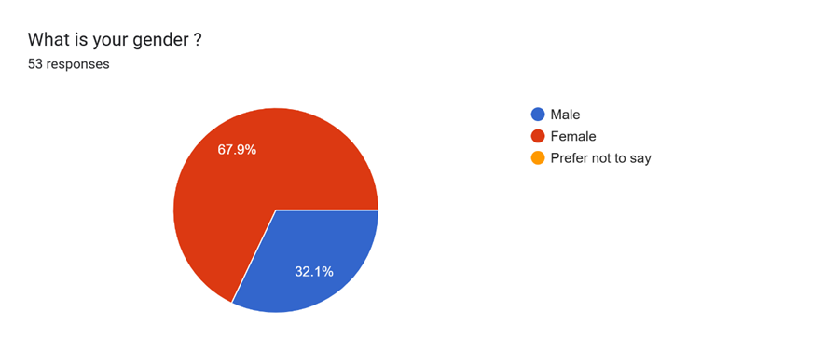
Figure 3 - The proportion of responders by gender.

The majority of the responders were above age 44. This represented seventy percent (70%) of responders. The largest group represented was those between the ages of 45 and 54 years (Thirty-six percent, 36%). This was followed closely by those between the ages of 55 and 64 years (thirty percent, 30%). The least represented groups were those between 18 and 24 years and 65 and above (Four percent, 4%). These figures have been illustrated in Figure 4 below.

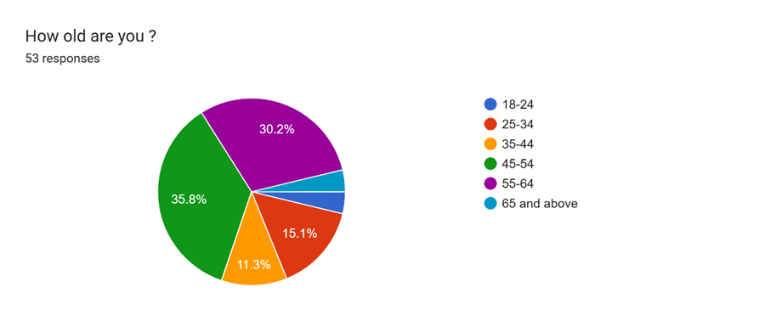

Figure 4- The proportion of responders by age groups

Professional Background
Of the 53 responders, seventeen (17) were in the nursing group, making them the most represented (Thirty two percent, 32%). These include ward managers, senior nurses, health care assistants and other nursing staff. The admin team and the occupational therapy staff followed with seventeen percent (17%) and fifteen percent (15%), respectively. Only one person (Two percent, 2%) from each of the Speech and Language and physical therapy teams completed the survey. The pie chart below (Figure 5) illustrates the proportion of responders by profession.

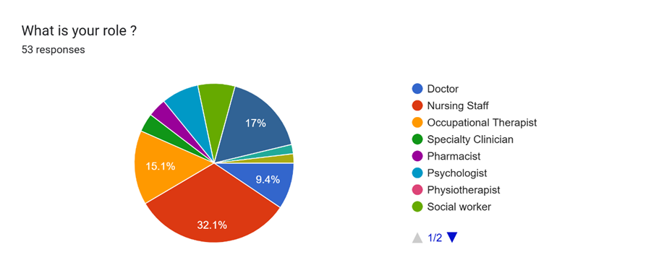
Figure 5- The pie chart shows the proportion of responders by Profession.

More than half (Fifty-seven percent, 57%) of these professionals had worked within the health sector for over 10 years. A third (Thirty-four percent, 34%) of the professionals had 20 years of experience in health care. Only ten percent (10%) had less than a year’s experience. This has been illustrated in Figure 6 below.

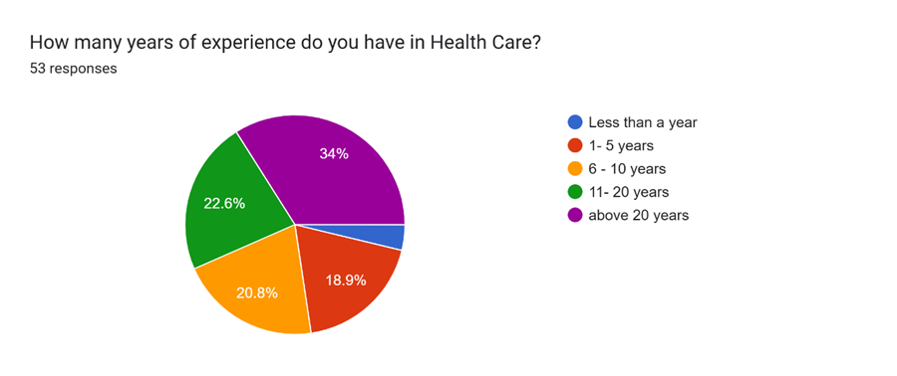

Figure 6- The Pie chart shows the experience (in years) of the professionals who responded to the survey.

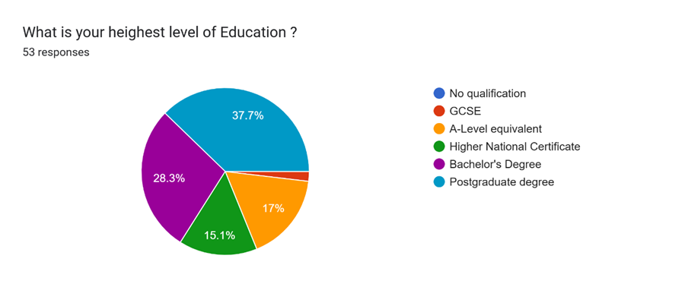

Figure 7- The chart shows the level of education achieved by the health professionals at Langdon Hospital.
Among the professionals who responded, two-thirds (Sixty-six percent, 66%) had at least a bachelor's degree. About a third of them (Thirty-eight per cent, 38%) had postgraduate degrees. Only 1 person (Two percent, 2%) had a GCSE as their highest level of education, as shown in the pie chart above (Figure 7)

The majority of the health professionals at Langdon Medium Secure Hospital had no qualification relating to information technology. This represented eighty four (84%) of the responders. Only fifteen percent (15%) had such a qualification. Figure 8 below illustrates the percentage of health professionals with a qualification relating to information technology 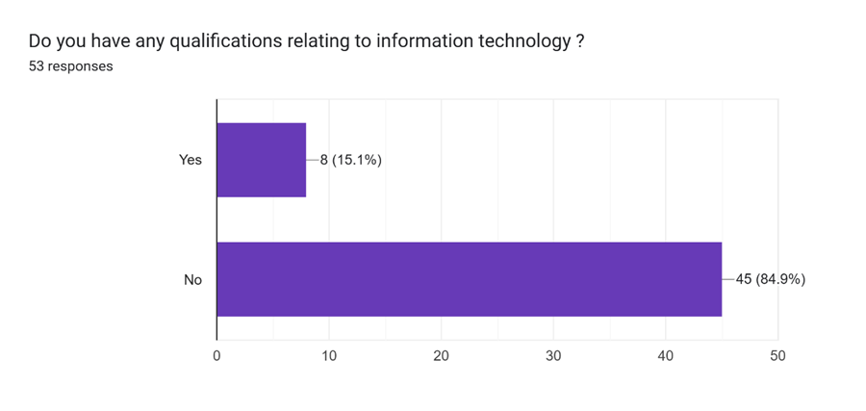

Figure 8 - The bar chart shows the proportion of responders with qualifications relating to information technology.

Of the eight (8) people who responded yes to having a qualification relating to information technology, two (2) of them, representing twenty-five percent (25%), had level 2 certificates. Two (2) others had GNVQ (General National Vocational Qualification) Certificates, and another two had ECDL certificates (European Computer Driving Licence). The remaining two (2) responders had certificates each in Word/Excel and level 2, as outlined in Table 1 below.

Qualification/Certificate | Number of responders | Percentage
GNVQ | 2 | 25%
GCSE | 2 | 25%
ECDL | 2 | 25%
Level 2 | 1 | 12.5%
Microsoft Word/Excel Advanced Certificate | 1 | 12.5%

Table 1- The Table shows the type of qualifications relating to information technology.

Regarding prior experience with Electronic Health records, almost all (Ninety-four percent, 94%) responders had prior experience with Electronic Health Records before using SystmOne EHR. Only three percent (3%) had no previous experience with Electronic health records. This is shown in Figure 9 below.

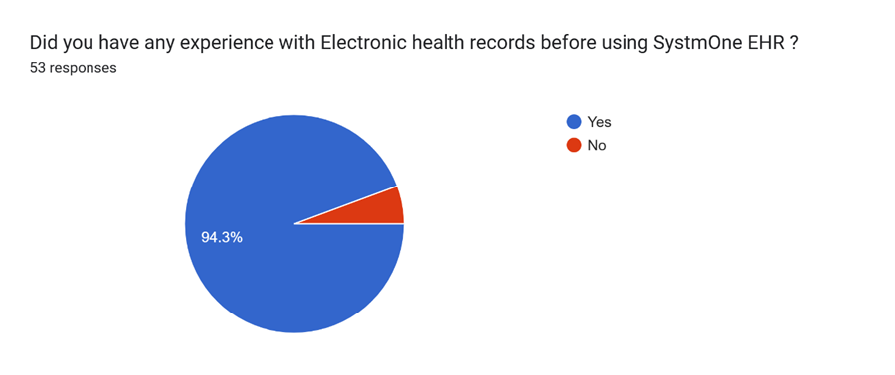
Figure 9 - The pie chart illustrates the proportion of health professionals at Langdon Medium Secure Hospital with previous experience with any kind of Electronic Health Records

Most (eighty-three percent, 83%) of the professionals had no prior experience with SystmOne HER. Only seventeen percent (17%) had used it in previous roles. This is shown in the pie chart (Figure 10) below.
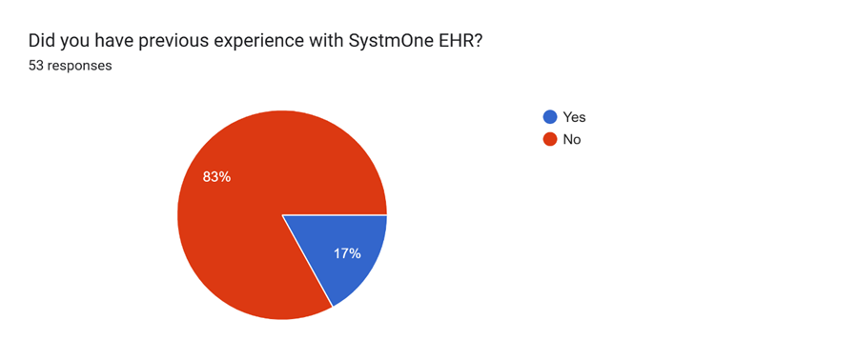

Figure 10- The image shows the percentage of Health Professionals who had prior experience with SystmOne EHR.

Of the seventeen (17) people who had previous experience with SystmOne EHR, an equal proportion of forty-one percent (41%) had used SystmOne EHR for less than a year and above three years. Eighteen percent (18%) had one to three years of experience using SystmOne EHR. The pie (Figure 11) chart below illustrates this.

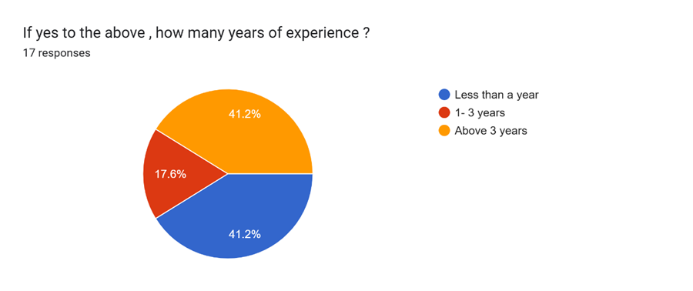

Figure 11- The pie chart shows the number of responders who had previous experience with SystmOne HER and their experience in years.

Training and Support
From the responses received, more than half (fifty-four percent, 54 %) of healthcare professionals prefer in-person training as a form of learning. Twenty percent (20%) prefer to learn on the job while 17 percent (17%) of responders prefer online training either live or recorded. Only one person (Two percent, 2%) prefer a blend of methods. The figure 12 below illustrates this

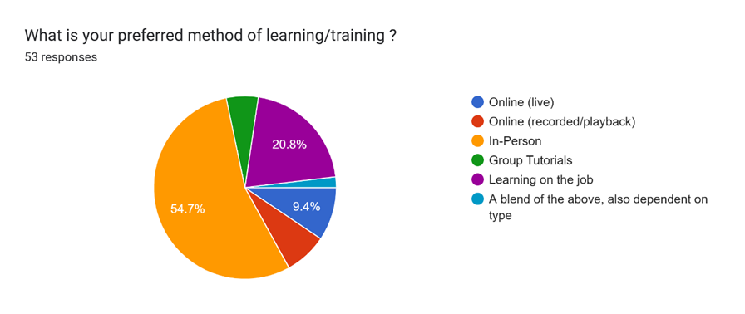

Figure 12- The pie chart shows the preferred method of learning by the healthcare professionals at Langdon Medium Secure Hospital.

Concerning training before the introduction of SystmOne EHR, the majority of responders (93%) received training before its introduction, with the remaining seven percent (7%) receiving no form of training. This has been illustrated in Figure 13 below.

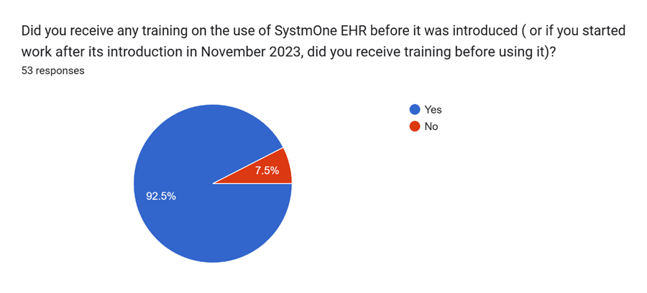
Figure 13- A chart showing the proportion of health professionals who received training before the introduction of SystmOne EHR.

A majority (70%) of those who received training watched videos demonstrating the use of SystmOne EHR. A third (33%) received online interactive training. About 14 percent said they learnt from other colleagues. None of the health professionals received in-person training. This is illustrated in figure 14 below.
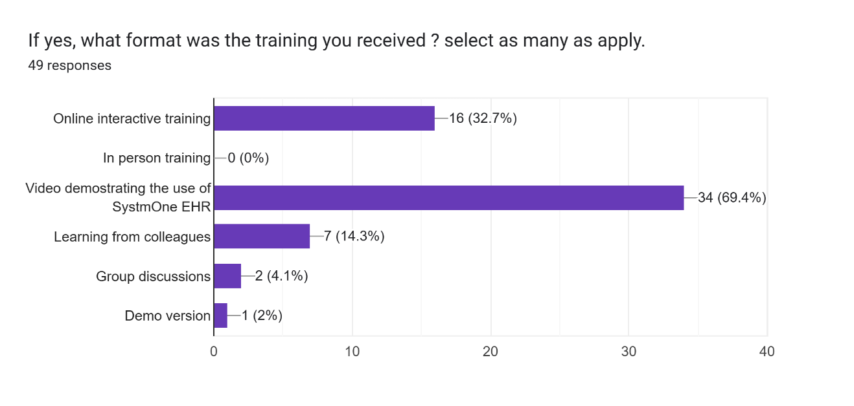

Figure 14- The bar chart illustrates the form of training received by health professionals at Langdon hospital.

Most (80%) of the responders received 1-6 hours of training. Eighteen percent (18%) received less than an hour of training. Only 2 percent received 7-12 hours of training. No health professional received more than 12 hours of training. This is illustrated in the pie chart (figure 15) below.

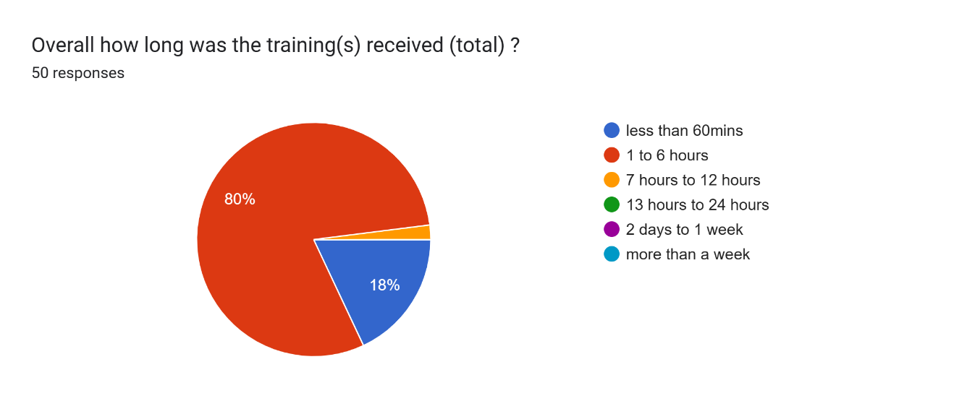

Figure 15- The diagram above shows the duration of SystmOne EHR training received by the health professionals at Langdon Hospital.
Following the introduction of SystmOne EHR, the majority of users (89%) did not receive further training. Only eleven percent (11%) received further training as shown in Figure 16 below.
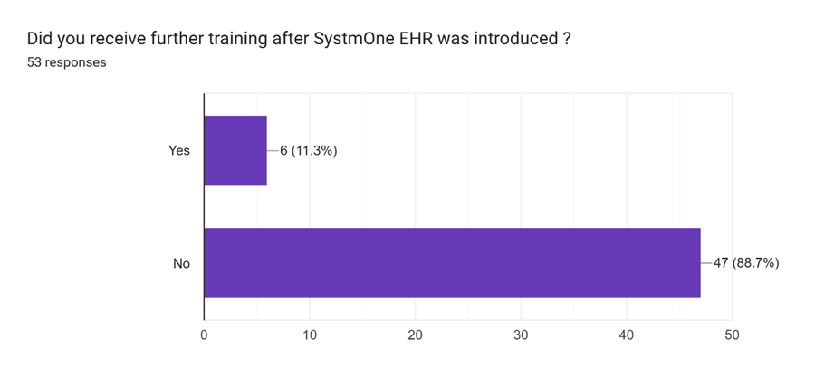

Figure 16- The bar chart above shows the proportion of responders who received further training after SystmOne EHR was introduced.

About half (51%) of the responders said they receive ongoing support, with the remaining half (49%) receiving no ongoing support. This is shown in figure 17 below.

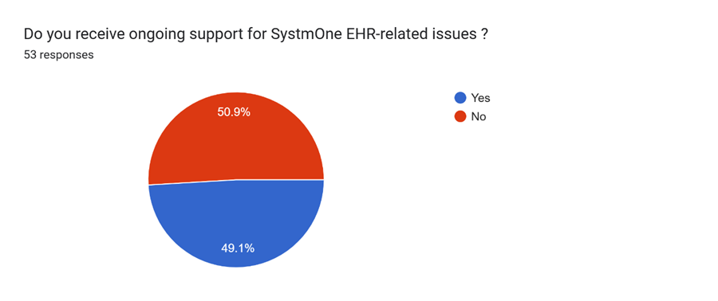
Figure 17- The pie chart above illustrates the proportion of responders who receive ongoing support.

The most common form of support received was from other colleagues. This represented sixty-seven percent (67%) of the ongoing support received. A third (33%) of the support received was by telephone. None of the responders received in-person support. Figure 18 below demonstrates this.

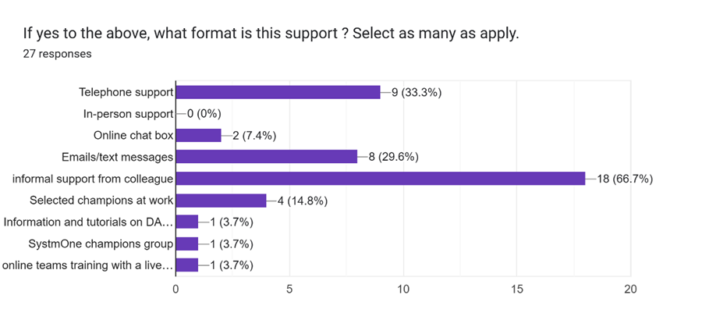

Figure 18- The bar chart above illustrates the proportion and type of ongoing support received by the responders.

Using the 5-star ratings, the majority of the responders indicated that they did not have enough training before the introduction of SystmOne EHR. The average rating from responders was 1.85. Rating one received the highest number of responses (50 percent). This was followed by rating 2, with 23 percent of the responses. The third highest responses were for rating three (Seventeen Percent). Rating 5 did not receive any responses. Figure 19 below illustrates this.

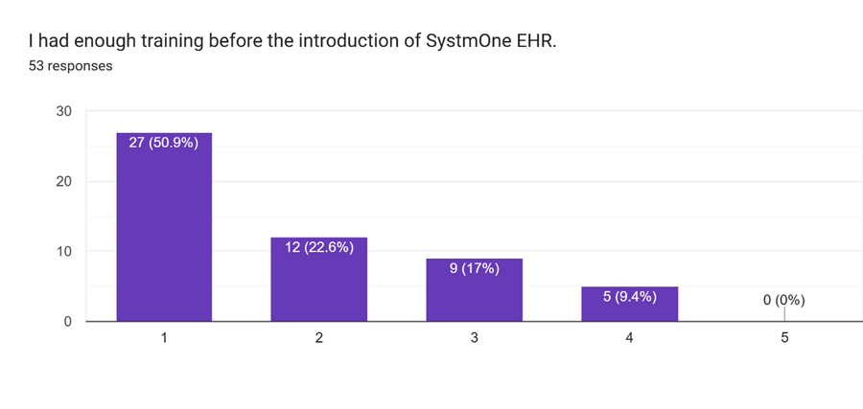

Figure 19- The bar chart above shows the results for the survey question ‘’I had enough training before the introduction of SystmOne EHR.

Concerning further training following the introduction of new features, the majority of responders (93%) said they do not receive any form of training when new features are added to SystmOne HER. Only eight percent (8%) of responders received further training following the addition of new features on SystmOne HER. This is shown in figure 20 below.
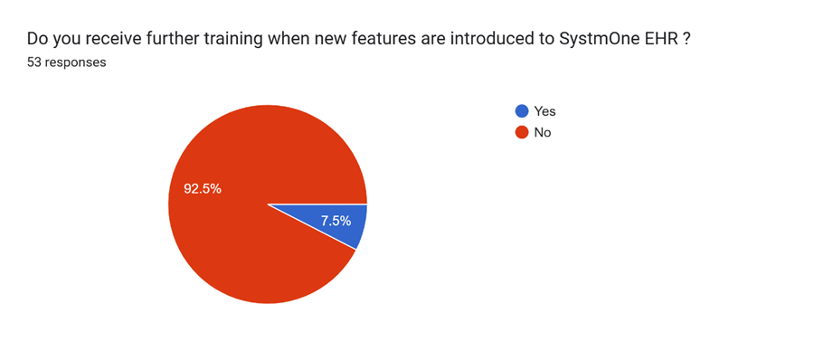

Figure 20- The above pie chart shows the proportion of responders who receive further training following the introduction of new features on SystmOne EHR.

Regarding logging on to SystmOne EHR, laptops were the most used device by responders, having been selected 47 times. Shared desktop and assigned desktop followed with 15 votes and 3 votes, respectively. Only one person had access to SystmOne EHR on a mobile phone.

System Usability
Eighty-five (85%) percent of responders said they were able to secure devices and log on to SystmOne EHR within 5 minutes. Twenty-three percent (23%) said they were able to achieve this within one minute. Two-thirds of responders said they were able to secure a device and log on to SystmOne EHR between 1 and 5 minutes. Only one responder said it took over an hour to secure a device and log on to SystmOne EHR.

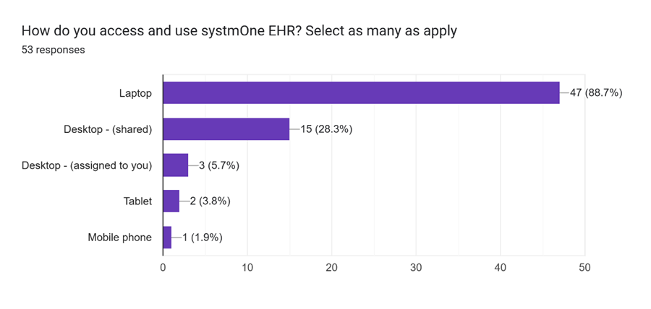
Figure 21- The bar chart above illustrates the devices used by responders.

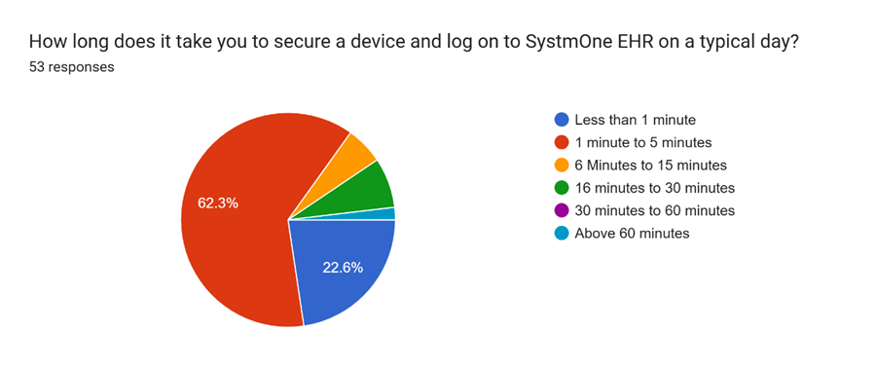
Figure 22- The pie chart above shows the time it takes for responders to secure a device and log on to SystmOne EHR on a typical day.

Seventy five percent (75%) of responders said they have a preference for working with laptops, while the remaining twenty five (25%) have a preference for working on desktops. None of the responders said they prefer using tablets for work done on SystmOne EHR. This is illustrated in figure 22 below.
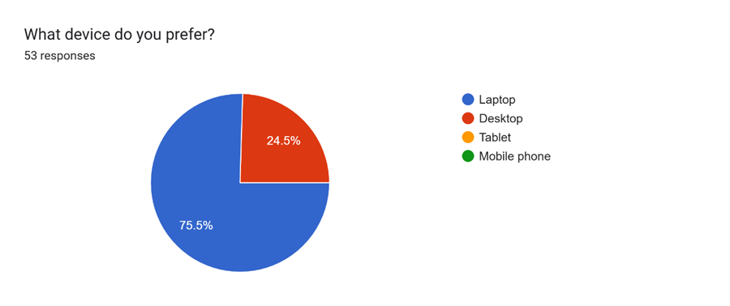
Figure 23- The pie chart above illustrates the device preference of responders.

Challenges
Concerning SystmOne EHR downtime, about two-thirds (68%) of responders said they had experienced SystmOne EHR downtime. A third (32%) said they had never experienced a SystmOne EHR downtime. Forty-percent (40%) of the responders who had experienced SystmOne EHR downtime said they experienced the downtime many times a week. Thirty-five percent (35%) of them reported experiencing SystmOne EHR downtime once or twice a year. Eleven percent (11%) of the group said they experienced SystmOne EHR downtime many times a week.

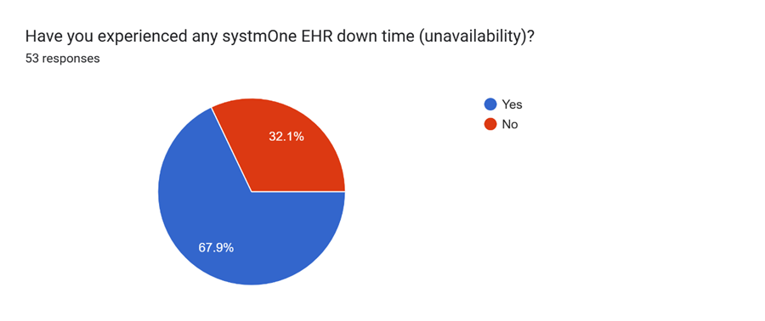
Figure 24- The image above illustrates the proportion of responders who have experienced a SystmOne EHR downtime.

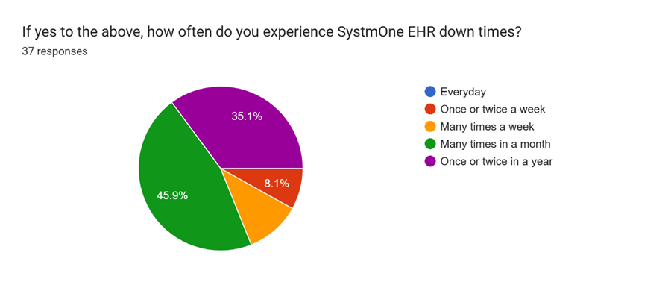
Figure 25- The pie chart above illustrates the frequency of SystmOne EHR and the proportion of responders who had experienced them.

Regarding the longest duration of SystmOne EHR downtimes experienced by users, more than half (51%) of the responders said they had experienced a downtime which lasted more than a day. About twenty-three percent (23%) of responders reported experiencing a downtime lasting 4-6 hours. Fourteen (14) percent experienced a SystmOne EHR downtime lasting between 7 and 9 hours.

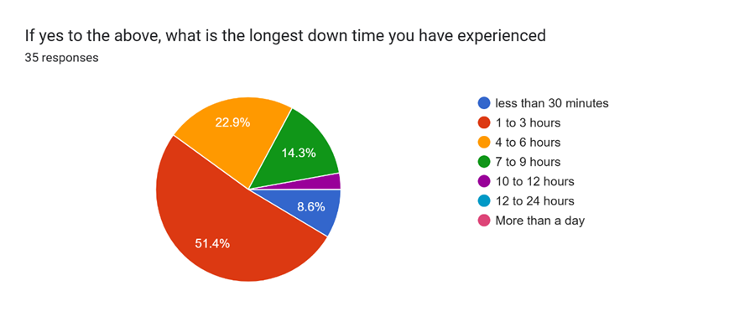
Figure 26- The pie chart above shows the duration of downtimes and the proportion of responders who reported experiencing them.

Concerning workarounds when SystmOne EHR is down, various methods were suggested by twenty-four (24) responders.
- Microsoft Word: The workaround mentioned the most was Microsoft Word. More than half (58%) of the 24 responders said they record they record the needed information temporarily on a Word document to transfer the information to SystmOne EHR once the system was back online and working.
- Emails: The second most mentioned workaround was email (8.3%). Two responders said they email the information to themselves to transfer to SystmOne EHR later. Another responder said they look through emails to identify any documents that they could use to complete their task or pick a different task altogether.
- Asking colleagues: One responder said they ask colleagues to input the data on SystmOne on their behalf.
- Handwritten notes: Another responder (4.2%) resorts to handwritten notes, which are later transcribed into SystmOne EHR.
- Nothing: 5 of the 24 responders (20.8%) said they are unable to complete their tasks when SystmOne is down, and only do so when it comes back online.

Regarding task completion, less than half (42%) of responders complete their daily task using only SystmOne EHR. A higher percentage (Fifty-eight percent are unable to complete their daily tasks using SystmOne alone.

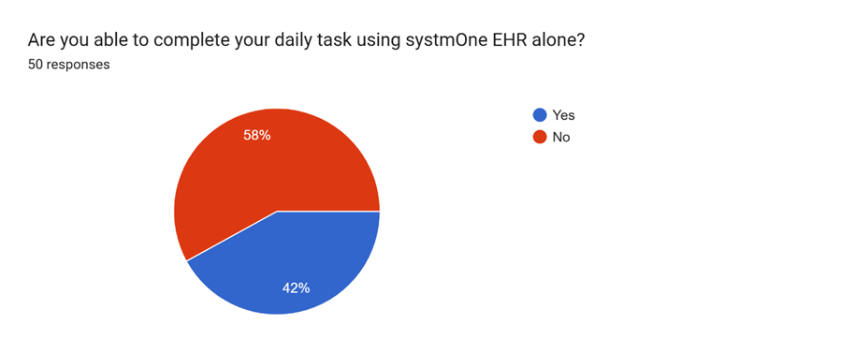
Figure 27- The pie chart above illustrates the proportion of responders who can complete their daily tasks using only SystmOne EHR.

Of those who are unable to complete their daily task using only SystmOne EHR, eighty-three percent (83%) are unable to access other platforms through SystmOne EHR. Seventeen percent (17%) of responders have access to other software through SystmOne EHR.

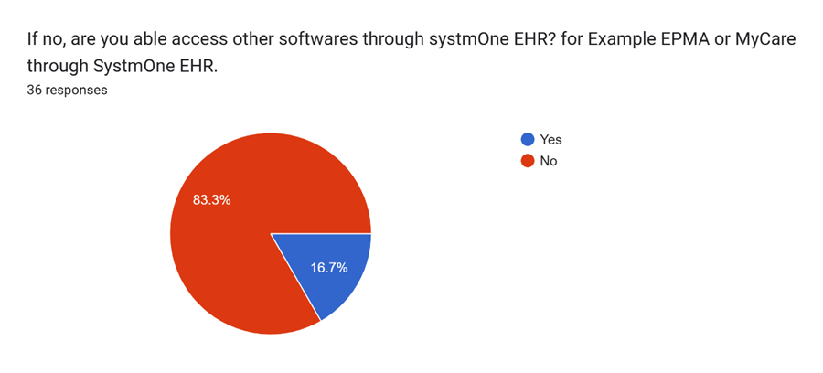

Figure 28- The pie chart illustrates the proportion of responders who can access other software through SystmOne EHR.

Using the 5-star ratings, a significant number of respondents indicated that SystmOne has not improved their output at work. This is shown by the highest number of responses (66%) at the lowest rating of 1. Ratings 2 and 3 received equal responses (17%). Ratings 4 and 5 received no responses. The average rating was low at 1.51.

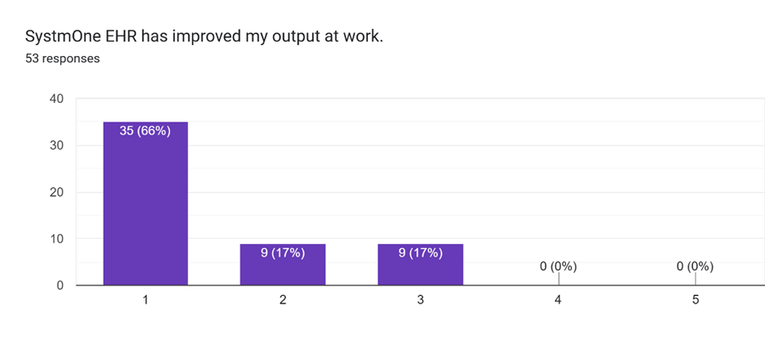
Figure 29- The bar chart above shows a summary of the responses to the survey question ‘’ SystmOne EHR has improved my output at work’’

Regarding task completion, forty-five percent (45%) responded to the statement ‘’I can complete all my tasks on SystmOne EHR’’ with one star (very poor). Twenty-three percent (23%) responded with 2 stars (poor) and Twenty one percent (21%) remained neutral. Only 2 percent rated the statement as 5 stars

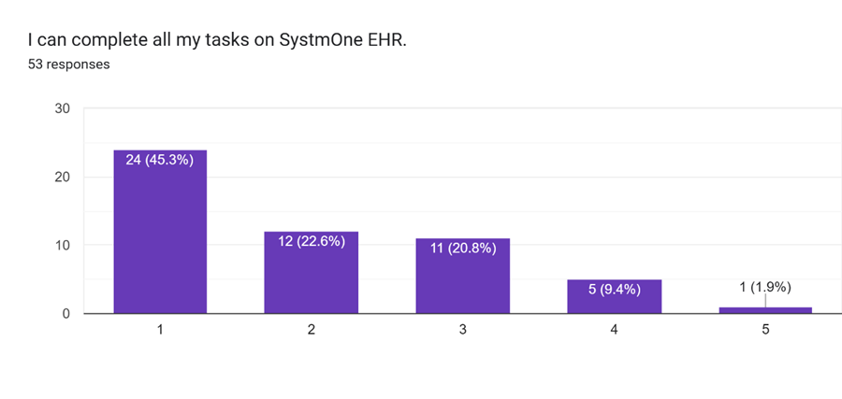
Figure 30- The image above shows a bar chart summarising the responses to the survey question; ‘’I can complete all my tasks on SystmOne EHR.’’

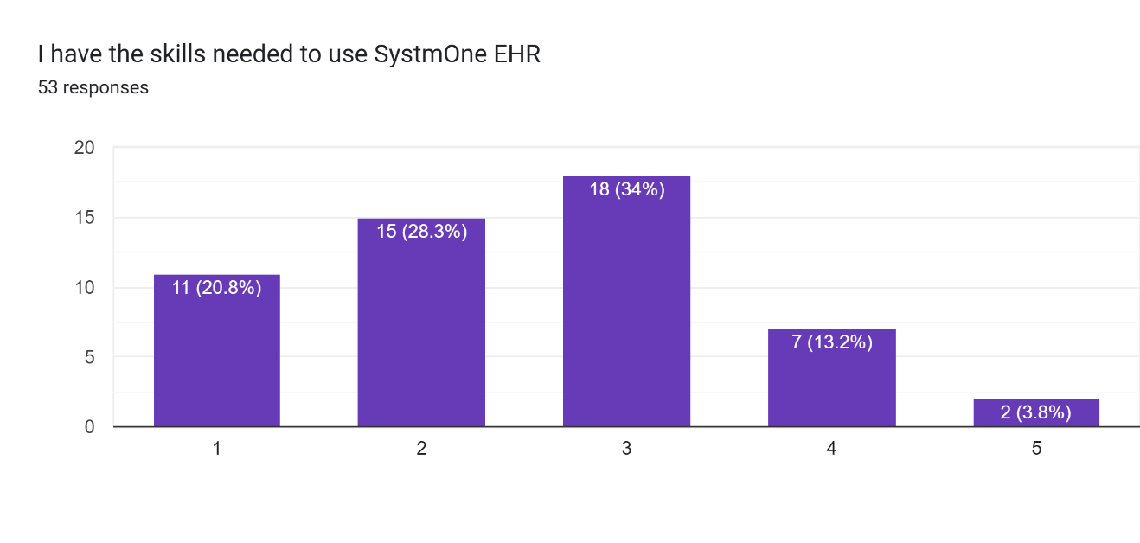
Figure 31- The bar chart above shows responses to the survey question; ‘’I have the skills needed to use SystmOne EHR’’.

Using 5-star rating, the average rating was 2.51. The highest responses were for rating 3 (Neutral). The second highest was for rating 2. Only 4 percent of respondents were confident (rating 5) in their SystmOne EHR skills.

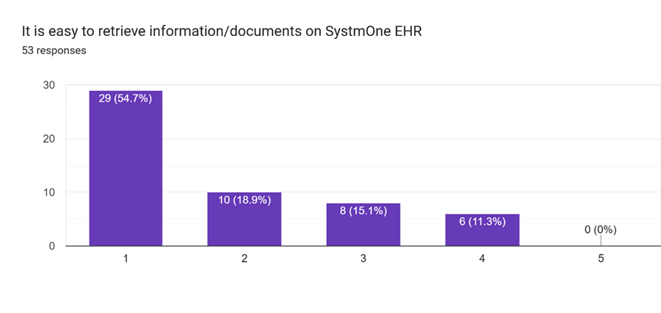
Figure 32- The bar chart above shows the results of the survey question, ‘’it is easy to retrieve information/documents on SystmOne EHR’’

The graph leans towards the left, with the majority (74%) of the respondents choosing ratings 1 and 2. This indicates that information retrieval is not easy on SystmOne EHR. The rating with the highest responses was rating 1(55%). This was followed by rating 2, with 19 percent of the responses. None of the respondents felt it was very easy (rating 1) to retrieve information from SystmOne EHR.

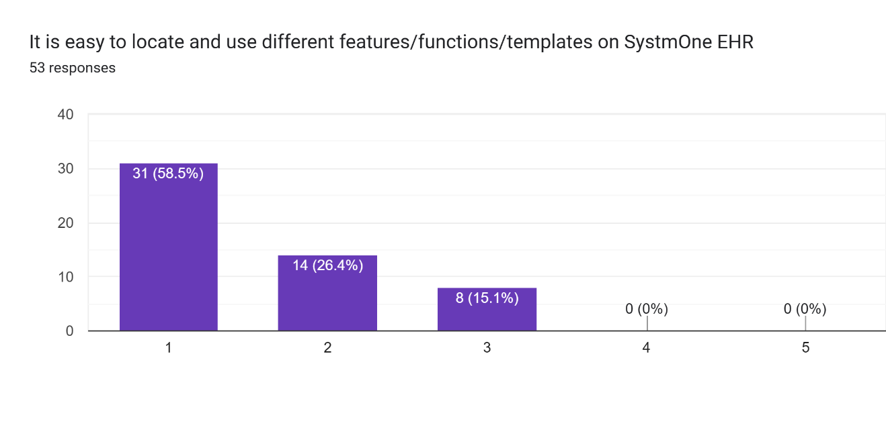
Figure 33- The chart above shows the responses to the survey question; ‘’It is easy to locate and use different features/functions/templates on SystmOne EHR.

An overwhelming majority of responders (85% for ratings 1 and 2) did not think it was easy to locate different functions on SystmOne EHR. About 60% and 26% of responders chose rating 1 (very difficult) and rating 2 (difficult), respectively, indicating the difficulty with locating features on SystmOne EHR. None of the responders chose rating 4 (easy) or 5 (very easy).
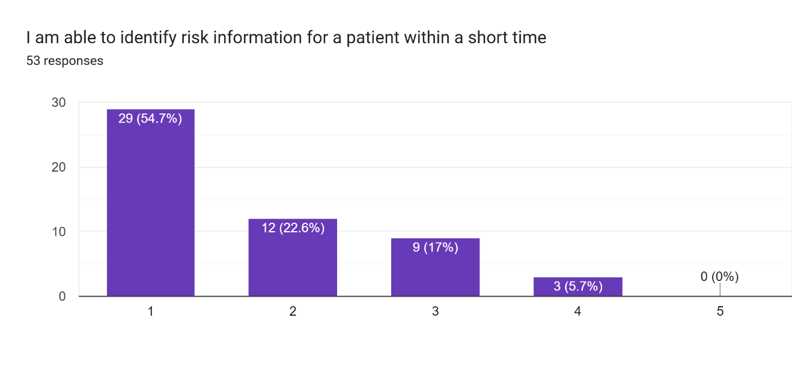
Figure 34- The chart above shows the responses to the survey question; ‘’I am able to identify risk information for a patient within a short time’’.

A significant number of responders (77% for rating 1 and 2) did not agree with the statement. 55% of responders chose rating 1 (strongly disagree) and 23 percent chose rating 2 (disagree). 17% of responders remained neutral with rating 3. Only 6% agreed with the statement and none strongly agreed.

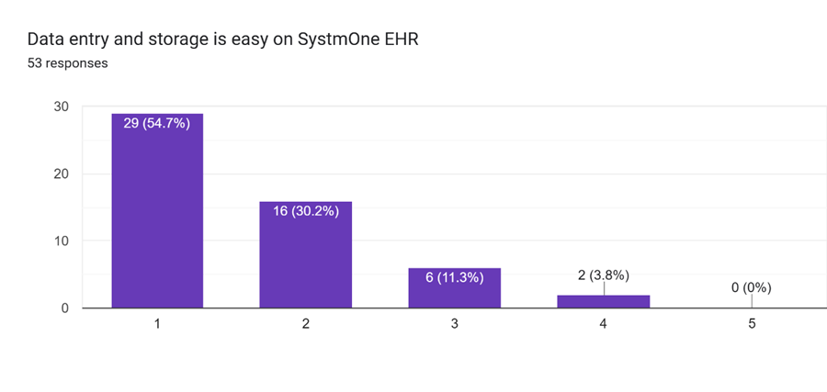
Figure 35- The diagram above illustrates the results for responses to the survey question; ‘’Data entry and storage is easy on SystmOne EHR.’’
A significant number of responders (85%) thought data entry and storage was not easy as indicated by majority choosing rating 1(55%) and rating 2 (30%). About 11% of responders remained neutral. Only 4% of the responders agreed that data entry and storage is easy on SystmOne EHR. None of the responders strongly agreed to the statement.

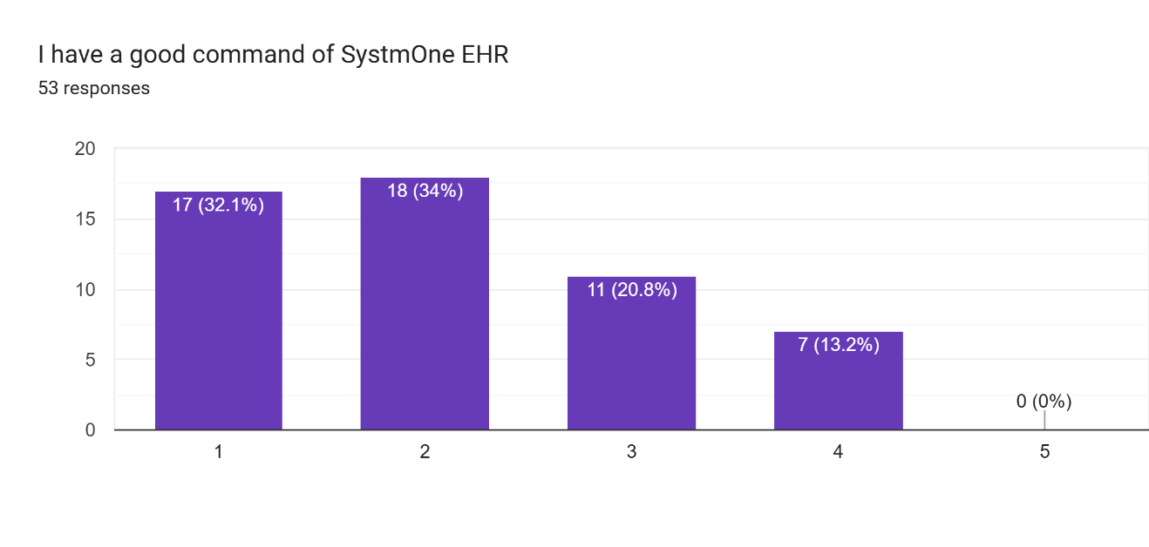
Figure 36- The bar chart above illustrates the percentages of responses received to the survey question;’’ I have a good command of SystmOne EHR.’’

Rating 1 (32.1%) and 2 (34%) had the highest responses indicating that majority of responders (66.1%) did not feel they had a good command of SystmOne EHR. 20.8% of responders remained neutral and 13.2% chose rating 4 indicating a good command of SystmOne EHR. None (0%) of the responders chose rating 5

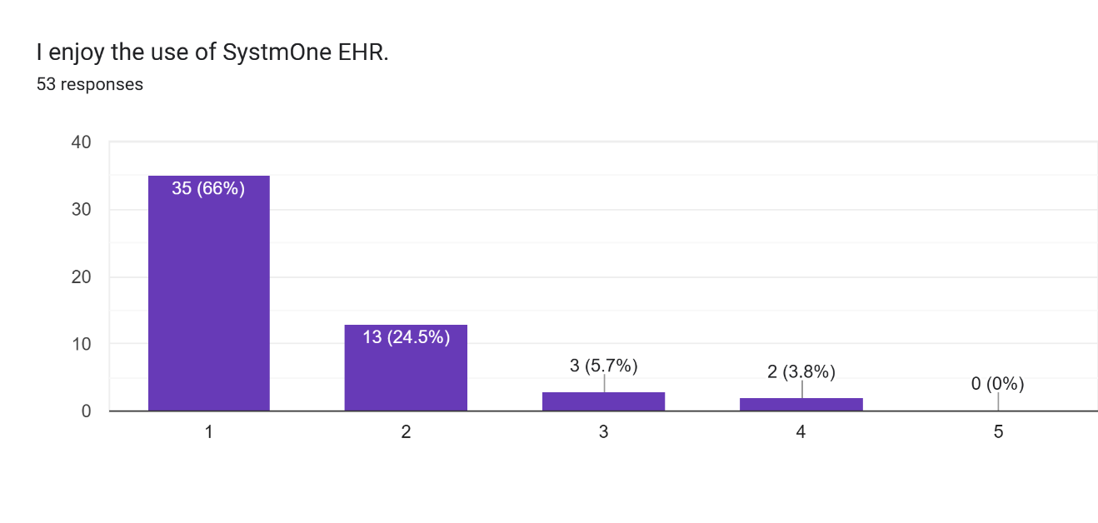
Figure 37- The bar chart above shows the responses received to the survey question; ‘’I enjoy the use of SystmOne EHR.’’

An overwhelming proportion (90.5%) of responders rated this question poorly, with 66% and 24.5% choosing ratings 1 and 2. This indicates that the majority of the responders did not enjoy using SystmOne EHR. Only 3.8% of responders said they enjoy using SystmOne EHR by choosing rating 4. None of the responders chose rating 5.

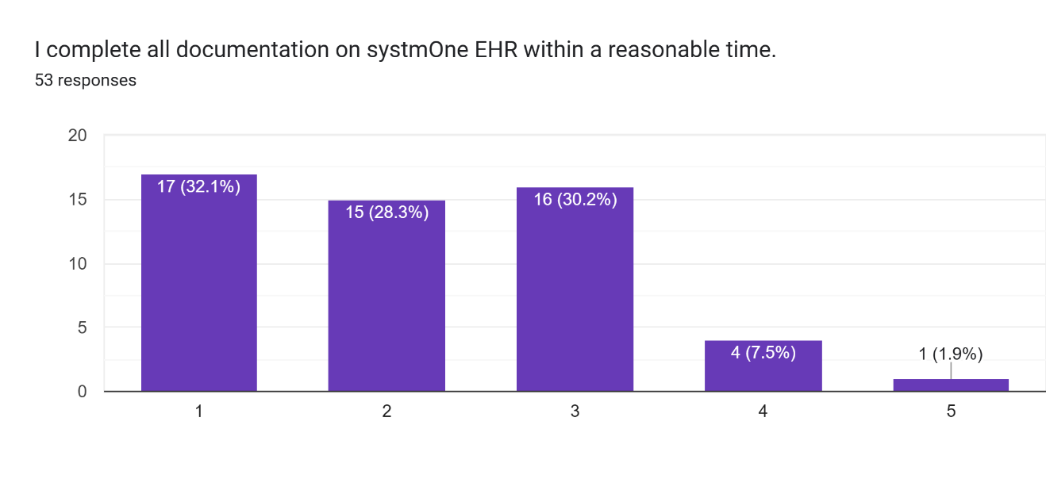
Figure 38- The bar chart above shows responses to the survey question; ‘’I complete all documentation on SystmOne EHR within a reasonable time.’’

The bar presenting rating 1 had 17 responses (32.1). Rating 3 had 30.2% responses, and Rating 5 received 1.9% of the responses. The responses are somewhat fairly distributed, but an average rating of 2.19 indicates that the majority of users do not feel they can complete documentation on SystmOne EHR within a reasonable timeframe.

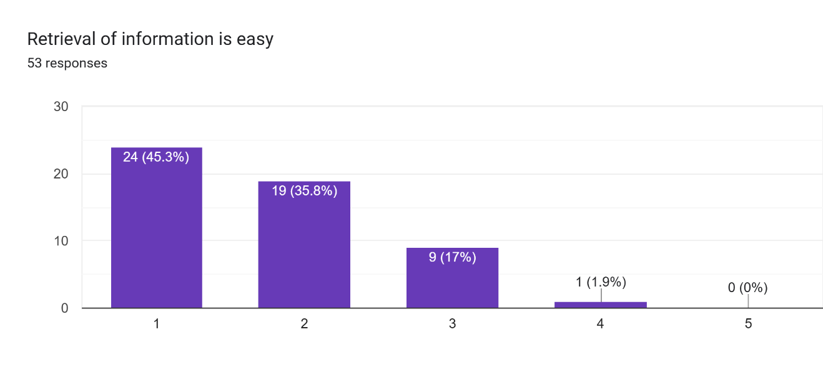
Figure 39- The bar chart above illustrates the responses to the survey question; ‘’Retrieval of information is easy.
An overwhelming majority of responders (81.1%) did not feel that the retrieval of information is easy. The highest responses were for rating 1 (45.1% ), followed by rating 2 ( 35.8%). 17% of responders remained neutral. Only 1.9% of respondents felt it was easy (Rating 4). None (0%) of the respondents thought it was very easy.

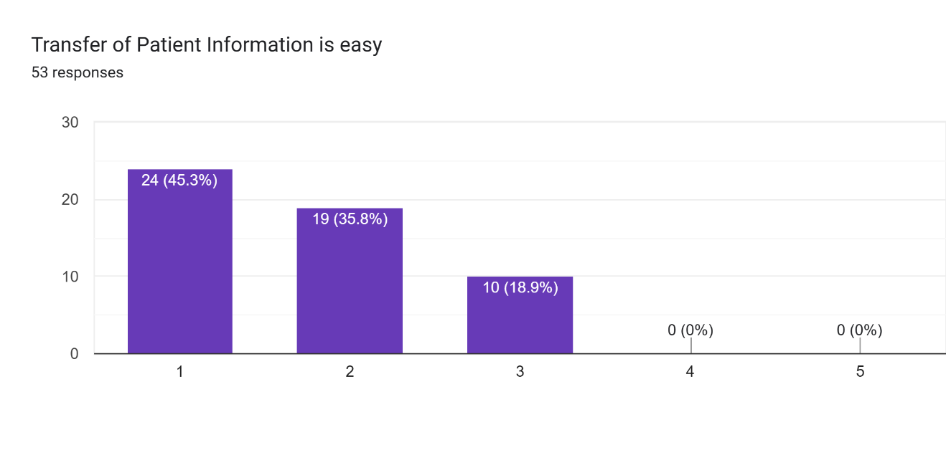
Figure 40- The bar chart above shows responses to the survey question; ‘’ Transfer of patient information is easy’’
The majority of responders (81.1%) to this question did not think the transfer of patient information was easy. The highest responses were for the poorest rating of 1 (45.3%) followed by rating 2 with 35.8% of the responses. The remaining 18.9% remained neutral. None of the respondents chose rating 4 or 5 representing easy and very easy respectively.

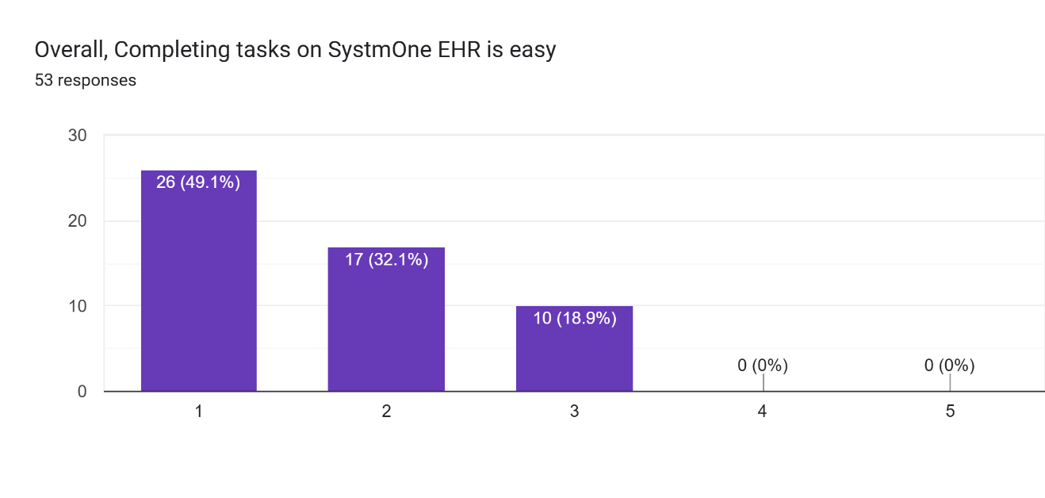
Figure 41- The chart above shows the results to the survey question;’’ Overall, completing tasks on SystmOne EHR is easy’’

An overwhelming majority of respondents did not think task completion on SystmOne was easy. A total of 81.2% chose the least ratings (1 and 2). The highest responses were for rating 1 (49.1%) followed by rating 2 (32.1). None of the respondents agreed that task completion was easy on SystmOne EHR.
Most used Systmone EHR features

Responders gave varied responses to the survey question ‘’What features on SystmOne EHR do you use most?’’. Below are the features mentioned by responders:
- Progress Notes- the most used feature on SystmOne EHR.
- Questionnaires
- Tabbed Journal
- Record Attachments/Documents.
- Care Plans.
- Tasks and appointments
- Risk assessments.
- Clinics.
- News 2.
- Inpatient Launchpad.
- Mental Capacity Act.
- Lester tool/high dose monitoring.

Impact on Quality of Care.
Regarding the impact of SystmOne EHR on the quality of care provided, the majority of the responses received were negative. The consensus is that SystmOne EHR negatively affects the quality of care provided by the responders. Some of the responders compared SystmOne EHR to the previous electronic health records (RIO and CareNotes EHR). Below are the various themes captured from the comments received:

- Time-consuming and inefficient- Some respondents described SystmOne EHR as ‘’clunky and slow, and others said it was time-consuming. A few of these comments have been highlighted in the quote box below.
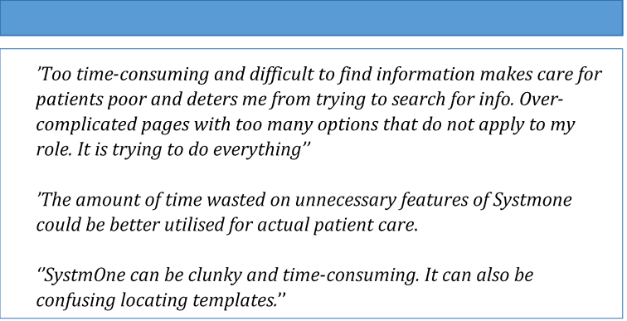
Quote Box 1- Showing comments from responders relating to the time wasting nature of SystmOne HER
- Difficult finding information- Some respondents said they struggle to locate information on Systmone EHR due to poor navigation. Others commented on the inconsistent labelling and unclear organisation of the interface. Below are some of the comments from respondents:
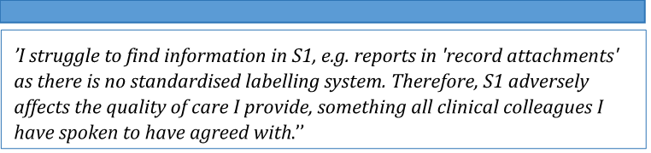
Quote Box 2- showing comments from responders relating to difficulty
finding information on SystmOne EHR

- Complexity- Some respondents felt that SystmOne EHR was too complex with unnecessary features. This complexity was felt to be adding to the time-consuming nature of the System as well as creating a gap between face-to-face patient care and documentation of the patient encounters.
Below are a few of the comments from responders:
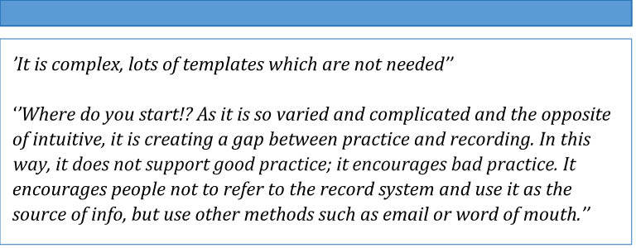
Quote Box 3- showing comments made by responders in relation to the
complexity of SystmOne EHR.

- Negative impact on record keeping- Record keeping seems to be affected by SystmOne EHR. Some respondents talked about information being lost due to limitations on the number of characters needed to complete detailed record-keeping. Patient safety was also raised by some respondents who are unable to retrieve information quickly and accurately. Below are a few comments on record keeping: 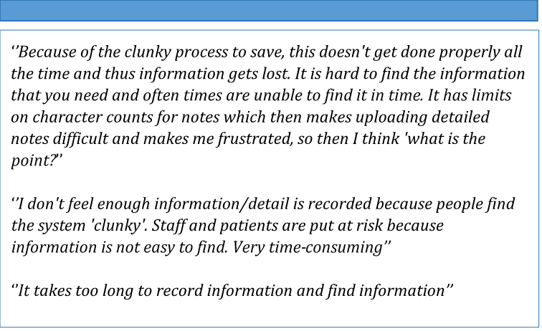
Quote Box 4- showing quotes from responders on how SystmOne EHR is impacting record keeping negatively.
- Concerns about Care Plans- Many respondents felt the care plans on SystmOne EHR are poor or have inappropriate templates.
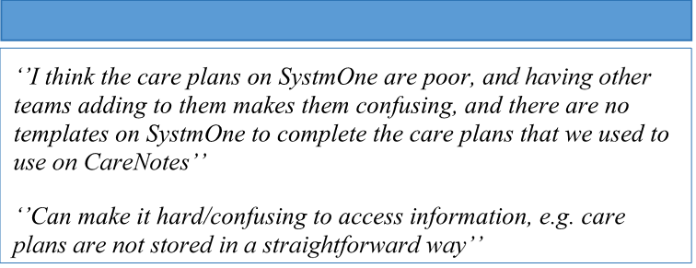
Quote Box 5- showing quotes describing the Care plans.
- Positive impact on the quality of care- Only 4 of 53 respondents (7.5%) had a somewhat positive thing to say about the impact of Systmone EHR on patient care. 2 of these respondents felt SystmOne EHR provided them with information needed for patient care. The four comments have been outlined below.
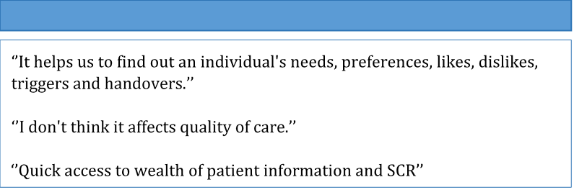
Quote Box 6- showing a few quotes from responders on positive aspects
of SystmOne EHR.

Additional Comments on Systmone EHR
Responders were asked to provide additional comments on SystmOne EHR. Many responders had further comments about SystmOne EHR. The general theme of the responses are outlined below.

- Not fit for purpose – Responders felt SystmOne EHR was not fit for the daily tasks and activities at Langdon Hospital. Responders said they struggle to fit their work to the functionality of SystmOne EHR.
A few comments are shown below.
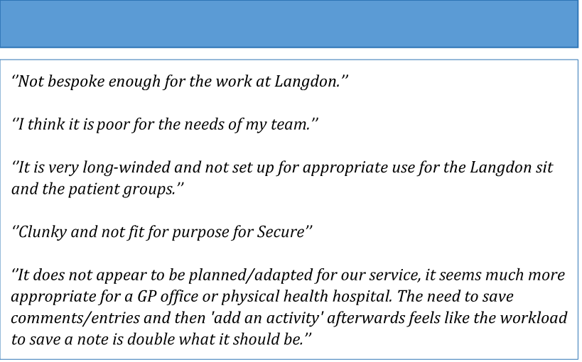
Quote Box 7- showing quotes indicating that SystmOne EHR is not fit for purpose.
- Insufficient training- a number of responders felt the training received before the introduction of SystmOne EHR was inadequate. Below are a few comments on this.
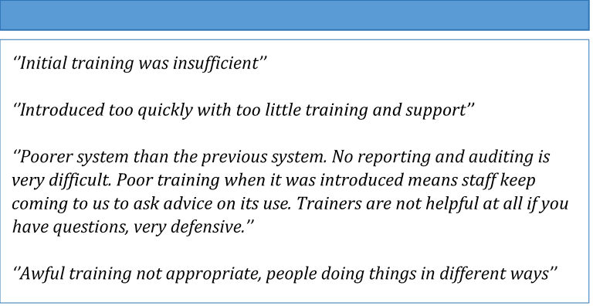
Quote Box 8- showing quotes from responders on insufficient training before the introduction of SystmOne EHR.

- Not user-friendly- 8 out of 53 responses felt SystmOne EHR was not user-friendly. A few of the comments have been outlined below.
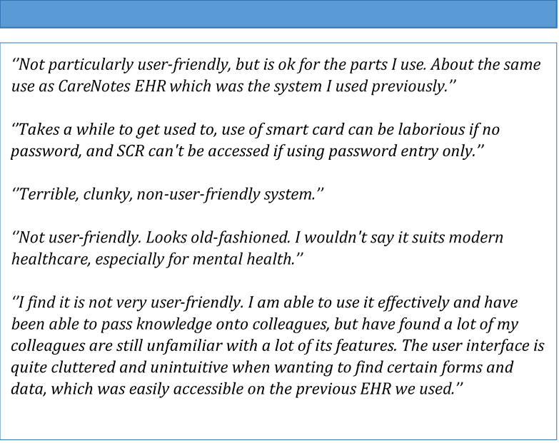
Quote Box 9- showing quotes from responders on the user-friendliness of SystmOne EHR.

Frequently Encountered Problems on Systmone EHR.
Regarding the open-ended survey question, ‘’What are some of the frequently encountered problems?’’, responders provided detailed and varied feedback. These have been outlined below.

- Difficult retrieving information and Navigating SystmOne EHR- many users expressed their frustration around information retrieval. This was a common theme among the responses received.
Below are such responses. 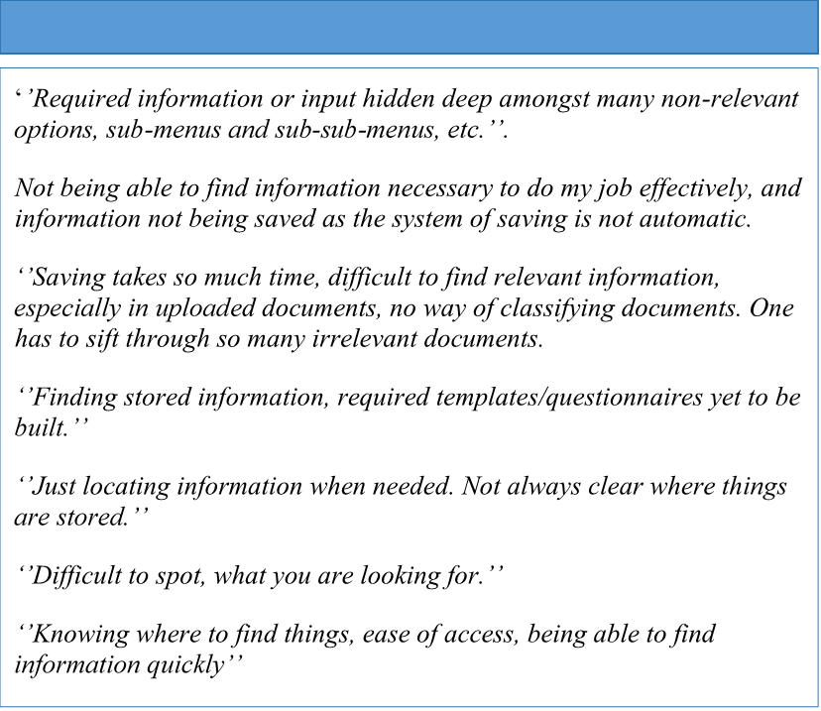
Quote Box 10 showing quotes on difficulty retrieving information.
- Difficulty experienced during data entry on SystmOne EHR – Many users felt it was too time-consuming and difficult saving data properly. This was also a source of frustration to many users. A few of such comments are below.
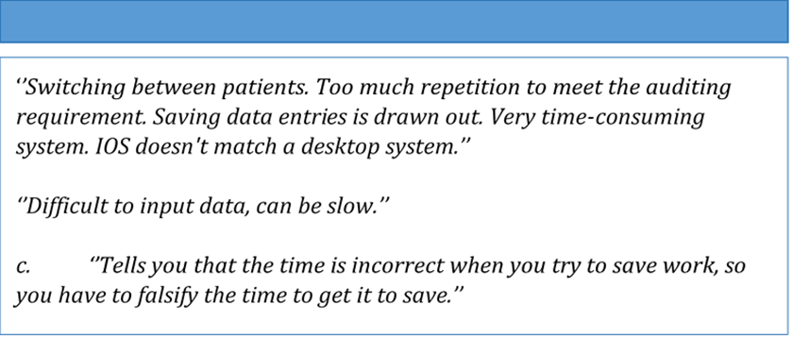
Quote Box 11 showing comments on the difficulty in saving data on
SystmOne EHR.
7. DISCUSSION

In general, the introduction of SystmOne EHR does not appear to improve patient care as anticipated. Research has shown that Electronic Health Records are broad and cover a wide scope; thus, a successful introduction is heavily dependent on technical requirements, the needs and readiness of the organisation and the human resources at the time of implementation and beyond. (Ahmadi et al, 2008)

In this section, the FITT framework will be used to discuss the results, focusing on the individuals (health care professionals), the task (functions performed on SystmOne EHR), and the technology (SystmOne EHR).

Individuals.
The majority of the responders were females. This appears to be a true reflection of the health care professionals working at Langdon Medium Secure Hospital. The majority of responders were above the age of forty-four (44). This could be a result of the population studied. Forensic Psychiatry is a highly specialised field with highly specialised professionals who have served the specialty appreciably. As shown in the results, more of these individuals have a postgraduate degree and many more have worked within the health sector for over 10 years.

The study had responses from varied health care professionals who perform different tasks using SystmOne EHR. This gives an idea of the multidisciplinary Team approach in dealing with the complex cases at the Dewnans Centre (MSU). The nursing staff, who are the major workforce of the hospital, were well represented in the study.

The health care professionals at the Dewnans Centre (MSU) - Langdon Hospital had limited certification in information technology and are not skilled in information technology. This could partly explain the anxieties exhibited by the healthcare professionals before the introduction of SystmOne EHR in November 2023, as well as be a contributing factor to the attitude exhibited by the professionals towards the new electronic health record. Knowledge and skills in information technology could contribute to how professionals accept, use and adapt to the challenges faced with software. (Olok et al, 2015)

Even though the majority of responders had previous experience with other electronic health records, only a few had any experience with SystmOne EHR.

The majority of the professionals did not have much confidence in their ability to use SystmOne EHR.

For SystmOne EHR training, some individuals received no training, while the majority who received between 1-6 hours of training watched videos demonstrating the use of SystmOne EHR. This could account for the struggles and poor adaptation of the software, as responders preferred in-person training. The lack of training was reported in the study, as the majority of responders did not think they had enough training before the introduction of SystmOne EHR. Another group got training from their peers who could have been struggling themselves. As highlighted in the responses, different teams performed the same tasks differently on SystmOne EHR. This, therefore, does not give confidence in what is being taught by peers and could also account for the poor feedback received. In addition, about half of the healthcare Professionals did not receive further training or support following the introduction of SystmOne EHR and when new features were added. The majority of the support received, if any, was from informal arrangements with colleagues. Training healthcare professionals on the use of electronic health records is an important and necessary factor in the successful implementation of electronic health records. (Columbus, 2006). The lack of training and support could account for why some professionals had challenges with the use of SystmOne EHR and why they did not feel they had a good command of SystmOne EHR. Improving the level of skills by way of training could improve the applicability and usability of SystmOne EHR.

Technology
It is commendable that accessing a device to use SystmOne EHR is not a challenge for most of the healthcare professionals. The majority of the professionals at the Dewnans Centre can secure a device within minutes. What is of concern, however, is the frequency of SystmOne EHR downtimes. This appears to be affecting the work output as reported by the healthcare professionals. Some individuals said they could not complete their task until SystmOne EHR was back online and working. This could affect the continuity of care. Electronic health records used all over the world come with challenges, including downtime events. These are inevitable and common. They are considered risky times for patients, and in secure settings could be risky for members of staff and the general public. (Lyon et al, 2023). At the Dewnan’s centre, risk information and escalation plans are documented on SystmOne EHR, a downtime affects how this information is stored, retrieved and shared within the wider multidisciplinary team, which could result in dire outcomes for patients and staff taking care of them or lead to delayed or suboptimal care. A significant event could include physical, verbal and sexual assault, just to name a few.

Additionally, many of the health professionals have used Electronic Health Records for years and are not so conversant with paper-based processes. In the event of a downtime leading to the use of paper-based processes, the risk of errors would be high. As shown in the results, the health care professionals have resorted to the use of workarounds like Microsoft Word, emails, and handwritten notes during SystmOne EHR downtimes. In addition to the increased risk of errors mentioned earlier, this increases the workload of the healthcare professionals who have a lot to accomplish within a short time. (Lyon et al, 2023). Also, a responder talked about hoping to remember to upload the information stored on a Word document to SystmOne HER when it was back online. There is therefore a risk that healthcare professionals would forget to upload the necessary information, which could result in bad outcomes for patients and staff in such a high-risk field.

Concerning the available features/functionality on SystmOne EHR, it does appear that the platform has many features/functions. The most used features reported by the healthcare professionals at Langdon Medium Secure Hospital were progress notes, questionnaires, tabbed journal, record attachments and care plans. The healthcare Professionals felt SystmOne EHR had too many unnecessary features, which were contributing to time wasting. Even though it is good to have many features on an electronic health record, having too many features which are not relevant to the specialty makes the system look too complicated, which consequently affects the ease of use and morale of the users. A study done in the USA showed that the complexity of Electronic Health Records directly contributes to burnout of users. (Budd J, 2023)

Also, the majority of healthcare professionals complete multiple tasks daily using multiple software programs like EPMA (Electronic Prescribing and Medicines Administration) and MyCare for blood tests and other investigations. They are, however, unable to access these other software programs through SystmOne EHR. The inability of SystmOne EHR to communicate with the other software programs means more time is used in logging in and out of other programs, which contributes to time wasting. Some health professionals who need to confirm a dosage of a drug or blood results may be reluctant to confirm this due to the login process. This could have dire consequences if decisions are made based on the wrong dose of medication or blood results. (Cahill et al, 2025)

The introduction of a minimum viable product proved to be a costly decision, resulting in the frustration of the users of SystmOne EHR.

Task

Overall, health professionals reported struggling with retrieving, storing and transferring information as well as using the various features on SystmOne EHR. Consequently, they reported not enjoying the use of SystmOne EHR. A complicated system deters users from trying to retrieve vital information, which affects work output negatively. It does not encourage users to refer to SystmOne EHR for secure and trusted information, but rather rely on colleagues to provide the needed information. Information is key in preventing negative outcomes in patient care. A piece of vital information could potentially be used to prevent a service user from causing harm to themselves and, more significantly, harm to the public. Additionally, it could lead to delayed care or patients receiving the wrong services due to the information available or lack of it.

Many health professionals raised concerns about the time it takes to document patient interactions. The process of saving recorded information is too complicated and time-consuming. Some stated that they write less due to the length of time it takes to save notes. This practice could result in dire consequences if the situation is not rectified. The majority of the healthcare professionals also reported not completing tasks on SystmOne EHR within a reasonable time. This leads to the build-up of uncompleted tasks and an overwhelming sense of workload. The healthcare professionals reported feeling frustrated, which would affect their morale and, subsequently, their work output. Also, spending too much time behind the screens while trying to complete tasks takes the healthcare professionals away from the patients they are supposed to take care of.
This would result in patients feeling they are uncared for or that their needs are unmet.

Another problem encountered is the limited characters permitted in certain templates. This seems to be a major challenge for the psychology group of professionals. Most of the patients admitted to the Dewnans Centre (MSU) – Langdon Hospital have committed violent offences and require extensive psychotherapy. These sessions need extensive documentation to ensure information is not lost. A limitation on characters leads to professionals having to summarise the information, resulting in key information being left out or having to record the information in parts which makes the information disjointed and the record keeping clumsy.

8. STRENGTHS AND LIMITATIONS OF THE STUDY
Like every study, this study had its strengths and limitations. This section will outline the main ones.

- This study is one of the few researches, if any carried out in a secure setting. It provides the foundation for future research work to be built upon.
- The research tool used provides good insight into the challenges faced by the users of SystmOne EHR at the Dewnans Centre (MSU) – Langdon Hospital.

- The Lack of resources and Time constraints- Time was a huge factor in deciding the research technique and tools used. It affected the plan for the study, resulting in many changes. The original plan for the study has been included in the appendix.
- Researcher bias- Due to my own experiences during the introduction of SystmOne EHR at the Dewnans Centre and the challenges faced after, there is a possibility that the study was influenced by my own biases. To limit this, I did not take part in the survey and did not provide my opinions to responders before the survey.
- Sampling bias – It is acknowledged that probability sampling gives all members of the population a fair chance of being sampled. In this study, the use of voluntary response sampling reduced this chance. As such, not all members of the group/views are equally represented. Additionally, members who have negative experiences with SystmOne EHR are more likely to respond and express their frustrations. It therefore reduces the chance of getting a balanced viewpoint from the healthcare professionals.

- Inclusion of the excluded population- During the process of sending out the link to the Google forms to the intended population, all healthcare professionals at Langdon Hospital were included in the email. This included professionals working with the low secure unit (Chichester House) and the Community Forensic team. Some of these individuals were keen on completing the survey. To limit this, individuals outside the interested population (Dewnans Centre) were asked not to complete the survey. However, there is a possibility that some of the responses were from healthcare professionals not working at Dewnans Centre (Medium Secure Unit). Their views and experiences will, however, not affect the results as they have similar, if not the same, challenges and experiences. Any additional views will add value to the study as they provide a broader view of the issues with the use of SystmOne EHR at Langdon Hospital.

- A significant limitation of this study is the limited existing research on the use of Electronic Health Records in Secure settings. Due to the scarcity of information, a comparative study could not be performed. This study however, provides insight into an area that has not been studied extensively.

9. CONCLUSION AND RECOMMENDATIONS.
In conclusion, electronic health records are essential in the modern era and provide secure and trusted clinical records that improve the efficiency of health care professionals and improve the care and safety of patients. SystmOne EHR, as an electronic health record, has the potential to provide this vital service to the Dewnan’s Centre (MSU) - Langdon Hospital.
The switch from CareNotes EHR to SystmOne EHR was born from necessity and strategic alignment. The implementation, however, was marred by poor planning, inadequate training, and unforeseen technical challenges. The introduction of minimum viable product should be discouraged in such a specialised field.
Training before the introduction of SystmOne EHR, as well as the ongoing support since its introduction, is woefully inadequate; as such, the recommendation is made for proper training and support to maximise the use of the Electronic Health Record (SystmOne EHR).
Robust evaluation of SystmOne EHR is recommended to resolve the critical issues identified in this study. Stakeholder consultations should also be done periodically to understand the changing needs of healthcare.
Additionally, it is recommended that further research in the area be done, targeting a wider population of healthcare professionals.
10. REFERENCES

- Ahmadi, M., Rezaei, H. and Shahmoradi, L., 2008. Electronic health record: structure, content, and evaluation
- Ammenwerth E, Iller C, Mahler C. IT-adoption and the interaction of task, technology and individuals: a fit framework and a case study. BMC Med Inform Decis Mak. 2006 Jan 9;6:3. doi: 10.1186/1472-6947-6-3. PMID: 16401336; PMCID: PMC1352353.
- Boonstra, A., Versluis, A., & J Vos, J. F. (2014). Implementing electronic health records in hospitals: A systematic literature review. BMC Health Services Research, 14, 370. https://doi.org/10.1186/1472-6963-14-370
- Budd, J. (2023). Burnout Related to Electronic Health Record Use in Primary Care. Journal of Primary Care & Community Health, 14, 21501319231166921. https://doi.org/10.1177/21501319231166921
- Busch AB, Bates DW, Rauch SL. Improving Adoption of EHRs in Psychiatric Care. N Engl J Med. 2018 May 3;378(18):1665-1667. doi: 10.1056/NEJMp1800465. PMID: 29719176; PMCID: PMC6568002.
- Cahill, M., Cleary, B.J. & Cullinan, S. The influence of electronic health record design on usability and medication safety: systematic review. BMC Health Serv Res 25, 31 (2025). https://doi.org/10.1186/s12913-024-12060-2
- Charlson F, van Ommeren M, Flaxman A, Cornett J, Whiteford H and Saxena S (2019) New WHO prevalence estimates of mental disorders in conflict settings: A systematic review and meta-analysis. The Lancet 394, 240–248.
- Columbus ML. 2006. The evaluation and effectiveness of an Interdisciplinary course in Electronic Health Record technology for health and rehabilitation professionals
- Devon Partnership NHS choices (2023). Available at: https://www.dpt.nhs.uk/resources/policies-and procedures/governance/information-governance (Accessed: 11 April 2025).
- Devon Partnership NHS Trust Goes Live with TPP SystmOne Mental Health (2023) TPP. Available at: https://tpp-uk.com/news/dpt-goes-live-with-tpp-SystmOne-mental-health/ (Accessed: 10 April 2025).
- Devon Partnership NHS Trust intranet (2023). Available at https://daisy.dpt.nhs.uk/directorates/secure
- J. Kaur, S. Upendra and S. Barde, "Implementation of Medical Technology in Records in Psychiatry Setting," 2023 International Conference on Integration of Computational Intelligent System (ICICIS), Pune, India, 2023.
- Kern LM, Barrón Y, Dhopeshwarkar RV, Edwards A, Kaushal R; HITEC Investigators. Electronic health records and ambulatory quality of care. J Gen Intern Med. 2013 Apr;28(4):496-503. doi: 10.1007/s11606-012-2237-8. Epub 2012 Oct 3. PMID: 23054927; PMCID: PMC3599037.
- Lyon, R., Jones, A., Burke, R., & Baysari, M. T. (2023). What Goes Up, Must Come Down: A State-of-the-Art Electronic Health Record Downtime and Uptime Procedure in a Metropolitan Health Setting. Applied Clinical Informatics, 14(3), 513. https://doi.org/10.1055/s-0043-1768995
- Mohan, D. (2023) ‘Digital technology: Transforming delivery of forensic mental healthcare’, Criminal Behaviour and Mental Health, 33(3), pp. 149–155. Available at: https://doi.org/10.1002/cbm.2290.
- Ratwani RM, Savage E, Will A, Fong A, Karavite D, Muthu N, Rivera AJ, Gibson C, Asmonga D, Moscovitch B, Grundmeier R, Rising J. Identifying Electronic Health Record Usability And Safety Challenges In Pediatric Settings. Health Aff (Millwood). 2018 Nov;37(11):1752-1759. doi: 10.1377/hlthaff.2018.0699. PMID: 30395517.
- Roth, C. B., Papassotiropoulos, A., Brühl, A. B., Lang, U. E., & Huber, C. G. (2021). Psychiatry in the Digital Age: A Blessing or a Curse? International Journal of Environmental Research and Public Health, 18(16), 8302. https://doi.org/10.3390/ijerph18168302
- Safdari, R., Ghazisaeidi, M., & Jebraeily, M. (2015). Electronic Health Records: Critical Success Factors in Implementation. Acta Informatica Medica, 23(2), 102. https://doi.org/10.5455/aim.2015.23.102-104
- Samadbeik M, Fatehi F, Braunstein M, Barry B, Saremian M, Kalhor F, Edirippulige S. Education and Training on Electronic Medical Records (EMRs) for health care professionals and students: A Scoping Review. Int J Med Inform. 2020 Oct;142:104238. doi: 10.1016/j.ijmedinf.2020.104238. Epub 2020 Aug 14. PMID: 32828034.
- Tsiknakis, Manolis & Kouroubali, Angelina & Vourvahakis, Dimitris & Orphanoudakis, Stelios. (2005). Implementing a Regional Health Information Network: Impact on Health Care Performance and the Management of Change. Advances in Health Care Management. 5. 297-329. 10.1016/S1474-8231(05)05011-1.
- Upadhyay, S. (2022). A Qualitative Analysis of the Impact of Electronic Health Records (EHR) on Healthcare Quality and Safety: Clinicians’ Lived Experiences. Health Services Insights. https://doi.org/10.1177/11786329211070722
- Wu Y, Wang L, Tao M, Cao H, Yuan H, Ye M, Chen X, Wang K, Zhu C. Changing trends in the global burden of mental disorders from 1990 to 2019 and predicted levels in 25 years. Epidemiol Psychiatr Sci. 2023 Nov 7.
- Zurynski Y, Ellis LA, Tong HL, Laranjo L, Clay-Williams R, Testa L, Meulenbroeks I, Turton C, Sara G. Implementation of Electronic Medical Records in Mental Health Settings: Scoping Review, May 2020

APPENDIX A

Dissertation Plan

TOPIC
Evaluating Optimal Use of SystmOne in Medium-Secure Mental Health Care
INTRODUCTION
Devon Partnership Trust (DPT) is an NHS organisation in the Southwest of England,
serving people in Devon and the wider South West region with mental health,
learning disability, and neurodiversity needs. Services encompass a wide range of
specialties’, including secure care at Langdon Hospital, which provides medium-secure
services to adult males with mental health needs related to the legal system.
To improve patient care, healthcare facilities and IT functionality in the Southwest of England, DPT replaced CareNotes Electronic Care Record with SystmOne EHR Mental in November 2023 to support its digital transformation. This was a significant milestone in the One Devon Vision: ‘’ equal chances for everyone in Devon to lead long, happy and healthy lives’’. The introduction of SystmOne EHR to DPT also ensures the unification of electronic patient records and standardisation of care pathways within Devon and the entire Southwest. The platform provides a connected and integrated care record across the different services in the region, including mental health, GP, community, urgent care and maternity services. This approach improves coordination among healthcare professionals and ensures a more comprehensive understanding of patient’s needs. (TPP SystmOne EHR, 2023).
The main aim of this project is to evaluate the implementation of the SystmOne
Electronic Health Record (EHR) system within this unique secure setting, focusing
on how well it meets professional needs, supports patient care, and integrates with
the workflows of varied healthcare professionals.

OBJECTIVES
1. To explore issues associated with the introduction and rollout of SystmOne.
2. To assess the ease of data entry, retrieval, and sharing by users of SystmOne in Langdon Hospital.
3. To evaluate the attitudes of NHS healthcare professionals in Langdon Hospital towards the use of SystmOne.
4. To identify the alignment between individual roles, tasks, and technology use.
5. To identify challenges encountered by healthcare professionals since SystmOne’s introduction.
6. To explore support systems for professionals before, during, and after SystmOne’s rollout.
7. To evaluate the benefits and limitations of SystmOne.
LITERATURE REVIEW
Mental disorders including substance misuse disorders are a global concern as they contribute to the financial burden on patients, their families and communities. Comorbidity with other medical conditions and lower life expectancy have been associated with individuals with mental illnesses. (Busch AB et al, 2018)
Globally they remain a leading cause of disability, leading to significant reduction in their quality of life. They cannot participate in production and labour due to losing control of their consciousness and behaviour. It is therefore an area that needs attention and improvement. (Wu Y et al, 2023)
Electronic health records have proven important in the delivery of healthcare. However, their introduction to psychiatry services, particularly forensic psychiatry, has been slow and delayed and often met with challenges from providers, healthcare professionals, software, and hardware. This has often led to problems like a lack of access to important patient information for healthcare professionals in the specialty. Also, the exchange of information between psychiatry services and other services is difficult and delayed due to the new models of healthcare coordination and integration. (Busch AB et al, 2018).
In forensic psychiatry, technological advancement has reduced the use of paper for data storage and transfer, taken away problems with illegible handwriting and improved coordination of processes which are key components in delivering high-quality forensic mental healthcare. Additionally, Electronic health records provide real-time measurement of standards set down by regulatory bodies and therefore improve compliance with these legislative standards of care. Electronic health records, if used effectively can make the community safer for all. An independent enquiry in the UK, after a homicide revealed the lapses in information sharing that could have prevented the sad event. (Mohan D, 2023)
Electronic Health Records offer an opportunity to improve patient care by making health information readily available to a broad spectrum of providers, and by enabling these providers to use such data in novel ways. Among the significant advantages of EHRs are ease of portability, facilitated communication among healthcare professionals, and a decreased risk of medical errors through systematized medication and allergy reviews. A health record that is accurate, up-to-date, and available when the patient needs medical attention could improve patient care across different settings. Moreover, EHR data can potentially generate new insight into disease, which can benefit all patients. At the same time, the mass storage and easy relay of sensitive health information raises significant ethical concerns related to confidentiality for both patients and their physicians. We will discuss these challenges and offer possible solutions.
Implementing Electronic Health Record (EHR) systems is meant to enhance the quality of care provided by the professionals using them. The benefits of these systems have been established in the literature. These include improved patient outcomes, enhanced safety measures, and a reduction in the cost of operation. Despite these benefits, implementing electronic healthcare records comes with challenges. It is therefore prudent to review the first-hand experiences of healthcare professionals to identify the costs and benefits of implementing these Electronic Health Records. (Upadhaya, S. 2002).
The successful implementation of Electronic health records is largely dependent on usability and fit with clinical processes. Additional challenges are encountered in mental health settings due to the personal and detailed nature of assessments carried out. (Zurynski Y et al, 2020).

The implementation of an Electronic healthcare record involves good planning and integration into the healthcare system. The process could take an extensive amount of time based on multiple factors including unpredictable ones. It is therefore important that it is planned properly.

There are broadly two types of EHR implantation

Introduction of Electronic health record in a paper-based health system

Replacement of an existing Electronic health record with a new one, known as Transition.

Both will require good planning and implementation.

The steps below have been described in the literature

Selection and identifying the team that would identify what EHR is best for the institution

Identifying what is required to be incorporated into the HER

Search for available vendors and then submit Requests for information (RFI) and Requests for proposals to prospective vendors

Evaluation of the RFI and RFPS- at this stage, the team will identify which vendor meets the requirements of the EHR

Shortlist vendors and request for a demonstration of their HER

The best vendor for the task and budget available is selected

Planning and go live preparation which is a key step involves the selection team and representatives from the vendor group to plan the deployment of the EHR. Staff training is incorporated in this stage.

For a successful implementation of a major project like SystmOne HER, a detailed process must be followed to support the various stakeholders. The period of transition known as cutover is critical to the success of this change as it could lead to a lot of service disruptions. This is even more critical in secure service. The process to ensure a smooth transition includes preparation activities, stakeholder training, preliminary activities for the cutover day, and activities for the cutover day itself, ongoing support for users and testing of the plan.
Following its implementation, a team of experts continue with process optimization, remote assistance, and ward-based support, especially in the early weeks of implementation.
2. Methods
Study Design:
A qualitative study focusing on the lived experiences of healthcare professionals at
Langdon Hospital. Data collection will involve individual interviews, questionnaires,
focus groups, and analysis of meeting records within the SystmOne Discussion group.
Participants:
The sample includes healthcare professionals across diverse roles, including doctors,
nurses, social workers, and support staff, using quota sampling to ensure representation
across departments.
Data Collection:
1. In-depth and semi-structured interviews: These interviews will capture personal
perspectives on SystmOne’s usability and impact.
2. Questionnaires: Distributed to gather demographic data and assess prior EHR
experience, familiarity with SystmOne, and usability.
3. Focus Groups: Facilitated discussions among professionals to explore shared experiences.
4. Documentation from SystmOne Discussion meetings: Analysis of recurring themes in
discussions on system issues, solutions, and ongoing support.
Data Analysis:
Qualitative data analysis will follow the Framework Method, encompassing stages of
transcription, familiarization, coding, and theme development. The CAQDAS software will
be used to support systematic data organization.
[*] Improvements: Consider incorporating observational data to validate self-reported
findings and support triangulation.
3. Results
Findings are expected to focus on several key themes:
- Initial challenges in the rollout (issues?) and adoption of SystmOne.
- User experiences (professional attitudes) with data entry, retrieval, and sharing functions.
- Attitudes and perspectives on system impact on workflow.
- Technology-task fit (use content from lectures).
- Observed alignment (or misalignment) between individual roles and system functionality.
Narrative examples and direct quotations from participants will be used to illustrate
themes and contextualize findings.
[*] Improvement: Comparative analysis by professional group (e.g., doctors vs. nurses)
could highlight varying needs or challenges, enriching findings. Include observational data (if possible) to complement self-reported experiences with real-time system interactions.

4. Discussion
The discussion will interpret findings in relation to established literature on EHRs in
secure mental health settings, identifying both strengths and limitations of the
SystmOne system. Limitations of the study, such as reliance on self-reported data and
potential biases will also be acknowledged.
Recommendations:
Suggestions may include targeted training enhancements, technical improvements to
system interfaces, and increased support for integrating SystmOne into secure care
workflow.
[*] Recommendations for Future Research: Longitudinal follow-up studies could provide
insights into the evolution of user experiences. Benchmarking against similar secure
hospitals using different EHR systems might also reveal best practices.

APPENDIX B
APPLICATION FOR ETHICAL APPROVAL

RESEARCH STUDENTS
This form is to be completed by the student within SIX months for full-time students and TWELVE months for part time students, after the commencement of the research degree or following progression to Part Two of your course.

Once complete, submit this form via the MyTSD Doctoral College Portal at (https://mytsd.uwtsd.ac.uk).

This document is also available in Welsh.

RESEARCH STAFF ONLY
All communications relating to this application during its processing must be in writing and emailed to pgresearch@uwtsd.ac.uk , with the title ‘Ethical Approval’ followed by your name.

STUDENTS ON UNDERGRADUATE OR TAUGHT MASTERS PROGRAMMES should submit this form (and receive the outcome) via systems explained to you by the supervisor/module leader.

In order for research to result in benefit and minimise risk of harm, it must be conducted ethically. A researcher may not be covered by the University’s insurance if ethical approval has not been obtained prior to commencement.

The University follows the OECD Frascati manual definition of research activity: “creative work undertaken on a systematic basis in order to increase the stock of knowledge, including knowledge of man, culture and society, and the use of this stock of knowledge to devise new applications”. As such this covers activities undertaken by members of staff, postgraduate research students, and both taught postgraduate and undergraduate students working on dissertations/projects.

The individual undertaking the research activity is known as the “principal researcher”.

Ethical approval is not required for routine audits, performance reviews, quality assurance studies, testing within normal educational requirements, and literary or artistic criticism.

Please read the notes for guidance before completing ALL sections of the form.

This form must be completed and approved prior to undertaking any research activity. Please see Checklist for details of process for different categories of application.

SECTION A: About You (Principal Researcher)
1 | Full Name: |  | Dr Stephen Ossom Djeagbo
2 | Tick all boxes that apply: |  | Member of staff: | ☐ | Honorary research fellow: | ☐
 | Undergraduate Student | ☐ | Taught Postgraduate Student | ☒ | Postgraduate Research Student | ☐

3 | Institute/Academic Discipline/Centre: | University of Wales, Trinity Saint David.
4 | Campus: | School of Business Building - Distance
5 | E-mail address: | 2211947@student.uwtsd.ac.uk
6 | Contact Telephone Number: | 07401253660
 | For students:
7 | Student Number: | 2211947
8 | Programme of Study: | MSc Digital Transformation for the Health and Care Professions
9 | Director of Studies/Supervisor: | Edward Conley

SECTION B: Approval for Research Activity
1 | Has the research activity received approval in principle?  (please check the Guidance Notes as to the appropriate approval process for different levels of research by different categories of individual) |  | YES | ☐ | NO | ☒
 |  |  |  |  | Date
2 | If Yes, please indicate source of approval (and date where known): Approval in principle must be obtained from the relevant source prior to seeking ethical approval | Research Degrees Committee |  | ☐
2 |  | Institute Research Committee |  | ☐
2 |  | Other (write in) |  | ☐

SECTION C: Internal and External Ethical Guidance Materials
 | Please list the core ethical guidance documents that have been referred to during the completion of this form (including any discipline-specific codes of research ethics, location-specific codes of research ethics, and also any specific ethical guidance relating to the proposed methodology). Please tick to confirm that your research proposal adheres to these codes and guidelines. You may add rows to this table if needed.
1 | UWTSD Research Ethics & Integrity Code of Practice | ☒
2 | UWTSD Research Data Management Policy | ☒
3 | [List any other relevant documents here] | ☐

SECTION D: External Collaborative Research Activity
If there are external collaborators then you should gain consent from the contact persons to share their personal data with the university. If there are no external collaborators then leave this section blank and continue to section E.
1 | Institution | N/A
2 | Contact person name | N/A
3 | Contact person e-mail address | N/A
4 | Is your research externally funded? |  | YES | ☐ | NO |  | ☒
5 | Are you in receipt of a KESS scholarship? |  | YES | ☐ | NO |  | ☒
6 | Are you specifically employed to undertake this research in either a paid or voluntary capacity? | Voluntary | YES | ☐ | NO | ☒
7 |  | Employed | YES | ☐ | NO | ☒
8 | Is the research being undertaken within an existing UWTSD Athrofa Professional Learning Partnership (APLP)? | If YES then the permission question below does not need to be answered. | YES | ☐ | NO |  | ☒
9 | Has permission to undertake the research has been provided by the partner organisation? | (If YES attach copy)  If NO the application cannot continue | YES | ☐ | NO |  | ☒

Where research activity is carried out in collaboration with an external organisation
10 | Does this organisation have its own ethics approval system? | YES | ☐ | NO | ☐
 | If Yes, please attach a copy of any final approval (or interim approval) from the organisation (this may be a copy of an email if appropriate).

SECTION E: Details of Research Activity
1 | Indicative title: | Evaluating Optimal Use of SystmOne EHR in Medium-Secure Mental Health Care
2 | Proposed start date: | 1.10.2024 | Proposed end date: | 30.04.2024
Introduction to the Research (maximum 300 words per section)
Ensure that you write for a Non-Specialist Audience when outlining your response to the points below:
- Purpose of Research Activity
- Proposed Research Question
- Aims of Research Activity
- Objectives of Research Activity
Demonstrate, briefly, how Existing Research has informed the proposed activity and explain
- What the research activity will add to the body of knowledge
- How it addresses an area of importance.
3 | Purpose of Research Activity  The purpose of this research is to gain knowledge about the implementation and use of Electronic Health Records, benefits to the service as well as ways to improve the service provided by the service.  (this box should expand as you type)
4 | Research Question  How does SystmOne EHR support the care provided by healthcare professionals at Langdon Medium Secure Hospital?  (this box should expand as you type)
5 | Aims of Research Activity  The main aim of this project is to evaluate the implementation of the SystmOne  Electronic Health Record (EHR) system within this unique secure setting, focusing  on how well it meets professional needs, supports patient care, and integrates with  the workflows of varied healthcare professionals.  (this box should expand as you type)
6 | Objectives of Research Activity  1. To explore issues associated with the introduction and rollout of SystmOne.  2. To assess the ease of data entry, retrieval, and sharing by users of SystmOne in Langdon Hospital.  3. To evaluate the attitudes of NHS healthcare professionals in Langdon Hospital towards the use of SystmOne.  4. To identify the alignment between individual roles, tasks, and technology use.  5. To identify challenges encountered by healthcare professionals since SystmOne’s introduction.  6. To explore support systems for professionals before, during, and after SystmOne’s rollout.  7. To evaluate the benefits and limitations of SystmOne  (this box should expand as you type)
Proposed methods (maximum 600 words)
Provide a brief summary of all the methods that may be used in the research activity, making it clear what specific techniques may be used. If methods other than those listed in this section are deemed appropriate later, additional ethical approval for those methods will be needed. You do not need to justify the methods here, but should instead describe how you intend to collect the data necessary for you to complete your project.
7 | Study Design:  A qualitative study focusing on the lived experiences of healthcare professionals at  Langdon Hospital. Data collection will involve individual interviews, questionnaires,  focus groups, and analysis of meeting records within the SystmOne Discussion group.  Participants:  The sample includes healthcare professionals across diverse roles, including doctors,  nurses, social workers, and support staff, using quota sampling to ensure representation  across departments.  Data Collection:  1. In-depth and semi-structured interviews: These interviews will capture personal  perspectives on SystmOne’s usability and impact.  2. Questionnaires: Distributed to gather demographic data and assess prior EHR  experience, familiarity with SystmOne, and usability.  3. Focus Groups: Facilitated discussions among professionals to explore shared experiences.  4. Documentation from SystmOne Discussion meetings: Analysis of recurring themes in  discussions on system issues, solutions, and ongoing support.  Data Analysis:  Qualitative data analysis will follow the Framework Method, encompassing stages of  transcription, familiarization, coding, and theme development. The CAQDAS software will  be used to support systematic data organization.
Location of research activity
Identify all locations where research activity will take place.
8 | Langdon Hospital, Dawlish – Ashcombe, Holcombe, Chichester, Warren and Cofton Wards.  (this box should expand as you type)
Research activity outside of the UK
If research activity will take place overseas, you are responsible for ensuring that local ethical considerations are complied with and that the relevant permissions are sought. Specify any local guidelines (e.g. from local professional associations/learned societies/universities) that exist and whether these involve any ethical stipulations beyond those usual in the UK (provide details of any licenses or permissions required). Also specify whether there are any specific ethical issues raised by the local context in which the research activity is taking place, for example, particular cultural and/or legal sensitivities or vulnerabilities of participants. If you live in the country where you will do the research then please state this.
9 | N/A  (this box should expand as you type)

10 | Use of documentation not in the public domain: Are any documents NOT publicly available? | NO | ☒
10 |  | YES | ☐
11 | If Yes, please provide details here of how you will gain access to specific documentation that is not in the public domain and that this is in accordance with the current data protection law of the country in question and that of England and Wales.  (this box should expand as you type)

 | Does your research relate to one or more of the seven aims of the Well-being of Future Generations (Wales) Act 2015? | YES | NO
12 | A prosperous Wales | ☐ | ☒
13 | A resilient Wales | ☐ | ☒
14 | A healthier Wales | ☐ | ☒
15 | A more equal Wales | ☐ | ☒
16 | A Wales of cohesive communities | ☐ | ☒
17 | A Wales of vibrant culture and thriving Welsh language | ☐ | ☒
18 | A globally responsible Wales | ☐ | ☒
19 | If YES to any of the above, please give details:
 | (this box should expand as you type)

SECTION F: Scope of Research Activity
 | Will the research activity include: | YES | NO
1 | Use of a questionnaire or similar research instrument? | ☒ | ☐
2 | Use of interviews? | ☒ | ☐
3 | Use of focus groups? | ☒ | ☐
4 | Use of participant diaries? | ☐ | ☒
5 | Use of video or audio recording? | ☐ | ☒
6 | Use of computer-generated log files? | ☒ | ☐
7 | Participant observation with their knowledge? | ☐ | ☒
8 | Participant observation without their knowledge? | ☒ | ☐
9 | Access to personal or confidential information without the participants’ specific consent? | ☐ | ☒
10 | Administration of any questions, test stimuli, presentation that may be experienced as physically, mentally or emotionally harmful / offensive? | ☐ | ☒
11 | Performance of any acts which may cause embarrassment or affect self-esteem? | ☐ | ☒
12 | Investigation of participants involved in illegal activities? | ☐ | ☒
13 | Use of procedures that involve deception? | ☐ | ☒
14 | Administration of any substance, agent or placebo? | ☐ | ☒
15 | Working with live vertebrate animals? | ☐ | ☒
16 | Procedures that may have a negative impact on the environment? | ☐ | ☒
17 | Other primary data collection methods. Please indicate the type of data collection method(s) below. | ☐ | ☐
 | Details of any other primary data collection method:  (this box should expand as you type) | ☐ | ☐
If NO to every question, then the research activity is (ethically) low risk and may be exempt from some of the following sections (please refer to Guidance Notes).

If YES to any question, then no research activity should be undertaken until full ethical approval has been obtained.

SECTION G: Intended Participants
If there are no participants then do not complete this section, but go directly to section H.

 | Who are the intended participants: | YES | NO
1 | Students or staff at the University? | ☐ | ☒
2 | Adults (over the age of 18 and competent to give consent)? | ☒ | ☐
3 | Vulnerable adults? | ☐ | ☒
4 | Children and Young People under the age of 18? (Consent from Parent, Carer or Guardian will be required) | ☐ | ☒
5 | Prisoners? | ☐ | ☒
6 | Young offenders? | ☐ | ☒
7 | Those who could be considered to have a particularly dependent relationship with the investigator or a gatekeeper? | ☐ | ☒
8 | People engaged in illegal activities? | ☐ | ☒
9 | Others. Please indicate the participants below, and specifically any group who may be unable to give consent. | ☒ | ☒
 | Details of any other participant groups: Healthcare workers at Langdon Hospital.  (this box should expand as you type) | ☒ | ☒

Participant numbers and source
Provide an estimate of the expected number of participants. How will you identify participants and how will they be recruited?
10 | How many participants are expected? | 50  (this box should expand as you type)
11 | Who will the participants be? | Healthcare professionals with assess to SystmOne EHR will be the focus of interest for this study. These professionals will be grouped into categories such as doctors, speciality clinicians, social workers, nurses, healthcare assistants, psychologists, physiotherapists, pharmacists, physiotherapists, occupational therapists, ward managers, secretaries, ward administrators and others identified during the research process.  (this box should expand as you type)
12 | How will you identify the participants? | I will approach the various healthcare professionals working in the hospital( Ashcombe, Warren, Holcombe, Chichester and Cofton wards)  (this box should expand as you type)

 | Information for participants: | YES | NO | N/A
13 | Will you describe the main research procedures to participants in advance, so that they are informed about what to expect? | ☒ | ☐ | ☐
14 | Will you tell participants that their participation is voluntary? | ☒ | ☐ | ☐
15 | Will you obtain written consent for participation? | ☒ | ☐ | ☐
16 | Will you explain to participants that refusal to participate in the research will not affect their treatment or education (if relevant)? | ☐ | ☐ | ☒
17 | If the research is observational, will you ask participants for their consent to being observed? | ☒ | ☐ | ☐
18 | Will you tell participants that they may withdraw from the research at any time and for any reason? | ☒ | ☐ | ☐
19 | With questionnaires, will you give participants the option of omitting questions they do not want to answer? | ☒ | ☐ | ☐
20 | Will you tell participants that their data will be treated with full confidentiality and that, if published, it will not be identifiable as theirs? | ☒ | ☐ | ☐
21 | Will you debrief participants at the end of their participation, in a way appropriate to the type of research undertaken? | ☒ | ☐ | ☐
22 | If NO to any of above questions, please give an explanation
 | (this box should expand as you type)

 | Information for participants: | YES | NO | N/A
24 | Will participants be paid? | ☐ | ☒ | ☐
25 | Is specialist electrical or other equipment to be used with participants? | ☐ | ☒ | ☐
26 | Are there any financial or other interests to the investigator or University arising from this study? | ☐ | ☒ | ☐
27 | Will the research activity involve deliberately misleading participants in any way, or the partial or full concealment of the specific study aims? | ☐ | ☒ | ☐
28 | If YES to any question, please provide full details
 | (this box should expand as you type)

SECTION H: Anticipated Risks

Outline any anticipated risks that may adversely affect any of the participants, the researchers and/or the University, and the steps that will be taken to address them.

If you have completed a full risk assessment (for example as required by a laboratory, or external research collaborator) you may append that to this form.
1 | Full risk assessment completed and appended? |  | Yes | ☐
1 |  |  | No | ☒
2 | Risks to participants  For example: sector-specific health & safety, emotional distress, financial disclosure, physical harm, transfer of personal data, sensitive organisational information
 | Risk to participants:  (this box should expand as you type) | How you will mitigate the risk to participants:  (this box should expand as you type)
3 | If research activity may include sensitive, embarrassing or upsetting topics (e.g. sexual activity, drug use) or issues likely to disclose information requiring further action (e.g. criminal activity), give details of the procedures to deal with these issues, including any support/advice (e.g. helpline numbers) to be offered to participants. Note that where applicable, consent procedures should make it clear that if something potentially or actually illegal is discovered in the course of a project, it may need to be disclosed to the proper authorities
 | (this box should expand as you type)
4 | Risks to the investigator  For example: personal health & safety, physical harm, emotional distress, risk of accusation of harm/impropriety, conflict of interest
 | Risk to the investigator:  (this box should expand as you type) | How you will mitigate the risk to the investigator:  (this box should expand as you type)
5 | University/institutional risks  For example: adverse publicity, financial loss, data protection
 | Risk to the University:  (this box should expand as you type) | How you will mitigate the risk to the University:  (this box should expand as you type)
6 | Environmental risks  For example: accidental spillage of pollutants, damage to local ecosystems
 | Risk to the environment:  (this box should expand as you type) | How you will mitigate the risk to environment:  (this box should expand as you type)

 | Disclosure and Barring Service
 | If the research activity involves children or vulnerable adults, a Disclosure and Barring Service (DBS) certificate must be obtained before any contact with such participants. | YES | NO | N/A
7 | Does your research require you to hold a current DBS Certificate? | ☐ | ☒ | ☐
8 | If YES, please give the certificate number. If the certificate number is not available please write “Pending”; in this case any ethical approval will be subject to providing the appropriate certificate number.

SECTION I: Feedback, Consent and Confidentiality

1 | Feedback  What de-briefing and feedback will be provided to participants, how will this be done and when?
All participants will be provided with information before during and after the research. This will be done by the use of either emails or face to face discussions.

(this box should expand as you type)
2 | Informed consent  Describe the arrangements to inform potential participants, before providing consent, of what is involved in participating. Describe the arrangements for participants to provide full consent before data collection begins. If gaining consent in this way is inappropriate, explain how consent will be obtained and recorded in accordance with prevailing data protection legislation.
Participants will be provided with information regarding the research and what it seeks to achieve. They will be made aware that no identifiable information will be added to the data collected/researched. Participants will be given the power to take part or withdraw at any point in the research activity. Information gathered will be stored on a secure laptop provided by the hospital for work and work-related purposes.

(this box should expand as you type)
3 | Confidentiality / Anonymity  Set out how the anonymity of participants and confidentiality will be ensured in any outputs. If anonymity is not being offered, explain why this is the case.
Information identifying people either overtly or subtly will be removed from the research. The privacy of participants will maintained at all times.

(this box should expand as you type)

SECTION J: Data Protection and Storage

 | Does the research activity involve personal data (as defined by the General Data Protection Regulation 2016 “GDPR” and the Data Protection Act 2018 “DPA”)? | YES | NO
1 | “Personal data” means any information relating to an identified or identifiable natural person (‘data subject’). An identifiable natural person is one who can be identified, directly or indirectly, in particular by reference to an identifier such as a name, an identification number, location data, an online identifier or to one or more factors specific to the physical, physiological, genetic, mental, economic, cultural or social identity of that natural person. Any video or audio recordings of participants is considered to be personal data. | ☐
 | If YES, provide a description of the data and explain why this data needs to be collected:
2 | (this box should expand as you type)
 | Does it involve special category data (as defined by the GDPR)? | YES | NO
3 | “Special category data” means sensitive personal data consisting of information as to the data subjects’ –  (a) racial or ethnic origin,  (b) political opinions,  (c ) religious beliefs or other beliefs of a similar nature,  (d) membership of a trade union (within the meaning of the Trade Union and Labour Relations (Consolidation) Act 1992),  (e) physical or mental health or condition,  (f) sexual life,  (g) genetics,  (h) biometric data (as used for ID purposes), | ☐
 | If YES, provide a description of the special category data and explain why this data needs to be collected:
4 | (this box should expand as you type)

 | Will data from the research activity (collected data, drafts of the thesis, or materials for publication) be stored in any of the following ways? | YES | NO
5 | Manual files (i.e. in paper form)? | ☐ | ☐
6 | University computers? | ☐ | ☒
7 | Private company computers? | ☒ | ☐
8 | Home or other personal computers? | ☒ | ☐
9 | Laptop computers/ CDs/ Portable disk-drives/ memory sticks? | ☒ | ☐
10 | “Cloud” storage or websites? | ☒ | ☐
11 | Other – specify: | ☐ | ☐
12 | For all stored data, explain the measures in place to ensure the security of the data collected, data confidentiality, including details of backup procedures, password protection, encryption, anonymisation and pseudonymisation:
Data on the laptop is backed up to One Drive which is a secure space provided by Devon Partnership NHS Trust. A username and password will be needed to access this information.
(this box should expand as you type)

 | Data Protection
 | Will the research activity involve any of the following activities: | YES | NO
13 | Electronic transfer of data in any form? | ☒ | ☐
14 | Sharing of data with others at the University outside of the immediate research team? | ☐ | ☒
15 | Sharing of data with other organisations? | ☐ | ☒
16 | Export of data outside the UK or importing of data from outside the UK? | ☐ | ☒
17 | Use of personal addresses, postcodes, faxes, emails or telephone numbers? | ☐ | ☒
18 | Publication of data that might allow identification of individuals? | ☐ | ☒
19 | Use of data management system? | ☐ | ☐
20 | Data archiving? | ☐ | ☐
21 | If YES to any question, please provide full details, explaining how this will be conducted in accordance with the GDPR and Data Protection Act (2018) (and any international equivalents, where appropriate):
Information gathered and stored may be transferred/discussed with my supervisor. This will be done securely via email. No information will be passed to parties not involved in this research.
(this box should expand as you type)
22 | List all who will have access to the data generated by the research activity:
Stephen Djeagbo
Edward Conley
Devon Partnership Trust

(this box should expand as you type)
23 | List who will have control of, and act as custodian(s) for, data generated by the research activity:
Stephen Djeagbo

(this box should expand as you type)
24 | Give details of data storage arrangements, including security measures in place to protect the data, where data will be stored, how long for, and in what form. Will data be archived – if so how and if not why not.
Data will be stored on a secure laptop for as long as it's needed.
All information on this laptop is stored in OneDrive

(this box should expand as you type)
25 | Please indicate if your data will be stored in the UWTSD Research Data Repository (see https://researchdata.uwtsd.ac.uk/ ). If so please explain. (Most relevant to academic staff)
 | (this box should expand as you type)
26 | Confirm that you have read the UWTSD guidance on data management (see https://www.uwtsd.ac.uk/library/research-data-management/) | YES | ☒
27 | Confirm that you are aware that you need to keep all data until after your research has completed or the end of your funding | YES | ☒

SECTION K: Declaration
The information which I have provided is correct and complete to the best of my knowledge. I have attempted to identify any risks and issues related to the research activity and acknowledge my obligations and the rights of the participants.

In submitting this application I hereby confirm that I undertake to ensure that the above named research activity will meet the University’s Research Ethics and Integrity Code of Practice which is published on the website: https://www.uwtsd.ac.uk/research/research-ethics/
1 | Signature of applicant: |  | Date: 01.11.2024

For STUDENT Submissions:
2 | Director of Studies/Supervisor: | Mr Edward Conley | Date:
3 | Signature: |  | Date:

For STAFF Submissions:
4 | Academic Director/ Assistant Dean: |  | Date:
5 | Signature: |  | Date:

Checklist: Please complete the checklist below to ensure that you have completed the form according to the guidelines and attached any required documentation:
☒ | I have read the guidance notes supplied before completing the form.
☒ | I have completed ALL RELEVANT sections of the form in full.
☐ | I confirm that the research activity has received approval in principle
☐ | I have attached a copy of final/interim approval from external organisation (where appropriate)
☐ | I have attached a full risk assessment (where appropriate) ONLY TICK IF YOU HAVE ATTACHED A FULL RISK ASSESSMENT
☒ | I understand that it is my responsibility to ensure that the above named research activity will meet the University’s Research Ethics and Integrity Code of Practice.
☒ | I understand that before commencing data collection all documents aimed at respondents (including information sheets, consent forms, questionnaires, interview schedules etc.) must be confirmed by the DoS/Supervisor, module tutor or Academic Director.

RESEARCH STUDENTS ONLY
Once complete, submit this form via the MyTSD Doctoral College Portal at (https://mytsd.uwtsd.ac.uk).

RESEARCH STAFF ONLY
All communications relating to this application during its processing must be in writing and emailed to pgresearch@uwtsd.ac.uk , with the title ‘Ethical Approval’ followed by your name.

STUDENTS ON UNDERGRADUATE OR TAUGHT MASTERS PROGRAMMES should submit this form (and receive the outcome) via systems explained to you by the supervisor/module leader.

