Dungeon Game Assignment

Student Name: Mathew Taylor

P Number: 149885

Module Title: Indie Games Development

Assignment Title: Dungeon Game Assignment

Module Lecturer’s Name: Kemi Ademoye

Table of Contents
Introduction 3
Design 3
Implementation 4
Scripts Created 4
Screenshots of the Completed Game 5
Evaluation 12
Errors 12
Gameplay 12
Future Versions 12
References 12

Table of Figures
Figure 1 - Level 1 Map 5
Figure 2 – Level 2 Map 6
Figure 3 - Boss Level Map 7
Figure 4 - Start Game and UI 7
Figure 5 - Player Attacking Animations 8
Figure 6 - Enemy Attacking the Player 9
Figure 7 - Exit for each level 9
Figure 8 - Start of the Boss Level 10
Figure 9 - Boss Enemy Next to Player Character 10
Figure 10 - Pause Menu 11
Figure 11 - End Game Screen 11
Figure 12 - Game over Screen 12

Introduction
For this assignment the produce game is a three-level dungeon crawler. This report will provide the reader with a brief description of the game, such as how to play and the set rules of the game as well as the goal of the game. Further into the report an implementation section will cover what scripts are used and screenshots of the completed game. Finally, the last section is the evaluation section, where any errors or challenges encountered will be shown and the final game will be evaluated.

Design
The game created is essentially a dungeon crawler type game. The player, an adventurer who recently died, and by some mysterious circumstances was revived as a skeleton must travel through the dungeon. Inside the dungeon there are many other skeletons who don’t see you as one of them and will attempt to stop and defeat you. The game consists of three levels currently, the first level contains three rooms of enemies, while the second level contains five rooms and several enemies in the corridors, and the final level contains one boss enemy which is a larger skeleton. In this game the player isn’t required to kill any skeletons except the boss to complete the game, however if the player doesn’t defeat any skeletons then the end result will be them only have one point.
- How to play
  - The user will use the ‘w’, ‘a’, ‘s’, and ‘d’ keys to move around in the maze.
  - The camera will rotate around the player character based on mouse movement.
  - To attack the enemies, the user must press the left mouse button.
  - Pressing ‘q’ will pause the game.
- The gameplay
  - The game consists of the playing travel through the dungeon defeating skeletons and as the skeletons are defeated the points obtained will increase.
- The goal
  - The goal of each level is to find the entrance, which takes you deeper into the dungeon, while obtaining as many points along the way as possible. On the final level the game will end once the boss has been defeated. Once the boss has been defeated, the user will be given the choice of playing the game again but with their points carrying over or quitting the game.

Implementation
This section will go through the many different script classes created.

Scripts Created
CameraMouseControl
- The ‘CameraMouseControl’ script handles all camera movement. This script allows the camera to rotate around the player character in game by moving the mouse. This script also handles hiding and locking the mouse when playing[1].
Damage
- The Damage script simply holds the damage that the player and each enemy will deal when attacking.
DeathTypes
- The ‘DeathTypes’ script determines which death animation to play.
EnemyWeapon
- The ‘EnemyWeapon’ script handles the collision of the enemy weapons. This script will check if the object colliding with the enemy’s weapon is the player and if it is, will decrease the player’s the health by one. The last task of this script is to check if the player has a died and is so will call the player’s ‘die’ function and change scenes to the ‘GameOver’ scene.
NewGame
- The ‘NewGame’ script is attached to two buttons in the ‘EndGameScene’ and one button in the ‘GameOver’ scene. The script for the first button, in the ‘game’ function will load the first level of the game again. The script for the second button, in the ‘finish’ function will quit the application (this won’t work until the game has been built).
NextLevel
- The ‘NextLevel’ script will check if the player has collided with the exit of the first level, which lead to the next level. If the script determines that the player has collided with the exit, the script will load level two.
Pause
- The ‘Pause’ script handles the pausing of the game. This script will check is ‘Pauses’ has become active, this will become active when the users presses ‘q’.
PlayerWeapon
- The ‘PlayerWeapon’ script will check to see if the player’s weapon has collided with an enemy character. If the weapon has collided with an enemy, then the script will subtract one from that enemy’s health, check if the enemy has died and check if that enemy was the boss enemy. If the enemy was the boss enemy, then it will load the ‘EndGameScreen’ scene.
SaveData
- The ‘SaveData’ script handles the saving and loading. This script is attached to two buttons on the pause menu. When the user presses the save button, the ‘SavDat’ function will run, saving the player character’s current position. When the user presses the load button, the ‘LoaDat’ function will run, loading the player character’s saved position.
ToBossLevel
- The ‘ToBossLevel’ script will check if the player character has collided with exit of the second level in the dungeon, and if the player has collided will load the third level, the boss level.

Screenshots of the Completed Game
(Figure 1) is a map of the first level of the dungeon game.
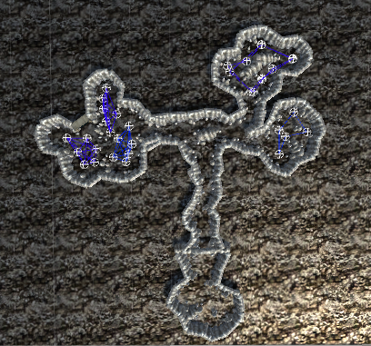
Figure 1 - Level 1 Map

(Figure 2) is a map of the second level of the dungeon game.
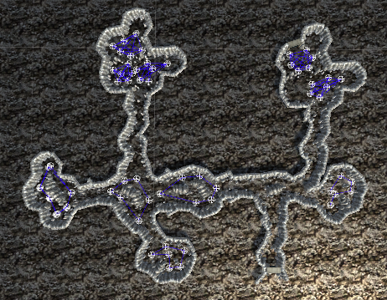
Figure 2 – Level 2 Map
(Figure 3) is a map of the boss level of the dungeon game.
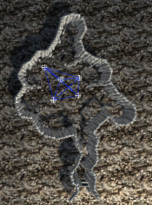
Figure 3 - Boss Level Map

(Figure 4) demonstrates the starting of the game on level one and the User Interface in the game.
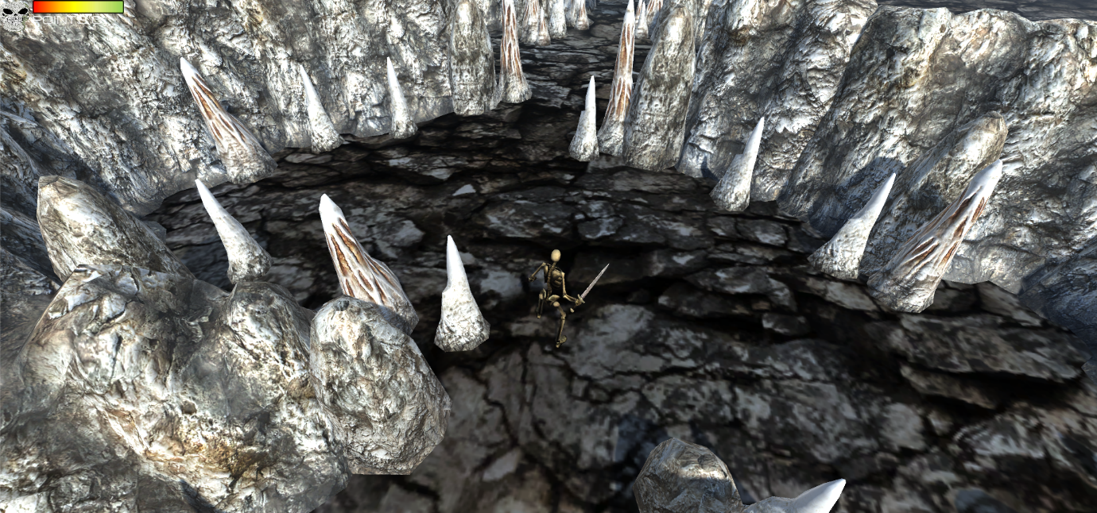
Figure 4 - Start Game and UI
(Figure 5) shows the player character attacking.
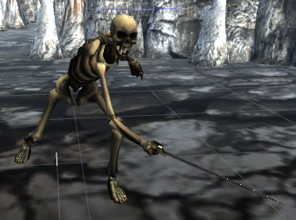
Figure 5 - Player Attacking Animations

(Figure 6) shows the enemy attacking the player.
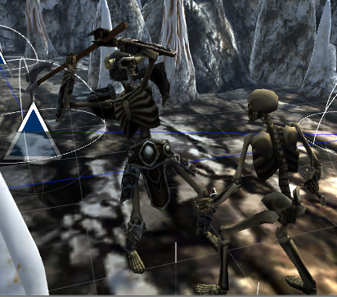
Figure 6 - Enemy Attacking the Player
(Figure 7) shows the door way that the player character must reach in order to progress to the next level.
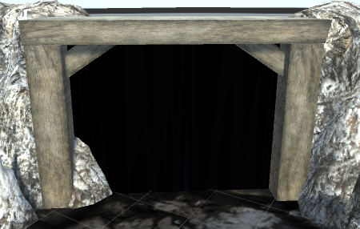
Figure 7 - Exit for each level

(Figure 8) shows the start area for the boss level.
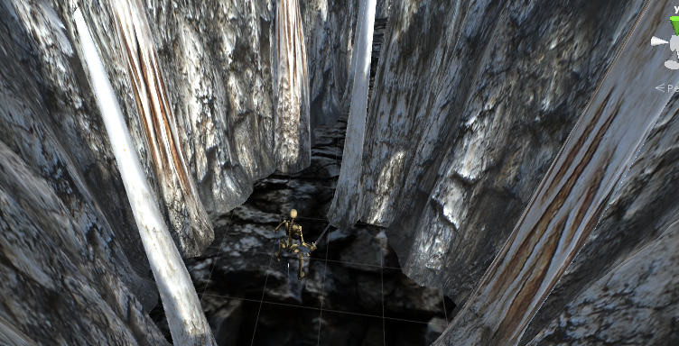
Figure 8 - Start of the Boss Level
(Figure 9) shows the boss enemy, which is much bigger than the player character, next to the player character.
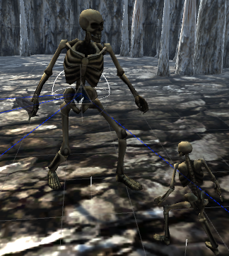
Figure 9 - Boss Enemy Next to Player Character

(Figure 1) shows the pause menu for the game, which has a save button, load button and a quit button.
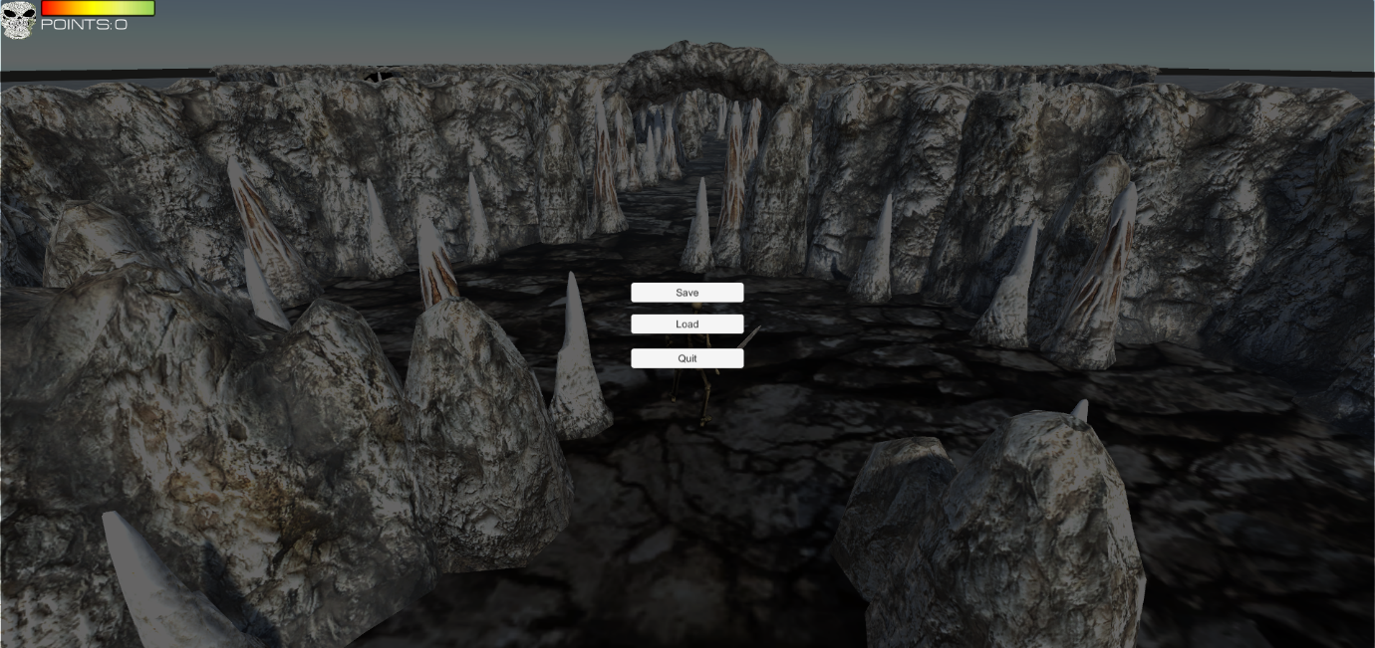
Figure 10 - Pause Menu
(Figure 11) shows the screen which the player will see when they have beaten the boss.
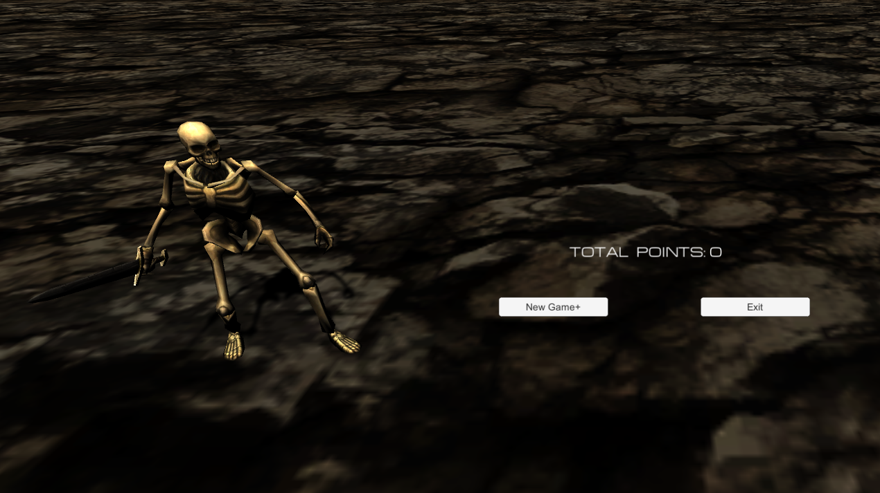
Figure 11 - End Game Screen

(Figure 12) demonstrates the game over screen the player will see when their character dies.
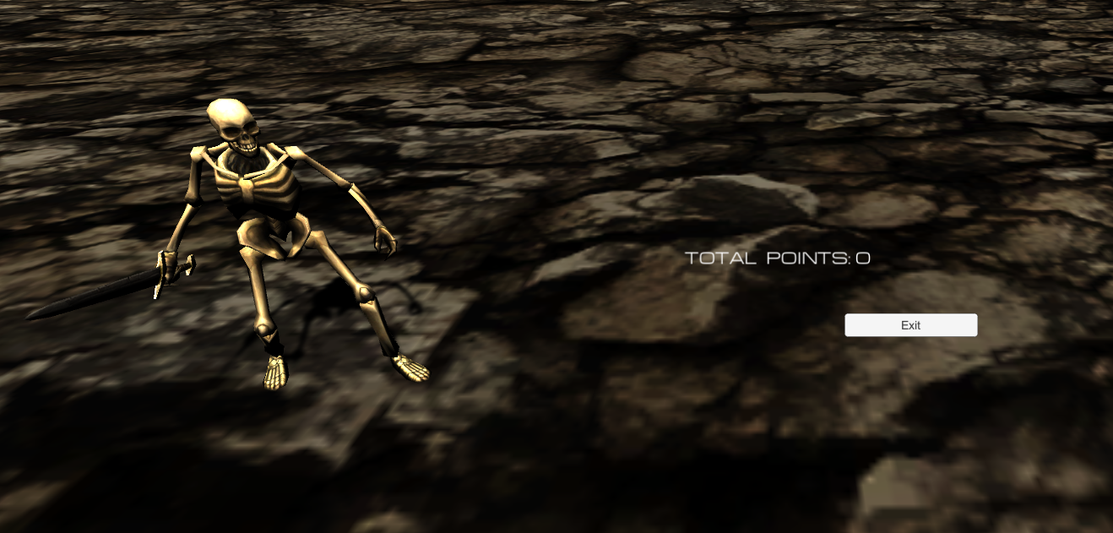
Figure 12 - Game over Screen

Evaluation

Errors
- Enemy instant kill
  - Currently the enemies will kill the player in one hit some times. This issue is caused by the collider on the weapons, as long as the player is in contact with the weapon they will continuously lose health.
- Player can kill without animation
  - The player is able to damage the enemy by simply turning so that the player’s sword is colliding with the enemy and the enemy will continuously lose health until they die.
- Enemy attack animations don’t repeat
  - When the enemy gets close enough to the player to attack, it will play the attack animation, but it won’t do it again until the player moves away from it.
- Enemies travel backwards
  - Several of the enemies would travel backwards and chase the player character with their back facing the player. This error was resolved as it was a simple mistake of rotating the enemy skeletons instead of the enemy object.

Gameplay
At times the game doesn’t provide the difficulty I was hoping for as the enemies don’t always attack correctly, while at other times the game is too difficult as the enemies can defeat the player character in essentially one hit. There are not obvious game breaking errors that interfere with the user playing so the game can always be completed.

Future Versions
There’s a multitude of way in which the game can be improved upon. In future developments the weapon hit boxes could be altered so they don’t appear until the attack animation has been triggered and disappear after the attack animation. This will stop the player from killing the enemies by just running into them.

References
[1] “How to rotate camera orbit around a game object on mouse drag - Unity Answers.” [Online]. Available: https://answers.unity.com/questions/1257281/how-to-rotate-camera-orbit-around-a-game-object-on.html. [Accessed: 01-May-2018].

